Marketing Fundamentals
Code: LCBB4004

Assessment 2- Marketing Fundamentals Analysis and Evaluation

Student ID:2114394

Table of Contents
Introduction 2
Marketing 3
Stages of Marketing 4
Macro and Micro Environment 5
STP Analysis 9
Marketing Mix 12
Conclusion and Recommendations 15
References 16

List of Figures
Figure 1: Definition of Marketing by CIM.UK. 2
Figure 2: GDP growth of the UK 5
Figure 3: Products of Coca-Cola 9
Figure 4: HQ of Coca-Cola 11

Introduction
This report is based on the marketing fundamentals. Here the report is divided into three parts- introduction, the body of the report, and the conclusion. In the body part marketing is defined, the definition given by CIM is also included. As there are several stages in a marketing process, four of them are described here. Then the two business environments are explained through PESTEL and SWOT analysis for the selected company- Coca-Cola. How the company selects its customers by segmenting and targeting them and where the brand stands in the market are also mentioned with numerical data. In the last part of the report body, a detailed marketing mix is stated through 7Ps analysis. The analysis contains the products, prices, promotional strategies, etc of Coca-Cola. Coca-Cola is a multinational company that was founded 129 years ago. From a single beverage, now there are numerous brands of coffee, tea, carbonated beverages, mineral waters of the company that is available around the world.

Marketing
Marketing is a combined set of business activities including generating ideas for innovations and products. The activities include the process of creation, production, communication, delivery process, etc. According to Kotler and Armstrong (2013), identifying the demand and needs of the customers is the starting of the marketing process. Selecting suitable customers for the products and communicating with them so that they get ideas about the brand and many potential customers are created are the main objectives of a general marketing process.
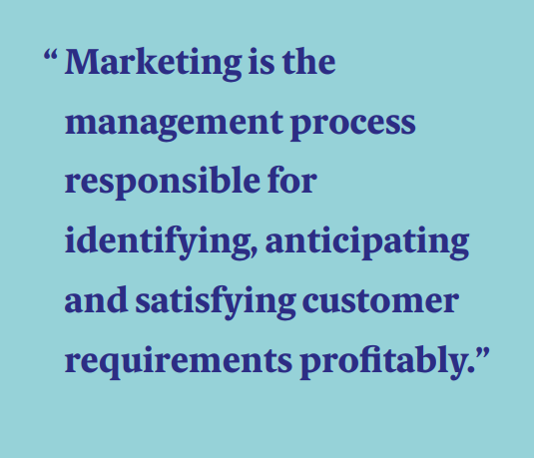
Figure 1: Definition of Marketing by CIM.UK.
Source: (Cim.co.uk, 2022).
Chartered Institute of Marketing (CIM) defined marketing as a management process that identifies customers’ requirements and fulfills them profitably.
Marketing creates values for the products toward the customers. Each company launches products keeping in mind to earn their desired profits. Marketing sets the balance point a business needs to reach so that they can do efficient business.

Stages of Marketing
The marketing process goes through some stages. By each stage, one or two business objectives are fulfilled by the marketing team. Here four marketing stages are described that are done consecutively.
Situational Analysis
This is the first stage of the marketing process. The company needs to have broad ideas about the market they will operate, about the business environments, types of stakeholders, competitors, customers’ needs, behaviours, etc. The company has to analyse its products in the market, demand and supply situations, how the customers are reacting, their buying habits, responses, feedbacks. Doing a business in a market, analysing the competitors is a must as they play a vital role in the competitive environment.
Objectives
Molina-Castillo et al (2020) mentioned objectives as the defined goals a business aim for a time limit in a specific market. The objectives are formulated for the profit goals to reach. Marketing objectives are formulated strategically with the consistency of the company’s mission and vision. There are some tools to formulate effective marketing objectives, one of them is SMART objectives. The elaborated forms are- specific, measurable, attainable, relevant, and time-based. This means, the objectives must be specifically mentioned, have numeric form, real that can be fulfilled, logical, and have a specific time.
Strategy formulation
The 3rd stage of the process is to formulate the strategies to attain the objectives. Various strategies will be made and STP analysis is one of them. It is a tool to identify potential customers, divide them into specific groups, and target them. The segmentation process is done by 4 types- geographically, demographically, psychographic, and behaviourally. Then the products are placed on the market.
Implementation and control.
Lastly, the whole process is done in reality. The strategies are implemented, they are observed the whole time being and managed. At the last effective measures are taken to control.

Macro and Micro Environment
In a business, there is an environment surrounding it where the business conducts happen. The elements of the environment affect the business directly or indirectly. The macro-environment is defined as the uncontrollable and external forces that affect business decisions and performances. (R. Abdul, 2017). On the other hand, the Microenvironment is the internal environment that is somehow controllable and uncontrollable.
Here in this report PESTEL analysis and SWOT analysis are done for Coca-Cola to analyse their macro and microenvironments. Some of their merits and demerits are:
PESTEL analysis helps to gather information about the outside environments, make past analyses and future predictions about any changes.
Sometimes the analyse becomes subjective because of different points of view to observe the situation, in that case, the business may suffer in the long run.
SWOT analysis identifies the internal strengths and weaknesses and external opportunities and threats. So, the business is fully analysed and the strategy-making teams familiar with the company processes begin with.
An overhyped self-praised analysis can be a huge threat for the company
PESTEL Analysis
Political- The UK is one of the most powerful political countries in the world. There is stability in the politics and the different parties are cooperative towards the general people. Business companies like Coca-Cola are highly influenced and affected by the politics in the UK. They are facing struggles after Brexit and their market has been shrunk. Buckton (2019) revealed that the government has decided to impose more taxes on sugar-related items and Coca-Cola is in trouble. They are also blamed to influence and risking public health by the national health institute in the UK. (Serodio, 2020).
Economic- In 2020 the UK has faced the biggest downfall in the economy in the last few decades. They have been recovering from it since 2021. In the 3rd quarter of 2021 GDP was 556431 million British pounds and it was much bigger than the previous year.
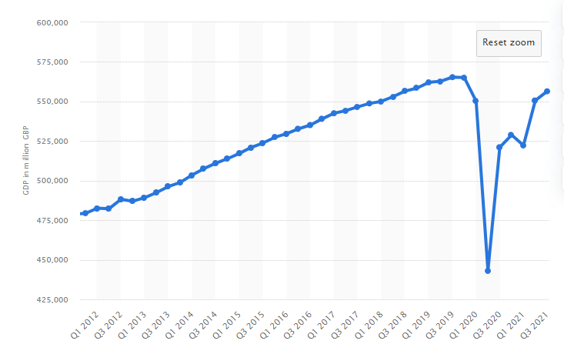
Figure 2: GDP growth of the UK
Source: (Statista. 2022)
Coca-Cola has also gained a large number of profits in the UK. They are the best-selling carbonated drink in the UK in 2021. (Statista. 2022). So economically the company is contributing a lot to the UK GDP and the economy is getting better, so both are having a positive situation here. But the tax may rise and so the cost of production for Coca-Cola too.
Societal- The population growth rate in the UK is 0.6% and the middle-aged people are the larger part. Soft beverages like Coca-Cola are consumed by almost all of the people in society excluding children under 5 years. So, the demand and buying behaviour of the customers in the UK are positive towards the brand. The people are mostly educated, economically stable in the UK. They belong to the lower middle to upper classes in society. The company has to be aware of the health rules in terms of ingredients as people are conscious of their heat. So, abiding by the rules of quality products, employment, etc are a must for the company.
Technological- The UK has a leading tech industry in the world where numerous scientists, institutions work in the R&D sectors. Technological innovations and industrial advancement have been possible for many years and companies like Coca-Cola is having those advantages. There is every possible technology for production plants, AI, robots, a delivery mechanism designed for the company in the UK. The government is investing a lot of funds to innovate new technologies in the market. And the western countries including the UK are gathering themselves to build a strong tech industry to prevent China’s innovation in the industry.

Environmental- Jones, and Comfort (2018) mentioned that Coca-Cola has been aiming for a sustainable future by preserving the environment. Their production system has been made more environment friendly. But on the other hand, Cole et al (2021) stated that the company may be held responsible for their excessive plastic waste and danger to the environment. In the UK people are environmentally aware and many protesters go against the companies who pollute the natural environment.
Legal- In the UK all the parties who abide by the rules and regulations have the right to have full law enforcement. The government is helpful to businesses. Coca-Cola can have any legal rights that are legal for them. There is the consumer rights act 2015 for the customers to protect them from unfair businesses and provide poor-quality products. They have rights in terms of delivery of the products, reactions, refunds, etc.

SWOT Analysis
Coca-Cola is a worldwide famous brand that is loved and consumed by numerous people around the world each day. They are easily recognisable because of their market reputation, products quality, design, and massive advertisements. Here some of their strengths, weaknesses, opportunities, and threats are mentioned.
Strengths- There are so many strengths that need to be mentioned for the company. They are operating in the market since 1892, almost 130 years. This represents their stability and growth in the market and within the company. As a multinational company, their market presence is no joke as they are the leading beverage in the market. In 2021 their brand value was nearly $87 billion. Their biggest market share and huge distribution system have made them a market giant. When it comes to customer loyalty, they are on the top lists. People in all countries in the world consume the drink because of the ease of availability. So, the business connections and production system are huge. From strategy making to customer connection, the company makes its best move to be the market leader and their skilled and united yet diversified workforce around the world makes them unique.
Weaknesses- There are also some weaknesses of the company. They are dependent on the 3rd parties in terms of technology. Coca-Cola has signed a partnership with Microsoft for five years for the deal of software supply. (Amanda, 2020). As a carbonated soft drink, brands like Coca-Cola have been suggested to be banned because of their health risks. They are not finding any suitable solution for this. The company has less product diversification. The competitors in the market are launching many products but Coca-Cola is focusing on single products so in the long run it may create risks. They are blamed for overusing plastics for their packaging and it is environmentally risky. Some lawsuits against the company also revealed their mismanagement side in the industry.
Opportunities- As the company has a huge and loyal customer base, it can expand its product line. They can launch new products and it will go well in the market from the very first. Because of their economic sufficiency, they can easily expand their market and industry through acquisitions. Entering into a poor or developing country is very easy for them. The growing demand and popularity around the world may increase their supply and the easy supply chain make it easier.
Threats- The biggest threats for the company can be the competitors in the market. Their biggest competitor is Pepsi. Other companies like Starbucks, Nescafe are also can be treated as threats to them. The recent economic fall in the world has proved that anything is possible and economic hazards can come at any time. Lawsuits and controversies are the inevitable threats for the company as they have been always fighting in the market and facing criticisms for those.

STP Analysis
STP analysis is defined as the tool to analyse the customers in the market, depending on the products, dividing the customers into different groups, and targeting a few of them. Here the STP analysis of Coca-Cola is described.
Segmentation- There are four ways to segment the whole customer base in a market. Firstly, geographic segmentation focuses on the place of the customers. They are segmented based on cities, towns, regions, etc. demographic segmentations are done based on the customer’s profiles- their age, gender, family, income, social status, etc. Coca-Cola segments its market/customers based on their age, income, family, etc. They are also targeted based on their buying behaviours- repeating customers, occasional, rare, potential, etc. The company also divide the customer groups according to their attitudes, values, opinions, and interests. As the pandemic goes on there are some slight changes in segmentation. People are changing their lifestyles; their concentrations are going onto healthy lives. So initial segmentation strategies are changing.
Targeting- Coca-Cola targets customers of all ages. As people of all ages consume the beverage and soft drinks are must for many people the company targets all genders and ages. The young people aged 18-30 are the most aimed customers for the drink. They are economically stable and educated too. They gather data from different websites, social media, market observations and create a customer profile for people in an area. Then list the most possible targeted and potentially successful customer groups. As all the customers can not be targeted, they start with the most potential ones. COVID-19 has forced the company to aim for potential customers in the market and identify loyal customers.
Positioning- In marketing, positioning refers to the place the company stands in the market. Kostelijk and Alsem (2020) as there are so many competitors, competitive products, a company needs to identify its place in the market and where they belong.

Positioning map of Coca-Cola
The positioning also means how a brand creates its images in the mind of people. As for Coca-Cola, they have created a positive vibe in the customer’s minds. They promote comfortable lives, happiness, and bright energy in daily life. They are always customer-centric so they are fully committed to the customer’s favours. The people’s outlooks are changing due to pandemics. They are changing their mind and focusing on reduce of carbonated beverages like Coca-Cola.

Marketing Mix
According to Išoraitė (2016), marketing mix is a comprehensive plan where several marketing activities include. It is said to be the foundation model, and companies use it to attain their set objectives and business goals. As a tool of marketing mix analysis, 7Ps analysis is a whole process where all the necessary segments are covered. Here 7Ps analysis is done for Coca-Cola.
Products- There are so many brands in the Coca-Cola company. Coca-Cola, Fanta, Sprite, Georgia, Gold peak tea, simply, peace tea, Ades, Aquarius, Appletiser, etc. are some of their brands. In this section, some of these are beverages, coffee, tea, and mineral waters.
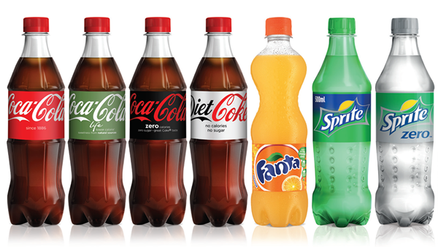
Figure 3: Products of Coca-Cola
Source: (The Coca-Cola Company, 2022).
Coca-Cola is a brand that almost all people in the world who drink beverages can recognise. Of the reasons are their unique logo and the distinguishable and captivating red colour. Carbonated water, phosphoric acid, caramel colour, and corn syrup are the main ingredients of Coca-Cola. It is the highest-selling brand in the beverage industry. But as the pandemic is going on, the people are decreasing their spending on drinks, they are aiming for a healthy life so the demand is somehow decreasing worldwide.
Price- Coca-Cola follows several pricing strategies around the world. Depending on the place and city the prices vary. In the UK their biggest competitor is Pepsi and the brand does a competitive pricing strategy. The prices are not too high or not too low as they need to comply with the customer’s affordability. In the UK the average price of 2 liters of Coca-Cola is around 2 British pounds. This price may vary depending on the online business shops, offline supermarkets, wholesales, or with or without taxes. Customers who do the bulk buying may have the advantage of less spending on Coca-Cola than the single bottle buyers. The recent prices are on the struggling point for the company as the COVID-19 is surging and people are decreasing their Coca-Cola consumption. So, the competitive pricing model has become more intense among the competitors.
Place- In marketing place indicates not only the location a business deal happens but also the distribution path a product follows to reach the customers. Delivering a product to the customers is important and based on the availability of the products, the buying behaviour changes. Coca-Cola has a huge distribution system for its products. They are producing their products in many countries to decrease the transportation cost and import taxes. The products are sold in 200 countries in the world and each country maintains a smooth delivery chain by the company. The distribution channel has been hampered because of continuous lockdowns and shutdowns of shops and supermarkets. On the other hand, online businesses are blooming for the brand.
Promotion- Coca-Cola does aggressive promotions for its products. They use all the traditional and modern strategies including Billboards, TV, radio, newspaper advertisements, etc. They have all social media accounts such as Facebook, Instagram, Twitter, and others. They have 3.3 million followers on Twitter, 3.7 million subscribers on YouTube. On YouTube, they upload lots of videos in different languages, where customers feel inclusive and valued. Their campaigns are spread through social media accounts and happen in events. According to Komańda, (2017), Coca-Cola sponsored a European football championship in 2016. They also sponsor athletes who take participate in several sports events. As for the ambassadors, the company chooses many influential people, stars to be their ambassadors.
People- As a huge company, Coca-Cola has a big workforce. Around 80 thousand employees are working in the company. The employees in the company get several benefits other than the monetary salary- bonus, paid vacations, good working conditions, etc. The company also gives the workforce to grow more in their career by giving many pieces of training and promotions. In 2020, during the pandemic, numerous employees were laid off by the company. (USA Today, 2020). As an efficient workforce plays the role of competitive advantage, the company tries to grow a more efficient and stronger base of their workforce.
Process- The company has many brands so their concentration has to be on all of them. They maintain positive relationships with the 3rd parties, suppliers, and retailers. As a market leader, they try to increase their bargaining power with the suppliers. Their distribution operations are monitored, operational performance of the employees is recorded for the measurements. They try to give excellent customer service to the customers.
Physical evidence- The company is renowned globally. They have physical existence all over the world. In all of the countries they operate, there are offices and buildings. They have production plants. The online presence is increasing too.

Figure 4: HQ of Coca-Cola
Source: (Abby Kleckler, 2020.)
The HQ of Coca-Cola is in Atlanta, Georgia, US.

Conclusion and Recommendations
Coca-Cola operates in 200 countries. In the UK the company is affected by politics as they get involved in politics often. Due to Brexit, the market in the UK has shrunk. Economically the company is the market leader in the UK being the best-selling beverage. People in the UK consume largely this brand. The company has a huge and loyal customer base that helps them to easily expand their business. Many lawsuits and controversies and competitors re their threats in the market. They target customers of all ages. The brand spread a happy vibe in the customer’s life they also are on the top of the market. The company is easily attracted by the customers because of its unique logo design and red colour. Prices vary for different distribution channels and regions. They follow aggressive promotional strategies and competitive pricing strategies.
Some suggestions for the company from the customer’s viewpoints are: The company needs to launch a new product line to be in the market for a long time as the people’s choices are changing. They need to consider the less use of plastic bottles for their packaging. Other than the huge usage of sugar, there should be an alternative to increasing the healthy ingredients in the products and building more trust of the customers in the products.

References

Serodio, P., Ruskin, G., McKee, M., and Stuckler, D., 2020. Evaluating Coca-Cola’s attempts to influence public health ‘in their own words: analysis of Coca-Cola emails with public health academics leading the Global Energy Balance Network. Public health nutrition, 23(14), pp.2647-2653.
Abby Kleckler, 2020. GenNext Winners Take Center Stage at Coca-Cola HQ. Progressive Grocer, 99(1), pp.65–66.
Amanda Jean Dalugdug, 2020. Coca-Cola signs a 5-year software deal with Microsoft. SNL Kagan Media & Communications Report.
Buckton, C.H., Fergie, G., Leifeld, P. and Hilton, S., 2019. A discourse network analysis of UK newspaper coverage of the “sugar tax” debate before and after the announcement of the Soft Drinks Industry Levy. BMC public health, 19(1), pp.1-14.
Cim.co.uk. 2022. Marketing Qualifications, Training and Membership | CIM. [online] Available at: <https://www.cim.co.uk/> [Accessed 5 January 2022].
The Coca-Cola Company. 2022. Brands & Products | The Coca-Cola Company. [online] Available at: <https://www.coca-colacompany.com/brands> [Accessed 8 January 2022].
Cole, R., Benstead, A.V. and Mc Loughlin, K., 2021. Live Classroom Debate: Should Coca-Cola Be Held Solely Accountable for the Environmentally Damaging Impacts of the Plastic Waste of Their Product?. SAGE Publications: SAGE Business Cases Originals.
Išoraitė, M., 2016. Marketing mix theoretical aspects. International Journal of Research-Granthaalayah, 4(6), pp.25-37.
Jones, P. and Comfort, D., 2018. The Coca-Cola Brand and Sustainability. Indonesian Journal of Applied Business and Economic Research, 1(1), pp.34-46.
Komańda, M., 2017. Brand Sponsorship and Social Media. Coca Cola and Carlsberg Illustrated with an Example of the European Football Championship 2016. Trendy ekonomiky a managementu, 11(28), pp.37–46. https://doi.org/10.13164/trends.2017.28.37.
Kotler, P. and Armstrong, G., 2013. Principles of marketing. 15th ed. Boston: Pearson Prentice Hall.
Kostelijk, E. and Alsem, K.J., 2020. Brand positioning: Connecting marketing strategy and communications. Routledge.
Molina-Castillo, F.-J., Meroño-Cerdan, A.-L. and López-Nicolás, C., 2020. Impact of business model objectives on marketing innovation activities: A comparison between manufacturing and service firms. European journal of innovation management, 23(1), pp.177–195. https://doi.org/10.1108/EJIM-12-2018-0259.
R. Abdul Maqin and Nevi Hendri, 2017. Comparative Analysis: The Effect of Macro and Micro Environment on Marketing Strategy and Marketing Performance of Small Medium Enterprises (Survey on Group of Small Medium Enterprises of Food and Non-Food Products in Cianjur Regency, West Java, Indonesia. International review of management and marketing, 7(5), pp.70–76.
Statista. 2022. Quarterly GDP UK 2021 | Statista. [online] Available at: <https://www.statista.com/statistics/785546/gross-domestic-product-per-quarter-united-kingdom/> [Accessed 8 January 2022].
Statista. 2022. Sales of leading carbonated brands UK c-stores | Statista. [online] Available at: <https://www.statista.com/statistics/1194496/leading-carbonated-drink-brands-retail-sales-revenue-uk/> [Accessed 8 January 2022].
USA Today, 2020. Coca-Cola says layoffs, buyouts imminent. New Orleans, Citi Business.

