A Critical Analysis of the Relationship Between Gender Marketing and Stereotypes
Business Management (BA)
Louie Greenwood (P149044)
2019
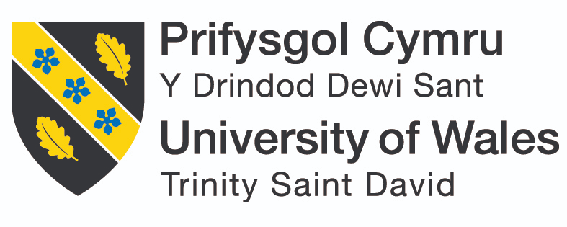

DECLARATION
This work has not previously been accepted in substance for any degree and is not being concurrently submitted in candidature for any degree.
Signed……………………………………………Date………………………………………
STATEMENT 1
This dissertation is being submitted in partial fulfilment of the requirements for the degree of BA.
Signed…………………………………………Date………………………………………
STATEMENT 2
This dissertation is the result of my own independent work/investigation, except where otherwise stated.
Other sources are acknowledged by footnotes giving explicit references. A bibliography is appended.
Signed……………………………………………Date………………………………………
STATEMENT 3
I hereby give consent for my dissertation, if accepted, to be available for photocopying and for interlibrary loan, and for the title and summary to be made available to outside organisations.
Signed………………………………………….. Date……………………………………
STATEMENT 4
I hereby give consent for my dissertation, if accepted, to be available on the university’s IT system to those who have consent to use the system.
Signed………………………………………………Date……………………………………

Acknowledgements
I would like to thank my friends and family for their support throughout the production of this dissertation. I could not have done it without them and their encouragement. I would like to specifically thank my partner for standing by me though this stressful time, and for helping me when it was becoming overwhelming. I would also like to thank each participant of my research for taking their time to help me gather the data.
Finally, I would like to thank my supervisor Beth Cummings for guiding me through this dissertation, without you I would have not had the motivation to complete this dissertation.

Abstract
This dissertation aimed to analyse the link between gender marketing and the construction of gender. Gender stereotypes have seemingly been used in many marketing campaigns throughout history. The literature review found that companies such as Gillette and Hoover have previously used gender stereotypes in order to market their products. They have also been seen to create gender stereotypes. This will be further analysed in reference to the affect the use of stereotypes will have on society.
In order to analyse this, 10 participants were gathered to take part in a focus group, each participant also filled out a short demographic survey. This was in order to understand the differences between different demographics. One focus group consisted of straight cisgender participants, and the other focus group was made up of members of the LGBT+ community, as members of the LGBT+ community may experience gender differently. After the focus group, two participants were asked to stay and take part in an interview to gain more in depth insight into the topic; one from each focus group.
The results were analysed using a thematic approach, which indicated various themes were found to have linked gender stereotypes and marketing. Themes such as family, and social influence were common between both the focus groups as well as the interviews.

Contents Page
Acknowledgments 2
Abstract 3
Chapter 1: Introduction 6
1.1 Research Aims and Objectives 6
1.2 Definitions 7
1.2.1 Marketing 7
1.2.2 Gender 8
1.2.3 Stereotypes 8
1.3 Rational 8
Chapter 2: Literature Review 10
2.1 The Evolution of Marketing 10
2.1.1 Simple Trade Era 10
2.1.2 Production Era 10
2.1.2.1 The Introduction of Corsets 11
2.1.3 Sales Era 11
2.1.3.1 Milady Décolleté 11
2.1.4 Strategic Marketing 12
2.1.4.1 Hoover 12
2.1.5 Marketing Today 13
2.1.5.1 Gillette 13
2.1.5.2 Harmful Stereotype Ban 14
2.2 Gender 15
2.3 Stereotypes 15
2.3.1 What Are Stereotypes? 15
2.3.2 How are Stereotypes Formed? 16
2.3.3 The Effects of Stereotypes on Society 16
2.4 Gender Stereotypes and Marketing 18
2.5 Conclusion 19
Chapter 3: Research Method 21
3.1 Research Onion 22
3.2 Philosophy 22
3.3 Approach 23
3.4 Strategy 23
3.5 Collection and Analysis 24
3.6 Focus Group Design 24
3.7 Pilot Study 25
3.8 Analysis 25
3.9 Sampling 25
3.10 Reliability and Validity 26
3.11 Limitations 27
3.12 Ethical Considerations 27
Chapter 4: Data Analysis 28
4.1 Focus Group Analysis 28
4.1.1 Theme One: The Impact of Peers 29
4.1.2 Theme Two: The Impact of Society and Social Media 31
4.2 Interview Analysis 34
4.2.1 Theme One: The impact of Peers 34
4.2.2 Theme Two: The Impact of Society and Social Media 35
Chapter 5: Conclusion 37
5.1 Objective Two 37
5.2 Objective Three 39
5.3 Recommendations 39
5.3.1 Recommendations for Marketing 39
5.3.2 Recommendations for Further Research 40
6. References 41
7. Appendices 49
7.1 Appendix 1 49
7.2 Appendix 2 50
7.3 Appendix 3 51
7.4 Appendix 4 52
7.5 Appendix 5 53
7.6 Appendix 6 55
7.7 Appendix 7 56
7.8 Appendix 8 60
7.9 Appendix 9 65

Chapter 1. Introduction

1.1 Research Aims and Objectives
This dissertation aims to analyse the relationship between gender stereotypes and marketing, as well as the influence that this has over society. The usefulness of gender marketing will also be analysed in order to make conclusions about its relevance in today’s society. These areas will be researched through the use of both primary and secondary data. A qualitative research study will be conducted, in the form of focus groups. Within these focus groups, participants experience with gender and marketing will be explored in depth in order to gain insight into the subject. Secondary data is important in order to test the validity of the data found, and see if others have found similar results, or if the results of this study has touched upon new findings. Secondary data also played a role in finding the area in which to research. While reviewing the literature within the topic area it was discovered that there was a gap within current research. This gap was in regards to whether gender is a product of marketing, or whether it is affected at all by marketing. Gender marketing’s effects on individuals has been extensively researched, and has caused reforms in the law. However, this research aims to analyse effects that this form of marketing has had in the formation of gender stereotypes. The aims of this dissertation are as follows:
- To undertake a review of the literature exploring the history of gender marketing.

This will be done in order to gain an understating of gender marketing through history. Analysing existing literature will give background to different theories. By analysing the literature currently out there it is possible to predict the results of this study. This will also show where research is needed, as some areas have more of a gap for research than others.

- To examine the extent to which gender marketing influences stereotypes through undertaking of qualitative primary research

By examining the relationship between gender and marketing it is possible to find the root of the link between them. This will be done through conducting focus groups with participants, aimed towards analysing their relationship with gender and marketing. In order for areas to grow, new research needs to be conducted. This research will aid the growth and creation of other research studies in the future.

- To identify whether using gender stereotypes for marketing purposes is effective in today’s society through the analysis of primary data.

The effectiveness of marketing towards gender needs to be analysed in order to appropriately examine the effects of it on society. This dissertation aims to be impartial; in order to do this both sides of the argument must be discussed. Gender marketing has effects on society however those effects may be equally weighted by the positive effects it has on businesses and thus employment.

1.2 Definitions
In order to analyse the relationship between marketing and gender stereotypes there must be an understanding of the definitions used within this research. There are different definitions of each concept within this research: marketing, gender and stereotypes. The definitions that have been used within this research are as follows:

1.2.1 Marketing:
“Engaging customers and managing profitable customer relationships.” The main aims are to attract new customers as well as maintain a businesses’ current customers (Kotler, 2018). This can be done in various ways, such as satisfying their consumers and customer wants and needs; while ensuring they are creating value for their customers.
Marketing is continuously evolving with new technologies being introduced as well as changes in society and how people perceive things. There has always been a need for marketing as there have always been products and services. Examples of marketing can be found from as far back as 3000 BC with businesses such as shoe makers writing on clay tablets to inform people of their services (Eagle, 2014). Since then marketing has evolved, and through time different eras can be seen within the marketing trends (see figure below).
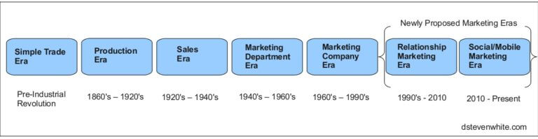
Figure 1 Marketing Eras: White (2018)

1.2.2 Gender:
“The characteristics of women and men that are socially constructed”, which differs from a person’s biological sex (WHO, 2019). The majority of people identify as the gender that was assigned to them at birth, making them cisgender. This is where the most common male/female gender stereotypes were created.
Transgender is a term that has been defined as “people whose gender is not the same as, or does not sit comfortably with, the sex they were assigned at birth” (StoneWall, 2019).

1.2.3 Stereotypes:
“A collection of beliefs and views that is formed about the personal attributes that a group of people will have” (Boca, 1981), with gender stereotypes being preconceived notions of “characteristics, or roles that are or ought to be possessed by, or performed by women and men” (OHCHR, 2019).

1.3 Rational
The concept of marketing is something that has changed over time, with changes in society having a large influence over the ways in which companies market their products. Marketing has been seen to have a close relationship with gender stereotypes, with research showing a distinct difference between the ways in which men and women favour advertisements (Perju-Mitrana & Budaciaa, 2015). This will be examined in relation to past marketing strategies in order to make conclusions about both the relationship between marketing and gender stereotypes, as well as the effectiveness of gender marketing within today’s society. Where there is research on the difference between men’s and women’s perception of marketing, there is a paucity of research on the effect this may have on society. Marketing to specific genders has been seen to cause changes within society, specifically changes in the perception of gender through stereotypes. This is something that the Advertising Standards Association has become aware of, leading them to create new legislations on the harmful use of gender stereotypes (ASA, 2018).

Chapter 2. Literature Review

2.1 The Evolution of Marketing
Marketing is a concept that has been around for as long as records show (Eagle, 2014). The concept has been changing throughout time, with new resources becoming available as well as people becoming more socially aware. Gender and marketing can be seen through many marketing campaigns through history. This chapter will explore the relationship between gender stereotypes and marketing through history, making conclusions about their influence on one another.

2.1.1 Simple Trade Era
The simple trade era consists of everything before the industrial revolution. This is a very different form of marketing to what can be seen in today’s society, however the main principles behind it are the same; ‘to attract and retain customers at a profit’ (Drucker, 1993). In the past, products were either harvested or handmade meaning that there was a limited supply of them. They were then traded for other products rather than sold for money and shipped off to different countries. In this time the main form of marketing was word of mouth as with limited resources companies had no other way to market products (White, 2018).
Through this era there was little gender marketing as most products were food and other necessities, with little to no products being targeted towards a specific gender (Ness, 2015).

2.1.2 Production Era
As time progressed as did the resources that companies could use to market their products. The industrial revolution sparked a change in the ways of marketing with more technological advances and more ways for people to market their products. White labelled this the production era as goods were still scarce and most of their focus was on creating products rather than marketing them (Ness, 2015).

2.1.2.1 The Introduction of Corsets
During this time period more gender specific products were being introduced; corsets for women were the height of fashion with posters stating that corsets create “beautiful women” (appendix 1) (ThisVictorianLife, 2019). The image of a stereotypical woman’s body shape is something that changes over time. Corsets were designed to make a woman have the appearance of a small waist and larger hips. This was something that society deemed the image of a perfect woman.
It is unclear whether it was the creation of the corset that led the change in a stereotypical woman’s body shape, or whether they were created in order for more women to fit the stereotype (ScienceOfPeople, 2019).

2.1.3 Sales Era
After the industrial revolution businesses became more focused on sales, granting the name of this era to be the era of sales. More companies started opening, making the market more competitive. This led companies to use marketing strategies in order to gain an advantage over their competitors. Strategizing their marketing allowed companies to understand the wants of their customers, which was used in order to sell their products. (White, 2018).

2.1.3.1 Milady Décolleté
In 1914 Harper’s Bazaar, a women’s magazine, created the first advertisement campaign that showed women that had removed their body hair. During this period fashion was changing, with women wearing clothes that showed off more of their body. This led to Gillette creating the “Milady Décolleté” campaign (Appendix 2) where their adverts encouraged women to remove their “unsightly” hair, stating that having no body hair was a “necessity” (Women'sMuseum, 2017). This trend however was not the first time that women’s body hair removal was a trend. It can be dated back to 3000BC when Egyptian women removed all their hair, believing that it was cleaner (Lubitz, 2016).
It is indicated that this led to the stereotype of women needing to have no body hair, and can be seen to have perpetuated as it still exists in modern western society. Within the media women are portrayed to have no body hair. With the majority of males only seeing female bodies within the media, this can be seen to have had a large effect on their relationship with women. When 10 volunteers were asked about their preferences with women’s body hair 9 of them believed that women should have little to no body hair, and that they would not date someone who has body hair (GetTheGloss, 2015). Even though this is was a small sample size, the results show that the portrayal of stereotypical women is having an effect on men’s perceptions of women. This, however, is something that is more recently changing, with the first ever razor advertisement depicting women with body hair. My Billie create razors specifically designed for women, at the same price as razors for men (Billie, 2019). Showing women with body hair within the media could lead to less pressure on women to shave, and could, in turn, change the stereotype again.

2.1.4 Strategic Marketing
This era consisted of companies needing to push their products in order to increase their sales (White, 2018). The rise in technology allowed marketing teams to widen their consumer base. Appliances such as radios and televisions allowed businesses to reach a larger audience. By the 1950’s marketing teams had started to market their products to different people, more specifically market products to different genders (Olenski, 2018). Models such as the segmentation, targeting and positioning (STP) model helped guide marketing teams create relevant and personalised campaigns in order to engage with different demographics (MindTools, 2019). It allowed them to identify demographics within their market, and categorise them based on characteristics or stereotypes, as well as identify the wants and needs of these demographics. This then leads them to develop detailed products and advertisements that will engage their target audience (Hanlon, 2018).

2.1.4.1 Hoover
An example of this can be seen in adverts such as the 1953 Hoover advert. During this period women were seen as housewives who take care of the children and do the cleaning. Hoover identified this and used those stereotypes to market their product; the advert stated “Christmas morning she’ll be happier with a Hoover” (Appendix 3) (Hussain, 2014). By identifying the target audience, and the stereotypes of their demographics, the marketing team have created an advertisement that will engage with their audience.
During World War II women took up more “masculine” work roles, with 90% of women between the ages of 18 - 40 being in employment (StrikingWomen, 2019). This however was something that significantly decreased after the war ended. With the men coming home and needing jobs women were pushed into roles such as nurses and cleaners as these roles were deemed more “feminine”. Married women or women with children were pushed out of work, and if they were returning to work their pay would be significantly less (StrikingWomen, 2019). This can be seen to have led to companies, such as Hoover, targeting women in order to keep them out of the work place, and ensuring that they fulfilled their role as a housewife (Lamb, 2011). This example shows marketers reinforcing stereotypes in order to sell their products, as well as using their influence to make changes within society.

2.1.5 Marketing Today
From the early 2000’s people have become more socially aware, meaning that people have a deeper understanding of the world around them. This includes things such as different cultures, norms and the environment (MindValley, 2018). This has led to people being more aware of marketing campaigns and the impact that negative stereotypes can have on society. Negative stereotyping can be defined as “stereotypes that are likely to cause harm, or serious widespread offence” and is something that can be seen throughout marketing (ASA, 2018). In a study conducted by Kantar, involving 2000 participants, two-thirds of women would skip advertisements that they believed to negatively stereotype women, with 85% of the participants agreeing that advertisements are doing a “poor job of depicting real women” (Rogers, 2018).

2.1.5.1 Gillette
This social awareness has led to campaigns such as the #metoo campaign and international woman’s day, which both aim to close the gender gap and fight harmful stereotypes. In response to this, Gillette created an advert in correspondence with the #metoo campaign, with the president of the company stating “we can help create positive change that will matter for years to come” (Baggs, 2019). Within this advert, Gillette are challenging the stereotype that men and are aggressive and do not show emotion. They are using their influence within society to ensure that harmful stereotypes, such as toxic masculinity, are not reinforced. This could, in turn, change the male stereotype which is something that Gillette has been seen to do previously.
Using campaigns such as the #metoo campaign within marketing can have positive impacts on society. By changing the ways in which men are portrayed within the media, marketers can guide the views of the wider population ensuing that toxic masculinity is no longer as prominent (APA, 2018). However it can be argued that the use of these campaigns are for the companies benefit, rather than the benefit of society. By following these social trends the company are ensuing that they are receiving the publicity, even if some of it is negative. There have been many news articles written about their #metoo advert, which has created a wide discussion about their brand, as well as giving the company a positive reputation (Thompson, 2017).

2.1.5.2 Harmful Stereotype Ban
A review by the Advertising Standards Association (ASA) brought forwards evidence that suggests that harmful stereotyping can have a negative effect on people’s choices and aspirations. This has led to a ban on all harmful gender stereotyping, in 2018, including stereotypes such as women being unable to complete a task because of their gender (ASA, 2018). The director of Advertising Policy and Practice within the ASA believes that harmful stereotypes “hold back people and society”, and that this policy will bring forwards a more gender equal society (BBC, 2018). While the use of gender stereotypes can still be used within advertising, eliminating harmful stereotypes could have an effect of the stereotypes themselves. Over time, if these harmful stereotypes are not reinforced then they could potentially diminish and be a less prominent part of gender stereotypes. The impact of stereotyping was seen to be lessened over time within an American study on the perception of new born babies. In the 1970’s parents were asked to describe their babies using adjectives, with the outcome stating that girls were “softer” and “weaker” than boys. This study was conducted again in the 1990’s showing less of a difference between the two genders (Deutsch, 2007). This shows that influences such as marketing can have a positive effect on stereotypes and that over time these harmful stereotypes can be lessened.

2.2 Gender
Similarly to the evolution of marketing, gender is a concept that has changed over time. While being transgender, a person who does not identify with the gender they were assigned at birth, is seemingly a more modern concept, it is something that has always been around. Throughout Native American society’s history people who do not identify with either male or female genders were labelled “Two Spirit”. These individuals were the spiritual leaders of their tribes, often respected people (Mesa-Miles, 2014). Similarly to this in 1954 Christine Jorgensen was the first transgender woman to come out publicly; after serving in the Second World War she underwent gender reassignment (CBSNews, 2019). Due to new legislations people are becoming increasingly more aware of other genders. In 2004 the government created the Gender Recognition Act. This act was revolutionary for its time, as it was one of the first of its kind. The act allowed transgender and non-binary people to legally change their gender on their birth certificates and all corresponding documents. There is currently an update being conducted on this act as it is believed the process is not accessible enough (GOV, 2018). Gender can now be viewed as a spectrum varying from both binary, such as male and female, to non-binary genders, such as being genderfluid or demigender. This spectrum also goes from being agender to feeling gender intensely, as someone who identifies as a binary gender would. Diagrams have been created in order to better understand these spectrums, these are the Gender Bread person and the Gender Unicorn (Appendix 4) (GenderBread, 2017). A survey conducted in the US, by the Pew Research Center found that 59% of people born between 1996 and 2004 believe that gender should not be only defined by the binary genders, male and female, but include nonbinary genders (Kopf, 2019).

2.3 Stereotypes

2.3.1 What are stereotypes?
Stereotypes can be defined as being “a collection of beliefs and views that is formed about the personal attributes that a group of people will have” (Boca, 1981), with gender stereotypes being preconceived notions of “characteristics, or roles that are or ought to be possessed by, or performed by women and men” (OHCHR, 2019). Research shows that the stereotype commonly accepted in a particular society, of a group of people, can influence the information that a person will be provided with, meaning that there will be information about a person that will be overlooked within the social environment (Lippmann, 1922). This can be seen within gender stereotypes such as women being bad drivers. For example if a man sees someone driving badly, they will assume that the driver is female, even though statistically women are safer drivers (Binding, 2018).

2.3.2 How are stereotypes formed?
The process of using stereotypes is seen as a natural occurrence that has the possibility of being an innate part of human nature (Allport, 1954). This is seen by evolutionary psychologists as being a survival instinct, as in prehistoric times other groups of people meant danger (Nicholson, 1998). Stereotypes are not necessarily a negative occurrence. Positive stereotypes and generalisations also exist and can influence the view someone will have on a group of people. An example of this is the idea that Asians are smart by default, or that Jewish people are good with money. A person’s stereotype of a group of people is rarely good or bad, but a mixture of both to create a more rounded picture of the group. Stereotypes can exist in many cases, however they are seen to be far more prominent in the BIG categories: race, gender and age (Brewer, 1989).
While most stereotypes have no specific origin, some have been created. An example of this is the stereotypes of gender colours; with pink being for girls and blue being for boys. Before World War II, blue was gendered towards females and pink was gendered towards men. However, due to Hitler using pink triangles to symbolise homosexual men, this was changed. Nowadays, men are gendered by the colour blue, and women are gendered by the colour pink. This was changed due to Hitler’s branding of the colour pink meaning ‘gay’ (Pomroy, 2015). This is something that can still be seen in society, with girl’s toys and clothes being predominantly pink, and boy’s toys and clothes being predominately blue.

2.3.3 The effects of stereotypes on society
Although stereotypes are normal and can be harmless, they can also lead to prejudice against outgroups. Prejudice has been described as the deep-seated feeling of aversion towards outgroups (Allport, 1954). These feelings are mostly based upon inflexible and inaccurate stereotypes towards others. Examples of this can be seen within Gillette’s #metoo advert, with people posting on social media that they will no longer be using their brand due to them challenging male stereotypes (Baggs, 2019). It can also be seen within campaigns such as Januhairy, where women are receiving backlash on social media for not shaving their body hair. The stereotype that women should have no body hair has caused both men and women to find it “disgusting” when women do not shave; this has caused prejudices towards women who do not shave (BBC, 2019). .
Another issue with stereotypes is the lack of knowledge people possess about people who are different to them. It is widely observed that people favour their ingroup members over outgroups, meaning that they have little experience with people who are in different groups to them. This leads to people having misleading information about other groups of people, which is a factor that causes harmful stereotypes (Brewer, 2002). This lack of knowledge led to the creation of contact theory, which is the idea that knowledge of other groups is key to reducing prejudice. The theory explains that having positive interactions with members of an outgroup, will make you less likely to believe in harmful stereotypes about this group. These effects can also be seen to be effective through secondary contact, such as seeing positive depictions of outgroup members on television (Allport, 1954). By using positive stereotypes within marketing, prejudice can be reduced as it will give people more knowledge about different groups.
An example of these prejudices can be found between the LGBT+ community and their outgroups. A study was conducted in Iowa State University to see the effects of implementing The Save Zone Project. The project consists of LGBT+ awareness and ally training workshops (TheSafeZone, 2019). The study concluded that implementing the project within the university has had “a positive impact” and has “increased support for LGBT people” (Evans, 2002). This suggests that knowledge about different groups of people can lessen prejudice towards different groups of people, which will in turn lessen the effects of harmful stereotyping.

2.4 Gender Stereotypes and Marketing
A study by Kantar found that 98% of laundry and cleaning products are targeted towards females, however when marketers were questioned 88% of male and 76% of female marketers believe that they do not use gender stereotypes (Koch, 2019). This supports the theory that stereotyping is a natural occurrence and is something that people do subconsciously (Allport, 1954).
Changes within society are leading towards more gender equality and more gender diversity, with the younger generations believing that gender is not just binary (Kopf, 2019). This is creating a crossover between stereotypes, with more men wearing typically female things such as makeup and skirts, which has left a gap in the market (Thomas, 2017). It has been said that there is a “new era of masculinity” in which men are seeming more comfortable in partaking in more typically feminine things, such as makeup. Even though makeup wasn’t always gendered, by the 20th century it was deemed not masculine, with male makeup being looked down on (Lunn, 2019). This is something that is quickly changing, with an increasing number of new makeup brands being created specifically for men in order to fill in this gap in the market, such as Mankind, and Mensmake-up (Mankind, 2019) (Mensmake-up, 2019). Having celebrities in the media normalising the use of male makeup is changing the stereotypes of men, allowing the younger generation to express themselves, rather than following stereotypes.
However, even though the stereotype of men being unable to wear makeup is being broken down gender marketing is still very prominent. Rather than just creating makeup that is for everyone, there is specific makeup for men and for women. Some companies that are pushing more male makeup have created brands around the fact that they are specifically made for men such as “Mankind” and “Mensmake-up” (Mankind, 2019) (Mensmake-up, 2019). This is similar to other cosmetic products that are labelled for men and women such as moisturiser, even though when more closely examined the ingredients of the products are almost identical (Hubbard, 2017). Even though this is changing stereotypes, it is still generating a gender gap and reaffirming the difference between men and women. By having makeup specifically marketed towards men, marketers are using the male stereotypes to create gender specific advertisements.
Studies have found that men and women react to online advertisements differently, with women being more favourable towards messaged that “inspire confidence” whereas men are more favourable to the “usefulness of message received” (Perju-Mitrana & Budaciaa, 2015). This supports the need for gender marketing as it creates more efficient marketing plans and can therefore generate more profit.
Even though marketing beauty products to a specific gender is common, there are companies that are aiming to be more gender neutral. Companies such as Jecca makeup have created a brand aiming to be highly accessible. They have created genderless makeup, specifically to be inclusive towards transgender people (Jecca, 2019). As well as companies set out to specifically create genderless products, more mainstream companies such as John Lewis and Zara are eliminating gendered products (Rodulfo, 2016) (Newbold, 2017). Genderless products can be more inclusive, especially for the LGBT+ community. They can help transgender people overcome their gender dysphoria, especially those who identify as nonbinary. Gender dysphoria is “when a person experiences discomfort or distress because there is a mismatch between their sex assigned at birth and their gender identity” (Stonewall, 2019).

2.5 Conclusion
Throughout the history of marketing there has been a prominent relationship between gender marketing and gender stereotypes. The two concepts can be seen to work together closely, however it is difficult to pinpoint which concept follows which. There is evidence that marketing has both followed stereotypes, and created stereotypes.
Marketing theories such as the STP model have created ways in which marketers can ensure they are creating advertisements that are relevant for their target audience (MindTools, 2019). Studies have shown that segmenting target markets by gender is an effective way of marketing, as men and women react differently to advertisements (Perju-Mitrana & Budaciaa, 2015). They each are favourable to different aspects of marketing, meaning that different content will make men more inclined to purchase the product to women.
The 1914 Gillette advertisements could be seen to have created the image of a stereotypical woman, which brings a debate of whether marketers follow existing stereotypes, or if they create them. Before this advert there was no market for razors for women which pushed the company to create their own market by changing the stereotype. This example shows the extent of power that marketing can have over stereotypes and people’s views of society, with few people knowing the history of the stereotype. The stereotype created by this marketing campaign has lasted over 100 years, and as influenced the ways in which society perceive women. This has blurred the lines between where stereotypes are created, allowing marketing teams to not only reinforce stereotypes but even create them in order to create a new market. This is something that is also prevalent within Hoover’s advertisements, and can show the extent of influence that marketing has over society. Not only does the advertising change stereotypes, but it has been seen to change the ways in which society functions through changing people’s views.
In today’s society the increase in social awareness has brought to light issues with harmful stereotypes within marketing. This has led to a ban on harmful stereotypes and more awareness of the use of stereotypes within marketing. The awareness of gender marketing has also created a gap in the market for more genderless products, as well as less marketing towards specific genders. However there still seems to be the need for gender marketing as studies find that men and women are more favourable to different aspects of marketing.

Chapter 3. Research Methods
This chapter has the aim of providing an overview of the research methods used by the researcher as well as the data analysis techniques in order to investigate the research title. The research title is “A Critical Analysis of the Relationship Between Gender Marketing and Stereotypes”.
The method of primary research will be closely analysed with the use of the ‘research onion’, created by Saunders and Lewis (Saunders, 2009) , to identify and justify the methodology. The primary research will be conducted in order to meet the dissertation’s objectives: ​​
- To undertake a review of the literature exploring the history of gender marketing

- To examine the extent to which gender marketing influences stereotypes through undertaking of qualitative primary research

- To identify whether using gender stereotypes for marketing purposes is effective in today’s society through the analysis of primary data.

The term research has been defined as a systematic study that explores a hypothesis or a theory in order to enlighten facts and come to new conclusions (Punch, 2016).

3.1 Research Onion
The research onion was created by Saunders and Lewis (2009) to aid the researcher with the planning of their research. The tool consists of different layers whereby the researcher can work their way from the outer layer, to the inner layer. Each layer focuses on a different aspect of research, where the researcher can rationalise each thing and explain the process that is used within the research.
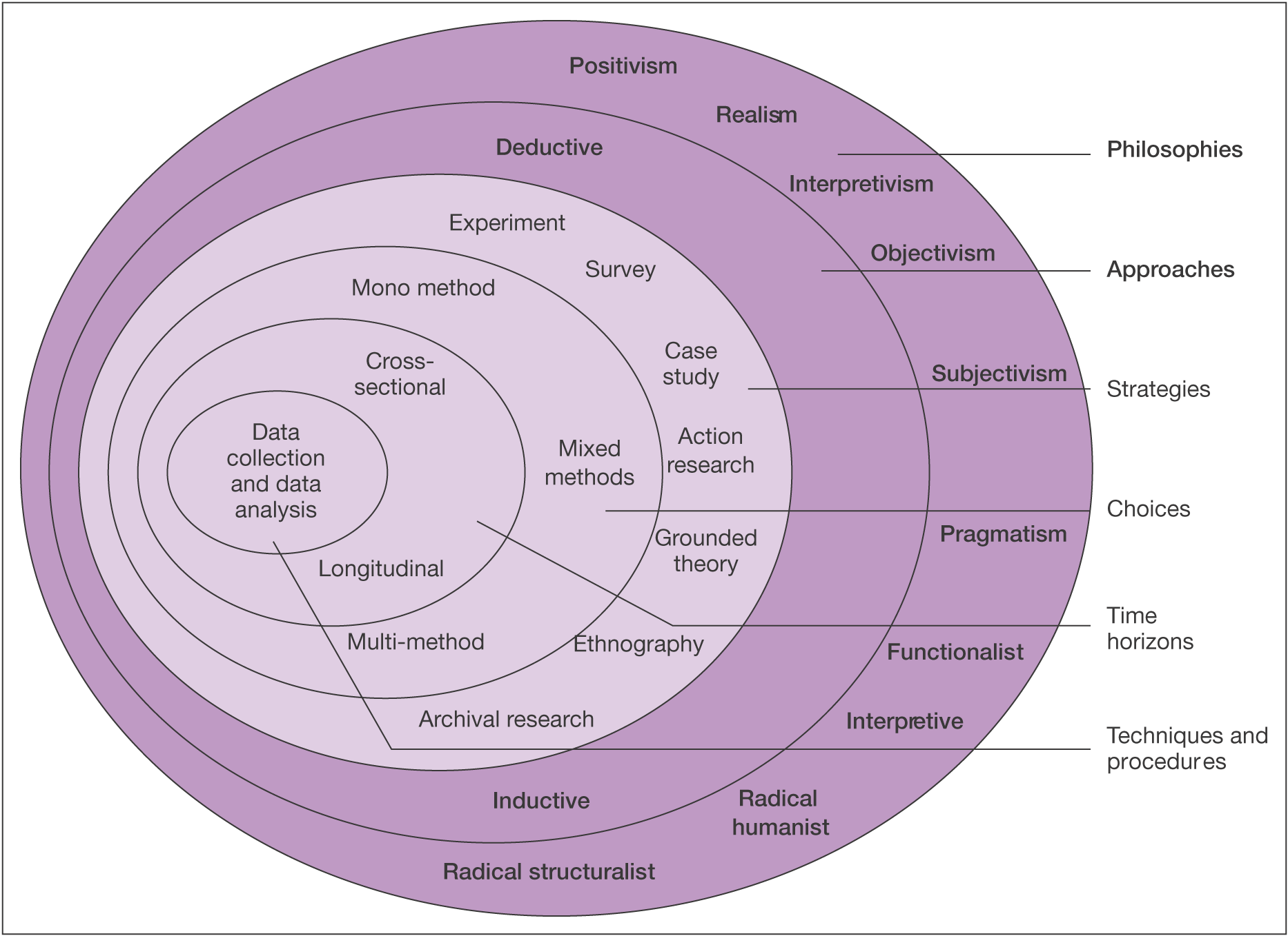
Figure 1: The Research Onion, Source: (Saunders, 2009)

3.2 Philosophy
This research study will take on the interpretivism philosophy. Interpretivism has been shown to be useful when human emotions and experience are involved in the study. This is due to these aspects not being down to an exact science, and not being able to be predicted. It is said that “interpretivism tends to focus on exploring the complexity of ‘social phenomena’ to gain a view that has an interpretive understanding” (Collis & Hussey 2014 p45).

3.3 Approach
For this research an inductive approach will be used. This has been defined as research which “involves the search for pattern from observation and the development of explanations” (Bernard, 2011). Inductive approaches can be used with both qualitative and quantitative research however it is mainly seen in qualitative research. It is used for exploratory analysis making it very useful for qualitative data analysis as it generates theory.
Within this research, connections between gender marketing and people’s views of gender will be analysed. An inductive approach will allow the researcher to identify patterns through focus groups and interviews, and aid the development of theories within this topic.

3.4 Strategy
The primary research will consist of a multi method approach, using a survey for demographic purposes. focus groups and in depth interiews. This will allow the researcher to gain a better understanding of the topic. This uses a pragmatism research philosophy as it allows different viewpoints to be given, which can give a wider view on the research (Saunders, 2012).
They survey consisted of four demographic groups: gender, sexuality, age and occupation. The survey was conducted in order to enable researchers to attribute the data collected to demographics. This is important due to a participant’s view on gender could be correlated to their age, as knowledge of transgender identities is more prominent in recent years. Furthermore, the research is on gendered marketing, therefore the gender of a participant will influence the data collected and this needs to be accounted for when analysing data.
The focus groups have been the selected method of research as they have been seen to help the participants to reflect on their answers in more depth due to the interaction between participants. Interaction will The topics discussed within this dissertation are daily life events that are mainly subconscious, meaning that further reflection from participants will gain a better understating of their views (Morrison, 1998).
In depth interviews have been the chosen method to collect more data in order to gain more knowledge about the discussions of the focus groups. This will allow the researcher to find common themes between both the focus groups, as well as having a deeper understanding of the participant’s answers (Hussey, 2009).

3.5 Collection and analysis
The data collected will be qualitative data, no numerical data will be collected. Qualitative data has been suggested to be very information heavy and has a greater ability to capture people’s true unfiltered emotions. This is due to quantitative measures being made up of mostly closed questions, whereas qualitative questions have open ended questions that promote free speech (Collis & Hussey, 2009). This method is appropriate to the research because of the nature of the study. Participant’s experiences and opinions of their experiences with gender and marketing will need to be captured in a raw element in order to truly understand the sentiment (Taylor, et al., 2015).

3.6 Focus Group Design
The focus groups will consist of a small group of participants gathering together with the researcher. There will be two focus groups, one group with no specific criteria, and one focus group consisting of people who identify as LGBT+. This will allow the researcher to gain diversity within the research, specifically diversity within the gender of the participants. The groups of participants will answer questions and take part in activities in order for the researcher to gather information. This is a good form of data collection because focus groups have been shown to be a useful way to obtain detail rich information about a groups personal feelings and opinions. Focus groups also save time in comparison to interviewing as the questions do not have to be repeated to every participant. They also allow the researcher to gain clarification on the information given as they allow more interaction between participants. This can allow them to speak freely rather than being concise, as they may be in a questionnaire, which can give the researcher more information which can led to better results for the research.

3.7 Pilot Study
A pilot study was conducted to ensure that the questions were clear and understandable. This will allow the researcher to make changes within the research questions which can increase the reliability of the research (Wilson, 2010).
It will also give the researcher an understanding of how long the focus groups will take, allowing the participants to put ample time aside to take part (Hart, 2005).
One focus group was conducted prior to the research, consisting of 5 friends of the researcher. They were asked to take note of any issues within the research questions which allowed the researcher to change any discrepancies. There were issues with the wording of one of the questions as participants struggled to understand what was being asked. This was rectified for the research, improving the quality of data that the research will find.

3.8 Analysis
Data will be analysed by using a thematic approach; this has been defined as “a method for identifying, analysing and reporting patterns within data” (Clarke, 2006). Themes will be identified within the data collected through the focus groups. These themes will be identified by firstly grouping individual statements into common themes, then analysing which of the themes are spoken about more often. The themes will also need to be analysed to see if some themes are umbrellas for other mentioned themes, such as an umbrella theme of “upbringing” can have other smaller themes within it. The themes found will then be analysed in order to explain the research question.

3.9 Sampling
The participants were chosen through a volunteer process, mainly through contacts within The University of Wales Trinity Saint David (UWTSD). For one of the focus groups there was no specific criteria for the participants to meet. This allowed a wide demographic of people to participate. Several societies were contacted in order to advertise the research and collect participants; society members were told to email the researcher in regard to their interest in the research. For the second focus group participants had to identify as LGBT+; the LGBT+ society within UWTSD were contacted to collect participants. They were told to contact the researcher if they were interested in taking part in the research.
Using random sampling allows for minimum amount of sampling compared to other sampling methods such as volunteer sampling. Random sampling was selected in order to minimise sampling bias, this is reduced due to the researcher not being able to influence who is in the focus group. By having random sampling, it also meant that the participant pool was larger than with other types of sampling as the demographics needed are not ass specific (Saunders, 2012).

2.10 Reliability and Validity
In studies where the conductor is in the room with participants there will always be bias; this bias is called sampling. The order of the questions asked, or the ways in which they are asked can affect the answer given. For instance, an investigator must ensure they are not asking leading questions. In a study by Loftus and Palmer, participants were shown videos of road accidents and then questions about it. They were then asked how fast a car was going when it passed the barn, there was no barn and yet participants still gave answers to the question (Palmer, 1974). This shows that leading questions can have a big effect on the data gathered, and participants will attempt to give the answers they think the researcher will want to hear, even if they are not giving correct information. The study may also suffer from demand characteristics, where participants will act in a certain manner, and say certain things because they feel that is what the conductor wants. They will not want to ‘ruin’ the study and thus act how they believe is favourable. This being said, these factors will be controlled and thus minimising the effects and possibilities of them occurring. These will be controlled by having set questions in which the investigator will ask, these will be monitored for leading questions, and will not be altered from group to group to ensure validity.

2.11 Limitations
There are limitations involved in this research in the form of time limitations and participant demographics. In order to complete the research within the time frame a Gantt chart has been created. The data collection, in the form of focus groups, will be collected over the space of 4 weeks, and the data will be analysed over a 5 week period. This could limit the research as it is only a short amount of time and may not be fully conducted or analysed before the research is written up. The other limitation of the research is the demographic of the participants. Due to the larger demographic of universities being people aged between 18 – 25 it is likely that this will be the majority within the focus groups. This will not give a true reflection of the general population and could therefore create an unreliable outcome. Further research could be conducted in order to widen the demographics of participants. This could give a better understanding of the relationship between gender and marketing.

3.12 Ethical Considerations
Within this study, the extent of ethical risk involved is minimal. The research for this study will be in the form of focus groups; all participants will be volunteers over the age of 18. All the data collected will be kept confidential and if a participant wishes to withdraw their data it will have to be discounted. The ethics form filled out prior to the research follows the OECD and BPS ethics guidelines which ensures that all that are involved within the study are protected from ethical risk (OECD, 2016).

Chapter 4. Data Analysis
The aim of this chapter is to give a detailed analysis of the primary data collected for this research. An inductive approach will be used to analyse both the focus groups; trends will be found within this data in order to conclude the research. This chapter will aim to satisfy the aim of the dissertation, which was to explore the relationship between gendered marketing and the construction of gender itself. The research was conducted through the use of focus groups and individual. The focus group participants were also asked to complete a short demographic questionnaire in order to analyse the answers given against demographic data. This data will be analysed thematically.
- To identify whether using gender stereotypes for marketing purposes is effective in today’s society through the analysis of primary data.

4.1 Focus Group Analysis
These focus groups took place in April 2018. The research that these focus groups were held were in order to grant the researcher the ability to seek opinions and first hand data about how gendered marketing has affected people. The groups were both treated as parallels, and there were no differences between the research settings in either group. The groups were told prior to recording what kind of questions were to be asked, and given time to pull out of the study, but also given time to think about the topic before it began to be discussed. The researcher was then able to ask questions about gender marketing throughout people’s lives such as questions analysing peoples’ childhood toys. This was done by asking open ended questions such as ‘What toys did you enjoy playing with as a child?’ This questions’ answers were analysed individually and tested against gender and age of the participant.
The focus groups have been analysed using a thematic approach (Bernard, 2011). Two prominent themes were found, the impact of family and peers, and the impact of society and social media.

4.1.1 Theme one: The impact of family and peers
The first and most prominent theme within the focus groups was how families were affected by gender marketing. This theme was discussed in both focus groups, mainly focusing on people’s parents. The participants agreed that their parents/guardians were the most influential people in their childhood, and that their views of society stemmed from their parent’s/guardian’s views. When discussing stereotypes, both groups mentioned that their views of gender stereotypes came from their families, mainly through learned behaviours such as mannerisms. Phrases such as “boys will be boys” and “that’s not lady like” were discussed within the second focus group, with the participants agreeing that they help reinforce gender stereotypes. This led onto a discussion about childhood friendships, with all participants stating that their friend groups as children always consisted of people of the same gender. From a young age they were taught that boys and girls were too different to be friends. One participant recalled that they “thought that boys had germs, so they had to stay away from them”. This created a divide between the two genders, which allows people to create stereotypes about the other genders as they do not have much first-hand knowledge of them.
Participants were asked to think back to their childhood toys and discuss toys that they played as well as toys that they wanted to play with. Within the second focus group a participant stated:
“My family bought all my toys for me, around Christmas time I got to look through an Argos catalogue and chose what I wanted. Most of my decisions were based on what toys my friends had.”
The participant recalled that they mostly bought toys that their friends had which, in the case of all the participants, aligned with their gender. This made some of the participants feel that they couldn’t play with toys that weren’t marketed towards their gender. This was particularly prominent within the LGBT+ focus group. When speaking about what toys specifically were played with participants who were assigned female at birth mentioned things such as baby dolls and barbies, whereas those assigned male at birth mentioned toy cars and toy soldiers.
When the question was asked to the first focus group there was a different reaction, with one participant recalling
“I felt no pressure to play with certain toys, I just asked for what I wanted”.
This was common within the first focus group with 4/5 participants agreeing to this statement. When choosing toys they felt no pressure to select toys that were marketed towards their gender. However, with more discussion they did agree that even though they could purchase any toy, they generally chose toys that were marketed towards their specific gender.
The second question asked the participants about the clothes they wore as a child, and whether they had a favourite item of clothing. Both focus groups had varying experiences with who chose their clothes as a child, some got to pick out their own clothes and some had their family member chose them, even when they could make their own decisions.
“My mum used to always buy me pink clothes, like flowery tops and skirts.”
This was common between the participants who were assigned female at birth, from both focus groups. When discussing the reason behind them wearing gendered colours some believed that it was easier for their parents, both to decide on clothes and for convenience. This was not something that most participants cared about, however participant 8 explains how they did not feel comfortable wearing these clothes. They recalled that their parents wouldn’t allow them to purchase clothes from the boy’s section, because they were only for boys.
Another participant goes on to say:
“I felt too embarrassed to wear pink because it is a girl’s colour and people would make fun of me if I ever did”
This statement links back to the previous discussion of the participant’s peers and their influence over gendered products. The colour pink is deemed a feminine colour, which can stop males from purchasing these products. It was discussed that peers had influence over what clothes they would wear because if they wore anything that was not marketed towards their gender then they would be ridiculed by their peers. In particular, one participants stated that when they were younger they through that the colour pink was a “gay” colour.
The final discussion point was about clothes that the participants would choose to wear now.
“The colour pink is generally seen as a feminine colour but there isn’t any stigma around it anymore. I’m happy to wear pink now, no one questions it anymore.”
The participants agreed that there is less pressure on them in today’s society to wear gendered products. When asked whether they would wear clothes from the opposite gender’s section, most participants said that they would. With some male participants stating that they would wear things like jeans and tops but that they would never wear dresses or skirts.
This theme brought to light the pressures that the participants felt from their family and peers to act in a certain way because of their gender. This was because of reinforced gender stereotypes, and the pressure to live up to these stereotypes. The participants agreed that stereotypes are an innate part of human society, which supports Allport’s theory (Allport, 1954). They also agreed that they mainly chose toys that their friends of the same gender had, and that they were one of the biggest influences on them.

4.1.2 Theme two: The impact of society and social media
Society has always had a large impact on people’s views, as well as stereotypes. With the introduction of social media, the views of wider society are widely accessible. This theme was discussed within both focus groups, and all participants agreed that society has a large influence over how different genders are seen and the impact this can have on the marketing of products.
When discussing the participant’s childhood, they spoke about how television adverts were their main source of societies influence. Social media wasn’t a large influence in the participant’s childhood and only became prominent in their teen years. While discussing the first topic of childhood toys, all participants agreed that their main source of advertisements was through the television. “I used to watch nickelodeon all the time and the adverts for toys were part of the fun.”
When asked about the adverts of toys that they owned as a child one of the participants from the first focus group recalled:
“I loved Barbies as a kid, I used to see them on TV between shows with little girls playing with their dolls”
Both females owned these dolls and agreed that they were one of the main toys that they played with. This led to a discussion about how seeing other girl playing with toys made them want to as well. They then went on to talk about their roles as a woman and how they had always thought that they would grow up to take care of their families. This is something that is a well-known stereotype for women and one of the participants stated: “when I was younger I thought that I had to take care of my husband”.
The conversation then led to how women are perceived in today’s society, where the participants agreed that having a family is no longer their main focus. The participants agreed that their career and their needs were a higher priority than having a family. When they were younger they felt the need to be stereotypically female, however more recently they do not feel that pressure as much. One participants started “obviously there is still that pressure to be a stereotypical woman, but it’s a lot less pressure now than it used to be”.
When addressing the male participants, they said that they never wanted to play with Barbie’s as they were “for girls”. The most common toy that the males participants spoke about were toy cars.
“My favourite toys were my cars, I used to make racetracks in our sandpit and drive them round for hours”
The majority of participants that were assigned male at birth in both focus groups mentioned playing with toy cars. Similarly to the participants who played with Barbies, they recalled watching adverts for Hot Wheels on television. However when discussing the same topic in the second focus group, all of the participants played with toy cars.
Participant 9 stated: “Me and my brother used to play with cars all the time together, my Baby Born was always my favourite toy but I used to love playing with cars too”
Another participant agreed that they also used to play with cars, however they stated that the toys were specifically their brother’s toys and not theirs. If they wanted to play with them they had to ask permission from their brother.
The second discussion point was about the clothes that the participants wore as a child. All participants agreed that the clothes they wanted to wear was very dependent on the fashion that was relevant at the time.
“I used to read magazines and look at what the celebrities were wearing”
However within the second focus group the participants identified that there are certain items of clothing that are deemed feminine and masculine, for example “suits are for men and dresses and skirts are for women”. All participants agreed that even though it would be socially acceptable for them to wear the other gender’s clothes, that they just did not want to. They also discussed that it was more acceptable for women to wear suits than it is for men to wear dresses. “Men wearing dresses is still pretty frowned upon, but women in suits is pretty common”.
This topic linked closely with the final discussion point, what clothes the participants chose to wear now. The second focus group discussed the change in people’s perception of gender in society, and the change in fashion role models.
“Having people in the media like Jayden Smith wearing skirts and dresses has made society more accepting of people wearing clothes that aren’t made for their gender”
They discussed the affect that people in the media have over society, and how that can affect individuals. They spoke about how it is more widely accepted for people to wear clothes that weren’t designed for their gender, and that people don’t care as much anymore. This supports findings by Thomas, as it shows that it is becoming more acceptable for men to wear skirts and dresses (Thomas, 2017).
Within the first focus group the discussion led to whether the participants would consider buying clothes from a different gender’s section. One female participant stated:
“If I saw something that I liked in the men’s section I would get it, but I wouldn’t go looking for clothes in the men’s section”.
When discussing this further the pressure of society became a prominent theme, some participants agreed that even though it was more acceptable, they still wouldn’t feel comfortable wearing clothes that weren’t designed for their gender. This was felt most strongly when asking the male participants if they would wear skirts in public.

4.2 Interview Analysis
After the focus groups were conducted a participant from each group was asked to stay and be interviewed more extensively. This person was chosen due to their answers given in the focus group. Participant 2 and Participant 8 were chosen to be interviewed. Findings in the interview were similar to the focus groups, however there was a third emerging theme that was not touched upon in the focus groups. This theme did not seem to overtake the strength of the two previously discussed themes, however, it was shown to have importance.

4.2.1 Theme One: The Impact of Family and Peers
The effects that family and upbringing has seems to be a large contributor to the amount that a person will feel impacted by their gender stereotypes and marketing. In the interviews, participants were asked to discuss their experience growing up, and if they ever felt like they were treated in a certain way due to their gender.
Participant 2 stated that they “feel like [their] mum pressured [them] into having a clean and tidy room and looking presentable more than [their] brother”
Participant 8’s answers showed an opposing childhood experience where they weren’t “outwardly pushed towards [their] gender it was more of an internal thing”
Participant 8 went on to describe how they feel their family did not push them into believing they had to behave a certain way, however, they believed that it was something they pushed upon themselves. This being said Participant 8 later went on to state that their family members brought them their toys, these toys seemingly aligned to their gender as they were “lots of dolls”. Participant 8 used to play with their sister, so it is a safe assumption that decisions made on how to play with toys were influenced by each other. Participant 8 stated that they would play with their toys and it was always the “generic mum, dad, kids”. They stated that “dad would usually go out to the pub” and “mum would just stay home, she’d look after the babies”
This is important as it shows that the effects of family influence stretch further than the parental guidance, and can be provoked by siblings and extended members of the family also. Friends, like family, seem to have a big impact on how people will present their gender. This effect was shown by the difference in answers given by participants when asked about what their friendship groups were like.
Participant 2 said “all my friends were girls like me” and that “it was common knowledge that boys and girls couldn’t be friends”
Whereas participant 8 said “most of my friends were of the same gender” however it was also stated that participant had “one male friend” who was a classmate.
Participant 2’s friendship group seemingly was more pressured by the confines of gender, as they showed a large pressure to not be friends with boys. This would mean that Participant 2 would have felt that gender had a bigger impact on their life than Participant 8 who still, to a certain extent, felt comfortable being friends with people of the opposite gender.

4.2.2 Theme Two: The Impact of Society and Social Media
This theme was also brought up in the focus groups, social media and the media in general has a large span on the people it can reach. Therefore the expectations and stereotypes that are created online and through the media can effect a large mass of people.
The theme was first mentioned when Participant 2 was asked about what stereotypes they believe are attributed to their gender currently. They answered are “pressured towards being very flawless […] like Instagram models even though it’s all in the editing”. Participant 2 also mentioned a pressure to be “skinny” and “caring and sweet all the time”.
This statement mentioned Instagram, which is a social media site that runs on people sharing photos with one and other. Instagram models have become large earners through their large following on the site. Participant 2 has seemingly felt influenced to be slim, and well presented at all times by simply seeing photos of the models on the site. This could be due to the Instagram models large following seemingly indicating a large population of people agreeing that the model is a role model.
When asked the same question participant 8 said that “if you’re not being super male, like masculine, then you feel like people don’t take you seriously”. Participant 8 then expanded to say that “a masculine man would be like, strong, muscular, hairy, […], have a deep voice”.
When asked where these expectations came from, participant 8 said they feel like they come from “society” and “social media”. They believed that “a lot of people turn to social media to find their community” and that this meant that social medias created expectations had a large grasp on people.

Chapter 5. Conclusion
This research examines the relationship between marketing and gender stereotypes, looking at the history of gender marketing and the evolution of gender. Both primary and secondary data was analysed in order to gain deeper understanding of gender stereotypes and the affect that their portrayal with marketing has on consumers. The results from the primary data will be summarised and analysed alongside the secondary data. Conclusions will be made about the findings, referring to the objectives:
- To examine the extent to which gender marketing influences stereotypes through undertaking of qualitative primary research

- To identify whether using gender stereotypes for marketing purposes is effective in today’s society through the analysis of primary data.

5.1 Objective Two
To what extent does gender marketing influence gender stereotypes?
When researching the history of marketing and gender stereotypes it can be seen that the two have existed throughout history, however it is not clear when either were established. Both have different definitions and be interpreted in different ways. This has led to a bias within the research as only one definition has been used within this study. The research has shown that the two concepts are closely interlinked, with no clear distinction between which leads and which follows. The primary research concluded that most stereotypes are taught through family and peers, as well as other influences such as the media.
Gillette have shown that marketing can have a large influence over creating stereotypes, with them creating the stereotype of hairless women (Baggs, 2019). When they brought in their “Milady Décolleté” campaign they created as new stereotype which is something that is still prominent within today’s society. This shows the extent to which marketers can influence society as this stereotype has existed for hundreds of years after this initial advertisement. When discussed within the focus groups the media was seen to have a large influence in reinforcing gender stereotypes, however most participants did not understand the origins of these stereotypes.
Marketing theories such as the STP model show that the aim of marketing is to follow the stereotypes in order to create effective marketing (MindTools, 2019). Stereotyping has been seen as a subconscious phenomenon, with the majority of marketers believing that they do not use stereotypes within their marketing strategies (Koch, 2019). This has allowed stereotypes to be reinforced within society which has both positive and negative effects. The use of gender marketing allows marketing teams to create affective and relevant advertisements. It also creates a more efficient way of shopping for consumers as it allows them to locate the products that they are wanting which was shown within the primary research. It also allows companies to focus on the wants and needs of their target audience and create and market products that are relevant. The primary research showed that gender marketing was something that was affective, and that the participants both consciously and subconsciously would favour products that are marketed towards their gender.
The influence that marketing has over society can be seen to have negative effects. Reinforcing gender stereotypes, such as toxic masculinity, can have a negative impact on society (APA, 2018). Stereotypes such as men having a lack of emotions being shown within advertisements has been seen to lead to mental health problems. By reinforcing these stereotypes boys group up to believe that they should not talk about their feelings, which has led to men being three times more likely to commit suicide than women (Samaritans, 2017). Things like this have led the ASA to create policies banning harmful stereotypes (ASA, 2018). These negative effects can also be seen within the labelling of the colour pink to mean “gay”. This is not something that marketing has pushed, however by reinforcing colour stereotypes also reinforces these negative connotations.
Marketing’s span today is wider than it ever has been previously. The internet and social media has made a company’s target audience accessible to them at all times. Social media has taken over traditional methods of gathering news. It has been reported that two out of ten people in America will gather the greater majority of their news from a social media platform, rather than through traditional methods. This research estimated that this would continuously increase in upcoming years (Pew Research Centre, 2017).

5.2 Objective Three
Is gender marketing affective in today’s society?
With the rise in technology creating more social awareness, marketers are under pressure to ensure that they are not negatively affecting society. While stereotypes can be harmful if portrayed incorrectly, they are innate within human society. Without stereotypes marketers would not be able to efficiently target their consumers, which would in turn create ineffective adverts. Studies show that men and women react to advertisements in different ways, with men being more favourable towards factual advertising. This shows that even with changes within society, gender marketing is an efficient way for marketers to sell their products to their target audience.
For certain demographics, such as the LGBT+ community, more genderless marketing would be affective. The beauty market in particular is seeing an increase in more genderless products. It has been seen that customers are shifting their views from making purchases for their gender, to making purchases based on the quality of the product (Steer, 2018).
This however does not necessarily mean that gender marketing is no longer an efficient form of marketing. The research has shown that gender marketing is still affective. Their impact on society prominent, meaning that policies such as banning harmful stereotypes are a positive step towards more socially aware marketing.

5.3 Recommendations

5.3.1 Recommendations for Marketing Teams
This research has brought to light the relationship between gender stereotypes and marketing, and their influence on society. With such a strong connection marketers need to ensure that they are not portraying stereotypes that can cause harm to society. The introduction of the harmful stereotypes ban is a step in the right direction, and this form of awareness will help advertising cause less negative effects on society.
The use of gender marketing is still useful to companies, however the incorporation of more accessible products could benefit them. Making more inclusive marketing strategies, as well as more inclusive products. This can positively affect society as it will create more awareness for other groups of people, for example LGBT+ people, as well as creating allowing companies to grasp the media’s attention. Through this companies can also educate the wider society on other groups of people, which will in turn lessen prejudice. If people are more aware of their outgroups then they will hold less prejudice against them.

5.3.2 Recommendations for Further research
Due to the limitations of this research, such as resource limitations, the research may not be a good portrayal of the wider society. All the participants were between the ages of 20-30, which limited the research to one generation. It would be recommended that this research is furthered to a wider array of age groups, ensuring that different generations are researched. Also a larger number of focus groups would make the research more accurate. Another factor that could positively influence any further research would be to include details of any siblings, or children that the participants may have. This could show differences between the participant’s views on certain topics.

6. References

Allport, G., 1954. The Nature of Prejudice. s.l.:Persus Books Publishing.
APA, 2018. Harmful masculinity and violence. [Online]
Available at: https://www.apa.org/pi/about/newsletter/2018/09/harmful-masculinity
[Accessed 23 May 2019].
ASA, 2018. Harmful Gender Stereotypes in Ads to be Banned. [Online]
Available at: https://www.asa.org.uk/news/harmful-gender-stereotypes-in-ads-to-be-banned.html
[Accessed 4 May 2019].
Baggs, M., 2019. Gillette faces backlash and boycott over '#MeToo advert'. [Online]
Available at: https://www.bbc.co.uk/news/newsbeat-46874617
[Accessed 20 May 2019].
Barbie, 2019. About Barbie. [Online]
Available at: https://barbie.mattel.com/en-us/about.html
[Accessed 28 March 2019].
Barbie, 2019. You can be anything. [Online]
Available at: https://barbie.mattel.com/en-us/about/you-can-be-anything.html
[Accessed 7 05 2019].
Barringer, T., 2013. History of Hair Removal. [Online]
Available at: https://www.elle.com/beauty/makeup-skin-care/tips/g8155/history-of-hair-removal/?slide=5
[Accessed 10 November 2018].
BBC, 2018. Watchdog bans 'harmful' gender stereotypes in adverts. [Online]
Available at: https://www.bbc.co.uk/news/business-46558944
[Accessed 20 May 2019].
BBC, 2019. Januhairy: What I learned when I stopped shaving. [Online]
Available at: https://www.bbc.co.uk/news/uk-england-devon-47001598
[Accessed 20# May 2019].
Bernard, H. R., 2011. Research Methods in Anthropology. 5th ed. s.l.:AltaMira Press.
Bernazzani, S., 2017. Women Shave Because of Marketers: How the Industry Created Demand for Women’s Razors. [Online]
Available at: https://velaagency.com/women-shave-marketers-industry-created-demand-womens-razors/
[Accessed 23 May 2019].
Billie, 2019. My Billie. [Online]
Available at: https://mybillie.com/
[Accessed 24 May 2019].
Binding, L., 2018. Women are better drivers than men, study finds. [Online]
Available at: https://news.sky.com/story/women-are-better-drivers-than-men-study-finds-11484839
[Accessed 10 05 2019].
Boca, R. D. A. a. F. K. D., 1981. Cognitive Processes in Stereotyping and Intergroup Behavior. New York: Psycology Press.
Brewer, M. .., 1989. When Stereotypes Lead to Stereotyping: The use of Stereotypes in Person Perception. In: C. S. M. H. Neil Macrae, ed. Stereotypes and Stereotyping. New York: The Gilford Press, p. 254.
Brewer, M. B., 2002. The Psychology of Prejudice: Ingroup Love and Outgroup Hate?. Social Issues, 55(3).
CAPNews, 2018. Consulting on a new rule to tackle harmful gender stereotype. [Online]
Available at: https://www.asa.org.uk/news/consulting-on-a-new-rule-to-tackle-harmful-gender-stereotypes.html
[Accessed 11 November 2018].
CBSNews, 2019. Transgender celebs you need to know. [Online]
Available at: https://www.cbsnews.com/pictures/transgender-celebrities-you-need-to-know/13/
[Accessed 5 May 2019].
Centre, A., 2018. Dieting pill abuse. [Online]
Available at: https://www.addictioncenter.com/stimulants/diet-pills/
[Accessed 11 05 2019].
Clarke, V. B. a. V., 2006. Using thematic analysis in psychology. Journal, p. 79.
Deutsch, F. M., 2007. Undoing Gender. Gender & Society, 21(1), p. 115.
Drucker, P., 1993. In: The Practice of Management. s.l.:HarperCollins.
Eagle, L., 2014. Advertising. In: Marketing Communications. s.l.:Routledge, p. 245.
Evans, N. J., 2002. The impact of an LGBT Safe Zone project on campus climate. ournal of College Student Development, 43(3), pp. 522-539.
Follows, T., 2017. The Future of Gender Marketing. [Online]
Available at: https://www.campaignlive.co.uk/article/future-gender-marketing/1442147
[Accessed 10 November 2018].
Freire, O., 2017. The effectiveness of celebrity endorsement in aspiring new celebrities: Examining the effects of brand, congruence, charisma and overexposure. RAUSP Management Journal.
GenderBread, 2017. Gender Bread Person. [Online]
Available at: https://www.genderbread.org/
[Accessed 17 February 2019].
GetTheGloss, 2015. The Naked Truth: What Men Really Think About Your Body Hair. [Online]
Available at: https://www.getthegloss.com/article/the-naked-truth-what-men-really-think-about-your-body-hair
[Accessed 24 May 2019].
GOV, 2018. TRANS PEOPLE. [Online]
Available at: https://assets.publishing.service.gov.uk/government/uploads/system/uploads/attachment_data/file/721642/GEO-LGBT-factsheet.pdf
[Accessed 5 May 2019].
Hanlon, A., 2018. The segmentation, targeting and positioning model. [Online]
Available at: https://www.smartinsights.com/digital-marketing-strategy/customer-segmentation-targeting/segmentation-targeting-and-positioning/
[Accessed 5 May 2019].
Hart, C., 2005. Doing a Masters Dissertation. 1st ed. London: SAGE.
Hubbard, L., 2017. The Myth of “Men’s Only” Beauty Products. [Online]
Available at: https://theklog.co/mens-beauty-products/
[Accessed 24 May 2019].
Hussain, A., 2014. Sexism In The 1950S. [Online]
Available at: https://visualpast.wordpress.com/2014/08/27/sexism-in-the-1950s/
[Accessed 5 May 2019].
Hussey, J. C. &. R., 2009. Business Research. 3rd ed. New York: Palgrave Macmillian.
Jecca, 2019. Our Story. [Online]
Available at: https://www.jecca-makeup.com/about/
[Accessed 23 May 2019].
Keay, L., 2017. When all women wanted for Christmas was a Hoover, and men were after some Pipe Appeal: Cringeworthy adverts show life in the days before political correctness. [Online]
Available at: https://www.dailymail.co.uk/news/article-5208475/Sexist-Christmas-adverts-women-want-hoovers.html
[Accessed 24 May 2019].
Koch, L., 2019. Do Marketers Use Gender Stereotypes?. [Online]
Available at: https://www.emarketer.com/content/do-marketers-use-gender-stereotypes
[Accessed 20 May 2019].
Kopf, D., 2019. Generation Z’s views on gender are what set it apart in the US. [Online]
Available at: https://qz.com/1528752/generation-zs-views-on-gender-set-it-apart-in-us/
[Accessed 28 March 2019].
Kotler, A., 2018. Marketing. In: Principles of Marketing. Harlow: Pearson Education Limited, p. 26.
Lamb, V. M., 2011. The 1950’s and 1960’s and the American Woman: The Transition from the "Housewife" to the Feminist, s.l.: HAL Id: dumas-00680821.
Leonard, K., 2019. The Importance of Demographics to Marketing. [Online]
Available at: https://smallbusiness.chron.com/importance-demographics-marketing-25365.html
[Accessed 28 March 2019].
Lippmann, W., 1922. Public Opinion. New York: Brace and Company.
Lubitz, R., 2016. The Unusual and Deeply Sexist History of Women Removing Their Body Hair. [Online]
Available at: https://www.mic.com/articles/151191/the-unusual-and-deeply-sexist-history-of-women-removing-their-body-hair
[Accessed 5 May 2019].
Lunn, O., 2019. Is the Rise of Male Male-up a Sign of a new Era of Masculinity?. [Online]
Available at: https://www.dazeddigital.com/beauty/head/article/43219/1/rise-male-makeup-new-era-masculinity
[Accessed 23 May 2019].
Mankind, 2019. About Us. [Online]
Available at: https://www.mankind.co.uk/info/about-us.list
[Accessed 28 March 2019].
McCarthy, 2014. Basic Marketing: A Marketing Strategy Planing Approach. 19th ed. New York: McGraw-Hill/Irwin.
Mensmake-up, 2019. About Mensmake-up. [Online]
Available at: https://www.mensmake-up.co.uk/about-mens-make-up/
[Accessed 28 March 2019].
Mesa-Miles, S., 2014. Two Spirit: The Trials and Tribulations of Gender Identity in the 21st Century. [Online]
Available at: https://newsmaven.io/indiancountrytoday/archive/two-spirit-the-trials-and-tribulations-of-gender-identity-in-the-21st-century-vJO2nkYbLkCiOWXteDhjsw/
[Accessed 5 May 2019].
MindTools, 2019. Segmentation, Targeting and Positioning (STP) Model. [Online]
Available at: https://www.mindtools.com/pages/article/stp-model.htm
[Accessed 24 May 2019].
MindValley, 2018. The Social Awareness Definition You Need to Know To Be Socially Aware. [Online]
Available at: https://blog.mindvalley.com/social-awareness-definition/
[Accessed 20 May 2019].
Morrison, D., 1998. The Search for a Method. Luton: University of Luton Press.
Ness, J., 2015. The simple trade era. [Online]
Available at: https://prezi.com/vqox_gu469pr/the-simple-trade-era/
[Accessed 24 May 2019].
Newbold, A., 2017. Childrenswear Goes Genderless At John Lewis. [Online]
Available at: https://www.vogue.co.uk/article/john-lewis-genderless-childrens-wear
[Accessed 11 November 2018].
Newbold, A., 2017. Childrenswear Goes Genderless At John Lewis. [Online]
Available at: https://www.vogue.co.uk/article/john-lewis-genderless-childrens-wear
[Accessed 24 May 2019].
Ng, A., 2019. Using AI Technology to Create Smarter Ads. [Online]
Available at: https://www.creadits.com/blog/using-ai-technology-to-create-smarter-ads
[Accessed 5 May 2019].
Nicholson, N., 1998. How Hardwired Is Human Behavior?. [Online]
Available at: https://hbr.org/1998/07/how-hardwired-is-human-behavior
[Accessed 20 May 2019].
OECD, 2016. Research Ethics and New Forms of Data for Social and Economic Research, Paris: OECD Publishing.
OHCHR, 2019. Gender Stereotyping. [Online]
Available at: https://www.ohchr.org/EN/Issues/Women/WRGS/Pages/GenderStereotypes.aspx
[Accessed 20 May 2019].
Olenski, S., 2018. 5 Ways Tech Will Change Marketing In 2018. [Online]
Available at: https://www.forbes.com/sites/steveolenski/2018/01/24/5-ways-tech-will-change-marketing-in-2018/
[Accessed 24 May 2019].
Palmer, E. L. a. J., 1974. Reconstruction of auto-mobile destruction: An example of the interaction between language and memory. Journal of Verbal Learning and Verbal Behavior, pp. 585-589.
Perju-Mitrana, A. & Budaciaa, A. E., 2015. Gender Differences in Modeling the Influence of Online Marketing, Romania: Elsevier B.V.
PEWResearchCentre, 2017. Key trends shaping technology in 2017. [Online]
Available at: https://www.pewresearch.org/fact-tank/2017/12/28/key-trends-shaping-technology-in-2017/
[Accessed 23 May 2019].
PlannedParenthod, 2019. What are gender roles and stereotypes?. [Online]
Available at: https://www.plannedparenthood.org/learn/sexual-orientation-gender/gender-gender-identity/what-are-gender-roles-and-stereotypes
[Accessed 5 May 2019].
Pomroy, M., 2015. Nazi colour coding. [Online]
Available at: https://www.esquireme.com/culture/nazi-colour-coding
[Accessed 23 May 2019].
Punch, K., 2016. Developing Effective Reseacrh Proposals. 3rd ed. London: SAGE Publications Inc..
QOTS, 2018. Gender Stereotype Ads. [Online]
Available at: https://www.youtube.com/watch?v=exzg7EvtcwM
[Accessed 29 March 2019].
QuickTrim, 2019. QuickTrim And The Kardashians. [Online]
Available at: https://sites.google.com/site/quicktrimproducts/home/quicktrim-kardashians
[Accessed 5 May 2019].
Radeloff, D. J., 1990. Role of Color in Perception of Attractiveness. s.l.:s.n.
Rodulfo, K., 2016. Now on Zara.com: A Genderless Clothing Section. [Online]
Available at: https://www.elle.com/fashion/shopping/news/a34593/zara-genderless-clothing/
[Accessed 23 May 2019].
Rogers, C., 2018. Brands are losing out on £774bn by failing to bridge the ‘self-esteem gap’. [Online]
Available at: https://www.marketingweek.com/2018/11/21/brands-losing-out-failing-to-bridge-self-esteem-gap/
[Accessed 20 May 2019].
Samaritans, 2017. Suicide statistics and trends for the UK and Republic of Ireland.. [Online]
Available at: https://www.samaritans.org/about-samaritans/research-policy/suicide-facts-and-figures/
[Accessed 23 May 2019].
Saunders, 2009. Research methods for business students. Essex: Pearson Education Limited.
Saunders, 2012. Research Methods for Business Students. 6th ed. s.l.:Pearson Education Limited.
ScienceOfPeople, 2019. Body Types Through History. [Online]
Available at: https://www.scienceofpeople.com/ideal-body-types-throughout-history/
[Accessed 24 May 2019].
Statista, 2019. Number of monthly active Facebook users worldwide as of 1st quarter 2019 (in millions). [Online]
Available at: https://www.statista.com/statistics/264810/number-of-monthly-active-facebook-users-worldwide/
[Accessed 5 May 2019].
Steer, C., 2018. Why gender neutral beauty brands aren't a trend, they're here to stay. [Online]
Available at: https://www.glamourmagazine.co.uk/article/gender-fluid-beauty-brands
[Accessed 24 May 2019].
StoneWall, 2019. gender Identity. [Online]
Available at: https://www.youngstonewall.org.uk/lgbtq-info/gender-identity
[Accessed 11 February 2019].
Stonewall, 2019. Glossary of Terms. [Online]
Available at: https://www.stonewall.org.uk/help-advice/glossary-terms#g
[Accessed 23 May 2019].
StrikingWomen, 2019. Gains and losses for women after WWII. [Online]
Available at: https://www.striking-women.org/module/women-and-work/post-world-war-ii-1946-1970
[Accessed 24 May 2019].
StrikingWomen, 2019. World War II: 1939-1945. [Online]
Available at: https://www.striking-women.org/module/women-and-work/world-war-ii-1939-1945
[Accessed 24 May 2019].
Taylor, s., Bogdan, R. & DeVault, M., 2015. Introduction to Qualitative Research Methods: A Guidebook and Resource. 4th ed. New York: Wiley and Sons.
TheSafeZone, 2019. The Safe Zone Project. [Online]
Available at: https://thesafezoneproject.com/
[Accessed 20 May 2019].
ThisVictorianLife, 2019. This Victorian Life. [Online]
Available at: http://www.thisvictorianlife.com/corset-advertisements.html
[Accessed 24 May 2019].
Thomas, D., 2017. Is the taboo around male make-up disappearing?. [Online]
Available at: https://www.bbc.co.uk/news/business-41971587
[Accessed 20 May 2019].
Thompson, M., 2017. 3 Ways to Promote Your Business With Charitable Marketing. [Online]
Available at: https://www.business.com/articles/promote-your-business-with-charitable-marketing/
[Accessed 24 May 2019].
TMC, 2016. The Evolution of Marketing. [Online]
Available at: https://www.trianglemarketingclub.com/the-evolution-of-marketing/
[Accessed 19 February 2019].
Tomlinson, A., 2019. Makeup Adert. [Online]
Available at: https://www.pinterest.co.uk/abbiejtphotography/makeup-advert/
[Accessed 28 March 2019].
Wheeler, A., 2009. Designing Brand Identities. 3rd ed. New Jersey: John Wiley and Sons.
White, D. S., 2018. The Evolution of Marketing. [Online]
Available at: https://nanopdf.com/download/the-evolution-of-marketing-d-steven-white_pdf
[Accessed 28 March 2019].
WHO, 2019. Gender: definitions. [Online]
Available at: http://www.euro.who.int/en/health-topics/health-determinants/gender/gender-definitions
[Accessed 20 May 2019].
Williams, R., 2017. John Lewis scraps 'boys' and 'girls' labels from children's clothes in bid to tackle gender stereotypes. [Online]
Available at: https://www.manchestereveningnews.co.uk/whats-on/family-kids-news/john-lewis-scraps-boys-girls-13564901
[Accessed 12 November 2018].
Wilson, J., 2010. Essentials of Business Research. London ed. London: SAGE.
Women'sMuseum, 2017. Women's Museum. [Online]
Available at: https://womensmuseum.wordpress.com/2017/11/22/the-history-of-female-hair-removal/
[Accessed 5 May 2019].

7. Appendix

7.1 Appendix 1
Corset advertisements (ThisVictorianLife, 2019).
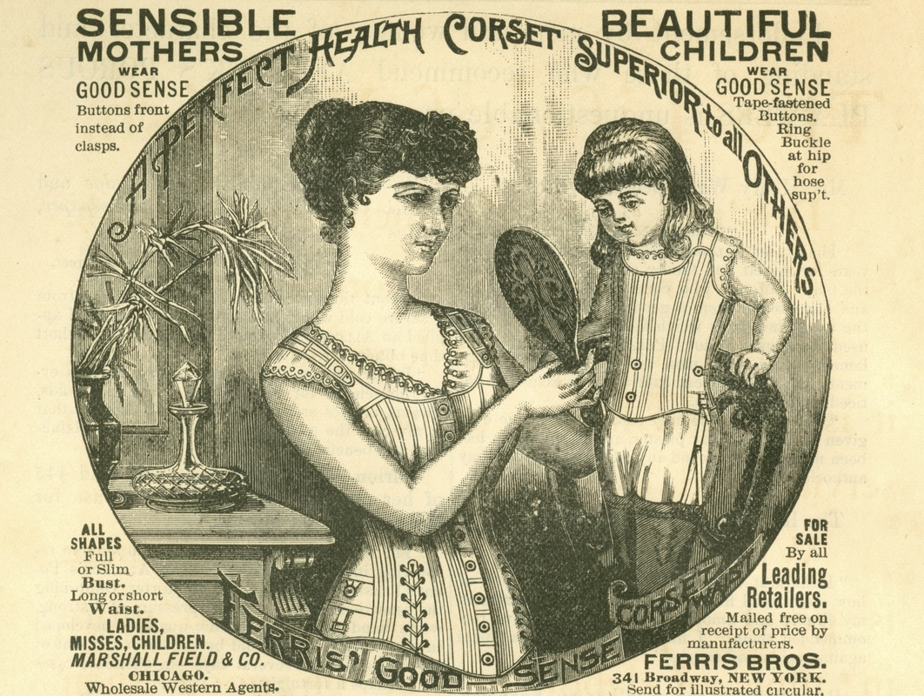

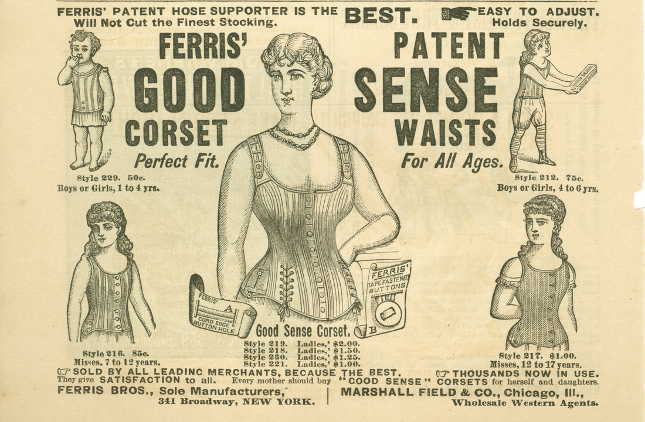

7.2 Appendix 2
Milady Décolleté (Bernazzani, 2017).
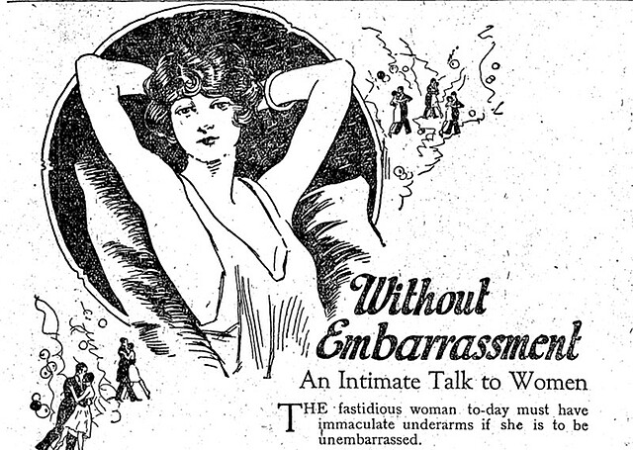

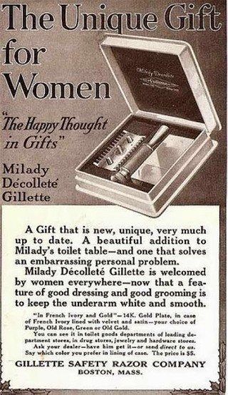
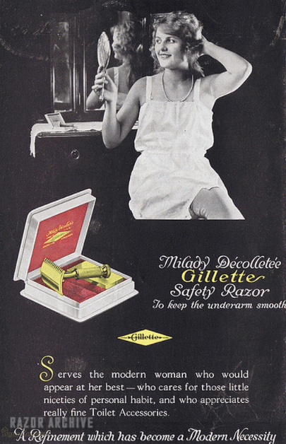

7.3 Appendix 3
Hoover (Keay, 2017)
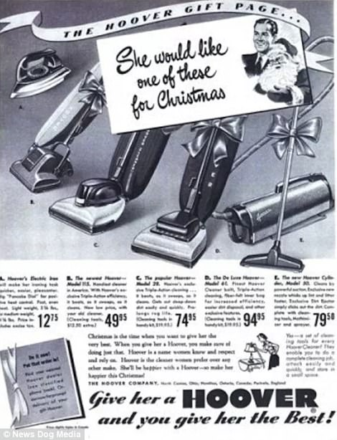

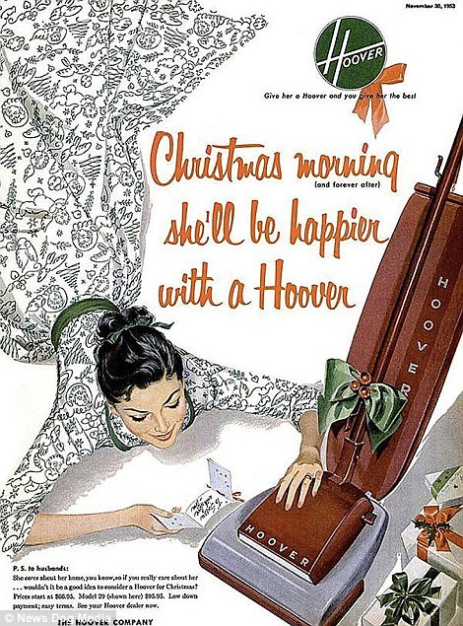
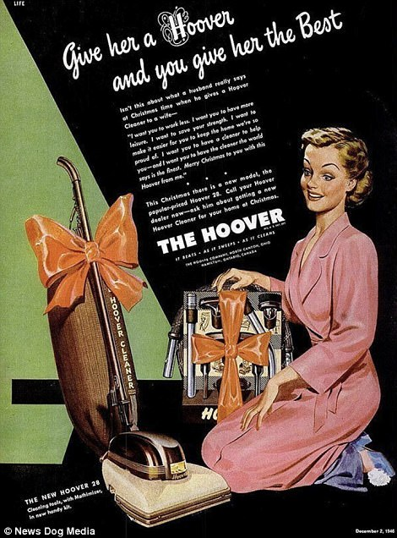

7.4 Appendix 4
(GenderBread, 2017)
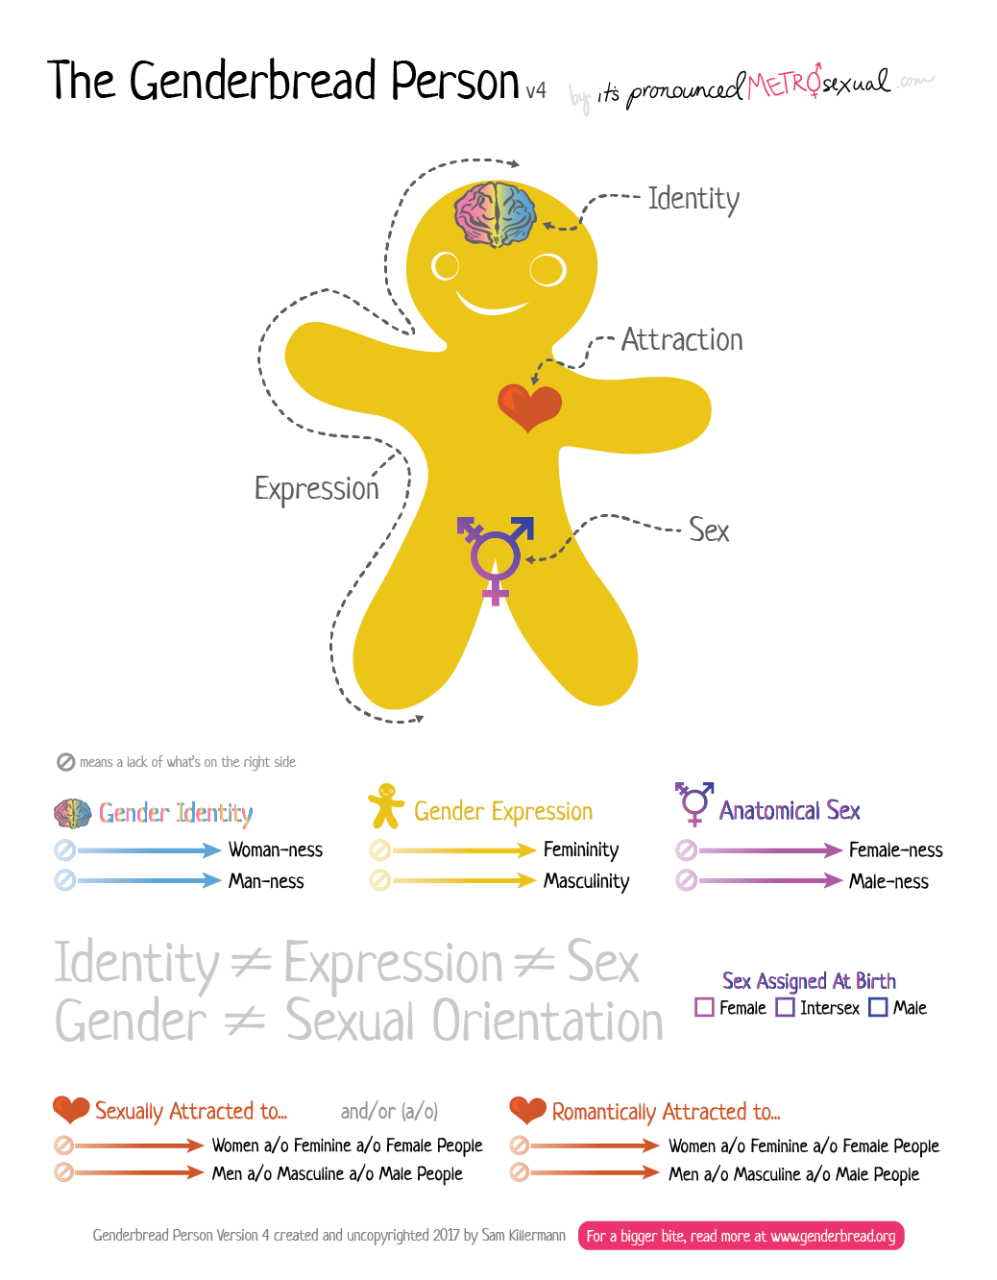

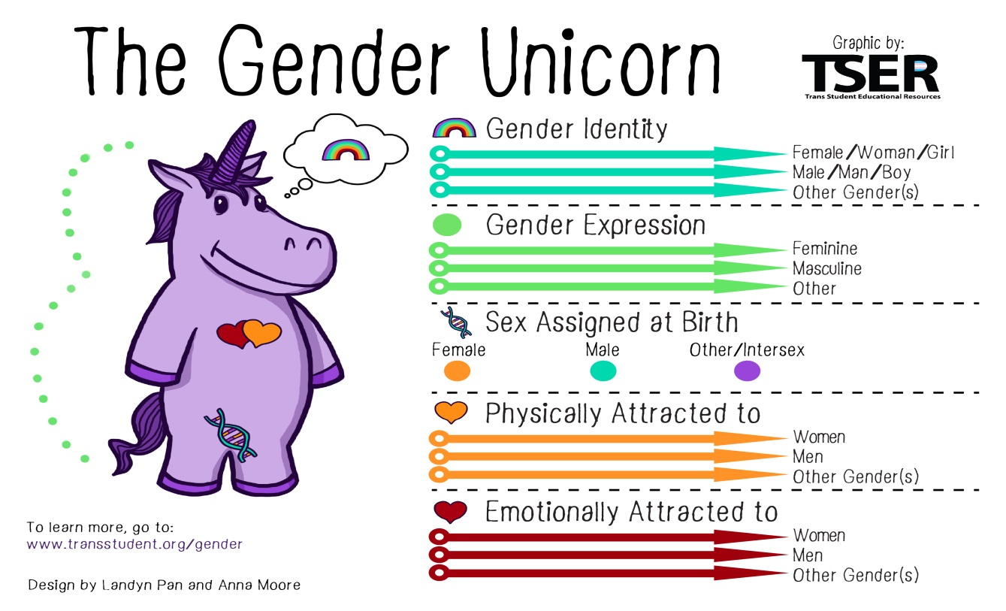

7.5 Appendix 5
Study consent form and debrief form

Study Consent Form

I understand that the research study I will be taking part in is being carried out by a 3rd year Business Management Student for their dissertation.
I understand that taking part in this study will involve completing a focus group discussion and a short demographic questionnaire.
These tasks will take approximately 15 minutes to complete.
I understand that participation in this study is on a voluntary basis and that I am free to withdraw my participation at any point without the need to give reason.
I understand that if I have any questions about the study, I am able to discuss these with the researcher or the dissertation supervisor at any point.
I am aware that any information I give will be held confidentially. I understand that there will be a code assigned to my name when stored in order to ensure confidentiality, thus my answers can’t be tracked back to me once given to researcher. The data files will be stored indefinitely, and in accordance with the regulations provided by the Data Protection Act.
Lastly, I understand that on ending this study I will be given a debrief form, and be given the chance to discuss any questions or problems with the researcher.

I, ___________________________________( NAME) consent to participate in the study conducted by [student], School of Business, University of Wales Trinity Saint David, Swansea under the supervision of Beth Cummings
Participant Signature:________________________________________________
Date:___________________
Name and signature of researcher taking consent
___________________________________________________________________

Study Debrief Sheet

Gender Marketing: How marketing formulates views of gender

Thank you for taking the time to complete this study.

The aim of this study was to assess the extent to how much gender marketing has aided the formation of gender and gender stereotypes.

If you wish to have your data withdrawn from the study, you must inform the researcher now. After this point, all data given will be kept confidentially and anonymously with no possibility of data being traced back to you.

If this study has raised any queries, please feel free to contact researchers on
Louie Greenwood - lgreenwood.149044@student.uwtsd.ac.uk or the academic supervisor on Beth Cummings – beth.cummings@uwtsd.ac.uk

Thank you again for taking the time to take part in this research study

Louie Greenwood

BA Honours Business Management

University of Wales Trinity Saint David, Swansea

7.6 Appendix 6
Focus Group Demographics
Focus Group 1
 | Gender | Sexuality | Age | Occupation
Participant 1 | Male | Heterosexual | 20 | Student
Participant 2 | Female | Heterosexual | 21 | Student
Participant 3 | Female | Heterosexual | 24 | Full-time work
Participant 4 | Male | Heterosexual | 26 | Full-time work
Participant 5 | Female | Heterosexual | 21 | Student

Focus Group 2 (LGBT+)
 | Gender | Sexuality | Age | Occupation
Participant 6 | Demi-girl | Bisexual | 22 | Full-time Work
Participant 7 | Male | Gay | 20 | Student
Participant 8 | Trans Male | Gay | 21 | Full-time work
Participant 9 | Female | Gay | 23 | Student
Participant 10 | Nonbinary | Bisexual | 21 | Student

Focus Group Questions
- What does gender mean to you?
- Do you think there are any expectations that come with your gender?
- Do you believe that there are stereotypes of your gender? If so what are they?
- Thinking back to when you were younger, what toys did you enjoy playing with?
- Do you remember what made these toys stand out to you?
- Do you remember seeing any adverts for these toys? What were they like?
- Were there any toys you enjoyed playing with or wanted that weren’t marketed to your gender? Were these brought for you?
- Did you have a say in what toys you had or did others buy toys for you?
- How about clothes? Did you choose your clothes or did someone else?
- What would a common outfit consist of back then for you?
- What made you want to wear those clothes?
- Did you ever wear clothes not marketed to your gender?
- How about now? Would you feel comfortable wearing clothes you wouldn’t back then?

7.7 Appendix 7
Focus Group Transcripts
Focus Group 1 Transcript
Theme one: The Impact of Family and Friends
1. I didn’t really play with girls toys because I didn’t really play with girls like there was no opportunity really
2: Yeah I agree like I thought that boys had germs so they had to stay away from them so this spanned onwards to boys toys I guess
5: I really liked barbies I remember that much I guess looking back they were a very for girls toys
3: I felt no pressure to play with certain toys, I just asked for what I wanted but then again I was one of five so we just mixed our toys constantly. It’s hard to have a claim to a toy with that many siblings

5: I had these sparkly jeans that were my favourite thing in the whole world, I wore them until they broke
4: I didn’t really have a favourite thing my mum would buy my clothes they’d be just usual t-shirts and trousers really
2: I’m the same, didn’t really have an attachment to anything clothing wise but my mum used to always buy me pink clothes, like flowery tops and skirts
1: Yeah same here, well not the pink thing I felt too embarrassed to wear pink because it is a girl’s colour and people would make fun of me if I did, it was the whole if you wear pink you’re gay. I love the colour pink now though.

Theme two: The Impact of Society and Social Media
2: I was the worst for adverts I wanted everything like I loved Barbies as a kid, I used to see them on TV between shows with little girls playing with their dolls and beg my mum for them
5: I used to watch nickelodeon all the time and the adverts for toys were part of the fun
1: They really were, my siblings and I used to have a list of things we had seen on TV we wanted in time for our birthdays and Christmas

1: My favourite toys were my cars, I used to make racetracks in our sandpit and drive them round for hours, typical boy toys
4: Yeah I loved cars too I wouldn’t play with barbies because they are for girls but I had an action man which I guess was the same in principal just a boys version

2: Looking back I think the toys I played with were very girly and kind of pushed me towards wanting to be that stereotypical stay at home mum
5: I feel that, I had so many baby dolls and I used to really want a baby but I was only a baby myself. I was always told how great of a parent I’d be and how lucky my future husband would be
3: Yeah when I was younger I thought I had to take care of my husband because everyone used to praise me for it. I also saw wives on TV doing it and it was just what I thought I had to do

1: I can’t speak for the women here but I do feel like from a man’s point of view that there isn’t as much expectation for genders? Or maybe they’re just very different expectations than they used to be?
2: yeah like obviously there is still that pressure to be a stereotypical woman, but it’s a lot less pressure now than it used to be
3: Yeah like when we spoke about clothes, now if I saw something that I liked in the men’s section I would get it, but I wouldn’t go looking for clothes in the men’s section. But like the option to wear mens clothes is very much there for me now whereas stereotypically previously this was very frowned upon.

Focus Group 2 Transcript
Theme one: The Impact of Family and Friends
6: I always felt so out of place because I wanted to play like my brother but I knew I was held to different expectations at home
8: I feel like most of my pressure to act a certain way came from people saying things like boys will be boys and that’s not lady like. It just created such a big divide between what a girl is and what a boy is for me
10: I feel super lucky that my parents never really cared much about that stuff, my brothers and I all had a housework chart and had to pull our weight for pocket money and such.

8: I really loved toy cars, I felt too awkward to ask my parents for some but they had them at after school club and it was the best
10: My family bought all my toys for me, around Christmas time I got to look through an Argos catalogue and chose what I wanted. Most of my decisions were based on toys my friends had.
9: I loved the argos catalogue. I remember they had a big pink page full of girls toys

8: I hated wearing pink and dresses, I guess it was because I was struggling with my gender, I don’t mind it as much anymore I have a cool pink shirt I love wearing and it makes me feel oddly masculine
7: The colour pink is generally seen as a feminine colour but there isn’t any stigma around it anymore. I am happy to wear pink now, no one questions it anymore
10: The colour pink still makes me feel feminine but it might be just because of the pink items I own

Theme two: The Impact of Society and Social Media
8: Apart from cars like I said before, Sylvanian Families were my toy of choice
9: Me and my brother used to play with cars all the time together, my Baby Born was always my favourite toy but I used to love playing with cars too
6: I never liked cars I don’t know why but I really really loved my bratz dolls

10: Clothes are just fabric I don’t know why people fuss over who wears what so much
7: yeah like who came up with the whole suits are for men and dresses and skirts are for women?
10: No idea its dumb
8: Yeah and like nowadays men wearing dresses is still pretty frowned upon, but women in suits is pretty common
10: Normalise men in dresses please
8: More media representation is needed like I used to read magazines and look at what the celebrities were wearing and I’d wear something similar because I thought that was what was accepted
10: I completely agree, like having people in the media like Jayden Smith wearing skirts and dresses has made society more accepting of people wearing clothes that aren’t made for their gender

7.8 Appendix 8
Interview Transcripts
Participant 8
Can you please tell me about your upbringing? Were there any times you can remember that you felt you were pressured to act a certain way because of your gender?
Erm, I don’t know. I think, a lot of the time I wasn’t outwardly pushed towards my gender. It was more of an internal thing. I played football and I danced, when I had to choose between these things I chose dancing because football is a boys thing. No one pushed me towards one or another, I just felt I couldn’t play football in the long term because it was a boys thing.

Still thinking back to when you were younger, did you tend to hang around with people of the same gender or was it more of a mix?
My two best friends were the same gender as me, two girls. I did have one male friend, a couple male friends, but they were more like classmates. I’d hang out with them in school but then out of school I wouldn’t. But yes, most of my friends were of the same gender.

What were things you enjoyed doing back then? Any particular games or toys that stood out?
Me and my sister used to play with Silvanian Families a lot. We used to do up the houses with the furniture and act out family lives. We also used to play with Barbies a lot. We’d play with pretty much anything family members brought us, so lots of dolls and such really.

You mentioned Silvanian families and how you would act out family life, what was this like? What roles did the characters play?
It was always the generic mum, dad, kids. Mainly because this is what the packs came with, mum, dad, a son, and a daughter. There were the odd ones where I brought the policeman and it was just a policeman and he would take care of all the orphan kids. In the house the kids would go to school, thinking back it was always a female teacher. The dad would usually go out to the pub, then we had our one policeman patrolling around. Most of the time the mum would just stay home, she’d look after the babies and such.

What stereotypes do you think there are around your gender now? For example do you feel you have to act or look a certain way?
So, my gender now is male. I think there is a pressure to look a certain way, especially in the transgender community. So, you feel like if you’re not being super male, like masculine, then you feel like people don’t take you seriously. A masculine man would be like, strong, muscular, hairy is a very big one in the community, have a deep voice, I don’t know what else there is really. But yeah those male roles are very much pushed on trans men.
Where do you feel these stereotypes come from?
Society, social media. A lot of people turn to social media to find their community, but with that comes a lot of pressure on how to be, trans I guess.
Do you feel those stereotypes have changed much from what they were when you were younger?
I think because obviously I grow up female, it was hard for me to gage what the stereotypes were, like I think the whole sporty thing is still there. But then things like now even being pressured to being very male, I still feel comfortable wearing pink, but when I was younger boys were made fun of for wearing pink, because it was a girls colour, so that’s something that has changed over time.

Participant 2
Can you please tell me about your upbringing? Were there any times you can remember that you felt you were pressured to act a certain way because of your gender?
When I was younger I had a little brother and I always felt like we were treated really differently. I always knew it was because hews a boy and I was a girl, it wasn’t really something hidden. My brother would always go out and get like dirty and cuts everywhere, but that was okay because “boys will be boys” but I wasn’t allowed out as much as he was. I also feel like my mum pressured me into having a clean and tidy room and looking presentable more than my brother, and I had more chores than him.

Still thinking back to when you were younger, did you tend to hang around with people of the same gender or was it more of a mix?
All my friends were girls like me, I hung around with my cousin and he was a boy. But it was just a family thing, I probably wouldn’t have if he was just my cousin, I feel like in school they kind of pushed you to stick with people who were your gender ,it was a punishment things when you were forced to sit boy girl oy girl. And it was just kind of just common knowledge that boys and girls couldn’t be friends. If I ever mentioned a boy at home my mum would just always be pushing me towards something like more of a relationship than a friendship, which just pushed into thinking that I couldn’t be friends with a boy if I was a girl

What were things you enjoyed doing back then? Any particular games or toys that stood out?
I loved Pokémon. My room was decorated with Pokémon toys and bed spreads. But I also loved Barbie so my walls were pink. I loved anything Disney I used to play dress up a lot. I remember dressing up my brother in my Disney costumes and getting him to strut down the hallway for me. My mum always said he would regret those photos when he was polder and I never got why. I also loved baby born, everyone told me i would be a great mum because I took her everywhere, o had a pram and a cot. Eventually I got one of those bay Anabelle dolls that carried and I would actually stay up in the night to sooth her, till my mum got angry and took the batteries out.

What stereotypes do you think there are around your gender now? For example do you feel you have to act or look a certain way?
I feel like as a girl I am pressured towards being very flawless, so like looking like I’m not looking like I’m wearing makeup we I actually have a full face on, being skinny no stretch marks, like Instagram models even though it’s all in the editing. I feel like girls are also pushed towards having an hourglass figure, even though there is no way to change your figure really, it’s just genetics. I also feel like other than physically, girls have to act caring, and sweet all the time, girls aren’t really taught to stand up for themselves. Erm, ad also the trope in films that girls are shy and quiet, but then we’re also expected to be not like the other girls and secretly enjoy boys things like football to keep our husbands happy.

Do you feel those stereotypes have changed much from what they were when you were younger?
Erm, I feel like they’re less intense, I feel like women are allows to be in power and heard, but I still feel like there’s a big stigma around won who are in power or heard I feel like there’s less pressure towards women to get married and have babies and being the home maker. But that society still pushed up to do that anyway.

7.9 Appendix 9

Ethics Form
APPLICATION FOR ETHICAL APPROVAL

In order for research to result in benefit and minimise risk of harm, it must be conducted ethically. A researcher may not be covered by the University’s insurance if ethical approval has not been obtained prior to commencement.

The University follows the OECD Frascati manual definition of research activity: “creative work undertaken on a systematic basis in order to increase the stock of knowledge, including knowledge of man, culture and society, and the use of this stock of knowledge to devise new applications”. As such this covers activities undertaken by members of staff, postgraduate research students, and both taught postgraduate and undergraduate students working on dissertations/projects.

The individual undertaking the research activity is known as the “principal researcher”.

Ethical approval is not required for routine audits, performance reviews, quality assurance studies, testing within normal educational requirements, and literary or artistic criticism.

Please read the notes for guidance before completing ALL sections of the form.

This form must be completed and approved prior to undertaking any research activity. Please see Checklist for details of process for different categories of application.

SECTION A: About You (Principal Researcher)

Full Name: |  |  | Louie Greenwood
Tick all boxes which apply:
Member of staff: | ☐ | Student: |  | ☒ | Honorary research fellow: | ☐

Faculty/School/Centre: | Business School
Campus: | Swansea
E-mail address: | Lgreenwood.149044@student.uwtsd.ac.uk
Contact Telephone Number: | 07473175342
For students:
Student Number: | P149044 | Undergraduate | ☒
Programme of Study: | Business management | Taught Postgraduate | ☐
Director of Studies/Supervisor: | Beth Cummings | Research | ☐

SECTION B: Approval for Research Activity

Has the research activity received approval in principle?  (please check the Guidance Notes as to the appropriate approval process for different levels of research by different categories of individual) |  | YES | ☒ | NO | ☐
 |  |  |  | Date
If Yes, please indicate source of approval (and date where known): | Research Degrees Committee |  | ☐
 | Faculty Research Committee |  | ☐
 | Other (write in) |  | ☒ | supervisor
Approval in principle must be obtained from the relevant source prior to seeking ethical approval.

SECTION C: External Ethical Guidance Materials

Please list the core ethical guidance documents that have been referred to during the completion of this form (including any discipline-specific codes of research ethics, and also any specific ethical guidance relating to the proposed methodology). Please tick to confirm that your research proposal adheres to these codes and guidelines.
BPS code of ethics | ☒
Dissertation handbook | ☒
 | ☐

SECTION D: External Collaborative Research Activity

Does the research activity involve collaborators outside of the University? |  | YES | ☐ | NO | ☒
If Yes, please provide the name of the external organisation and name and contact details for the main contact person:
Institution
Contact person name
Contact person e-mail address

Where research activity is carried out in collaboration with an external organisation
Does this organisation have its own ethics approval system? | YES | ☐ | NO | ☐
If Yes, please attach a copy of any final approval (or interim approval) from the organisation

SECTION E: Details of Research Activity

Indicative title: | Gendered marketing: An exploration of the structure of gender in marketing processes
Proposed start date: |  | Proposed end date:
Purpose of research activity (including aims and objectives)
Outline the purpose, aims and objectives of the research activity, including key research questions. Show briefly how existing research has informed the proposed activity and explain what the research activity will add and how it addresses an area of importance. (Maximum 300 words)
To research into whether gender is an effective target group for marketing to be effective.
To explore the question “does marketing shape gender stereotypes, or gender stereotypes shape the way we market?”
Research conducted is mostly based on the effects of gendered marketing on children, and this has been shown to have had an influence on buying habits. This is important because if marketing towards a gender is effective, it may have an effect on how a gender is seen in society.

(this box should expand as you type)
Proposed methods
Provide a brief summary of all the methods that may be used in the research activity, making it clear what specific techniques may be used. If methods other than those listed in this section are deemed appropriate later, additional ethical approval for those methods will be needed. (Maximum 600 words)
Focus groups
Questionnaire (both online and physical)
(this box should expand as you type)

Location of research activity
Identify all locations where research activity will take place.
Online.
Swansea Business School Conference room
(this box should expand as you type)
Research activity outside of the UK
If research activity will take place overseas, you are responsible for ensuring that local ethical considerations are complied with and that the relevant permissions are sought. Specify any local guidelines (e.g. from local professional associations/learned societies/universities) that exist and whether these involve any ethical stipulations beyond those usual in the UK (provide details of any licenses or permissions required). Also specify whether there are any specific ethical issues raised by the local context in which the research activity is taking place, for example, particular cultural sensitivities or vulnerabilities of participants.
N/A
(this box should expand as you type)

SECTION F: Scope of Research Activity

Will the research activity include: | YES | NO
Use of a questionnaire or similar research instrument | ☒ | ☐
Use of interviews? | ☒ | ☐
Use of diaries? | ☐ | ☒
Participant observation with their knowledge? | ☐ | ☒
Participant observation without their knowledge? | ☐ | ☒
Use of video or audio recording? | ☒ | ☐
Access to personal or confidential information without the participants’ specific consent? | ☐ | ☒
Administration of any questions, test stimuli, presentation that may be experienced as physically, mentally or emotionally harmful / offensive? | ☐ | ☒
Performance of any acts which may cause embarrassment or affect self-esteem? | ☐ | ☒
Investigation of participants involved in illegal activities? | ☐ | ☒
Use of procedures that involve deception? | ☐ | ☒
Administration of any substance, agent or placebo? | ☐ | ☒
Working with live vertebrate animals? | ☐ | ☒
Other primary data collection methods, please explain in this box | ☐ | ☒

If NO to every question, then the research activity is (ethically) low risk and may be exempt from some of the following sections (please refer to Guidance Notes).

If YES to any question, then no research activity should be undertaken until full ethical approval has been obtained.

SECTION G: Intended Participants

Who are the intended participants: | YES | NO
Students or staff at the University? | ☒ | ☐
Adults (over the age of 18 and competent to give consent)? | ☒ | ☐
Vulnerable adults? | ☐ | ☒
Children under 18? | ☐ | ☒
Prisoners? | ☐ | ☒
Young offenders? | ☐ | ☒
Those who could be considered to have a particularly dependent relationship with the investigator or a gatekeeper? | ☐ | ☒
People engaged in illegal activities? | ☐ | ☒
Others (please identify): | ☐ | ☒

Participant numbers and source
Provide an estimate of the expected number of participants. How will you identify participants and how will they be recruited?
30 participants, recruited through a volunteer process.

this box should expand as you type)

Information for participants: | YES | NO | N/A
Will you describe the main research procedures to participants in advance, so that they are informed about what to expect? | ☒ | ☐ | ☐
Will you tell participants that their participation is voluntary? | ☒ | ☐ | ☐
Will you obtain written consent for participation? | ☒ | ☐ | ☐
Will you explain to participants that refusal to participate in the research will not affect their treatment or education (if relevant)? | ☒ | ☐ | ☐
If the research is observational, will you ask participants for their consent to being observed? | ☒ | ☐ | ☐
Will you tell participants that they may withdraw from the research at any time and for any reason? | ☒ | ☐ | ☐
With questionnaires, will you give participants the option of omitting questions they do not want to answer? | ☒ | ☐ | ☐
Will you tell participants that their data will be treated with full confidentiality and that, if published, it will not be identifiable as theirs? | ☒ | ☐ | ☐
Will you debrief participants at the end of their participation, in a way appropriate to the type of research undertaken? | ☒ | ☐ | ☐
If NO to any of above questions, please give an explanation

Information for participants: | YES | NO | N/A
Will participants be paid? | ☐ | ☒ | ☐
Is specialist electrical or other equipment to be used with participants? | ☐ | ☒ | ☐
Are there any financial or other interests to the investigator or University arising from this study? | ☐ | ☒ | ☐
Will the research activity involve deliberately misleading participants in any way, or the partial or full concealment of the specific study aims? | ☐ | ☒ | ☐
If YES to any question, please provide full details
(this box should expand as you type)

SECTION H: Anticipated Risks

Outline any anticipated risks that may adversely affect any of the participants, the researchers and/or the University, and the steps that will be taken to address them.

If you have completed a full risk assessment (for example as required by a laboratory, or external research collaborator) you may append that to this form.

Full risk assessment completed and appended?

Yes ☐
No ☒

Risks to participants
For example: emotional distress, financial disclosure, physical harm, transfer of personal data, sensitive organisational information
Although this research piece is not particularly triggering of any obvious distress points, it is important to be aware that this is a possibility. If a participant were to be uncomfortable with the subject for whatever reason, this participant will be reminded of their right to withdraw, and directed to the dissertation supervisor for extra support and feedback. Personal data will be collected in the consent form, such as the participants name, this will be kept apart from their research data as to allow for confidentiality. Data will be transferred from a recording on to a computer. This recording will then be destroyed. This will keep data safe. All scripts will be safely encrypted and not transferred.

(this box should expand as you type)
If research activity may include sensitive, embarrassing or upsetting topics (e.g. sexual activity, drug use) or issues likely to disclose information requiring further action (e.g. criminal activity), give details of the procedures to deal with these issues, including any support/advice (e.g. helpline numbers) to be offered to participants. Note that where applicable, consent procedures should make it clear that if something potentially or actually illegal is discovered in the course of a project, it may need to be disclosed to the proper authorities
Although these types of topics should not come up, if someone were to be upset by the nature of the study, they will be reminded of their right to withdraw. They will also be directed to the dissertation supervisor in order to provide feedback for the study to improve on, and also for extra support.

(this box should expand as you type)
Risks to investigator
For example: personal safety, physical harm, emotional distress, risk of accusation of harm/impropriety, conflict of interest
In every study there is a risk for a participant to lash out and cause physical or emotional harm to the researcher. In order to minimise this, participants mood will be monitored and no participant will be pushed to speak if they do not seem comfortable doing so. Participants rights to withdraw and not give an answer to questions will also be told before the study, and again in the consent form, then once more in the recording. This will ensure that participants know what to expect.

(this box should expand as you type)
University/institutional risks
For example: adverse publicity, financial loss, data protection
As a university, if the research were to be harmful to the participants that would give bad press to the institution.

(this box should expand as you type)
Adverse outcomes
List measures put in place to limit any adverse effects or outcomes of research activity where appropriate. Include any emergency protocols.
In order to minimise the adverse outcomes, this study will work within the ethical guides provided, and ensure participant comfort and also researcher professionalism. This title was also chosen with prior knowledge of research in the field, so there is relevance and indication that an adverse outcome is unlikely. his box should expand as you type)

Disclosure and Barring Service
If the research activity involves children or vulnerable adults, a Disclosure and Barring Service (DBS) certificate must be obtained before any contact with such participants. | YES | NO | N/A
Has a DBS certificate been obtained? | ☐ | ☐ | ☒

SECTION I: Feedback, Consent and Confidentiality

Feedback
What feedback will be provided to participants, how will this be done and when?
A debrief form will be provided to participants with a more detailed explanation of the information gathered from them, and the aims of the research. Emails from the lead researcher and dissertation supervisor will be on this sheet, and the participants will be encouraged to ask questions at any point after the study if they have queries or concerns. This dissertation will also be available to participants on request.

(this box should expand as you type)
Informed consent
Describe the arrangements to inform potential participants, before providing consent, of what is involved in participating. Describe the arrangements for participants to provide full consent before data collection begins. If gaining consent in this way is inappropriate, explain how consent will be obtained and recorded.
Participants will know a brief part of the study before signing up in order to ensure that the research is appropriate to them. Once participants arrive, a consent form describing the main study area of the study will be given, and what the study entails will again be explained to them, opening up the opportunity for questions. If the participant signs the consent form and decides to continue, verbal consent will be recorded on the tape recorder to indicate that consent to record was given too. At the end of the study along with a debrief form, participants will be reminded of their right to withdraw their data, and how that is the last instance where they can exercise that right. If consent is given that last time, then their data will be entered into the dissertation results.
Confidentiality / Anonymity
Set out how anonymity of participants and confidentiality will be ensured in any outputs. If anonymity is not being offered, explain why this is the case.
Participants will not be giving names in their recording or on any questionnaires given to them. Consent forms will have names, but will be kept completely separate from data in order to not be able to link the data to the names. Participants in the recording will be given a unrelated number in order to identify speech without giving names. Recording will be written up into a script and recordings will be destroyed.

SECTION J: Data Protection and Storage

In completing this section refer to the University’s Research Data Management Policy and the extensive resources on the University’s Research Data Management web pages (http://uwtsd.ac.uk/library/research-data-management/).
 | YES | NO
Does the research activity involve personal data (as defined by the Data Protection Act)?  “personal data” means data which relate to a living individual who can be identified—  (a) from those data, or  (b) from those data and other information which is in the possession of, or is likely to come into the possession of, the data controller, and includes any expression of opinion about the individual and any indication of the intentions of the data controller or any other person in respect of the individual. | ☒ | ☐
If YES, provide a description of the data and explain why this data needs to be collected:
Personal data will be collected in the form of a questionnaire. This data will not have identifiable data, although will have demographic data such as age, gender, sexuality, and country of birth. These are all needed fields in order to see the difference of effect in different demographics.
(this box should expand as you type)
Does it involve sensitive personal data (as defined by the Data Protection Act)?  “Sensitive personal data” means personal data consisting of information as to –  (a) the racial or ethnic origin of the data subject,  (b) his political opinions,  (c ) his religious beliefs or other beliefs of a similar nature,  (d) whether he is a member of a trade union (within the meaning of the Trade Union and Labour Relations (Consolidation) Act 1992),  (e) his physical or mental health or condition,  (f) his sexual life,  (g) the commission or alleged commission by him of any offence, or  (h) any proceedings for any offence committed or alleged to have been committed by him, the disposal of such proceedings or the sentence of any court in such proceedings. | ☐ | ☒
If YES, provide a description of the data and explain why this data needs to be collected:
(this box should expand as you type)

Will the research activity involve storing personal data on one of the following: | YES | NO
Manual files (i.e. in paper form)? | ☒ | ☐
University computers? | ☒ | ☐
Private company computers? | ☐ | ☒
Home or other personal computers? | ☒ | ☐
Laptop computers/ CDs/ Portable disk-drives/ memory sticks? | ☐ | ☒
“Cloud” storage or websites? | ☐ | ☒
Other – specify:  Tape recorder | ☒ | ☐
For all stored data, explain the measures in place to ensure data confidentiality, including details of password protection, encryption and anonymisation:
All data will be encrypted, and not transferred between devices. Tape recordings will be deleted within a week of recording, and kept only in script form with numbers in place of names in order to make data unidentifiable. All this data will be password protected.

(this box should expand as you type)

Will the research activity involve any of the following activities: | YES | NO
Electronic transfer of data in any form? | ☐ | ☒
Sharing of data with others at the University? | ☐ | ☒
Sharing of data with other organisations? | ☐ | ☒
Export of data outside the European Union or importing of data from outside the UK? | ☐ | ☒
Use of personal addresses, postcodes, faxes, emails or telephone numbers? | ☐ | ☒
Publication of data that might allow identification of individuals? | ☐ | ☒
Use of data management system? | ☐ | ☒
Data archiving? | ☐ | ☒
If YES to any question, please provide full details, explaining how this will be conducted in accordance with the Data Protection Act (and/or any international equivalent):

List all who will have access to the data generated by the research activity:
The principle researcher, the dissertation supervisor

(this box should expand as you type)
List who will have control of, and act as custodian(s) for, data generated by the research activity:
The principle researcher

(this box should expand as you type)
Give details of data storage arrangements, including where data will be stored, how long for, and in what form. Will data be archived – if so how and if not why not.
Data will be stored by the researcher during the study, this will be kept in a password protected file. Once this is complete, the university will store securely the data and dissertation for 5 years.

(this box should expand as you type)
SECTION K: Declaration

The information which I have provided is correct and complete to the best of my knowledge. I have attempted to identify any risks and issues related to the research activity and acknowledge my obligations and the rights of the participants.

In submitting this application I hereby confirm that I undertake to ensure that the above named research activity will meet the University’s Research Ethics and Integrity Code of Practice
Signature of applicant: |  | Date:

For students:
Director of Studies/Supervisor:
Signature:
Date:

For staff:
Head of School/Assistant Dean:
Signature:
Date:

Checklist: Please complete the checklist below to ensure that you have completed the form according to the guidelines and attached any required documentation:
☒ | I have read the guidance notes supplied before completing the form.
☒ | I have completed ALL RELEVANT sections of the form in full.
☒ | I confirm that the research activity has received approval in principle
☒ | I have attached a copy of final/interim approval from external organisation (where appropriate)
☒ | I have attached a full risk assessment (and have NOT completed Section H of this form) (where appropriate)
☒ | I understand that it is my responsibility to ensure that the above named research activity will meet the University’s Research Ethics and Integrity Code of Practice.
☒ | I understand that before commencing data collection all documents aimed at respondents (including information sheets, consent forms, questionnaires, interview schedules etc.) must be confirmed by the DoS/Supervisor, module tutor or Head of School.

RESEARCH STUDENTS AND STAFF ONLY
All communications relating to this application during its processing must be in writing and emailed to pgresearch@uwtsd.ac.uk , with the title ‘Ethical Approval’ followed by your name.
You will be informed of the outcome of your claim by email; therefore it is important that you check your University and personal email accounts regularly.

STUDENTS ON UNDERGRADUATE OR TAUGHT MASTERS PROGRAMMES should submit this form (and receive the outcome) via systems explained to you by the supervisor/module leader.

This form is available electronically from the Academic Office web pages: http://www.uwtsd.ac.uk/academic-office/

