DS 1 Template

My Screenshots/Photos
- Please add 4–6 screenshots or photos of your digital life.
- You can use your phone or laptop.
- For each screenshot, write one or two sentences explaining what it shows.

Screenshot/Photo 1
[Insert Photo/Screenshot below]
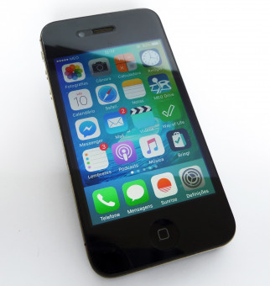
1.I been using mobile phone because it is become part of our daily life.
2.I feel good at using for online banking and shopping. Connecting my loved ones here and overseas through different social media platform anytime and anywhere.
3.I want to improve my knowledge in how to navigate this high-tech smart phones.
4.These skills matter because it is useful to navigate the world as technology become increasingly driven.

Screenshot/Photo 2
[Insert Photo/Screenshot below]
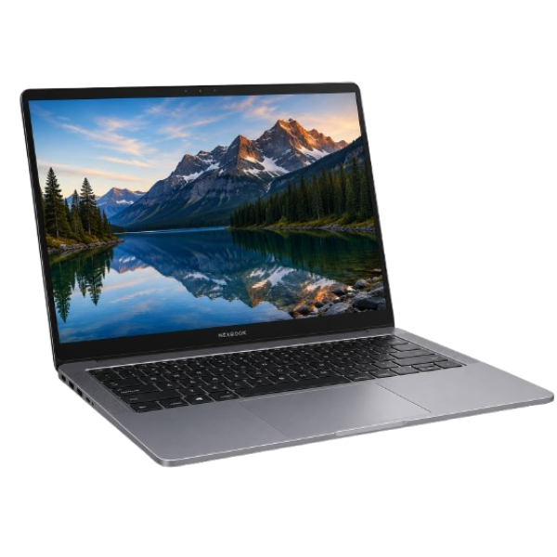
1.I use laptop for my studies and doing some home task because it has a larger screen and has a built-in keyboard.
2.Sometimes I feel nervous If I click a wrong search engine, but I am resilient and eager to learn.
3 I want to improve my technical skills like PowerPoint, excel and word document.
4.This can help to improve your typing skills as it has a built-in keyboard

Screenshot/Photo 3
[Insert Photo/Screenshot below]
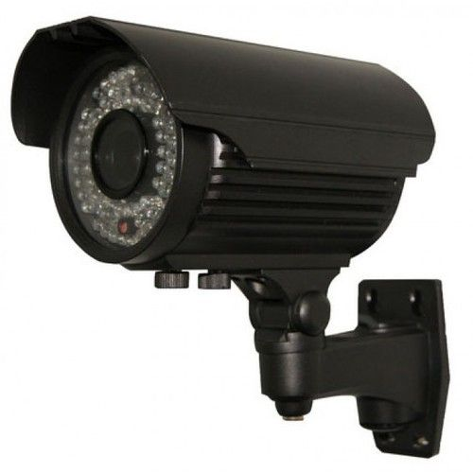
- I install this device at home because it helps our household safe and to deter burglars especially now a days.
- I feel safe and secured and have peace of mind even if I’m away.
- I want to improve on how to detect the voices and facial recognition.
- This can help for the investigation of any criminal doings and track suspect.

Screenshot/Photo 4
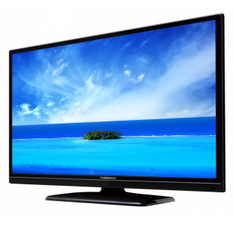
1.I use smart television for education, relaxation and entertainment instead of any other device like mobile phone.
2.I feel more satisfied and entertained of what I am watching in a bigger screen and you can choose different channel.
3. I want to know more about the new features.
4 .

Screenshot/Photo 5
[Insert Photo/Screenshot below]
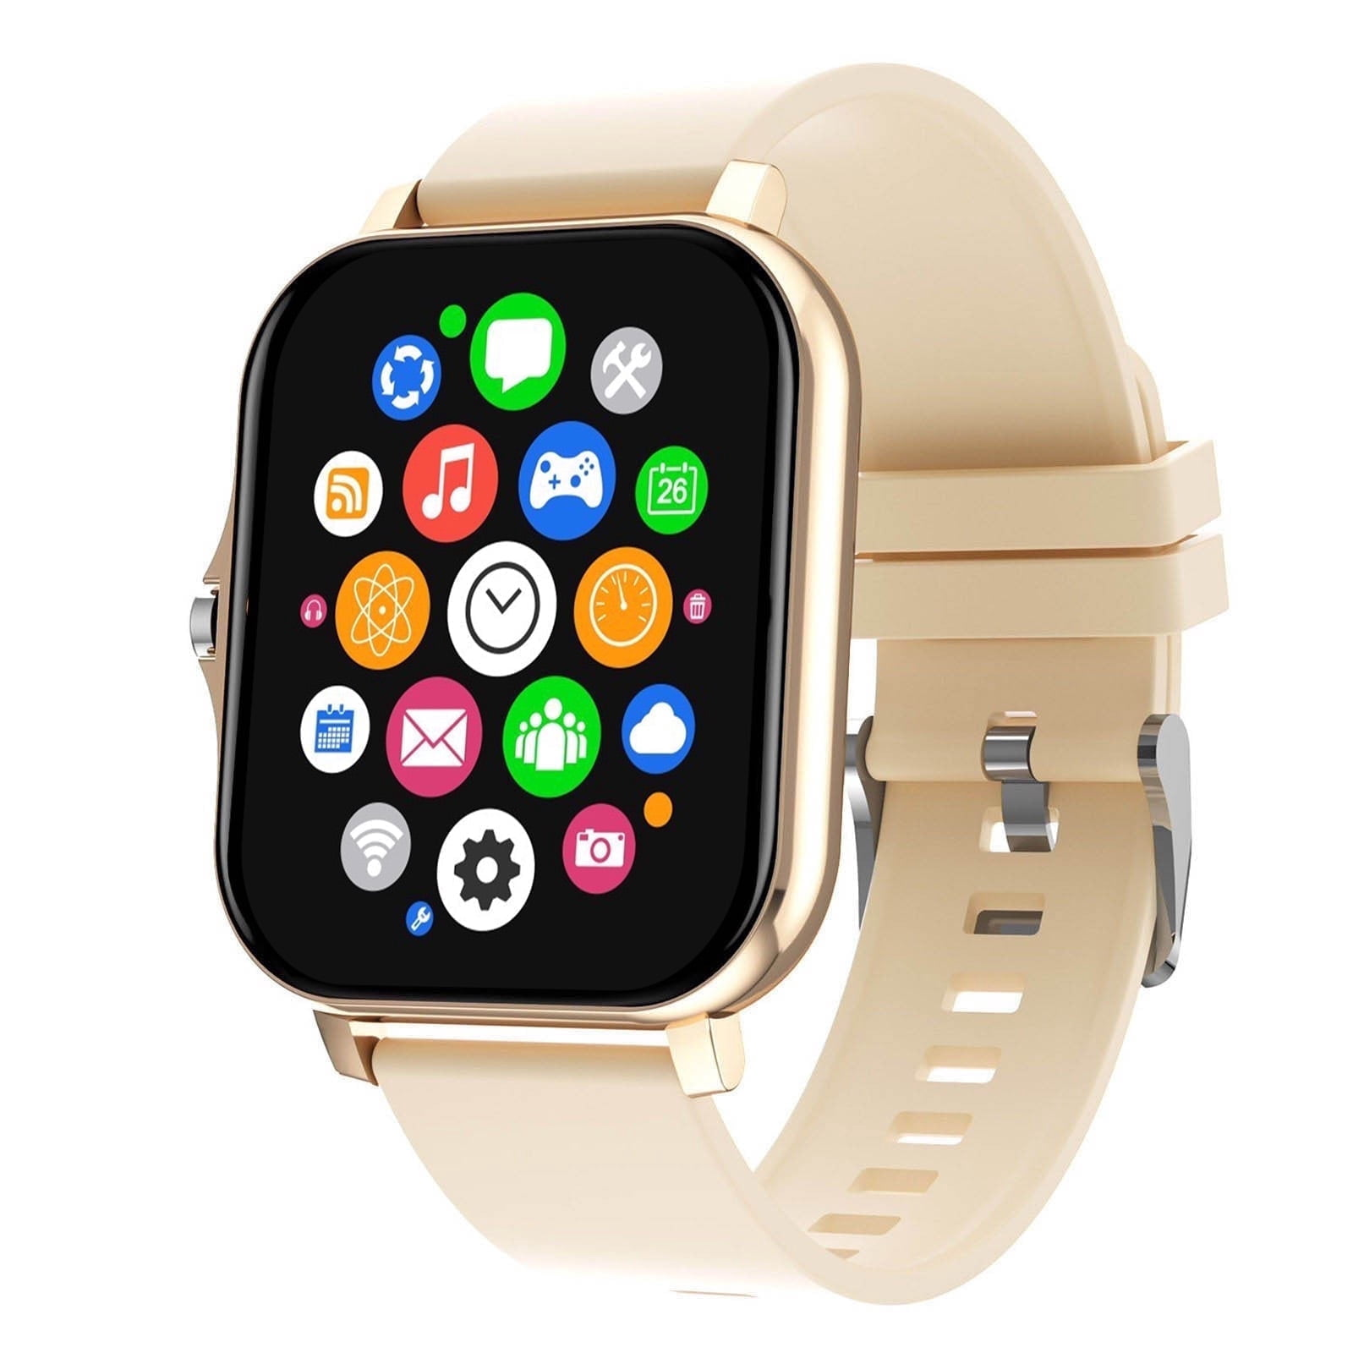
1.I use smart watch for my daily routine.
2.I feel excited of using it because I can monitor my health, navigate and can use for communication
3. I want to improve in navigating this high-tech device although it is challenging.
4.It is easy to wear, very useful and educational.

Screenshot/Photo 6

My Short Reflection
- Write 5–8 simple sentences about your digital life.
- You can use the sentence starters below if helpful.
I use digital tools as it is become part of my daily life. Through the social media platform like Messenger, I can communicate my family back home.
I feel confident using my laptop for my home task and research
I want to improve my technical skills like PowerPoint, excel and word document.
Learning this digital tools is very challenging because in my era we didn’t have this kind of technology.
I hope this module will help in my studies in preparation of future occupation.
Digital skills are important for me because it gives me more knowledge on how technology evolves in the world and it also help promote businesses.

Sentence starters
- I use digital tools to …
- I feel confident when I …
- I want to improve …
- I often use these tools: …
- I sometimes feel nervous about …
- I hope this module will help me …
- Digital skills are important for me because …
You can write more if you want.

Submission Checklist
Before you submit, please check:
​​​ ☐ I added 4–6 screenshots
☐ I wrote short sentences for each screenshot
☐ I wrote my short reflection
☐ My work is my own
☐ My file opens correctly
​​☐ My file opens correctly

