Distinctiveness and Regeneration
(BMSP 4005)
Learning Log
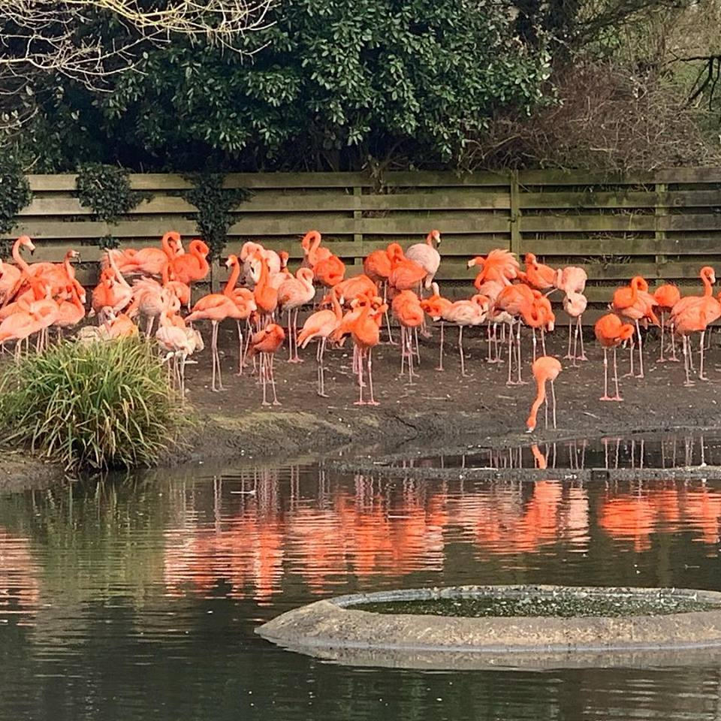

Claire Davies-1806680
Tutor: Anthony Burns
Introduction
My learning log is going to cover what I have learnt about the distinctiveness and regeneration of Llanelli. We had a guest speaker called Julie Hannam that spoke to us about The Roots of Modern Llanelli, Nicola Jones came to talk to us about Tata Steel, steel works in Port Talbot and Trostre and we also took a trip to the Wetland Centre where we were given a talk by Sarah Rees and then were left to wander around the centre, taking in what the centre has to offer Llanelli. The distinctiveness and regeneration of Llanelli will be explained throughout the learning log.
The Roots of Modern Llanelli- guest speaker Julie Hannam
What was Llanelli like before the Industrial Revolution?
Llanelli was an agricultural society, with many major landowners. The land was controlled by large estates and farms run by small families. Some of the estate names live on today, such as the Stradey and Mansell’s. Small coal mines provided an income for the associated families. Smelting also took place but didn’t seem to very successful as a family run business.
When did the change begin?
The changes began between 1700-1750 this seeing coal seam being leased out from the larger estates. The area was well know for the high quality exports of coal, this seeing a mass increase in development of steam engines and machinery. New technologies saw a significant increase in how much coal would be mined.
The Industrial Revolution!
This saw the development of vast technologies such as the seed drill invented by Jethro Tull, the spinning Jenny to be used in Textile Factories and the invention of the Locomotive which was powered by coal.
1750 saw changes to Llanelli when it began to catch up with the rest of the country and taking advantage of technology that was being developed. The first steam engine was placed in their mines by the Rees family, this enabling them to work faster and more efficiently and to transport coal from pit to port. 4 years later, the first metal works was introduced, this requiring 3 elements to set up and expand:
Land: with natural resources
Money: start up costs
Workers: are there enough local workers
How was it funded?
It was funded by local landowners, looking to invest in their land holdings rather than just maintaining them. Inroads were brought into the area by serious investors that had made their money elsewhere. Speculators arrived and would purchase shares in emerging companies.
Raby was a major investor for many years and was indirectly involved in the area. Squire, Robert Morgan and Evans & Beynon formed a partnership with an interest in forges and iron furnaces.
1797 saw the year of changes, two significant but unrelated events occurred: the death of Townsend’s son-in-law, passing his interests on to his sons and the arrival of Alexander Raby who took up residence in Llanelli.
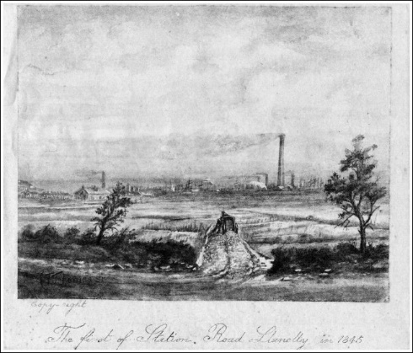

Image of industrial landscape dominating the Llanelli skyline.
(Heritage, 2019).
Raby gained a lease for 91 years of coal under the Stradey Estate, this enabled him to an abundant supply of quality coal. Furnace and Clifig house were built for himself and his agent. Raby took on shareholders as well as investing his own money into the region.
Tramroad systems were put in place to interlink collieries, docks and the ironworks.
The Pemberton family arrived from England in 1804, investing mass sums into the area, they installed steam pump engines into unsuccessful mines and sinking extra mines.
1830-1870 transport infrastructure was expanded interlinking rail and tramways with mines, industries expanded and saw the building of new industrial complexes. (Hannam, 2019).
Guest speaker Nicola Jones, Tata Steel-19th Feb 2019
Nicola Jones is the packaging recycling educational manager at Tata Steel. Tata own 2 steelworks, one in Port Talbot and one in Trostre, Llanelli. Port Talbot is the largest of the 2 steelworks and is 5 miles long and 3 miles wide.
Tata Steel Port Talbot are capable of producing around 5 million tonnes of steel a year, this making them the larger of the 2 major steelworks in the UK and one of the largest in Europe.
Being the only plant left in Wales making steel from scratch. They produce slabbed steel, hot and cold rolled steel and also galvanised coil. Trostre produces tinplate which is used within the food and rinks industry and they also have the facilities for cold rolling.
Steel is made of 3 components: coke-limestone-ironore
Raw materials are brought in from various places worldwide like, Australia, Brazil and China and the lime stone comes from Peru.
Tata Steel in Port Talbot have 2 lagoons, one is on site and used for their cooling system and one is based at Margam.
Scrap metal usually ends up at the Port Talbot steelworks where it is sorted into different bays for different scrap metal. This is where it is then made into new steel. The furnace they use heat up to 1200 degrees.
A direct train link runs between the Trostre and Port Talbot steelworks.
With Port Talbot being the larger of the 2 steelworks, they have 3,500 employees, approx. 3,000 contractors and Trostre have 600 employees and approx. 600 contractors working throughout the company. (Jones, 2019).
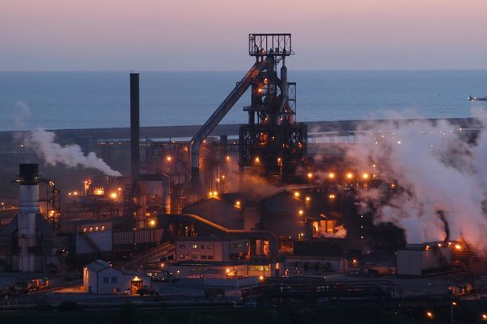

UK’s largest steelworks at Port Talbot. (Beattie, 2016).

Visit to the Wetland Centre 19th Feb 2019
WWT Llanelli Wetlands Centre is one of nine wetland reserves in the UK and is managed by the Wildfowl and Wetlands Trust.
The wetlands started with 300 acres in 1984, 7 years later the centre opened. The land used for the wetland centre was unused farm land. Many different wetland habitats are created around the centre. 57 varieties of bird are homed at the wetlands centre, 30 Hawiian geese have found sanctuary here and is also home to several flamingo’s.
There is a visitors and education attraction within the centre, visitors increased from 52,000 in 2014 to 69,000 in 2018, the majority of visitors are families. (Rees, 2019).

“WWT was founded by Sir Peter Scott as a conservation charity to protect wetlands for wildlife and people. We believe that showing people first-hand how amazing wetlands are can ignite their passion to help us conserve them – so we also welcome one million visitors every year to our unique wetland reserves.” (Trust, 2019).
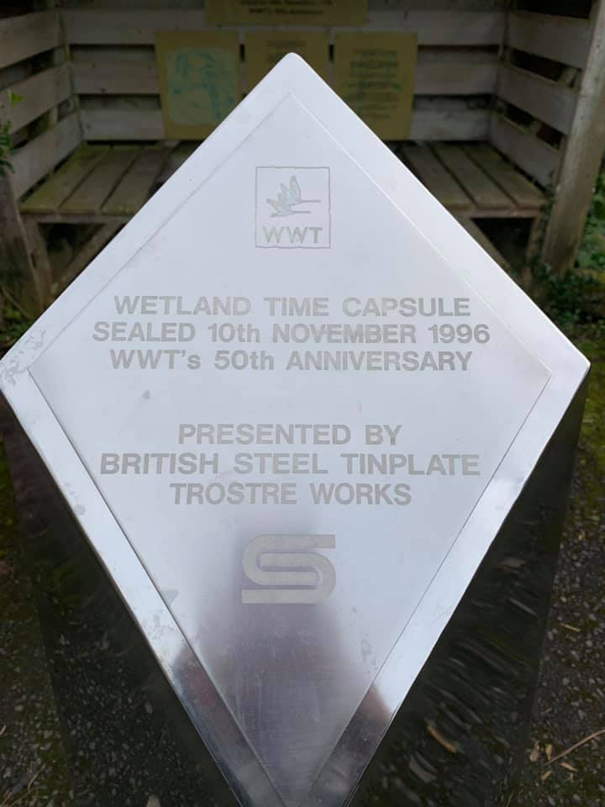
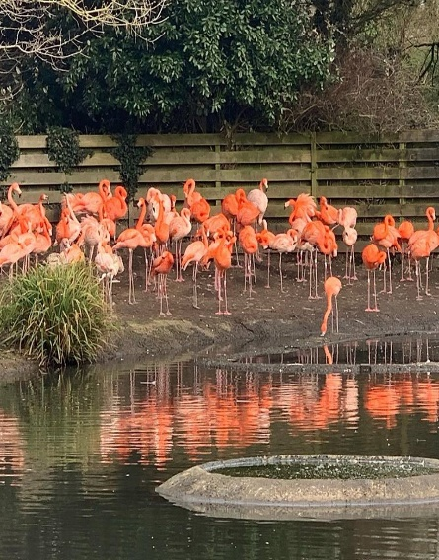
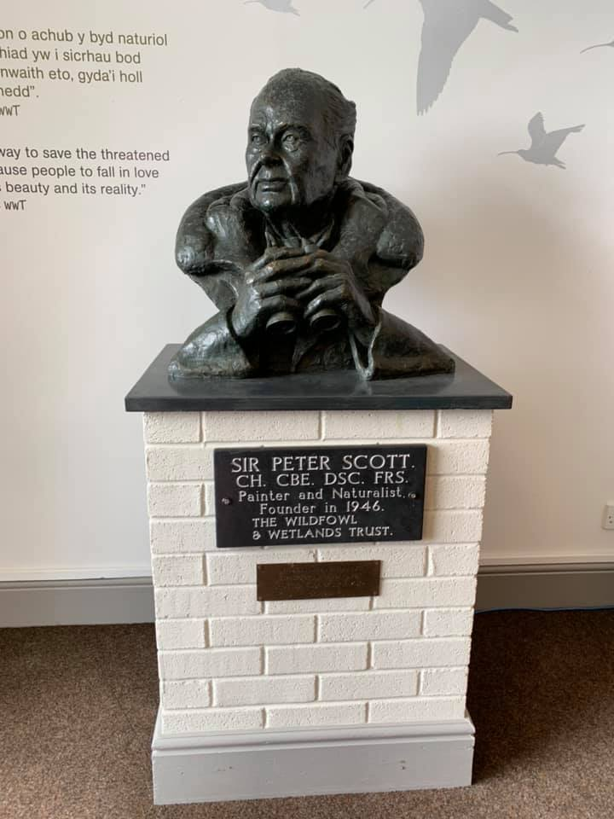
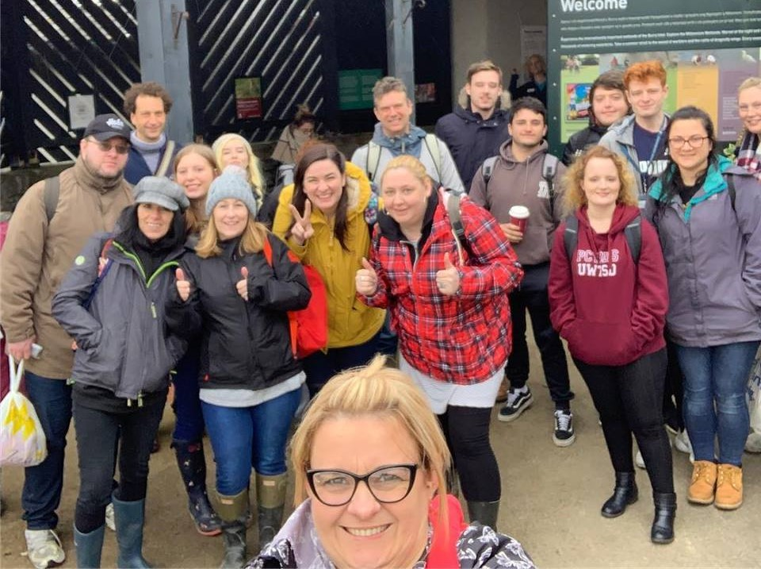

Here are some photos I took of our trip to the Wetlands Centre. (Davies, 2019).

Conclusion
From all of the research and evidence gone into the learning log, it appears that for Llanelli to thrive again it needs an injection of money and investors. The wetlands centre seems to be attracting people/families not only from Llanelli but also outside of the town, this is a great attraction helping to regenerate Llanelli and is growing year by year.

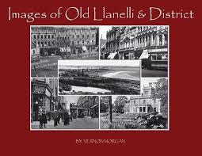

Bibliography
Beattie, J. (2016, January 8). Retrieved from https://www.mirror.co.uk/news/uk-news/uks-largest-steelworks-port-talbot-7137638
Davies, C. (2019, Feb 19). Wetland Centre Trip.
Hannam, J. (2019, January 29). The Roots of Modern Llanelli.
Heritage, L. C. (2019, March). Llanelli Community Heritage. Retrieved from https://www.llanellich.org.uk/m/files/250-llanelli-1860s
Jones, N. (2019, February 19). Tata Steel Packaging Recycling Educational Manager.
Rees, S. (2019, February 19). Wetland Centre Llanelli.
Trust, W. a. (2019, March). Retrieved from https://www.wwt.org.uk/who-we-are/

