8/14/2026
Igor Zabolotnii (2414255)
University of wales trinity saint david
Module Name: Databases and Application Development
Module Code: ACCA 5026
Student Name: Igor Zabolotnii
Student ID: 2414255
Lecturer’s Name: Suresh Shanmugasundaram

Database Design & Implementation

Contents
Introduction 2
Database Analysis and Design 3
1.1 Identifying entities, attributes and relationships rules 3
1.2 Entity-Relationship Diagram (ERD) 6
1.3 Cardinality rules and entity links 6
1.4 Normalization to Third Normal Form (3NF) – justification and steps 7
1.5 Establishing primary, foreign keys and integrity constraints 7
Database Implementation 8
2.1 Creating tables and applying SQL constraints 8
2.2 Populating with realistic sample data 11
2.3 Validating data integrity and testing constraints 14
2.4 Stored procedures for CRUD operations with transactional management 15
2.5 Triggers and functions for auditing data changes 17
2.6 Complex transactional scenario – justification for COMMIT and ROLLBACK 19
Optimization and Performance 20
3.1 Analysis of frequent and critical queries 20
3.2 Indexing strategy and justification of choices 20
3.3 Effects of indexing on execution speed and system efficiency 21
Scientific Support for Implementation Decisions 22
Develop a database-driven website 23
5.1 General structure of the application 23
5.2 Connecting to the database and managing data 23
5.3 Dynamic display of recipes 24
5.4 Administration system and adding recipes 24
5.5 Navigation, security and additional functionalities 24
Conclusion 25
References 26

Introduction
This assessment is structures in two distinct parts, each with a specific objective, but together contributing to the understanding of the complete process of designing, implementing and using database-based systems. The first four chapters are dedicated exclusively to the topic of analysis, design and optimization of a relational database, while the last chapter addresses a separate topic, oriented towards the development of a web application that uses a database to manage information. Although the two topics are not directly dependent on each other, they illustrate two complementary perspectives on how data is structured, managed and integrated into real software applications.
The first part of the paper presents the fundamental stages of database design. It begins with the analysis of the requirements and the identification of the entities, attributes and relationships necessary for the correct modelling of information. Based on these elements, the entity-relationship diagram (ERD) is built, which provides a visual representation of the conceptual structure of the system. The process of normalization to third normal form (3NF) is explained and justified, highlighting how redundancy is eliminated and data integrity is maintained. Subsequently, primary key, foreign keys and integrity rules that govern the operation og the database are established.
The chapters dedicated to database implementation describe how the conceptual model is transformed into a physical structure. Tables are created, SQL constrains are applied and the database is populated with realistic data. Advanced mechanisms such as stored procedures, triggers and transactions are analyzed, explaining their role in automating operations and maintain data consistency. Complex transactional scenarios are also presented that justify the use of COMMIT and ROLLBACK statements.
To ensure system performance, the work includes a section dedicated to query optimization and indexing strategy, Common queries are analyzed, critical areas are identified and optimization solutions are proposed. It explains how indexes affect execution speed and overall system efficiency, providing a practical perspective on the database tuning process.
The final chapter addresses a separate topic, focusing on the development of a web application that uses a database to manage culinary recipes. This part presents the general structure of the application, how to connect to the database, dynamically display information and implement a management system. Although not directly related to the first four chapters, this section demonstrates the practical application of fundamental data concepts in a real software context, highlighting how stores information can be manipulated and presented to users through a web interface.

Database Analysis and Design

Identifying entities, attributes and relationships rules
Following the analysis of the operational processes of the MedAssist Clinic, 6 main entities were identified that cover all the specified functional requirements: Patient, Department, Doctor, Appointment, Treatment and Feedback. Each entity is defined by specific attributes, and data integrity is ensured by primary keys, uniqueness constraints and appropriate data types, according to the table below [1]:
Entity | Attribute | Data Type | Constraints | Description
PATIENT | Patient_ID | INT | PRIMARY KEY, AUTO_INCREMENT | Unique identifier for each registered patient
PATIENT | FirsName | VARCHAR(50) | NOT NULL | Patient’s given name
PATIENT | LastName | VARCHAR(50) | NOT NULL | Patient’s family name
PATIENT | DOB | DATE | NOT NULL | Patient’s date of birth
PATIENT | Gender | CHAR(1) | CHECK ('M' / 'F') | Patient’s gender
PATIENT | Phone | VARCHAR(20) | NOT NULL | Primary contact number
PATIENT | Email | VARCHAR(100) | UNIQUE, NOT NULL | Patient’s unique email address
PATIENT | Address | VARCHAR(200) | — | Residential street address
PATIENT | City | VARCHAR(100) | — | City of residence
PATIENT | Postcode | VARCHAR(10) | — | UK postal code
PATIENT | Emergency_contact_name | VARCHAR(100) | NOT NULL | Next of kin / emergency contact name
PATIENT | Emergency_contact_phone | VARCHAR(20) | NOT NULL | Emergency contact phone number
PATIENT | Registration_date | DATE | DEFAULT: CURRENT_DATE | Date the patient registered with the clinic

DEPARTMENT | Department_ID | INT | PRIMARY KEY, AUTO_INCREMENT | Unique department identifier
DEPARTMENT | DepartmentName | VARCHAR(100) | UNIQUE, NOT NULL | Specialty name (e.g., General Medicine)
DEPARTMENT | Description | VARCHAR(255) | — | Brief overview of department services
DOCTOR | Doctor_ID | INT | PRIMARY KEY, AUTO_INCREMENT | Unique staff identifier for medical staff
DOCTOR | FirstName | VARCHAR(50) | NOT NULL | Doctor’s given name
DOCTOR | LastName | VARCHAR(50) | NOT NULL | Doctor’s family name
DOCTOR | Email | VARCHAR(100) | UNIQUE, NOT NULL | Professional work email address
DOCTOR | Phone | VARCHAR(20) | NOT NULL | Clinic contact number
DOCTOR | Hire_Date | DATE | NOT NULL | Date of employment start
DOCTOR | Is_Active | BIT | DEFAULT: 1 (active) | Employment status (active/inactive)
DOCTOR | Department_ID | INT | FOREIGN KEY → DEPARTMENT | Links doctor to their assigned specialty

APPOINTMENT | Appointment_ID | INT | PRIMARY KEY, AUTO_INCREMENT | Unique booking reference number
APPOINTMENT | Patient_ID | INT | FOREIGN KEY → PATIENT, NOT NULL | The patient attending the consultation
APPOINTMENT | Doctor_ID | INT | FOREIGN KEY → DOCTOR, NOT NULL | The assigned consulting doctor
APPOINTMENT | Appointment_datetime | DATETIME | NOT NULL | Scheduled date and time of consultation
APPOINTMENT | Reason_for_visit | VARCHAR(255) | NOT NULL | Primary reason for the appointment
APPOINTMENT | Status | VARCHAR(20) | CHECK ('Scheduled'/'Completed'/'Cancelled') | Current booking state
APPOINTMENT | Created_at | DATETIME | DEFAULT: CURRENT_TIMESTAMP | Date/time the booking was logged

TREATMENT | Treatment_ID | INT | PRIMARY KEY, AUTO_INCREMENT | Unique clinical record identifier
TREATMENT | Appointment_ID | INT | FOREIGN KEY → APPOINTMENT, NOT NULL | Links treatment to its consultation
TREATMENT | Diagnosis | VARCHAR(255) | NOT NULL | Clinical diagnosis issued by the doctor
TREATMENT | Prescription | VARCHAR(255) | — | Prescribed medication or treatment plan
TREATMENT | Notes | VARCHAR(500) | — | Additional clinical observations
TREATMENT | Created_at | DATETIME | DEFAULT: CURRENT_TIMESTAMP | Date/time the record was created

FEEDBACK | Feedback_ID | INT | PRIMARY KEY, AUTO_INCREMENT | Unique feedback entry ID
FEEDBACK | Patient_ID | INT | FOREIGN KEY → PATIENT, NOT NULL | Patient who submitted the feedback
FEEDBACK | Doctor_ID | INT | FOREIGN KEY → DOCTOR, NULLABLE | Optional: specific doctor being reviewed
FEEDBACK | Appointment_ID | INT | FOREIGN KEY → APPOINTMENT, NULLABLE | Optional: linked to a specific consultation
FEEDBACK | Rating | INT | CHECK (BETWEEN 1 AND 5) | Satisfaction score (1–5 scale)
FEEDBACK | Comments | VARCHAR(500) | — | Written feedback/comments
FEEDBACK | Submitted_at | DATETIME | DEFAULT: CURRENT_TIMESTAMP | Date/time feedback was submitted

Entity-Relationship Diagram (ERD)
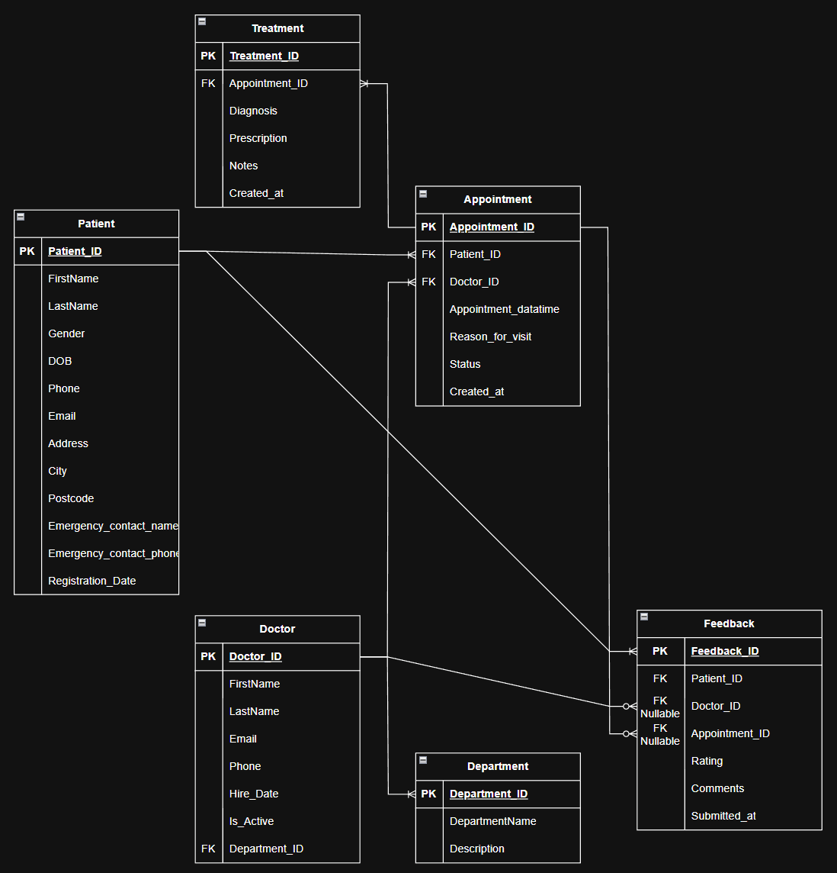

Cardinality rules and entity links
All links respect the clinic’s operational logic and referential integrity rules [2]:
- PATIEN (1 to many) APPOINTMENT – A patient can have anu number of appointments, but each appointment belongs to a single patient.
- DOCTOR (1 to many) APPOINTMENT – A doctor can manage multiple appointments, but an appointment is assigned to a single doctor.
- DEPARTMENT (1 to many) DOCTOR – A department can have multiple doctors, but each doctor is assigned to a single department.
- APPOINTMENT (1 to many) TREATMENT – An appointment can end with one or more treatment records, but each treatment records, but each treatment belongs to a single appointment.
- PATIENT (1 to many) FEEDBACK - A patient can submit multiple ratings, but each feedback belongs to a single patient.
- DOCTOR (0 to many) FEEDBACK – A rating can be associated with a doctor, and a doctor can receive multiple feedbacks.
- APPOINTMENT (0 to many) FEEDBACK – Feedback can be linked to a specific appointment, and an appointment can have multiple ratings.

Normalization to Third Normal Form (3NF) – justification and steps
The project was developed following the principles of normalization to eliminate redundancy and ensure data consistency:
1st Normal Form (1NF) – All tables contain atomic values, there are no repeated groups and each row is unique through the primary key.
2nd Normal Form (2NF) – All non-key attributes are fully dependent on the primary key – there are no partial dependencies. For example, department data is not stored in the DOCTOR table but is separated into its own entity.
3rd Normal Form (3NF) – There are no transitive dependencies between non-key attributes. Any information that can be obtained from other fields is moved to a separate table. For example, treatment data is not included in the APPOINTMENT table, but forms a distinct entity linked by a foreign key [3].

Establishing primary, foreign keys and integrity constraints
In addition to primary and foreign keys, additional restrictions have been defined to protect the correctness of information:
- Uniqueness restrictions for patient and doctor email addresses, as well as for accepted values (gender, appointment status, evaluation score).
- Default values for fields such as registration date or doctor activity status.
- Delete/update action rules: ON UPDATE CASCADE and ON DELETE RESTRICT it is prohibited to delete a patient/doctor if there are associated appointments, so as not lose the medical history.

Database Implementation

Creating tables and applying SQL constraints
The Database MedAssist Clinic is created first, followed by all tables in logical dependency order, to ensure foreign key constraints are applied correctly. All scripts use MySQL-compatible syntax, with explicit constraints for data integrity, default values and relationship rules [4].
Step 1 – Create and Select Database
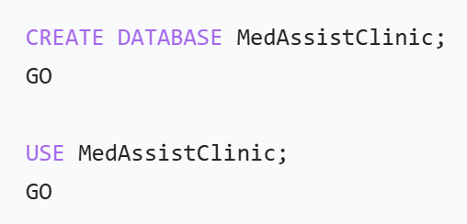
The database is initialized and the session is set to use this database for all subsequent operations.
Step 2 – Create Department Table
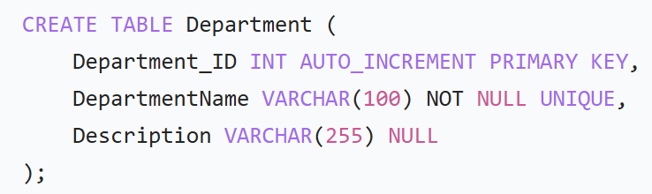
Stores clinic departments/specialties. DepartmentName is enforced as unique to prevent duplicate entries. The primary key ensures each department is uniquely identified.
Step 3 – Create Patient Table
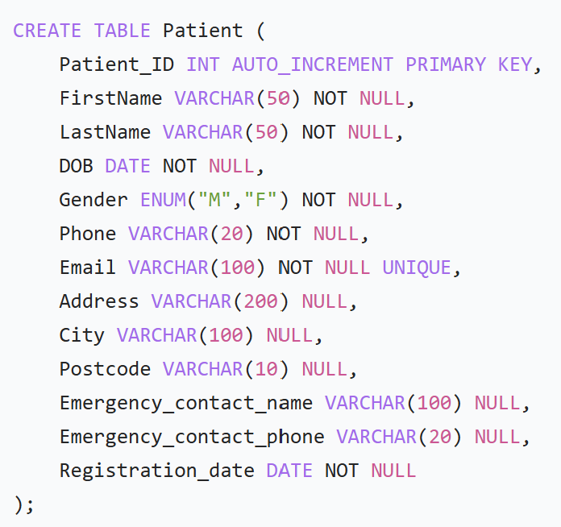
Stores all patient records. ENUM restricts gender to valid values. Email is unique to avoid duplicate patient accounts. Mandatory fields ensure all required registration data is captured.
Step 4 – Create Doctor Table
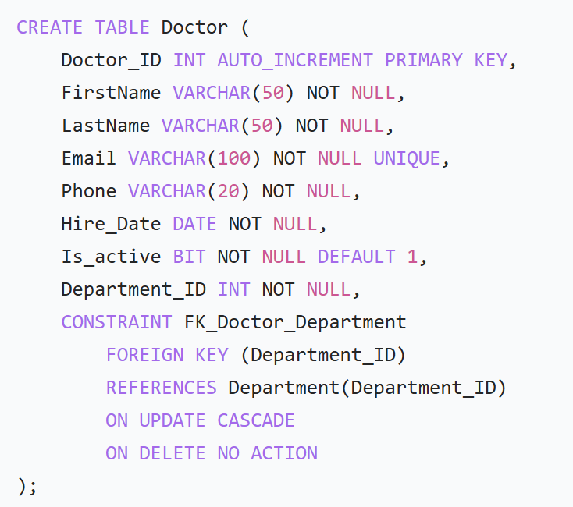
Stores medical staff details. The foreign key links each doctor to their department:
- ON UPDATE CASCADE – If a department ID changes, the update propagates automatically
- ON DELETE NO ACTION – Prevents deleting a department of doctors are still assigned to it, preserving referential integrity
- Is_active defaults to 1 to track current employments status
Step 5 – Create Appointment Table
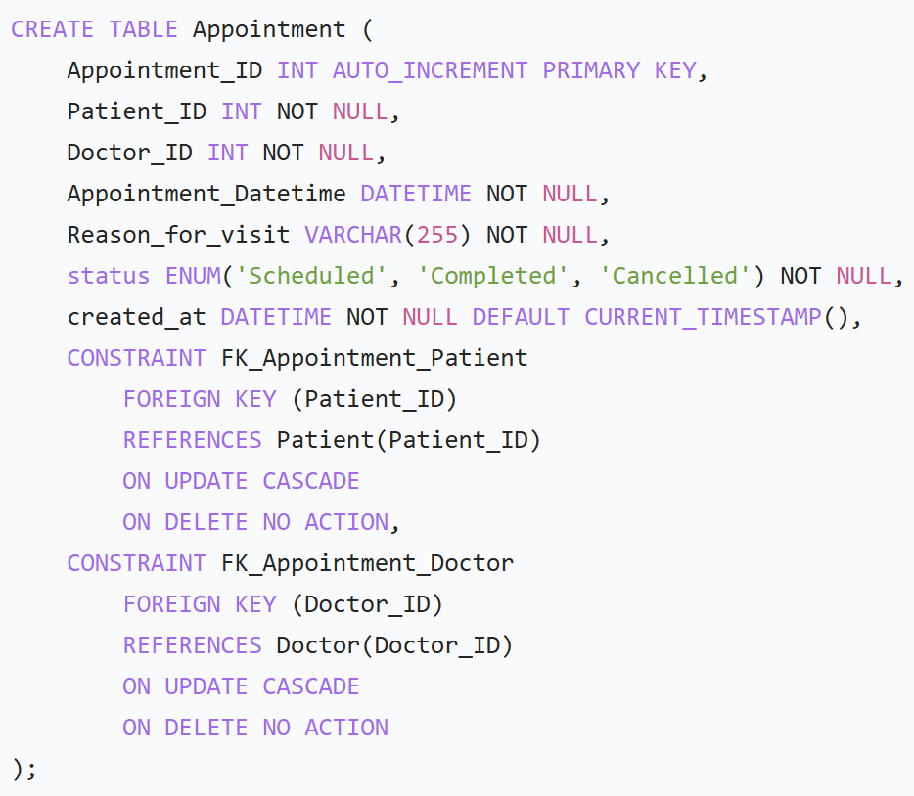
Manage all scheduled consultations:
- ENUM enforces valid appointment statuses:
- CURRENT_TIMESTAMP auto-logs when a booking is created
- ON DELETE NO ACTION prevents deleting a patient or doctor if linked appointments exist, preserving historical records
Step 6 – Create Treatment Table
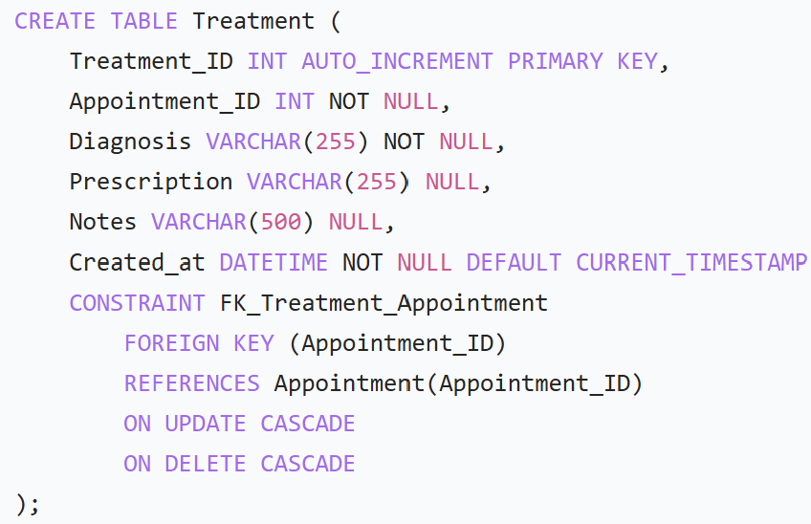
Stores clinical outcomes from each consultation:
- Linked directly to an appointment – no treatment can exist without a valid appointment
- ON DELETE CASCADE – If an appointment is removed its associated treatment records are also removed, avoiding orphaned data
Step 7 – Create Feedback table
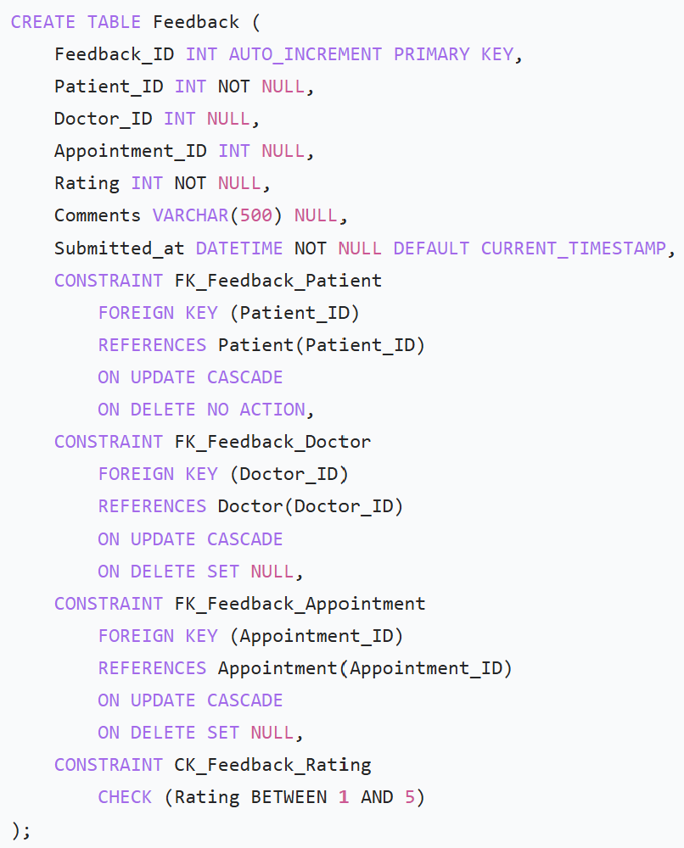
Captures patient satisfaction feedback:
- Doctor appointment references are optional, allowing general feedback not tied to a specific consultation
- CHECK constraint ensures rating are only between 1 and 5
- ON DELETE SET NULL – If a doctor or appointment is removed, the feedback record remains, with only those links cleared
- ON DELETE NO ACTION - a patient cannot be deleted if they have submitted feedback, preserving service quality history
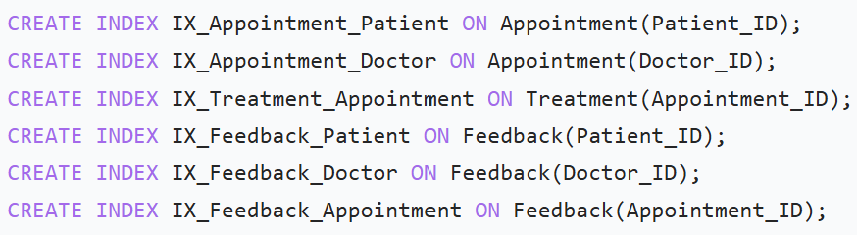
- Index are added to columns used most frequently for filtering, joining or searching:
- Appointment lookups by patient or doctor are the most common daily operations
- Treatment and feedback are almost always queried alongside their linked appointment or patient
- Indexes reduce full-table scans, speeding up search and report generation without affecting data integrity

Populating with realistic sample data
To \validate the functionality of the database and demonstrate how entities interact within the MedAssist Clinic system, realistic test data was inserted into all main tables. This data simulates authentic scenarios from a medical clinic, allowing verification of the integrity of relationship, constraints and operational flows.
Five appointments have been inserted into the Appointment Table, each associated with a patient and a doctor. The data includes:
- Unique appointment identifiers (Appointment_ID)
- References to existing patients and doctors
- Data and time of the appointment
- Reason for the visit
- Appointment status (Scheduled, Completed, Cancelled)
- Data created in the system
Appointment Table
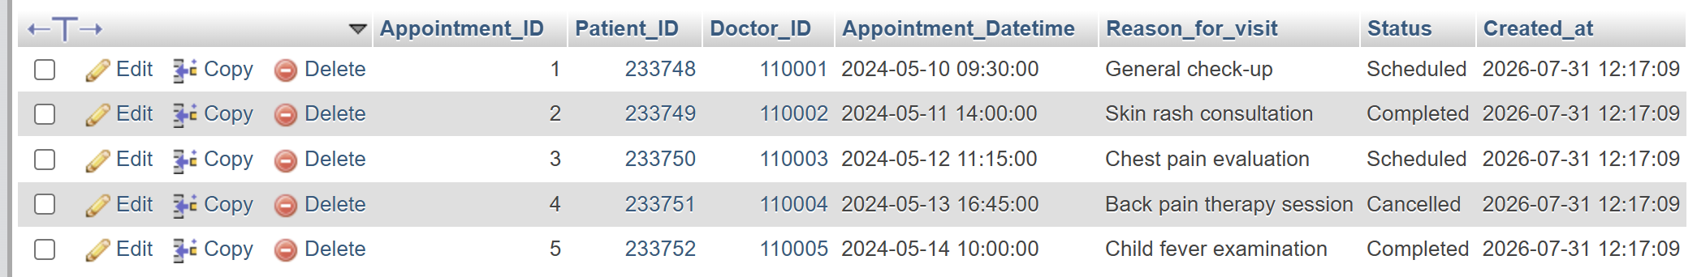
The Department Table contains five real medical departments, each with:
- A unique identifier (Department_ID)
- A department name
- A clear description of the speciality
This data is essential for testing the Department (1 to Many) Doctor relationship, because each doctor must belong to a valid department, inserting this data allows for referential integrity to be checked through the foreign keys in the Doctor Table.
Department Table
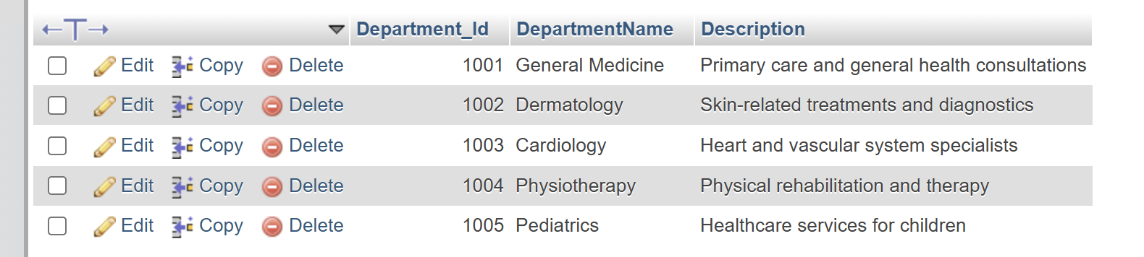
The Doctor table was populated with eight doctors, each with:
- Personal data (Last Name, First Name)
- Contact information
- Hire date
- Activity status
- Department to which they belong
The data entered is realistic and spans multiple departments, demonstrating the correct functioning of the Department_ID foreign key.
Doctor Tabel
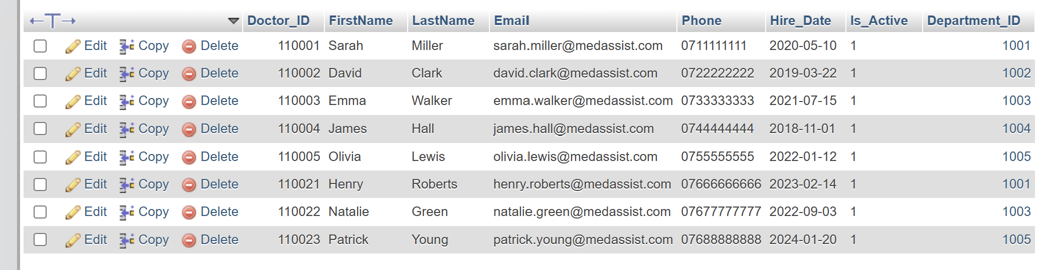
The Feedback Table contains five patient ratings, each including:
- Feedback identifier
- Patient who provided the rating
- Targeted physician
- Associated appointment
- Rating (1-5)
- Descriptive comments
- Date the feedback was submitted
Feedback Table
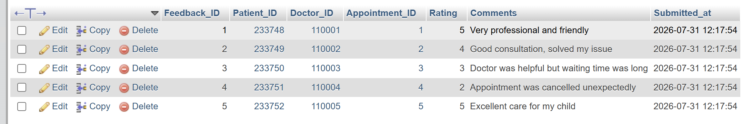
The Patient table was populated with ten patients, each with:
- Full person details
- Contact information
- Address
- Emergency contact person
- Date of registration in the system
Patient Table
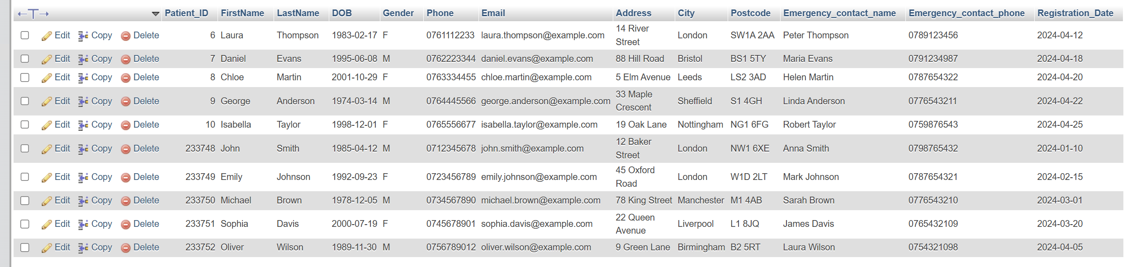
The Treatment Table contains five treatments associated with existing appointments. Each record includes:
- Diagnosis
- Prescription
- Additional notes
- Treatment creation date
Treatment Table
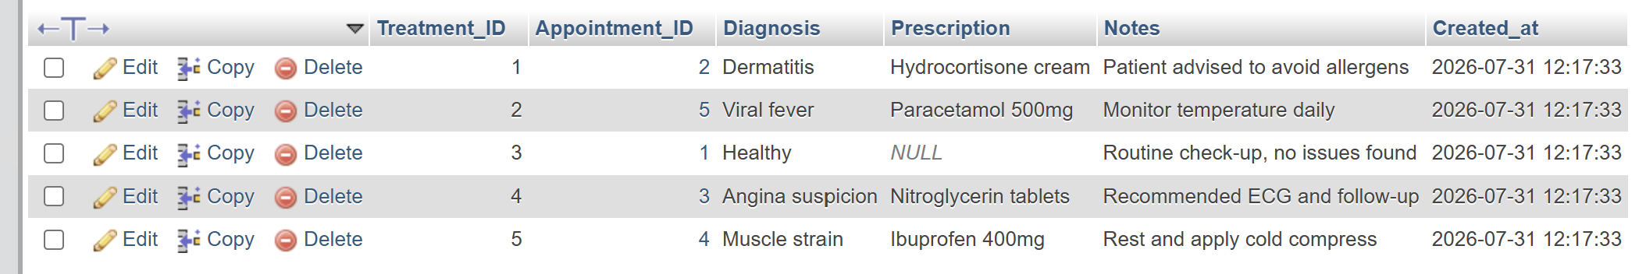

Validating data integrity and testing constraints
Data integrity validation is an essential step in assessing the correctness and robustness of a relational database. Within the MedAssist Clinic system, we conducted a serios of practical tests to demonstrate how MySQL enforces the constraints defined in the database schema. I performed the tests by intentionally inserting invalid data, to observe the system’s reaction, and to confirm that data integrity is protected [5].
Primary Key testing – Duplicate ID
To verify the correct functioning of the PRIMARY KEY constraint, an attempt was made to insert a department with an already existing identifier:
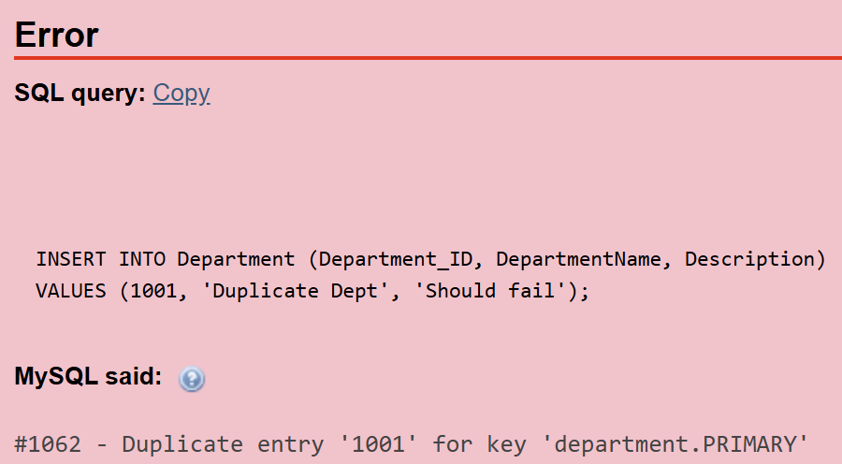
Referential integrity testing – Invalid Foreign Key
To verify the functioning of foreign keys, an attempt was made to insert a doctor belonging to a non-existent department:
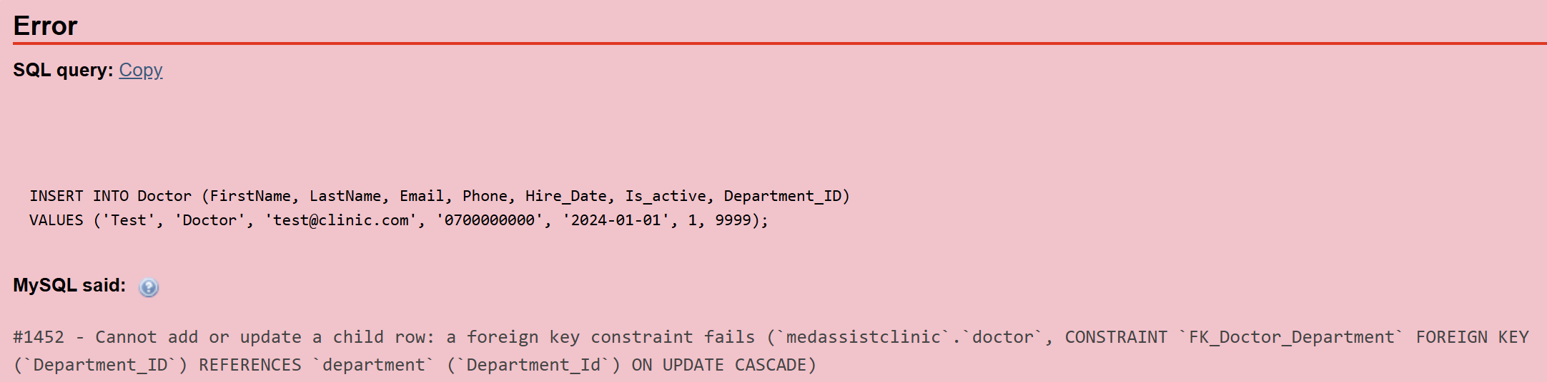
Testing the UNIQUE constraint – Patient Email
To verify the uniqueness of the Email field in the Patient Table, an attempt was made to insert a patient with an existing email address:
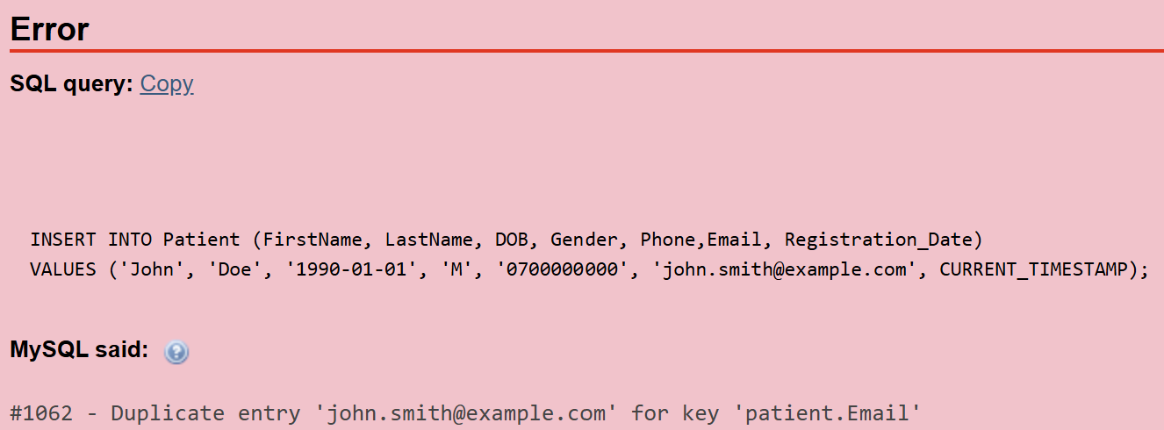
ENUM/Status Testing – Invalid value in Appointment
To verify the validation of the Status field, defined as ENUM, an attempt was made to enter an invalid value:
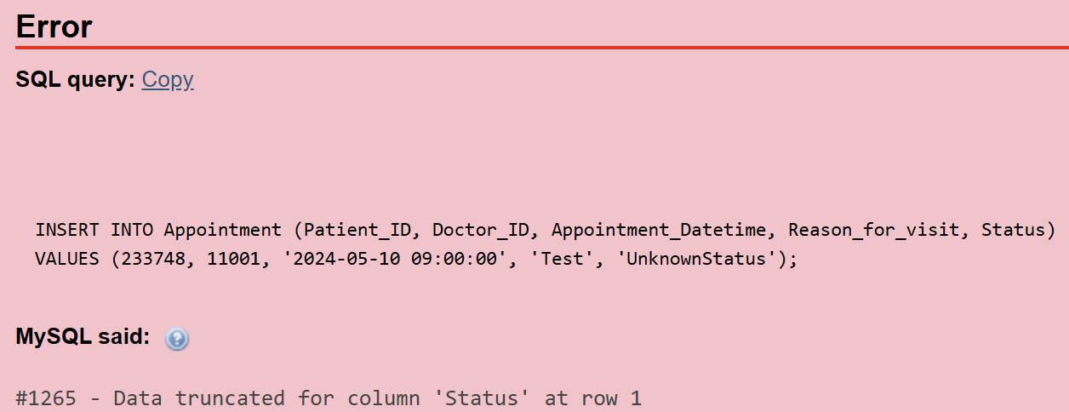
Testing NOT NULL – required field
To verify compliance with NOT NULL constraints, an attempt was made to insert a department without a name:
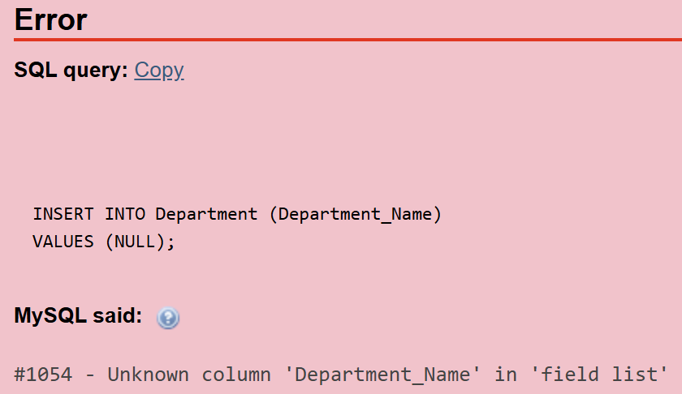
The tests performed demonstrate that the MedAssist Clinic database is built correctly and rigorously applies all integrity rules:
- Primary keys prevent duplication
- Foreign keys protect relationships between tables
- UNIQUE fields guarantee the uniqueness of sensitive data
- ENUM fields accept only valid values
- NOT NULL fields prevent the insertion of incomplete data
This, the database schema is robust, coherent and ready for complex operations, stored procedures and transactional scenarios.

Stored procedures for CRUD operations with transactional management
To ensure efficient, secure and controlled data management in the MedAssist Clinic system, Stored Procedures were implemented for CRUD operations: Create, Read, Update and Delete. These procedures allow centralization of data and facilitate code reuse [6].
In addition, critical operations were integrated into SQL transactions, using START TRANSACTION, COMMIT and implicit ROLLBACK instructions in case if failure.
Create – AddDoctor procedure
The procedures were implemented for the Doctor entity. As it is one of the most important in the system and interacts directly with departments, appointments and feedback. The AddDoctor procedure allows a new doctor to be inserted into the database.
The operations is encapsulated in a transaction to guarantee that the insertion is atomic: it either executes completely or it does not execute at all.
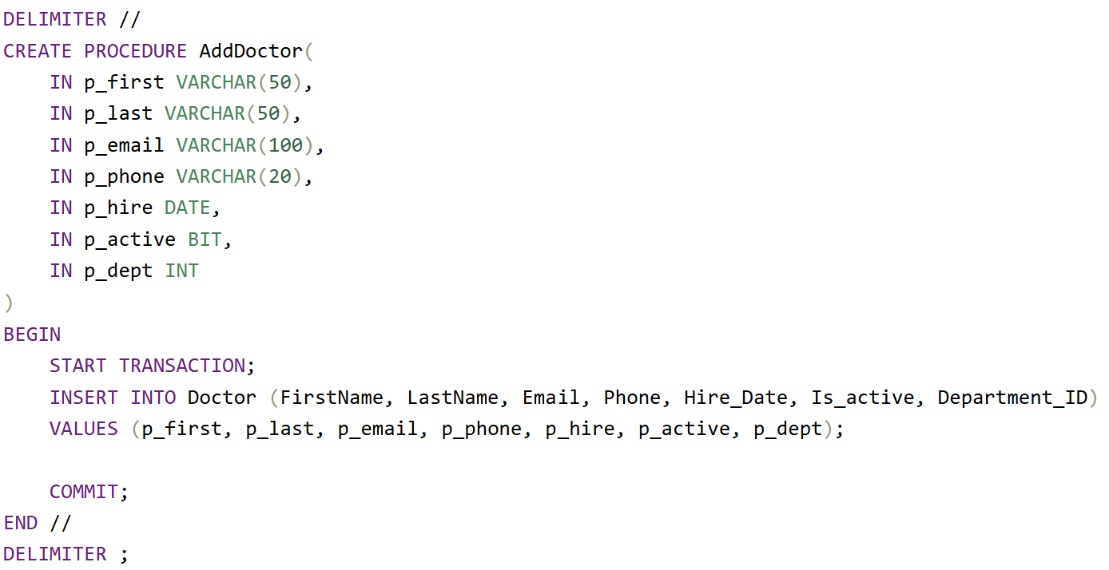
Read – GetDoctor Procedure
The GetDoctor procedure allows querying a doctor based on his unique identifier.
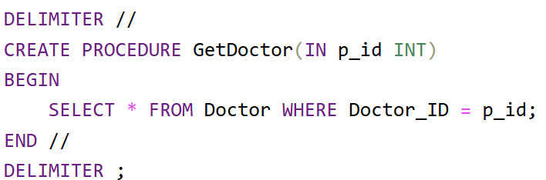
Update – UpdateDoctorPhone procedure
The UpdateDoctorPhone procedure updates a doctor’s phone number. The operation is encapsulated in a transaction to prevent incomplete updates.
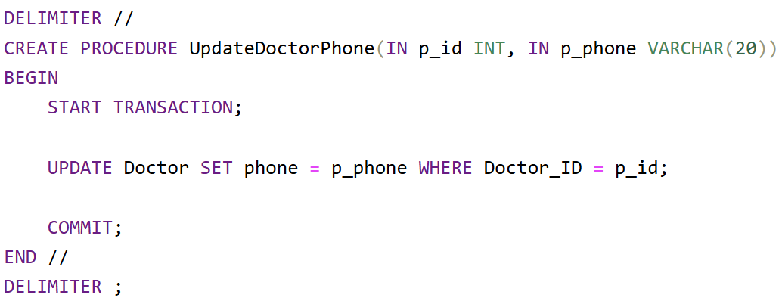
Delete – DeleteDoctor Procedure
The DeleteDoctor procedure removes a doctor from the database. The delation is protected by a transaction to prevent inconsistencies, especially if the doctor has appointments of feedback associated with it.
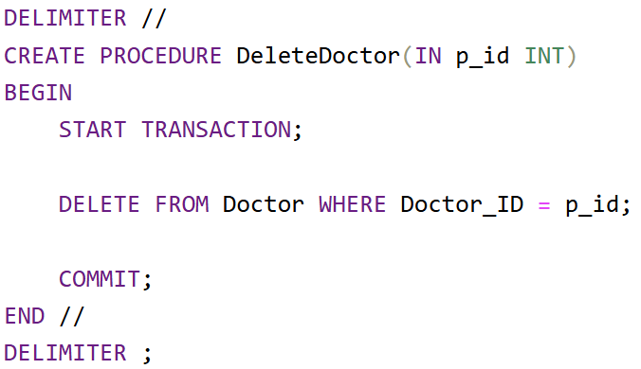
The stored procedures implemented for the Doctor entity demonstrate how the MedAssist Clinic system handles CRUD operations in a controlled and secure manner. The use of SQL transactions guarantees:
- Data consistency
- Prevention of incomplete inserts
- Protection against accidental deletions
- Referential integrity in the case of sensitive operations
These procedures represent an essential component in the database architecture, providing a high level of reliability.

Triggers and functions for auditing data changes
Auditing changes in a database is an essential component for maintaining data integrity, traceability and security. Within the MedAssist Clinic system, auditing mechanisms have been implemented through SQL triggers, which automatically record changes made to the Doctor entity. These mechanisms allow monitoring if critical actions, such as updates and deletions, providing a complete record of data history.
Creating the audit table
To store the information generated by the triggers, a dedicated auditing table was created:
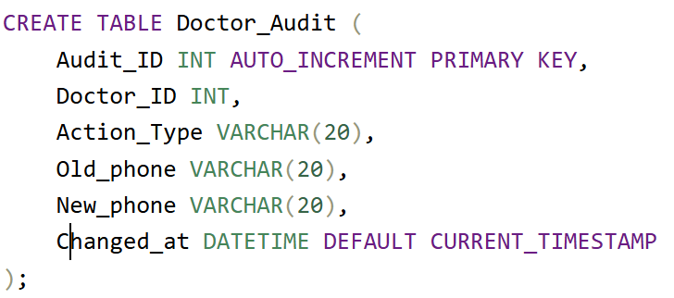
UPDATE triggers
To monitor updates made to doctors, a trigger was created that runs automatically after each UPDATE operation:
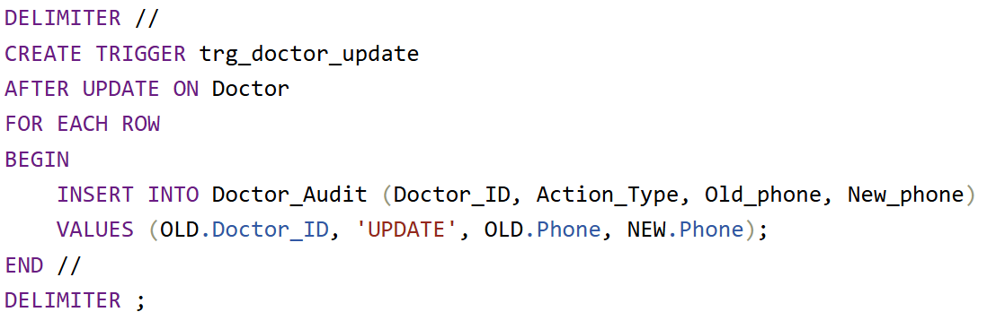
Trigger for DELETE
To monitor deletions, a trigger was implemented that automatically records each row deleted from the Doctor table:
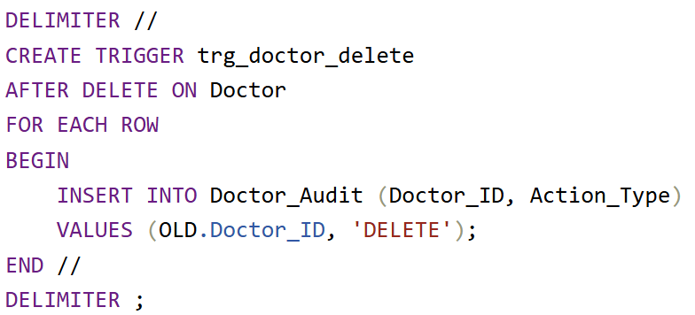
Benefits of Audit Mechanisms. Implementing audit triggers offers multiple advantages:

Complex transactional scenario – justification for COMMIT and ROLLBACK
Within the MedAssist Clinic system, managing appointments and treatments is a critical process, as these two entities are closely linked. To ensure data consistence and prevent situations where an appointment is created without the associated treatment, we implementead a complex transactional scenario using a stored procedure.
The CreateAppointmeantWithTreatment procedure demonstrates how SQL transactions are used to ensure that dependent operations are executed automatically – that is, either all succeed or none are applied [7].
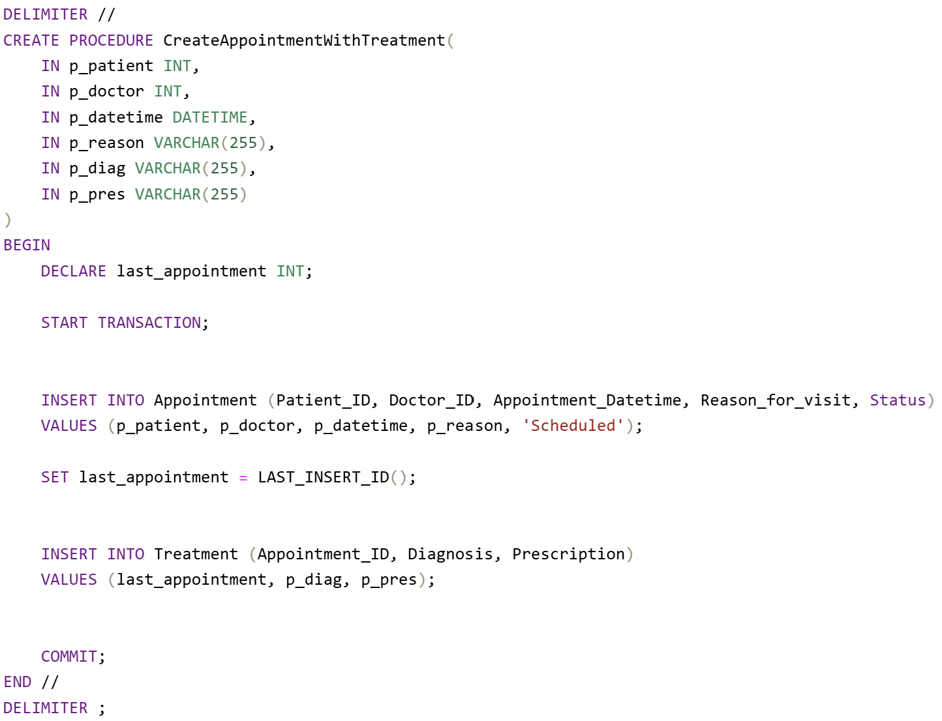

Optimization and Performance
Optimizing database performance is essential for ensuring fast response time, an efficient user experience and adequate scalability in the context of a medical system. At MedAssist Clinic, I analysed critical queries, implemented strategic indexes and evaluated their effects on overall performance.

Analysis of frequent and critical queries
To identify areas that require optimization, I analysed frequently used queries in the system. These are operations that are essential for application to function and are executed several times a day.
Queries for Doctor appointments
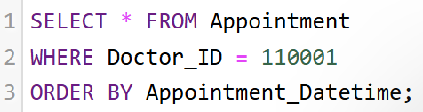
Queries for a patient’s appointments
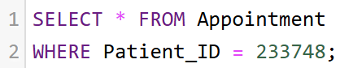
Queries for treatments for an appointment
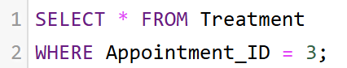
Queries for Doctor feedback
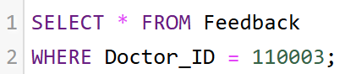
Searching for a patient by email
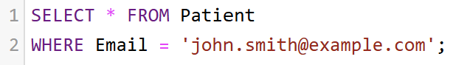

Indexing strategy and justification of choices
Indexing is one of the most effective methods for optimizing performance. In the MedAssist Clinic database, I implemented indexes on the columns most frequently used in filtering and JOINs.
Index on Patient_ID (Feedback)
Index on Doctor_ID (Appointment)
Index on Patient_ID (Appointment)
Index on Appointment_ID (Treatment)
Index on Doctor_ID (Feedback)

Effects of indexing on execution speed and system efficiency
Implementing indexes in the MedAssist Clinic database has a direct impact on the overall performance of the system. Indexing is one of the most effective optimization techniques, as it allows for fast data access, reduced query execution time and improved user experience. However, this optimization also comes with certain trade-offs, which must be understood to maintain a balance between speed and resources [8].

Scientific Support for Implementation Decisions
Implementing a medical data management system requires the use of fundamental database concepts. The choice of transactions, COMMIT/ROLLBACK mechanisms, stored procedures, triggers and indexes in not random, but is based on well-established theoretical principles in the specialized literature. This section presents the scientific justification for these concepts and how they contribute to the consistency, performance and reliability of the MedAssist Clinic system.
Transactions
Transactions are the fundamental mechanism by which databases ensure the integrity of operations. They allow multiple instructions to be grouped into a single atomic block, guaranteeing that all operations are executed completely or not at all.
COMMIT and ROLLBACK
The COMMIT and ROLLBACK statements are critical components of transaction management.
- COMMIT commits changes and makes them permanent
- ROLLBACK rolls back to the previous state in the event of an error.
Stored Procedures
Stored procedures allow the centralizations of application logic directly in the database server. They reduce traffic between the application and the server, increase security and ensure consistent behavior of complex operations. In MedAssist Clinic, stored procedures are used for critical operations such as the simultaneous creation of an appointment and associated treatment.

Develop a database-driven website

General structure of the application
The application is based on a simple and efficient architecture, built around the PHP language and MySQL database. The main goal was to create a system through which users can view recipes and the administrator can manage the content through a dedicated panel. I organized the project into several files and directories, each with a clear role: public pages, administration pages, PHP scripts for date processing. The modular structure allows for easy expansion of the application and maintaining a clean code [9].
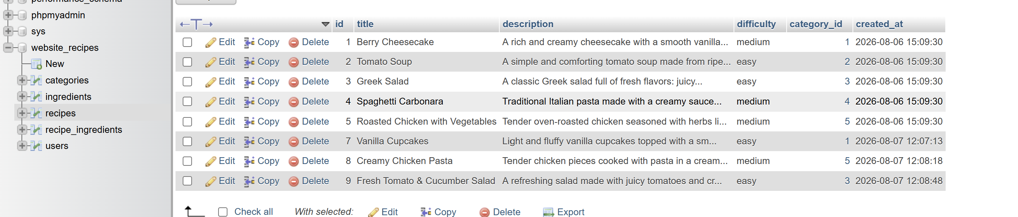
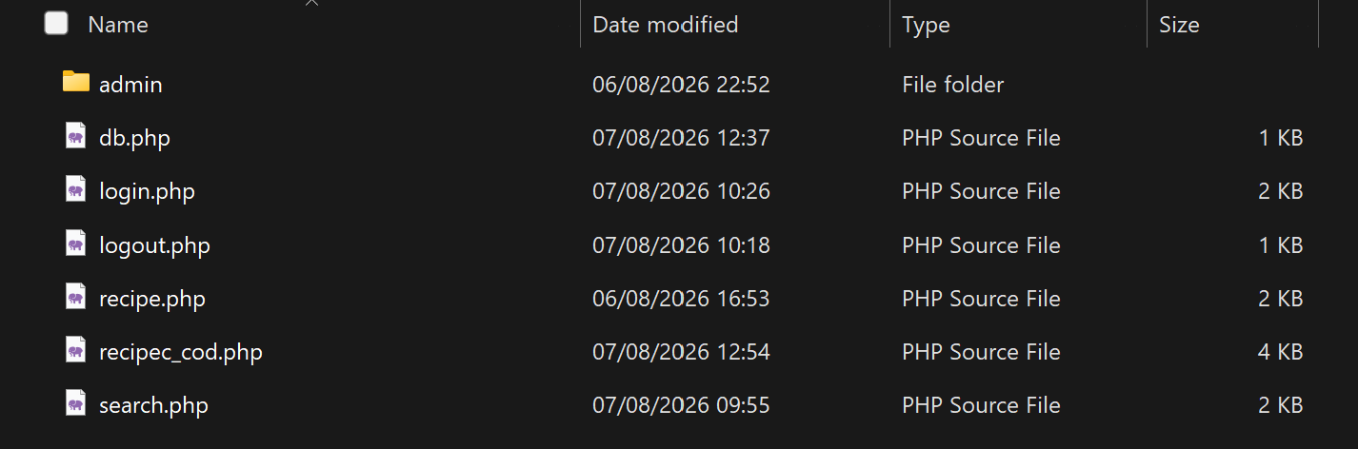
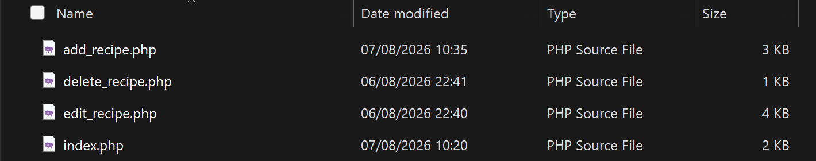

Connecting to the database and managing data
For communication with MySQL I used PDO, a modern and secure connection method. The db.php file contains all the information needed to establish the connection and is included in the pages that need to access the data. I created a table dedicated to recipes, which stores the title, description category difficulty and other relevant information. The data is retrieved from the database and displayed dynamically in the PHP pages, so that any change in MySQL is automatically reflected in the interface [10].
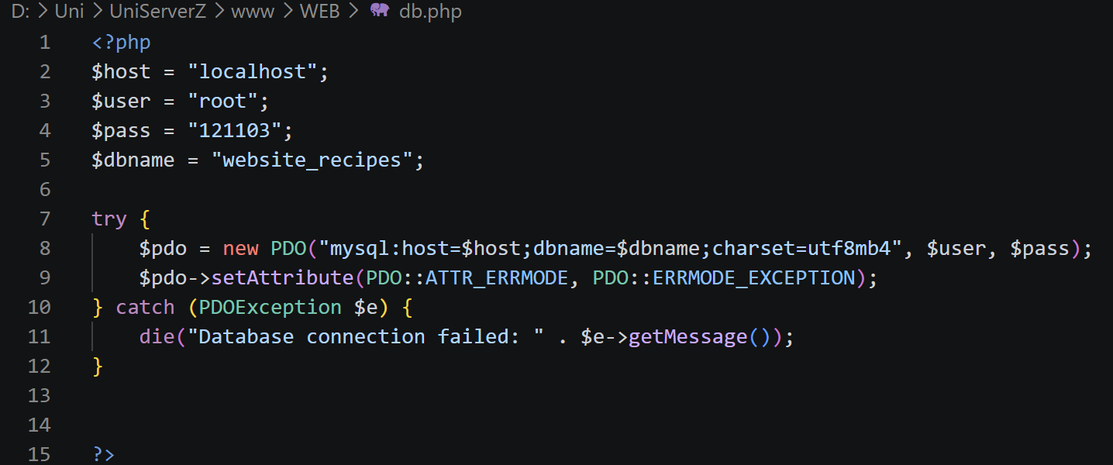

Dynamic display of recipes
A central element of the application is the page that display all the recipes. Using a foreach, each recipe is automatically generated HTML, with a title, description and link to the individual page. To improve the presentation, I used cards build exclusively with HTML and inline styles, without external CSS files. Each card has a title and a descriptive text. I added an icon to enter the application as an administrator for different actions. I also added a search bar for all existing categories.
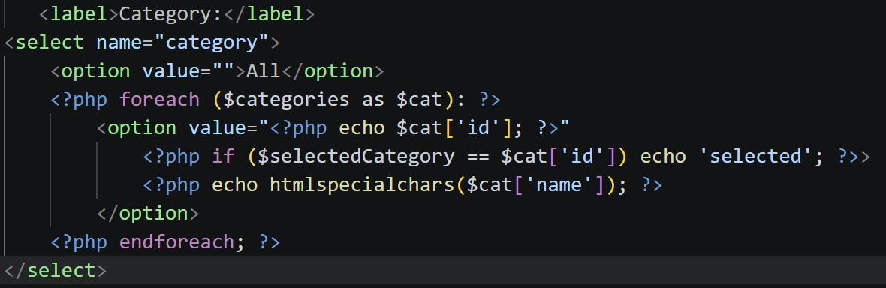

Administration system and adding recipes
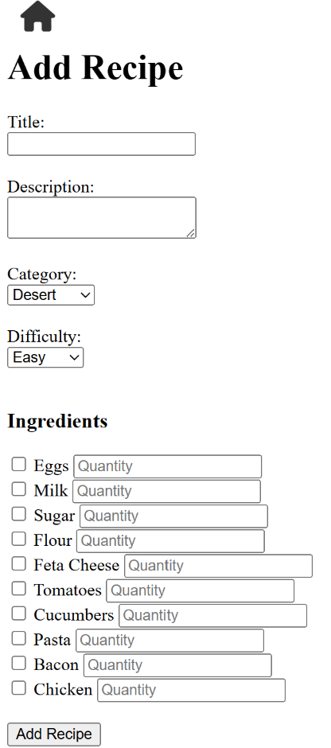
For the administrator I created a separate section accessible only after authentication. The form adding recipes allows you to enter the title, description, category, difficulty level and ingredients. Ingredients are selected via checkboxes, each with a field for quantity. The data is sent to the server via the POST method, validated and inserted into the database. The administration panel also includes navigation options, such as returning to the main page and logout. Logout is implemented by destroying the PHP session, thus ensuring access security.
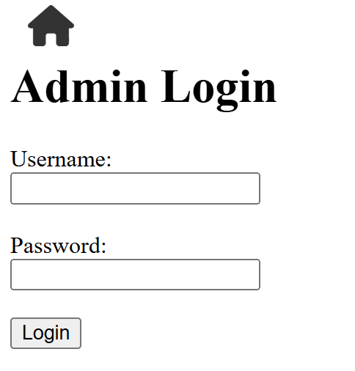

Navigation, security and additional functionalities
Navigation between pages is done through dynamic links, generated based on the recipe ID. I used PHP sessions for authentication, so that only validated users can access the administration area. Logout redirects the user to the login page and closes the session. For security, all display data is passed through htmlspecialchars(), preventing the introduction of malicious code. All these elements contribute to a stable, easy to use and easy to extend application.

Conclusion
Taking this assessment was a valuable experience for me, helping me to better understand both the theoretical side of databases and how they can be applied in a real project. The first four chapters gave me the opportunity to delve deeper into fundamental concepts such as entity analysis, normalization, data integrity, transactions and query optimization., Although some of these topics seemed abstract at first, over time I was able to understand them logically and apply them correctly, which strengthened my confidence in my technical skills.
The database design and implementation process taught me how to think structurally, how to anticipate problems that may arise and how to build a coherent, stable and easily extensible system. I better understood the importance of normalization, the role of primary and foreign keys, and how stored procedures and triggers can automate complex operations. All of these elements showed me that a well-designed database is the foundation of any serious application.
The last chapter, dedicated to the web application, was a different but equally useful experience. Here I had the opportunity to put into practice what I had learned, working with PHP, connecting the application to the database and creating an interface that displays information in a dynamic way. I learned how to manage forms, how to work with sessions, how to display data securely and how to organize an application so that it is easy to use. This part helped me see how theory turns into practice and how a database becomes useful in a real context.
Overall, this assessment helped me develop my knowledge, clarify concepts that I had only superficially understood before and gain practical experience in the field of software development. I learned new things that will definitely be useful to me in the future whether I work in similar projects or continue to delve deeper into the field of databases and web applications. It was a job that challenged me, made me think critically and helped me evolve professionally.

References

[1] | “Medium,” 12 09 2012. [Online]. Available: https://deepanshutiw03.medium.com/understanding-entities-attributes-and-entity-relationships-f2c6e3992c02. [Accessed 20 07 2026].
[2] | “redgate,” 15 10 2014. [Online]. Available: https://www.red-gate.com/blog/cardinality-in-data-modeling/. [Accessed 21 07 2026].
[3] | “redgate,” 14 10 2026. [Online]. Available: https://www.red-gate.com/blog/normalize-2nf-3nf/. [Accessed 21 07 2026].
[4] | “centron,” 18 05 2010. [Online]. Available: https://www.centron.de/en/tutorial/constraints-in-sql-guide-to-creating-and-managing-data-rules/. [Accessed 22 07 2026].
[5] | “datacamp,” 22 04 2023. [Online]. Available: https://www.datacamp.com/tutorial/integrity-constraints-sql. [Accessed 23 07 2026].
[6] | “SQLShack,” 11 10 2015. [Online]. Available: https://www.sqlshack.com/creating-using-crud-stored-procedures/. [Accessed 2026].
[7] | “linkedin,” 12 02 2015. [Online]. Available: https://www.linkedin.com/advice/0/what-commit-rollback-statements-sql-how-z9rge. [Accessed 25 07 2026].
[8] | “Medium,” 30 03 2022. [Online]. Available: https://medium.com/@maryam-bit/the-impact-of-database-indexing-on-query-execution-time-310af4370a4d. [Accessed 25 07 2026].
[9] | “DEV,” 01 10 2016. [Online]. Available: https://dev.to/dbazhenov/how-to-optimize-the-code-structure-of-a-simple-php-application-as-your-project-grows-4273. [Accessed 27 07 2026].
[10] | “php,” 12 08 2015. [Online]. Available: https://www.php.net/manual/en/pdo.connections.php#:~:text=Connections%20are%20established%20by%20creating,and%20password%20(if%20any).. [Accessed 28 07 2026].

