

Jack Frampton
2413011

Reflection on Study Skills

University of Wales Trinity Saint David
Study Skills ACDB4010

Academic Year: 2024-2025

Supervisor: Jenni Steen

Contents
Section 1 - 3
1.1 A brief overview of myself – 3
1.2 Screen grabs of my powerpoint - 3
1.3 Key points learnt when producing a presentation – 5
1.4 Areas for improvement – 6
Section 2 – 6
Skills needed for successful learning in a higher education environment 6
2.2 Critical thinking – 6
2.3 Reading skills – 7
2.4 Communication skills – 7
2.5 Transferable skills – 7
2.6 Self Evaluation exercises - 8
2.7 My goals – 9
2.8 Improving myself to achieve my goals – 9
Section 3 – 10
Application - 10
3.1 Looking after your data – 10
3.2 Time-management and self-organisation - 10
3.3 e-Portfolio – 12
3.4 Independent Study – 12
Section 4 – 13
4.1Conclusion and Evaluation - 13

Section 1 -

1.1 A brief overview of myself –
My name is Jack Frampton. I currently live in Shoeburyness, Essex. I am an OME Engineer, working for Qinetiq, specialising in ammunition. My hobbies include swimming, going to the gym and playing the drums, this allows to personally enjoy myself outside of work.

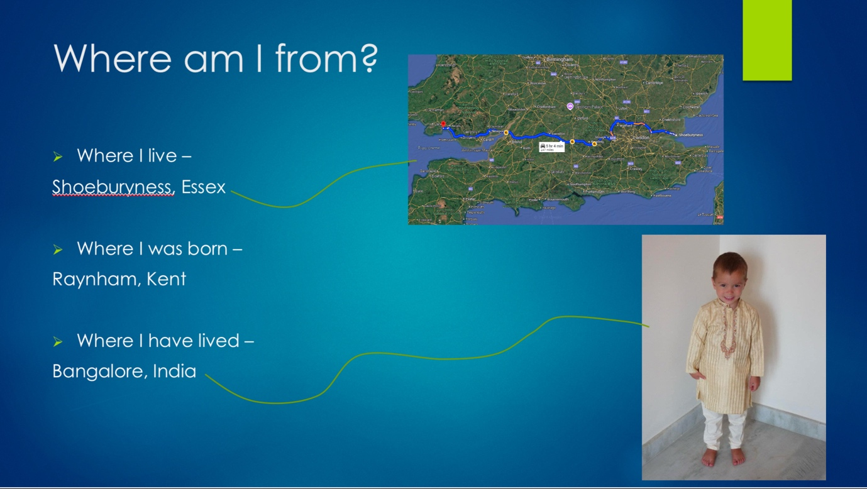
1.2 Screen grabs of my powerpoint -

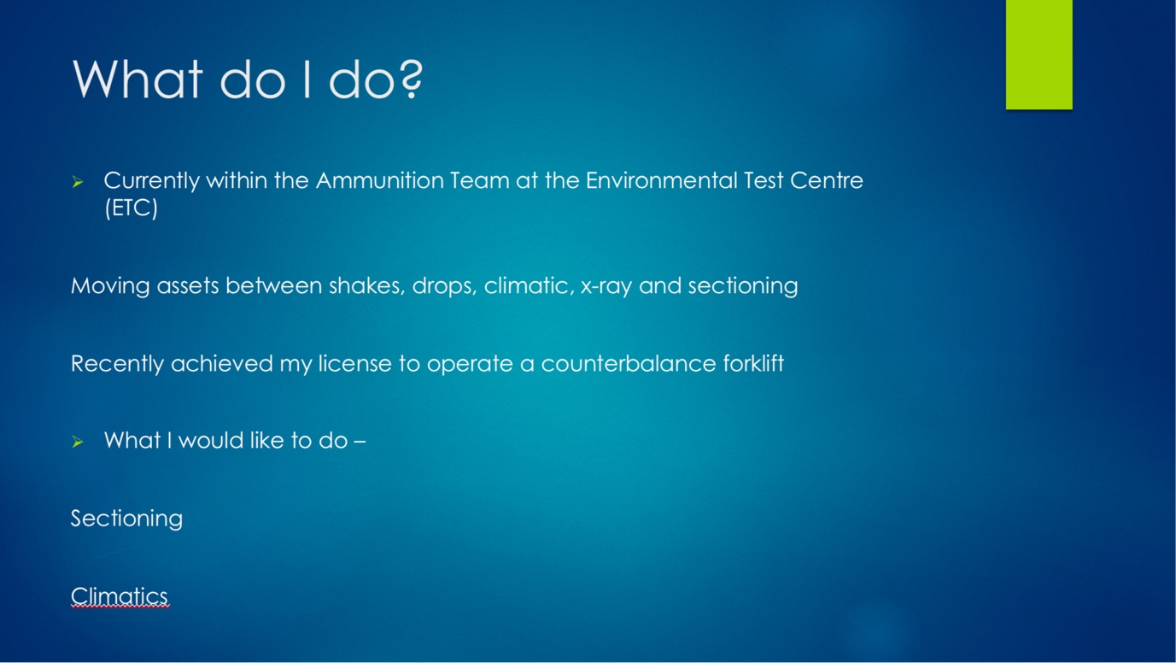

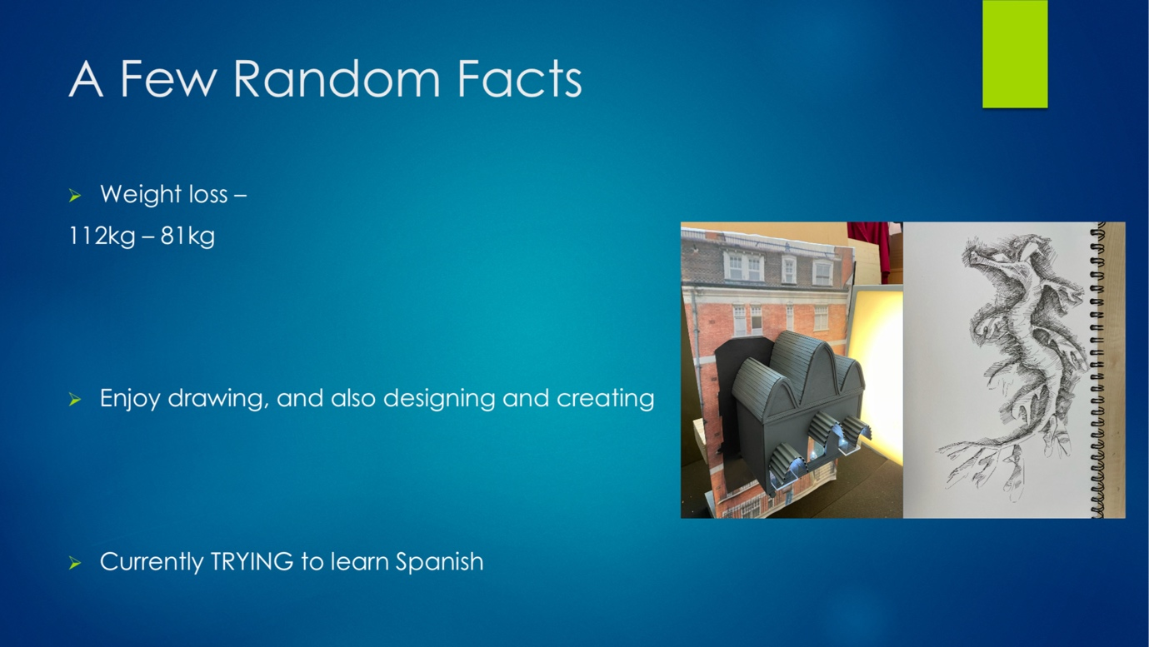

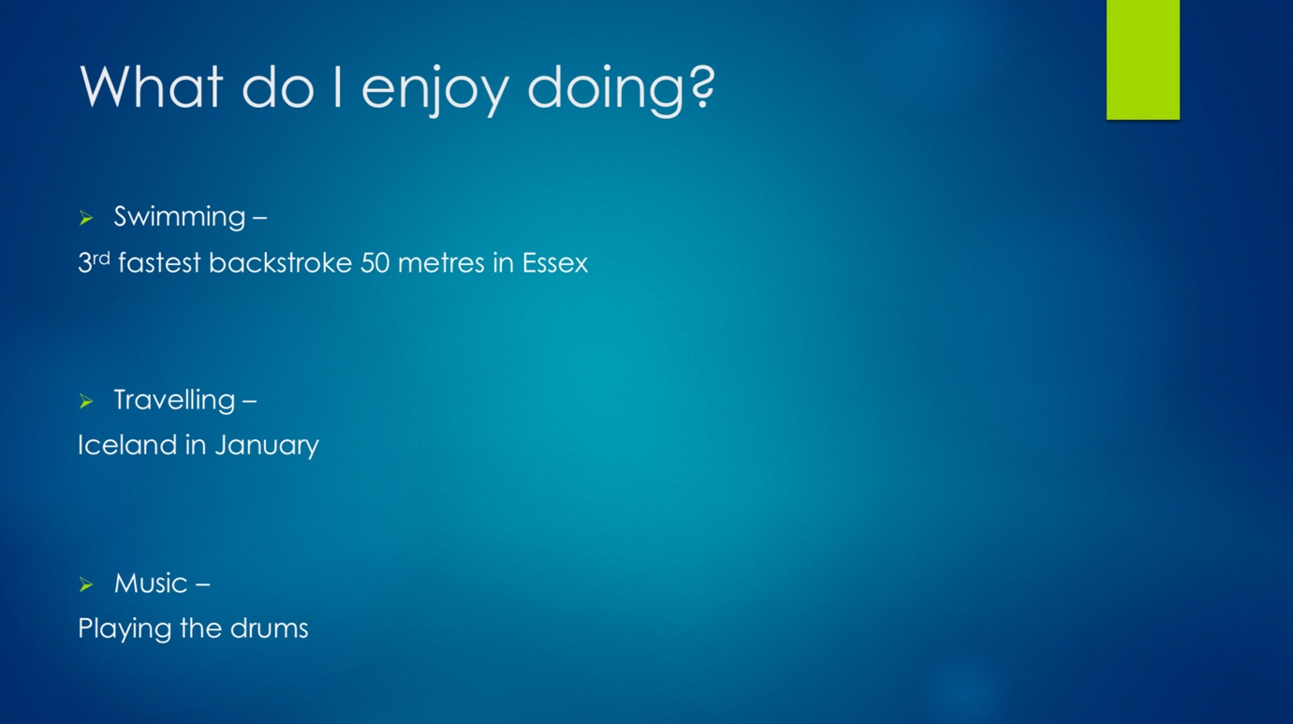

1.3 Key points learnt when producing a presentation –
- Keep the slides of the presentation short and simple:
Try not to include too many pictures as to into overcrowd the slide.
- Engage with your audience:
Encourage questions and notes as it can improve your presenting skills
- Talk more than you read:
Meaning, do not read directly from the presentation. Have short headings that you can then further explain to the audience. This allows the presenter to look more professional a knowledgable on the subject.
- Keep the audience involved:
Engage in eye contact with your audience, make it feel like you are talking to all of them individually.
- Utilise the space around you:
Do not stand in one position was it can make the presenter look nervous and not confident in what they are saying. Using the space can relax the audience, make them feel more com for table in the presenter's presence.

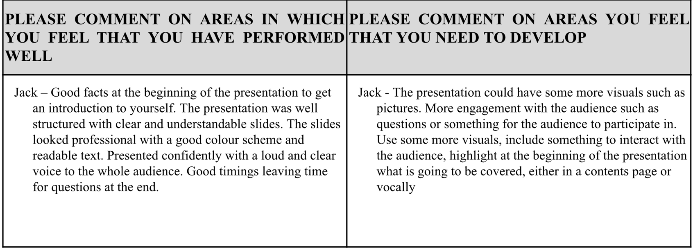
1.4 Areas for improvement –

The improvements stated by my peer are fairly exact. I could have included some short clips/ photographs showing my hobbies which would further aid my audience in visualising these activities. I could have given a more intriguing introduction to my presentation – either having a more professional, interesting cover page, or having more energy and use of body language. I feel I could also improve on the volume of which I speak, the way I position myself and how I portray my character. I speak too quietly which shows me as nervous and unprepared but normally I am the opposite. I could stand in a more professional position instead of hunched over the computer while I change the slides which could be portrayed but the audience as a lack of understanding, constantly reading off the presentation. I also must portray myself in my natural character – quite outgoing, confident and I have a growing will to learn and understand new topics. If I practise and master these skills, I will be a knowledgeable, self-assured presenter.

Section 2 –

Skills needed for successful learning in a higher education environment

2.2 Critical thinking –
‘Critical thinking is a skill defined by thinking clearly, rationally and being able to recognise and understand good arguments and then create an assessment from the evidence presented to you’ [1]. This learning skill is vital in academia as it allows, when mastered, students like me to read an assignment brief and understand what is being asked, how to approach it and ways in which it can be executed.

2.3 Reading skills –
Reading skills are especially important when studying in higher education as it can improve your speed in choosing the correct content to include in your assignments and reports [2]. This pushes the student to read more about their specific subject and widen their knowledge on that chosen subject.

2.4 Communication skills –
Communication skills allow to work within groups to complete projects while at university, it also allows you to stand in front of a group of people and present your findings/research [3]. Communication skills, from what I have read, is one of the most important as, once practiced, can be applicable anywhere. Whether it is in the workplace, completing a project or in your personal life when making plans with friends.

2.5 Transferable skills –
All skills listed previously can be applicable in the workplace. Critical thinking can be used when someone is presenting a workplace project, and using this skill you can suggest improvements or point out any unrecognised issues to the presenter.
Reading skills will be used everyday in the workplace, which is why it is so sought out by employers, they are looking for someone who will not waste valuable time reading up on something they should have learnt previously; the employer wants someone with a wide knowledge base and can input ideas when needed.
In the workplace, communication skills are vital. This is what keeps the company standing, if you have an improvement on a workplace project, you must know how to effectively portray that idea in the form of a presentation or a formal conversation. This will show the employer that you can lead a team and to show exactly what you expect of that team.

2.6 Self Evaluation exercises -
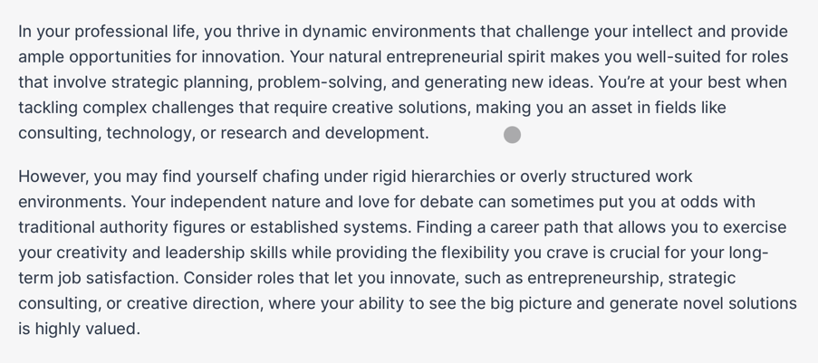
My first thoughts on my personality test are as follows; extroverted, leaning towards fact rather than intuition/feelings, open to other people's thoughts/opinions, too caught up in the insignificant details that I lose sight of the bigger picture.

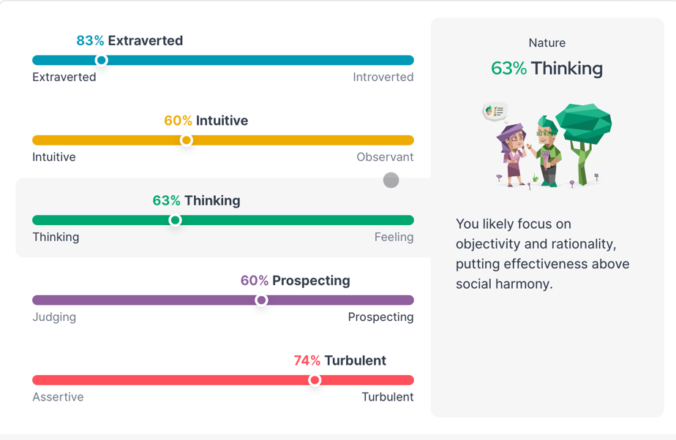

After taking my personality test, I can see that my first thoughts were quite correct. This shows I have a correct review of myself. This shows I am forward-thinking, will notice the smaller details to add/remove features to improve performance.

I have learnt that, based on my personality, I fit perfectly into my field of work, which is engineering, hands-on work, not in an office working a 9 till 5 job. I thrive in a career where producing solutions is necessary on a day-to-day basis.
What I could improve is my consideration of other people's feelings/opinions. Once I produce an idea, I think is efficient and applicable, I shut out other ideas that may be better than my own which could be seen as arrogant and is not sought out in the workplace.

2.7 My goals –
My short-term goals include:
- Gain my electric vehicle (dilly) license
- Pass January Maths Exams
- Purchase a new car
My long-term goals –
- Join the sectioning group at work
- Complete the 5-year apprenticeship
- Own a house

2.8 Improving myself to achieve my goals –
To gain my electric vehicle license, first I must research the vehicle to get myself familiar with how it runs. Completing my forklift course will help massively as now I know what to expect on the day of the test and how the instructors work. Furthermore, I must expand my networking to get an assessment; this involves emailing the Head of Transportation to find available tests. So, I must improve my communication skills within the company.
Linking with improving my communication skills, I have emailed the leading technician in sectioning to secure my placement for my financial year in the company. Doing this is also revealing the importance of proactivity to employers, as I am actively reaching out to people to find placements to further my knowledge in my specific field of work.
Over the next 5 years, I will apply myself exceptionally to ensure I secure the degree that this course offers. To solidify this goal, I must improve my time management skills; completing assignments on time, setting time aside to revise for exams and expand my knowledge.
I would like to be a homeowner by the age of 25 which, if I am sensible with money and time, is more than possible. My plan for the next 7 years is to set aside at least 40% of my paycheque each month. The way I will measure this goal is to have a target amount that I would like to reach each year – if I do not reach this by the end of the year, I must make it up in the first month of the new year.

[1] R. Needleman (2024, Dec. 11.) ‘What are the 6 essential skills for university students?’ [Online]. Available: https://www.uniadmissions.co.uk/application-guides/6-essential-skills-for-university-students/
[2] R. Needleman (2024, Dec. 11.) ‘What are the 6 essential skills for university students?’ [Online]. Available: https://www.uniadmissions.co.uk/application-guides/6-essential-skills-for-university-students/
[3] R. Needleman (2024, Dec. 11.) ‘What are the 6 essential skills for university students?’ [Online]. Available: https://www.uniadmissions.co.uk/application-guides/6-essential-skills-for-university-students/

Section 3 –

Application -

3.1 Looking after your data –
The “3 different places” rule states that a university student should have at least 3 different copies of the data, 2 of which should be stored separately, and 1 to be kept off-site. The 3-2-1 method provides a safety net for university students, as if one copy of the data is lost, you are still able to rely on the other 2. For example, the device the data is stored on stops working and you have no way to access your files, you can count on the other 2 storage devices with the other copies. Also, hypothetically, you misplace the hard copy of the data, you can load into your files and print another one.

3.2 Time-management and self-organisation -
The steps I take to enhance my productivity is to remove any distractions from my workspace e.g. my phone, television, family members disturbing me. This allows me to focus on the prioritised tasks. To reduce my stress levels and increase my concentration, I prefer to have background noise while I work; this, I feel, calms me down and heightens my rate of work. For example, listening to music while I am writing really helps as it puts me into a rhythm.

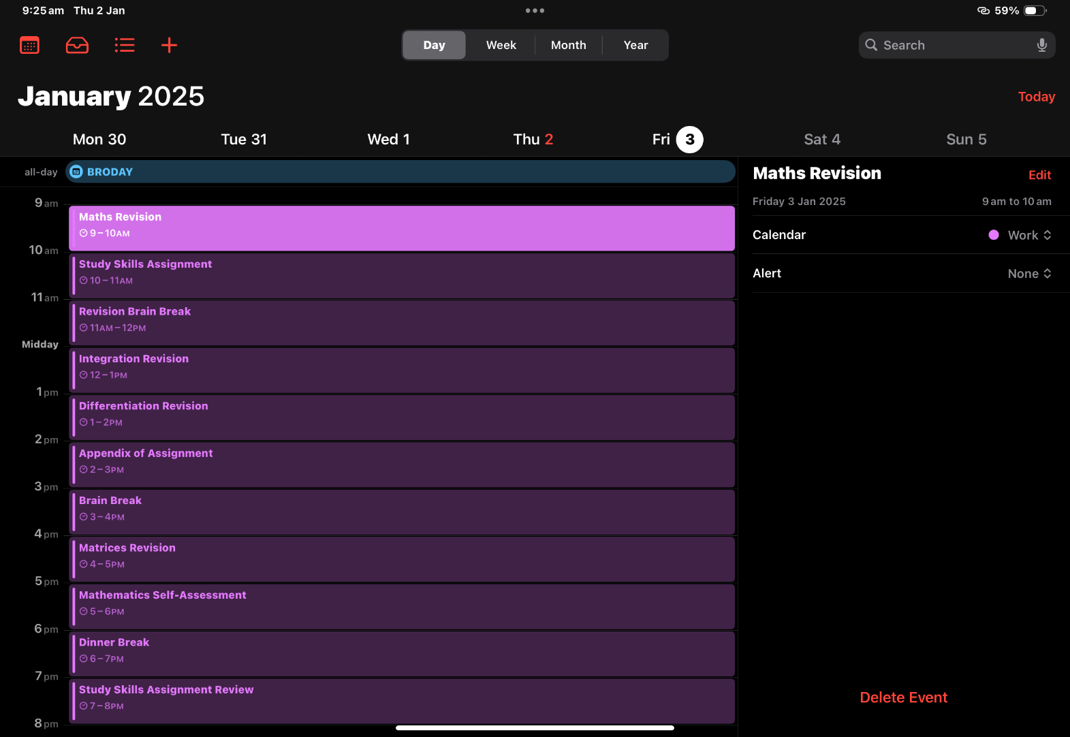

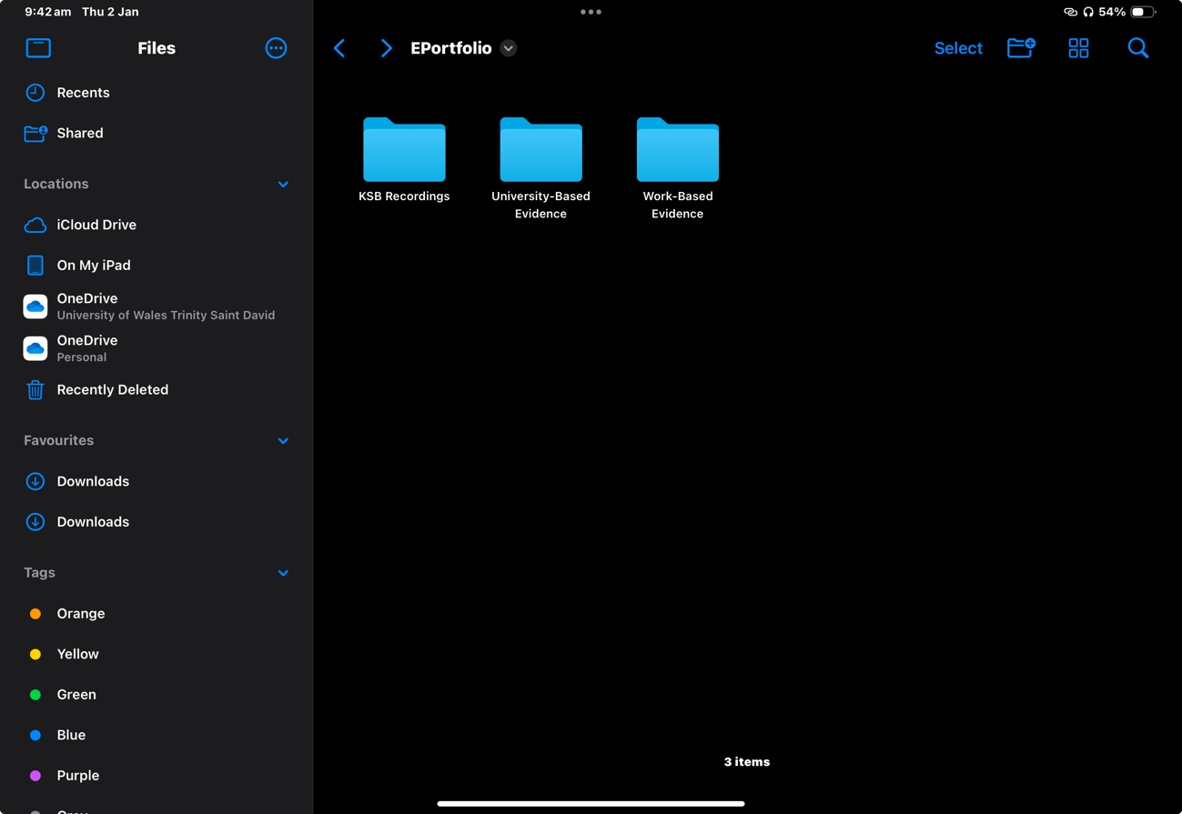
3.3 e-Portfolio –

Displayed above is the way I am separating my e-Portfolio. I have broken it down into 3 separate folders; KSB Recordings, University-Based Evidence and Work-Based Evidence. this is so I have specific, relevant places to save my findings/evidence. I have used this method as, once completed I can then bring all the data together to create my final piece. The data can be easily found and referenced using this method.

3.4 Independent Study –
Torpex (also known as ‘torpedo explosive’) is a high explosive mixture consisting of RDX (Royal Demolition Explosive), TNT (trinitrotoluene) and aluminium, used for depth charges underwater [1]. Meaning it is an explosive used in underwater explosives, for example, torpedoes. The explosive was primarily used in World War 2 against German U-Boats. Holston Ordnance Works began production of the explosive in May 1943 which would provide 90% of the explosives used by American forces and 10% of the British[2]. This allowed the allies to successful destroy and immobilise German U-Boats. Furthermore, under the Pacific, torpex warheads were able to deliver an explosive force 150% greater than TNT alone, this stopped Japanese shipping during the Pacific War. The American Mark 14 was the primary example of torpex used during the Pacific War. It was used from December 1941 to November 1943 despite it having many technical problems that took two years to fix [3].

[1]Merriam-Webster (2025, Jan. 02.) ‘Torpex’ [Online]. Available: https://www.merriam-webster.com/dictionary/torpex
[2] F. Blazich, “The Secret History of RDX: The Super-Explosive that Helped Win World War II” Journal of Advanced Military Studies, Volume 12, Number 1, page 242, 2021.
[3] E. W. Jolie. (1978, Sept. 15.) ‘A Brief History of U.S. Navy Torpedo Development’ [Online]. Available: https://www.maritime.org/doc/jolie/index.php

Section 4 –

4.1Conclusion and Evaluation -
After looking over section 1, there is much to learn when it comes to presenting, whether its showing understanding and practise or the way you hold yourself. Many aspects can be improved all the time, making an art that can always be changed and adapted.
My assumptions of myself in section 2 were very much correct. It shows you can find out much more about yourself through personality tests/evaluations. For example,I am much more extroverted than I thought, this makes me more self-assured and confident in my character.
Section 3 shows that not all tasks can be done off the top of your head, certain assignments and exams require preparation and planning to achieve the best you possibly can. The use of Google Scholar can assist you greatly when finding sources to reinforce your point and grants you access to the original literature.
The use of the skills learnt in this Study Skills module are applicable in opens personal and professional life. It improves conversation and presentation, time-management and planning in all aspects, it teaches how to reference without plagiarising so the appropriate people get the appropriate credit. The knowledge this course provides can be used in any situation to better the outcome.
This course has allowed me to recognise flaws in my presenting skills which will be a main focus of mine over the coming years. Furthermore, researching Torpex has sparked interest in me about the use of secondary explosives in my workplace, this has encouraged me to ask more questions with the assets I am handling on a day-to-day basis.

