The Head and Heart

People change because they are shown a truth that influences their feelings, not because they were given endless amounts of logical data. When changing behavior, both thinking and feeling are essential. Highly successful organizations know how to overcome antibodies that reject anything new. But first, a process of change must happen that uses both the head & the heart.
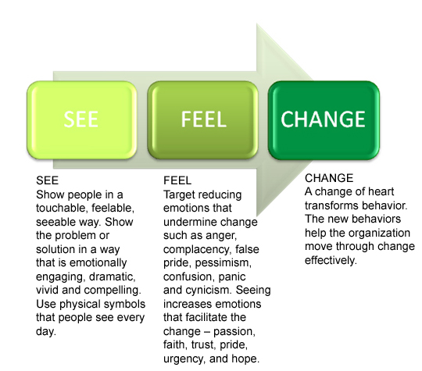
Thinking vs. Feeling
To change successfully, people need to be able to both think and feel positively about what they need to do. Without addressing both sides, change is less likely to occur.
THINKING differently can help change behaviour and lead to better results.
• Collect data, analyze it.
• Present the information logically to change people’s thinking.
• Changed thinking, in turn, can change behavior.
FEELING differently can change behavior MORE and lead to even better results.
• Create surprising, compelling, and, if possible, visual experiences.
• The experiences change how people feel about a situation.
• A change in feelings can lead to significant change in behavior.
Checklist for Speaking to both the Head & Heart



