Student Name | Mazhar Abbas
Student Id | 2542523
Campus | University of Wales Trinity Saint David
Scenario | River Fitness
Date | 22nd of July 2026

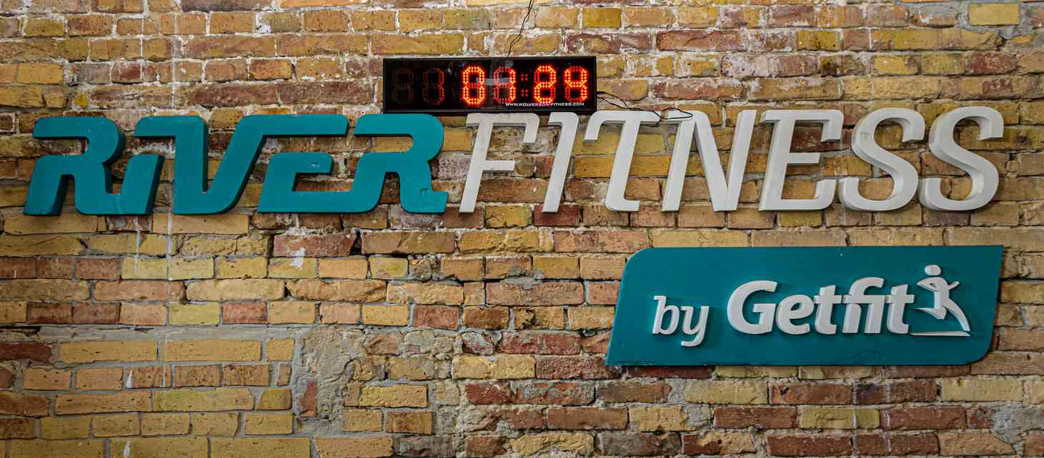

River Fitness Customer Feedback Summary
Introduction
River Fitness carried out a customer survey to find out how satisfied members were with the gym services. The manager wanted the results to be presented in a simple digital format that could be understood quickly. I decided to use Microsoft Excel because it is a good application for organising information and creating charts. Excel allowed me to display the survey results clearly in both a table and a bar chart. This report explains how I created the artefact, the changes I made, the feedback I received and why Excel was the best choice for this task.

Customer Feedback Data
Customer Response | Number of Customers
Satisfied | 46
Neutral | 18
Not Satisfied | 11
Total | 75

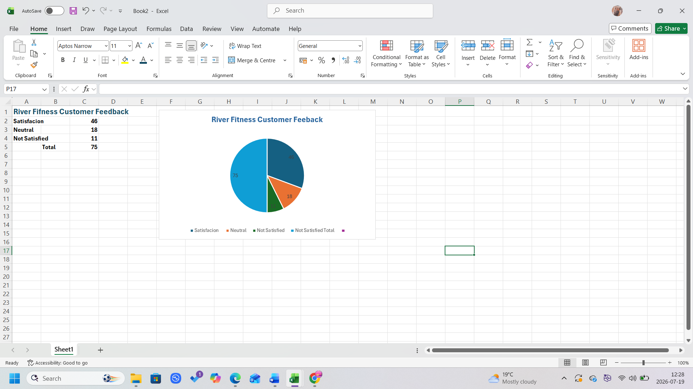

Blog and Artefact of River Fitness
- Why I chose my tool
For this task, I selected Microsoft Excel because it is designed to work with numbers and tables. The customer survey contained numerical information, so Excel was the most suitable application. It allowed me to enter the data into rows and columns and then quickly create a bar chart from the same information. Another reason I chose Excel is that it is commonly used in businesses to present reports and statistics. Managers often need information that is easy to understand without reading long documents. A chart helps people compare results much faster than looking only at numbers. I also looked at the Microsoft support website to learn how to create and edit charts(Microsoft, n.d.). This helped me make the chart clearer and more professional.

- What information do I use
The information I used came directly from the customer feedback survey provided by the River Fitness manager. There were three response categories.

- Satisfied – 46 responses
- Neutral – 18 responses
- Not Satisfied – 11 responses
I understood the information exactly as it was given in the scenario. After entering the figures, I checked them carefully to make sure there were no typing mistakes. Using accurate data is important because managers use reports like this to help make decisions.
- How I created my artefact
I began by opening a new worksheet in Microsoft Excel. First, I typed the survey categories into one column and the response numbers into the next column. After entering all the information, I formatted the table by making the headings bold and adjusting the column widths. Next, I highlighted the data and inserted a bar chart using the insert menu. I selected a simple design because it makes the results easy to compare. I also added a title called River Fitness customer feedback results, so anyone reading the chart would understand what it shows. Finally, I checked the worksheet to make sure the chart matched the data in the table that everything was easy to read.

- What changes did I make
While creating the artefact, I made a few improvements to make it look better. At first, the worksheet looked very plain, so I changed the heading style by using bold text. I also increased the font size so information could be read more easily.
The first chart I created did not stand out very well, so I changed the colours and resized it. I also made the chart title larger and clearer. These changes improved the appearance of the final artefact and made the information easier to understand.

- Feedback I used
Before finishing my work, I asked for feedback.
My tutor suggested making the Excel table data more noticeable and adding the screenshot of the table and chart into word documents. A classmate suggested using a better chart title and making the labels easier to read and colourful (University of Wales Trinity Saint David, 2026).
I used this feedback to improve my work by increasing the font size, using bold heading and adding a screenshot of the table and chart into the assignment document.
This feedback helped me make the final artefact look more professional.

- Final Explanation
The completed artefact provides a clear summary of customer opinions about the River Fitness. The table shows the exact number of responses, while the bar chart allows the manager to compare customer satisfaction quickly.

The survey shows that most of the customers were satisfied with the gym because this category received the highest number of responses. However, there were also neutral and not satisfied responses, which could help the manager identify areas that need improvement. Using Microsoft Excel made the information organised, accurate and easy to understand (Microsoft, n.d.). This task has also improved my confidence in creating tables and charts for business reports.
References!
Microsoft. (n.d.) Available chart types in Office. Microsoft Support. Available at: Microsoft Support – Available chart types in Office (Accessed: 19 July 2026).
Microsoft. (n.d.) Select data for a chart. Microsoft Support. Available at: Microsoft Support – Select data for a chart (Accessed: 19 July 2026).
University of Wales Trinity Saint David (2026) Digital Skills 2 Assessment Brief: River Fitness Scenarios. Unpublished course material.

