The Severn Bridges report
Skills for professional practice
Swansea university

Figure 1 Photo of severn bridge (www.aol.com)


Figure 2 Photo of Old Severn bridge (https://beautiful-bridges-2013.blogspot.com/)
Introduction
The Severn bridge was originally known as the Second Severn Crossing which opened on June 5th,1996. It was then renamed to the Prince of Wales bridge in 2018 to honour Prince Charles. it is a cable-stayed bridge which connects South Wales with the West of England. It was introduced in 1996 to deal with the traffic as its estimated that 20,000 vehicles cross the bridge every day.
The main significance of the Severn bridge is to alleviate the traffic congestion on the older Severn bridge therefore it improves travel and trade between the two countries. The purpose of this report is to present information regarding the two bridges.
“The bridge is significant for its engineering design, boosting economic growth, and supporting industries such as logistics and tourism. It also symbolizes regional cooperation and cultural ties between England and Wales, particularly through its renaming to honour Prince Charles. Additionally, it serves as a long-term investment in sustainable transport infrastructure.” (OpenAI, 2024).
Location:
Bridge Access Rd, Aust BS35 4BL.
The Original Severn bridge which was built in 1966, at the time of completion it was the longest suspension bridge in the world. It is about 1.25 miles long.
The Prince of Wales bridge extends the M4 motorway from Wales to England. It has a total length of about 2.8 miles
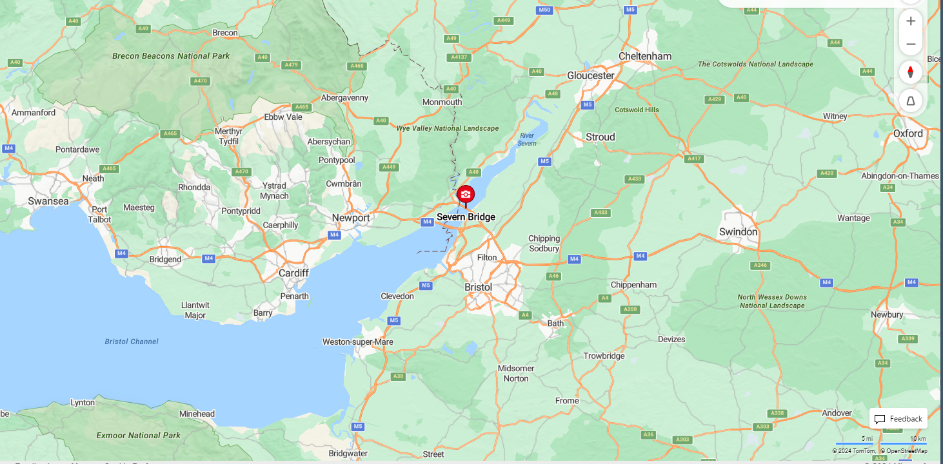

Type:
The Original bridge (1966) was a suspension bridge and the Prince of Wales bridge is a cable stayed suspension bridge.
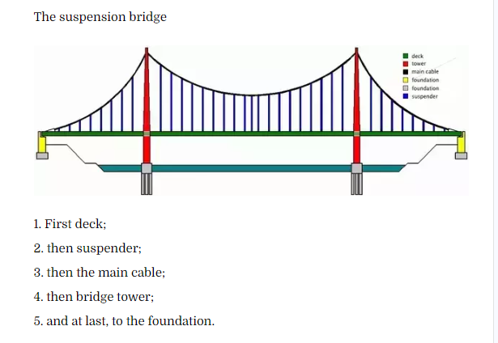
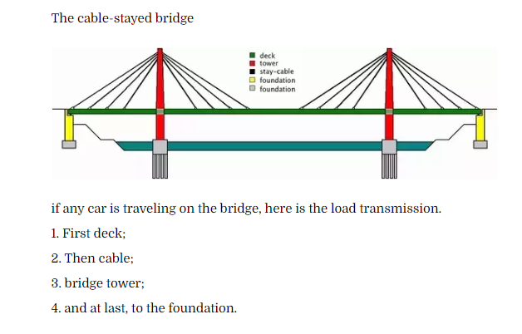
Figure 3 The suspension bridge (https://theconstructor.org/)
Figure 4 Cable-stayed bridge (https://theconstructor.org/)
“Cable stayed bridges may look similar to suspension bridges. They both have roadways that hang from cables and both have towers. But the two bridges support the load of the roadways in very different ways. The difference lies in how the cables are connected to the towers . In suspension bridges, the cable ride freely across the towers, transmitting the load to the anchorages at either end. In cable stayed bridges, the cables are attached to the towers, which alone bear the load.
The cable can be attached to the roadway in a variety of ways. In a radial pattern cables extend from several points on the road to a single point at the top of the tower. In a parallel pattern, cables are attached at different heights along tower running parallel to one another”. ( theconstructor.org) (nikeetasharma , 2020) What is key differences between cable stayed and cable suspension bridge? – theconstructor.org

Key Stakeholders:
Owner:
The original Severn bridge was owned by the Severn bridge company which was private concession where they we allowed to make a profit off the public with the use of tolls which carried on for decades.
The Prince of Wales bridge is currently owned by the UK government. It was also a toll road before 2018 when it was owned by a private consortium under the Severn River Crossing concession.
Architects:
In the original Severn bridge the architect and engineer who designed the bridge and also designed the Severn bridge was Sir Owen Williams he is a renowned British civil engineer.
The Prince of Wales bridge architect was a joint project between the architectural teams from WSP Group and Ffreyssinet. Which are both French engineering companies that specialise in the construction of bridges.

Engineers:
A company called John Laing Ltd was responsible for building the original Severn bridge.
The architects WSP and Ffreyssinet were also involved in engineering the Prince of Wales bridge. Ffreyssinet are experts on cable-stayed technology therefore making them a great asset and contractor contributing the construction of the Prince of Wales bridge.
Contractors:
John Laing Ltd were the main contractor for the original Severn bridge project, John Laing Ltd at the time was one of the biggest construction companies in the UK.
To construct the Prince of Wales bridge a joint venture between the companies Kvaerner (Norwegian engineering company) and Balfour Beatty (which in terms of turnover it is the biggest construction companies in the UK)
Engineering aspects
Original Severn bridge
- Suspension bridge with steel cables
- Concrete towers to support a steel- reinforced concrete deck
The Prince of Wales bridge
- Cable stayed design
- Single central tower
- Fan shaped cables supporting a composite deck made of steel and concrete
Cable stayed uses less steel and concrete than the suspension system used in the older Severn bridge therefore making the cable stayed a lot more material-effective and cost-effective.
Innovative Design Elements
The Severn bridge towers are one of the tallest towers on a bridge at the time of construction at 137 metres. They were designed to withstand high winds and strong tidal forces due to it being over the river Severn, the river Severn has a tidal range of up to 15 metres. A lot of design and engineering went into the construction of these towers due to the environmental challenges.

Construction timeline.
The original Severn bridge
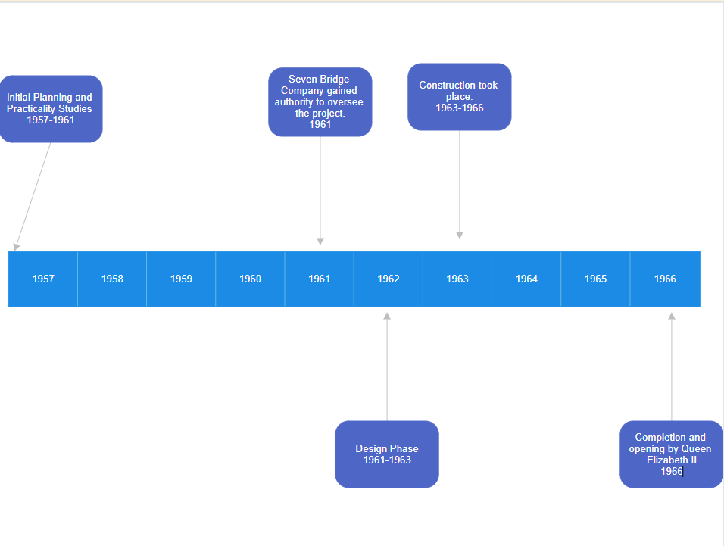
The Prince of Wales bridge (new bridge)
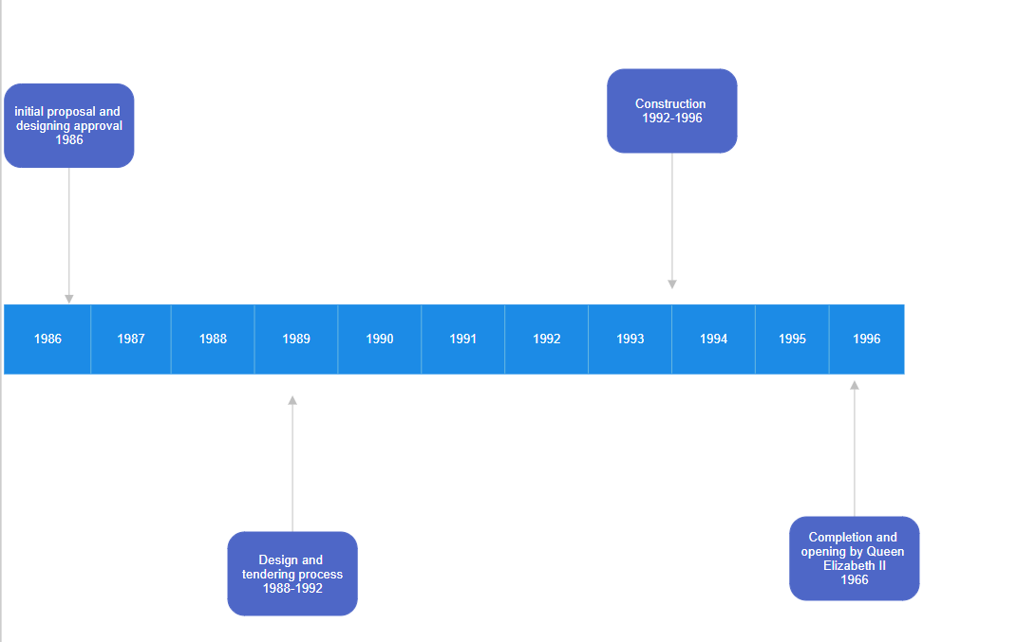
Discuss the construction methods and techniques employed
The original Severn bridge used older methods of construction methods such as the catenary cables, caisson foundations, and a suspended deck. Where as the Prince of Wales bridge used more modern and simple methods such as a cable-stayed design, with fan-shaped cables, steel-reinforced concrete towers, and composite decking. As the Prince of Wales bridge consisted of simpler methods of construction it made the process more efficient therefore making the job more cost-effective than the old more complex Severn bridge.
Identify any significant challenges during construction
- Limited working hours due to high tides prolonging the construction of the bridge
- Harsh environmental conditions
- Foundation construction made very difficult due to the soft riverbed
- Very high winds which sometimes interfered with crane operations
Summary
This report has highlighted the key challenges and innovative engineering solutions that were used in order to complete the construction of both bridges.
In conclusion, over the past 30 years both bridges are vital infrastructures used to commute from Wales to England or England to Wales. It also demonstrates how far construction technology has improved over 30 years, such as using different materials and less of them and making a more cost-effective system whilst still keeping the strength and integrity of the bridge.

Referencing
The constructor, (19/7/2020) The Severn Bridge (Online) Available at:
What is key differences between cable stayed and cable suspension bridge? – theconstructor.org
[Accessed 09/12/2024]

Chatgpt, (09/12/2024) The Severn Bridge (Online) Available at:
ChatGPT
[Accessed 09/12/2024]

