Structural and Fluid Analysis ACMA6010
Designing a tanker propeller: Fluid flow assessment

James Thomas – 2010180

Contents
Abstract 3
Reynolds Number 4
Boundary flow and separation 5
Propeller development 8
Modelling 10
Validation 13
Works Cited 15

Abstract

A discussion into the influence of Reynolds number regarding fluid flow around propeller blades. Taking into consideration numerical methods, practical testing and modeling techniques used to anticipate boundary flow and separation at varying points along each blade section. Focusing on modelling techniques such as computational fluid analysis (CFD), large-eddy simulation (LES) and cavitation effecting fluid flow caused by the geometry of propeller blades in varying materials (MAB,NAB,CFRP) and designs.

Reynolds Number

When considering the design of a structure, fluid flow must be considered to determine its performance. Fluids are substances, both gases and liquids, that when in contact with a solid body or structure, deform and this will affect its flow around the object [1]. The fluid can have laminar or turbulent flow around a structure. Laminar flow is streamline when liquids or gases flow in laminations. Turbulent flow is unstable, this can happen in pipelines when the velocity of a fluid is increased and can be seen clearly with the inclusion of dyes [2]. As engineers, to improve performance a laminar flow would be more efficient, as less energy is lost. To understand whether a flow is laminar or turbulent we use Reynolds number.

The Reynolds number is a dimensionless ratio of internal forces to viscous forces in a fluid. This is defined by the relationship of; density of the fluid x the velocity x reference length and divided by dynamic viscosity known as the Reynolds number: Re = $\frac{ρVL}{μ}$ and is specifically important when analyzing the boundary layers [3]. Dependent on its application, low values of the Reynolds number (Re <2100) flow is considered to be laminar. At high values flow is turbulent (Re >4000). The Reynolds number which determines laminar or turbulent flow will vary dependent on its application for example, flow around a sphere or flow inside a pipe.

For the performance of propeller blades, the design should produce propulsion to move the ship through water. Therefore, we should consider the blade pitch ratio, chord length and inflow velocity of the fluid as well as the kinematic viscosity of the fluid (kinematic viscosity = dynamic viscosity of the fluid/ density of the fluid). This is important to determine the boundary layer flows and whether they are laminar or turbulent [4]. The Reynolds number is crucial to the design stage, it allows us to determine the flow on a much smaller scale, we can then predict the behavior and properties on the larger full-scale prototype based on the tests. Using the drag coefficient of the propeller blade at 0.7 – 0.75 of the radii, performance prediction methods such as the ITTC use these scale models and then correct torque coefficients to the full-scale model [5].

The inflow velocity of the fluid is assumed to be the correlation of rotation of propeller blade in RPM. For a slow steaming ship this can be considered anything from 80-130 RPM. In this instance I will assume 80RPM. To convert to angular velocity, using the radius of the propeller at 70% of the chord length when considering scaling effects. There for my inflow velocity of the fluid is equal to $\frac{2xπx\left(2.979x.7\right)}{60}x80=17.46m/s$

Assuming the application of ship propeller, density of sea water at 5 degrees Celsius is 1028 kg/m³ and a dynamic viscosity of 0.00161 Pa s (pascal-second) and considering the design of the propeller blade and its length where fluid flow will affected at 3.035 metres on specified geometry, I calculate Reynolds number for the blade to be $Re=\frac{1028x17.46x3.035}{1.61x10-3}=33.8353x10^6$ This would suggest a turbulent flow around the propeller blade.

As well as the ITTC scale models, RANS (Reynolds average Navier stokes) solvers are used to accurately predict, what appears to be fully turbulent flow caused by scale effects and to identify the flow transitions from laminar to turbulent [6].

Boundary flow and separation

To improve efficiency of the propeller blade, laminar flow is desired. This will reduce frictional losses and delay the separation by reducing the pressure gradient. As the pressure gradient increases, separation will occur, and the flow will become turbulent [7]. The flow around the propeller blade appears to have a significantly large value for its Reynolds number and this is likely to the model scaling. However, this indicates that its likely that laminar, transition and turbulent flow all occur simultaneously at the boundary layer. The geometry of the propeller blade causes the boundary flows to behave in this way.

Boundary layers on the blade back or suction side of a propeller blade Is the region of high loading, which occurs at the tip of the blade. Whereas, at the leading edge short laminar separation bubble exists, causing the boundary layer to behave in a turbulent manor over the remaining section of chord. The separation occurs in the region of the upper part of the blade where flow becomes turbulent from the laminar region. The position at when this occurs is strongly dependent on the propeller loading. The middle of the blade section where flow turns from laminar to turbulent is known as the transition region. The Reynolds number will dictate this area of transition, predominantly is located at some distance from the leading edge. Laminar separation occurs at mid chord (lower region) due to the very low sectional Reynolds number at those radii in combination with thick propeller sections. The shape of the propeller sections, the propeller loading, and the propeller Reynolds number can all influence the regions in which the flow changes within these boundary layers.

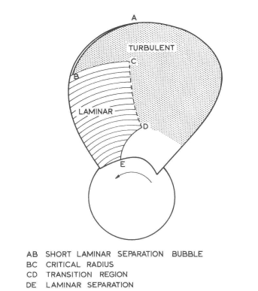
Figure 1: representation of the boundary layer regime on the suction side of propeller [8]

Boundary layers on the blade front or pressure side of a propeller blade is generally less complex. In normal operating conditions no laminar separation occurs on the pressure side and a significant laminar region exists near the leading edge. The blade back, known as the suction side is where transition often occurs more gradually due to a favorable pressure gradient [8].

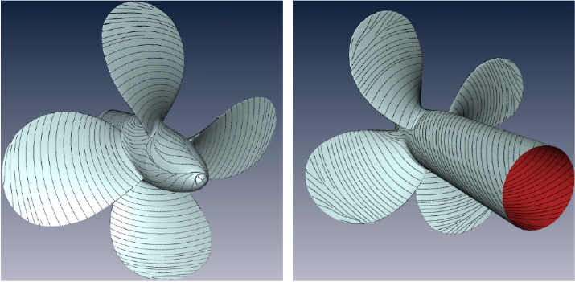
Figure 2: Left: Pressure side, right: Suction side. Flow separation can be observed at the tip of the blades at the suction side [9]

The propeller is designed in this way with a large diameter to create the most efficient propulsion. The pitch in each blade section creates the thrust for the forward momentum of the ship. As the ship moves through the fluid, the friction of the ships hull and fluid creates a boundary layer, where the velocity of the fluid is equal to that of the ships hull. The further the fluid moves from the front of the ship the boundary layer increases. This means that the pressure is lower towards the rear the ship in comparison to the front which results in the viscous pressure resistance. There for the propeller will be working in a wake field which is turbulent in flow [10]. Fluid flow around ships results in increased frictional forces and higher skin friction component of drag, compared to laminar flows. At the same time, the boundary layer separation is delayed in turbulent flows as the separation point moves further downstream [11].

The profile of marine propeller blades is critical as it will directly affect how the flow is produced in each rotational movement. The efficiency of the propeller relies on this principle to reduce vibration and erosion caused by cavitation [12]. Cavitation can be caused by the turbulent inflow of the fluid that is apparent in the wake field. Each blade section has a pitch and skew which has been designed to suite the average wake at each radius. We know the flow is turbulent in this region and the shape of the blade is chosen to minimize cavitation and improve efficiency by reducing the resistance which is onset by the viscosity of the fluid. [12].

Propeller development

Historically, the majority of marine propeller are manufactured using metallic alloys which are subject to turbulent flows, high loading, cavitation, and vibration as they operate in the ships wake field. There for the choice of a metallic alloy to withstand the long-term stress and fatigue would seem obvious. However, due to this environment, some drawbacks of the metallic alloys are corrosions, when the cavitation causes formation of galvanic cell formation [13]. A case study conducted by (Balasubramanian, R.) suggest that the performance of Manganese bronze in aggressive conditions are far from satisfactory, even more so in marine propellers. It is well knowing that copper-zinc alloys are prone to corrosions in sea water and also problems arising with Manganese bronze had been discussed many years before and that alone is justification for new suitable alloys or materials in marine propellers [14].

In recent years the use of CFRP in marine propeller has become a popular choice over the predecessor of metallic structures such as Nickel-aluminum bronze or Manganese-aluminum-bronze. The rigidity of metallic propellers allows for separation of the hydrodynamic and structural analysis. Therefor the use of CFRP can take advantage of the Fluid-structure interactions [15].

CFRP propellers can improve cavitation performance which we have discussed earlier, this has been shown to improve efficiency when compared to the metallic counterparts. The advantage of using CFRP is that they are lighter and corrosion resistance. Also, the deformation of the CFRP propeller can be controlled to improve the performance in varying flows (laminar and turbulent) as well as the pressure differences on the suction and pressure sides of the blades, hence the exploiting fluid-structure interactions [16]. This is not true when using metallic propeller blades such as NAB and MAB due to the rigidity of the materials.

Historically, metallic marine propellers deflection is small enough that pre-deformed design is unnecessary. However, the deflection of composite propellers can be larger with certain stacking sequences and a pre-deformed design may help to solve the optimization problem encountered with the varying flows (fig.3) [16].

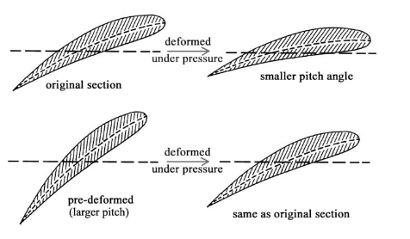

Figure 3: pre deformed propeller [16]

However, there are difficulty’s when comparing the CFRP propeller with its metallic predecessor. Fluid performance is dictated by the geometry of the propeller, so the metallic blades only consider the ratio of advanced speed. Whereas the CFRP depends on the magnitude and the ratio, which is dictated by varying flows caused change in vessel speed and fluid viscosity in operating environment.

Even though the performance of the CFRP marine propeller is promising, more thorough understandings of the mechanical properties in these environments is required in relation to the fatigue performance in harsh weather. The voids in poorly bonded fibers can allow for the water molecules to diffuse into the CFRP material, and it is known that the CFRP plays a role in water absorption. Two important aspects that need investigation are the effect of absorption of moisture in marine condition and the fatigue behaviour [13]. In short CFRP propeller can improve the hydrodynamic efficiency and reduce acoustic emissions caused by cavitation. The damping ratio of CFRP materials is said to be four times larger than metallic alloys such as NAB. The cavitation erosion of metallic alloys is much greater than those made from CFRP [17].

When manufacturing marine propellers, a desired accuracy must be chosen by the customer such as states in ISO 484/1 – 1981 (CE), this tolerance must be adhered to when we consider the harsh environments operated in [10]. Complying with ISO 19030 It is critical to measure the performance change in a ship. The standard focuses on hull and propeller performance, to illustrate the power required to move the ship through the water [18]. “The general principles outlined, and performance indicators defined are applicable to all ship types driven by conventional fixed pitch propellers, where the objective is to compare the hull and propeller performance of the same ship to itself over time.” [19].

Modelling

The development of a new propeller would require modelling techniques to understand how the fluid flow deforms around the solid body. A current method is to use computational fluid analysis (CFD) to analyse the hydrodynamics around ship and propeller components and predict resistance, drag, lift and cavitation. A 3D model is primarily created using CAD and the model then used in the CFD software. It can be very costly and time consuming to build full scale models, so scaling methods are used in CFD models to analyse fluid flow. Laminar and turbulent flows can be simulated accurately. However, the transition between flows can sometime prove more difficult because in that region the flow can fluctuate between laminar and turbulent and turbulent slugs can frequently appear in laminar flow far below the critical Reynolds number for transition to turbulent flow. From CFD modelling it is useful to separate possible flows into the following: laminar-turbulent, steady-transient, single-phase – multiphase. When considering turbulent flows, the economical method is to resolve only the large-scale turbulence, by filtering out the fine-scale turbulence, and model these small scales as flow-dependent effective viscosity. Becoming more popular is the large-eddy simulation (LES). This method makes it possible to simulate simple engineering flows on a fast PC. However, this can take a considerable amount of time dependent on the grid meshing mesh and boundary conditions (known boundaries for a problem) selected in the program.
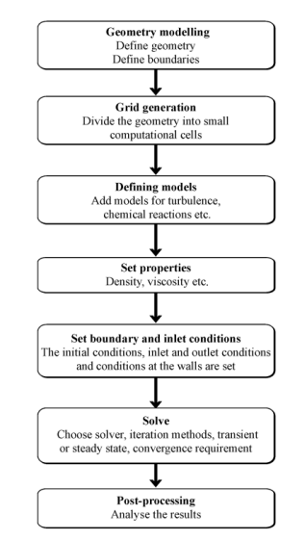
Figure 4: steps in CFD simulations [20]

CFD allows engineers to perform numerical experiments using computer simulations by gathering the relevant data, set boundary conditions and mesh, then perform numerical solution of the equations, so that we can carry out analyses of results. This can predict the flow under varying conditions by using such numerical methods as the RANS equations (Reynolds-averaged Navier–Stokes equations) [11].

For the development of the viscosity fluid dynamic method, more researchers have been focusing on predicting propeller hydrodynamics by CFD, where the interest lays in hydrodynamic performance of propellers, pressure distribution on the blade surface, generation of the tip vortex, and working less with the detailed spatial evolution process of a propeller wake [21]. This modelling technique is growing more popular as engineers try to predict fluid flow around an object, with the ability to analyse and solve complex equations with high speed and accuracy. It allows us to create designs and analyse the flow before going into production, we can change structures to improve efficiency and then run the CFD software to re analyse the results again and again until satisfied. One drawback is the simulations require a high degree of computational power, this can be time consuming for one simulation to complete, which depends on your grid mesh and boundary conditions. This can take weeks to achieve good statistical averages even for rather simple flows, so its likely supercomputers would be used in this case [20].

Given the geometry of the propeller blade it is likely that a finer mesh will be needed as the shape is not simplistic in design. Therefor the elements next to these boundaries will be finer and so on and so forth. The grid mesh quality will have a direct influence on the accuracy achieved in the simulation, and it has been known for hybrid mesh approach to be used [21]. Considering that each element has 5 Navier stokes equations and on average each simulation has 60 million elements, the experience of the user is critical and understands the software to identify true or inaccurate results based on the inputs. CFD can sometime be a tradeoff between the level of accuracy and how quickly you desired to obtain the results.

“The numerical predictions performed at model scale are more challenging than those at full scale due to the possible simultaneous cohabitation of laminar and turbulent flow regimes and to the subsequent difficulty in the accurate prediction of the transition to the turbulence in the computations. Since the flow separation may be present at model scale, but it may be absent at full scale, one may raise a question whether the extrapolation of the solution from the model to the full scale may be a reliable procedure or not” [22].

Validation

Validation of simulation CFD with a small-scale porotype can be done using open water tests. Practical tests will be carried out following ITTC – recommended procedures and guide lines – Open Water Test, which only considers model scale propeller [23]. This will give an accurate representation whether the computational predictions will reflect in the results observed in both testing regimes at a scale level. Methods of practical testing such as towing tank and cavitation tunnels are used to understand the efficiency of the propeller and then collate back to the simulation. This will allow to change the design structure using CAD and carry out the simulation again using CFD to improve efficiency of the propeller, only when we have verified the results of both previously can we be assured that the CFD simulation is representative to reality.

Experimental design of the cavitation tunnel is to validate numerical results and the optimal performance of the propeller, in this case the CFRP prototype, known to improve performance through deformation. Using an aluminium mould to create the prototype and using recorded values of the material properties to study its deflection and fluid flow around each blade. This is done by taking superimposed photography to study the deflection between pixels and measuring this can be quite difficult without this method [16].

Known velocity of the fluid flow and cavitation number are set before the test, this would be replicated by boundary conditions in the CFD simulation. The test is carried out at varying RPM of the propeller until cavitation is present on both faces of the propeller. This method depends on visual inspection, of the super imposed photography, so development into detection system are recently being used to improve accuracy, rather than on the visual capacity of the tester [24].

Prior to propeller cavitation analysis, CFD simulations were carried out to select a cavitation model for highly precise cavitation analysis of fluid flow. Now CFD simulations can be compared to the model test results for marine propeller cavitation, and improvements on grid meshing techniques can accurately estimate cavitation transitions [25].

Data acquisition on reduced drag, cavitation, turbulent and laminar flows will all be recorded from the cavitation tunnel and collated back to the results from the CFD simulations. To ensure accuracy a two point validation would be carried out by experts in CFD to prove results compared to practical testing.

Once satisfied that CFD analysis is accurate by both parties, produce further designs based on original prototype to see how the performance can be improved even further using CFD modelling. Studying the pressure distributions on the suction side and pressure side to understand the effects performance and reduce cavitation, use CAD software to re design and follow CFD modelling and run further simulations to analyse the results.

Only when validation collates between both numerical and practical testing would the prototype be manufactured, as scale models can only be used in open water tests. This needs to be robust and valid when using CFD simulation to compare with real data acquired from cavitation tunnel.

Works Cited

[1] | T. Al-Shemmeri, Engineering Fluid Mechanics, Ventus Publishing , 2012.
[2] | E. Shashi Menon, Transmission pipeline calculation and simulation manual, Gulf Professional Publishing, 2015.
[3] | S. Gudmundsson, General Aviation Aircraft Design, Butterworth-Heinemann, 2014.
[4] | H. Yao and H. Zhang, "A simple method for estimating transition locations on blade surface of model propellers to be used for calculating viscous force," International Journal of Naval Architecture and Ocean Engineering, vol. 10, no. 4, pp. 477-490, 2018.
[5] | J. Baltazar, D. Rijpkema and J. Falcão de Campos, "Prediction of the Propeller Performance at Different Reynolds Number Regimes with RANS," Journal of Marine Science and Engineering, vol. 9, no. 1, p. 1115, 2021.
[6] | S. B. Müller, M. Abdel-Maksoud and G. Hilbert, "Scale effects on propellers for large container vessels," First Internatioal Symposium on Marine Propulsors, 2009.
[7] | H. J. Heinke, K. Hellwig-Rieck and L. Lübke, "Influence of the Reynolds Number on the Open Water Characteristics," Potsdam Ship Model Basin, Germany, 2019.
[8] | G. Kuiper, Cavitation Inception on Ship Propeller Models (Ph.D. Thesis), Delft: Delft University of Technology, 1981.
[9] | O. Rosanwo, C. Petz, S. Prohaska, H. Hege and I. Hotz, "Dual streamline seeding," in IEEE Pacific Visualization Symposium PacificVis, Beijing, China, 2009.
[10] | W. Windeln, "Basic Principles of ship propulsion," MAN enegry solutions , Denmark , 2018.
[11] | A. Z. SARIM and B. PAUL, "PROPELLER MODELLING USING CFD TECHNIQUES. SIMULATION AND REPORT," Universitatii Maritime Constanta, Analele, 2013.
[12] | A. Mihaela, "Developments in the desgin of ship propeller," scientific bulletin of the politehnica universtiy of timisoara transactions on mechanics, pp. 131-138, 2005.
[13] | A. Kumar and L. Krishna, "Design and analysis of a carbon composite propeller for podded propulsion," in 4th International conference on ocean engineering, Chennai, 2018.
[14] | R. Balasubramanyan, "A case history on the phenomenal corrosion," central institute of fishery technology, vol. 10, no. 1, pp. 21-23, 1973.
[15] | M. R. Motley and Y. L. Young, "Performance-based design and analysis of flexible composite propulsors," Journal of fluids and structures , vol. 27, no. 8, pp. 1310-1325, 2011.
[16] | C. C. Lin, Y. J. Lee and C. S. Hung, "Optimization and experiment of composite marine propellers," Composite structures , vol. 89, no. 1, pp. 206-2015, 2008.
[17] | T. Yamatogi, H. Murayama, K. Uzawa, T. Mishima and Y. Ishihara, " Study on Composite Material Marine Propellers," Journal of the JIME, vol. 46, no. 3, pp. 330-340, 2004.
[18] | C. Gonzalez, "Continuous Performance Monitoring – A Practical Approach to the ISO 19030 Standard," in ship performance , Bergnen, 2016.
[19] | ISO, "ISO 19030-1:2016 Ships and marine technology — Measurement of changes in hull and propeller performance — Part 1: General principles," 01 November 2016. [Online]. Available: https://www.iso.org/standard/63774.html. [Accessed 31 May 2022].
[20] | B. Andersson, R. Andersson, L. Håkansson, M. Mortensen, R. Sudiyo and B. Van Wachem, "Introduction. In Computational Fluid Dynamics for Engineers," in Computational fluid dynamics for engineers, cambridge, Cambridge University Press, 2011, pp. 1-7.
[21] | M. He, C. Wang and X. H. S. Chang, "Analysis of a Propeller Wake Flow Field," in College of Shipbuilding Engineering, Harbin Engineering University, Harbin, 2012.
[22] | A. LUNGU, "Scale Effects on a Tip Rake Propeller Working in Open Water," Journal of Marine Science and Engineering, vol. 7, no. 11, p. 404, 2019.
[23] | I. T. T. Conference, "Recommended Procedures and Guidelines - Open Water Test," in ITTC - recommended Procedures and Guidelines, Venice, 2014.
[24] | UKEssays, "Open Water Propeller Characteristics Testing Engineering Essay," 01 November 2018. [Online]. Available: https://www.ukessays.com/essays/engineering/open-water-propeller-characteristics-testing-engineering-essay.php?vref=1. [Accessed 02 June 2022].
[25] | I. LEE, S. PARK, W. SEOK and H. R. SHIN, "A Study on the Cavitation Model for the Cavitating Flow Analysis around the Marine Propeller," Mathematical Problems in Engineering, 2021.

