Student name: Anat Dranciuc-Georgescu
Student Id: 2125394
Module: Personnel Resourcing & Development (BMIH5005)
Lecturer name: Deborah Lloyd

Word Count: 1965
Careers at Hilton (2023)
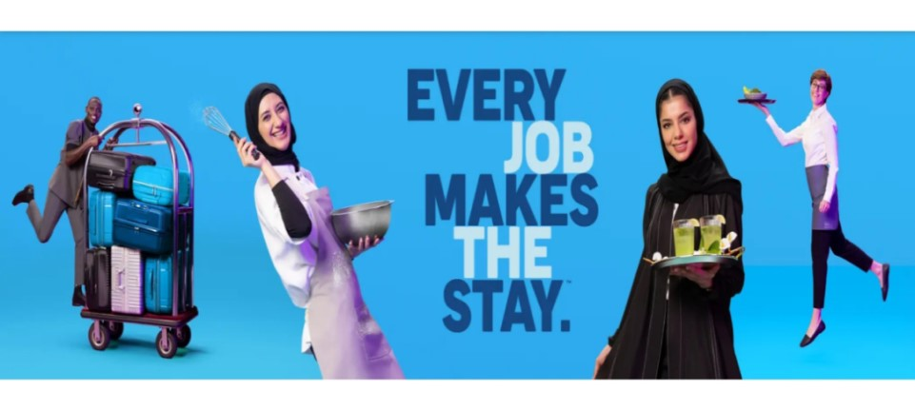

Is the external challenge a good or bad? Analyse the impacts of the external environment on employee recruitment and retention.

Executive Summary

This report will highlight the following subjects: Hilton London Hyde Park hotel, Hilton history, a brief glimpse into Hilton competitors, Pestel and Swot analyses, AI and technology break through within the hospitality industry.

Table of Contents
Is the external challenge a good or bad? Analyse the impacts of the external environment on employee recruitment and retention. 0
Executive Summary 1
Introduction and Background 2
Discussion/Literature 2
Evaluation and Conclusion 4
Reference List: 4

Introduction and Background
First Hilton hotel was built in 1925 in Texas USA by Conrad Hilton, from 1927 till 2013 Hilton brand has placed its mark in stock exchanges, multi hotel reservation system, appearing in Times Magazine for the first time, purchased of largest estate. Hilton had its first central reservation office called HILCON in 1955, was the first company to build a hotel after World War Two in Istanbul, in 1965 Hilton builds its first women hotel designed especially with amenities for women. 1970 Hilton became the first company to enter the NYSE-domestic gaming business as Las Vegas Hilton,1987 had its first official loyalty program named Hilton HHonors and in 1995 launched Hilton.com. In 2006 Hilton Corporation rebuys Hilton International reuniting the company under one brand and in 2013 Hilton returned to the stock market as HLT as stated by The Story of Hilton (2023).
As for the legal part of the business Zippia (2023) points out that in February 2016, Hilton would turn the company’s assets into a real estate investment trust, while being approved by the IRS, this was completed by January 2017. Since 2018 Hilton has been a fully independent publicly traded company.
Hilton Hotel and Resorts (2023) describes Hilton London Hyde Park as a well-positioned hotel in the heart of London, UK sitting opposite Hyde Park, a short walk from the Central line at Queensway Station. Kensington Palace, Paddington, and the Royal Albert Hall are all within a mile. Buckingham Palace, Trafalgar Square, and Big Ben are less than 30 minutes away via the underground with French cuisine at our restaurant, Aubaine, and drinks at the lobby bar.
It also includes the following aspects: Hilton Honors discount rates, points towards free nights, digital check-in, and digital key access, children under 18 that stay in the room with an adult stay for free, and children under de age of 12 years old receive a complimentary breakfast.
On another note, Hilton's main competitors so far are Marriot International and Intercontinental Hotels Group and Resources.
The following graphs explain Hilton’s current competitors roughly worldwide and its current Hilton USA salary.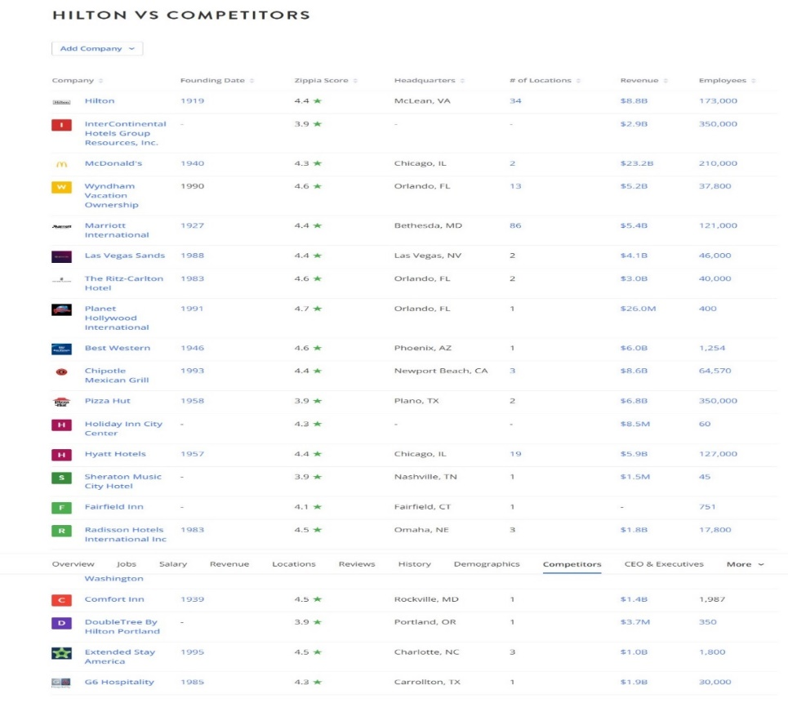(Zippia, 2023)
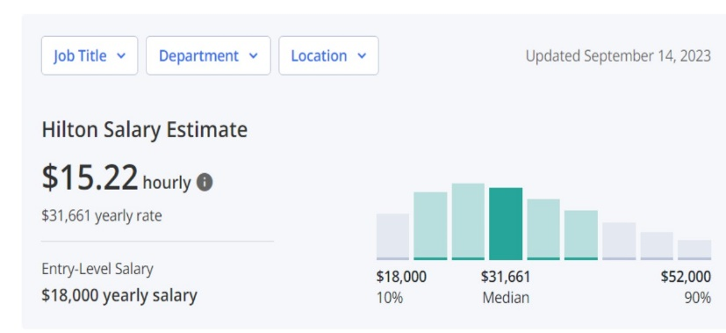(Zippia, 2023)
As for all Hilton assets and estates worldwide, Stories by Hilton (2023) suggests the following data: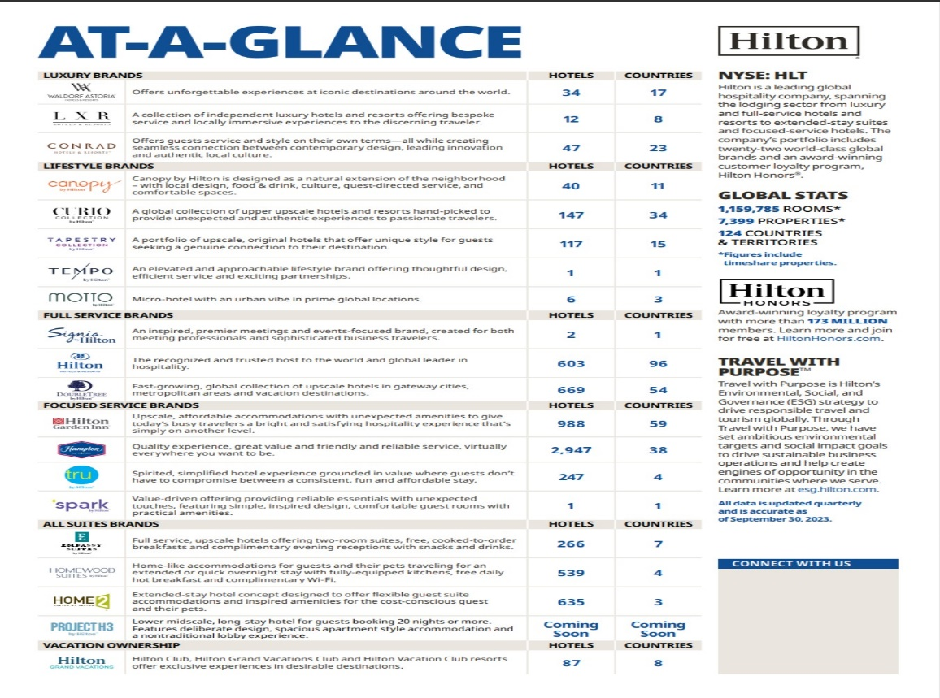(Stories by Hilton, 2023)

Discussion/Literature
Linda (2023) discusses the main purpose of PESTEL is that to analyse macro environmental elements that can directly affect a business. Companies that use this tool differentiate themselves from competitors and can boost their future operations.
As such this graph will show the main factors that affect Hilton company worldwide and local in these past years.

  - 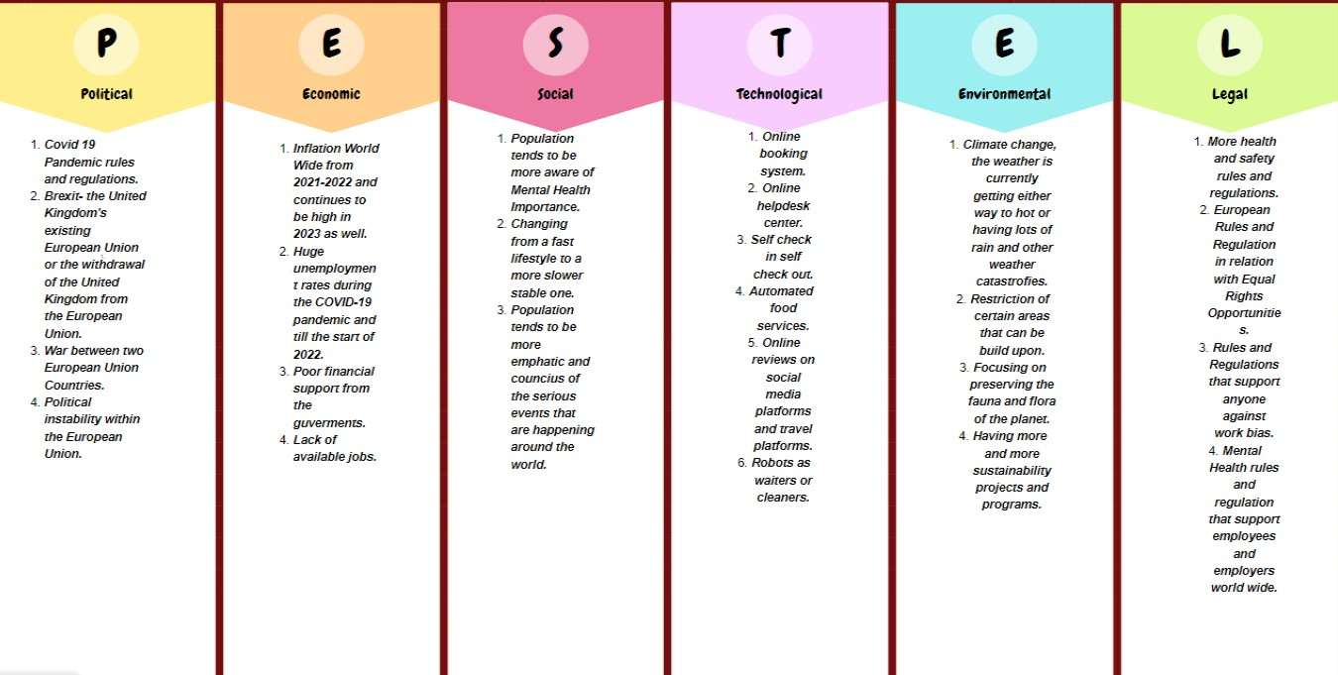 (Linda, 2023)
As shown in the graphs above, technology has a major impact into todays business and corporation are pushed by society to make changes in their industry faster then it is sometimes possible.
Johnson, Stone and Lukaszewski (2021) point out that the main reason why companies should make use of AI and E-recruiting and E-selection tools are due to hospitality being labour intensive and its very high rate of staff leaving the company or the industry or needing to be replaced. With these issues at hand embracing Ai and its tools to attract new employees and retain talented staff seems the best option.
AlMarwani (2020) discusses the idea that critical thinking is imperative for humanity’s future and sustainable development. Making reasonable judgments and finding reasonable solutions is the best practice one can do, knowing the skills necessary for this is as imperative such as interpretation, analysis, evaluation, and self-regulation.
After carefully analysing the external factors (Momin, 2022, Hauqe,2023 and Shaw, 2023) discuss the internal factors that affect the Hilton franchise as a company:
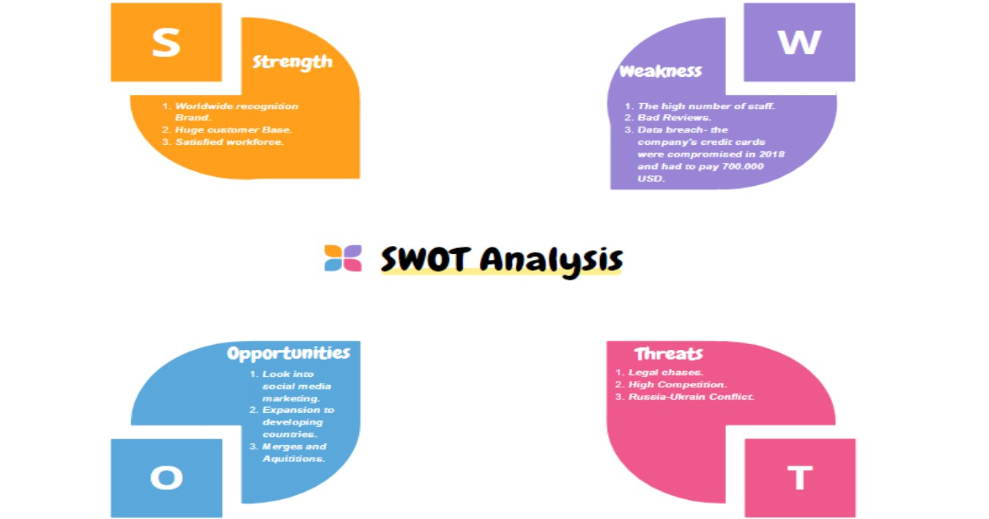
(Linda, 2023)
One of the main threats that can be found in hospitality industry and especially in Hilton corporation is high number of staff or the lack of talented staff.
Pinto (2023) discusses several situations in which HR needs to consider AI as the main tool in day-to-day activities:
- Pymetrics is an AI tool that uses neuroscience-based games that evaluate potential employee that are then matched with corresponding jobs that suit with the skills that they have. It can be used in interviews, training, and development.
- Dream Team is a platform that focuses on recruiting, it creates personalised HR dashboards based on the applicant's input.
- AI can manage employees' real-time performance so managers can send reviews back to their employees and this improves their morale and team communication.
- Chat GPT and chatbots are used as virtual HR help desks and can cover a multitude of employee enquiries.
The main idea is that AI is an inevitable step in the HR domain, having access to multiple data from potential employees to staff members that left the company, HR can keep track of everything and correct or improve its ways and the companies as well.
Ibrahim and Alrawadieh (2023) point out that the use of AI and robots can drastically impact the employment rates within the hospitality industry since robots and AI can and would be able to cover a wide variety of jobs within the industry and lack of unemployment could rise drastically within the next five to ten years.
On another note, Chaitali (p 17.18,2023) suggests that technological development has no bounds and so far, consumers are the ones driving businesses' technology standards. As such: drones, robots, augmented reality, virtual reality and blockchain should be used as learning tools and supports for innovation and not letting them ruin businesses.
As for the working-age population, the future is another probability, and it can only be guessed in graphs but with time change will happen.
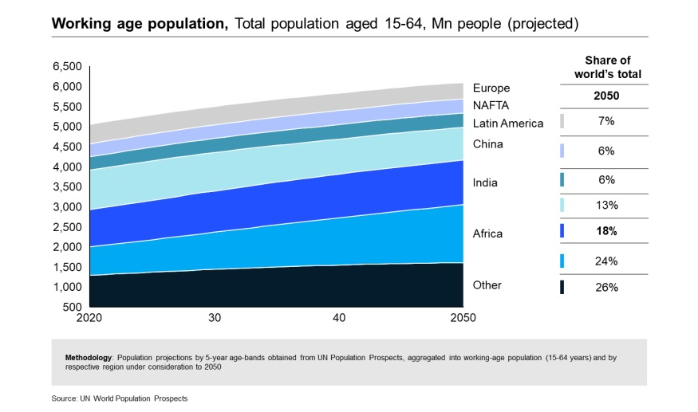(Chaitali,2023)
Vlad (pp. 182-194, 2015) point out that as a hospitality business managers should allow its employees the ability and independence to act on their own, as a result employees feel more empowered and in control at work and in life, dedication can be seen more frequent afterwards. Another point is that Hilton employees have the right to decide as a manager would. Since frontline employees are the first to have contact with customers, they have the most experience in such situations and they can solve problems much faster than running to a manager for solutions. If mistakes occur, they are analysed as a team and learned to be tackled in the future.
On the other hand, to break the bridge between guest expectations and employees and of course leaders, regular meetings, training and even role-playing should be provided. Giving employees the right to speak up and to solve different situations on their own builds confidence and teamwork collaboration more effectively.
As for the way Hilton recruits and retains its employees Sales Operation UK and Ireland (2022) point out that Hilton offers travelling perks at low rates and staying in the company for more than twenty years those perks remain for life, Hilton UK is the best in inclusive and diversity of minorities, and in 2021 was named top three in best places to work in the UK.

Evaluation and Conclusion

Mogelonsky L. Mogelonsky A. (2023) point out that considering automation as a consummate process, there are some ideas that follow such as:

-allowing for rich, centralized guest profiles for better analytics, personalized service and real-time connections with supplementary profit centres like restaurant, spa, golf, events and activities so that there’s less offline paper pushing by managers to reconcile all this previously disparate information.

-Advanced business intelligence platforms that can incorporate operational data points to give accurate predictive recommendations of what tasks are eating away at the teams’ time, where the labour savings are and which are likely to be the morale-eroding culprits.

-Omnichannel outbound messaging platforms can flow through a series of channels to reach guests on their preferred communication medium, all with the end goal of reducing the need for front desk agents to restate these.

-Machine learning chatbots to handle repetitive questions posed on the company’s website live chat, via text and on social media, with some systems even capable of handling reservations.

-Conversational AI that’s intelligent enough to accurately replicate a human voice for incoming calls to replace the IVR and, like chatbots, handle basic inquiries before passing the customer off to a live agent.

-Call centres to outsource companies' reservation and service calls as well as offering quality reporting to keep track of conversions and call abandonment, freeing up managers’ time in trying to source and supervise the company's agents while also redirecting calls away from the front desk so that those associates can focus on in-house guests.

-In-room tablets and mobile apps that act as a single point of control for service requests, hotel information, virtual concierge, and additional purchases.

-Payroll and accounts payable automation so that an executive isn’t needed to authorize every minor payment, thereby freeing up time and helping with supply chain management.

In conclusion Hilton London Hyde Park is a well-positioned hotel in the heart of London, UK sitting opposite Hyde Park, a short walk from the Central line at Queensway Station. Kensington Palace, Paddington, and the Royal Albert Hall are all within a mile. Buckingham Palace, Trafalgar Square, and Big Ben are less than 30 minutes away via the underground with French cuisine at our restaurant, Aubaine, and drinks at the lobby bar.
Technology has a major impact on today's business and corporations are pushed by society to make changes in their industry faster than it is sometimes possible.
The main reason why companies should make use of AI and E-recruiting and E-selection tools is due to hospitality being labour intensive and its very high rate of staff leaving the company or the industry or needing to be replaced. With these issues at hand embracing AI and its tools to attract new employees and retain talented staff seems the best option.
technological development has no bounds and so far, consumers are the ones driving businesses' technology standards. As such: drones, robots, augmented reality, virtual reality and blockchain should be used as learning tools and supports for innovation and not letting them ruin businesses.
In a hospitality business managers should allow their employees the ability and independence to act on their own, as a result, employees feel more empowered and in control at work and in life, and dedication can be seen more frequently afterwards. Another point is that Hilton employees have the right to decide as a manager would. Since frontline employees are the first to have contact with customers, they have the most experience in such situations and they can solve problems much faster than running to a manager for solutions. If mistakes occur, they are analysed as a team and learned to be tackled in the future.
On the other hand, to break the bridge between guest expectations and employees and of course leaders, regular meetings, training and even role-playing should be provided. They give employees the right to speak up and to solve different situations on their own build’s confidence and teamwork collaboration more effectively.
As for Hilton, Hilton offers travelling perks at low rates and staying in the company for more than twenty years those perks remain for life, Hilton UK is the best in inclusive and diversity of minorities, and in 2021 was named top three in best places to work in the UK.
As a summary of everything that has been discussed and analysed, technology and AI will be a part of the hospitality industry without a doubt, the best way to cope with it is to learn and adapt to it every day, as for Hilton London's hotel changes: advanced business intelligence platforms, payroll and accounts payable automation, in-room tablets and mobile apps that act as a single point of control for service requests, hotel information, virtual concierge, and additional purchases, would be the best and fast changes to be done as soon as possible.

Reference List:

Careers at Hilton (2023) | Hilton job opportunities. [Online] Available at: https://jobs.hilton.com/emea/en (Accessed: 11 November 2023).
Stories from Hilton (2023) The Story of Hilton. [Online] Available at: https://stories.hilton.com/history (Accessed: 13 November 2023).
Zippia The Career Expert (2023) HILTON HISTORY. [Online] Available at: https://www.zippia.com/hilton-worldwide-holdings-careers-5583/history/ (Accessed: 13 November 2023).
Stories from Hilton (2023). Multimedia. [Online] Available at: https://stories.hilton.com/media-library?brand=corporate (Accessed: 13 November 2023).
Linda (2023) How a PESTEL Analysis can help your business strategy? [Online] Available at: https://conceptboard.com/blog/pestel-analysis-guide-template-free/ (Accessed: 11 November 2023).
ABDUL MOMIN (2023). Hilton SWOT Analysis: Your Helpful Guide to the Hotel Chain. [Online] Available at: https://pestleanalysis.com/hilton-swot-analysis/ (Accessed: 12 November 2023).
Ahsanul Hauqe (2023). Hilton SWOT Analysis 2023: An Insightful Analysis Report. [Online] Available at: https://swotwizard.com/hilton-swot-analysis/ (Accessed: 12 November 2023).
Ahsan Ali Shaw (2023). SWOT Analysis of Hilton Hotel Worldwide. [Online] Available at: https://swotandpestleanalysis.com/swot-analysis-of-hilton-hotel-worldwide/ (Accessed: 12 November 2023).
PINTO, Ashish (2023). The Future of HR Tech: How AI Is Transforming Human Resources-Financial Express. [Online] Available at: https://www.proquest.com/docview/2791048510/66F0B8C44DF542BCPQ/3?accountid=130472 (Accessed: 13 November 2023).
Johnson, Richard D; Stone, Dianna L; Lukaszewski, Kimberly M (2021). The benefits of CRM and AI for talent acquisition. Journal of Tourism Futures, 7(1), pp. 40-52. [Online]Available at: https://www.proquest.com/docview/2526824926/3B0C37E2AD9B4CF2PQ/6?accountid=130472 (Accessed: 13 November 2023).
Ibrahim CİFCİ; ALRAWADİEH, Derya DEMİRDELEN (2023). Predicting the future of the foodservice industry: A robot-based economy perspective. Journal of Tourism, Leisure and Hospitality, 5(1), pp. 22-29. [Online] Available at: https://www.proquest.com/docview/2860047611/3B0C37E2AD9B4CF2PQ/9?accountid=130472 (Accessed: 13 November 2023).
Mukherjee, Chaitali (2023). Multi-Dimensional Leader Capabilities for Organizational Agility in the Future of Work. [Online] Available at: https://www.proquest.com/docview/2861553115/E43F2FBFCD2B46E1PQ/1?accountid=130472 (Accessed: 13 November 2023).
Sales Operation UK and Ireland (2022). Hilton's of London Recruitment – YouTube. [Online] Available at: https://www.youtube.com/watch?v=kRLaN8TpD6I (Accessed: 13 November 2023).
Vlad, M. (2015). Exceeding Guest Expectations: An Overview of the Best Practices in the Hospitality Industry. In J. Feng, S. Stocklin, & W. Wang (Eds.), Educational Strategies for the Next Generation Leaders in Hotel Management. IGI Global. [Online] Available at: https://www-igi-global-com.ezproxy.uwtsd.ac.uk/gateway/chapter/full-text-html/131197 (Accessed: 13 November 2023).
Manal AlMarwani (2020) Pedagogical potential of SWOT analysis: An approach to teaching critical thinking. [Online] Available at: https://www.sciencedirect.com/science/article/abs/pii/S1871187120302157 (Accessed: 13 November 2023).
Hilton Hotels and Resorts (2023). Hilton London Hyde Park. [Online] Available at: https://www.hilton.com/en/hotels/lonhphn-hilton-london-hyde-park/?SEO_id=GMB-EMEA-HN-LONHPHN (Accessed: 13 November 2023).
Larry Mogelonsky and Adam Mogelonsky (2023). Prioritizing the Human Stack to Enable Tech Growth. [Online]. Available at: https://www.hospitalitynet.org/opinion/4116284.html (Accessed: 13 November 2023).

