BMHP5023 Introduction to Physiology
Student Name: Bernice Afriyie
Lecture Name: Shaila Hussain
Written Assignment 1( Case Study Report)

Contents
1. Introduction 2
2. Blood Sugar Regulation 3
3. Oxygen and Glucose in Cellular Metabolism 5
4. Recording and Tracking Blood Sugar Levels 6
5. Evidence-Based Lifestyle Recommendations 8
6. Conclusion 9
Reference List 11

1. Introduction
As a practice nurse based in a local GP surgery, it is important to consider how to enhance patient education and support as more and more patients are diagnosed with diabetes. A large proportion of patients presenting to diabetes clinics have a poor knowledge of the disease and its lifestyle risk factors and are therefore not engaged in supporting their diabetes management. This report gives patients the facts and knowledge necessary to recognize Type 2 diabetes, how blood glucose is managed, the significance of monitoring blood glucose levels and lifestyle changes that lead to better long-term health outcomes.
Diabetes mellitus is a chronic metabolic disease, defined by hyperglycemia or high blood sugar due to insufficient insulin production, decreased insulin activity or both (Diabetes.org, 2026). There are two main types of diabetes. Type 1 diabetes is an autoimmune disease where the insulin-producing β-cells in the islets of Langerhans are destroyed by the immune system which leading to the production of little or no insulin. Type 2 diabetes, the type of diabetes covered by this case study, occurs when the body cells become resistant to insulin and the pancreas then gradually stops producing enough insulin to counteract this resistance (Nice.org.uk, 2015).
Both modifiable and non-modifiable risk factors are important for the development of Type 2 diabetes. The risk of developing this condition is very high due to obesity, lack of exercise, unhealthy diets, smoking, an aging population, a family history and some ethnic groups (NHS website, 2025). Educating patients about these risk factors can promote health that allows them to make better decisions related to their lifestyle, better treatment adherence and effective self-management. This means patients can keep their blood sugar levels more stable and prevent the development of complications such as cardiovascular disease, kidney disease and neuropathy (Diabetes.org, 2026).
Figure 1. Types of Diabetes Mellitus
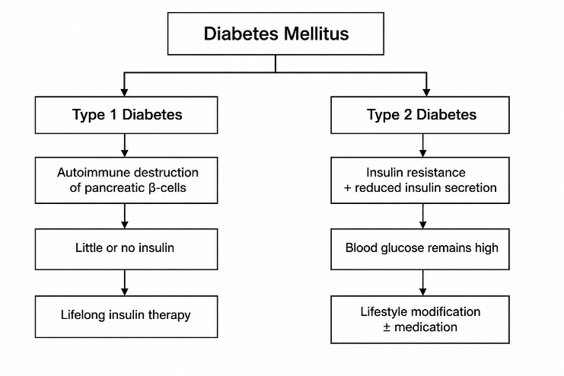
Source: Adapted from Diabetes.org (2026) and Nice.org.uk (2015).

2. Blood Sugar Regulation
Homeostasis is the process by which the body regulates blood glucose and other processes occur within a fairly constant internal environment regardless of changes in the external environment or internal state of the body. The body's primary source of energy is blood glucose which must be maintained between a normal fasting range of 4-6 mmol/L. This regulation is reliant on a negative feedback system from the pancreas to the liver, skeletal muscles and adipose tissue (NHS website, 2025). For example, when blood glucose is raised (hyperglycaemia) it can harm blood vessels, nerves and organs in the long-term. Also, when the blood glucose level drops too far (hypoglycaemia), the brain doesn't get enough glucose and can experience signs including dizziness, confusion and passing out (Nice.org.uk, 2015).
Carbohydrates get converted to glucose after eating which increases the blood glucose level. The increase is noticed by the β-cells which are present in the islets of Langerhans of the pancreas and produces insulin (Diabetes.org, 2026). Insulin functions as a key to unlock GLUT4 (such as in skeletal muscle and adipose tissue) and permit glucose entry into cells. The glucose is then used to produce energy. Insulin also causes the liver and muscles to store excess glucose as glycogen (glycogenesis) to lower blood glucose levels back into normal range (Hall, 2021).
The α-cells of the pancreatic islets secrete glucagon in response to a decrease in blood glucose during periods of fasting and exercise. This hormone has the opposite effect of insulin. It activates the liver enzymes that convert stored glycogen into glucose (glycogenolysis) and that convert other materials into glucose (gluconeogenesis). The glucose released into the blood stream lowers blood glucose back to normal, preventing a shortage of glucose to the brain and other organs of the body which are directly affected (Guy et al., 2021).
In Type 2 diabetes, this feedback system does not function properly since the body cells become insulin-resistant. Initially the pancreas makes more insulin to compensate but eventually the β-cells are no longer able to do this (Nice.org.uk, 2015). This leaves the glucose in the blood and does not allow it to enter body cells which leads to long-term hyperglycaemia. These are physiological processes that are important for the patient at the GP surgery in this case study since it can explain why the importance of taking prescribed medicines, blood glucose monitoring and lifestyle change to improve glycaemic control and minimise the risk of long-term complications (Diabetes.org, 2026).
Figure 2. Homeostatic Regulation of Blood Glucose
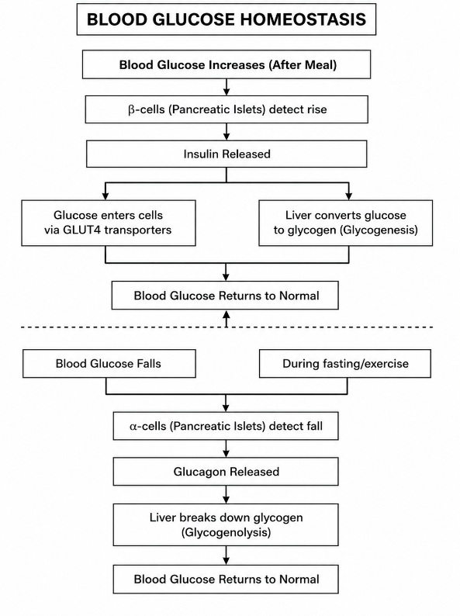
Source: Adapted from Hall (2021), Diabetes UK (2024) and Nice.org.uk, (2015).

3. Oxygen and Glucose in Cellular Metabolism
Cellular respiration is the physiological process whereby body cells utilise glucose and oxygen to generate adenosine triphosphate (ATP) which is the primary source of energy needed for normal body functions. ATP supplies energy for muscle contraction, nerve transmission, protein synthesis and for active transport across cell membranes. Glucose is fully catabolised to release a lot of energy in the presence of oxygen (Aerobic Respiration) (Schmidt-Rohr, 2020). The overall equation is:
Glucose + Oxygen = Carbon dioxide + Water + energy (ATP)
This process occurs on-going within most body cells bodily cells such as muscles, brain and the heart that have high energy demands (Hall, 2021). Insulin resistance in people with Type 2 diabetes, these cells have a decreased ability to absorb glucose and therefore glucose is not available for ATP production, even though blood glucose levels are high.
There are 3 stages of aerobic respiration. Glycolysis occurs in the cytoplasm in which the glucose molecule is converted into 2 molecules of pyruvate, generating a small quantity of ATP (Chandel, 2021). Pyruvate is next taken into the mitochondrion where further ATP and other energy carriers are produced in the Krebs cycle. Oxidative phosphorylation (ATP production) takes place on the inner mitochondrial membrane where oxygen serves as the last electron acceptor along the electron transport chain. In this stage, the most ATP molecules are produced, about 30-32 ATP molecules for each molecule of glucose (Guy et al., 2021).
Without oxygen, the cells breathe anaerobically, generating just 2 ATP molecules for each glucose molecule and lactic acid which causes muscle fatigue (NHS website, 2025). In a patient who doesn't control his Type 2 diabetes well, the reduced glucose uptake means that when he has high blood glucose levels, his body can't produce energy. In this little clinical scenario, patients can see that cellular respiration is necessary and that they need to take their medicines, measure their blood glucose levels regularly and make a healthy lifestyle choice to ensure normal production of energy and minimise the risk of metabolic complications.

Figure 3. Stages of Aerobic Cellular Respiration
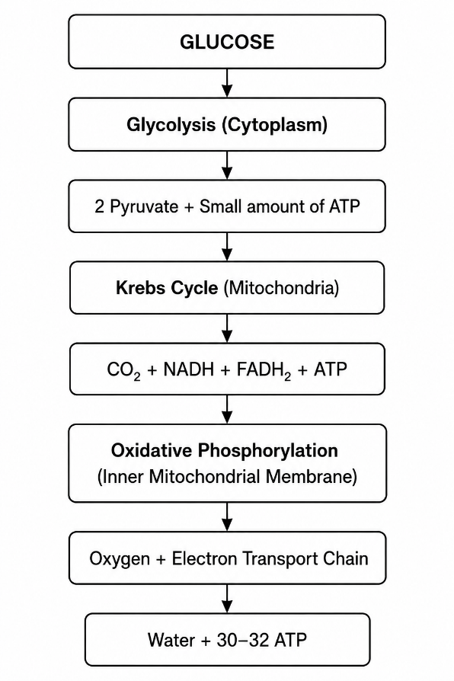
Source: Adapted from Hall (2021) and Guy et al. (2021).

4. Recording and Tracking Blood Sugar Levels
Broadly, monitoring blood glucose is an essential component to Type 2 diabetes management as it aids patients and health care providers evaluate blood glucose control. Keeping a record of blood glucose levels gives patients information about how their diabetes is affected by their medication, diet, physical activity and illnesses so they can make sure that their diabetes is managed as soon as it needs to be (Nice.org.uk, 2015). In the GP surgery outlined in the case study, offering patients advice regarding self-monitoring will empower them to take charge of their care which helping to ensure that it is safe and effective.
There are a number of ways to check blood glucose. Self-monitoring of blood glucose (SMBG) is the use of a finger-prick blood sample and glucose meter to obtain blood glucose reading. This enables the patient to recognise when they are having hyperglycaemia or hypoglycaemia and what activities might affect their blood sugars (NHS website, 2025). One of the other tests is the HbA1c which is a measure of the average blood glucose levels over the last 2-3 months. A test that can be used to assess long-term glycaemic control and to assess the effectiveness of current treatment (Diabetes.org, 2026).
Regular monitoring of blood glucose levels helps keep patients safe by helping detect patterns that could warrant adjustment of meds, diet and activity. It also minimises the risk of diabetes-related complications, aids clinical decision making and fosters active involvement of patients in their diabetes management. Regular monitoring enhances individual care plans for those patients visiting the GP surgery and plays a role in better long-term health outcomes (Nice.org.uk, 2015).
Figure 4. Common Blood Glucose Monitoring Methods
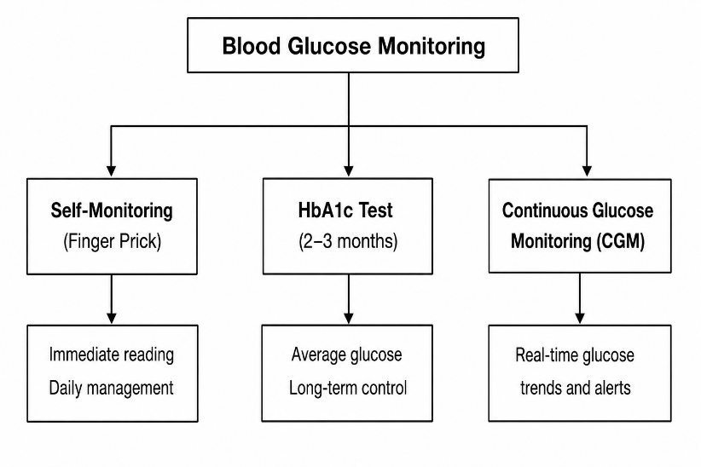
Source: Adapted from Nice.org.uk (2015), NHS website (2025) and Diabetes UK (2024).

5. Evidence-Based Lifestyle Recommendations
Lifestyle modification plays an important role in Type 2 Diabetes (T2D) management as it can enhance insulin sensitivity and keep blood glucose levels normal. As a practice nurse, advising patients on evidence-based information can help them understand the importance of healthy lifestyle choices alongside taking medication to minimise the risk of complications and enhance their wellbeing. These individualised recommendations, taking into account each patient's needs and everyday routine are more likely to help achieve long-term behavioural change (Nice.org.uk, 2015).
Eating a healthy diet is a key factor in maintaining a good blood sugar level. It is important to encourage patients to consume a healthy diet that includes whole grains, fruits, vegetables, protein and legumes but not excessive amounts of foods rich in refined carbohydrates, added sugars and saturated fats (Willett et al., 2017). Foods with a low-glycaemic index (GI) will help to prevent the sharp rise in blood sugar levels after eating or drinking. The Mediterranean diet which features vegetables, whole grains, olive oil, fish and nuts is also supported by evidence that it may benefit glycaemic control and cardiovascular risks in individuals with Type 2 diabetes (Diabetes.org, 2026). Appropriate portion control and maintaining a gradual weight loss also enhance insulin sensitivity in overweight people (NHS website, 2025).
Regular exercise is also a key component as it enhances the utilisation of glucose by skeletal muscles and the body's sensitivity to insulin. World Health Organisation recommends that adults engage in at least 150 minutes of moderate intensity aerobic activities per week along with muscle strengthening activities on two or more days per week (World Health Organization, 2020). Brisk walking, cycling, swimming and resistance training are examples of activities that enhance blood glucose control, help weight maintenance and decrease cardiovascular risk. As a practice nurse, it's important to help patients set achievable targets to promote sustained compliance.
Another key suggestion is to stop smoking. Smoking causes insulin resistance leads to blood vessel damage and substantially increases the risk of cardiovascular disease, stroke and kidney disease in those living with diabetes (Nice.org.uk, 2015). Smoking cessation efforts should involve behavioural counselling, smoking cessation services in the local NHS and if appropriate, medication such as nicotine replacement therapy or a prescription drug or the NHS website (NHS website, 2025).
In this case study, the patient attending the GP surgery benefits from having a healthy diet, undertaking regular exercise and quitting smoking as well as taking the prescribed medicines and monitoring their blood glucose levels routinely as these methods would be most effective in terms of improving glycaemic control and reducing diabetes complications and long-term self-management.

Figure 5. Evidence-Based Lifestyle Management for Type 2 Diabetes
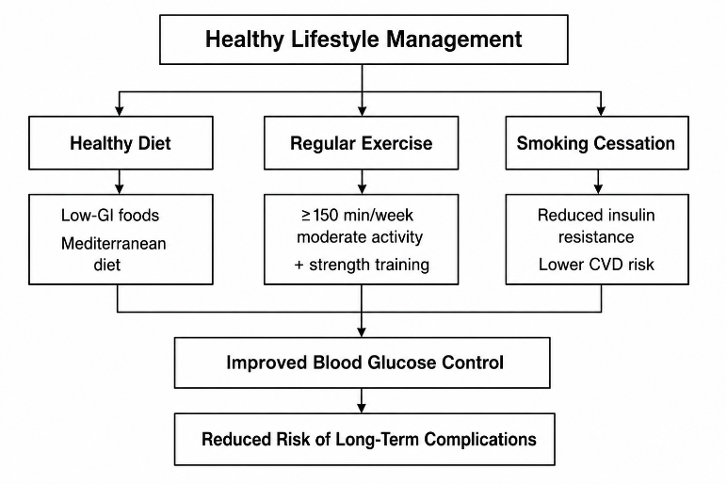
Source: Adapted from Nice.org.uk (2015), World Health Organization (2020), NHS website (2025) and Diabetes UK (2024).

6. Conclusion
Mature diabetes type 2 is a chronic condition that needs self-care and management to keep blood glucose levels at a healthy range and to prevents any complications. This report described that blood glucose is controlled by the mechanism of homeostasis with the aid of two hormones (insulin and glucagon) and that insulin resistance is responsible for disrupting the regulation of blood glucose. It has also pointed out the role of cellular metabolism in energy and the importance of having normal level of blood glucose in normal body function. Moreover, blood glucose monitoring both self-monitoring diabetes mellitus and testing has been demonstrated to help the patient and healthcare provider determine the efficacy of treatment and inform clinical care. Promotion of a healthy diet, regular exercise and quitting smoking are also crucial to improve insulin sensitivity and maintain the glycaemic targets over time. Patients who receive this kind of care at the GP surgery will be better equipped to manage their condition, minimise complications and enjoy a better quality of life as a result of their education and their ability to follow personalised care plans.

Reference List
Chandel, N.S., 2021. Glycolysis. Cold Spring Harbor Perspectives in Biology, 13(5), p.a040535.
Diabetes UK (2024) Type 2 diabetes. Available at: https://www.diabetes.org.uk/ (Accessed: 22 July 2026).
Diabetes.org. (2026). Standards of Care in Diabetes | ADA Clinical Guidelines. [online] Available at: https://professional.diabetes.org/standards-of-care [Accessed 22 July 2026].
‌Guy, J., Portillo, I., Beckett, R.D., Bowman, L.A., De La Rosa, D., Duba, V., Draime, J., Gill, K., Gilman, N., Hoover, R. and Kosnieczny, A., 2021. AACP Basic Resources for Pharmacy Education.
Hall, J.E. ed., 2021. Guyton & Hall. Tratado de fisiología médica. Elsevier Health Sciences.
‌NHS website (2025). Type 2 diabetes. [online] nhs.uk. Available at: https://www.nhs.uk/conditions/type-2-diabetes/ [Accessed 22 July 2026].
Nice.org.uk. (2015). Overview | Type 2 diabetes in adults: management | Guidance | NICE. [online] Available at: https://www.nice.org.uk/guidance/ng28 [Accessed 22 July 2026].
‌Schmidt-Rohr, K., 2020. Oxygen is the high-energy molecule powering complex multicellular life: Fundamental corrections to traditional bioenergetics. ACS omega, 5(5), pp.2221-2233.
Willett, W., Skerrett, P.J. and Giovannucci, E.L., 2017. Eat, drink and be healthy: the Harvard Medical School guide to healthy eating. Simon and Schuster.
World Health Organization (2020). WHO guidelines on physical activity and sedentary behaviour. [online] World Health Organization. Available at: https://www.who.int/publications/i/item/9789240015128 [Accessed 22 July 2026].

