

ACCA7027 — Cloud Engineering Principles and Practice

Name: Dev Vijaykumar Gajera (2538542)
Lecturer: Renuga Jayakumar
Table of Contents

Table of Contents…………………………………………………………………………………...…2
1. Introduction…………………………………………………………………………………………4
2. The Principles of Virtualisation…………………………………………………………………….4
2.1 The Problem It Solves……………………………………………………………………4
2.2 Hypervisors and Shared Hardware…………………………………………….................4
2.3 The Cost of the Guest Operating System………………………………………………...5
3. The Principles and Benefits of Containerisation…………………………………………………...5
3.1 Operating-System-Level Virtualisation…………………………………………………..5
3.2 Comparing the Two Models……………………………………………………………...6
3.3 Benefits in Practice……………………………………………………………………….6
4. Building an Image: The Dockerfile………………………………………………………………...7
4.1 Images, Layers and the Build Cache……………………………………………………..7
4.2 A Worked Dockerfile……………………………………………………………………..7
4.3 Building and Running…………………………………………………………………….8
5. Images and Publishing Images……………………………………………………………………..8
5.1 Registries and Tags……………………………………………………………………….8
5.2 Pushing to Docker Hub…………………………………………………………………...9
6. Container Volumes………………………………………………………………………………….9
6.1 Why Containers Need External Storage………………………………………………….9
6.2 Creating and Using a Volume…………………………………………………………...10
7. Container Networking…………………………………………………………………………….10
7.1 Network Drivers………………………………………………………………………...10
7.2 Why User-Defined Networks Matter………………………………………………...….10
7.3 Creating a Network……………………………………………………………………...11
7.4 The Whole Process End to End……………………………………………………….....11
8. Video Demonstration………………………………………………………………………………12
9. Load Balancing, Scalability and Application Gateways…………………………………………..12
9.1 The Chosen Application…………………………………………………………………12
9.2 Load Balancing………………………………………………………………………….12
9.3 Scalability………………………………………………………………………………..13
9.4 Application Gateways……………………………………………………………..…….13
9.5 Why Load Balancing and Scaling Are Complementary…………………………...……14
9.6 The Benefits of Combining All Three………………………………………………...…14
10. Driving Forces and Serverless Computing……………………………………………………….15
10.1 The Forces Driving Cloud Expansion……………………………………………...…..15
10.2 What Serverless Functions Are…………………………………………………….…..15
10.3 Serverless Compared with Containerisation……………………………………..…….16
10.4 Applying Both to the Example…………………………………………………..……..17
11. Conclusion………………………………………………………………………………………..17
12. References………………………………………………………………………………….…….18

1. Introduction

Cloud computing has become the default way software gets built and delivered, and the numbers behind that shift are hard to ignore. Gartner expects worldwide IT spending to reach around $6.37 trillion in 2026, up 14.2% on the year, with data centre systems and infrastructure as a service growing fastest [19]. Synergy Research put cloud infrastructure spending at roughly $129 billion in the first quarter of 2026 alone, a 35% jump year on year [20]. A lot of what sits behind those figures is a change in how applications are packaged and run, and containerisation is at the centre of it.
This report looks at containerisation, using Docker as the example, and puts it in the context of the wider cloud. It starts with virtualisation, because containers only really make sense once you know what came before them. From there it works through the practical side of Docker: writing a Dockerfile, building and publishing an image, keeping data alive with volumes, and wiring containers together with networks, using examples from class.
The second half moves up to the platform level. Load balancing, scalability and application gateways are discussed through a single running example, an online shop, so the connections between them stay visible rather than just asserted. The report then looks at why cloud keeps expanding and compares serverless functions with containers.

2. The Principles of Virtualisation
2.1 The Problem It Solves
Virtualisation turns physical computing resources into logical ones, so one machine can present itself as several. Popek and Goldberg set out the theory in 1974, defining three properties a virtual machine monitor needs: equivalence, resource control and efficiency [3]. A virtualised workload should behave as it would on real hardware, the monitor should keep control of the physical resources, and most instructions should run directly on the processor rather than being emulated.
A server sized for peak demand sits mostly idle, but still draws power, takes up rack space and needs cooling. Before virtualisation, the usual defence against software conflicts was giving every application its own box, which made that waste structural. Putting several workloads on one host, each in its own virtual machine, pushes utilisation up without bringing back the dependency clashes that caused the habit in the first place.
2.2 Hypervisors and Shared Hardware
The hypervisor does the abstracting. It intercepts privileged instructions from guest operating systems and controls their access to the physical CPU, memory, storage and network interfaces.
There are two kinds. A Type 1, or bare-metal, hypervisor runs straight on the hardware: VMware ESXi, Hyper-V, and the Xen and KVM hypervisors under the big public clouds [2]. A Type 2, or hosted, hypervisor runs as an application on a normal operating system, like VirtualBox. Type 1 dominates production because taking the host OS out of the path shortens the route from guest instruction to physical execution.
Hardware support from Intel VT-x and AMD-V has closed most of the performance gap, and SR-IOV has done something similar for I/O. What has not changed is the size of the unit. Every virtual machine carries a complete guest operating system: its own kernel, system libraries, background services and package manager.
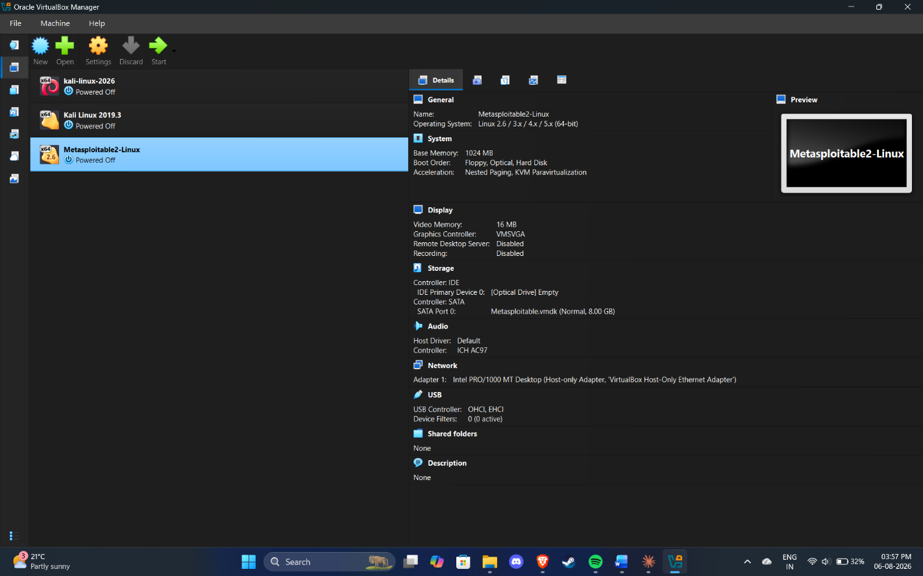
Figure 1: Several guest operating systems sharing one physical host through a hypervisor.
Figure 1 shows the basic arrangement. One host's resources are split by the hypervisor and handed to several guests, each of which believes it has the machine to itself. This is exactly how Infrastructure as a Service works: an Azure virtual machine or an EC2 instance is a slice of a much larger physical host, with the hypervisor holding the line between tenants.
2.3 The Cost of the Guest Operating System
The strength of virtual machine isolation is also where its overhead comes from. Each guest duplicates a kernel and a full userland, which usually means hundreds of megabytes to several gigabytes of disk and a similar amount of RAM before the application has even started. Boot times run to tens of seconds or minutes, because a whole operating system has to initialise first.
That is fine for a handful of machines. It stops making sense when you want a hundred copies of a small stateless web service, because you end up provisioning a hundred operating systems to run a few megabytes of code. If the isolation you need is between applications rather than operating systems, the guest kernel is dead weight, and removing it removes nearly all the overhead. That is the observation containers are built on.

3. The Principles and Benefits of Containerisation
3.1 Operating-System-Level Virtualisation

A container is an isolated process, or group of processes, running on the host kernel with its own private view of the system. Docker describes it as a sandboxed process isolated by kernel features rather than by a hypervisor [1]. On Linux those features are namespaces, which give a process its own process tree, network stack, mount table and hostname; control groups, which cap and account for CPU, memory and I/O; and a union filesystem, which stacks a thin writable layer over read-only image layers.
Because there is no guest kernel, a container starts in roughly the time it takes to fork a process, and its image holds only the application, its runtime and its libraries. A small Alpine-based image might be a few megabytes where the VM equivalent would be hundreds. Density improves by about an order of magnitude, and running one more container costs about as much as running one more process.
3.2 Comparing the Two Models
Table 1 sets out the differences that matter day to day. It is not a ranking: the two are used together constantly, and every managed container service the major clouds offer schedules containers onto virtual machines underneath.
Characteristic | Virtual Machines | Containers
Unit of isolation | Complete guest operating system | Process group on a shared kernel
Isolation mechanism | Hypervisor (hardware-assisted) | Namespaces, cgroups, seccomp, capabilities
Typical image size | Hundreds of MB to several GB | A few MB to a few hundred MB
Start-up time | Tens of seconds to minutes | Milliseconds to a few seconds
Density per host | Tens | Hundreds to thousands
Kernel flexibility | Any guest OS and kernel version | Must match the host kernel family
Security boundary | Strong; hardware-enforced | Weaker; the shared kernel is a shared attack surface
Best suited to | Mixed OS estates, legacy systems, strict multi-tenancy | Microservices, CI/CD pipelines, elastic stateless workloads
Table 1: Hardware virtualisation compared with operating-system-level virtualisation.
3.3 Benefits in Practice

- Portability and consistency. The image carries the application and its dependencies together, so the "works on my machine" class of bug largely disappears. The artefact that passed testing is the artefact that gets deployed, which removes configuration drift between environments.
- Efficiency and density. Dropping the duplicated guest kernels frees memory and disk for useful work, so a given host runs far more workloads and the cloud bill falls with it.
- Speed of deployment and scaling. Sub-second start-up makes containers a credible answer to sudden traffic, and it makes rolling deployments, blue-green releases and quick rollbacks practical rather than aspirational.
- Immutability. Images are versioned, content-addressed artefacts. A deployment is a change of image tag and a rollback is the reverse. The Dockerfile makes the build reproducible and reviewable in source control alongside the code.
The weaknesses deserve the same directness. Containers share the host kernel, so a kernel vulnerability is a boundary vulnerability, and container escape is a more realistic worry than hypervisor escape. Persistent state has to be designed for deliberately, which Section 6 covers. And once you outgrow a single host you need an orchestrator such as Kubernetes, which brings plenty of operational complexity of its own.

4. Building an Image: The Dockerfile

4.1 Images, Layers and the Build Cache
An image is a read-only template: an ordered stack of filesystem layers plus a manifest and configuration, in the format the Open Container Initiative standardised [5]. A container is a running instance of that image with a thin writable layer on top, and anything written there disappears when the container is removed. A Dockerfile is the set of instructions the image is built from [4], and each instruction that touches the filesystem creates a layer.
Layering is what makes the build cache useful. Docker reuses cached layers when an instruction's inputs have not changed, so ordering instructions from least to most frequently changed makes rebuilds much faster. The example below does that, installing dependencies before copying the application source, so editing code does not invalidate the install step.
4.2 A Worked Dockerfile
The class exercise was a containerised web server serving a static HTML page. Here is the Dockerfile, with the reasoning underneath it.
Stage 1: build / prepare static assets
FROM node:20-alpine AS build
WORKDIR /app
COPY package*.json ./
RUN npm ci --omit=dev
COPY . .
RUN npm run build

Stage 2: minimal runtime image
FROM nginx:1.27-alpine
LABEL maintainer="devgajera dev.viram01@gmail.com"
COPY --from=build /app/dist /usr/share/nginx/html
COPY nginx.conf /etc/nginx/conf.d/default.conf
EXPOSE 80

FROM sets the base image. Pinning node:20-alpine rather than node:latest keeps the build reproducible, and Alpine keeps it small. WORKDIR sets the directory for what follows, which is cleaner than chaining cd commands. The split COPY, manifest first and source second, is the cache optimisation described above. EXPOSE documents the port but does not publish it; that happens at run time with -p. CMD gives the default process in exec form, so nginx runs as PID 1, receives signals directly and shuts down cleanly.
The two-stage structure is a multi-stage build [9]. The first stage carries the whole Node.js toolchain and produces the compiled assets. The second starts from a clean nginx image and copies only those assets across, so the compiler, the package manager and the development dependencies never reach the published image. In our exercise this took the final image from roughly 1.1 GB down to under 60 MB. Every pull after that is faster, and the attack surface is smaller, because software that is not there cannot be exploited.
A .dockerignore file sits alongside the Dockerfile and keeps node_modules, .git, local environment files and build output out of the build context. Without it the whole working directory is uploaded on every build, which is slow and is a good way to accidentally bake the credentials from a local .env file into an image.

4.3 Building and Running

# Build, tagging with both a version and latest
docker build -t devgajera/cloud-web:1.0 \
-t devgajera/cloud-web:latest .

# Inspect the resulting image and its layers
docker images
docker history devgajera/cloud-web:1.0

# Run it, publishing host port 8080 to container port 80
docker run -d --name web1 -p 8080:80 devgajera/cloud-web:1.0

# Verify
docker ps
curl http://localhost:8080
docker logs web1
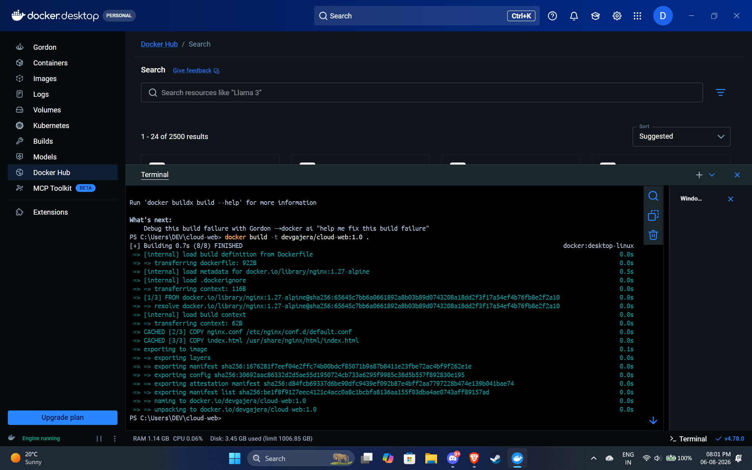
Figure 2: Building the image from the Dockerfile, each instruction producing a layer.
Figure 2 shows the build running. Each instruction appears as a numbered step, and building again after an unrelated change makes the cache obvious: unchanged steps come back marked CACHED and finish instantly.
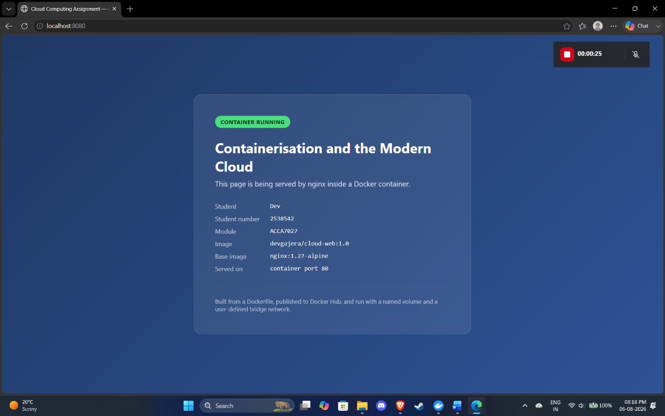
Figure 3: The running container serving the static HTML page on the published host port.
Figure 3 is the result: a page served by nginx inside a container, reached from the host browser through the published port.
5. Images and Publishing Images

5.1 Registries and Tags

A registry stores and distributes images. Docker Hub is the default public one, the major clouds each have their own in Azure Container Registry, Amazon ECR and Google Artifact Registry, and self-hosted options exist. Publishing turns a locally built image into something deployable, because every host, CI runner and orchestrator can then pull identical bytes.
Image references take the form registry/namespace/repository:tag. Leave the registry off and Docker assumes Docker Hub; leave the tag off and it assumes latest [6]. That last one causes a lot of confusion, because latest carries no meaning at all and simply names whichever image was tagged with it most recently. Production should reference a version tag, or better a digest of the form image, which cannot be quietly repointed at different content later.
5.2 Pushing to Docker Hub

# Authenticate (use a Personal Access Token, not the account password)
docker login -u devgajera

# If the image was built with a local name, retag it for the registry
docker tag cloud-web:1.0 devgajera/cloud-web:1.0

# Push both tags
docker push devgajera/cloud-web:1.0
docker push devgajera/cloud-web:latest

# Prove the image is genuinely remote: delete locally, then pull it back
docker rmi devgajera/cloud-web:1.0
docker pull devgajera/cloud-web:1.0
docker run -d -p 8081:80 devgajera/cloud-web:1.0
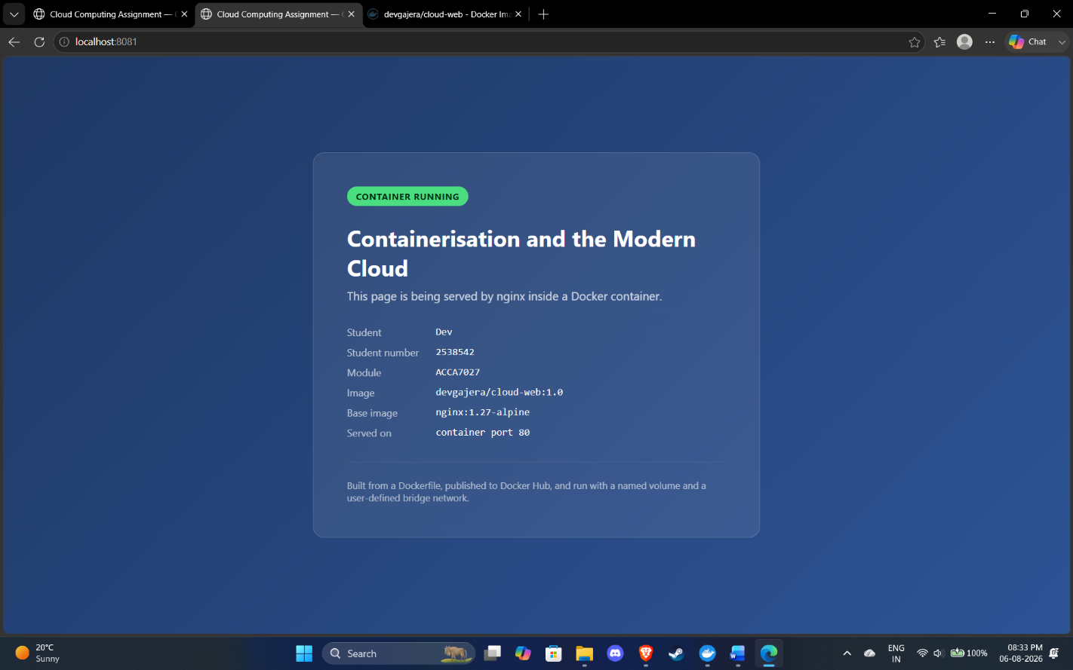

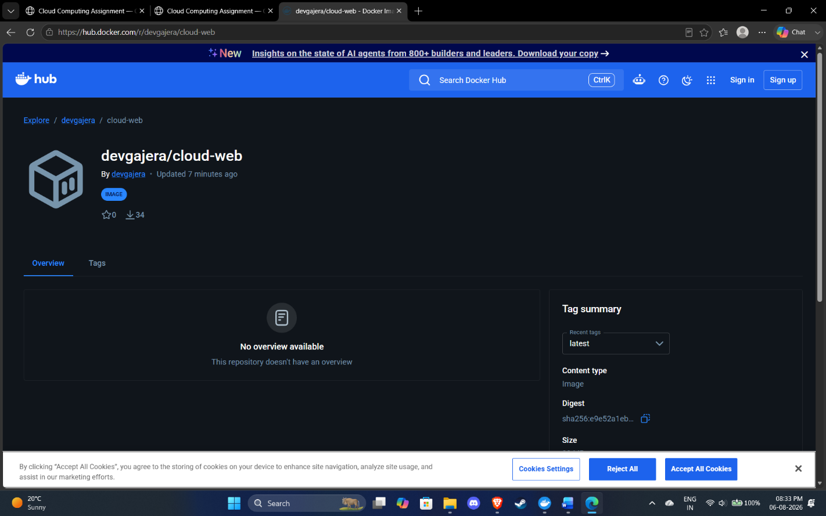
Figure 4: Pushing the tagged image to Docker Hub and the resulting public repository.
Figure 4 shows the push finishing and the repository as it appears on Docker Hub. The output is worth reading closely, because layers already held by the registry come back as "Layer already exists" and are not sent again. Only changed layers cross the network, which is why a small code change pushes quickly even on a large image.
Deleting the local copy and pulling it back, as in the last few commands, is a small demonstration but a convincing one. The artefact really is hosted remotely and reproducible from the registry alone. That is the mechanism behind the portability claim in Section 3, and it is how one image reaches a laptop, a CI pipeline and a production cluster without being rebuilt.
Two practical points. Log in with a narrowly scoped Personal Access Token rather than an account password, so credentials can be revoked individually. And scan images before publishing, using docker scout cves or an equivalent CI step, because a base image pinned six months ago will have picked up known vulnerabilities by now.

6. Container Volumes

6.1 Why Containers Need External Storage
A container's writable layer lives and dies with the container. Remove the container and everything written to that layer goes with it. That is what you want for a stateless service, where disposability is the point, and exactly what you do not want for a database or an audit log. So Docker provides storage that exists independently of any container [7].
There are three options. Volumes are managed by Docker, kept in its own area of the host filesystem, and are the recommended choice for persistent application data. Bind mounts map any host directory into the container, which is mostly a development convenience, since mounting live source code into a running container gives you an immediate edit-and-refresh loop. tmpfs mounts exist only in host memory, which suits secrets or scratch data that should never touch disk.
Volumes beat bind mounts in production because you manage them through the Docker CLI, they do not depend on the host's directory layout, they behave identically across operating systems, and they can be backed by drivers that store the data on networked or cloud storage.
6.2 Creating and Using a Volume

# Create a named volume
docker volume create app-data
docker volume ls
docker volume inspect app-data

# Attach it to a container at the path the application writes to
docker run -d --name db \
-v app-data:/var/lib/mysql \
-e MYSQL_ROOT_PASSWORD=abcd123 \
-e MYSQL_DATABASE=shopdb \
mysql:8.4

# Demonstrate persistence: destroy the container, keep the data
docker exec -it db mysql -uroot -p -e "CREATE TABLE shopdb.t (id INT);"
docker rm -f db
docker run -d --name db2 -v app-data:/var/lib/mysql \
-e MYSQL_ROOT_PASSWORD=abcd123 mysql:8.4
docker exec -it db2 mysql -uroot -p -e "SHOW TABLES IN shopdb;" # table survives
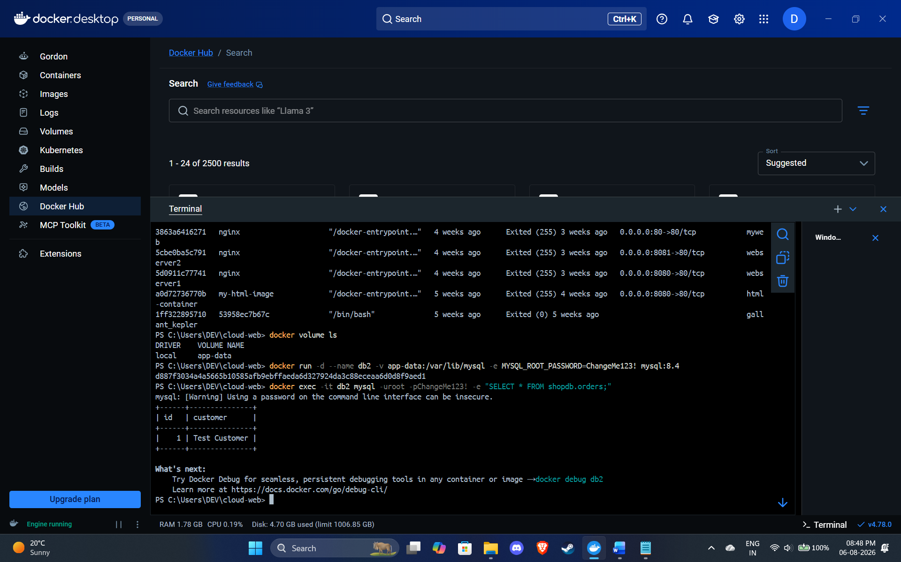
Figure 5: A named volume keeping data alive after the container that wrote it has been destroyed.
Figure 5 captures the point. The table created inside the first container is still there after that container has been forcibly removed and a completely new one attached to the same volume. The data belongs to the volume, not to the container, and that separation is what lets stateful services be treated with the same disposability as stateless ones.
It also matters later in this report. Because the state sits outside the container, any instance can serve any request, which is precisely what a load balancer needs. Section 9 returns to this, since horizontal scaling only works cleanly when the things being scaled hold no session state of their own.

7. Container Networking

7.1 Network Drivers
Docker attaches containers to networks through pluggable drivers [8]. The bridge driver is the default for standalone containers and creates a private host-internal network with NAT to the outside world. The host driver drops network isolation and shares the host stack, removing NAT overhead but costing you isolation and port flexibility. The overlay driver spans several hosts and sits underneath Docker Swarm. The macvlan driver gives containers their own MAC addresses so they appear as physical devices on the LAN, which helps with legacy applications. The none driver turns networking off entirely, which suits batch jobs that should have no connectivity.
7.2 Why User-Defined Networks Matter

Containers on the default bridge can only reach each other by IP address, and those addresses are assigned dynamically and change on restart. A user-defined bridge network adds an embedded DNS resolver, so containers resolve each other by container name instead. An application container can open a connection to the host name db and reach the database container whatever address it currently holds. That turns service discovery from a configuration problem into a naming convention, and it is the strongest single reason to create your own network rather than rely on the default bridge.
They also isolate better. Containers on separate networks cannot reach each other at all, so putting the database on a network shared only with the application, and never publishing its port, makes it unreachable from outside the host by construction. The old --link flag did something similar and is now deprecated.
7.3 Creating a Network

# Create an isolated user-defined bridge network
docker network create --driver bridge shop-net
docker network ls
docker network inspect shop-net

# Database: attached to the network, NO published port
docker run -d --name db --network shop-net \
-v app-data:/var/lib/mysql \
-e MYSQL_ROOT_PASSWORD=abcd123 mysql:8.4

# Web app: same network, published to the host
docker run -d --name web --network shop-net -p 8080:80 \
-e DB_HOST=db \
devgajera/cloud-web:1.0

# Prove name-based service discovery works
docker exec -it web ping -c 3 db
docker exec -it web nslookup db

# Prove the database is not reachable from the host
curl http://localhost:3306 # connection refused - port never published
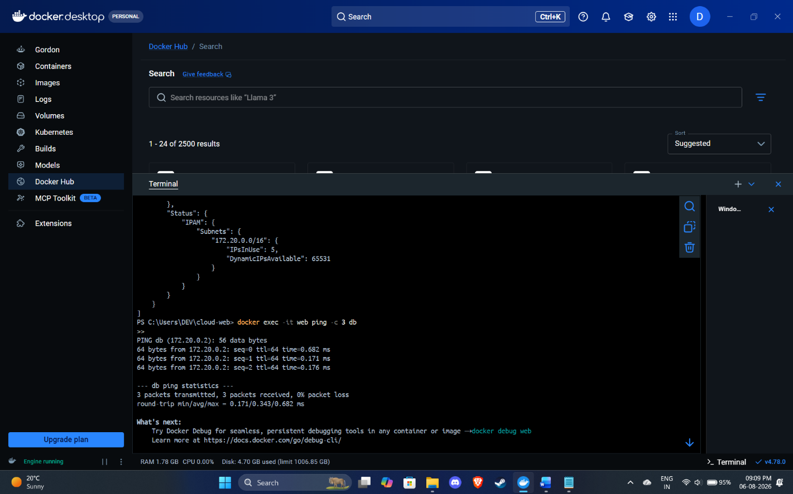
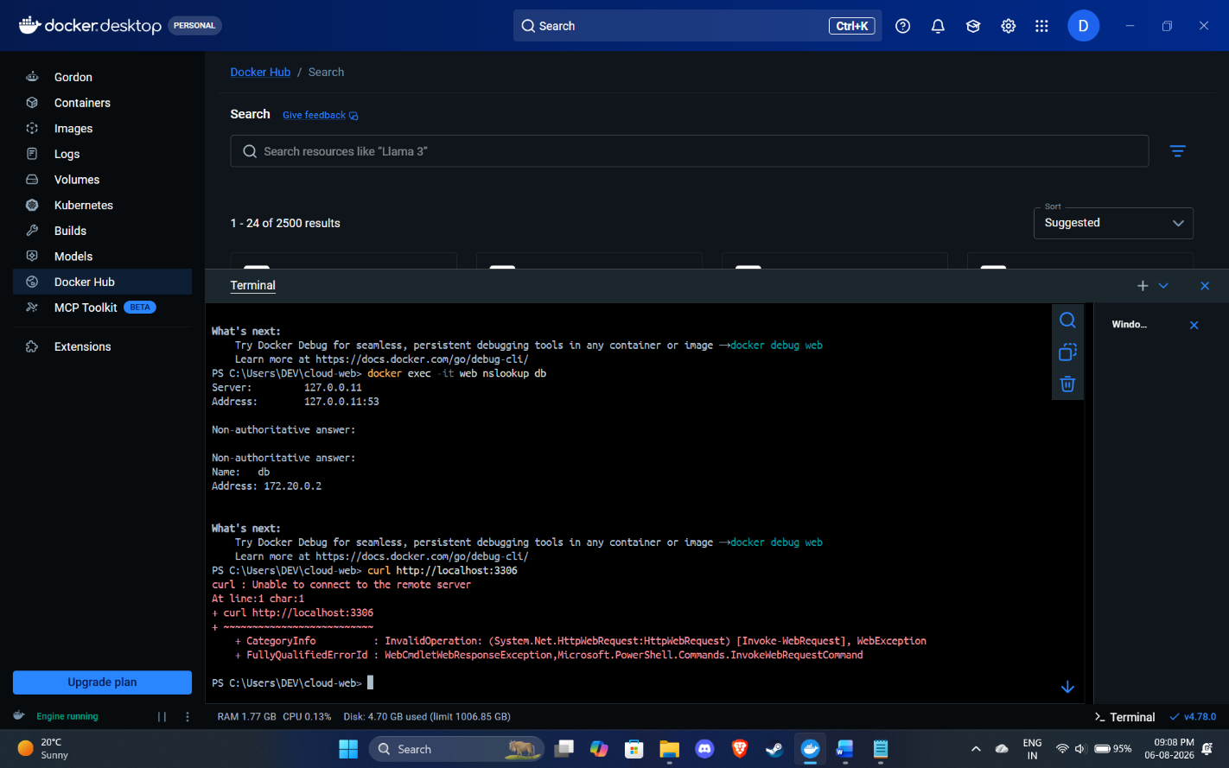
Figure 6: A user-defined bridge network giving DNS-based service discovery between containers.
Figure 6 shows both containers listed in the network inspection output and the web container resolving db by name. The last command is the negative test, and it matters as much as the positive one. The database port was never published, so it is unreachable from the host while remaining fully reachable from the application container.
7.4 The Whole Process End to End
Sections 4 to 7 together cover the full lifecycle: a Dockerfile is written, an image built and tagged, the image published to Docker Hub, a volume created for persistent data, a network created to connect the tiers, and containers run from the published image to serve an HTML page on a mapped port. In practice you would express the whole stack with Docker Compose [24], which creates the network and volumes for you and starts services in dependency order:
services:
web:
image: devgajera/cloud-web:1.0
ports:
- "8080:80"
environment:
DB_HOST: db
depends_on: [db]
networks: [shop-net]
db:
image: mysql:8.4
environment:
MYSQL_ROOT_PASSWORD: abcd123
MYSQL_DATABASE: shopdb
volumes:
- app-data:/var/lib/mysql
networks: [shop-net]
volumes:
app-data:
networks:
shop-net:

driver: bridgeA single docker compose up -d then rebuilds the entire environment on any machine with Docker installed, which is the portability argument in its most concrete form.

8. Video Demonstration
A recorded demonstration accompanies this report and covers the examples above: writing the Dockerfile, building and tagging the image, running the container and viewing the page in a browser, pushing to Docker Hub, attaching a volume, and creating a network to show service discovery.
Video link: https://youtu.be/JEDFL3JraLE

9. Load Balancing, Scalability and Application Gateways

9.1 The Chosen Application

To keep this concrete, take an online shop: the containerised store from earlier, deployed properly. It has a public storefront, a catalogue and search service, a checkout path, and an admin back office. Traffic is uneven — quiet overnight, busy at lunchtime and in the evening, occasionally enormous during a promotion. Checkout is latency-sensitive and tied to revenue. Catalogue browsing is high volume but tolerates latency. The back office is low volume and should never be publicly reachable. That mix exercises all three concepts.
9.2 Load Balancing
Load balancing spreads incoming requests across several backend instances, so no single instance becomes the bottleneck and no single failure takes the service down. Azure Load Balancer works at Layer 4, distributing TCP and UDP flows using a hash over a configurable tuple of addresses, ports and protocol [10]. Working below the application layer makes it protocol-agnostic and very fast, and it handles RDP, SSH and DNS as happily as web traffic. Health probes are the important part: it polls each backend on a defined port and path, pulls failing instances out of rotation, and restores them when they recover.
AWS does the same through Elastic Load Balancing, with the Network Load Balancer at Layer 4 and the Application Load Balancer at Layer 7 [15]. The pattern is identical across providers; only the names change.
For the shop, a Layer 4 balancer in front of the web tier spreads storefront traffic across healthy instances and drops a failed one within seconds. Customers see nothing, because their requests are simply sent elsewhere.
9.3 Scalability
Scalability is how well a system copes with more load when it is given more resources. Vertical scaling makes an existing instance bigger, which is capped by the largest size available and usually needs downtime to apply. Horizontal scaling adds more instances and is effectively unlimited, which is why cloud architecture leans so heavily on it.
Azure implements horizontal scaling with Virtual Machine Scale Sets, which manage a group of identical VMs as a single resource [11]. Autoscale rules watch host metrics such as CPU, memory and disk activity and add or remove instances in response, with no agent needed inside the guest [12]. A typical rule set might add two instances when average CPU stays above 70% for five minutes and remove one when it drops below 30% for ten, within a floor of two and a ceiling of twenty. Azure also supports scheduled scaling, which is the right answer to a known event like a Black Friday sale, since reactive scaling only starts once the load has arrived.
The asymmetry between those two rules is deliberate. Scaling out quickly and in slowly stops the platform oscillating around a threshold, and errs towards serving customers rather than saving a little money. AWS Auto Scaling Groups follow the same design.

9.4 Application Gateways
An application gateway is a Layer 7 reverse proxy that makes routing decisions using the content of the HTTP request. Azure Application Gateway routes on host header and URL path, terminates TLS so certificates are managed in one place instead of on every backend, supports cookie-based session affinity, rewrites headers and URLs, and includes a Web Application Firewall [13]. Because it understands HTTP, it can send /images to one backend pool, /api to another and /admin to a third. A Layer 4 balancer cannot, because it never looks inside the request.
The firewall component is the security argument for putting a gateway in front of the application. It applies managed rule sets derived from the OWASP Core Rule Set to block SQL injection, cross-site scripting and other common exploits centrally, before any of it reaches an application instance [14]. Patching one gateway is a great deal more manageable than patching twenty backends.
AWS splits these duties between the Application Load Balancer, API Gateway and AWS WAF. For traffic spread across regions, Azure Front Door does global HTTP load balancing and would sit in front of regional Application Gateways [23].
In the shop, the gateway is where the topology earns its keep. Requests to /checkout go to a dedicated pool sized for latency rather than throughput. /catalogue goes to a bigger and cheaper pool. /admin is restricted by source IP and never exposed on the public path at all. TLS terminates once at the gateway, and the firewall screens every request before it reaches application code.
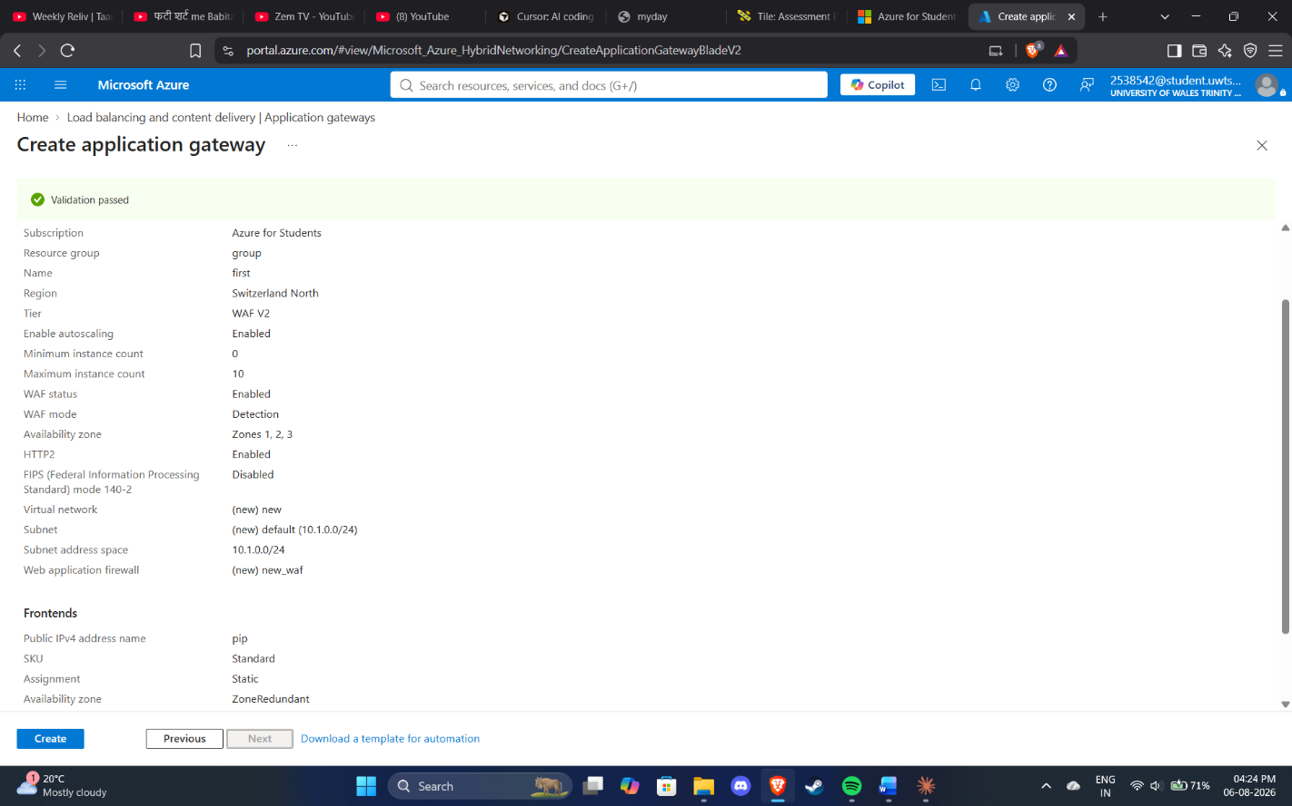
Figure 7: A reference architecture combining an application gateway, a load balancer and an autoscaling backend tier.
Figure 7 shows the three assembled. Traffic enters through the gateway, is inspected and routed, then spread by the load balancer across a backend pool whose size is governed by autoscale rules.

9.5 Why Load Balancing and Scaling Are Complementary
These two are not merely compatible. Neither is much use without the other, and it is worth being precise about why.
Scaling without load balancing achieves nothing. Add ten instances behind a single published endpoint and every request still arrives at the one instance clients know how to reach. The extra capacity exists but nothing can get to it. The load balancer is what converts added instances into added throughput, and it is the stable address that lets the instance population change without clients noticing.
Load balancing without scaling only delays the failure. Spreading load evenly across a fixed pool improves utilisation and gives you failover, but once total demand passes what the pool can handle, every instance saturates at the same time and the whole service degrades together. A load balancer has no capacity of its own to offer. It can only share what already exists.
Put together, you get genuine elasticity. Autoscale sees CPU rising and adds instances. The scale set registers them with the balancer's backend pool automatically. Health probes confirm they are ready before traffic reaches them. Traffic redistributes with nobody touching anything, and when demand falls the process runs in reverse. That feedback loop between the metric that triggers scaling and the mechanism that spreads traffic is what makes pay-for-what-you-use real rather than theoretical.
The dependency also explains a common failure. If instances keep session state locally, adding instances does not help evenly, because users pinned to a saturated instance stay stuck there, and removing one destroys sessions outright. This is why Section 6 matters: pushing state out to a shared database or cache is a precondition for any of this working.

9.6 The Benefits of Combining All Three
Deployed together, the three give you things none of them gives alone. Availability improves, because the gateway and the balancer both drop unhealthy backends and the scale set replaces failed instances, so a single failure never reaches the customer. Performance holds steady under variable load, because capacity follows demand and requests go to pools tuned for their workload. Cost falls, because the fleet shrinks overnight instead of being sized permanently for the annual peak. Security concentrates at one hardened, centrally patched entry point rather than being reimplemented on every instance. And deployments get safer, because the gateway can weight traffic between pools for blue-green and canary releases, with rollback amounting to shifting the weighting back.
For the shop, that adds up to one visible outcome. A promotional email goes out, traffic spikes hard, and the system absorbs it: the gateway screens and routes it, the scale set grows, the balancer spreads it across new instances as they come up healthy, and the fleet contracts afterwards. The alternative is provisioning permanently for that peak and leaving most of the capacity idle all year.

10. Driving Forces and Serverless Computing

10.1 The Forces Driving Cloud Expansion
NIST defines cloud computing by five essential characteristics: on-demand self-service, broad network access, resource pooling, rapid elasticity and measured service [21]. The commercial drivers follow from those fairly directly.
- Cost structure. Cloud turns capital expenditure into operating expenditure. Instead of buying hardware against a five-year forecast that is certainly wrong, you pay for what you use. That lowers the barrier for start-ups and helps cash flow for everyone else. It is worth saying plainly, though, that cloud is not automatically cheaper. Steady, high-utilisation workloads can cost less on owned hardware, and several well-known companies have moved workloads back for that reason.
- Flexibility and elasticity. Capacity arrives in minutes and can be released just as quickly. Experiments that once needed a purchase order can be run and abandoned in an afternoon, which changes what an organisation is willing to attempt.
- Speed to market. Managed databases, queues, identity providers and machine learning services remove work that would otherwise be built and maintained in-house, so engineering effort goes into the parts of the product that actually differentiate it.
- Reliability and reach. Availability zones, cross-region replication and content delivery networks provide resilience and worldwide latency that very few organisations could build for themselves.
- Focus and staffing. Racking hardware and replacing disks is not a competitive advantage for most organisations, and the specialists who do it well are expensive and scarce.
- AI workloads. The newest accelerant is demand for GPU capacity. Synergy attributes much of the current growth rate, with cloud infrastructure spending up 35% year on year and rising for ten consecutive quarters, to AI, because getting hold of large accelerator fleets any other way is not realistic for most organisations [20].

10.2 What Serverless Functions Are

Serverless computing, or Functions as a Service, lets you deploy code as individual event-triggered functions with no server or runtime environment to manage. Servers obviously still exist; the word means their provisioning, patching, scaling and capacity planning are entirely the provider's problem. The defining traits are event-driven invocation, automatic scaling from zero upwards, per-invocation billing, and a stateless execution model with a time limit attached.
AWS Lambda runs a function in response to events from more than two hundred integrated services. Each invocation can run for up to fifteen minutes with up to 10,240 MB of memory, and CPU is allocated in proportion to memory [16]. Azure Functions offers the same model across several plans. Flex Consumption is now the recommended serverless plan, keeping pay-per-use billing while adding private networking, instance sizes of 512 MB, 2,048 MB or 4,096 MB, and configurable always-ready instances [17]. The classic Consumption plan is documented as legacy, and the Premium plan removes cold starts and extends the limit to sixty minutes [18].
The main technical drawback is the cold start. If no warm instance is available, the platform has to initialise a new execution environment first, adding anywhere from tens of milliseconds to several seconds depending on the runtime. Provisioned concurrency on Lambda and always-ready instances on Azure fix this by keeping instances warm, at the cost of a baseline charge that gives back some of the economics the model was meant to deliver. The Berkeley review of serverless identified this tension, along with weak support for stateful and long-running work, as the main barriers to wider adoption [22].

10.3 Serverless Compared with Containerisation

The two sit at different points on the same spectrum, trading control for convenience.
Dimension | Containers (Docker / Kubernetes) | Serverless functions (FaaS)
Unit of deployment | Image containing a whole application or service | A single function responding to an event
Operational burden | You manage the image, runtime, scaling policy and cluster | Provider manages everything below your code
Scaling | Autoscale rules or an orchestrator; minimum fleet usually above zero | Automatic, per-request, genuinely scales to zero
Billing | Charged for allocated capacity, busy or idle | Charged per invocation and per GB-second used
Start-up latency | Sub-second once the image is cached on the node | Cold start of tens of milliseconds to several seconds
Execution limits | None imposed by the platform | 15 min on Lambda [16]; 60 min on Azure Premium [18]
State | Persistent via volumes and attached storage | Stateless by design; state must be externalised
Portability | High — OCI images run on any conformant runtime | Lower — triggers and bindings are provider-specific
Best suited to | Long-running services, complex or legacy apps, steady load | Spiky, event-driven, short-lived, parallel tasks
Table 2: Containerisation compared with serverless functions.

Both serve the cost and flexibility drivers above, but by different routes. Containers attack cost through density: more workloads per host, therefore fewer hosts. Serverless attacks it through granularity, because nothing running means nothing paid and an idle function costs literally zero. For a service handling a few requests a day, serverless is dramatically cheaper. Push the volume up and the relationship inverts, since per-invocation pricing eventually costs more than a container that simply stays running.
The flexibility trade is just as clear. Containers give you control — any language, dependency, runtime and duration — and hand you the operational responsibility that comes with it. Serverless gives you delivery speed and takes back some freedom: bounded execution, no local state, and tighter coupling to one provider's event model. Container images follow the OCI specification [5] and run unchanged on any conformant runtime, whereas a Lambda function wired to DynamoDB streams and EventBridge does not move to Azure without real work. Lock-in is a genuine and asymmetric consideration.
The line between the two is blurring anyway. Lambda accepts container images as a packaging format, Azure Container Apps and AWS Fargate scale containers with no cluster to manage, and Knative brings scale-to-zero behaviour to Kubernetes. The useful question now is not containers or serverless, but which parts of a system suit which model.

10.4 Applying Both to the Example

For the shop, a hybrid is the obvious answer. The storefront and checkout run as containers behind the gateway and balancer from Section 9, because they take steady traffic, hold long-lived connections and cannot afford cold starts. The event-driven work around the edges runs as functions: resizing product images on upload, sending order confirmations, generating nightly reports, handling payment webhooks. All of those are short, bursty, stateless and idle most of the time, which is exactly what serverless bills well. Each model gets used where it suits the job.

11. Conclusion
Virtualisation, containerisation and serverless form a sequence of abstractions, each removing a layer of concern and accepting a constraint in return. Hypervisors freed workloads from specific hardware and raised utilisation, but duplicated an operating system per workload. Containers removed that duplication by isolating processes on a shared kernel, giving portability, density and near-instant start-up at the cost of a weaker security boundary and state that has to be handled deliberately. Serverless removed the runtime as well, delivering scale-to-zero economics in exchange for time limits, cold starts and provider coupling.
The practical work here demonstrates the container model end to end: a multi-stage Dockerfile producing a small, reproducible image; that image published to Docker Hub, then deleted locally and pulled back to prove it is portable; a named volume showing data outliving the container that wrote it; and a user-defined network giving service discovery between tiers while keeping the database unreachable from outside.
At platform level, load balancing, scalability and application gateways turned out to be interdependent rather than merely related. Scaling produces capacity that only a balancer can reach. Balancing shares a pool that only autoscaling can enlarge. The gateway adds the content-aware routing, central TLS termination and firewall a Layer 4 balancer cannot provide. Together they make elasticity a property of the running system rather than just the billing model.
The forces behind continued cloud growth, including cost structure, elasticity, speed to market, global reach and now demand for AI infrastructure, are served by both containers and functions, but through different mechanisms and with different break-even points. The conclusion is not that one model replaces the other. It is that long-running, stateful, steady-traffic services belong in containers and short, bursty, event-driven work belongs in functions, and that most of the engineering skill lies in telling them apart.

12. References

[1] Docker Inc., "Docker overview," Docker Docs. [Online]. Available: https://docs.docker.com/get-started/docker-overview/
[2] Broadcom (VMware), "What is a hypervisor?" VMware Glossary. [Online]. Available: https://www.vmware.com/topics/hypervisor
[3] G. J. Popek and R. P. Goldberg, "Formal requirements for virtualizable third generation architectures," Communications of the ACM, vol. 17, no. 7, pp. 412–421, 1974. [Online]. Available: https://dl.acm.org/doi/10.1145/361011.361073
[4] Docker Inc., "Dockerfile reference," Docker Docs. [Online]. Available: https://docs.docker.com/reference/dockerfile/
[5] Open Container Initiative, "OCI Image Format Specification." [Online]. Available: https://github.com/opencontainers/image-spec
[6] Docker Inc., "Docker Hub quickstart," Docker Docs. [Online]. Available: https://docs.docker.com/docker-hub/quickstart/
[7] Docker Inc., "Volumes," Docker Docs. [Online]. Available: https://docs.docker.com/engine/storage/volumes/
[8] Docker Inc., "Networking overview," Docker Docs. [Online]. Available: https://docs.docker.com/engine/network/
[9] Docker Inc., "Multi-stage builds," Docker Docs. [Online]. Available: https://docs.docker.com/build/building/multi-stage/
[10] Microsoft, "What is Azure Load Balancer?" Microsoft Learn. [Online]. Available: https://learn.microsoft.com/en-us/azure/load-balancer/load-balancer-overview
[11] Microsoft, "Azure Virtual Machine Scale Sets overview," Microsoft Learn. [Online]. Available: https://learn.microsoft.com/en-us/azure/virtual-machine-scale-sets/overview
[12] Microsoft, "Overview of autoscale with Azure Virtual Machine Scale Sets," Microsoft Learn. [Online]. Available: https://learn.microsoft.com/en-us/azure/virtual-machine-scale-sets/virtual-machine-scale-sets-autoscale-overview
[13] Microsoft, "What is Azure Application Gateway?" Microsoft Learn. [Online]. Available: https://learn.microsoft.com/en-us/azure/application-gateway/overview .
[14] Microsoft, "Azure Web Application Firewall on Azure Application Gateway," Microsoft Learn. [Online]. Available: https://learn.microsoft.com/en-us/azure/web-application-firewall/ag/ag-overview
[15] Amazon Web Services, "Elastic Load Balancing," AWS Documentation. [Online]. Available: https://docs.aws.amazon.com/elasticloadbalancing/ .
[16] Amazon Web Services, "Lambda quotas," AWS Lambda Developer Guide. [Online]. Available: https://docs.aws.amazon.com/lambda/latest/dg/gettingstarted-limits.html .
[17] Microsoft, "Azure Functions Flex Consumption plan hosting," Microsoft Learn. [Online]. Available: https://learn.microsoft.com/en-us/azure/azure-functions/flex-consumption-plan
[18] Microsoft, "Azure Functions Premium plan," Microsoft Learn. [Online]. Available: https://learn.microsoft.com/en-us/azure/azure-functions/functions-premium-plan
[19] Gartner, "Gartner Forecasts Worldwide IT Spending to Grow 14.2% in 2026, Totaling $6.37 Trillion," Press Release, 27 July 2026. [Online]. Available: https://www.gartner.com/en/newsroom/press-releases/2026-07-27-gartner-forecasts-worldwide-it-spending-to-grow-14-point-2-percent-in-2026-totaling-6-point-37-trillion
[20] ITPro / Synergy Research Group, "Cloud infrastructure spending just hit an eight-year high," 2026. [Online]. Available: https://www.itpro.com/cloud/cloud-computing/cloud-infrastructure-spending-just-hit-an-eight-year-high
[21] P. Mell and T. Grance, "The NIST Definition of Cloud Computing," NIST Special Publication 800-145, National Institute of Standards and Technology, 2011. [Online]. Available: https://doi.org/10.6028/NIST.SP.800-145
[22] E. Jonas et al., "Cloud Programming Simplified: A Berkeley View on Serverless Computing," Technical Report UCB/EECS-2019-3, University of California, Berkeley, 2019. [Online]. Available: https://www2.eecs.berkeley.edu/Pubs/TechRpts/2019/EECS-2019-3.html
[23] Microsoft, "What is Azure Front Door?" Microsoft Learn. [Online]. Available: https://learn.microsoft.com/en-us/azure/frontdoor/front-door-overview
[24] Docker Inc., "Docker Compose overview," Docker Docs. [Online]. Available: https://docs.docker.com/compose/

