Identify the short term and long-term benefits for a young person through their involvement in youth work.
The aim of this assignment is to research and discuss the short term and long-term benefits for a young person through their involvement in youth work and how these benefits are underpinned by both policy and legislation. Youth Service in Wales states that youth work is a universal entitlement that is age specific, eleven to twenty-five years old (WAG, 2007, p.3). Youth work is a process from which young people can learn and gain experience.
Although “the main objective of youth work is to provide opportunities for young people to shape their own futures” (Lauritzen, 2006) there are many short term and long-term benefits for young people through their involvement in youth work. These benefits include confidence building, self-belief, becoming more sociable, learning to work as a team, develop interdependence and increased resilience. While focusing on these benefits it needs to remain that at the “heart of all youth work is a young person led approach” (National Occupational Standards, 2012, p.4). There are different areas that all form part of the youth work sector. These areas include Youth Justice Team, Alcohol and substance misuse teams, Outreach and Detached youth workers, school based youth workers and mental health teams. Despite the area of youth work you choose to be a part of, each team has a similar aim. This aim is to safeguard young people and ensure their well-being needs are being met (National Occupational Standards for Youth Work, 2012, p.5). What makes youth work different from other support networks is that youth work is based on voluntary engagement by the young people (The National Youth Work Strategy for Wales, 2014). It is the young person’s choice to take part and be involved in the activities or programmes offered. Young people also have the option to disengage at any time. Youth work has a non-formal education approach which is an “organised educational activity outside the established formal system” (Ahmed and Coombs, 1973). Operating this way often makes disengaged young people more comfortable while learning valuable skills. They feel more in control of decisions they make and often don’t feel as restricted as they would within a classroom setting, this is according to The British Youth Council. This council consists of two hundred and thirty national and local youth organisations “which supports young people to influence and inform decisions that affect their lives”.
Short term benefits for young people include how they react to different situations during their lives, how they deal with disappointments and how they build resilience. (WAG, 2007). For a young person resilience is extremely important when they transition into adulthood (The Benefits of Youth work, 2010). Resilience is an essential life skill and for any young person that takes part in any form of youth work their resilience is often better than those who have never had any involvement or contact with a youth setting. (Maclean, 2004,). “One way to foster resilience in young people is through meaningful youth participation”. (Oliver, Collin, Burns and Nicolas, 2006).
Resilience enables young people to adapt and change in difficult, stressful and upsetting situations in a positive manner. According to Gilligan (2000) the definition of resilience is a “set of qualities that helps a person to withstand many of the negative effects of adversity”. Being involved in youth work helps young people to understand that all actions have consequences and that they need to be responsible for all the choices that they make. Accepting responsibility for their decisions is a valuable life skill and will benefit a young person in the future. (Maclean, 2004, n.p).
“Young people’s development between the age of eleven and twenty-five provides the foundation for the rest of their lives – their relationships, family lives, contribution to their communities and to their employment opportunities”.
(WAG, 2007, p.6).
Some young people have been exposed to Adverse Childhood Experiences while growing up. These experiences “are potentially traumatic events that can have negative, lasting effects on health and well-being”. (Child Trends, 2014) These experiences include domestic violence, alcohol or substance misuse, divorce, mental illness and any form of abuse therefore taking part in positive forms of youth work can often break the destructive cycle and a young person can develop and reach their full potential (The truth about ACES, no date). For these young people being involved in youth work provides them with at least one positive role model. Research by the Robert Wood Johnson Foundation (2013) suggests that the more Adverse Childhood Experiences that a child or young person has been exposed to, the higher the risk is of them becoming a perpetrator of Adverse Childhood Experiences and the risk of negative health outcomes increases dramatically. During the study carried out by The Robert Wood Johnson Foundation on seventeen thousand participants it was found that sixty-four percent have experienced at least one Adverse Childhood Experience. Only thirty-six percent of all participants had never been exposed to any. See Appendix 1.
Maslow’s (1943, 1954) hierarchy of needs shows a structured pyramid of what developmental stages people need to go through to reach their full potential. Research (Maslow, 1943 1954) suggests that young people cannot progress on to one stage of the pyramid unless the previous stage has been fully developed. All children and young people therefore must start life at the base of the pyramid. The base of the pyramid begins with Physiological Needs. These needs are what people need to survive including food, water, warmth and rest. Once these needs are met the person can progress onto the next stage of the pyramid. This stage is the need to feel safe and secure. Both these stages are basic human needs. Only when both these stages are fully developed then the individual moves up the pyramid again. The third stage of the pyramid is belongingness and love needs. This is a person’s need for intimate relationships and friendships. Esteem needs is the fourth stage. This is an individual’s need for feeling of accomplishment. Both the third and fourth stages are part of the psychological needs of each person and the next stage cannot be reached unless all four of the lower stages of the pyramid have been developed fully. The last stage of the pyramid is self-actualization. This is where an individual reaches their full potential and their self-fulfilment needs are met. If one stage of the pyramid is not fully developed then a person cannot progress on to the next stage. Being involved in youth work helps young people develop the skills they need to progress through the stages of the pyramid therefore they become the best person they can be with valuable skills to help them through life. See Appendix 2.
Long term benefits
After researching Maslow’s hierarchy of needs, I looked at how these developmental stages affect the outcomes for young people set by the Welsh Assembly Government (2007). Being involved in youth work enables young people to reach outcomes that will help them throughout their lives. The first outcome I would like to discuss is active participation. This encourages young people to actively take part in activities and helps them to learn how to enjoy these activities. While taking part in different activities young people will gain a sense of achievement, improved health and fitness while all the time their well-being needs remain paramount (National Youth Agency, 2001). Young people will become actively involved in community activities which could change some people’s perspectives of young people in general.
Youth work participation also builds wider skills. These skills include team building, good communication and problem-solving skills. These skills are essential for a young person when they are seeking employment or further education opportunities. Young people will need these skills throughout their lives therefore active youth work participation is invaluable (WAG, 2007, p.7).
Another long-term benefit for a young person being involved in youth work is that they gain enhanced emotional competence. These young people have increased levels of self-belief, self-confidence, self-motivation and self-reliance. They become able to maintain, develop and sustain positive relationships while having empathy and consideration for others. (WAG, 2007, p.7).
The National Youth Service Strategy for Wales (2007) states that all young people should have the right to voice their own opinion, make decisions about their own future, be given equal opportunities and support that will help them develop personally, socially, emotionally and intellectually. “Relationships with young people are based on voluntary engagement and are underpinned by the five pillars in Youth Work in Wales: Principles and purposes” (Youth Work in Wales: Principles and Purposes, 2013,). These five pillars are the key principles for youth work in Wales. They are Educative, Expressive, Participative, Inclusive and Empowering.

Educative
This means giving young people the skills they need to develop educationally so they can contribute to their society and community appropriately. This also makes young people more appealing to future employers (Youth Work in Wales: principles and Purposes, 2013).
Expressive
This is giving young people plenty of opportunities to express their feelings, emotions, ideas and opinions through a wide range of activities including sporting and creative activities (Youth Work in Wales: principles and Purposes, 2013)
Participative
This gives young people the opportunity to actively participate in any decisions that may affect their future (Youth Work in Wales: Principles and Purposes, 2013)
Inclusive
This teaches young people about the importance of equal opportunities and how everybody should have equal rights despite race, religion, gender or sexual preference. It also teaches young people to value other people’s opinions even though they may differ from their own (Youth Work in Wales: Principles and Purposes, 2013).
Empowering
This is about helping young people to understand their rights and teaches them to exercise their rights in the correct manner (Youth Work in Wales: Principles and Purposes, 2013). These five pillars are more examples of the long-term benefits for young people that engage in youth work.
When evaluating the evidence for short term and long-term benefits for young people through their involvement in youth work, it is clear there are many. Short term benefits include increased confidence, self-esteem, self-belief, and resilience. While the long-term benefits include resilience, interdependence, self-actualization, active participation within their community, learning valuable problem-solving skills, enhanced emotional competence and how to build and maintain positive relationships. Maslow’s (1954) Hierarchy of Needs illustrates the process individuals go through to reach their full potential. The principles underpinning youth work link directly to the hierarchy of needs thus recognising the importance of the short term and long-term benefits I have outlined above. I conclude that that youth work is a vital tool in helping young people achieve their full potential. It also plays an essential role in breaking the cycle of adverse childhood experiences. This is supported by the study carried out by the Robert Wood Johnson Foundation on seventeen thousand participants. The study shows the more adverse childhood experiences a child or young person is exposed to, the least likely they are to reach their full potential.

References

Great Britain. Department of Education (2010) Positive for Youth: A New Approach to Cross-government Policy for Young People aged 13-19. London: Cabinet Office.
Lauritzen, P. (2006). The Benefits of Youth Work. Unite the Union. Council of Europe.
Learning and Skills Improvement Service (2012). National Occupational Standards for Youth Work. Coventry: LSIS. LSIYW00. P.5
Maclean, K. (2004). International Child and Youth Care Network. 62nd ed. [online]. Available at: www.cyc-net.org (Accessed 19 January 2018).
Maslow, A. H. (1943). A Theory of Motivation. Psychological Review, 50(4), 370.
NYA. (2001). Prepare for Life| National Youth Agency. [online] Available at: http://www.nya.org.uk (Accessed 21 December 2017).
Oxford Dictionary, (2018). [online] Available at: https://en.oxforddictionaries.com (Accessed 20 Jan. 2018).
Psych Central Professional. (2018). Psych Central Professional. [online] Available at: https://pro.psychcentral.com (Accessed 4 December 2017).
The Young Foundation. (2012). Home - The Young Foundation - A leading independent centre for disruptive social innovation. [online] Available at: https://youngfoundation.org (Accessed 5 December 2017).
Welsh Assembly Government, (2018). [online] Available at: http://www.wlga.gov.uk>youth-service (Accessed January 2017).
Welsh Government (2014) The National Youth Work Strategy for Wales 2014-2018. Cardiff: Crown copyright (WG21174).
Youth Work Wales, (2018). [online] Available at: http://www.Youthworkwales.org.uk (Accessed 15 December 2017).
Youthpolicy.org. (2018). Youthpolicy.org. [online] Available at: http://www.youthpolicy.org (Accessed 9 Jan. 2018).

Appendix 1
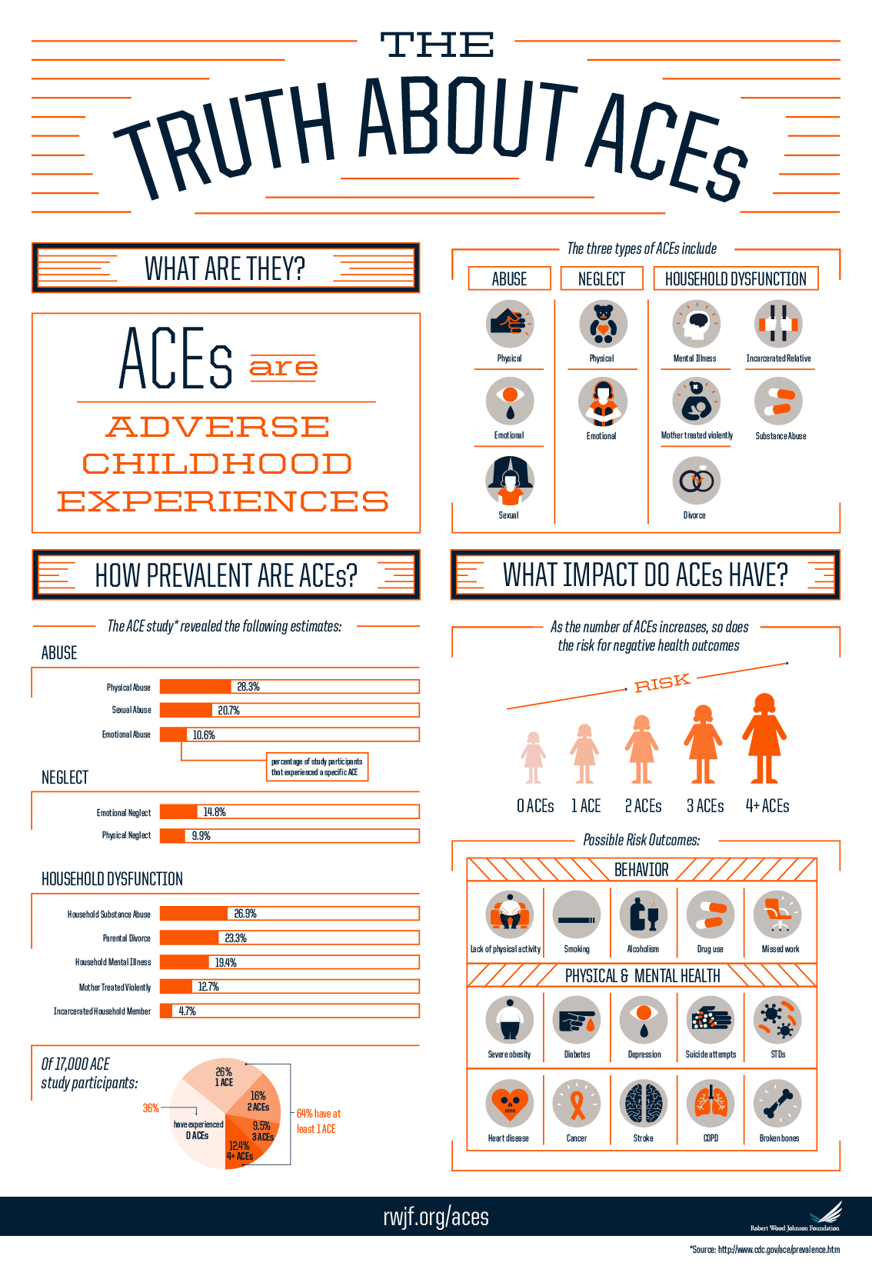

Appendix 2



