

Student Name: Vishal Singh
Student ID: 2543470

Module Name: Marketing Management
Module Code: LCMB7024

Lecturer’s Name: Sinan He

Work Count: 3000

Term 1
Table of Content
- Marketing environment analysis
- The natural environment as a Macro-Environmental Actor
- The political-legal environment as the second macro-environmental factor
- Synthesis: Interaction of the two Actors
- Strategic Growth and Competitive Positioning
- Critical Reflection on AI Usage
- Tool disclosure
- Critical environment of AI Output
- Contribution Analysis
- Ethical and professional reflection
- AI use Acknowledgement
- References

Task 1: Marketing Environment Analysis
To give an example of a business case in the field of metals and mining where a company reacts to the marketing environment through repositioning by virtue of low-carbon products, the case study of Tata Steel Limited can be used. Being headquartered in Mumbai and having the biggest integrated steel business operation in the world, Tata Steel plans to lower its emission intensity to less than 1.8 tons of CO2 per ton of crude steel in its operations in India till 2030, as well as reaching net zero emission in its UK operations by 2045 and in the Netherlands by 2050 (Tata Steel, 2024). This paper will discuss how Tata Steel reacts to the changes in the macro marketing environment regarding the natural and political-legal environments.
Natural Environment as a Macro
Environmental Actor
Kotler et al. (2024) state that the natural environment is viewed as one of the main actors which impact on the marketing strategy of the companies of today because of the presence of the necessary resources, high cost of energy, and high level of pollution, making companies face additional challenges. Speaking of Tata Steel, natural environment is both a limitation and an opportunity. As for limitations, traditional processes of steel making by blast furnaces and basic oxygen furnaces cause significant emissions – 2.0 to 2.5 tons of CO2 per ton of crude steel, while electric arc furnaces allow steel production with 70 per cent decrease in CO2 emissions (OREACO, 2026). This limitation exposes the company to the risk of damage to the reputation, asset stranding, and stakeholders' pressure who see the environmental performance as an important condition for the social license to operate (Tata Steel, 2024).
In regards to opportunities, the natural environment is making Tata Steel both reconfigure its technologies of production and its marketing proposition. The company has increased its capacity of electric arc furnaces based on scrap in India, it investigates direct reduced iron and hydrogen-based technologies in its operations in Europe, and it is building a new electric arc furnace in its UK plant with governmental aid in its transformation (Tata Steel, 2024; ATI News, 2026). Such changes in technologies are complemented with a shift in marketing, and Tata Steel is now promoting its proposition of green steel, claiming that such a technological change would allow it to cut its emissions by around 5 million tons per year, which Tata Steel converts into 2 million houses' worth of carbon footprint.
Regarding fast-moving companies like Tata Steel compared to other slow-moving companies still employing blast furnaces, the natural environment acts as a first mover advantage positioning actor with respect to green-steel certification programs, in which Tata Steel is a pioneer. Undoubtedly, there are competitive implications in that respect because the clients of carbon aware value chains, including the European-based ones, demand more and more from their partners to offer them the steel that does not produce much carbon dioxide (Tata Steel, 2024). But the force that influences the natural environment actor acts on all competitors in the industry in the same way, which means that there will be no competitive advantage derived from faster adaptation to the natural environment actor since other companies will eventually catch up and reduce their CO2 emissions equally.
Resource security is yet another aspect in the context of the natural environment actor. As stated by Grant (2016), in the case of resource intensive industries, the availability and volatility of physical inputs become strategic variables, and the same applies to Tata Steel.
Availability of scrap steel, which is the primary raw material for EAF steel, is not even distributed globally, and India, not being sufficiently advanced in collecting scrap steel, requires Tata Steel to create a capacity for scrap steel recycling along with increased EAF steel production volume, which does not apply to EAF steel producers from Europe and North America whose scrap steel recycling facilities are more advanced (IEEFA, 2024). Environmental constraint directly affects marketing, as it sets the pace at which Tata Steel will be able to produce sufficient amount of green steel for its customers, and excessive eagerness to produce green steel might be viewed as greenwashing.
The Political-Legal Environment as the Second Macro
Environmental Factor
The second macro-environmental factor is political-legal environment. According to Kotler et al. (2024), it consists of laws, governmental agencies, and pressure groups that influence and limit the activities of organizations and individuals in a specific society. The political-legal environment interacts with the natural environment since most recent legislations related to the issue of climate change deal either with pricing or restriction of the environmental externalities. One of the recent changes in this environment is the introduction of the Carbon Border Adjustment Mechanism (CBAM) of the EU in January 2026, when importers of carbon-intensive products should buy the carbon footprint certificates for their products (Whalesbook, 2026; Discovery Alert, 2026).
The implications that come from the CBAM for Tata Steel are quite significant. In fact, India is still highly reliant on blast furnace steel production, and according to independent modelling from the Indian Council for Research on International Economic Relations, CBAM could decrease India's exports of steel to Europe by about 24%, and currently, the reduction for FY25 is 35% of steel alone (ICRIER, 2026; Outlook Business, 2026). The fact that Tata Steel and JSW Steel are major suppliers of India's steel exported to Europe means that CBAM poses a business risk for Tata Steel concerning its Europe-bound revenue stream if the company does not change its production mix to low carbon processes (Mongabay, 2024). At the same time, CBAM also provides an opportunity, as decarbonization ahead of competition makes it possible to avoid the costs of certificates, which are estimated to amount to 173.8 euros per ton, and enables Tata Steel to offer itself to EU customers as a lower carbon risk option than its coal-dependent competition (Mongabay, 2024).
The same can be noted about the political-legal environment in India that fosters this approach even more. Being guided by the National Steel Policy with the focus on significant capacity increase alongside the development of the green-steel taxonomy, the Carbon Credit Trading Scheme of the Indian government, which at the moment is significantly cheaper than EU carbon prices but definitely shows the future direction of development with the introduction of carbon pricing, should be taken into account by the marketing and public affairs departments of Tata Steel (Outlook Business, 2026; IEEFA, 2024). Moreover, the government programs like Steel Scrap Recycling Policy help to decrease the cost of EAF steel production through increased supply of scrap steel and therefore solve the issue with the constraint of the natural environment (IEEFA, 2024).
Synthesis: The Interaction between the Two Actors
In total, the combination of the pressure from the natural environment and that from the political-legal environment forces Tata Steel to arrive at the same conclusion concerning the strategic orientation of the organization, that is, the operation of carbon-intensive blast furnaces can no longer be economically viable for reasons of either cost of resources and the cost of reputation or increasing exposure to CBAM costs. From the perspective of stakeholder expectations management, Freeman’s (1984) position on the need to manage the expectations of those groups that can influence or be influenced by the organization’s activities is relevant here: the company faces several simultaneous pressures from regulators, investors, customers, and local communities and must coordinate the marketing function’s response to them.
Tata Steel’s response to the challenge is an example of how the coordination works. Investing more in the electric arc furnace technology in India, testing hydrogen and direct reduced iron technologies in Europe, and establishing the brand image of green steel in the respective markets are all examples of how this big industrial corporation is transforming the converging pressure of nature into its marketing and competitive strategy. The only risk in this case may be the speed, as Tata Steel will need 2045 and 2050 to switch to its low carbon business model in connection with its international operations, and it is probably too late given the dynamics of increasing CBAM costs and specification from customers.
One should bear in mind critically that the pressures of the two actors may not necessarily coincide with each other. The political and legal instruments such as CBAM are designed to be regional, which means that they will be able to distort the competitive balance in unpredictable ways compared to the logic of the natural environment, for instance, CBAM is expected to increase the profitability of EU-based steel producers because of the repricing of the imports, and the Tata Steel's European subsidiary will take advantage of the same instrument that punishes Tata Steel's Indian export volumes (Whalesbook, 2026). This example illustrates why the marketing strategy should not be limited to one environmental actor and why the corporate communication should be developed especially for the target market. In order to market the same decarbonization program of Tata Steel in India in a context of the high costs and in Europe in the price-protected market, the company should take into account this nuance. This understanding presents the next strategic challenge discussed in the following section with the use of the Ansoff Matrix.
Task 2: Strategic Growth and Competitive Positioning
Following the environmental analysis done above, the next stage would be to use the Ansoff Matrix (Ansoff, 1957) to make recommendations concerning the strategy that will be used for the growth of Tata Steel while moving towards the lower carbon business model. The Ansoff Matrix discusses growth strategies based on two dimensions: product and market. It has four possible options including market penetration, market development, product development, and diversification. These strategies involve different risks and resource requirements and Grant (2016) says that the decision about them should be based on the capabilities of the company, not their novelty. Specifically, the purely market penetration approach, that is, selling the existing carbon-based steel in the same markets more aggressively, should not be used. Given the costs and specifications that have been identified in the context of the CBAM in Task 1, penetrating the markets with the existing product line offered by Tata Steel would result in even greater exposure to carbon-related costs and risks for the company, which would be the opposite of what the company needs. Furthermore, venturing into completely unrelated business areas is not advisable now, because this approach would dilute both the management attention and capital of the company in the race for the green steel production.
The strategy that will be outlined in what follows below comprises aspects of product development and market development. As far as product development is concerned, Tata Steel needs to expedite the introduction of its certified low-carbon steel grade, launching the Optimism product range on the basis of the planned EAF and hydrogen-based capacities in order to offer it separately as an exclusive product range and not as a replacement of the conventional product (Tata Steel UK, 2026). In doing so, Tata Steel will be able to capitalize on the fact that the purchasers will be willing to pay an extra cost due to the low-carbon footprint of the product, which will be a necessity in the future auto manufacturing and construction industries.
Speaking about the development of the market, Tata Steel must be oriented at penetrating into the markets with the demand for green steel rather than ensuring its current level of exports to the EU regardless of the expenses necessary to achieve it. It was shown in Task 1 that Indian steel producers have started redirecting their exports from Europe to the Middle East because of easier conditions for the sale of carbon-intensive products that are now refused in the EU and also due to new market opportunities in Africa and Latin America (GMK Center, 2025; Outlook Business, 2026). In turn, the opposite to this approach will be market development strategy implying the sales of green steel to the EU with mandatory CBAM compliance and conventional and transitional products to carbon-insensitive markets.
Apart from this, the above strategy also fits the competitive advantage theory, as proposed by Porter (1985), through the concept of generic strategies. Instead of competing on cost alone, which is becoming difficult in India against the integrated EU competitors because of CBAM, it would be better for Tata Steel to adopt a focused differentiation strategy for its export products through green steel production through their low carbon emissions while maintaining cost leadership position in the large domestic Indian market, in which cost is the sole motivating factor for buying (Tata Steel, 2024). This positioning strategy suits the performance segmentation of Tata Steel, in which growth in Indian operations has contributed to their profitability in recent years but operations in Europe still need support (Whalesbook, 2026).
Nevertheless, the mentioned strategy has certain risks that can arise during its implementation. Firstly, it requires considerable investments into EAF and hydrogen production capacities; moreover, as per Tata Steel, the path of green hydrogen production still remains costly when compared to conventional production, and therefore, the overinvestment before the buyer becomes ready to buy the green products may negatively impact the return on investment (IEEFA, 2024). Secondly, there are certain constraints of scrap availability for further capacity expansion in India that may impede Tata Steel's ambitions in regard to new products, and therefore, the company should make investments in a phased manner in line with the offtake agreements with key buyers. Still, generally, the strategy of product development together with the market development is more resistant to competitive advantage than penetration and diversification strategies due to its focus on the transformation of environmental regulatory factors into competitive advantage.
For the realization of the strategy described above, the Tata Steel marketing team needs to track only a few relevant indicators associated with the environmental factors described above: market share of certified low carbon steel sold under premium contracts, market share of EU-bound exports with low-carbon steel certification for the upcoming CBAM pricing period, and the percentage of secured scrap feedstock to develop EAF capacities in India. This will give the Tata Steel company an opportunity to adjust its capital investments according to the demand and not following any set timeline, thereby protecting itself from any stranded assets in the case when premium demand develops more slowly than expected, yet preparing itself for rapid response as soon as certain groups of customers, for example EU automotive and construction companies, require it.
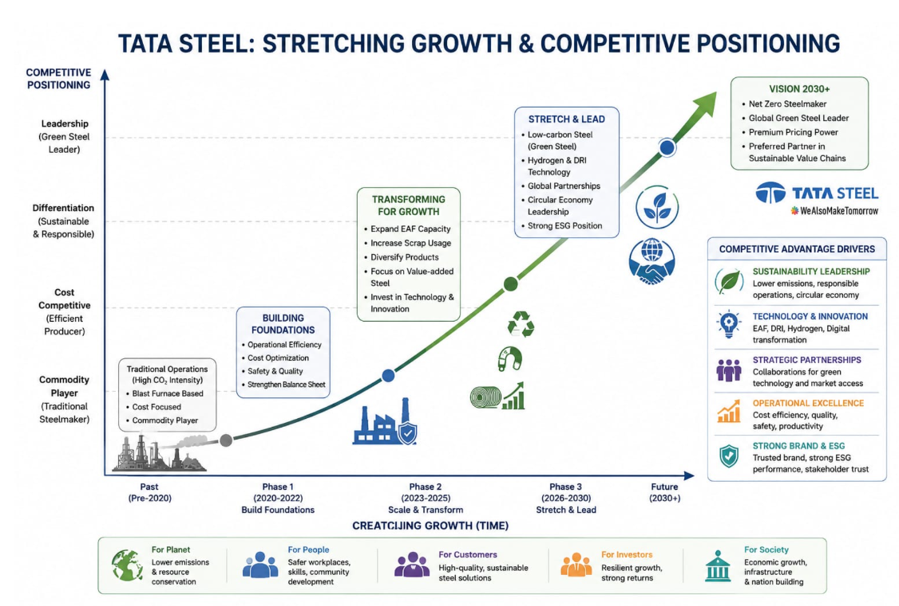

Task 3: Reflective Critique on AI Employment
Disclosure of Tools Used
Generative AI (Claude, Anthropic) was used in the process of creating this report at three clearly defined stages of work according to the assessment's conditions of Generative AI use. Specifically, Generative AI was used to facilitate research of available and recent data regarding decarbonization strategy of Tata Steel and EU Carbon Border Adjustment Mechanism and to summarize the information obtained; such data sources were verified independently for credibility and chosen. Furthermore, Generative AI was used to check the correctness of grammar, sentence structures, and language of this text. Moreover, formatting of this document was partially facilitated by Generative AI. According to the assessment's guidelines, AI was not used to create the structure and original content of Tasks 1 and 2.
AI Output Critique
The information that was generated by the AI tool was regarded as a starting point rather than the final product. Each fact mentioned in relation to the research with AI assistance (such as carbon emissions, cost of CBAM, and the company's goals, etc.) was re-checked using the cited references in the report. By this method, any discrepancy and error, including overgeneralization of numerical data, could be spotted in the summary of original research results by AI (e.g., AI erroneously summarized Tata Steel's 26% worldwide reduction goal for 2030 as its target for 2045-2050 UK and Netherlands operations). The problem was solved by referring to the actual data sources of the company, distinguishing Indian and UK/Netherlands emission intensity/net-zero targets.
Contribution Analysis
The role of AI was to find the relevant sources, summarize them and proofread the language used. The argument structure, the identification of Natural Environment and Political/Legal as the two most significant factors, the argument related to the relation between the influence of CBAM on the company and the recommendation offered based on the Ansoff Matrix of the company, as well as the consideration of the risk involved and potential performance measures for CBAM-related activities, are all generated by me based on the readings I did independently from the sources provided in the module. Whenever any sentence created by AI is used, it is rephrased and edited to ensure that the argument and conclusion are my own.

Reflection on Ethics and Professionalism
The use of AI in completing a marketing analysis assignment creates some very real ethical dilemmas, which extend well beyond the context of this particular report. Overreliance on summary information provided by AI without additional checks may lead to incorporation of inaccurate and out-of-date data into the professional analysis, which might be particularly dangerous in case of analyzing a strategy, used in the business reality and informing investment decision-making process. In general terms, it raises questions of academic integrity, as the use of AI makes research easier and improves the language significantly, however it cannot replace the critical thinking, which is developed through Level 7 postgraduate study. The method chosen for completing the assignment by using AI in research and proofreading, while still being the only author of the analysis presented in this report, is my conception of the reasonable standard of using AI in the professional practice.

AI Use Acknowledgment
While conducting this assessment, Generative AI (Claude, Anthropic) was utilized for the purpose of helping in the research process (in terms of finding and summarizing credible sources which have been independently verified) as well as in the proofreading process (of my own original writing) in line with the permission accorded by the assessment’s Generative AI declaration. AI was not used for structuring the report or for coming up with the analysis in Tasks 1 and 2.

References
Ansoff, H.I. (1957) Strategies for diversification. Harvard Business Review, 35(5), 113-124.
ATI News Team (2026) Tata Steel UK launches construction of electric arc furnace in Port Talbot for green transformation. S&P Global AutoTechInsight, 14 July.
Discovery Alert (2026) CBAM Framework: Carbon trade transformation 2026. Available at: https://discoveryalert.com.au/cbam-framework-carbon-trade-transformation-2026/ (Accessed: 20 July 2026).
Freeman, R.E. (1984) Strategic management: a stakeholder approach. Boston: Pitman.
GMK Centre (2025)
Grant, R.M. (2016) Contemporary strategy analysis: text and cases. 9th edn. Chichester: Wiley.
Indian Council for Research on International Economic Relations (ICRIER) (2026) Carbon Border Adjustment Mechanism (CBAM): effects on India's steel exports to the EU and carbon taxation. New Delhi: ICRIER.
Institute for Energy Economics and Financial Analysis (IEEFA) (2024) Decarbonizing steel production in India. Cleveland, OH: IEEFA.
International Energy Agency (IEA) (2024) Technology roadmap on iron and steel: moving towards sustainable steel production. Paris: IEA.
Kotler, P. and Keller, K.L. (2016) Marketing management. 15th global edn. Harlow
Kotler, P., Armstrong, G., Harris, L.C., & He, H. (2024) Principles of marketing. 19th
Source: Mongabay India (2024) 'Indian steel exports could take a beating as EU fences its carbon borders'. Available at: https://india.mongabay.com/2024/12/
OREACO (2026) "Tata Steel's pioneering conversion to the electric arc furnace". Available at: https://www.oreaco.com/news-
Outlook Business (2026), ‘EU CBAM: a wake-up call for Indian steel units to decarbonise’. Available at: https://www.outlookbusiness.com/magazine/eu
Porter, M. E. (1980). Competitive strategy: Techniques for analysing industries and competitors. New York: Free Press.
Porter, M. E. (1985). Competitive Advantage: Creating and Sustaining Superior Performance. New York: Free
Integrated report and annual accounts of Tata Steel (2024). Mumbai: Tata Steel Limited.
Tata Steel UK (2026) Green Steel Future. Available at: <https://www.tatasteeluk.com/green
Whalesbook (2026) "Tata Steel Surges on India Strength, Europe Faces Policy Gap". Web. Available from: <https://www.whalesbook.com/news
Report on sustainability indicators 2024. World Steel Association (2024). Brussels

