

Community Profile

This community profile will be hugely focused on Carmarthen with a view to people from local areas travelling into the town, and the facilities that it has to offer the young people living in and around the area. This will be an opportunity to consider its social assets as well as its social deficits, and ways in which they can be adjusted to make for a more positive experience for young people living in Carmarthen.
The opinions of young people in Carmarthenshire will be taken into consideration, while also looking at statistics that cover Carmarthen and Carmarthenshire.

Location and Environment
Carmarthen is the historic county town of Carmarthenshire; the town is built next to the river Towy and is around a 26-minute walk from the local hospital (Glangwili), around 4 minutes by car. It’s a relatively busy town; some say it’s the oldest town in Wales.
Carmarthen castle can be seen opposite the river.
Carmarthen town is an agricultural town with the market, shopping centres and many places to dine.
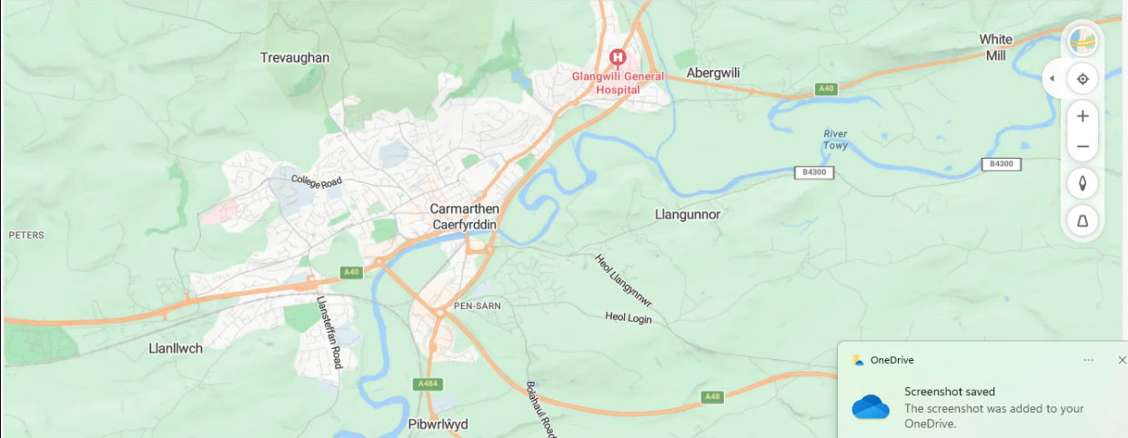

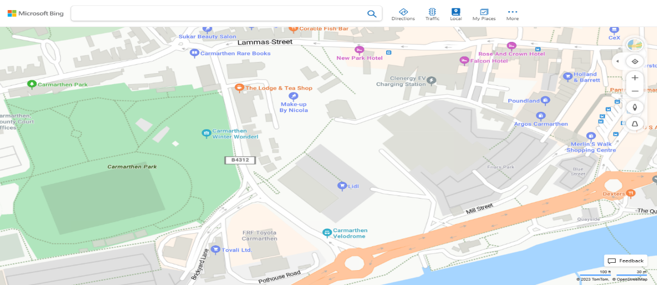

Population Data
According to The Office of National Statistics (2022), Carmarthen had a population of 14,600, with an estimated 2,642.6 being young people aged between 10- 24 years.
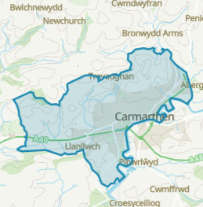
According to the Office of National Statistics (2022), 9.9% of 16- 18 year olds living in Carmarthenshire in 2021, were considered NEET (not in education, employment, or training), in comparison to 2020, when 7.9% of young people were considered NEET. An explanation for the rise in young people considered NEET was because of covid, there were less jobs available due to businesses that closed during the pandemic and less people embarking on training courses.
As reported by Carmarthenshire County Council [hereafter CCC], (2022), Carmarthenshire had 155,486 residents in 2021, from the age of 16 and above, 31,165 of these (20% of the population) held no qualifications at all.
Figures also show that all Carmarthenshire residents from the age of 5 and above gave a population of 178,840. 17.9% of this population were classed as being a student in 2021.

Economy and Labour Market
CCC (2023) reported being the largest employer in Carmarthen, employing 8,300 members of staff, offering work opportunities to include teaching, care workers, sports facilitators, and highway maintenance workers.
While CCC do provide opportunity for young people to engage in apprenticeship’s, allowing them to learn a trade, at the time this community profile was carried out in January 2024, there were no current vacancies being advertised. There were also no vacancies for the Graduate Scheme being advertised.
Hywel Dda University Health Board [hereafter HDUHB], (2022) reported having 14,328 employees in 2021, with 6,257 of these being based in Carmarthenshire. Employment opportunities within HDUHB are varied roles, to include Doctors, Nurses, Health Care Support Workers, Laundry, and Domestic staff and admin-based roles.
HDUHB had no current apprenticeship vacancies during January 2024, however, they did report on social media in December 2023 that they had conducted school visits within their catchment area, promoting volunteering opportunities and the careers on offer to young people, they assisted with mock interviews, aiding young people with interview experience and employment skills.

Infrastructure
Carmarthen has key roads that link to the wider areas, to include Swansea, Cardiff, Ceredigion, and Pembrokeshire, with bridges overlooking the river Towy.
Towy Bridge is the first bridge which has an exit to Carmarthen railway station.
According to Transport for Wales (2024), the station opened its doors in 1902 and now has almost half a million commuters through its doors every year. The station has links to include Llanelli, Swansea, Cardiff, and Pembrokeshire.
The King Morgan Bridge is a pedestrian bridge that allows pedestrians to walk across to Carmarthen town from the train station.
Carmarthen Bridge has links to main roads that are accessible via bus, these roads give access to the M4.
Carmarthen Bus station has buses that travel to surrounding areas and beyond, with many of these services offering regular journeys.
As explained by CCC (2023), a ‘my travel pass’, allows all young people between the ages of 16- 21 years a 30% discount on all bus travel.
As CCC (2023) report, there are 12 secondary schools based in Carmarthenshire, two of these being in Carmarthen itself- Bro Myrddin and Queen Elizabeth.

Social Assets
There is a Youth Club close to the town centre, called Carmarthen Youth Project (Dr M’z), they provide opportunities for young people.
Carmarthen Park has a large play area for children of various ages, which leads on to a skate park, rugby field, velodrome, outdoor gym, and walkway.
Carmarthen Leisure Centre has its own athletic track along with a swimming pool, gym, and various fitness classes.
Carmarthen Reservoir offers a walkway, decorated by the young people living locally, with fairy houses.
The Lyric is home to Carmarthen and District Youth Opera, for young people that want to be involved in performing arts.

Social Challenges
Having held discussions with young people living in and around Carmarthen, and conducting an online survey, it has been highlighted that the cost is the greatest challenge:
Young person A said, “Loads of stuff in town is dead expensive, so you might do it a few times then you don’t have money”. A few agreed with young person A, providing similar comments. Having reviewed prices for many of the assets within the town, many of them do charge, some that are not cost friendly for young people, unless parents or carers can help with the cost.
Young Person B said, “I would like Carmarthen to have more job spaces for Younger people”. Having looked at what some local employers are able to offer young people, there does not appear to be many employment opportunities.
Young Person C commented- “Definitely need more sports clubs that aren’t a massive treck to get to”. This comment was made by a young person living outside of Carmarthen that travels into the town.
Many young people were unaware of opportunities provided in Carmarthen, some not attending a Youth Club or engaging with a youth worker.

Conclusion
Having reviewed many assets in Carmarthen, with many young people unaware of them, it is suggested that better advertising, and advertising in the right places (e.g. social media), might help, as well as advertising in schools, colleges, and youth clubs.
Following the engagement with young people who enjoy the sports facilities, but often can’t afford to go, a better discounted price or free for young people who are in education is a suggestion.
Many young people like to earn their own money, while Carmarthen do have work opportunities for young people, young people between the ages of 13- 17 years find it more difficult to seek employment. As youth workers, holding conversations with local employers, to give young people a voice, would benefit the local young people, who are eager to work.
The discount for young people travelling via bus, is a great opportunity for young people travelling around Carmarthenshire, as are the volunteering opportunities with the health board.
It would be beneficial for local youth workers to visit schools and colleges to engage with young people and inform them of opportunities available in Carmarthen and to provide knowledge on the local youth club.


Reference List
Carmarthenshire County Council [CCC] (2023) Bus Services. Available at: https://www.carmarthenshire.gov.wales/home/council-services/travel-roads-parking-bus-services/ (Accessed:12th January 2024).

Carmarthenshire County Council [CCC] (2023) Carmarthenshire Local Well- being Assessment. Available at: https://www.carmarthenshire.gov.wales/home/council-democracy/research-statistics/carmarthenshire-local-well-being-assessment/ (Accessed: 12th January 2024).

Carmarthenshire County Council [CCC] (2023) Education and Schools. Available at: https://www.carmarthenshire.gov.wales/home/council-services/education-schools/find-a-school/secondary-school/queen-elizabeth-high/ (Accessed: 10th January 2024).

Hywel Dda University Health Board [HDUHB] (2022) Appendix 4: Key Workforce Findings. Available at: https://hduhb.nhs.wales/about-us/your-health-board/board-meetings-2021/board-agenda-and-papers-27-january-2022/agenda-and-papers-27-january-2022/appendix-4-hywel-dda-university-health-board-key-workforce-findings (Accessed: 14th January 2024).

Office for National Statistics (2022) Census 2021: Build a custom area profile. Available at: http://www.ons.gov.uk/visualisations/customprofiles/build/ (Accessed: 21st January 2024).

Transport for Wales (2024) Stations Carmarthen. Available at: https://tfw.wales/places/stations/carmarthen#toc-qtt-widget (Accessed: 14th January 2024).

