
Skills for the Workplace
Module Assignment Submission
Student Name: | Emma-Jayne Newell
Student Number: | 1708897
Module No: | BMSK5006
Module Title: | Knowledge and Information Management Skills for the Workplace

Statement of Confirmation of Authenticity
By the act of making this submission, the student declares that this is the work of the student named above. The work has not, in whole or in part, been knowingly presented elsewhere for assessment, or where assessment has been built on a previous assessment, this has been identified. Where materials have been used from other sources it has been properly acknowledged. If this statement is untrue, the student acknowledges that an assessment offence has been committed.
Attention is drawn to the plagiarism and unfair practice policies of both the University and of ILM.
Permission for ILM to use this script
ILM uses learners’ submissions – on an anonymous basis – for assessment standardisation. By submitting, both the centre and the learner agree that ILM may use this script on condition that identifying information is removed. However, if you are unwilling to allow ILM use this script, please refuse by ticking the box: □

Table of Contents
Introduction 3
1.0 Provide an evaluation of the concept and importance of knowledge management in the context of an organisation’s knowledge assets 3
Data, Information and Knowledge. 3
The relationship between individual knowledge and organisational knowledge 3
Modelling techniques that identify knowledge assets. 4
Evaluate actual and potential knowledge assets. Provide a rationale for capturing and managing knowledge. 4
2.0 Demonstrate an understanding of important knowledge management processes in the context of organisational development 5
What is required to create, store, apply and integrate knowledge? 5
The importance of Intellectual Property rights 6
3.0 Provide a framework for establishing a knowledge management culture 7
Knowledge Assets within the workplace. 7
Organisations framework for enabling knowledge sharing 7
What improvements can be made to the current framework? 8
Conclusion 8
References 9
Appendix 1 10
A – People, Process, and Information Model 10
B- The SECI Model 10
Appendix 2 11
A – Knowledge Management Cycle 11
B – Information Flow Chart 11
C – Registered Trademark Symbol 11
Appendix 3 12
A – Knowledge Assets 12
B - Communities of Practice. 12

Introduction
Within this assignment the student will discuss Knowledge management through the workplace. There are several aspects to knowledge management. Where do we get knowledge from? What is Knowledge? Within this assignment, the student will also demonstrate their understanding on Data, Information and Knowledge. As organisations need to evaluate their sources to ensure that they are performing to the best of their ability, the student will also perform a SWOT analysis within their workplace to determine what areas need to be managed. They will also evaluate how Information Management and Knowledge Management can benefit an organisation and how sharing and utilizing information can provide an organisation with advantages.

1.0 Provide an evaluation of the concept and importance of knowledge management in the context of an organisation’s knowledge assets

Data, Information and Knowledge.

Within an organisation Data, information, and knowledge build a learning sharing system which can provide an organisation with structure. Each element connects to one another in order for a process to flow but when are looked at individually can cause problems and not make sense. On its own, Data has no structure. It is full of numbers, letters, or symbols i.e.,24/04/1987. When data is explained, such as the data entered 24/04/1987 is a date of birth, it can be transferred from data with no meaning to information.
Information is data that has been evaluated in a significant way to become useful. Even though the information has been managed, it still has very little value. By adding more information such as a Name it changes the outlook to an employee in which they can understand the meaning of the information in which creates knowledge.
With all the data and information assembled, using knowledge allows an employee to elaborate on these and learn. By using knowledge, it causes a person to be aware and have an understand on the topic. Knowledge and Information can be composed into Three components to build Knowledge management. These components are People, Technology and Process. (Appendix 1 – A) . As people are the main holders of knowledge, organisations should be aware that they are an essential asset to helping an organisation progress. When using this process, it supplies results on constant learning and makes use of knowledge, information, and experience.
The relationship between individual knowledge and organisational knowledge.
Individual knowledge and organisational knowledge can be linked together but are equally different. They are part of a learning cycle. For example, the SECI Model (Nonaka, I. 1990) shown in Appendix 1 – B shows how Tacit and Explicit knowledge can be converted into Organisational knowledge.
Individual knowledge is knowledge that is stored in each person’s head. This knowledge can be acquired by on-the-job training, shadowing a colleague or storytelling. There are shortcomings to individual knowledge such as it leaves when the owner leaves. It can also cause errors within the progression of work. To overcome obstacles, you can create a guidebook/training manual which enables staff to confirm information and it can also help staff members who do not know certain information gain the knowledge in which this can be transformed from Tacit knowledge to Explicit Knowledge.
Organisational knowledge is a quantity of knowledge controlled within the organisation. It can be hard to exchange or hold this knowledge unless you have the ideal resources. There are a few types of Organisational Knowledge. For example, some of them are, Know-How, Tacit Knowledge, and Explicit Knowledge. Sometimes within an organisation only limited number of staff may know specific tasks. As stated above, an organisation can lose knowledge if an employee exits. Space (2017) Stated that ‘’ Organizational knowledge is prone to waste and loss’’.

Modelling techniques that identify knowledge assets.

Knowledge assets can be hard to grasp. For an organisation to succeed they need to identify what assets are valuable within the company. There are different types of knowledge assets such as, Human Knowledge, Structural Knowledge and Market Knowledge. Investors acknowledge the value of a company with the growth of their knowledge assets. Organisations can perform SWOT analysis, PESTLE and K-SWOT analysis so they are able to find indicators of the value to an organisation.
To identify these assets within my workplace, I have performed a SWOT analysis
STRENGTHS | WEAKNESS
- Oral Communication between members of staff  - Researching price and quality of products  - Trustworthy Staff members  - Loyal Customers  - Preparation time provided | - Lack of technology – i.e., Card reader  - Limited number of Staff trained in all aspects of work.  - Limited Online Presence  - No Online ordering system  - No Official work schedule for all employees to see
OPPORTUNITIES | THREATS
- Grow Presence on Social Media  - Provide training for staff in all work areas  - Obtain additional equipment for events i.e mobile van  - Create/ offer new products | - Competition  - Weather  - Potential staff sickness and possible resignation  - Equipment Failure

Evaluate actual and potential knowledge assets. Provide a rationale for capturing and managing knowledge.

As shown in the SWOT analysis above, one of the Weaknesses that can become an opportunity is the online presence of the company. At present the organisation has a direct website and a Facebook page. The page is not updated as often as other organisations. By posting offers and information on the current services the organisation has it can draw in potential clients. As the organisation deals with take-outs, at present orders are only taken by face-to-face or phone calls, it would be beneficial for the organisation to create an online ordering service via company website or via a food delivery service, i.e Just Eat/Uber. The organisation could promote that if a client ordered online, they could receive a discount or promotion. This process is not only beneficial for clients to process an order quicker but by using the online service they could potentially order more that they would originally. It also gives employees more time to process current orders than having to delay them by stepping away to take new ones.
Whilst creating a presence online, another benefit for the organisation is that they can discover information regarding competitors. By doing this the organisation can confirm what offers a competitor has available, do they offer the same products/ services as us? Are the products equal or better than ours? Do we have the best prices available? Although there are always other organisations who offer what we do, by staying vigilant it enables the organisation to be prepared for anything.
Another Weakness the organisation has is that not all members of staff are trained in all aspects of work. The student’s organisation is based in three locations. Several members of staff work in all locations but have only been trained on certain aspects of the job which limits them to fulfil all the daily responsibilities/tasks within the workplace. For example, two members off staff have been trained how to use specific catering equipment within one location. If one staff member is working in a different location and the other is off due to sickness or annual leave, there is no-one else available to continue with this task. If additional members of staff are trained on this task, it enables them to proceed with the duty and does not put a stop to the current work.

2.0 Demonstrate an understanding of important knowledge management processes in the context of organisational development

What is required to create, store, apply and integrate knowledge?
When looking into a business, Knowledge Management (KM) is a vital part of an organisations work process. Some organisations use a four-stage process (Appendix 2 -A) that can ensure that completing a task is efficiently managed. By using this process, it can also enable a company to discover if the current process is being used in the most efficient way possible, if there are any complications that need to be reviewed and adjusted and if it is still relevant.
For an organisation to deal with data and information it can be processed through an information flow chart (Appendix 2 – B). This can be beneficial to an organisation as it enables them to not only protect the data but have easy access to it when needed. For example, an organisation may have a spreadsheet of external client information which includes names, addresses, product order and distribution dates. If an e-mail is received by a client who wishes to confirm the date for the order, an employee can access the database to then confirm the information for them.
There are various ways in which data can be received in an organisation. Some examples are E-mails, Newsletters, Policy documents, Instant messages such as WhatsApp or I. Messenger and even Face-to-face meetings. Many organisations still use fax machines and receive information via post (paper form). When the document is received via paper form it cannot be changed but can also be entered into the electronic system incorrectly. There is also a chance that the document could be misplaced or even forgotten about. Fortunately, with the new technology available the document can be scanned onto a system so if the paper form is lost there is a copy. With working with electronic documents, it can be moved through and processed quickly but there is also a chance that it can be deleted within seconds. It is beneficial for an organisation to have the information electronically as it can flow efficiently though and out of an organisation and makes it accessible for several employees when needed.
When evaluating information that is received within an organisation it is necessary that actions are taken to evaluate the material. An organisation needs to determine where did the information come from? Is it credible? How can it be used within the organisation or can it be implemented? Sometimes, organisations may not capture information as the source it was delivered from is not a reliable one. Even if the source is not reliable, it is always worth the organisation looking into it internally as they could discover the material or even part of it is reliable.

The importance of Intellectual Property rights
Within the workplace, it is important to protect personal and confidential data. Companies follow the DPA (2018) which insures new and existing clients that their information will be secure.
There are various types of legal mechanisms that can protect a company’s data. They include Copyright, Trademarks and Patents.
Copyright protects the product that your company has prevents anyone from using it without your clearance. It blocks people from showing your work in public or adapting the primary work.
Trademarks protect symbols, i.e., official signs, flags, or hallmarks. Some company’s names do not always qualify for a trademark. If your company has a trademark, it enables others from using similar logos. When companies apply for a trademark and it is accepted to which it becomes a registered trademark (Appendix 2 – B)
Patents are granted by the government to a person/company for an invention giving them the right to prevent others from using said product etc from using, making, or selling it without their permission. When the person/company has been granted the patent, it can be rented or sold.
It is also important for an organisation to ensure that legal and policy documents are up to date. For example, within the student’s organisation, there are several documents that are required to run the business and insure the company’s protection. These are.
Employers’ liability: This ensures that the organisation compensates employees if they are to get injured or sick due to a business activity.
Gas Safety checks/Certificates; This verifies that any equipment usage is safe to use
Retail and Concessions and Environmental health; Checks are made within the organisation and workspace to ensure that the facilities are safe to use. Each employee is also required to have a level 2 Food hygiene certificate which enables them to work and handle food within the safest way possible.
If the student’s organisation did not have these legal documents within place, the organisation would not be able to continue providing services and possibly occur a fine or be closed until further notice.

3.0 Provide a framework for establishing a knowledge management culture

Knowledge Assets within the workplace.

Knowledge assets is information within an organisation that can cause an organisation to become more valuable. There are different actions that an organisation can follow to produce benefits for the organisation. Some of these actions include: Databases, textbooks, principles, formulas, and Client intelligence. It is important for an organisation to manage its knowledge assets. By identifying the individuals with the required knowledge, not only internally but externally it enables on organisation to assemble resources that are valuable to the firm.
There are processes that a manager can implement within an organisation to manage knowledge assets (Marr, B., Schiuma, G. 2001). By implementing this structure (Appendix 3 – A) it enables the organisation to manage and measure each asset which contributes to the development of an organisation. Additional processes that an organisation can use to enhance knowledge management are:
- Internal and External Feedback; By receive feedback from clients regarding a product and ordering process, it enables an organisation to evaluate if the current process that is implemented is the sharpest and most efficient way or if any adjustments need to be made.
- Research and development; By researching competitors and evaluating new and current products/work systems, it enables the organisation to keep their customers and possibly win additional customers.
- Review current products; By reviewing current products that an organisation has it ensures that the current quality of the products is the same as they were before or even better. It can also determine if you are getting the best value for the product. i.e., visiting or contacting new suppliers to see if the same product quality is out there for better value.
There are two types of knowledge. They are Tacit which is knowledge that is collected within your mind and Explicit which is recorded via manuals, leaflets etc so that others may access and use it. As stated Previously in section 1 the SECI model (Nonaka, I. 1990) expresses about Tacit and Explicit knowledge. Tacit knowledge is difficult to confine as it if someone has the knowledge, they may not wish to share it. The Knowledge they consume may also be incorrect. Explicit knowledge is supposedly available for anyone.

Organisations framework for enabling knowledge sharing

Within an organisation there are different formats to how knowledge is captured and shared. Organisations have different ways of Sharing information within a workplace. For example, if there is a new employee some companies provide them with a training manual that includes all information on how to work a system or process any client information. The training manuals would have been created by a manager reviewing an employee’s daily task and writing down a step-by-step guide to the process. With an organisation having the training manual, if an employee notices that the process they are using can be used differently or is no longer relevant, they can provide this information to the managers so that the correct this for future employees. By using knowledge sharing within an organisation, it allows others to contribute and generate new ideas which can strengthen own knowledge.
When it comes to Knowledge sharing there are some obstacles that can have an impact on conveying knowledge. Some of these could be that an employee lacks trust within the workplace and is not willing to share or receive information, different cultures and vocabularies and lack of desired time and meetings. Some organisations may have Motivational Limitations in which when issues are tackled it allows communities of practice to grow (Appendix 3 -A) Wenger, McDermott, et al (2002) stated ‘’Communities of practice are groups of people who share a concern, a set of problems, or a passion about a topic, and who deepen their knowledge and expertise in this area by interacting on an ongoing basis”.
Another aspect of knowledge sharing is when to know who to share the information to and when. Many organisations use the Influence – Interest Matric (Mitchell et al. 1997). This gives organisations indication on who to tell and when. For example, if there is a problem with an ordering system, it is important that firstly managers should be made aware so they can inform I.T to fix the problem, employees so they are aware of the reason they are not receiving orders and Clients/Customers so they can either order a different way (Phone of E-mail) or hold off until the problem is fixed.

What improvements can be made to the current framework?

When looking into the student’s organisation, at present, when a potential client contacts the organisation regarding a booking, all information is logged via paper form. Only a few employees know where this document is and can access it. By doing this it can cause a problem if the employee is away from work and if this document is misplaced. The student suggests that the organisation creates a one drive account which can be accessed by employees when on company premises and the owner. With this being formed an order spreadsheet can be created which will include all information for previous and new clients and their new, outstanding, or previous orders. It not only will ensure that the document is not misplaced but can organise additional documents such as creating a tab for suppliers containing contact information, prices and orders placed with them and employee information such as contact numbers, addresses for pay slips and national insurance numbers.
Another improvement that can be implemented regarding creating an electronic spreadsheet is a work schedule/annual leave document. At present, the student’s organisation does not have a document with each employee’s schedule. The owner of the organisation is the only person who knows everyone’s work schedule and who is on annual leave or sickness. By creating a monthly work schedule, each employee can confirm the days and times that they are working. They will also be able to view how many days of annual leave they have available to take and what dates other employees are on annual leave so that if they needed time off, it shows if the date is available for them or not and who is available to cover their days to have the time off.

Conclusion

Organisations have various ways to how they gather and share knowledge. Some organisations may use knowledge cycles, and some may not but it is essential for an organisation to recognise that certain tasks are required to create and retain a successful organisation.
As many organisations has different ways of dealing with daily tasks, how they manage their staff responsibilities and dissolving problems, they have one thing in common. They want the best for their organisation and to produce a functional and productive way of working.

References

Marr, B. Schiuma, G. (2001): Measuring and Managing Intellectual Capital and Knowledge Assets in New Economy Organisations, in Bourne, M. (ed.), Handbook of Performance Measurement, Gee, London.
Mitchell, R.K., Agle, B. R., and Wood, D.J., (1997). Toward a Theory of Stakeholder Identification and Salience: Defining the Principle of Who and What really Counts. New York : Academy of Management Review
Nonaka, I. (1990). Management of Knowledge Creation. Tokyo: Nihon Keizai Shinbun-sha
Spacey, J. (2017). 8 Types of Organizational Knowledge. https://simplicable.com/new/organizational-knowledge.
Wenger, E., McDermott, R. & Snyder, W.M. (2002). Cultivating communities of practice. Boston, MA: Harvard Business Press,

Appendix 1

A – People, Process, and Information Model
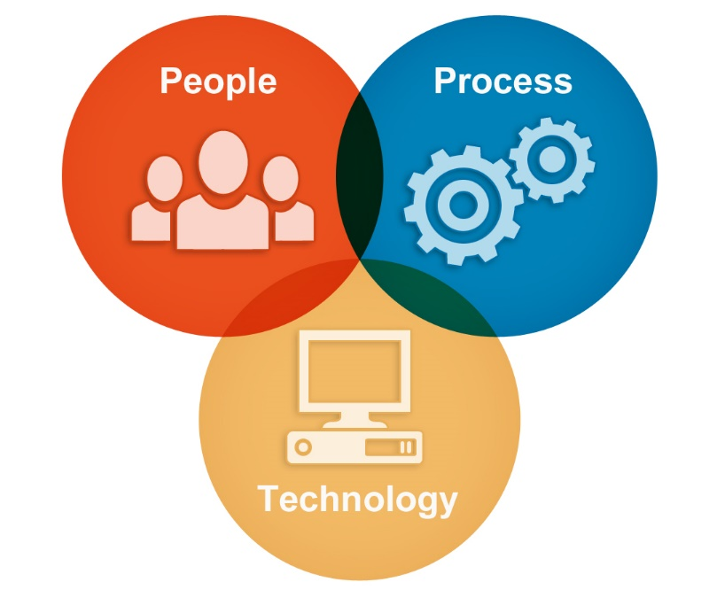

B- The SECI Model

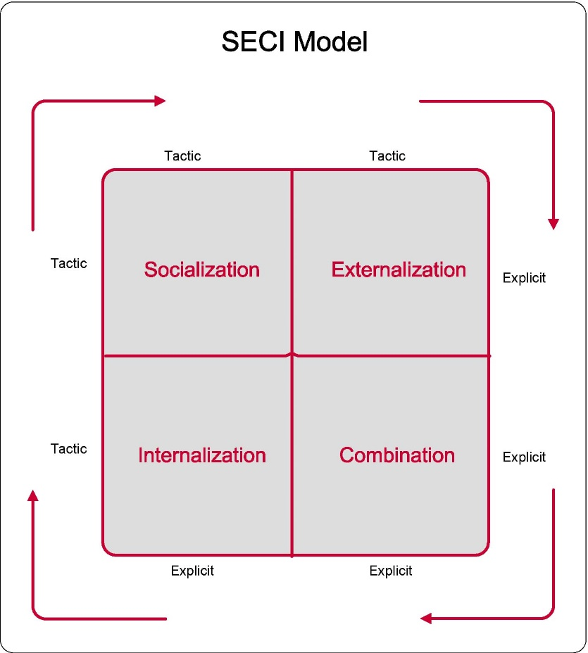

Appendix 2

A – Knowledge Management Cycle

B – Information Flow Chart
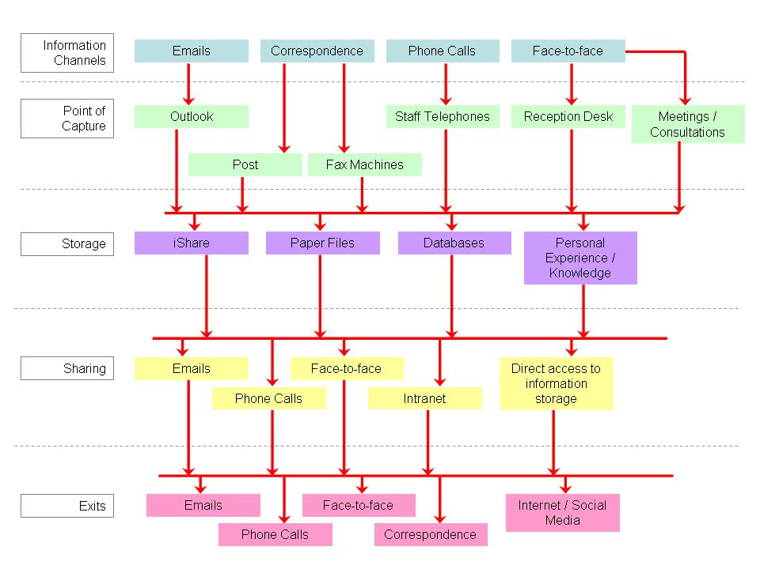

C – Registered Trademark Symbol


Appendix 3

A – Knowledge Assets

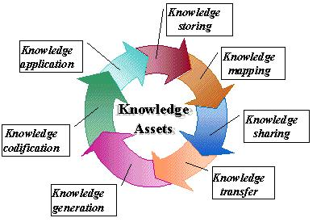

B - Communities of Practice.

