Components 1
Coursework Portfolio
Name: Charlie Layson
Student ID: 2541896
Module Software Solution for Business
Module code: (ACCA4026_LON)
Lecture: Kwame Assa-Agyei

SOFTWARE SOLUTIONS FOR BUSINESS


Contents
Introduction 1
Task 1. e-Commerce Website builders/software solutions 1
1.1 Wix 1
1.2 Shopify 1
Task 2. Mind-map of contemporary software applications 1
2.1 Describe mind mapping and explain the benefits of using mind mapping 1
2.2 Create a mind map of contemporary software applications 2
Task 3. Office Applications 2
3.1 Four office software solutions for business operations 2
Ms Word 2
Ms Excel 2
Ms PowerPoint 2
Ms Access 2
3.2 Test any two features 2
Mail Merge 2
IF Statement 3
Task 4. Communication and Collaboration applications 3
4.1 One contemporary Communication and one Online Collaboration 3
Gmail 3
Zoom 3
4.2 Test one feature of a freely available Communication (1) and one feature of a Collaboration (1) application 3
Gmail 3
Zoom 3
Conclusion 4
References 4

Introduction
today’s digital business environment, organisations rely on a wide range of software applications to improve communication, productivity, collaboration, and data management. Modern software solutions help businesses automate processes, enhance customer service, analyse information, and support informed decision-making. From e-commerce platforms and office productivity tools to communication and collaboration applications, these technologies play a vital role in the day-to-day operations of organisations of all sizes.

This assignment explores several contemporary software applications used in business operations. It begins by examining two popular e-commerce website builders, followed by an explanation of mind mapping and its benefits in business. The report then discusses four Microsoft Office applications—Microsoft Word, Microsoft Excel, Microsoft PowerPoint, and Microsoft Access—highlighting their key features, benefits, and limitations. Practical demonstrations of selected software features are also included to provide evidence of hands-on use. Finally, the assignment analyses one communication application and one online collaboration tool, explaining how they support effective teamwork and business communication in today’s workplace.

Overall, this assignment aims to demonstrate an understanding of how modern software applications contribute to improving organisational efficiency, communication, collaboration, and overall business performance.

Task 1. e-Commerce Website builders/software solutions

1.1 Wix
<Insert info for ecommerce 1 here>


Wix is a website-building platform that allows users to create professional websites and online stores without advanced coding skills. It offers templates, drag-and-drop tools, payment options, product management, and other e-commerce features. Wix can help small businesses display products, accept customer orders, and manage their online activities. However, some advanced features require a paid plan, and customisation may be limited compared with more complex website-building systems. For e-commerce, Wix can help a business: I can use Wix Website to promote my product like bakery shop for example, a small bakery could use Wix to show cakes, bread and other product to provide prices, accept online orders or collect payments, and allow customer to choose delivery or collection. Wix is a marketing services site. It lets you interact with customers via forms, chat, invoice and price quotes, and trigger actions. It even offers workflow organization tools. Social posting, and video tools. Wix’s automations include sending reminders to the customers about invoices due. likewise, the service’s workflows are useful for lead follow-up and contact management. Its Task tool saves you from using an external option like Asana. Finally, it lets you create a member’s area, and features like a forum, store accounts.

1.2 Shopify
<Insert info for ecommerce 2 here>

Shopify is an e-commerce platform that helps individuals and businesses create and manage online stores. It provides tools for displaying products, processing payments, managing orders and stock, arranging delivery, and communicating with customers. Businesses can also customise their store using themes and add extra functions through applications. Shopify is suitable for small businesses, start-ups, and larger companies that want to sell products online or in physical shops. Users can choose a store theme, add products with photos, prices and descriptions, and customise the website without needing advanced coding knowledge. For example, a clothing business can use Shopify to display different products, receive customer payments, monitor stock levels, and arrange deliveries. Every day, millions of people use Shopify to power their businesses. From online side hustles to global retail giants, Shopify makes commerce better for everyone.
Shopify is a commerce platform that helps you sell online and in person. Entrepreneurs, retailers, and global brands use Shopify to make sales, run stores, and grow their businesses. Shipping with Shopify is simple, fast, and cost-effective. Print labels, collect import taxes, provide order tracking, and receive discounts of up to 88% on shipping rates.

As orders increase, use the Shopify Fulfilments Network to connect with trusted 3PL partners who handle inventory storage and returns. Offer local delivery to nearby shoppers and give customers extra delivery reassurance with Shop Promise. Shopify helps manage your business finances, ensuring you're collecting the right sales tax and monitoring expenses.

Keep bestsellers stocked and ads running with funding from Shopify Capital. Or boost your cash flow with Shopify Credit for up to 3% cash back on eligible marketing, shipping, or wholesale purchases.
Reference: https://www.shopify.com/uk/blog/what-is-shopify
Reference: https://www.shopify.com/uk/blog/what-is-shopify
Reference: https://www.shopify.com/uk/blog/what-is-shopify
Reference: https://www.shopify.com/uk/blog/what-is-shopify

Task 2. Mind-map of contemporary software applications

2.1 Describe mind mapping and explain the benefits of using mind mapping

Mind mapping can benefit a business by helping employees organise information visually and connect related ideas. It can support brainstorming because team members can record ideas quickly and group them into clear categories. This makes complex topics easier to understand.
Mind maps can also improve planning. A business can use one to divide a project into tasks, deadlines, resources, and responsibilities. They are useful for problem-solving because possible causes, solutions, risks, and outcomes can be compared in one place. Other benefits include better communication, improved memory, faster decision-making, and increased creativity. During meetings, a mind map can summarise the main discussion points and show how different ideas are connected. It can also help managers explain plans clearly to employee.
Organising ideas, is one benefit of mind mapping in business. A mind map allows employees to place the main topic in the centre and connect related information through branches. This makes ideas easier to group, compare, and understand.

For example, when planning a new product, a business can create branches for costs, customers, marketing, staff, and deadlines. This helps the team see all important information in one place and reduces the chance of forgetting key points.

Solving problems is another benefit of mind mapping in business. A mind map helps employees examine a problem by separating it into possible causes, effects, risks, and solutions. This makes the situation easier to understand.
For example, when customer complaints increase, a business can create branches for product quality, delivery delays, staff service, pricing, and communication. The team can then compare the possible causes and choose the most suitable solution.
Making decisions is another benefit of mind mapping in business. A mind map helps employees compare different choices by showing their advantages, disadvantages, costs, risks, and possible results in one clear diagram.
For example, when choosing a new supplier, a business can create branches for price, product quality, delivery time, reliability, and customer service. This helps managers compare the available options and make a more informed decision.
Brainstorming is a benefit of mind mapping in business because it helps employees generate and record ideas quickly. The main topic is placed in the centre, while related ideas are added as separate branches. This allows team members to see connections between ideas and develop them further.
For example, when a business is planning a new product, employees can create branches for the product name, design, target customers, price, advertising, and packaging. This encourages creativity and helps the team collect many ideas before choosing the best ones.
Presenting information clearly is another benefit of mind mapping in business. A mind map displays information visually by placing the main topic in the centre and connecting related points through branches. This makes complex information easier to follow and understand.
For example, during a business presentation, a manager can use a mind map to show the main goal, important tasks, staff responsibilities, deadlines, and expected results. This helps employees quickly understand how each part is connected and make informed decisions efficiently.

2.2 Create a mind map of contemporary software applications
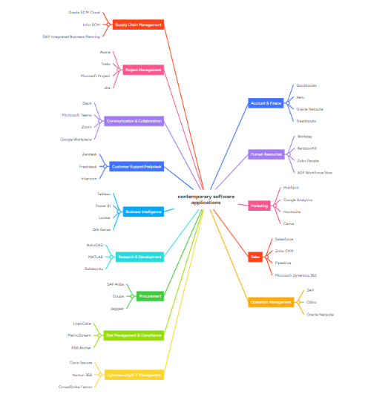

Task 3. Office Applications

3.1 Four office software solutions for business operations

Ms Word

Microsoft Word is a word processing application developed by Microsoft. It is widely used by businesses, educational institutions, and individuals to create, edit, format, and print professional documents. Microsoft Word helps users produce letters, reports, resumes, contracts, meeting minutes, and other business documents efficiently. It is part of the Microsoft 365 Office suite and supports both desktop and cloud-based collaboration. Microsoft Word is an element of Microsoft office which helps with the creation, editing, and formatting of documents. It includes facilities for spell and grammar checking, as well as text formatting you can also include photos, tables, and charts in your documents. For task life formal communication, adding signature in Microsoft word can be quick and secure way to finalize your documents. It’s popular for laters, reports, and resumes.
Word allows many people to work on a document together, keeping track of changes, it provides templates to make document creation easier. It is commonly utilised by users, organisation, and schools because of its ease of use and multiple useful features. For more visually driven can serve as a complementary tool to word for creating dynamic, multimedia presentations.

Major Features

1. Document Creation and Formatting

Microsoft Word allows users to create professional documents using various fonts, styles, headings, page layouts, tables, and themes.

2. Templates

Word includes a wide range of built-in templates for business letters, reports, resumes, newsletters, invoices, and meeting agendas, helping users save time.

3. Spell Check and Grammar

The application automatically checks spelling and grammar, providing suggestions to improve the quality and accuracy of documents.

4. Mail Merge

Mail Merge enables users to create personalised letters, labels, envelopes, and emails for multiple recipients using data from a list or database.

5. Collaboration

With Microsoft 365, multiple users can work on the same document simultaneously. Users can also leave comments, track changes, and share documents through OneDrive.

Uses of Microsoft Word

* Writing business reports
* Preparing letters and official documents
* Creating resumes and cover letters
* Producing meeting agendas and minutes
* Designing newsletters and brochures
* Preparing contracts and proposals
* Creating manuals and project documentation

Benefits

* Easy to use with a user-friendly interface
* Produces professional-looking documents
* Includes templates that save time
* Improves writing with spelling and grammar tools
* Supports collaboration through cloud sharing
* Integrates with other Microsoft Office applications

Limitations

* Some advanced features require a Microsoft 365 subscription
* Large or complex documents may reduce performance on older computers
* Limited desktop publishing capabilities compared to specialised design software

Conclusion

Microsoft Word is one of the most widely used word processing applications in the world. It provides powerful tools for creating, editing, formatting, and sharing professional documents. Features such as templates, spell check, Mail Merge, and collaboration make it an essential application for businesses, students, and organisations. Although it has some limitations, Microsoft Word remains an important tool for everyday business communication and documentation.

Ms Excel
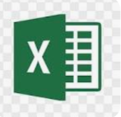
MS Excel provides powerful tools such as formulas, functions, charts, graphs, PivotTables, and data analysis features that make it useful for students, teachers, businesses, accountants, and organizations. It is commonly used for preparing budgets, maintaining records, creating reports, tracking expenses, and managing data efficiently.
Microsoft Excel is a spreadsheet application used to organise, calculate, analyse, and visualise data. It is widely used in accounting, finance, sales, inventory management, and business reporting.

Major Features

Worksheets

Data is organised into rows and columns for easy management.

Formulas and Functions

Excel includes hundreds of built-in formulas such as:

* SUM
* AVERAGE
* IF
* COUNT
* VLOOKUP
* XLOOKUP

Charts

Users can create bar charts, pie charts, line graphs, and dashboards.

PivotTables

PivotTables summarise large amounts of data quickly and efficiently.

Conditional Formatting

Cells automatically change colour based on specific conditions.

Benefits

* Powerful data analysis
* Fast calculations
* Professional charts
* Widely used in business
* Supports automation using macros

Limitations

* Complex formulas require training
* Large datasets can reduce performance
* Human errors may affect calculations

Ms PowerPoint
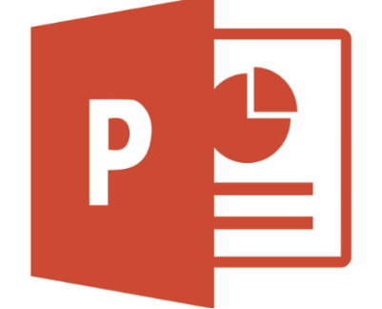
PowerPoint is an essential multifunctional tool for making presentations which had been created by MS. As a part of the Microsoft Office Suite, it offers a toolbox to organise the presentation by using different tools and features to make it visually pleasant and attractive. MS PowerPoint gives the opportunity for the text, graphics, multimedia objects, and animation elements to be combined in one place to allow the users to present information in a more effective way.

Evolution of PowerPoint
In the course of time, PowerPoint has become a very functional tool to produce high-quality presentations Moreover, a secure system would be established to manage risks of data leakage or theft. First released in 1987 for Apple computers, it defies to the competition with its easy Graphical User Interface (GUIGUI)) and its large range of functions. With every new release, MS PowerPoint offered new functionality and boasted significant improvements, staying the wonder of the world of presentations.

PowerPoint was originally designed to provide visuals for group presentations within business organizations but has come to be widely used in other communication situations in business and beyond.[17] The wider use led to the development of the PowerPoint presentation as a new form of communication,[18] with strong reactions including advice that it should be used less,[19] differently,[20] or better.[21]

Microsoft PowerPoint is a presentation software developed by Microsoft. It is part of the Microsoft Office suite and is widely used to create professional and educational presentations. PowerPoint allows users to combine text, images, charts, tables, audio, video, animations, and transitions to present information in an attractive and organized way.

PowerPoint is commonly used in schools, colleges, businesses, and seminars for teaching, training, project presentations, and meetings. It provides a variety of templates, themes, and design tools that help users create visually appealing slides quickly and easily.

Overall, Microsoft PowerPoint is a powerful and user-friendly application that helps communicate ideas effectively through engaging presentations.

Main features

* Create presentations using slides
* Add text, images, shapes, charts, tables, and SmartArt
* Insert audio and video
* Apply themes and templates
* Use animations and slide transitions
* Present with Presenter View
* Collaborate with others in real time
* Export presentations as PDF or video

Common uses

* School and college presentations
* Business meetings
* Project reports
* Training sessions
* Marketing presentations
* Seminars and conferences

Advantages

* Easy to use
* Professional-looking templates
* Supports multimedia content
* Available on Windows, Mac, web, and mobile devices
* Integrates with other Microsoft Office apps

Disadvantages

* Requires practice to create effective presentations
* Advanced features may require a Microsoft 365 subscription
* Large presentations can become slow to edit

In short, MS PowerPoint is a powerful tool for creating and delivering visually engaging presentations.

Ms Access


Microsoft Access is a database management system (DBMS) developed by Microsoft. It is used to create, store, organise, and manage large amounts of information in a structured database. Businesses commonly use Microsoft Access to manage customer records, employee information, inventory, sales data, and other business-related information. It combines a user-friendly interface with powerful database management features, making it suitable for small and medium-sized organisations.

Major Features

1. Tables

Tables are used to store data in rows and columns. Each table contains records (rows) and fields (columns) that organise information efficiently.

2. Queries

Queries allow users to search, filter, sort, and retrieve specific information from one or more tables. They make it easy to analyse data and generate useful information.

3. Forms

Forms provide a simple interface for entering, editing, and viewing records. They reduce data entry errors and improve user experience.

4. Reports

Reports are used to create professional summaries of database information. They can be printed or exported for business meetings and decision-making.

5. Relationships

Access allows users to create relationships between different tables, reducing duplicate data and improving database accuracy.

Uses of Microsoft Access

* Managing customer databases
* Storing employee records
* Tracking inventory
* Recording sales transactions
* Managing student or patient records
* Generating business reports
* Organising supplier information

Main Features

* Tables: Store data in rows and columns.
* Queries: Search, filter, and analyse data.
* Forms: Provide a user-friendly way to enter and edit data.
* Reports: Generate professional summaries and printable reports.
* Relationships: Link related tables to reduce duplicate data.
* Macros: Automate repetitive tasks.

Benefits

* Easy to create and manage databases
* Reduces duplicate data through table relationships
* Quick searching and filtering using queries
* Professional reports and forms
* Integrates with other Microsoft Office applications such as Excel and Word
* Powerful data analysis
* Fast calculations
* Professional charts
* Widely used in business
* Supports automation using macros
* Suitable for small and medium-sized businesses* Stores large amounts of data securely
* Reduces duplication through linked tables
* Makes it easy to search and update records
* Produces professional reports

Limitations

* Not suitable for very large databases with many users
* Available only on Microsoft Windows
* Less powerful than enterprise database systems such as Microsoft SQL Server or Oracle
* Performance may decrease as the database grows significantly
* Best suited for small to medium-sized databases.
* Not ideal for very large organisations with thousands of simultaneous users.
* Requires some knowledge of database design to use effectively. * Complex formulas require training
* Large datasets can reduce performance
* Human errors may affect calculations

Example

A school could use Microsoft Access to create a database with:

* A Students table (Student ID, Name, Class)
* A Teachers table (Teacher ID, Name, Subject)
* A Results table (Student ID, Subject, Marks)

Access can then generate reports, such as all students in a class or each student’s exam results, without storing the same information repeatedly.

3.2 Test any two features
PIVOT TABLE 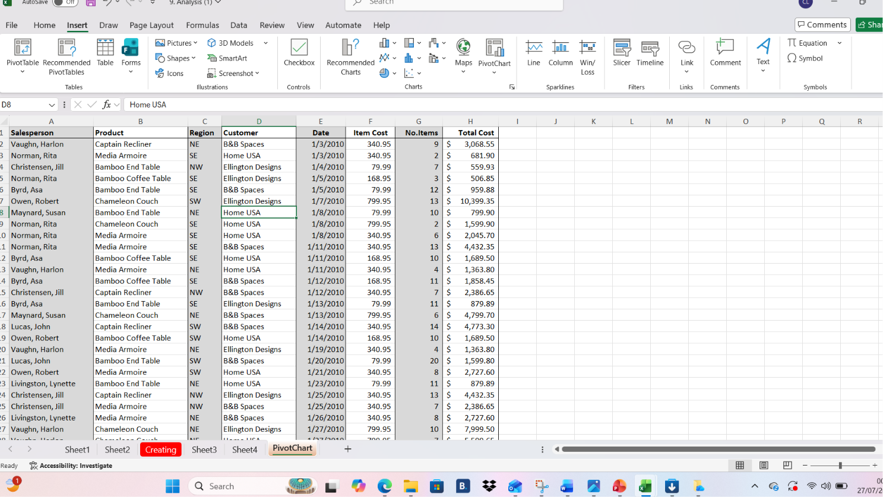

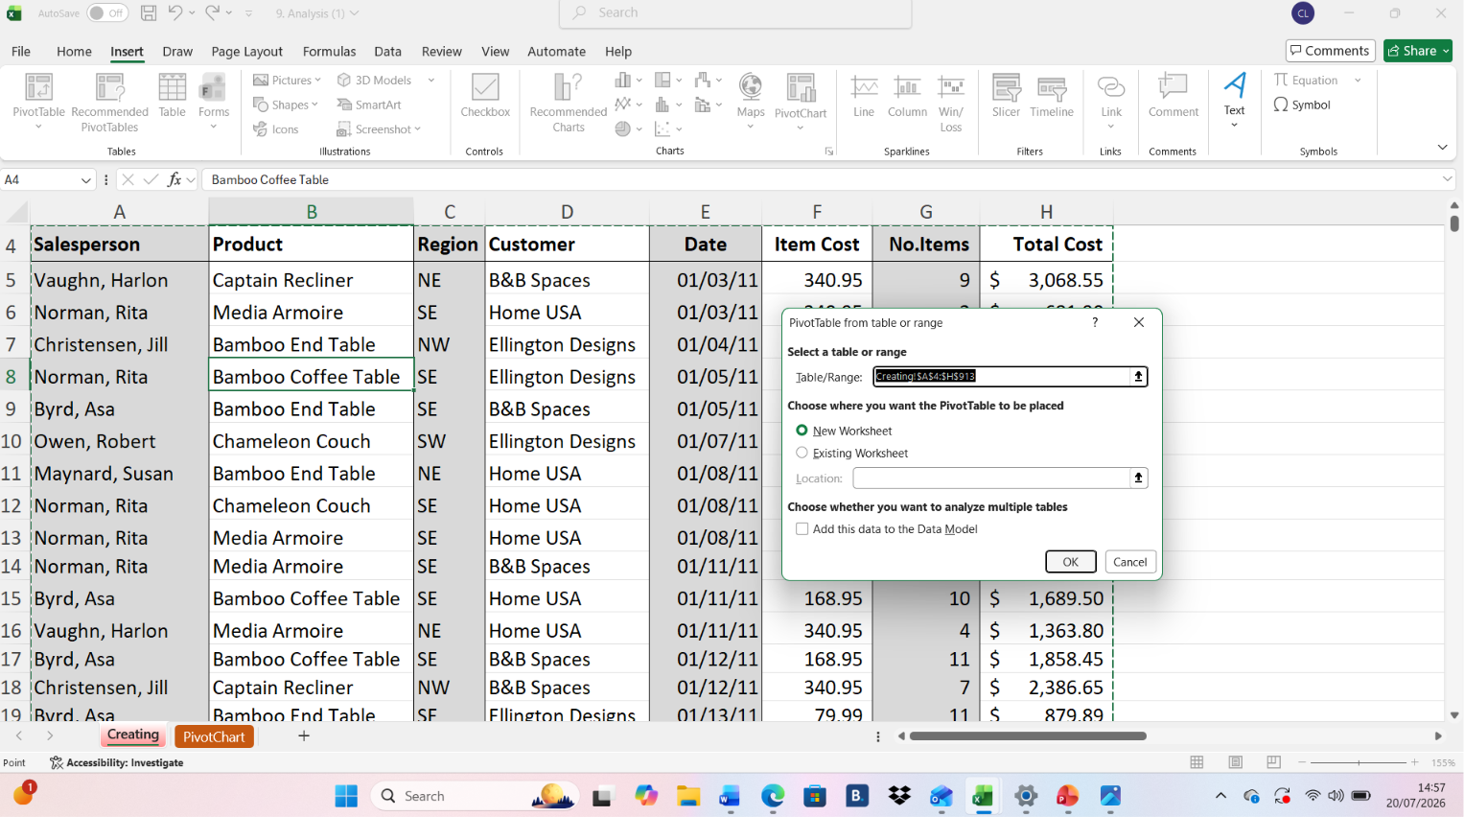

Mail merge

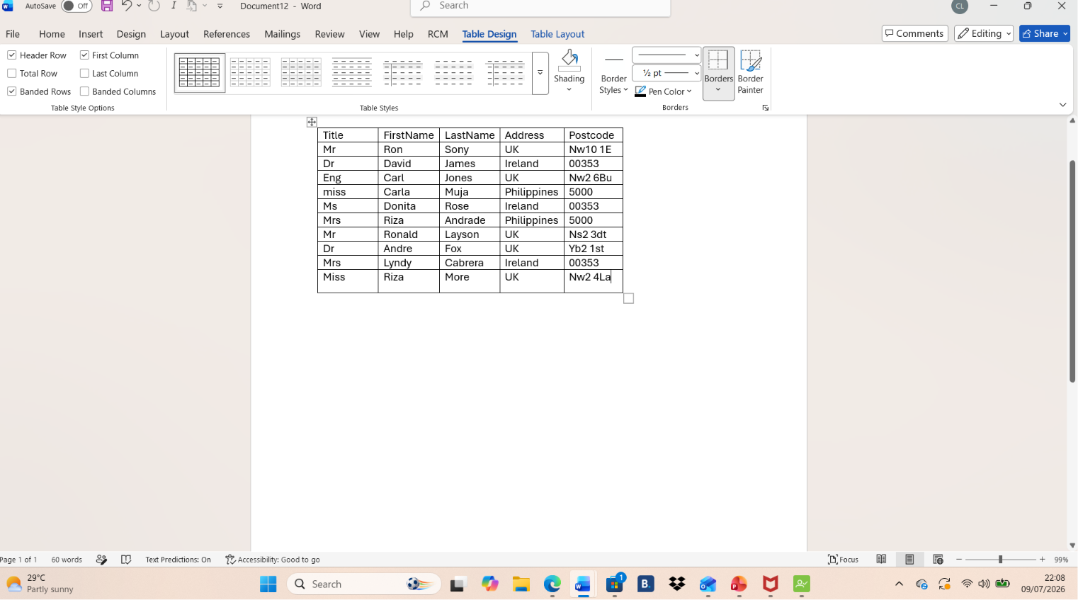

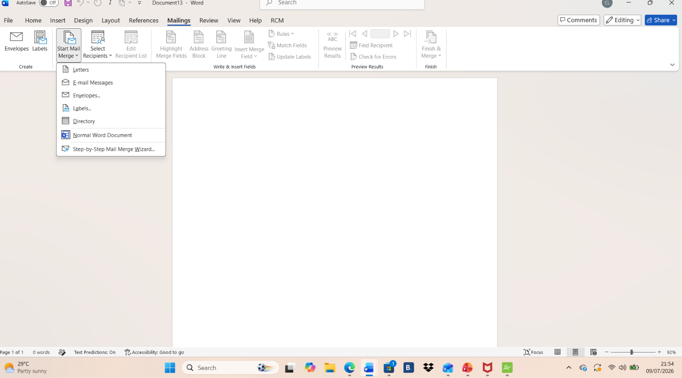
Use Start Mail Merge
Click on the Mailings Tab
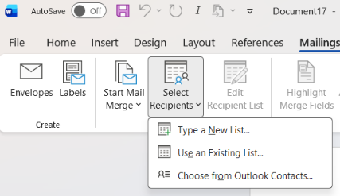
Click Use an Existing List to create something.
Click on the select recipients then

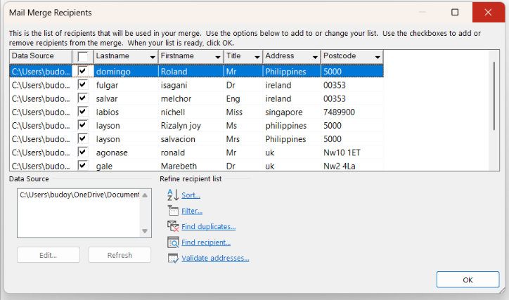
This is a mail merge recipient

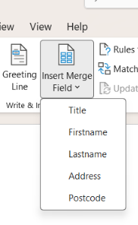
Click Insert Merge Field, then you can find the Title, FirstName, LastName, address and postcode, that you want to write.

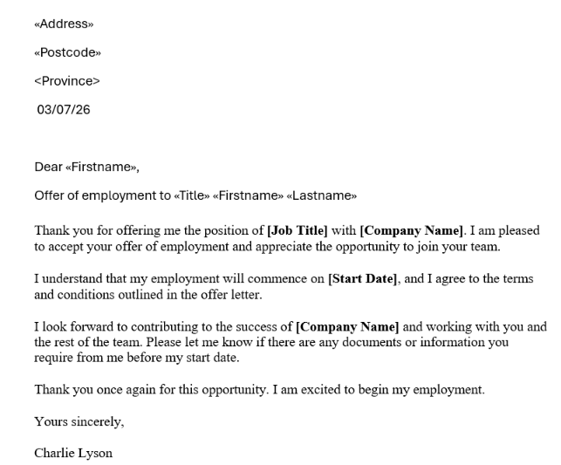
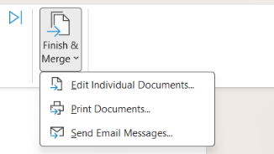
Click finish & merge to select edit and print documents, and send Email Messages.

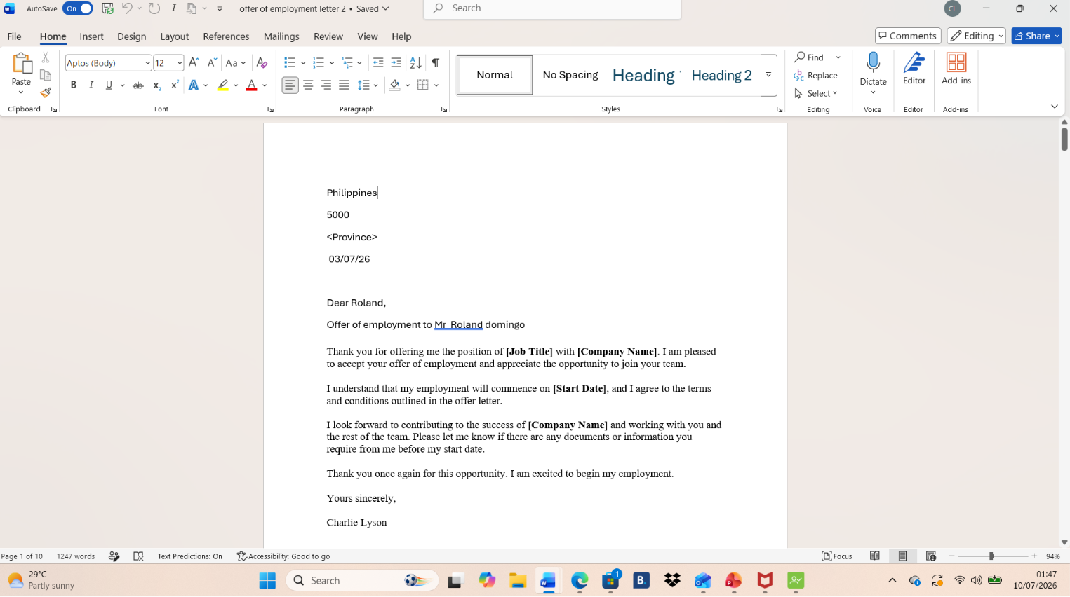

IF Statement
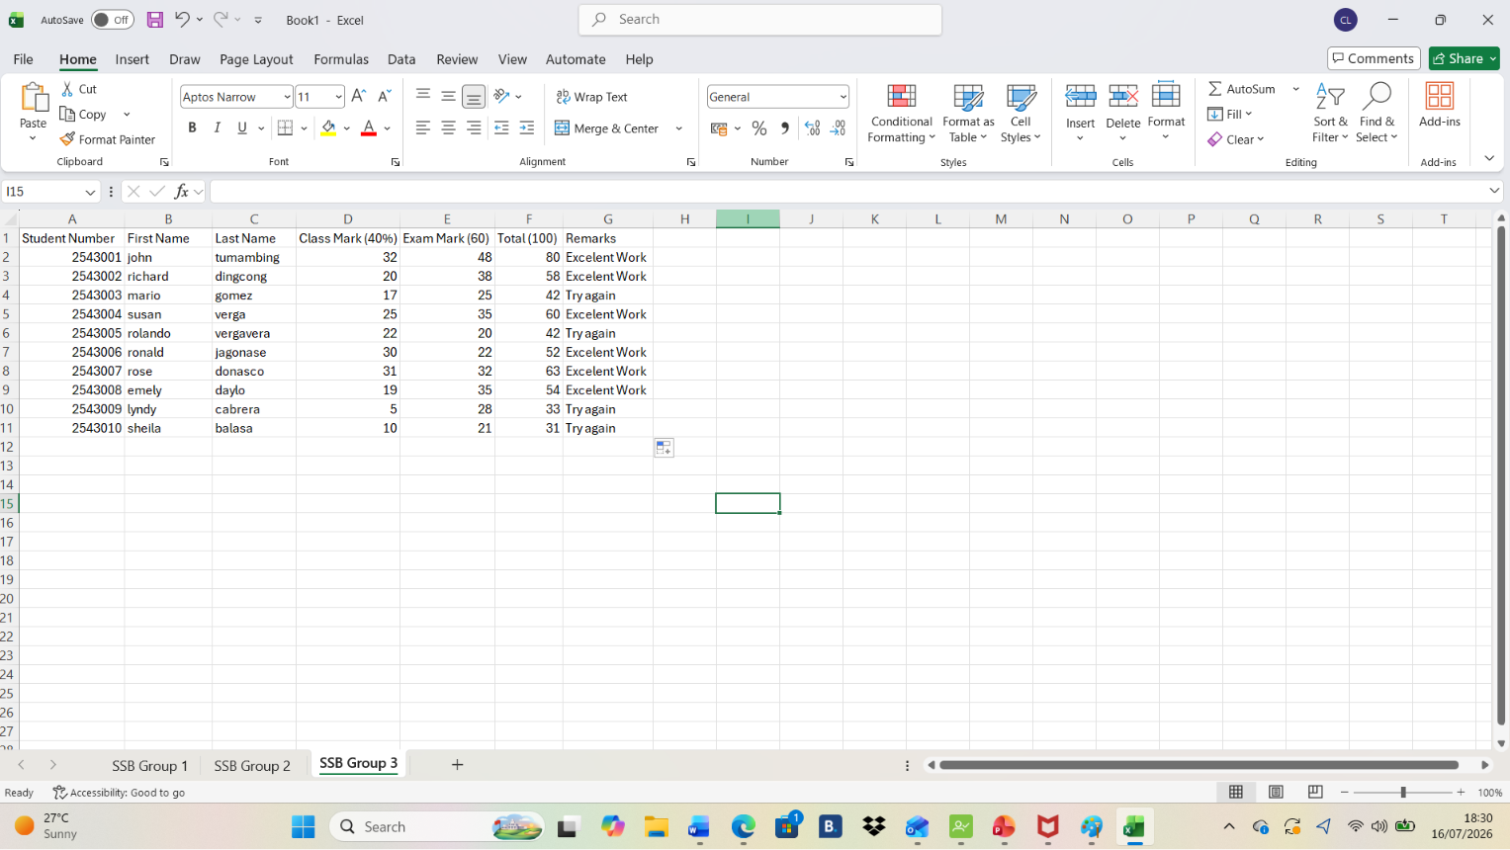

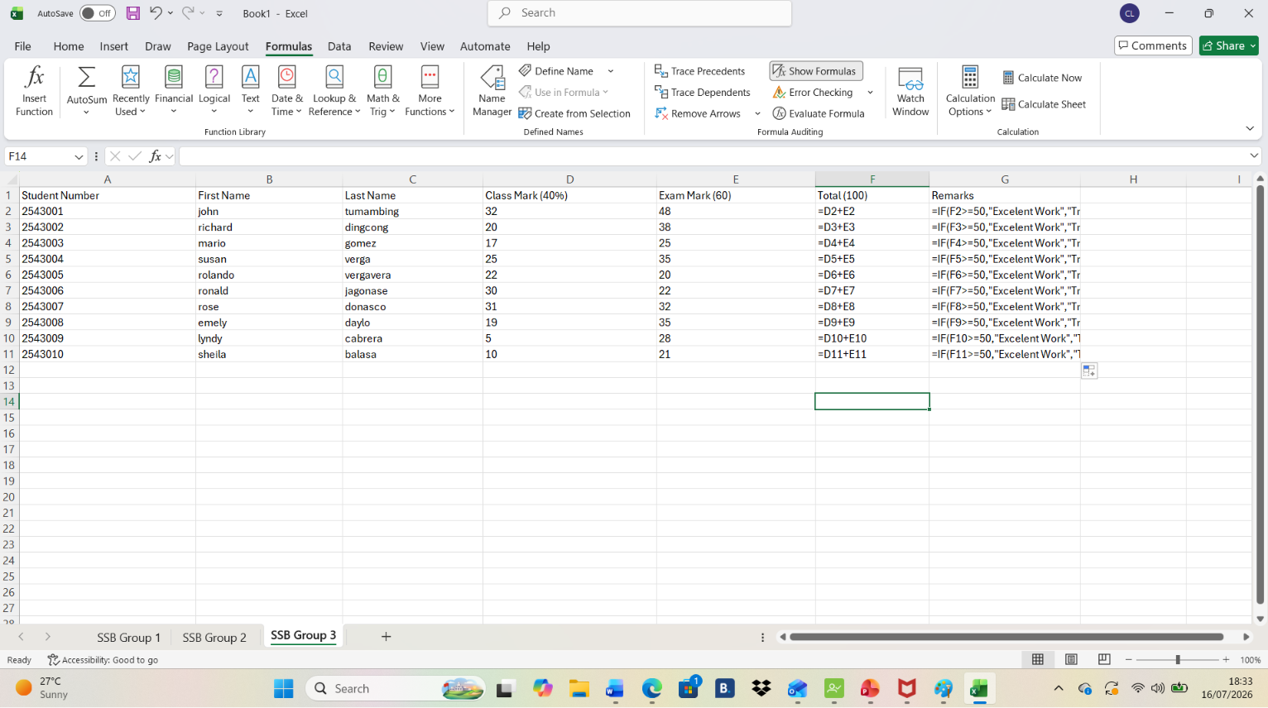

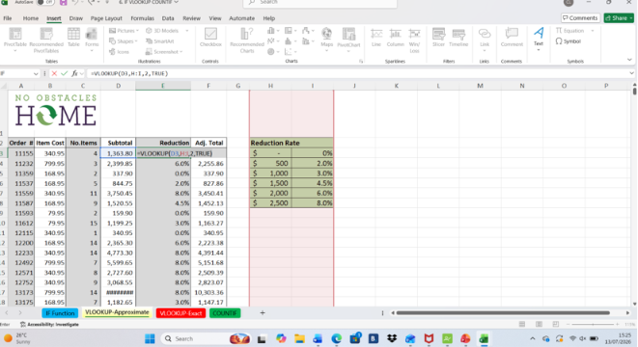
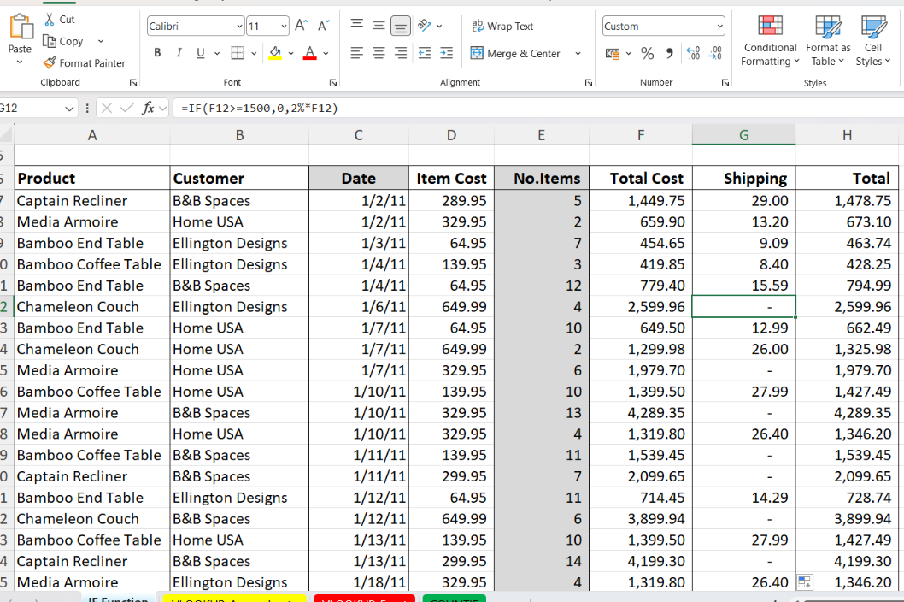
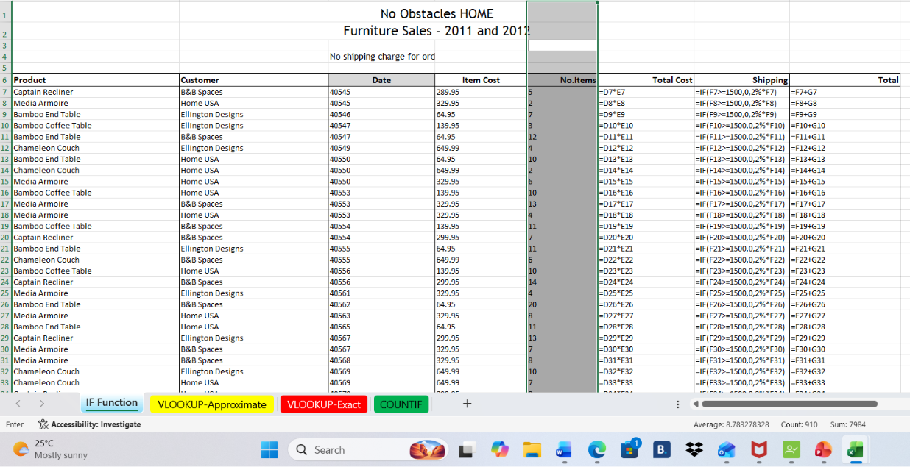

Task 4. Communication and Collaboration applications

4.1 One contemporary Communication and one Online Collaboration

Gmail is an email service developed by Google. It allows users to send, receive, organise, and store emails using the internet.
Gmail can be used to:
- Send and receive emails and attachment
- Communicate with friends, colleagues, teachers, and businesses.
- Organise messages using folder, labels, and filters.
- Store contact and important messages
- Access email from computers, tablets, and smartphones.

Gmail is a useful email service for students because it helps them communicate, share information, and manage their academic work. Students can use Gmail to communicate with teachers, classmates, and college or university staff.

Microsoft Team
Microsoft Teams is a team collaboration platform developed by Microsoft as part of the Microsoft 365 suite. It offers features such as workspace chat, video conferencing, file storage, and integration with both Microsoft and third-party applications and services. Teams gradually replaced earlier Microsoft messaging and collaboration platforms, including Skype for Business, Skype, Flip, and Microsoft Classroom.
The platform saw significant growth during the COVID-19 pandemic, alongside competitors such as Zoom, Slack, and Google Meet, as organizations shifted to remote work and virtual meetings.
As of January 2023, Microsoft reported approximately 280 million monthly active users.]

History
On August 29, 2007, Microsoft acquired Parla no, the developer of the persistent group chat tool Mind Align. Years later, on March 4, 2016, Microsoft considered acquiring Slack for $8 billion. However, the proposal was reportedly opposed by Bill Gates, who advocated for focusing on enhancing Skype for Business instead. Lu Qi, then executive vice president of Applications and Services, had led the initiative to pursue the Slack acquisition. Following Lu's departure later that year, Microsoft announced Microsoft Teams on November 2, 2016, at an event in New York City, positioning it as a direct competitor to Slack. Teams launched worldwide on March 14, 2017. The service was initially led by corporate vice president Brian MacDonald.
In response to the launch, Slack published a full-page advertisement in The New York Times welcoming the competition and outlining its product philosophy. Although Slack was used by 28 companies in the Fortune 100, The Verge wrote that executives will question paying for the service if Teams provides a similar function in their company's existing Office 365 subscription. However, ZDNET noted that the platforms initially served different markets, as Teams did not support external users, making it less appealing to small businesses and freelancers, a limitation Microsoft later addressed. In response to Teams' announcement, Slack deepened in-product integration with Google services.
In May 2017, Microsoft announced that Teams would replace Microsoft Classroom in Office 365 Education. A free version of Teams was released on July 12, 2018, offering most core features at no cost, albeit with limits on users and storage. In January 2019, Microsoft introduced updates targeting "Firstline Workers" to improve Teams’ performance across shared or limited-access devices.
In September 2019, Microsoft announced the retirement of Skype for Business in Favor of Teams, which took effect on July 31, 2021. In early 2020, Microsoft introduced a push-to-talk "Walkie Talkie" feature aimed at first line workers using smartphones and tablets over Wi-Fi or cellular networks.
The COVID-19 pandemic significantly boosted usage of Teams. On March 19, 2020, Microsoft reported 44 million daily active users. In April, the platform logged 4.1 billion meeting minutes in a single day.
A public preview of Microsoft Teams for Linux was released in December 2019, but the Linux client was discontinued in 2022. In July 2020, Microsoft shut down its video game livestreaming platform and announced that some of its technologies would be repurposed for use in Teams.
On February 28, 2025, Microsoft announced that Skype would be fully retired on May 5, 2025, with users given options to export their data or transition to Microsoft Teams.
In October 2025, together with other Microsoft 365 suite apps, Teams had its logo updated.

4.2 Test one feature of a freely available Communication (1) and one feature of a Collaboration (1) application

MS Outlook
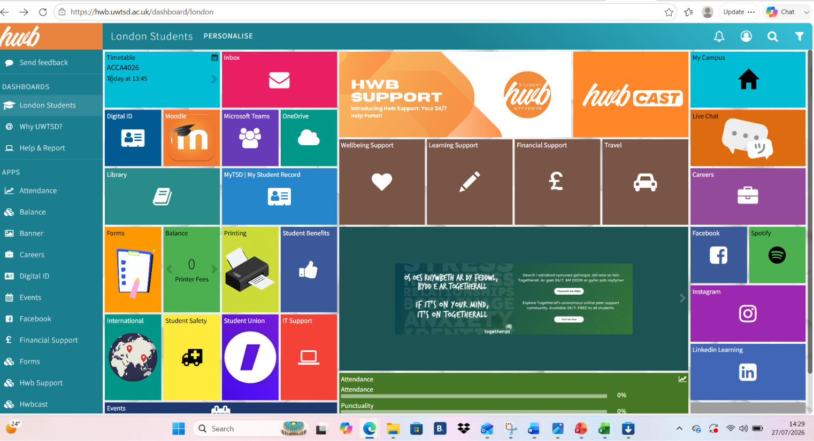
As a student we need to click the Moodle to see our student dashboard.
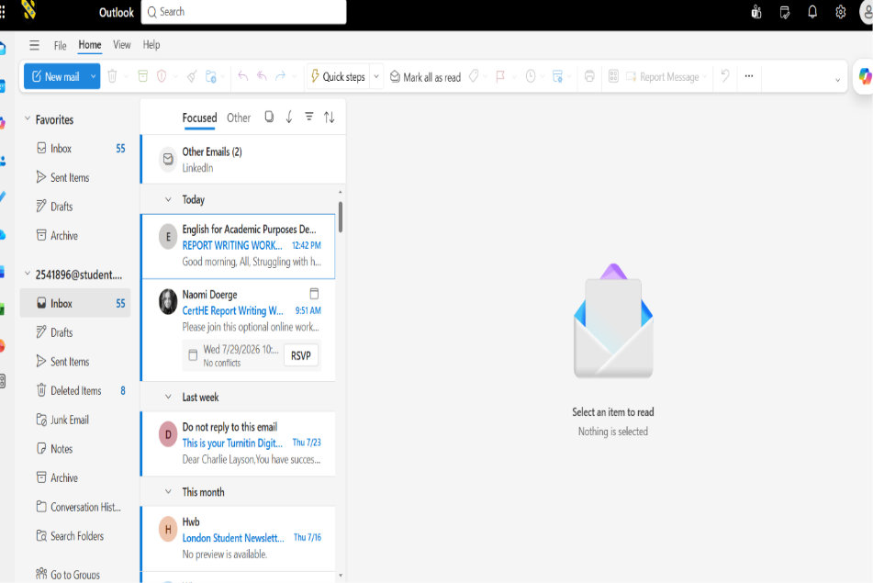
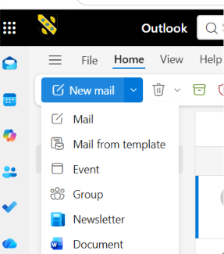
This is the image of my Email Inbox messages.
Click New Mail, then you can see or select which one you would like to click.
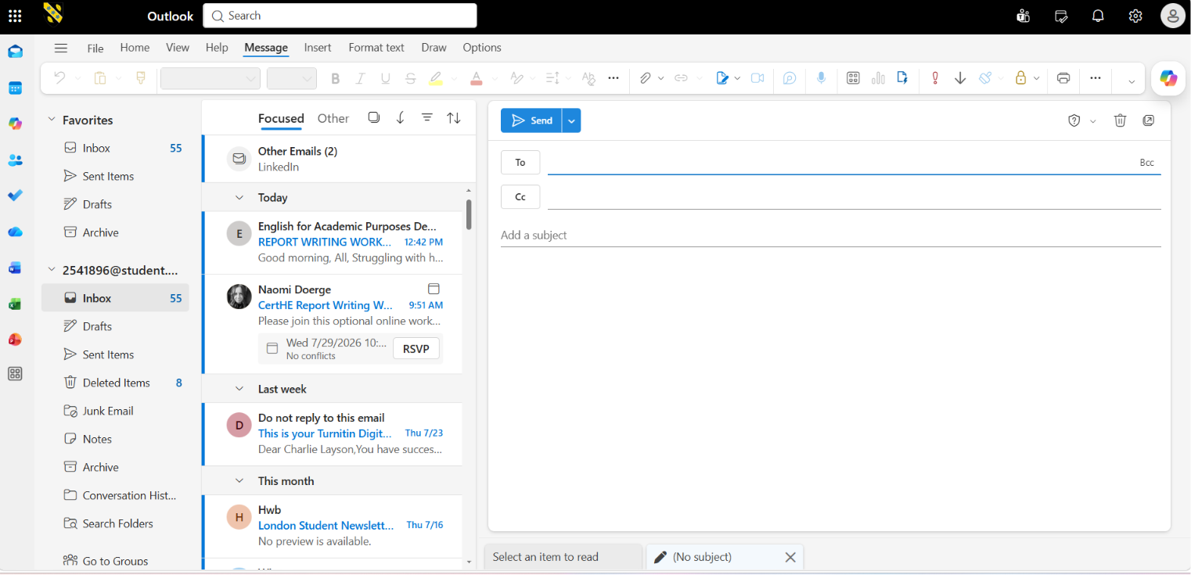
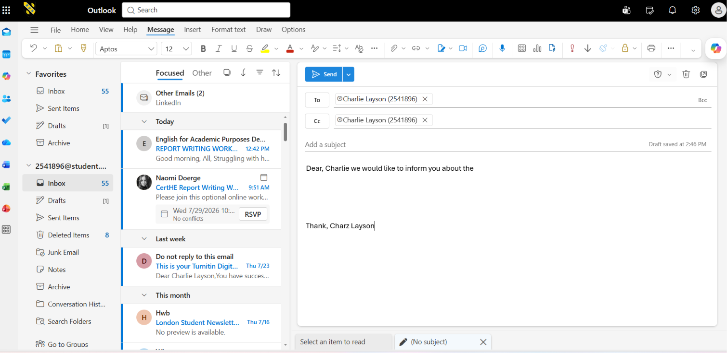
This is how to email the person you want to email it.
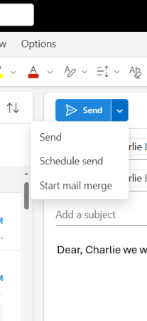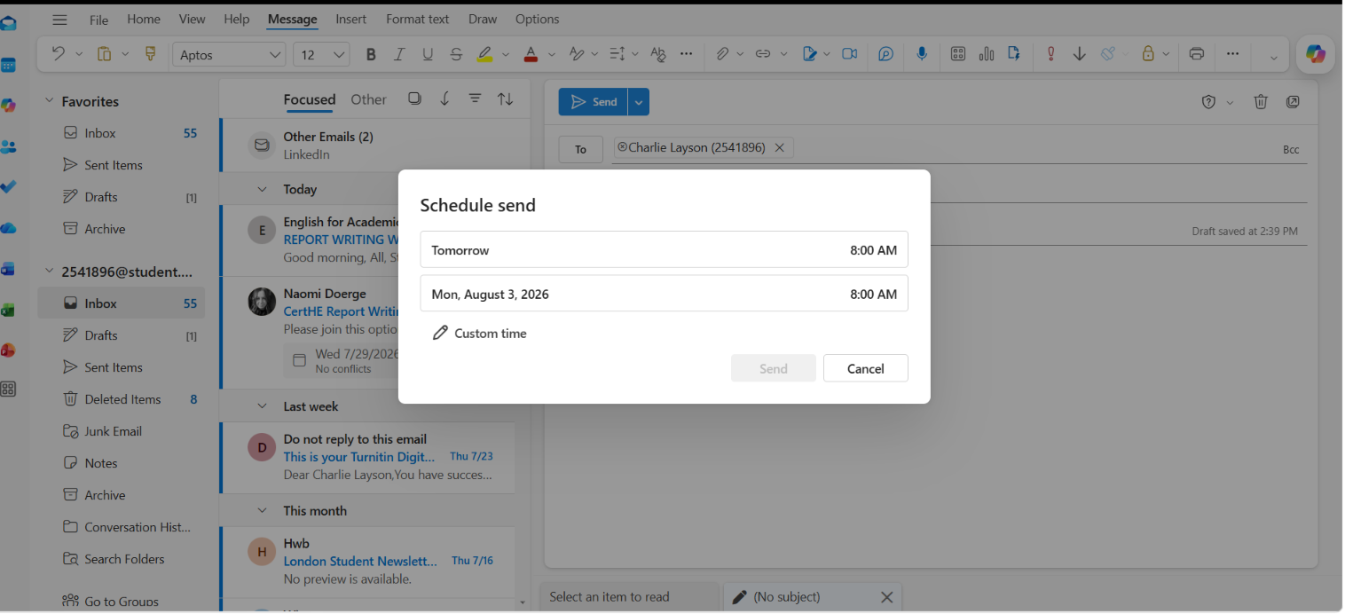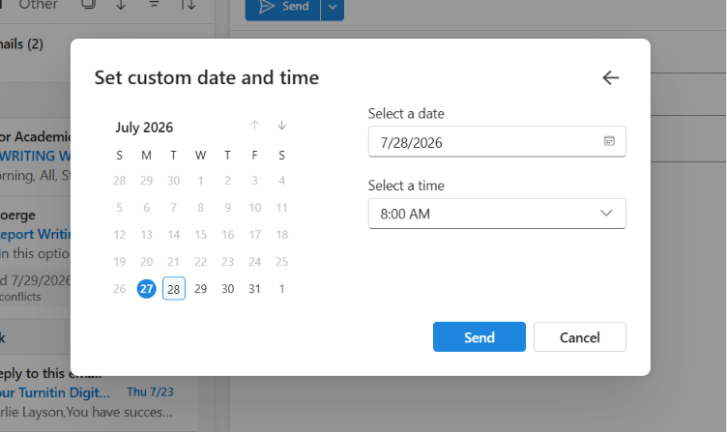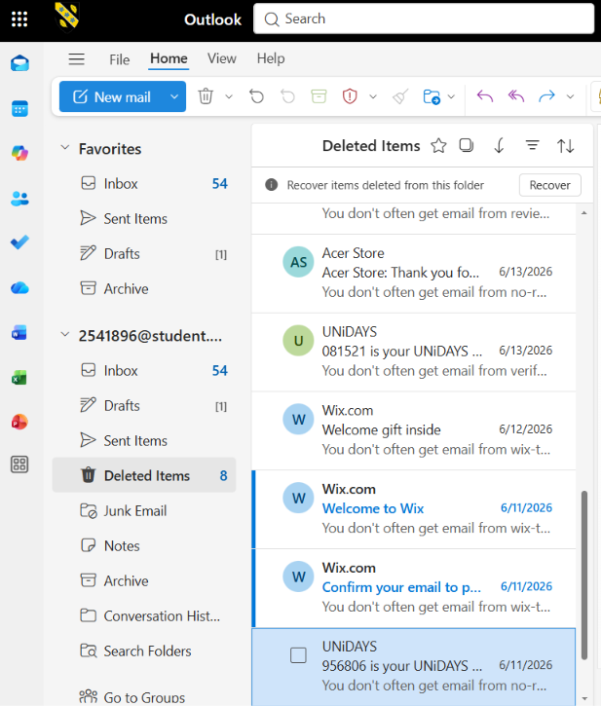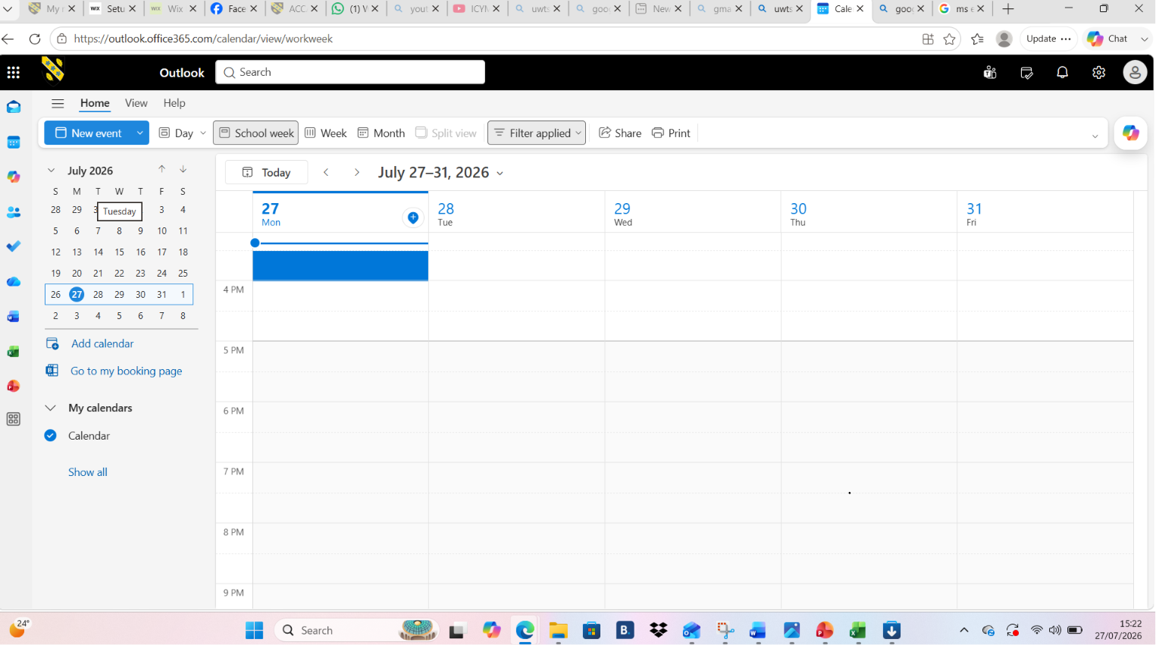

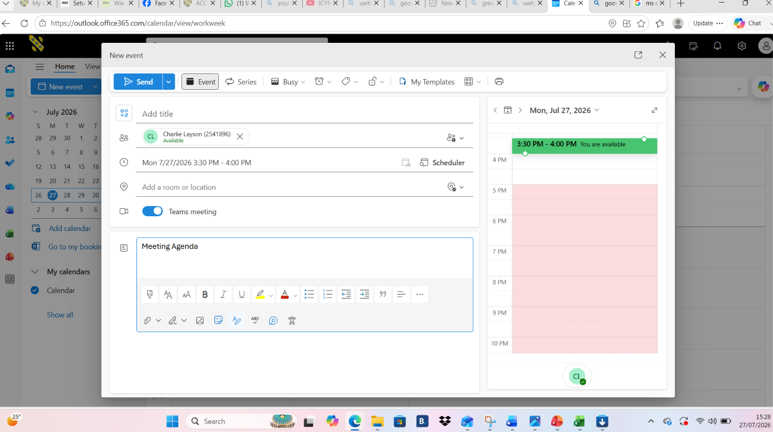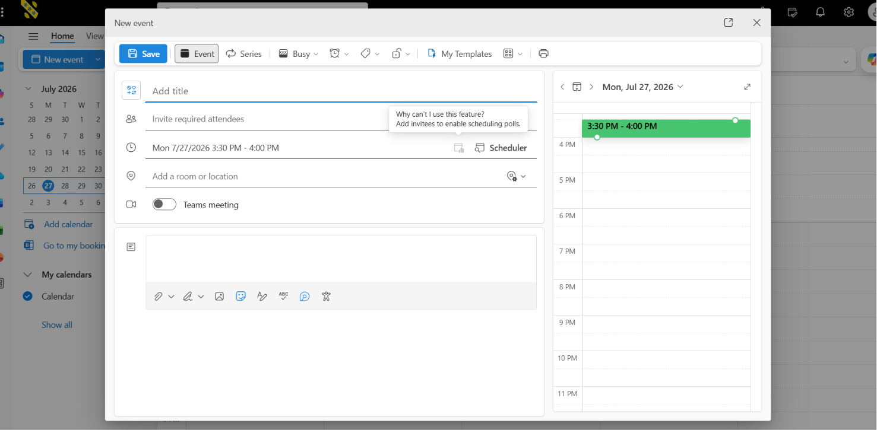

Click this send an e amil to the person you want.

Conclusion
software programs and computing skills are essential in modern education, business, and everyday life. Software programs such as Microsoft Word help users create, edit, organise, and share information efficiently. Developing good computing skills enables individuals to use different software confidently, solve problems, communicate effectively, and complete tasks accurately. Therefore, improving computing skills is important for personal development, academic success, and future employment opportunities. software programs are essential tools that help people complete tasks efficiently and effectively. They are used in many areas, including education, business, communication, and everyday activities. Programs such as Microsoft Word make it easier to create, edit, organise, and share information. As technology continues to develop, software programs will remain an important part of modern life and the workplace.

References
Microsoft. (2024). Microsoft Word. https://www.microsoft.com/microsoft-365/word

References (APA 7th Edition)

* Microsoft. (2024). Microsoft Excel. https://www.microsoft.com/microsoft-365/excel
* Shelly, G. B., & Vermaat, M. E. (2018). Microsoft Office 365 & Office 2019: Introductory. Cengage Learning.
References (APA 7th Edition)

* Microsoft. (2024). Microsoft Access. https://www.microsoft.com/microsoft-365/access
* Shelly, G. B., & Vermaat, M. E. (2018). Microsoft Office 365 & Office 2019: Introductory. Cengage Learning. * Microsoft. (2024). Microsoft Access. https://www.microsoft.com/microsoft-365/access
* Shelly, G. B., & Vermaat, M. E. (2018). Microsoft Office 365 & Office 2019: Introductory. Cengage Learning.
Reference: https://www.shopify.com/uk/blog/what-is-shopify
Reference: https://www.shopify.com/uk/blog/what-is-shopify
Reference: https://www.shopify.com/uk/blog/what-is-shopify

Reference: https://www.shopify.com/uk/blog/what-is-shopify

Buzan, T. (2018). The Mind Map Book: Unlock Your Creativity, Boost Your Memory, Change Your Life. BBC Active.

In-text reference:
(Buzan, 2018)
Wix.com Ltd. (n.d.). Wix. Available at: Wix official website⁠￼ (Accessed: 10 August 2026).

In-text citation:
(Wix.com Ltd., n.d.)

