

Report Title: Integrated Human Capital Blueprint
Option 1 - Re-Engineering Performance & Job Design

Student Name: Hira Akter
Student ID: 2530059

Programme: Master of Business Administration
Module Name: Human Capital Management
Module Code: LCMB7023

Lecturer’s Name: Dr Anupam Mazumdar

Work Count: 1647+1008=2655

Submission Date: 20 March, 2026

Table of Contents
Part 1: Re-Engineering Performance & Job Design at Aether Innovations 3
1. Introduction 3
2. Evaluation of the Current Performance Appraisal and Job Design Practices 3
3. Proposed Modern Performance Management System 5
4. Job Design Principles and Job Characteristics Model 7
4.1 Job Analysis and Design for Key Positions 8
5. Integration: Making it a Performance-Driven Culture. 9
6. Conclusion 10
Part 2: Reflective Analysis and Future Professional Development 11
Reflective Learning Using Gibbs’ Reflective 11
1. Description 11
2. Feelings 12
3. Evaluation 12
4. Analysis 12
5. Conclusion 13
6. Action Plan 13
7. Staying Relevant in the Age of AI 13
References 15

Table 1: Traditional vs Contemporary Performance Management Systems 4
Table 2: Job Descriptions and Specifications for Key Roles 8

Figure 1: Performance Improvement Over Time 6
Figure 2: Job Characteristics Model at Aether Innovations 7
Figure 3: Integrated Human Capital System at Aether Innovations 9
Figure 4: Gibbs Reflective Cycle 11

Part 1: Re-Engineering Performance & Job Design at Aether Innovations

Introduction
Aether Innovations is a 300 employees-based technology company which has experienced stagnated growth, high employee turnover and decreasing customer satisfaction. These organisational symptoms are often the characteristics of the inappropriate human capital systems, especially the inefficient performance management and poorly constructed job positions (Purcell and Boxall, 2017). Competitive advantage is also becoming built on the strategic synchronization of people, processes and performance systems in knowledge-intensive firms instead of just technological capability (Collings, Wood and Szamosi, 2018).
This report is a critical assessment of modern-day performance appraisal and job design as applied by technology companies and a proposed growth-focused cannabis of the Aether Innovations-integration. The report is able to illustrate the effectiveness of a consistent HR structure in reconstructing re-engagement, innovation, and organisational performance by integrating modern performance systems like Objectives and Key Results (OKRs) and 360-degree feedback with enhanced job design anchored in the Job Characteristics Model.

Evaluation of the Current Performance Appraisal and Job Design Practices
Conventional performance appraisal systems, commonly described by their annuality and top-down based nature, have been largely criticised due to their backward-looking nature and minimal developmental nature (DeNisi and Murphy, 2017). Such systems are especially off track in dynamic technology settings since they do not employ iterative provisions and real-time problem-solving. In addition, the episodic quality of annual appraisals tends to strengthen cognitive bias even recency and halo effects, which discredit perceived fairness and employee confidence (Cappelli and Tavis, 2016).
As a reaction, several major technological companies have shifted to the use of continuous performance management systems. Systems like OKRs can help organisations to align goals and attain strategic clarity, as well as cascade goals at different levels of the system (Doerr and Page, 2018). But, although OKRs increase transparency, this process depends upon the organisational maturity and disciplined implementation. Highly ambiguous key results or too much goal-setting may cause goal fatigue and outcry compliance instead of serious performance enhancement (Niven and Lamorte, 2016).
In the same way, 360-degree feedback is indeed becoming more and more popular to ensure multi-source appraisal and develop-insight. Such systems also minimize the single-source bias, but create new complications with other complexities such as feedback inconsistency and the possibility of interpersonal tension (Bracken and Rose, 2011). Unless the feedback culture and training are strong, there became ambiguity, rather than clarity, in the 360-degree systems, especially in organisations that lack psychological safety.
In reference to job design, the conventional models based on task specialisation focus on efficiency without concern with flexibility and creativity (Taylor, 1911). Such strategies can be optimal in processing regular processes, but they are essentially not in line with the innovation requirement of technology companies. Job Characteristics Model by Hackman and Oldham (1976) is a lie that has a better structure because it focuses on intrinsic motivation that is achieved due to enriched job dimensions . But, according to modern studies, its efficacy is conditional by situational aspects like organisational culture and personality, meaning that job design is not universal but should be designed flexibly (Parker, Morgeson and Johns, 2017).
Traditional vs Contemporary Performance Management Systems
Dimension | Traditional Appraisal | Contemporary System (OKRs & 360°)
Frequency | Annual | Continuous / Quarterly
Feedback Source | Line Manager | Multi-source (360°)
Focus | Evaluation | Development & growth
Flexibility | Low | High
Employee Role | Passive | Active participant
Strategic Alignment | Weak | Strong
Table 1: Traditional vs Contemporary Performance Management Systems

Proposed Modern Performance Management System
A mixed-performance framework that combines the use of OKRs and 360-degree feedback based on the current managerial coaching is suggested to help resolve the problems Aether Innovations is facing today.
To begin with, OKRs ought to be implemented on both the organisational and team as well as individual levels to create a vertical and horizontal alignment. As an illustration, an organisational goal like the increase of customer satisfaction may be transformed to measurable key results with time constraints at the departmental level. This alignment has the great advantage of not only clarifying expectations but also enhancing employee line-of-sight between individual inputs and organisational results (Doerr and Page, 2018). Nevertheless, to prevent the performative goal-setting, Aether should reduce the amount of the OKRs and focus on the quality rather than the number.
Secondly, 360 feedback needs to be conducted on an annual or semi-annual basis to provide performance information in its entirety. However, in contrast to old methods of appraisal, this one also includes the behavioural competencies and teamwork efficiency which are essential and were required in the knowledge-based workplaces. However, it succeeds in depending on the level of cultivation of feedback literacy and trust with without that, employees can look at feedback as evaluative and not developmental (London and Smither, 2002).
Third, the scheme of conducting regular performance check-ins alters the managerial role of being an evaluator to a coach. Recent data suggests that coaching-based leadership has a positive impact on the levels of engagement and performance results (Aguinis, 2024). Nevertheless, this change comes at a high cost in terms of managerial capacity since any bad conduct of coaching can become a credibility and consistency killer.
Notably, this system must be digitally empowered with performance management system, which provides real time tracking and transparency. Digital integration is not only functional in technology companies, but also strategic because it enables data-based decision-making and constant enhancement (Collings, Wood and Szamosi, 2018).

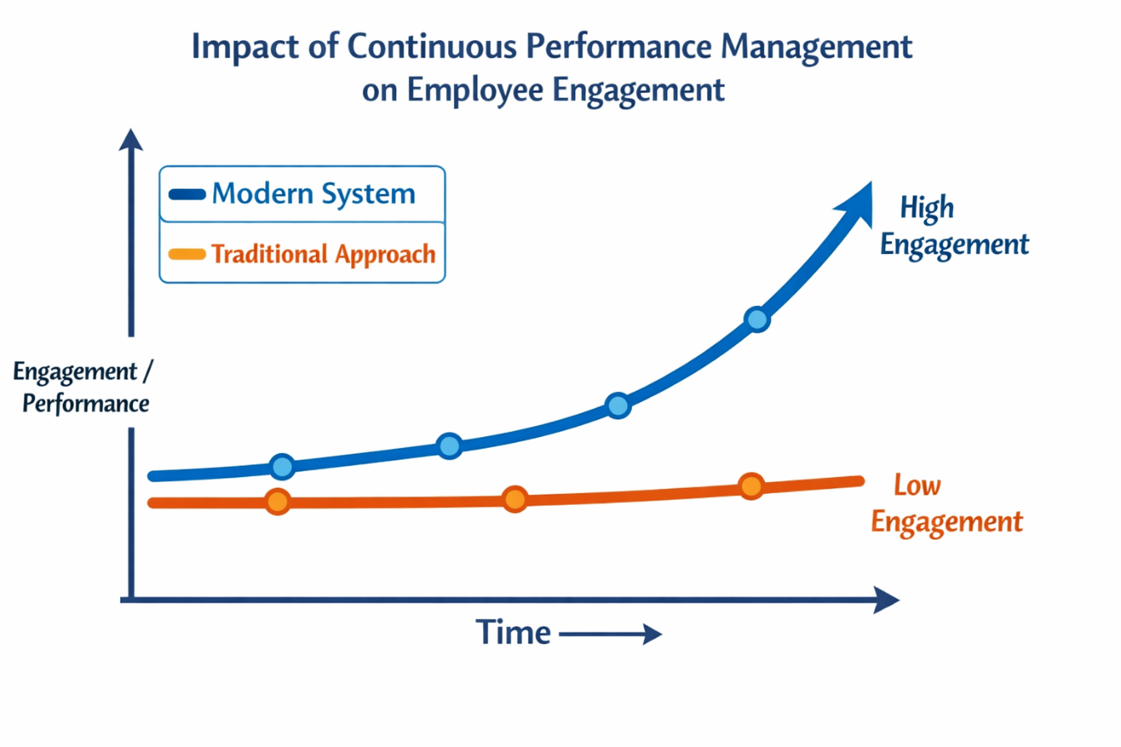
Figure 1: Performance Improvement Over Time

4. Job Design Principles and Job Characteristics Model
The skills-based design will make sure that the employees work based on competences and not on the definite assignments and functions, making organisations more agile and knowledge sharing (Parker, Morgeson and Johns, 2017).
- Autonomy: The employees are provided with a certain level of freedom in the manner in which they carry out their tasks and this improves ownership and responsibility.
- Skills Variety: Roles involve many skills, so the variety of skills is high, which encourages involvement and flexibility.
- Task Significance: Jobs will be designed in such a way that they illustrate their contribution on the organisational outcome.
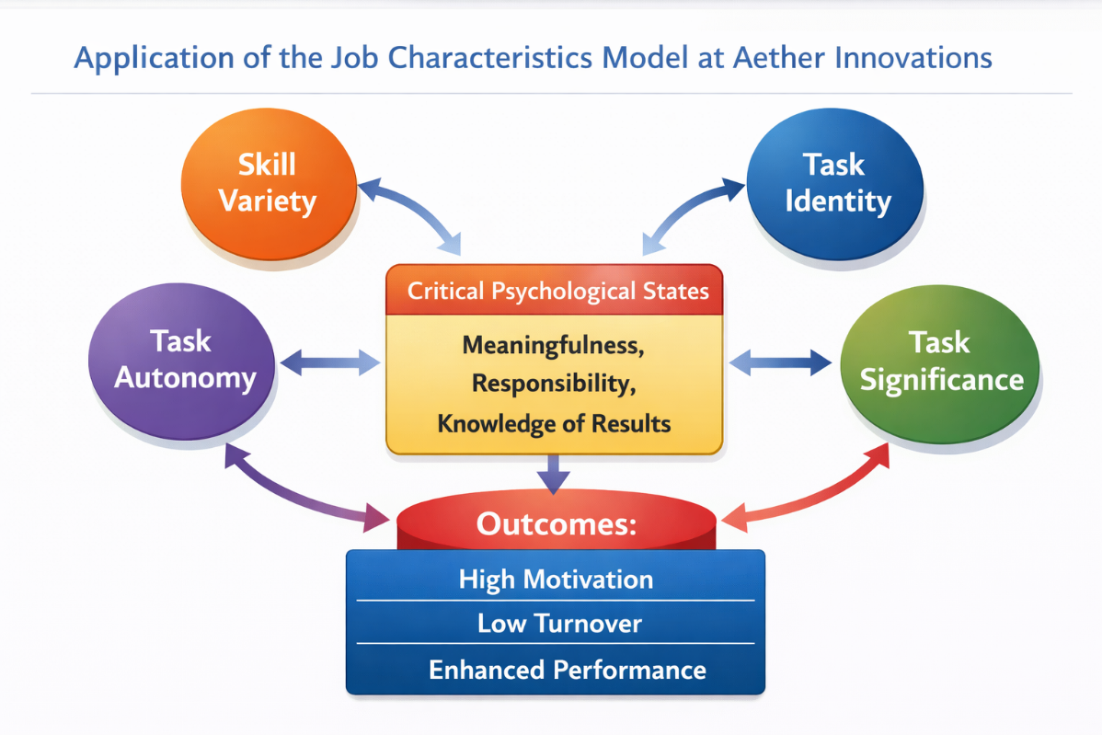
- Learning opportunities: The ongoing learning is promoted to promote the continuous development, flexibility and the growth of capabilities.

Figure 2: Job Characteristics Model at Aether Innovations

4.1 Job Analysis and Design for Key Positions
In order to supplement the performance system, Aether needs to re-design some of the key organisational roles based on the Job Characteristics Model and skills-based approach. This not only makes the employees to be reviewed but to be in a structural position to deliver.
The restructured positions are characterised by autonomy, skill variety, task significance and learning opportunities.
Job Descriptions and Specifications for Key Roles
Role | Key Responsibilities | Skills/Competencies | Job Design Features
CEO | Strategic leadership | Vision, decision-making | High autonomy
CFO | Financial strategy | Analytical, risk management | Task significance
CTO | Technology leadership | Innovation, technical skills | Skill variety
CIO | Innovation strategy | Creativity, collaboration | High autonomy
HR Director | Talent & culture | Leadership, HR expertise | Task significance
Head of R&D | Product development | Technical + creative | Feedback-rich
Table 2: Job Descriptions and Specifications for Key Roles
By incorporation of these attributes, Aether improves intrinsic motivation, highly related to creativity and innovation. Nevertheless, it is imperative to note that the lack of support with increased autonomy can result in role ambiguity. Job enrichment must therefore be well balanced in terms of expectations as well as the availability of resources.

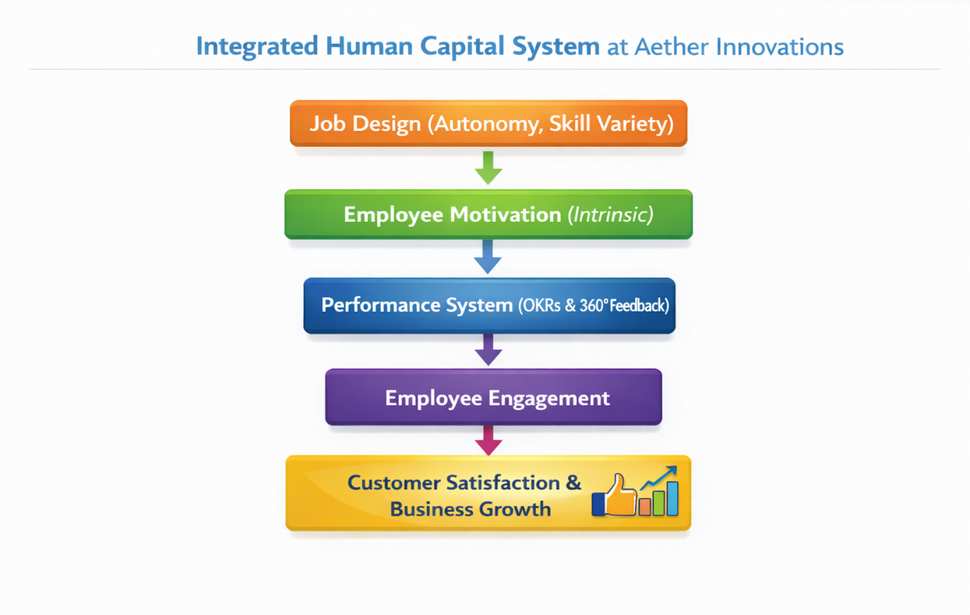
Integration: Making it a Performance-Driven Culture.
Figure 3: Integrated Human Capital System at Aether Innovations
Performance management and job design are the key to the development of sustainable performance culture within the Aether Innovations. In these systems everything should not run on its own rather should be interdependent to one another.
To begin with, enriched job roles give the structural settings that are required to ensure performance management. Workers who reside in a job setting that involves high degree of autonomy and skill variety are in a better position to react to the OKRs in a manner that is meaningful because they have the ability and the freedom to exert power. On the other hand, the incorrectly designed roles limit the performance systems forming a form of administrative exercises.
Secondly, job design motivates continue to foster motivational systems due to feedback mechanisms that are continuously in place. One of the fundamental dimensions of the Job Characteristics Model, Feedback, is operationalised based on 360-degree systems or frequent check-ins that support learning and development in the team of employees (Parker, Morgeson and Johns, 2017).
Third, this integration directly responds to the organisational challenges that Aether is facing. Enhanced job meaningfulness and engagement is used to mitigate high turnover, whereas better customer outcomes are achieved by promoting greater accountability and enhancing alignment. Contact with irregular audience surveys invariably prove differences in a positive connection concerning employee involvement and customer selection, especially in service-based situations (Harter, Schmidt and Hayes, 2002).
To accomplish such integration however, cultural transformation is needed. Excessive emphasis on performance measures can erode intrinsic motivation whereas lack of adequate managerial capacity can erode effectiveness of the system. As such, Aether needs to obtain a moderated and progressive implementation strategy which should be aided by leadership dedication and organisational learning.

Conclusion
The existing performance and engagements issues facing Aether Innovations require restructuring of its human capital systems. The inflexible job designs and the traditional appraisal techniques are no longer sufficient in the reality of a modern technological company. The integration of the hybrid performance management system that includes OKRs and 360-degree feedback along with the enhanced job design based on the Job Characteristics Model will help Aether to develop a unified and flexible HR structure.
Most importantly, the combination of these systems allows aligning individual motivation with organisational strategy which is promoting the culture of accountability, innovation and ceaseless improvement. In spite of the implementation challenges, especially on capacity building and culture match, the framework proposed has a strong basis in ensuring sustainable organisational success.

Part 2: Reflective Analysis and Future Professional Development

Reflective Learning Using Gibbs’ Reflective
The module has been completed and has offered a critical platform on which I have developed on my learning in the field of strategic Human Resource Management (HRM) and its application in complex organisational settings. This reflection is based on the Gibbs Reflective Cycle (Gibbs, 1988), which can be applied in assessing my learning experience and its contribution to the further development of my professional growth.

Figure 4: Gibbs Reflective Cycle

Description
During the module, I was able to work with diverse sophisticated concepts of HRM such as performance management systems, job design and aligning human capital with the strategies. At first, my knowledge of HRM was mainly operational in nature, looking at individual functions of the HRM like recruitment and appraisal. Nonetheless, having been exposed to academic literature and through taking practical case analysis especially the Aether Innovations scenario, I have come to a more integrated attitude. HRM is not viewed as a support operation any more but as a force of organisational performance and innovation.

Feelings
Initially, I was undecided when trying to convert theoretical models into the real world. Structures like the OKRs and the Job Characteristics Model were not conceptually understood but practically unclear. This first distress is indicative of what Schön (1983) explains to be the difficulty in transitioning between the state of technical rationality and that of reflective practice. Nevertheless, the more I was critically approaching the contents, the more confident I became. I started to realise that complex organisational situations are always ambiguous, and successful decision-making involves both analytical and reflective decision-making.

Evaluation
One of my strengths throughout the learning experience was that I was able to integrate theory and practice. I also acquired the ability to be critical of the HRM frameworks instead of describing only. As an example, I realised that despite performance management tools like OKRs improving the fit, their success relies on organisational culture and management potential. Nevertheless, one of the weaknesses of my style was the initial inclination towards descriptive writing. This was a sign of a deficiency in my skills as I could not do more critical analysis, a skill that is critical in studying at a postgraduate level.

Analysis
This learning process goes in line with the experiential learning theory whereby knowledge is built by the transformation of experience (Kolb, 1984). My practical situation shifted my theoretical knowledge and skills towards analytical competence by applying theoretical knowledge to the practical situations. Notably, I also gained the value of being contextually sensitive in HRM practices. Indicatively, job design policies that enhance autonomy might be beneficial to motivation but they might also lead to role ambiguity unless complemented by well-defined structures. Such understanding is an indication of a movable towards a more delicate thinking whereby HRM practices have been put into a perspective where they are considered by both advantages and constraints. Moreover, the interaction with new studies has supported the need to make evidence-based decision-making in HR, especially in such a dynamic industry as technology.

Conclusion
On the whole, the module has greatly contributed to my knowledge in strategic HRM and its contribution to the success of an organisation. It has also enabled me to develop critical thinking and ability to think deeply and reflect on issues thereby making me more involved when dealing with complex issues. My skills in synthesising various views and creating more advanced arguments should still be strengthened, even though I have achieved a significant progress.

Action Plan
In future, I will take a more proactive and systematic standpoint concerning my professional growth. This involves constant involvement in scholarly journals and industry journals to keep pace with the current trends in HR. Besides, I will also acquire my analytic and digital skills, in which HR analytics and performance data interpretation are considered essential. The component of reflective practice will also be part of my learning practice, which will enable me to constantly review and improve my skills. Through developing a lifelong learning mentality, I will develop the skills that will enable me to effectively contribute towards organisational innovation and performance.

Staying Relevant in the Age of AI
The rapid development of artificial intelligence (AI) is fundamentally changing the essence of work especially in knowledge intensive domains like HRM. Although AI technologies become more and more efficient in handling mundane procedures, such as data analysis, screening staff, and tracking their performance, they do not perform well in the jobs requiring emotional intelligence, moral decision-making, and critical thinking (Brynjolfsson and McAfee, 2014).
In order to stay business-relevant amid this dynamic environment, one needs to acquire competencies that do not replace AI. Such skills as critical thinking, creativity and interpersonal communication are also turning out to be more and more valuable and they help professionals to process data, deal with relationships and cope with organisational complexity. This is consistent with the recent discoveries made by the World Economic Forum (2023) which state that human-centric skills are becoming increasingly important in the future labour force.
Instead of perceiving AI as a threat, I will use it in strategically placing myself to be more efficient. As an illustration, using AI, it is possible to help in data-driven decision-making, which could help see patterns and trends in data of the workforce. Nevertheless, the perception of these insights ought to be construed in a context and professional evaluation, which are still innately human potentials. The application of AI to my work processes would mean that I am able to enhance my efficiency and at the same time, retain control over my strategic decision making.
Moreover, life-long education will play a pivotal role in change in technology. This will involve the creation of digital literacy, the knowledge of AI use in HR, and their receptiveness to novel developments. Through technological expertise and personal abilities (such as being strategic and sociable), I will strive to establish myself as a strong and flexible professional in the world that is more AI-focused.

References
Aguinis, H. (2024) Performance Management. SAGE Publications. Available at: https://books.google.com.bd/books?id=9cbsEAAAQBAJ.
Bracken, D. and Rose, D. (2011) ‘When Does 360-Degree Feedback Create Behavior Change? And How Would We Know It When It Does?’, Journal of Business and Psychology, 26, pp. 183–192. Available at: https://doi.org/10.1007/s10869-011-9218-5.
Brynjolfsson, E. and McAfee, A. (2014) The second machine age: Work, progress, and prosperity in a time of brilliant technologies., The second machine age: Work, progress, and prosperity in a time of brilliant technologies. New York, NY, US: W. W. Norton & Company.
Cappelli, P. and Tavis, A. (2016) ‘The performance management revolution’, Harvard Business Review, 94, pp. 58–67. Available at: https://api.semanticscholar.org/CorpusID:168392402.
Collings, D.G., Wood, G. and Szamosi, L.T. (2018) Human Resource Management: A Critical Approach. Taylor \& Francis. Available at: https://books.google.com.bd/books?id=dmYPEAAAQBAJ.
DeNisi, A.S. and Murphy, K.R. (2017) ‘Performance appraisal and performance management: 100 years of progress?’, Journal of Applied Psychology. DeNisi, Angelo S.: A. B. Freeman School of Business, Tulane University, 7 McAlister Drive, New Orleans, LA, US, adenisi@tulane.edu: American Psychological Association, pp. 421–433. Available at: https://doi.org/10.1037/apl0000085.
Doerr, J. and Page, L. (2018) Measure What Matters: How Google, Bono, and the Gates Foundation Rock the World with OKRs. Penguin Publishing Group. Available at: https://books.google.com.bd/books?id=u2NDDwAAQBAJ.
Gibbs, G.R. (1988) ‘Learning by doing: A guide to teaching and learning methods’, in. Available at: https://api.semanticscholar.org/CorpusID:59957500.
Hackman, J.R. and Oldham, G.R. (1976) ‘Motivation through the design of work: Test of a theory.’, Organizational Behavior & Human Performance, 16(2), pp. 250–279. Available at: https://doi.org/10.1016/0030-5073(76)90016-7.
Harter, J.K., Schmidt, F.L. and Hayes, T.L. (2002) ‘Business-unit-level relationship between employee satisfaction, employee engagement, and business outcomes: A meta-analysis.’, Journal of Applied Psychology. Harter, James K.: The Gallup Organization, 301 South 68th Street Place, Lincoln, NE, US, 68510, jim_harter@gallup.com: American Psychological Association, pp. 268–279. Available at: https://doi.org/10.1037/0021-9010.87.2.268.
Kolb, D. (1984) Experiential Learning: Experience As The Source Of Learning And Development, Journal of Business Ethics.
London, M. and Smither, J. (2002) ‘Feedback orientation, feedback culture, and the longitudinal performance management process’, Human Resource Management Review, 12, pp. 81–100. Available at: https://doi.org/10.1016/S1053-4822(01)00043-2.
Niven, P. and Lamorte, B. (2016) ‘Introduction to OKRs’, in, pp. 1–27. Available at: https://doi.org/10.1002/9781119255543.ch1.
Parker, S.K., Morgeson, F.P. and Johns, G. (2017) ‘One hundred years of work design research: Looking back and looking forward.’, Journal of Applied Psychology. Parker, Sharon K.: UWA Business School, University of Western Australia, M252, Perth, WAU, Australia, 6009, haron.parker@uwa.edu.au: American Psychological Association, pp. 403–420. Available at: https://doi.org/10.1037/apl0000106.
Purcell, J. and Boxall, P. (2017) Strategy and Human Resource Management. Bloomsbury Publishing (Management, Work and Organisations). Available at: https://books.google.com.bd/books?id=oCVHEAAAQBAJ.
Schön, D.A. (1983) The Reflective Practitioner: How Professionals Think in Action. Ashgate (An Ashgate book). Available at: https://books.google.com.bd/books?id=E85qAAAAMAAJ.
Taylor, F.W. (1911) The Principles of Scientific Management. Harper (Engineering special collection). Available at: https://books.google.com.bd/books?id=5ek4cYPdndYC.
World Economic Forum (2023) The Future of Job Report 2023 Insight Report May 2023, World Economic Forum. Available at: https://www3.weforum.org/docs/WEF_Future_of_Jobs_2023.pdf.

