INTRODUCING THE MODERN WORKPLACE

LCBB4003

ASSIGNMENT 1

Organisational Structure and Culture
Amazon.com

Dr. Gregory Cowan

Lilija Tconeva
2029799
Word count 2106

LONDON
January 2022

TABLE OF CONTENTS

1. Introduction 4
2. Organisational Structure 4
3. Organisational Culture 5
4. Organisational Behaviour 6
5. SWOT Analysis 7
5.1 Strengths 7
5.1.1 Motivation, Rewards and Communication 8
5.2 Weaknesses 8
5.3 Opportunities 9
5.3.1 Covid- 19 Impact on Amazon in the Q1 2021 9
5.4 Threats 10
6. Conclusion 10
REFERENCES 11
REFERENCES (Figures) 13

LIST OF FIGURES

Figure No | Description | Page No
1 | Hierarchical Organisations | 5
2 | Blake and Mouton Managerial Grid | 6

1. Introduction
Amazon.com, Inc. is one of largest revenue generating retailer in the world with huge selection of products and services, online and in physical stores. The company serves sellers, consumers, enterprises and content creators. Furthermore, Amazon manufactures their own electronic devices including Fire tablets, Fire televisions (TVs), Kindle e-readers and Echo, offers a membership program- Amazon Prime, with unlimited free shipping on 100 million items and access to thousands of TV episodes and films. (MarketLine, 2021a)

Reliable, scalable and robust web services give Amazon a global domination. In the first quarter of 2021, Amazon achieved a 44% increase in sales of $108.5bn, compared to $75.5bn for the same period last year. (MarketLine, 2021b)

This report investigates Amazon’s structure, culture and behaviours that boost their profit to 220% for the quarter. Additionally, the report includes SWOT analysis and evaluates the external and internal factors that have influenced individual behaviour at the company towards their growth.

- Organisational Structure
The purpose of organisational structure is to allocate different organisational activities to sub-units, so it controls and coordinates them in order to achieve a company’s goals. The aspects of structure include levels of hierarchy, chain of command, span of control, division of labour, departmentalisation and communication channels. (Buchanan and Huczynski, 2016, p. 486- 492)

Amazon organisational structure is divided into five geographic regions based on economic conditions, three segments and 15 Fresh physical stores. The US accounts for the largest part of the company's revenue, followed by Germany and
the UK. The business segments incorporate North America, International and Amazon Web Services. (MarketLine, 2021c)

Due to its gigantic size the organisational structure of Amazon is hierarchical, with the chain of command travelling from top to bottom, ensuring coordination and communication to all the stakeholders. The purpose of this vertical structure is to control and manage all functional and divisional units. Each major business operation has a team with a senior manager. Top management are responsible for all major decisions, new ideas and their implementation.
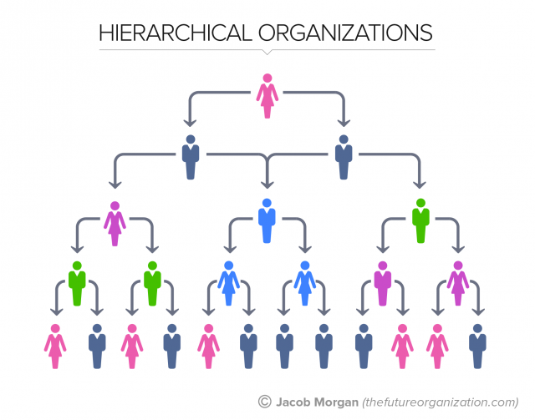
Figure 1: Hierarchical Organisations (Source: Morgan, 2015)
The corporate structure proves favourable for Amazon’s growth. For instance, Amazon’s finance chief, B. Olsavsky has said that the company is investing in future growth. Over $50bn was spent over a year on building logistics operations and data centres. (Weise, 2021) Outsourcing tasks is beneficial for Amazon as it cuts costs, reduces operations and concentrates on product development and marketing. Moreover, Amazon tried to enter healthcare industry outside its domestic market, planning to sell prescription drugs through Amazon Pharmacy. Beyond online retailing, Amazon has also entered business-to-business commerce and offers its business operations to other businesses. It earns fixed fees, per-unit activity fees and interest on sellers’ transactions.
- Organisational Culture
Amazon’s organisational culture is another key factor in the online retail business success. It is defined by the norms, values, beliefs, attitudes and assumptions that lead the employees to behave in a certain way and get things done. (Armstrong, 2012, p. 122)
Amazon has an intensive corporate culture suitable for employees who can thrive under pressure and fast paced environment. It values diversity, promotes inclusion and is open to new ideas, encouraging boldness among employees, brainstorming new ideas to improve the e-commerce business. Thus, their cultural characteristics also support innovation. The company employs people from diverse backgrounds and takes steps to ensure they have sense of belonging, opportunity and value. Amazon leadership at senior level is visionary, with Jeff Bezos communicating visions of exceptional customer service and an extreme customer-centricity. Diversity, equity and inclusion (Amazon, 2021)
The company’s Code of Conduct sets out principles such as rules, laws and regulations at the workplace. In case of violation the employees may be discharged. Employees are expected to act lawfully and ethically, always in the company’s interest because when personal and organisational goals differ, disharmony and conflict may arise, impacting performance negatively. Discrimination and harassment are not tolerated. Employees follow health and safety rules and procedures in incident reporting. They cannot bribe anyone, discuss prices or make agreements with competitors. There are procedures in case of conflict of interest, although it should be avoided. Code of business conduct and ethics (Amazon, 2021)
- Organisational Behaviour

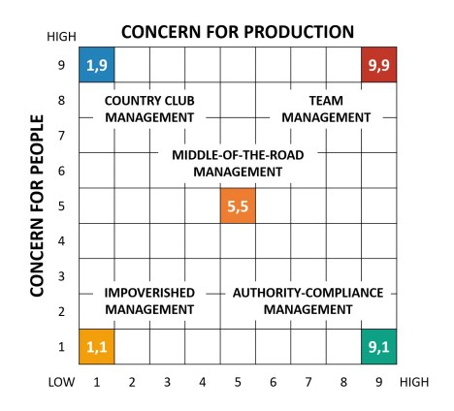
Figure 2: Blake and Mouton Managerial Grid (Source: Bruin, 2020)

Bruin (2020) provides a detailed figure based on behavioural approach towards management. Blake and Mouton’s Managerial Grid determines leadership style by comparing it against two main principles: concern for production (task oriented) and concern for people, (relationship oriented). It specifies the team management style as the most effective because it fully considers tasks and relationships. Ultimately the Grid helps managers to critically evaluate their management style and make amends in their behaviour where needed. (Mullins and McLean, 2019, p. 388)

Business flexibility and stability in the top management of Amazon corporate structure results in limited turnover in the senior management team. In the middle and bottom management autocratic leadership style prevails, creating micro-management. However, a few drawbacks have been reported with the management behaviour at the lower levels of the hierarchy including poor employee treatment, high employee turnover, negative feedback and issues with the warehouses, specifically in the international segment. (MarketLine, 2021d, p. 10)

Nevertheless, Amazon generated large amount of revenue in the first quarter 2021 and its employees totalled 1,271,000 worldwide which is 51% more than the same time last year. (Weise, 2021)

Following the findings regarding Amazon organisational behaviour, it seems that the company faces some challenges, however the evidence shows efforts to manage these shortcomings. Some of them include workplace safety in the pandemic, offering mass testing and vaccines and 2 weeks paid quarantine for positive cases; support network for employees and sellers through various programmes; holiday over-time pay; employee discount on purchases; It is expanding Workwell, a successful health and safety program committed to manage and prevent MSD (musculoskeletal disorders, common for warehouse workers). Amazon fits delivery vehicles with cameras and artificial intelligence to prevent accidents and keep drivers and communities safe. The company invests in workers training, education and development. (MarketLine, 2021b)
5. SWOT Analysis
According to Mullins (2019), organisational behaviour is the nature of people- organisation relationship. Therefore, the way companies manage their work climate, motivation and rewards systems, will define job satisfaction and organisational performance. Subsequently, discussed below are the internal and external factors that influence individual behaviour at Amazon towards their quarterly record sales.
5.1 Strengths
One important strength of Amazon is their ability to offer economies of scale, resulting in reasonable prices that fit all customers’ budgets. It attracts consumers with seasonal promotions, loyalty cards, free gifts, money off coupons. Additionally, it offers 1-click shopping, next day delivery and ability to create value for customers. Amazon uses methods to study customers’ behaviour and data through their website (Customer Relations Management) and combined with wishlist and customers reviews the company strategically boosts its business. Amazon consists of systems, which critically evaluate the company’s efficiency to influence performance. Such systems include employee recruitment and performance, selection system, team development, based on the internal factors listed below.
5.1.1 Motivation, Rewards and Communication
According to Armstrong (2012), motivation is defined by the strength and direction of behaviour as well as the factors that make people behave in a certain way. He states that expectancy (performance), goal setting (feedback and evaluation), and equity (fairness) motivation theories are more relevant than Maslow’s hierarchy of needs in operational success because they do not generalize that everyone is motivated in the same way by the same pattern of expectations. In theory, motivation influences behaviours as it combines skills, abilities, knowledge, emotions and feeling and conditions outside individual’s control prompting management to focus on the level of motivation to influence behaviours and direct employees’ efforts towards achievement of companies’ goals. (Mullins and McLean, 2019)
Amazon motivates their employees with rewards, ability to attract talents, working environment, providing training for employees to learn new skills and career progress as well as equal opportunities. Starting wage in US is $15 per hour. It offers employees and eligible family members health care coverage, flexible pay leave for parents, ways to save for the future and benefits after retirement, provides childcare and eldercare as part of work recognition, paid time off and more. Employees have opportunity to own company’s stock. It pays college tuition to front line employees. Employee benefits (Amazon, 2021)
In the Q1 2021, Amazon announced that it would increase wages for half a million employees and create tens of thousands more vacancies. (Weise, 2021)
Networked organisations reshape the way employees’ function, because they are coordinated by social networks and are better at communication. Although hierarchical structures are known for communication implications, Amazon ensures clear flow of information through meetings, one on one meetings and regular opportunities to talk to leaders. Some other examples include conferences for employees such as AmazeCon, highlighting the gender diversity, AmazeWit, conversations on race and ethnicity, Global Accessibility awareness month and affinity groups meetings that lead community building and mentorship.

5.2 Weaknesses
In 2020, the company generated 68.3% of the revenue in U.S, making its business operations dependant on the political and economic factors of the States, due to the geographical business concentration in this region. The liabilities of the company increased to $126.385m, which could affect future investment purposes. (MarketLine, 2021a) Employees from lower levels of hierarchy may not participate in making decisions and managers have power over the employees, which is also one of the disadvantages of hierarchical structures.

5.3 Opportunities
In 2021, Amazon expanded its electronic market. It has opportunities to penetrate developed markets and collaborate with competing companies. It focuses on the innovation of products and services. On the 31 March 2021, Amazon announced Amazon Prime Air, a drone delivery system and new technology planning to create smart warehouses. It also introduced Amazon Fresh, grocery stores with no check out requirement based on latest technology. The company aims at reducing its carbon footprint and operating on 100% renewable energy.

    - COVID-19 impact on Amazon in the Q1, 2021
Record quarterly profits were reached amid the pandemic- driven shift to online purchasing. Consequently, Amazon has run its warehouses to nearly full capacity, operating more efficiently, saving costs and delivery time with high volume of orders. High degree of logistics and surge in demand for large supplies saw sales grew 44% and the cost to fulfil the orders was up 31%. (Weise, 2021)
In the first quarter, Amazon operating income grew to $8.9bn with Net income increasing to $8.9bn. (MarketLine, 2021b)

Although these figures are supported by higher revenue and strong operational performance, the COVID 19 pandemic proved to be central for Amazon’s growth. Lockdowns and stay at home policies were major beneficiary for Amazon which managed to retain and attract more consumers.
Strong networks and global fulfilment centres give the company competitive advantage. Buchanan and Huczynski (2016, p. 556) believe that networked organisations (chaordic) can react rapidly to uncertainty and generate order. Networking helped Amazon to leverage its online commerce to cater to the growing demand, offering stability. Demand for online grocery and pickup services increased resulting in more pickup locations as the demand for subscription services which reached 200 million and $ 7.6bn in the quarter. The shift to remote computing during the period brought AWS, (computing platform) $13.5bn. Sales in North America increased 40% and international sales saw 60.4% growth. 3P seller revenue climbed 60% to $23.7bn and the advertising business grew 77% to almost $7bn. (Weise, 2021)
5.4 Threats
Stringent regulations and changes in socio-cultural environment can increase the cost of doing business, affecting the financial and future growth of the company. Potential treat of competitors and new entrants exists although there are entry barriers such as strong brand name and economy of scale. Possible lawsuits against Amazon.

6. Conclusion
Amazon’s continuing success in expanding its business and profitability is an indicator of the suitability of its structure. It also contributes to the company’s global brand image and ability to deal with competitors such as Google, Apple and Microsoft. Aggressive marketing strategy, customer-oriented approach, product diversity and innovations into new niche markets are other fundamental philosophies that are responsible for Amazon’s growth.

However, a company is only as good as the employees who work in it. I believe Amazon recognises that the company’s organisational success depends on the organisational behaviour and its ability to satisfy the needs and expectations of the employees. Therefore, Amazon ties to build a culture that is welcoming and motivating, fundamental to achieve best results. In conclusion, the strong Covid pandemic impact, the different internal and external factors discussed above influenced Amazon’s performance to reach profits that surpassed Wall Street’s expectations while it prepares for another strong year. (Weise, 2021)

REFERENCES

MarketLine (2021a) Amazon.com Inc. Available at: https://advantage-marketline-com.ezproxy.uwtsd.ac.uk/Company/Summary/amazoncom_inc (Accessed: 02 December 2021)

MarketLine (2021b) Amazon announces first quarter results. Available at: https://advantage-marketline-com.ezproxy.uwtsd.ac.uk/News/amazon-announces-first-quarter-results (Accessed: 02 December 2021)

Buchanan, D. and Huczynski, A. (2016) Organisational behaviour. 9th Ed. Harlow: Pearson Education

MarketLine (2021c) Amazon.com Inc. Available at: https://advantage-marketline-com.ezproxy.uwtsd.ac.uk/Company/Profile/amazoncom_inc?companyprofile (Accessed: 02 December 2021)

Weise, K. (2021) ‘Amazon’s profit soars 220 percent as pandemic drives shipping online’ [ The New York Times Online] Accessible on: https://www.nytimes.com/2021/04/29/technology/amazons-profits-triple.html

Armstrong, M. (2012) Armstrong’s handbook of human resource management practice. 12th Ed. London: Kogan Page

Amazon (2021) Our workplace. Available at: https://www.aboutamazon.com/workplace (Accessed: 02 December 2021)

Amazon (2021) Code of Business Conduct and Ethics. Available at: https://ir.aboutamazon.com/corporate-governance/documents-and-charters/code-of-business-conduct-and-ethics/default.aspx#:~:text=Code%20of%20Business%20Conduct%20and%20Ethics%20In%20performing,%22Code%20of%20Conduct%22%29%20sets%20out%20basic%20guiding%20principles (Accessed: 02 December 2021)

Mullins, L. and McLean, J. (2019) Organisational Behaviour in the Workplace. 12th Ed. Harlow: Pearson Education

MarketLine (2021d) Amazon.com, Inc.: Value Chain Analysis. Available at: https://advantage-marketline-com.ezproxy.uwtsd.ac.uk/Analysis/details/amazoncom-inc-value-chain-analysis-127418 (Accessed: 02 December 2021)

Amazon (2021) Our workplace. Available at: https://www.aboutamazon.com/workplace (Accessed: 03 December 2021)

REFERENCES (Figures)

Morgan, J. (2015) The 5 types of organisational structures: Part 1, The Hierarchy,
[Forbs Online] 1 Figure. Available at: https://www.forbes.com/sites/jacobmorgan/2015/07/06/the-5-types-of-organizational-structures-part-1-the-hierarchy/?sh=66fec6e15252 (Accessed: 03 December 2021)

Bruin, L. (2020) Blake and Mouton Managerial Grid [B2U Online] 2 Figure. Available at: https://www.business-to-you.com/blake-mouton-managerial-grid/
(Accessed: 03 December 2021)

