
Managing Food & Beverage Operations
Learning Log
Student Name- Bianca Alexandra Burcea
Student ID- 2122114

Executive Summary
The report has laid out in this reflective log his 10-week placement experience at The Savoy Hotel in the Food and Beverage department. It has provided insight: into the developments of some key work-based skills, such as communication and teamwork, and to some of the problems of understaffing. Practical solutions to achieve improved operational efficiency are discussed as proposed by the log in view of the need for effective practices of management in maintaining high service standards in the hospitality industry.

Table of Contents
Introduction 4
Section 1: Reflection on Experience and Personal Development 5
Shadowing a Supervisory Role Reflection 5
Gibbs reflective model 5
Section 2: Critical Analysis of Work-Based Skills and Technical Knowledge 8
Section 3: Reflection on Organisational Issues 10
Solutions and Recommendations being proposed 10
Action plan 11
Conclusion 12
References 13

Introduction
The reflection will reflect upon the 10 weeks spent working in The Savoy Food and Beverage department. Through shadowing a Food and Beverage Supervisor, the author covers the key learnings about daily operations, communication, teamwork, and guest service. This log will focus on the development of key work-based skills through the use of Gibbs Reflective Cycle, whilst exploring the challenges: staffing levels and service quality to develop further insight on the hospitality industry.

Section 1: Reflection on Experience and Personal Development

Shadowing a Supervisory Role Reflection
While on placement, I observed a Food and Beverage Supervisor providing first-hand guidance into the day-to-day running of daily operations in a high-end environment. I was responsible for managing staff provision and delivery of service and meeting guest satisfaction. I found the experience enlightening as it let me see how important it was to communicate well and work within a team to maintain our service standing (The Savoy Hotel, 2024). I learnt that when you are in a supervisor position, you have to cope with staff being absent, no staff or people coming to work, and a varying number of guests and lots of people’s needs.
One of those key moments I recall was during a busy service period where the staff member got ill and the supervisor took it upon him to shift the responsibility rationally on the team to make sure the service does not break (Walker, 2021). Now having this experience, it is apparent how important it is to be adaptable and make rapid decisions in a fast environment, which really reinforced to me the management principles that are taught.

Gibbs reflective model
Description: Whilst on my 10-week placement at The Savoy Hotel in London I shadowed a Food and Beverage Supervisor and gained directly from this placement, several insights into aspects of the department (Liu-Lastres et al., 2023).
Feelings: When I joined, the thinking was: Now, I need to get used to the responsibilities and the fast-paced environment of a luxury hotel. But I get more and more familiar with operations, with the team, and my confidence grows (ASET, 2017).
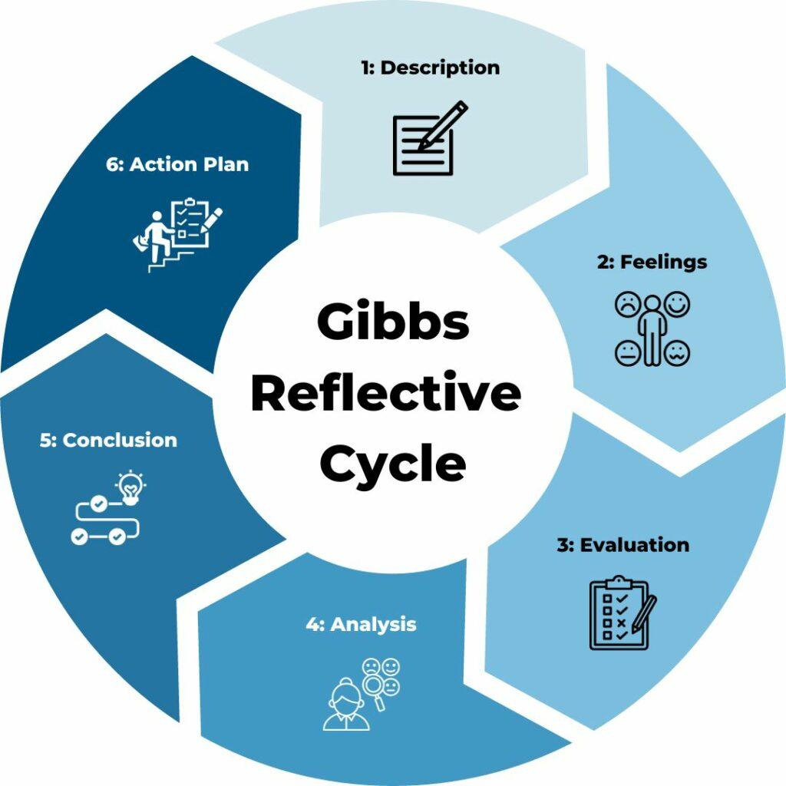
Figure: Gibbs reflective model
Source: (Walker, 2021)
Evaluation: I gained some valuable experience into how important effective communication and working as a team is. During busy service periods, communication among staff was needed in order to ensure the seller's timely service and guest satisfaction (Fallon, 2010).
Analysis: Understaffing was shown by the incident that happened in the high-end restaurant. Not only service quality was affected, but also employee morale (Liu-Lastres et al., 2023). This made them frustrated, which in turns affected the full guest experience.
Conclusion: As I contemplate on my experience, one can’t be an effective communicator or a team player or can’t be adaptable in the hospitality industry. Staffing issues also brought up areas of improvement in operational management, which imposed such a need for strong forecasting and flexible staffing policies (Hagg, 2013).
Action Plan: In any similar situation in the future, I would recommend proactive staffing strategies involving routine staffing levered based on historical data and peak periods (Fanthorne, 2004). I would also suggest that feedback be set up with staff to air their opinions and ideas, which is good for solving problems together.

Section 2: Critical Analysis of Work-Based Skills and Technical Knowledge
My placement at The Savoy significantly enhanced my work-based skills and technical knowledge in several key areas:
Communication: I realised how important it is to have clear and effective communication to keep service standards really high. By having regular briefings before service shifts, the team could align on expectations and work on any potential issues (Walker, 2021). During these briefings, I practised assertive communication (voicing concerns and giving suggestions) and felt more confident in a professional setting doing that.
Teamwork: Working together really reinforced the idea that collaboration is the key to great service delivery. I learned to appreciate the difference in the strengths of team members and how those differences contribute to overall success. One example was at peak hours, the synergy between the kitchen and floor staff was necessary to fast service so food gets to the guest and has them (Johnston, 2012).
Task Management: I gained some experience in prioritising tasks effectively (Fanthorne, 2004). I learned how to balance the needs of the immediate now with long term planning as I help the supervisor manage inventory and staff schedule. Developing organisational skills for success in the hospitality industry, this experience was of help.
Personal Skills: This fostered personal growth by both allowing me to question and grow from problems and to grow myself emotionally. I had a guest complaint to which I learnt how to handle with empathy and professionalism, growing my skills as a customer service (Vallen, 2014).
Guest Service: The Savoy so closely adhered to the standards of guest service that I can remember observing. I got to interact with guests, and that improved my opportunity to offer custom service (Hagg, 2013). For instance, I found myself being attentive and proactive in recognizing guests' needs; this skill alone was crucial in nurturing good guest experiences.
Looking back on my experience from Level 4 to Level 6, I realised during my journey theoretical concepts of management, marketing and customer service created my ground for my practices. The course work taught me to think critically and solve problems on real-world challenges.

Section 3: Reflection on Organisational Issues
Organisational Issue Encountered: In my placement I discovered an organisational issue with staffing levels over the peak service periods. One time the restaurant was not well staffed, which was causing longer wait times for guests and increased stress from the other staff (Hagg, 2013). It also showed that scheduling is a difficult task with serious consequences for employee morale and guest satisfaction.
Performance and Guest Service issue: The understaffing issue gave me a different experience as I felt the pressure my colleagues faced caused a lack of service quality. Delays frustrated guests and, along with it, proved a far from ideal atmosphere for staff that were expected to support guests with professionalism and restraint (Johnston et al., 2012). The cases would illustrate that you needed effective workforce planning, and it was a good idea to have backup measures ready.

Solutions and Recommendations being proposed
In order to address the staffing issue, I propose several practical solutions:
Enhanced Staffing Forecasting: By making use of the historical data and the trends, introducing a more robust forecasting system can provide an approximation of busy periods. Management can be able to provide adequate staffing levels, by analysing past performance in peak seasons and special events (Fanthorne, 2004).
Flexible Staffing Solutions: Having a pool of on call staff or part time workers available to come in when it gets busy would give the department a bit more flexibility (Fallon and Rutherford, 2010). This would provide a means to minimise the effect of the occurrence of such sudden absences thereby ensuring service standards.
Training and Cross-Training: Staff members should be trained regularly so that they are ready to take on any number of roles, if necessary. Cross training employees in other department functions within the Food & Beverage Department may assist in building team work and a higher level of efficiency to maintain this experience during times of high demand (Hagg, 2013).
Regular Staff Feedback Sessions: Creating a system of feedback from staff for commenting on staff levels, can increase the inclusiveness of the environment (Johnston et al., 2012). Not only does it create an open environment for communication but also gives an opportunity for employees to actively transform their operations.

Action plan
Action | Description | Responsibility | Timeline
Staffing Forecasting | Use historical data to predict staffing needs during peak periods. | Management Team | 1 month
Flexible Staffing | Create a pool of on-call staff for busy times (Fallon and Rutherford, 2010). | Human Resources | 2 months
Training Sessions | Regularly train staff to handle multiple roles. | Supervisors | Ongoing
Feedback Mechanism | Implement feedback sessions for staff to discuss staffing issues (Johnston et al., 2012). | Management Team | Bi-weekly
Performance Monitoring | Track service metrics to evaluate the impact of staffing changes. | Management Team | Monthly

Conclusion
The reflection has been on placement at The Savoy Hotel where he has acquired so much experience within the Food and Beverage department. Effective communication, teamwork, and adaptability have been emphasised during this period as the very basis of integrity in maintaining high levels of guest service standards. Furthermore, the issues that have also been related to the quantity of staff present have demonstrated a vital need to take a forceful approach to workforce planning. The results have mainly helped to shape future practices as well as highlight a detailed topic of efficient management in key businesses, such as the hospitality sector.

References
ASET (2017) Good Practice Guide for Workbased and Placement Learning in Higher Education. Sheffield: ASET.
Fallon, M. & Rutherford, D. (2010) Hotel Management and Operations. London: Wiley.
Fallon, M. and Rutherford, D. (2010) Hotel Management and Operations. London: Wiley.
Fanthorne, C. (2004) Work Placements – Survival Guide for Students. Basingstoke: Macmillan.
Hagg, E. (2013) Internship Guide: Work Placements Step by Step. 5th Ed. The Hague: Eleven International Publishing.
Hagg, E. (2013) Internship Guide: Work Placements Step by Step. 5th Ed. The Hague: Eleven International Publishing.
Johnston, R., Clark, G. & Shulver, M. (2012) Service Operations Management: Improving Service Delivery. 5th Ed. London: Pearson.
Johnston, R., Clark, G. and Shulver, M. (2012) Service Operations Management: Improving Service Delivery. 5th Ed. London: Pearson.
Liu-Lastres, B., Wen, H. and Huang, W.J., (2023). A reflection on the Great Resignation in the hospitality and tourism industry. International Journal of Contemporary Hospitality Management, 35(1), pp.235-249. https://doi.org/10.1108/IJCHM-05-2022-0551 [Accessed Date 24 October 2024]
The Savoy Hotel (2024) https://www.thesavoylondon.com/ [Accessed Date 24 October 2024]
Vallen, G.K. & Vallen, Jerome J. (2014) Check-In Check- Out: Managing Hotel Operations. 9th Ed. Harlow: Pearson Education Limited.
Walker, J.C. (2021) Introduction to Hospitality. 8th Ed. Harlow: Pearson Education Limited.

