Q1. As part of her actions to improve systems and procedures at Nexxobyte, Aisha has established monthly on-site Management Team meetings to be attended by her, Kit, you and the three Team Leaders. She would like you to make a short presentation at the first meeting ‘appraising what it means to be a people professional, and some of the ways you can contribute at Nexxobyte.’

Provide a written response covering the points you would include in this presentation.
(AC 1.1)

As per the CIPD profession map, a people professional is someone who “champion[s] better work and working lives” (CIPD, 2026). They promote cultures and environments with the aim of optimising employee potential (CIPD, 2026). There are three rules to making favourable decisions in people practice; ‘work matters, people matter and the importance of professionalism’ (CIPD, 2026). Whilst not regulated like some other professions there is still a code of practice that people professionals should follow. HR now encompasses a wider scope of duties and people professionals are more strategic partners than 10 years ago with further input into business decisions (CIPD, 2025a). This however means that boundaries are blurred whereby administrative work is being carried out in addition to problem-solving which can prove challenging to manage (CIPD, 2025a).

In accordance with ‘resourcing’ under the profession map, I would aim to rectify the recruitment predicament Nexxobyte has; there is no coherent recruitment process with managers being able to recruit how they see fit with no guidance. Having effective recruitment strategy helps secure the right talent and expertise and will cement the long-term success of Nexxobyte (CIPD, 2025b). Only 28% of employers up-skill their managers on legal requirements and the importance of objectivity (CIPD, 2025b). Processes at Nexxobyte need to be designed to reduce bias and discrimination meanwhile allowing for the selection of the best candidate (CIPD, 2025b). Resourcing means correctly recognising and finding people who are the right fit for Nexxobyte (CIPD, 2026b). I would ensure I effectively know how to analyse workforce data to determine gaps and for attracting recruits I would strive to attract diverse candidates (CIPD, 2026b). Inclusivity is paramount; South Warwickshire NHS Trust (SWFT) aimed to recruit a workforce that represented local community diversity so reviewed its systems (NHS Employers, 2021). By working with a local inclusion partnership, an audit was done which recommended a change to policies and processes and provided equality impact assessment training to staff (NHS Employers, 2021). Vacancies were promoted via community forums to have a wider reach, and the recruitment process was anonymised (NHS Employers, 2021). I would introduce these processes at Nexxobyte.

In line with the ‘employee experience’ element of the profession map, I would engage employees at Nexxobyte to ensure they have a positive working environment and help them get the most out of work (CIPD, 2026d). I would introduce clear policies and assess their effectiveness (CIPD, 2026d). Biffa introduced gender-inclusive polices in a male-dominated workforce where 15% of employees were female (Whitehouse, 2022); for example, they introduced a menopause policy to combat the difficulties women experience from working in a mostly male workplace (Whitehouse, 2022). This will likely be relevant for Nexxobyte as only 18% of the software development workforce is female (Wilkins, 2022). I would also look to introducing a clear grievance and whistleblowing procedures so that any issues can be raised and reported and qualifying disclosures can be made (ACAS, 2026).

Q2. You are excited by your new role and whilst you can see that there is a lot to do, you feel ready for the challenge.

Discuss two of your personal or ethical values that you believe will help you in your new role, and how consistently applying these will inform your people practice work at Nexxobyte. (AC 1.2)

I act with integrity; I show honesty in my work, and I show consistency by following through in what I say I will do as per the Profession Map (CIPD, 2025). This also means I ensure confidentiality is upheld within HR processes and my daily work. I ensure that records are kept in line with data protection rules which is regulated under the The Data Protection Act 2018 including sensitive data which has stricter handling rules (CIPD, 2025f). I’d ensure that consent is fully provided by employees at Nexxobyte and that employee data is managed carefully and any data breach would be reported to Nexxobyte’s Data Protection Officer who can then escalate to the Information Commissioner’s Office if necessary (CIPD, 2025f). In any disciplinary or grievance investigations I carry out, I will ensure that I follow a fair procedure in line with the ACAS code and adhering to any deadlines.

When I make mistakes, I am open and honest about these and will do my best to rectify any issues as soon as discovered and learn from them, in line with the profession map (CIPD, 2026c). I also believe culture plays a big part in openness and being upfront about issues. Competing forces can prevent there being a culture of honesty which promotes concealment (Goodridge, 2024). Accountability is paramount and creating a culture of accountability at Nexxobyte will be a goal of mine as it encourages greater transparency (Goodridge, 2024). As can be seen from the recent Post Office scandal whereby CEOs denied their responsibility (Goodridge, 2024); excuses and defensiveness hinder accountability (Goodridge, 2024). Therefore, I would make it my aim to ensure Nexxobyte has a culture of openness via clear policies like Whistleblowing, but also engaging employees to discuss any issues openly, via regular one-to-one meetings, and team meetings to allow clear employee voice. Nexxobyte should promote a speak-up culture, so employees feel allowed to raise issues and they are protected from discrimination from blowing the whistle (Hernandez, 2019). Tesco increased its accountability scope by providing regular discussions about its operating model (CIPD, 2024b). I would therefore make sure that employees are being engaged with, and updates are being shared with them, so they feel included and able to speak up.

Q3. Aisha has emphasised that she wants you to be a ‘a firm voice for people practice at Nexxobyte’. This means communicating with the management team in an informed, clear and confident way to convince them of the need for change and new ways of working.

Consider why it is important to communicate in this way and two potential consequences (one for you and one for Nexxobyte) if you are unable to do so. (AC 1.3)

Communicating will promote ethical practice as without communication and confidence to address issues, unethical decisions continue (CIPD, 2026c). This is problematic at Nexxobyte, as can already be seen through favouritism and poor decision making. Hierarchical structures can exacerbate ethical problems as it has been found that 28% of HR staff make unethical decisions because they were merely following orders (Butt, 2019). Toxic cultures can exist where unethical situations are ignored and even rewarded and professionals are reprimanded for challenging any unethical decisions (Butt, 2019). Additionally, not having the ability to speak up at work can ‘cost lives’ as it is integral to knowing how to prevent wrongdoing and inequality (Baska, 2020). Nexxobyte therefore needs to encourage open conversations and involve employees in decision-making processes (Baska, 2020). Employee voice needs to be utilised through consultation and regular meetings (CIPD, 2025g). Managers should consider their mood and demeanour as this can determine whether employees will easily raise issues with them which can in turn reduce costs and provide greater benefit (Xu et al, 2020 in Young, 2020).

Personally, if I did not speak up, I think this would impact my credibility as a HR professional at Nexxobyte. Communication is key in this profession generally. I would want to keep in line with the professional courage and influence aspect of the profession map. It is important to exhibit certain behaviours as a people practitioner and a core behaviour is having the capacity to influence others and have the confidence to challenge decisions (CIPD, 2026c). At Nexxobyte, having courage to raise issues such as favouritism and lack of formal procedures would be important to me to be ethical but also for my own sense of integrity. I would want to speak up when there is an issue and to stand up for the issue when that is the morally correct thing to do (CIPD, 2026c). This follows the CIPD profession map; showing courage will influence others (CIPD, 2026c).

Q4. During a conversation with the two administration staff, you learn more about some of the problems there have been at Nexxobyte. Some of these involved unethical behaviour (one manager regularly approving attendance at expensive training events and conferences for his ‘favourite’ team members, whilst consistently refusing similar requests from others) and even some illegal activity (a former employee using Nexxobyte work time and equipment to operate his own separate business).

Explain how, if you had been at Nexxobyte and aware of these two situations when they existed, you would have approached and raised them (AC 1.4)

Regarding the unethical behaviour exhibited by a manager, I believe the best course of action would be an informal process to initially gather more facts about the situation and discuss with the manager the reasons why he has been doing this; is it that he does not see an issue with it and sees it as a way of rewarding his best-performing employees perhaps. This would be the first port of call, to fully understand what has been happening, how long it has been happening and for what reasons. The manager might not think that what he is doing is unethical and he might not have been given training on the situation and how to deal with such matters. I would ensure I am following Nexxobyte’s policy too; it should be in the Disciplinary Policy that less serious matters will be dealt with informally. Or, as Worcestershire Acute Hospitals NHS Trust has, a policy regarding ‘Conversations of Concern’ could be implemented whereby minor misconduct is addressed (NHS, no date). Once I have had a discussion with the manager, guidance and training could be given to the manager on equal opportunities and rewards.

In the second scenario, an employee was doing illegal activity. I would follow the ACAS code of practice and carry out a formal procedure to establish the facts via an investigation meeting first, then a disciplinary hearing and then would deliver the outcome (ACAS, 2015). I would utilise active listening to really understand what the employee was saying to me and ask the right questions. I would follow Nexxobyte’s disciplinary policy as there should already be one, if not I will follow ACAS guidance on disciplinary procedures and maintain confidentiality throughout so that a fair process is maintained. I would ensure that any witnesses uncovered during the investigation process are interviewed too so that the full facts are gathered. I would tell the employee ahead of the disciplinary meeting what outcome they could expect from the meeting. As this is likely gross misconduct, the ultimate decision could be a dismissal as he most likely has breached his implied duties of trust and confidence (ACAS, 2025a). I would inform them that they have the right to bring a colleague or trade union representative along to the hearing (ACAS, 2025b).

By carrying out these procedures, I will demonstrate situational decision making as per the profession map as I show that I can distinguish between the two matters and the right course of action for each. I will show that I can make realistic decisions based on what is in front of me and make evidence-based decisions based on the evidence that emerges through the investigation processes (CIPD, 2025f).

Q5. You are pleased that your presentation at the manager’s meeting (see Q1) was well received. However, one manager has since commented in the Manager Chat group, “We don’t really need to change anything - the company is doing well financially and anyway people work much harder when they are not protected by a load of feel-good policies and procedures.” You want to respond to this comment in a professional and informative way which may help to change these views.

With reference to research or theory, argue the human and business benefits of people feeling included, valued, and fairly treated at work. (AC 2.1)

Human benefits

Fairness should not be a luxury and should be a prerequisite (National Centre for Diversity, no date). Employees feel more valued when they are respected at work and this can be transformative in how they experience work (BPS, 2025), bettering their mental health and increasing trust (BPS, 2025). Humans need to feel a sense of belonging (Ahmed, 2025) it is an essential need which brings a sense of meaning to our lives (Ahmed, 2025). Ahmed points out that it is not enough to just be hired in a family-like atmosphere at work (Ahmed, 2025); employees need to feel like they belong and need to feel seen by others (Ahmed, 2025). For example, mandates to force people back to the office is often an incentive to bring people together however this can have the opposite effect as employees who enjoy working from home can actually become withdrawn when they are back in the office as opposed to having a flexible policy as it feels forced and they feel unsupported (Ahmed, 2025). Research identifies that more workplace inclusion results in higher employee satisfaction, more creativity and a reduction in employee absenteeism (CIPD, 2019). Moreover, stress and unfair treatment can cause undue tension for employees, and it can be the inconsistency of this which causes the most strain (Matta et al, 2017 in CIPD, 2017).

Business benefits

Roberson says there are benefits of having a diversity of identities, cultures and life experiences within an organisation and organisations should not only focus on recruitment but consider the requirements of diverse staff once they are in the role (LSE, 2018). Employees need to feel personally valued and included and like they add value to the company, and diversity and inclusion should be about the participation and opportunities not just optics (LSE, 2018).

Companies that are more ethnically and racially diverse perform 35% better financially than those that are not (Korica, 2019). However alarmingly only 36% of senior leaders have commitment to an inclusive workplace (CIPD, 2022). There is evidence that greater diversity allows for more innovative and creative thinking (Korica, 2019), with Clearfield and Tilcsik finding that unique views from minorities can change the group-think mentality and increases scepticism amongst a group (Korica, 2019); evidence is evaluated from a different angle and the group are less likely to jump to conclusions (Korica, 2019).

Jaguar Landrover introduced a family friendly policy that reflects modern society and its diversity (Jackson, 2026), providing 52 weeks of fully paid maternity leave which has also been extended to adoption leave (Jackson, 2026). From a human perspective this allows people to spend important quality time with their family (Jackson, 2026), and in turn this heightens employee retention and engagement which is positive for business as it is an “investment in performance” (Jackson, 2026). Companies with greater gender diversity have a 25% higher profitability (Taylor and Woodhams, 2022 p 160). I would look at the policies that Nexxobyte has and implement inclusive policies as it is evident that these benefit the business and employees alike and are not just ‘feel-good’ policies.

Q6. Following several of the complaints about unfair practice in relation to staff training, Aisha has asked you to devise a fair Staff Learning & Development Policy, which will include all staff members and will set out factors such as: allowable paid time for development activities, individual training budgets, type of learning activities that can be included, etc.

Discuss the steps you will take
· to make your design of the initiative fair and inclusive
· to check, after three months of implementation, that the initiative is as inclusive as you have intended.

NOTE: there is no need to devise a policy here, only to discuss how you will design it to be inclusive and how you will check inclusivity after three months. (AC 2.2)

A Learning & Development (L&D) policy displays the “capabilities, skills and competencies” of an organisation (CIPD, 2025c). It needs to be ensured there’s equal opportunity for everyone to access learning resources (CIPD, 2025c). Offering extra resources to develop the skills of underrepresented groups and those who need further support is recommended (CIPD, 2025c). Diversity should incorporate intersectionality therefore recognising people have different attributes that comprise their identity (Challouki, 2024). Workplace inclusion should represent everyone and not just a select few who hold the most privilege (Challouki, 2024). EDI training is therefore important to teach employees this information, so they know how different identities interconnect and how to behave in an inclusive manner (Challouki, 2024). 15-20% of people in the UK are neurodivergent (Maskell, 2025) and many of the ways that training is provided such as being in-person can significantly disadvantage neurodivergent employees (Maskell, 2025).

Personal development plans can help employees achieve their unique personal growth and individual objectives rather than follow a linear path (Maskell, 2025), whilst understanding that not all employees who have excellent technical skills will necessarily want to move into management (CIPD, 2024a). Therefore, further opportunities to develop in these areas is important with alternative career paths available (CIPD, 2024a). Neurodiverse individuals can struggle with self-confidence and self-advocacy which results in missed career development opportunities and there can be an assumption from managers that neurodiverse employees will not make good managers (CIPD, 2024a).

Public Health Wales in their L&D policy have said they are committed to equitable and fair access to learning and development; (Public Health Wales, 2024) all requests for time taken to complete training are considered and should be supported (Public Health Wales, 2024). This is important as only 39% of employees believe they were given adequate time away from their normal role to complete training (Howlett, 2023). This should be implemented at Nexxobyte, allowing employees ample time to complete training.

After 3 months, I would complete staff surveys to investigate the effectiveness of the training, and to determine the uptake data. Like how Kroese and Thalheimer did in their study, I would use questions that incorporate obstacles to learning like ethnicity, gender, and neurodiversity (Kroese and Thalheimer, 2025), the diversity of images used and whether the training was accessible (Kroese and Thalheimer, 2025). This is all significant data to analyse; learning environments can show negative stereotypes and can make diverse learners feel excluded (Kroese and Thalheimer, 2025). However, I will ensure that survey questions are not oversimplified so that the data is valuable (CIPD, 2025d). My questions will therefore be thorough with open questions to obtain specific data.

Q7. Using a combination of your own reflections and feedback from at least one other person, review your own behaviour against the six Associate-level standards for ‘Working inclusively’ in the CIPD Profession Map. https://www.cipd.org/uk/the-people-profession/the-profession-map/explore-the-profession-map/core-behaviours/working-inclusively/

Summarise your conclusions from this activity, along with a brief explanation of who you involved and how their feedback informed your review. (AC 2.3)

You don't need to provide a reference or in-text citation for AC 2.3.

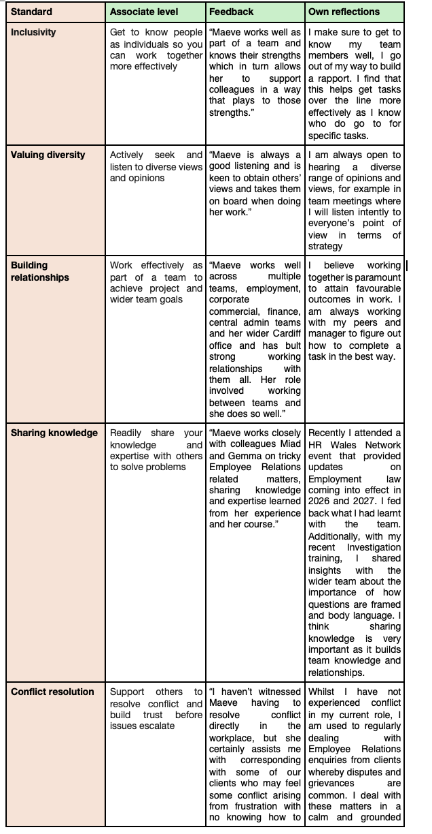

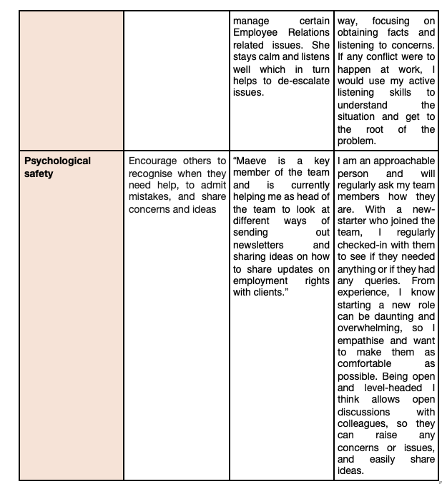

Q8. Research and identify two ways the people practitioner role (generalist or any specialist) is evolving. Summarise these two developments and the implications they have for your ongoing professional development. (AC 3.1)

There has been the biggest transformation in technology in HR for decades with cloud platforms revolutionising the profession through greater scope for analytics and flexibility (Larkin, 2017). This will help me in my role as I can analyse data to identify trends and determine what can be improved. Data analytical tools will help scrutinise data to aid decision making (Larkin, 2017). In absence management I could identify trends and check-in with identified employees to see how they are. Technology can be used for employee engagement; social media style training can make training engaging and user-friendly (Larkin, 2017). I can therefore quickly become upskilled with any employment law or compliance changes. Increased technology promotes greater collaboration though employees should be provided with platforms to voice their opinions and concerns and add to the company’s strategy (Larkin, 2017). Lincolnshire Co-op created their own intranet app to encourage communication and knock down hierarchies and now enables employees to easily view their payslips (CIPD, 2021). Technology will provide greater bottom-up strategy formation (Larkin, 2017). 86% of employers believe in the next five years Artificial Intelligence will be a key driver of business change (CIPD, 2025a). This means I need to continually keep myself updated on changes to processes and policies so that I am using such technologies correctly. It will help enormously with drafting contracts, and administrative tasks. It will provide more scope to focus on the personal side of people management, such as liaising with employees to gather feedback to help with strategic change, however I will maintain caution with regards to data privacy and bias risks.
The Equality Act 2010 has compelled organisations to include policies to dismantle barriers for marginalised groups and provide greater opportunities (CIPD, 2025). Social movements like Black Lives Matter highlighted the disparities within the workplace for BAME individuals (CIPD, 2025), It also means the requirement of inclusive recruitment policies (CIPD, 2025). I will keep informed with laws, ensuring that I am fully aware of the law and the implications of it. I will follow ACAS guidance and helpful guidance provided by the EHRC (CIPD, 2025e). The policies that I prepare will need to be aligned with this; I will prepare informative diversity, inclusion and anti-harassment and bullying policies (CIPD, 2025e), making it completely transparent that the company does not tolerate discrimination in any form (CIPD, 2025e). I will also ensure to speak to employees regularly to gather their feedback to ensure that policies are being followed and will develop surveys to gain feedback from employees with long-term health conditions, disabilities and from ethnic minorities (CIPD, 2025e).
Q9. With reference to your reflections and feedback at Q7, and your research at Q8, assess your current strengths, weaknesses and development areas in relation to people practice. (AC 3.2)

You don't need to provide a reference or in-text citation for AC 3.2.

I am inclusive in my way of working; I enjoy talking to my team and it comes naturally for me to enquire how people are and how they are getting on, and if they need any help. This in promotes a positive working environment, as I feel more at ease with my colleagues once I have built a rapport, and it makes it easy to ask any questions I may have myself. I am in favour of good teamwork and working together towards an objective. For example, when there are deadlines to adhere to, I will assist my colleagues to get the task over the line. This helps to build a healthy working environment; I value diversity as I believe everyone has something to give and different opinions provide greater decision making; it is good to be challenged on your views. I also try to make working environments a space where issues can easily be raised.

However, sometimes I do not let people know if I am struggling with workload, as I will try my best to continue regardless. This is something that I am improving on, as fortunately my team is approachable enough to flag if your workload is too high. However, I need to learn to prioritise work more effectively to prevent stress. Sometimes I work on tasks in accordance with their timeframes, however sometimes I may not know when a task will need to be done by, so I try and get it done urgently, which can leave me stressed if there are competing tasks with a similar deadline.

Q10. Following on from your self-assessments, identify two development activities you will undertake (or commence) in the next six months. Provide a brief explanation of the activities you have selected along with your reasons for choosing them. (AC 3.3)

You don't need to provide a reference or in-text citation for AC 3.3

I am going to investigate methods of time management that I can utilise in my every day. From research, there is the ‘Eisenhower Matrix’ that can help me to rank what is most important and identify what can be determined as urgent (Stern, 2018). I am going to research further into this and read books on how to implement this into my every day, as well as other methods that may be helpful. My aim is to make my everyday tasks more manageable. Whilst not an everyday occurrence, sometimes tasks can feel overwhelming. I hope that learning time management methods will alleviate any issues and aligns with the profession map under ‘self as instrument’ to develop organisational culture (CIPD, 2024c).

I will attend a “Wellbeing at Work” talk to better understand the stressors experienced in the workplace and coping methods, in line with specialist knowledge of the profession map. It will help me understand the psychological reasons behind stress; to understand that it is normal and human, but there are management strategies. I hope it will help me focus on my own wellbeing, when I am used to focusing on my tasks, leading to built-up stress. I want to build greater resilience and confidence in my abilities; I think as someone new to the industry, I can overthink a lot of my decisions. This will help me to build confidence in my abilities and to understand that building expertise is a process.

Q11. Shifting your focus to development activities you have already undertaken within the last two years, reflect on the two activities (formal or informal) that you consider had the greatest impact on your behaviour and performance.

Provide your reflections, attached to your assessment, as either:
· your own format CPD record, edited to include just the two selected activities, or
· a report (or reports) from the CIPD ‘My CPD Reflections’ tool. (AC 3.4)

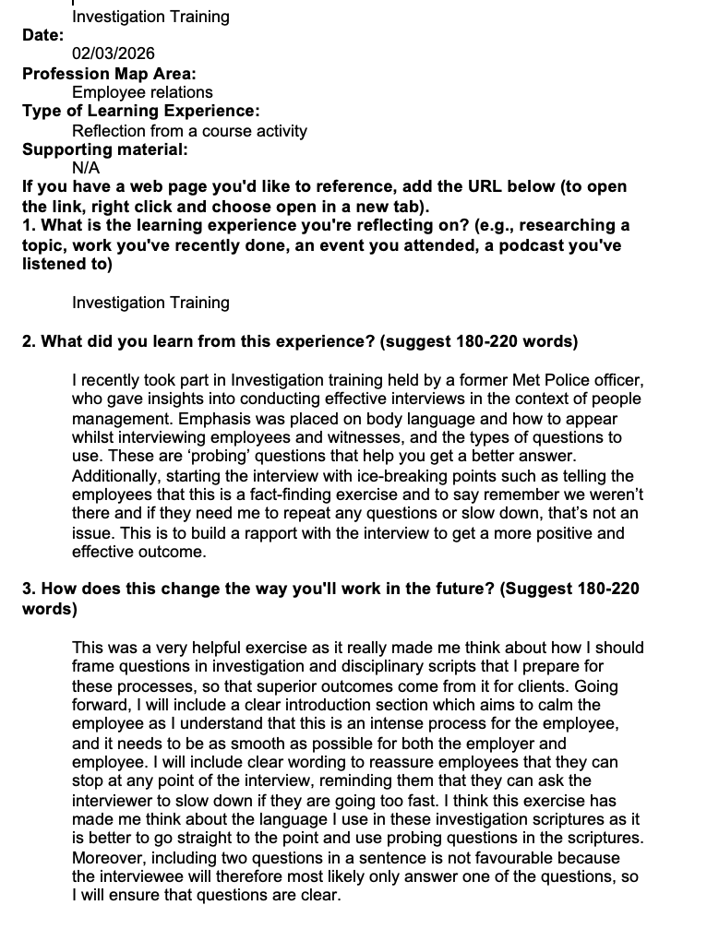

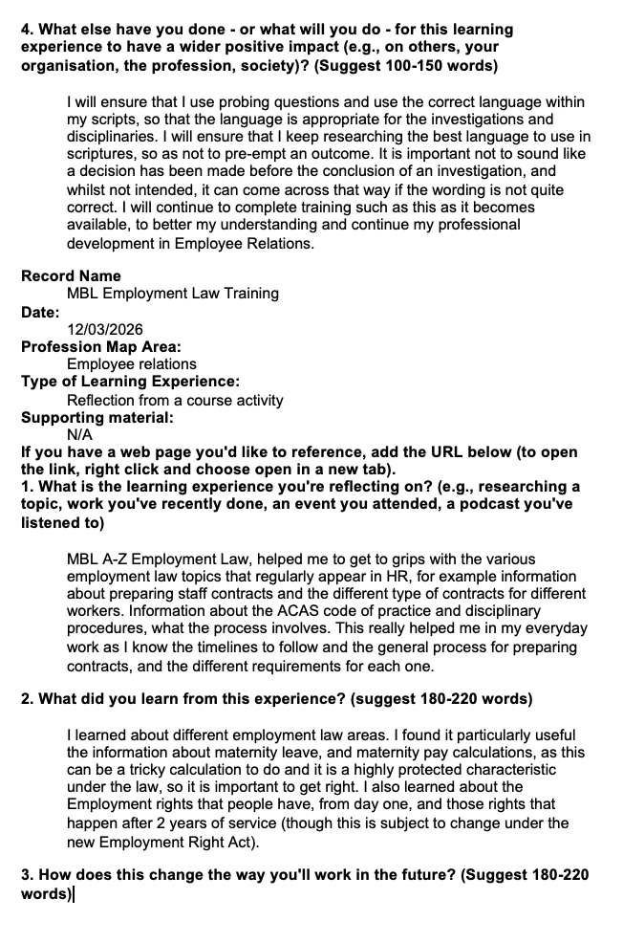

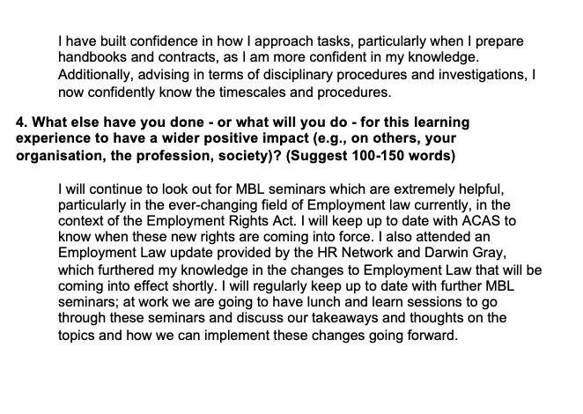

Reference list

ACAS (2015) Acas Code of Practice on disciplinary and grievance procedures. Available at: https://www.acas.org.uk/acas-code-of-practice-on-disciplinary-and-grievance-procedures. (Accessed: 19 March 2026).
ACAS (2025a) Implied duties: Trust, confidence and fidelity. Available at https://www.acas.org.uk/implied-duties/trust-confidence-and-fidelity. (Accessed: 3 March 2026).

ACAS (2025b) Disciplinary procedure Step 4: The Hearing. Available at: https://www.acas.org.uk/disciplinary-procedure-step-by-step/step-4-the-disciplinary-hearing. (Accessed 3 March 2026).

ACAS (2026) Whistleblowing at Work: What someone can whistleblow about. Available at: https://www.acas.org.uk/whistleblowing-at-work/what-someone-can-whistleblow-about. (Accessed: 17 March 2026).

Ahmed, N (2025) Do you feel like you belong at work? Here’s why it’s so important for your health, happiness and productivity. Available at: https://www.business-reporter.co.uk/management/do-you-feel-like-you-belong-at-work-heres-why-its-so-important-for-your-health-happiness-and-productivity. (Accessed: 22 February 2026).

Baska, M. (2020) CIPD Annual Conference 2020: not being able to speak up at work ‘can cost lives’, says Reitz. Available at: https://www.peoplemanagement.co.uk/article/1745039/cipd-annual-conference-2020-not-being-able-to-speak-up-at-work-can-cost-lives. (Accessed: 25 February 2026).

BPS (2025) Psychology Matters: "The impact we have is personal: when employees feel understood, respected, and valued in the workplace, it transforms their lives.” https://www.bps.org.uk/blog/psychology-matters-impact-we-have-personal-when-employees-feel-understood-respected-and-valued (Accessed: 1 March 2026).

Butt, S. (2019) The time to act on ethics is now. Available at: https://www.peoplemanagement.co.uk/article/1743756/the-time-to-act-on-ethics-is-now. (Accessed: 25 February 2026).

Challouki, H. (2024) Why EDI must have a clear place in L&D initiatives. Available at: https://www.peoplemanagement.co.uk/article/1879737/why-edi-clear-place-l-d-initiatives (Accessed: 18 February 2026).

CIPD (2019) Building inclusive workplaces. Available at: https://www.cipd.org/uk/knowledge/evidence-reviews/building-inclusive-workplaces/ (Accessed: 22 February 2026).

CIPD (2021) Mobilising wellbeing initiatives through technology. Available at: https://www.cipd.org/uk/views-and-insights/thought-leadership/insight/mobilising-wellbeing-initiatives/ (Accessed: 7 March 2026).

CIPD (2022) Inclusion at Work 2022. Available at: https://www.cipd.org/globalassets/media/knowledge/knowledge-hub/reports/2023-pdfs/inclusion-at-work-exec-summary_tcm18-112951.pdf (Accessed 7 March 2026).

CIPD (2024a) Neuroinclusion at work. Available at: https://www.cipd.org/uk/knowledge/guides/neuroinclusion-work/ (Accessed: 20 February 2026).

CIPD (2024b) Transforming the HR operating model: Tesco. Available at: https://www.cipd.org/en/knowledge/case-studies/operating-model-tesco/ (Accessed 7 March 2026).

CIPD (2024c) The Profession Map. Available at https://www.cipd.org/globalassets/media/comms/the-people-profession/profession-map-pdfs/profession-map-nov-2024.pdf. (Accessed 17 March 2026)

CIPD (2025a) Analysis – Evolution of the people profession. Available at: Analysis | Evolution of the people profession https://www.cipd.org/en/views-and-insights/thought-leadership/insight/evolution-people-profession/#Increasing-remit (Accessed: 15 February 2026).

CIPD (2025b) Recruitment: An introduction. Available at: https://www.cipd.org/uk/knowledge/factsheets/recruitment-factsheet/ (Accessed: 15 February 2026.

CIPD (2025c) Learning and development strategy and policy. Available at: https://www.cipd.org/uk/knowledge/factsheets/strategy-development-factsheet/ (Accessed: 15 March 2026).

CIPD (2025d) Employee engagement and motivation. Available at: https://www.cipd.org/uk/knowledge/factsheets/engagement-factsheet/ (Accessed 7 March 2026).

CIPD (2025e) Discrimination in the workplace. Available at: https://www.cipd.org/uk/knowledge/factsheets/discrimination-workplace-factsheet/#good-employment-practices, (Accessed 7 March 2026).

CIPD (2025f) Situational decision-making. Available at: https://www.cipd.org/en/the-people-profession/the-profession-map/explore-the-profession-map/core-behaviours/situational-decision-making/. (Accessed 7 March 2026).

CIPD (2025g) Employee Voice. Available at: https://www.cipd.org/uk/knowledge/factsheets/voice-factsheet/ (Accessed: 18 March 2026).

CIPD (2026a) Principles-led https://www.cipd.org/uk/the-people-profession/the-profession-map/explore-the-profession-map/professional-values-purpose/principles-led/ (Accessed: 15 February 2026)

CIPD (2026b) Resourcing. Available at: https://www.cipd.org/uk/the-people-profession/the-profession-map/explore-the-profession-map/specialist-knowledge/resourcing/ (Accessed 1 March 2026).

CIPD (2026c) Professional courage and influence. Available at: https://www.cipd.org/uk/the-people-profession/the-profession-map/explore-the-profession-map/core-behaviours/professional-courage-influence/. (Accessed: 25 February 2026).

CIPD (2026d) Employee experience. Available at: https://www.cipd.org/uk/the-people-profession/the-profession-map/explore-the-profession-map/specialist-knowledge/employee-experience/ (Accessed: 3 March 2026).

Goodridge, M. (2024) In a world full of business crises, it’s still critical to have accountability. Available at: https://www.peoplemanagement.co.uk/article/1892084/world-full-business-crises-its-critical-accountability. (Accessed: 7 March 2026).

Hernandez, J. (2019) What can companies learn from infamous corporate scandals? Available at https://www.peoplemanagement.co.uk/article/1746074/what-can-companies-learn-infamous-corporate-scandals#gref. (Accessed 10 March 2026)

Howlett, E. (2023) How can HR and L&D collaborate to allow employees more time to learn? Available at: https://www.peoplemanagement.co.uk/article/1828439/hr-l-d-collaborate-allow-employees-time-learn (Accessed: 7 March 2026).

Jackson, I. (2026) Why Jaguar Land Rover transformed its parental leave policy. Available at: https://www.peoplemanagement.co.uk/article/1947830/why-jaguar-land-rover-transformed-its-parental-leave-policy. (Accessed: 28 February 2026)

Korica, M (2019) Why diversity and inclusion will improve your business. Available at: https://www.wbs.ac.uk/news/why-diversity-and-inclusion-will-improve-your-business/ (Accessed: 18 February 2026).

Kroese, I.C., and Thalheimer, W. ‘Evaluating the inclusiveness of employee training programmes: a research-practice partnership’, Human Resource Development International, DOI: 10.1080/13678868.2025.2563354

Larkin, J., 2017. HR digital disruption: the biggest wave of transformation in decades. Strategic HR Review, 16(2), pp. 55-59.

Maskell, L. (2025) How to make L&D more neuroinclusive. Available at: https://www.peoplemanagement.co.uk/article/1936916/l-d-neuroinclusive (Accessed: 18 February 2026).

Matta, F., Scott, B., Colquitt, J., Koopman, J. and Passantino, L. ‘Is consistently unfair better than sporadically fair? An investigation of justice variability and stress’. Academy of Management Journal. April 2017, Vol 60, No 2. pp 743–770., in CIPD (2017) Fairness in organisations - is consistency key? Available at: https://www.cipd.org/uk/knowledge/bitesize-research/fairness-organisations/ (Accessed: 25 February 2026).

National Centre for Diversity (no date). Available at: https://nationalcentrefordiversity.com/fairness-isnt-a-luxury-its-a-human-necessity-its-hardwired-into-us/. (Accessed: 28 February 2026).

NHS Employers (2021) INCLUSIVE RECRUITMENT LEADING POSITIVE CHANGE: A report by NHS Employers and commissioned by NHS England and NHS Improvement. Available at: https://www.nhsemployers.org/system/files/media/Inclusive-recruitment-leading-positive-change_0.pdf (Accessed: 15 February 2026).

NHS (no date) Guidance - Conversations of Concern, Worcestershire Acute Hospitals NHS Trust. (Accessed: 10 March 2026).

Wilson, D (2025) The importance of HR policies. Available at: https://croner.co.uk/resources/employment-contracts-and-documentation/the-importance-of-hr-policies/ (Accessed: 15 February 2026).

Public Health Wales (2024) Learning and Development Policy. Available at: https://phw.nhs.wales/about-us/policies-and-procedures/policies-and-procedures-documents/human-resources-policies/learning-and-development-policy/ (Accessed: 1 March 2026).

Roberson, Q. (2018) The value of diversity and inclusion. Available at: https://www.lse.ac.uk/management/news/quinetta-roberson-091018 (Accessed at: 18 February 2026).

Stern, S. (2018) We all need to get better at time management. Available at: https://www.peoplemanagement.co.uk/article/1743880/we-all-need-get-better-time-management (Accessed: 7 March 2026)

Taylor, S and Woodhams, C. (2022) Human resource management: people and organisations, 3rd Edition, Kogan.

Wilkins, R. (2022) Coding: Female engineers deleting myth that tech is for men. Available at: https://www.bbc.co.uk/news/uk-wales-63839738. (Accessed: 3 March 2026)

Whitehouse, E. (2022) How Biffa is boosting the professionalism of its HR team. Available at: https://www.peoplemanagement.co.uk/article/1792317/biffa-boosting-professionalism-its-hr-team (Accessed: 3 March 2026).

Xu, E., Xu, H.,, Ouyang, K., Wu, L., and Hu, S. Human Resource Management Journal. May/June 2020, Volume 59, Issue 3, pp 255-269, in Young, J.(2020) The tactics of speaking up at work. Available at: https://www.cipd.org/uk/knowledge/bitesize-research/speaking-up/, (Accessed: 3 March 2026).

