Name: Ana-Maria Moise
Student number: 2233131
Title: Planning and Delivering An International Meeting/ Event
The Module Title: International Meetings Management BMIH6007
Lecturer Name: Chris Wilkin

Executive summary:
This report evaluates the crucial need for inclusive hotel room designs that accommodate people with different impairments.
Applying the EMBOK (Event Management Body Of Knowledge) framework, it summarizes an extensive approach to planning and executing an event centred on developing and implementing such designs. By incorporating the five EMBOK domains:
- Administration
- Design
- Marketing
- Operations
- Risk
Across the five phases of management event:
- Initiation
- Planning
- Implementation
- Event
- Closure
This report delivers a systematic procedure guaranteeing that accessibility and inclusivity are central to the process. It discusses specific design considerations, for different impairments, talks about the importance of stakeholders’ engagement, and highlights the need for consistent development in creating genuinely accessible hospitality experience.

Introduction
Creating inclusive and welcoming spaces for every guest is crucial for all hospitality businesses. The conventional hotel room design regularly fails to properly address the requirements of individuals with different needs like mobility, sensory, and cognitive challenges. This event wants to change this and offer every person an unforgettable experience.
The location of the event will be at Glasgow Science Centre in Glasgow on the 24th May 2025 between 10 am and 4 pm. The location was selected based on the facilities that the space has to offer for people with special requirements.

Event Cycle
The Event Cycle refers to the chronological phases involved in planning, executing, and evaluating an event. It comprehends the entire process from initial concept to post-event assessment. The idea is to design a hotel room that is not only compliant but truly inclusive for all guests, regardless of their impairments.
The purpose is to raise awareness about the importance of accessibility in a hotel room, display advanced and functional design solutions, enhance partnerships between designers, managers, owners, and people with special needs.

The target audience is constituted of interior designers who specialize in accessibility, architects, hotel owners and managers, consultants, individuals, and alliances representing people with different impairments, and media (hospitality, design publications). The event is fully accessible due to its location perfect for people with special needs.

Event concept
The event will begin with attendees arriving at 10 am, registering, and enjoying a light breakfast. At 11 am, the guests will attend a discussion regarding the needs of people with impairments in a hotel room with a specific focus on hotel room designs.
At 12pm, a short break will allow attendees to have a drink and a little chat. At 12:15 am, it will be presented a workshop that will expose what material can be used, and how it can be used allowing direct interaction and product demonstrations.
At 1 pm, the lunch will be provided by ‘’Regis Banqueting’’ that will showcase their products and services.
At2 pm, a detailed showcase of a designed hotel room where it will be highlighted the challenges, solutions and the final result.
At 3 pm there will be like a closing session where it will be presented the key elements, emerging design trends and how to implement them in a hotel room and of course, a Q&A session.

Aim and objectives of the event
The purpose of the event is to develop a hotel room atmosphere that encourages independence, comfort, and pride for all guests regardless of their abilities.
This aim includes various principles:
- Designing spaces to be universal for all ranges of people without needing for adjustments or special design.
- Creating environments and focusing on developing a welcoming experience going beyond legal requirements.
- Empowering guests to use the room with confidence and relaxed.

Event management – EMBOK

Initiation Phase
- To develop and support creative hotel rooms that can accommodate the needs of all the guests with different impairments.
- To raise awareness within the hospitality industry about the significance of accessibility and inclusivity.
- To initiate a relationship between designers, hotel owners, managers, and organizations supporting people with disabilities.
- Analyse the demand for this kind of hotel room.
- Allocate a certain budget and identify potential funding sources.
- Identify stakeholders like people with disabilities and their industry associations, architects and interior designers, hotel operators and managers, and consultants.

Planning Phase
- Establish a complete program including workshops, presentations and interactive sessions.
- Implement activities that imitate various disabilities, allowing participants to experience the accessibility challenges.
- Develop an environment that can be visually engaging as well as accessible.
- Create design principles and superior practices for inclusive hotel rooms.
- Set up a budget for renting venue, catering and other expenses.
- Build a schedule and delegate assignments for each team member.
- Supervise registration and check that the accessibility needs are in place.
On the marketing domain, it needs to be checked:
- The marketing strategy needs to achieve its target audience, especially the people with different impairments and hotel owners.
- Generate approachable marketing materials like websites, brochures and posts in social media.
- Make use of channels to promote the event, like publication in the hospitality industry.
In the operation domain, it's needed to be selected a venue fully accessible, restrooms, and meeting rooms. The necessary equipment needs to be set up such as lights, sound, and aids for people with disabilities such as hearing aids, sign language interpreters. Assure all vendors can provide accessible products.

In connection with the risks, conduct a thorough hazard risk assessment to determine potential accessibility barriers.
Formulate an emergency plan to settle any issues that might emerge such as equipment malfunctions or accessibility issues.
Check that all emergency procedures are handy to all participants.
Establish protocols for accommodating diverse dietary requirements and allergies.

Process Application
Set up clear communication channels between stakeholders.
Formulate a clear agenda that includes breaks and flexibility.
Carry out feedback system to gather information from attendees throughout the planning process.

Implementation phase
- Synchronize all logistic arrangements, ensuring that accessibility is prioritized.
- Supervise all vendors and suppliers, confirming their capability to provide accessible services.
- Track the budget and make adjustments if needed.
- Check that all accessibility accommodations are in place and functioning properly.
- Ensure training for all staff and volunteers to prevent any incidents.

Event Phase
- Monitor the management of the event, ensuring support for attendees when needed.
- Manage any problems that might arise.
- Encourage interaction between participants.
- Ask feedback during the event from the attendees.
Closure Phase
- Lead a post-event assessment, collecting feedback on the event’s timeline, accessibility, and effectiveness.
- Complete financial reporting and create a record of key learnings for future references.
- Communicate key event results and suggested strategies to the hotel industry and stakeholders.
- Compile a document outlining the event result analysis.

Design Phase for Different Impairments
- Mobility Impairment

- To ensure access of wheelchairs and other mobility devices, wide doorways and hallways are recommended.
- In the bathrooms, there must be grab bars, roll-in showers, and adaptable showerheads.
- Variable-position beds and furniture.
- To access multi-level, ramps and elevators are needed.
- Sufficient turning space within the room.

- Visual Impairment

- Enhanced visual and sensory signs.
- Suitable lighting and variable light levels.
- Visual and audio accessibility aids.
- Voice controls and assistive technology.

- Hearing Impairment

- Graphic alarms and alerts.
- Hearing assistance and captions for audio content.
- Well-lit environments supporting sign language communication.

- Sensory Sensitivities

- Rooms with a low noise background.
- Light systems with warm colours.
- Fragrance-free environments.

- Cognitive Impairments

- Easy to understand signage and navigation.
- Coherent layout to minimise confusion.
- Quiet and calming environment.
- Easy to use technology.

Event Budget

This report evaluates the funding sources for this event, describing the contributions of each individual. The total budget for this event was £10,900, the amount coming from government grants, sponsorship, and ticket sales.

A significant percentage of the funding was from the government, £3,000 which represents 27,5% of the total budget allocated for this event.
Leonardo Hotel Glasgow’s contribution was £1,500 meaning 13,8%, demonstrating the importance of corporate sponsorship.

The community support towards the event, gathered around £1,000, representing 9.2% of the total income for the event.
The ticket sales generated £ 2,400, 22% of the total budget, this showing the public’s interest in the event.
The organiser of the event contributed £3,000 representing 27.5% of the total income.This shows the commitment of the organizer towards the event.

Another component of the report is the costs of the event.
The venue rental is £1,400, representing 15.7% of the total income. This emphasizes the high cost of the venue.
The rental of the AV system summed £1,000, meaning 11.2% of the total expenditure. This shows the effort to ensure the event has technical equipment.
The cost of the marketing advertisement was £1,000, 11.2% of the total income. This demonstrates the high investment in promoting the event.
The staff costs came up to £3,000, with a percentage of 33.7% of the total budget.
The investment in food and beverage was £2,000 representing 22.5% of the total budget for the event.
A £500 was allocated for unexpected expenses, meaning 5.6% of the total expenditure.

The financial analysis reveals the event was successful, originating a profit of £2,000.
A post-event financial review will help identify the areas for costs savings.

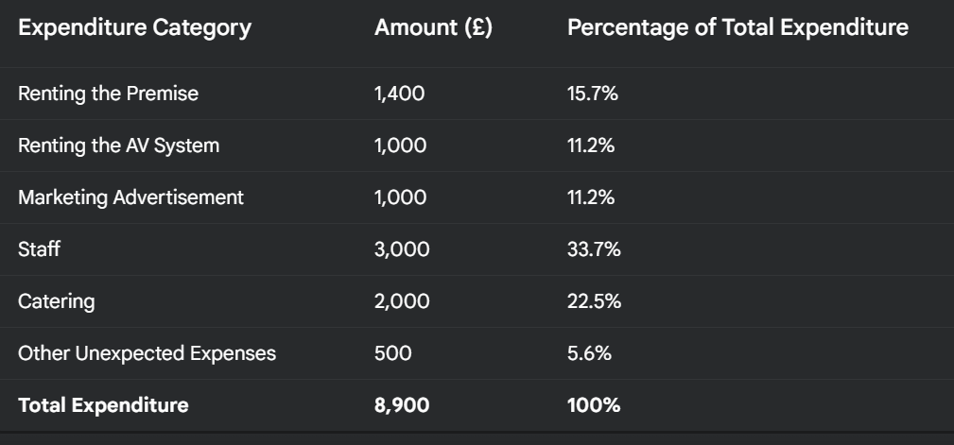

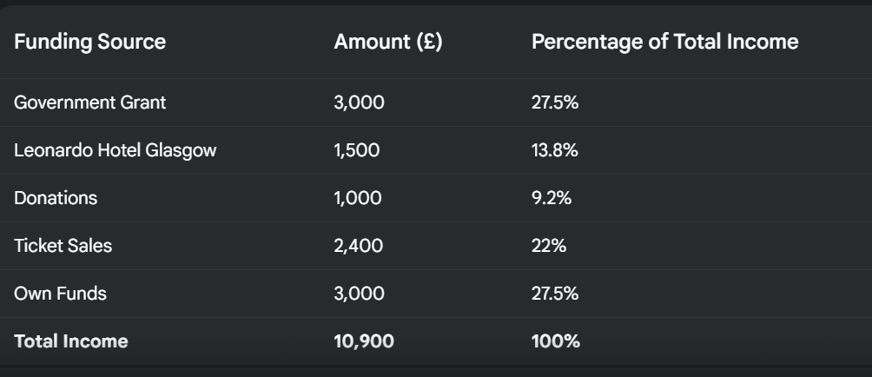

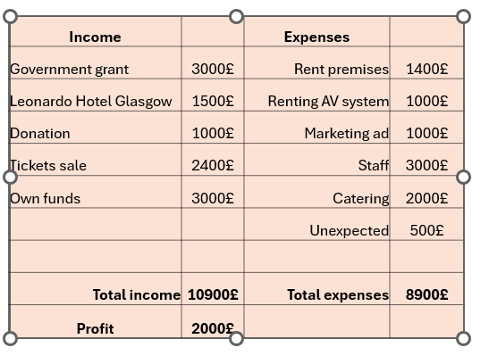

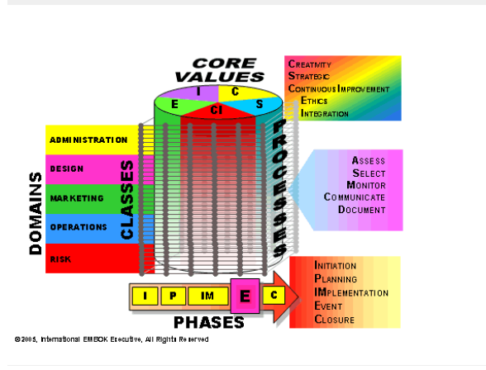

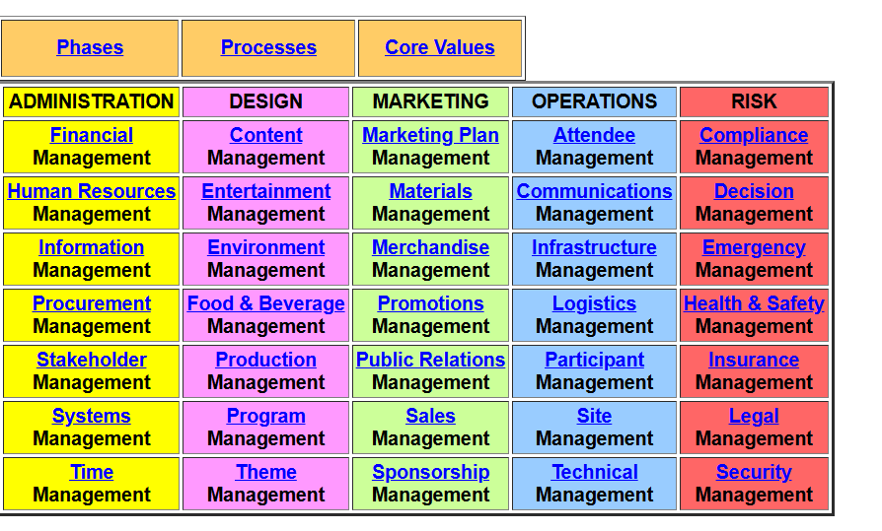

References

https://www.proquest.com/docview/2688608385?accountid=130472&parentSessionId=Htl0WorwIzDrt3lrhn60EpEVTtwN%2FPCG020dmgqEPMw%3D&pq-origsite=primo&sourcetype=Magazines
https://fhahoreca.com/blog/accessible-hotel-room/
https://www.egyankosh.ac.in/bitstream/123456789/69839/1/Unit-2.pdf
https://studyrocket.co.uk/revision/a-level-leisure-studies-ocr/leisure-in-action/event-feasibility-and-planning
https://event-organisation-guide.readthedocs.io/en/latest/eog/feasibility-stage.html
https://augustbrown.com/news-item/5-key-components-of-a-feasibility-study/
https://www.carmarthenshire.gov.wales/business/organising-events/community-toolkit/venue-planning/
https://www.carmarthenshire.gov.wales/business/organising-events/community-toolkit/financial-and-budget-planning/
https://www.carmarthenshire.gov.wales/business/organising-events/community-toolkit/marketing-and-promotion/
https://www.carmarthenshire.gov.wales/business/organising-events/community-toolkit/managing-the-event/
https://www.carmarthenshire.gov.wales/business/organising-events/community-toolkit/establishing-aims-and-objectives/
- https://www.carmarthenshire.gov.wales/business/organising-events/community-toolkit/agreeing-the-why-s-how-s-and-when-s/
- https://www.carmarthenshire.gov.wales/business/organising-events/community-toolkit/creating-your-event-team/
- https://www.asha.org/practice/feasibility/
- https://event-organisation-guide.readthedocs.io/en/latest/eog/feasibility-stage.html
- https://www.euansguide.com/venues/glasgow-science-centre-glasgow-6639/reviews/visits-off-peak-16812 ( for venue and accessibility for disabled persons)
- https://www.whitelight.ltd.uk/markets/event-production-services/ ( video lights and sound company)
- https://www.regisbanqueting.co.uk/menus ( for catering)
- https://www.glasgowsciencecentre.org/organise-event/event-spaces/science-street
- https://hirewl.com/
- https://www.regisbanqueting.co.uk/menus
- https://www.embok.org/
- https://www.embok.org/juliasilvers/embok/Guide/Matrix.html

Contents
Executive Summary………………2
Introduction………….3
Event Cycle………..3
Event concept……….4
Aim and objectives………5
EMBOK…….6
Event budget …..10
Appendix….12
Reference….15

