

Assessment 1: Marketing Audit Report for KFC
Module: BMBM6016 Strategic Marketing

Student ID:2500387
Written by：Junwei Wang
Instructor：Gwyneth Jones
Date：20 March 2026

Table of Contents
1. Introduction 3
2. PESTLE Analysis 3
3. Porter’s Five Forces Analysis 5
4. VRIO Analysis 8
5. SWOT Analysis 9
6. Key Strategic Issues & Forward Outlook 11
References: 12

1. Introduction
KFC is one of the largest quick-service restaurant (QSR) chains in the world, operating in more than 150 countries with over 30,000 outlets (KFC Careers, 2026). It is operating under the parent company Yum! Brands, which owns many popular fast-food restaurant chains aside from KFC, including Taco Bell, Pizza Hut, and so on. In the UK market, it has over 1,000 outlets all over the United Kingdom with millions of customers (KFC UK&I, 2026). It indicates that KFC remains one of the most popular joints in the UK market.
The UK fast-food industry has undergone tremendous developments owing to the growing health consciousness, technology, and economic challenges like inflation and the escalating cost of living. This report reviews the strategic position of KFC in the UK market by analysing the external environment using the PESTLE framework, competitiveness within the industry using the Five Forces model by Porter, internal resources using the VRIO model and summarises major findings using a SWOT analysis.

2. PESTLE Analysis
Political
The UK government policy is becoming more focused on public health and obesity, directly impacting fast-food businesses such as KFC. The government introduced strategies to reduce consumption of unhealthy food, such as limiting promotions of high-fat, salt and sugar foods (HFSS), affecting in over £18 billion in sales, or 16% of food market (Department of Health and Social Care, 2023). Moreover, the government is also aggressively promoting the re-formulation of menus in the out-of-home (OOH) food industry to make them healthier (Finlay et al., 2025). Thus, the imposed restrictions can pose challenge for KFC for its high-fat menu but create opportunity to diversify their menu with healthier alternatives.
Economic
The UK foodservice sector is estimated at 104.8 billion in 2025, and is expected to achieve 5.7% yearly growth, reaching a figure of 40.5 billion in 2025, which shows its economic importance (UK Food Council; Caddy, 2025). Also, the fried-chicken area is very robust, and the UK market is estimated to be about 3.1billion pounds, which represents an escalating consumer demand in chicken-based meal quick services (Reuters, 2025). Thus, it creates opportunity for KFC to cater to rising demands of chicken as fast-food and differentiate itself from other brands.
Social
The convenience food market is very favourable due to the hectic lifestyle and the growing urbanisation in the UK. Studies indicate that 8 out of 10 consumers in the UK still buy takeaway or delivery meals, which points to the popularity of fast-food sources (Caddy, 2025). Figure 1 showcases that Domino's leads the takeaway market, and KFC is one of the key players with 4.8% market share.
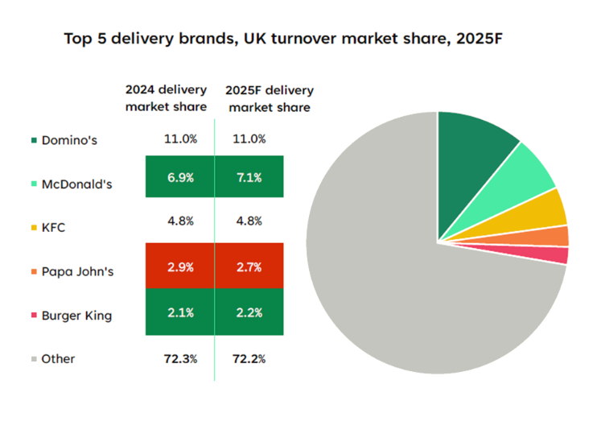
Figure 1: Delivery Brands market share in the UK
Source: Caddy, 2025
Simultaneously, the market is being transformed by the shift in the tastes of consumers. Fried-chicken items are gaining popularity among younger buyers (Reuters, 2025). The trend of health consciousness is increasing. According to NIQ (2025), 60% of British shoppers say that they take active measures to improve their health. The trend puts pressure on the fast-food companies to provide healthier or vegan alternative dishes on their menu. Thus, while KFC still caters to the need of quick services, there are significant opportunities untapped with limited healthier menu options.
Technological
The UK quick-service restaurant industry has been changed by technology. The food delivery sector in the UK is projected to reach 14.3 billion in 2025, and the use of digital channels is becoming increasingly relevant (Lumina Intelligence, 2026). Thus, the role of cutting-edge technology in making the service faster and more efficient is undeniable. Numerous fast-food chains have started using a hybrid service format of a combination of dine-in, takeaway, and delivery, which enhances convenience to the consumer (Lumina Intelligence, 2026). In the case of KFC, digital ordering and collaboration with delivery services are the only ways to remain competitive in the UK market.
Legal
One major regulation in the UK is the mandatory calorie labelling law, which requires large food businesses with more than 250 employees to display calorie information on menus and delivery platforms (Kalbus & Rinaldi, 2025). It indicates the need for adherence to legal obligations in order to ensure long-term operations. Research indicates that this regulation has already resulted in a 2% reduction in the average energy content of menu items, encouraging companies to adjust menu formulations (Essman et al., 2025). Employment laws also influence fast-food operations, as labour regulations and wage policies increase operating costs for companies like KFC with large workforces.
Environmental
Consumers and regulators are demanding that the companies minimise the environmental effects of packaging waste, energy use, and food sourcing. The fast-food chains are expected to adhere to the net-zero goal of the UK (Gov.uk, 2019). Firms are thus engaging in green supply chains and packaging. Environmental policies and sustainability programs will remain influential in the strategic decision-making in the fast-food industry. KFC requires adhering to the prevalent regulations in order to avoid operational complications.

3. Porter’s Five Forces Analysis
Competitive Rivalry -Very high
The UK fast-food industry has high levels of competitive rivalry owing to a large number of global and domestic brands that compete in the industry to gain market share. The key competition includes McDonald's, Burger King, Subway, Greggs, Domino's, and the emerging chicken chains like Popeyes and Wingstop. McDonald's has captured about 35% of the UK fast-food market, Burger King about 20 per cent, and KFC about 15%, which is a strong indication that the major brands compete with each other (Rafqat, 2025). Moreover, the market of quick-service restaurants (QSR) in the UK is highly fragmented, and there is no dominant company in the sphere in spite of the high level of global chains' penetration. In one instance, the level of competition marketing strategies was intense as promotional campaigns grew by 25% in QSR outlets in the year 2024 (QSR Media UK, 2025). Overall, the intense rivalry lowers the profit margins and compels KFC to invest in marketing, product innovation and customer experience as a constant practice in remaining in the market.
New Entrants Threat- Moderate
The UK fast-food industry has a moderate threat of new entrants. The capital that will be needed to start small takeaway stores or independent restaurants is relatively low, which makes the entry to the market of local competitors a fairly easy task. A new international fried chicken brand has also entered the UK market due to the increasing popularity of the product. For instance, Popeyes has grown fast since launching in the UK in 2021 and has dozens of new locations in the country (Mee, 2025). Nevertheless, there are some major entry barriers that restrict the threat of large-scale competition. Established brands like KFC enjoy the advantage of:
- Worldwide brand recognition
- wide networks of franchising
- supply chain economies of scale
Thus, small standalone restaurants can easily penetrate the market, but it is difficult to compete with the major QSR brands nationwide.
Bargaining Power of Suppliers- Moderate
KFC has a large network of suppliers. The supplier power is medium since the large fast-food chains usually buy ingredients in large quantities and can negotiate some favourable contracts. The big QSR chains also enjoy the economies of scale and high purchasing power, enabling them to buy at reduced prices and stable supply contracts (Mordor Intelligence, 2026). The supplier power can, however, be enhanced by fluctuations in world food prices, especially the price of food fed to poultry and the farming inputs. Therefore, the suppliers have some power because of input price volatility, but the large volume of purchasing in KFC prevents the suppliers from exercising their power.
Bargaining power of Buyers- High
The bargaining power of consumers is high in the fast-food sector since they have a wide choice of options. The cost of switching is very low; customers can readily switch between different competing brands, and they make their decisions on prices, convenience, promotions, and brand perception. The promotional activity in the QSR industry has grown tremendously, with promotional campaigns increasing by 25% in 2024, signifying that price promotion is important in customer attraction (QSR Media UK, 2025). Consequently, KFC has been forced to keep on improving value propositions such as competitive prices, product innovation, and convenient delivery services.
Threat of Substitutes- High
The threat of substitutes is also high in the UK fast-food sector since consumers have numerous substitutes for food. The alternatives are home-cooked food, supermarket ready-to-eat and meal kits, as well as healthier restaurant food. Health awareness is also changing consumer behaviour because of the changing dietary preferences. Figure 2 indicates the shift from traditional industry to an interconnected domain towards healthier alternatives (PwC, 2025). Hence, numerous consumers are now demanding healthier or plant-based food substitutes, which would diminish demand for traditional fried fast food.
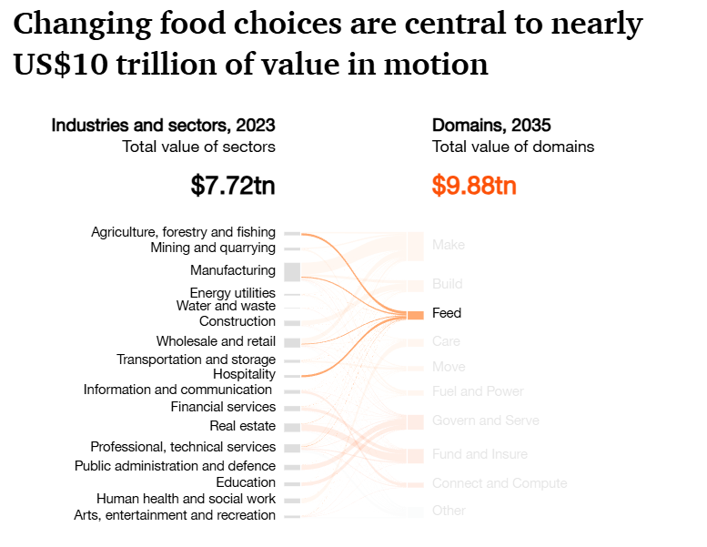
Figure 2: Shift in the Traditional Food Industry, indicating a potential decline in unhealthy food
Source: PwC, 2025
Moreover, with the fast development of food delivery services, the availability of various types of cuisine and independent restaurants has increased. The UK QSR market is increasingly becoming diverse, and this is reflected in the rising number of new restaurants and new types of food. Therefore, KFC is required to become more innovative by diversifying its menu and adding alternatives like healthier and plant-based dishes. Moreover, it also requires promoting products for a limited time.

4. VRIO Analysis
In addition to understanding the external environment, consideration of internal capability is essential for efficient strategic decisions. Table 1 presents a brief VRIO analysis.
Resource / Capability | Valuable | Rare | Inimitable | Organised | Competitive Implication
Global brand recognition | Yes | Yes | Yes | Yes | Sustained competitive advantage
Secret recipe & product differentiation | Yes | Yes | Yes | Yes | Sustained competitive advantage
Franchise network & supply chain | Yes | Yes | Moderate | Yes | Sustained competitive advantage
Digital ordering & delivery platforms | Yes | No | No | Yes | Competitive parity
Table 1: VRIO Analysis of KFC in the UK
The global brand recognition of KFC is one of the resources that can offer the company a long-term competitive advantage in the UK fast-food market. The brand has more than 1,000 restaurants in the UK, which is why it is one of the largest quick-service restaurant (QSR) chains in the country (ScrapeHero, 2024). The good brand equity is advantageous since it draws customers and instils loyalty, and its international fame makes it almost impossible and incomparable to other businesses. KFC is also structured in a manner to capitalise on this resource by means of regular branding, advertising, and franchise management.
KFC's competitive advantage is further enhanced by the secret recipe and product differentiation according to the 11 herbs and spices of Colonel Sanders (Pasaribu and Ellitan, 2025). This recipe brings uniqueness to the product in the fried-chicken category. The competitors find it hard to copy the recipe and processes involved in its preparation because of the secrecy surrounding the recipe.
KFC has a franchise network and supply chain that also give it strategic benefits of uniform operations across over 1,000 outlets. Nevertheless, digital ordering and delivery platforms are valued at 14.3 billion by 2025 (Lumina Intelligence, 2025). These are common throughout the industry and thus are able to offer only competitive parity.

5. SWOT Analysis
Strengths | Weaknesses
- Strong global brand recognition  - Unique “11 herbs and spices” recipe  - Large franchise network and efficient supply chain  - Strong digital ordering and delivery partnerships | - Strong association with fried and high-calorie food, which may harm brand perception  - Heavy reliance on chicken-based menu, limited diversification  - Rising operational costs
Opportunities | Threats
- Growing UK foodservice industry  - Rising demand for fried chicken among younger consumers  - Expansion of the digital food delivery market  - Potential development of healthier and plant-based menu options | - Intense competition  - Government regulations on HFSS foods and advertising restrictions  - Increasing consumer preference for healthier and plant-based foods
Table 2: SWOT Analysis of KFC in the UK
KFC has a number of strengths which can be used to endorse its high standing in the fast-food industry in the UK. Its global brand recognition can be considered one of its strengths, as the company has more than 1,000 restaurants in the UK, which makes it one of the largest chains of quick-service restaurants in the UK (ScrapeHero, 2024). Its product differentiation using the proprietary formula of 11 herbs and spices as the basis is another strength of the company as far as fried chicken is concerned, as this recipe sets KFC apart. Besides this, the company is also advantaged with a big franchise network and robust supply chain that allows the company to expand efficiently and maintain uniform operations. KFC has also embraced online ordering and delivery systems, which enhance the convenience of their customers in the expanding UK food delivery industry worth 14.3 billion in 2025 (Lumina Intelligence, 2025).
Nevertheless, KFC also has a number of weaknesses. The brand is closely identified with food that is fried and contains a lot of calories, and this could have a detrimental impact on the perceptions of the consumers as they become more health-conscious. It is also financially straining as a result of increased operational expenses caused by labour, food ingredients and the supply chains.
KFC has a number of opportunities since the UK foodservice market is expanding, and it has reached 104.8 billion in 2025 (UK Food Council, 2025). The growing popularity of fried-chicken products by younger consumers and the growth of digital food delivery services are other sources of growth. However, KFC is threatened by the high competition, government HFSS policy, and the growing need for a healthier and more sustainable food substitution among consumers.

6. Key Strategic Issues & Forward Outlook
The UK market presents KFC with a number of strategic challenges that will affect its future competitiveness. A big challenge is the increased regulatory pressure on unhealthy food products, especially the government policies against high-fat, salt, and sugar (HFSS) foods. The regulations can limit the promotion and advertisement practices, which may force KFC to modify its marketing and more likely change its menu development to suit the health expectations of the people. Also, the increase in health awareness of the UK consumers is stimulating demand for healthier and plant-based food options, which could also decrease the demand for the conventional fried fast-food products.
The next main problem is that the market of quick-service restaurants (QSR) in the UK is highly competitive since competitors, including McDonald's, Burger King, Domino's, and new chicken competitors like Popeyes and Wingstop, are strong rivals. This competitive environment ties down the pricing, innovations and customer experience.
In spite of these obstacles, there are a number of opportunities that favour the KFC future perspective. The UK foodservice business is ever-growing, and the fast growth in the digital market of food delivery offers the possibility of online sales growth. KFC is likely to create more than 7000 jobs in the UK, indicating its commitment (Reuters, 2025). To stay competitive, KFC must still invest in digital ordering, delivery relationships and efficiency. Moreover, the further development of a healthier menu and plant-based alternatives might enable the company to address changing consumer preferences and still retain its prominent brand name in the UK fast-food sector.

References:
Caddy, C. (2025) UK fast food restaurants market report 2025. Mintel. Available at: https://store.mintel.com/report/uk-fast-food-restaurants-market-report (Accessed: 11 March 2026).
Department of Health and Social Care (2023) Restricting promotions of products high in fat, sugar or salt by location and by volume price: implementation guidance. GOV.UK. Available at: https://www.gov.uk/government/publications/restricting-promotions-of-products-high-in-fat-sugar-or-salt-by-location-and-by-volume-price/restricting-promotions-of-products-high-in-fat-sugar-or-salt-by-location-and-by-volume-price-implementation-guidance (Accessed: 11 March 2026).
Essman, M., Burgoine, T., Huang, Y., Jones, A., Polden, M., Robinson, E. and Adams, J. (2025) ‘Changes in energy content of menu items at out-of-home food outlets in England after calorie labelling policy implementation: A pre–post analysis (2021–2022)’, BMJ Public Health, 3(2).
Finlay, A., Jones, A., Thorp, P., Putra, I.G.N.E., Polden, M., Adams, J. and Robinson, E. (2025) ‘Accuracy of menu calorie labelling in the England out-of-home food sector during 2024: Assessment of a national food policy’, British Journal of Nutrition, 134(8), pp. 696–704.
Gov.uk (2019) UK becomes first major economy to pass net zero emissions law. Available at: https://www.gov.uk/government/news/uk-becomes-first-major-economy-to-pass-net-zero-emissions-law (Accessed: 11March 2026).
Kalbus, A. and Rinaldi, C. (2025) ‘Calorie labelling regulations in England: Menu change not behaviour change?’, Public Health Nutrition, 28(1), e125.
KFC Careers (2026) Who are we. Available at: https://careers.global.kfc.com/who-we-are (Accessed: 11 March 2026).
KFC UK & Ireland (2026) About KFC. Available at: https://www.kfc.co.uk/about-kfc (Accessed: 11 March 2026).
Lumina Intelligence (2026) UK food delivery market: Growth, share, and size statistics. Available at: https://www.lumina-intelligence.com/blog/foodservice/uk-food-delivery-market-growth-share-size-statistics-2025/ (Accessed: 11 March 2026).
Mee, E. (2025) ‘Popular US fast food giant that “wipes the floor with KFC & McDonald’s” to open 45 new restaurants in UK this year’, The Scottish Sun, 12 June. Available at: https://www.thescottishsun.co.uk/money/14926396/popeyes-45-new-restaurants-uk-expansion/ (Accessed: 11 March 2026).
Mordor Intelligence (2026) United Kingdom quick service restaurant market size & share analysis – Growth trends and forecast (2026–2031). Available at: https://www.mordorintelligence.com/industry-reports/united-kingdom-quick-service-restaurant-market (Accessed: 11 March 2026).
NIQ (2025) UK shoppers want to live healthier lives – but only at the right price, reveals NIQ’s 2025 global health and wellness trends report. Available at: https://nielseniq.com/global/en/news-center/2025/uk-shoppers-want-to-live-healthier-lives-but-only-at-the-right-price-reveals-niqs-2025-global-health-and-wellness-trends-report/ (Accessed: 11 March 2026).
Pasaribu, E.M. and Ellitan, L. (2025) ‘A review of the strategic role of supply chain management for developing competitive advantage’, International Journal of Research, 12(1), pp. 383–396.
PwC (2025) A new recipe for the food industry. Available at: https://www.pwc.com/gx/en/issues/c-suite-insights/voice-of-the-consumer-survey.html (Accessed: 11 March 2026).
QSR Media UK (2025) Promotions continue to drive growth in the UK’s foodservice industry. Available at: https://qsrmedia.co.uk/research/exclusive/promotions-continue-drive-growth-in-uks-foodservice-industry (Accessed: 11 March 2026).
Rafaqat, A. (2025) Number of McDonald's restaurants in the United Kingdom in 2025. Available at: https://www.xmap.ai/blog/number-of-mcdonalds-restaurants-in-the-united-kingdom (Accessed: 11 March 2026).
Reuters (2025) ‘KFC to invest $2 billion in UK and Ireland over five years’, Reuters, 27 May. Available at: https://www.reuters.com/business/world-at-work/kfc-invest-2-bln-uk-ireland-over-five-years-create-7000-jobs-2025-05-27/ (Accessed: 11 March 2026).
ScrapeHero (2026) 10 largest food chains in the United Kingdom in 2026. Available at: https://www.scrapehero.com/location-reports/10-largest-food-chains-in-the-uk/ (Accessed: 11 March 2026).
UK Food Council (2025) Insight report highlights: The future of UK independent restaurants in a chain-dominated market. Available at: https://foodcouncil.uk/restaurants (Accessed: 11 March 2026)

