3/24/2025
University of Wales Trinity Saint David
London campus
E-Portfolio Link:
Module Name: Learning In the Digital Era
Module Code: ACCA 4025

Student Name: Marcos Bruno
Student ID: 2512504
Group: 1

Lecturer’s Name: Koushik Modak

Assignment 1
E-Portfolio
Table of Contents
Introduction 2
Main Body 2
Task 1: Essential Academic and Employment Skills for the future career Path 2
Task 1 (a): Report on Essential Academic and Employment Skills 2
Task 1 (b): Evaluation of Task 1 (a) based on Similarity report 2
Task 2: Collaborative Mind Map and Individual Poster 2
Mind Map (Collaborative) 2
Poster (Individual) 2
Task 3: Virtual Collaboration and RefWorks 2
Report on Virtual Collaboration 2
Step-by-step process of using RefWorks with visuals 2
Task 4: E-Portfolio Creation and Evaluation 2
Task 4 (a): E-Portfolio Creation 2
Task 4 (b): Illustrative Review of E-Portfolio tool Selection 2
Conclusion 2
References 2
Task 1 References: 2
Task 3 References: 2

Introduction

Main Body

Task 1: Essential Academic and Employment Skills for the future career Path

Task 1 (a): Report on Essential Academic and Employment Skills
Essential Skills for Study and Employment
To be able to enter a good college or a good job, is necessary to acquire skills for these areas such as communication, teamwork, organization or adaptability, depending on the area where you want to work or study.
Let’s say I want to study in IT for work on at Microsoft in the future. The essential skills required to study in the IT and to start a career at the company include Database Management, Operating System Knowledge, and Technical Writing [1].
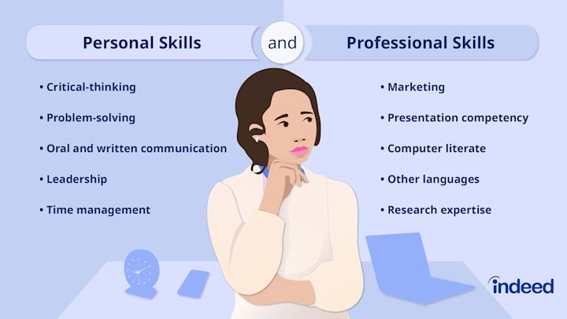
Database Management is for understanding how to store, organize, and protect data. Operating System Knowledge is important for learn how to operate different platforms and use technologic equipment. Finally Technical Writing help to understand what is written in document and code writing, prevents errors in the communication when programming or preparing technical reports [2].
To receive these skills, you need to work on your personal growth. This way, you’ll be able to enter the work you want.
With your personal growth, you’ll be able to discover new skills and improve the ones you already have. This will make you stand out in your field of study and work. As a result, you’ll be recognized more easily in your area may even reach levels that are unattainable for others [3].
Another important thins you’ll need to use a lot is teamwork. If you leam to work well with your colleagues, you’ll always have the key to success.

Task 1 (b): Evaluation of Task 1 (a) based on Similarity report

Task 2: Collaborative Mind Map and Individual Poster

Mind Map (Collaborative)

Poster (Individual)

Task 3: Virtual Collaboration and RefWorks

Report on Virtual Collaboration
Put your Chosen topic here

Step-by-step process of using RefWorks with visuals

Task 4: E-Portfolio Creation and Evaluation

Task 4 (a): E-Portfolio Creation

Task 4 (b): Illustrative Review of E-Portfolio tool Selection

Conclusion

References

Task 1 References:

[1] | Gallagher and P. Kevin, “The requisite variety of skills for IT professionals,” Communications of the ACM, vol. 53(6), no. 2, pp. 144-148, 2010.
[2] | Sousa and J. MARIA, Entrepreneurial skills development, Lisboa: Recent Advances in Applied Economics, 2014.
[3] | C. Stella, Skills for success: Personal development and employability, London: Bloomsbury Academic, 2021.

Task 3 References:

