

Programme: BSC Health and Social Care

Module: Digital Transformation in the Health and Care Professions

Module Code: BMHP6026

Lecturer: Zakiyyah Ahmed

Student Name: Alessandra Vinhal

Student number: 2244815

Table of Contents
1. Introduction
2 Chosen Areas
2.1 Service Delivery
2.1.1 The way daily practice has been affected workflows, communication and integration
2.1.2 Benefits such as faster services or improved coordination
2.1.3 Challenges such as high costs or technical problems
2.2 Patient/Service
2.2.1 The way patient/service user experiences have changed
2.2.2 Issues of privacy, digital literacy or fairness of access
2.2.3 Evidence from studies or patient perspectives
3 Recommendations and conclusion
3.1 Recommendations. 3.2 Conclusion
References

1. Introduction
The chosen digital innovation is the NHS App, which is a form of smartphone application that provides patients with convenient access to a range of NHS services. It works more like a central digital door to NHS services. It helps patients use triage and get around, plus there are online health checks, ways to order prescriptions, book appointments, and receive screening reminders (Institute global, 2025). However, people can upload info from wearable devices, which supports more proactive health tracking. The NHS App was launched in 2019 and expanded a lot since then, so it has become important for health and social care because it helps patients handle their own wellbeing in a convenient, modern way, and maybe lessens the strain on GP surgeries.
This report aims to examine an innovation in the digital world that has been deployed in the UK health or social care service in the past 10 years. The report will concentrate on NHS Apps, examining the impact of these in two main areas such as Service Delivery and Patient/Service User experience. The final section will draw all these findings together, restate the importance of choosing a recent innovation and make actionable recommendations, informed by the analysis of the impact of these digital tools on the accessibility and efficiency of healthcare services.

2. Chosen Areas

2.1 Service Delivery

2.1.1 The way daily practice has been affected workflows, communication and integration
The NHS App has had a profound impact on health services in the UK, enhancing service delivery through better workflow, communication, and integration of NHS and patient services. The app was brought in across the country in 2019 and enables users to book appointments, order further prescriptions, view their health records, as well as access healthcare information via one portal (Reidy et al., 2025). This has decreased use of the manual processes of administration, telephone and in person. An very crucial improvement is the automation of repetitive work. Patients are able to book appointments and make requests for medicine prescription themselves, which lightens administrative duties in GP practices. This has allowed health care personnel to spend more time accommodating patients’ complex needs and less on compliance duties (McCahon et al., 2022).
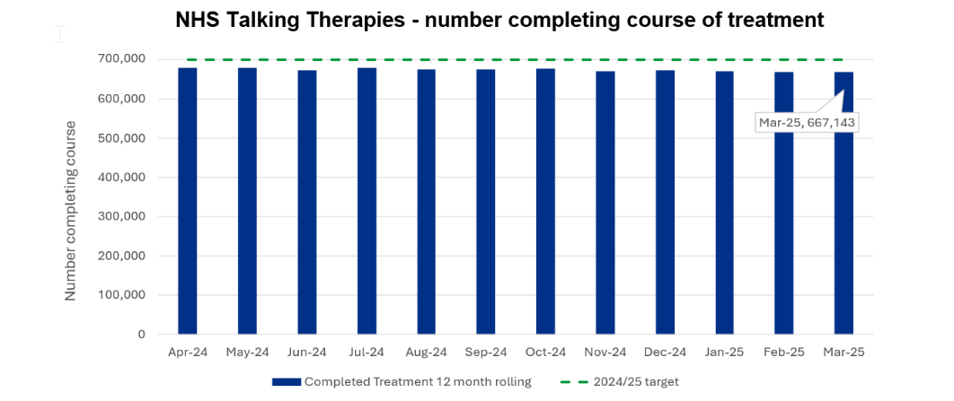
Figure 1: NHS Talking Therapies-Number of Patients Completing a Course of Treatment
(Source: NHS England, 2025)
Improvements in integration, due to linking NHS App, GP systems to the wider NHS digital platforms (NHS England Digital, 2024). The above figure shows that during the period April 2024 to March 2025, the number of patients that engaged with NHS Talking Therapies treatment has been broadly steady, from around 678,000 to 667,143 patients (NHS England, 2025). This helps to facilitate coordinated care and information flow among care settings. These developments mirror those outlined in the A Plan for Digital Health and Social Care (2022) set by the UK Government, aimed at modernising the running of services and helping to deliver better patient outcomes (Department of Health and Social Care, 2022). Moreover, the What Good Looks Like Framework advocates the use of digital technologies that can improve service delivery and interoperability at healthcare organisations (Lawrence, 2025).
Through the improvement of the services delivered the NHS App has made healthcare services quicker, more effective and better coordinated. Patients can book appointments, ask for repeat prescriptions, view health records or get NHS communications via the app, rather than calling NHS providers directly (NHS England, 2025a). This has decreased the burden of administration for GP practices and has been a benefit for staff to spend more time on patient care. This has resulted in improved workflows and reductions in routine service waiting times.
The app has also helped to improve the co-ordination of care services, by embedding patient information into NHS digital systems. Access to relevant information is more streamlined for healthcare professionals aiding informed decision making and continuation of care (NHS England, 2023). Through improvement of patient provider dialogue, it has become more convenient for patients and resources to connect with each other and share information to help patients better control their own health. These benefits align with the aims of A Plan for Digital Health and Social Care (2022), which aims to accelerate the adoption of digital technologies to increase efficiency and achieve better health and care outcomes (Department of Health and Social Care, 2022).
For example, according to GOV UK (2025), the growth of the NHS App hospital services contributed to the prevention of around 1.5 million missed hospital appointments in 2025. The digital system allowed patients to be reminded, receive information about their appointments, and make appointments using the application. The government estimated that this saved approximately 5.7 million staff hours and helped to reduce NHS waiting lists (GOV UK, 2025). Moreover, 87% of hospitals in England were providing services via the NHS App as of April 2025, further underlining the increasing importance of the NHS App in healthcare delivery (GOV UK, 2025)

2.1.3 Challenges such as high costs or technical problems
Although the NHS App has many positive aspects, there are also a number of challenges that could reduce the effectiveness of the App and its accessibility. Digital exclusion is one of the big problems. The app may be difficult to use for people who are older, less digitally literate, have a disability, or do not have internet access or a smartphone. According to a systematic review by Jacob et al. (2022), usability challenges, low digital literacy and fears of technology are all factors that limit patient uptake of mobile health tools. Likewise, Giebel et al. (2023)

2.2 Patient/Service User

2.2.1 The way patient/service user experiences have changed
The NHS App has significantly enhanced patient’s experiences through increased accessibility to health care services, convenience, and fast diagnosis. Okolo et al. (2024) stated that strength of using this app is it gives 24/7 access to various types of services provided by the National Health Service. In relevance to consider ‘the access of care’, the NHS App has greatly facilitated to health care services especially for those residing in rural locations. Edmunds (2024) stated that individuals using the NHS App to book, reschedule, change or cancel appointments, order repeat prescriptions, view their medical records and receive vital updates on their health status.
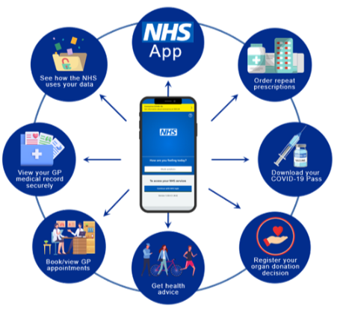
Figure 2: NHS App application
(Source: Edmunds, 2024)
Persons experiencing mobility issues and busy individuals. Patients do not have to visit general practitioner’s surgeries or call them in order to access information about their health issues. Goel and Taneja (2025) suggested that healthcare organisations integrate technologies in healthcare services to enable the users to book an appointment of doctors and other several healthcare services by using app. Convenience refers to the opportunity that patients have been given to manage all aspects of their health via an app (Zhong, Cao and Xue, 2024). Test results, vaccination details, referral information and prescription service have all been integrated in one system, which makes the entire process faster and more convenient for patients.
The NHS App also helps to diagnose and treat patients quickly by providing easy access to healthcare information and services (NHS-Diagnosis, 2026). They have the chance to view test results and their health records, which allows them to detect any possible illnesses early enough and seek advice from professionals. There are even online symptom checking apps and triage services that help to lead the patient to the correct healthcare pathway, thereby helping the process to proceed smoothly without any delays. Hamberger et al. (2022) stated that an effective interaction with health workers also means that there will be no further delays. The use of the NHS App has really changed how patients interact with the NHS by making things easier for everyone involved.

2.2.2 Issues of privacy, digital literacy, or fairness of access
There are a number of potential problems associated with NHS app. One of the most important challenges associated with the usage of the app is that of privacy. The NHS App contains private information regarding user’s health (NHS App-Issues, 2026). Some patients are concerned about data leakage, unauthorised access, and other aspects despite the high level of security involved in protecting user’s health information. Another potential problem associated with the application is the matter of digital literacy (Younis et al., 2024). Some patients will probably lack necessary skills and knowledge to utilise digital technologies efficiently. Elderly patients, persons with learning difficulties, and those who have no experience with smartphones and/or the internet will most likely find it difficult to use the NHS App to get necessary services (NHS App-Issues, 2026). It should be acknowledged that not all citizens own a smartphone or can afford using the internet regularly. Thus, the question of access to healthcare services due to patient’s financial constraints arises.

2.2.3 Evidence from studies or patient perspectives
Many respondents appreciated access to their records, the ability to book appointments and obtain repeat prescriptions using the app. In relevance to this, 64% of the users had not engaged before with online GP services before (NHS-Patient Review, 2022). This reflects that the app promoted usage of digital technology for healthcare purposes. However, it was noted that some patients encountered problems when using some functions since not all of them are available for all GP services and some information on health is provided in medical terminology. Reidy et al. (2025) suggested that prescription ordering and record access were generally well-received by patients. The problem of insufficient digital literacy and unequal access to such resources was discussed. It has been evident that around 81% of NHS App users considered this app easy to use but 70% of users reported that it takes time to provide reliable information to them (The Patients Association, 2024). One respondent was able to receive the result of their blood tests much faster by using the app and appreciated being able to see their results and information about appointments in one application.

3. Recommendations and Conclusion3.1 Recommendations
Recommendation 1: NHS should support Digital Inclusion and Users
A series of digital inclusion programs should be introduced to facilitate the use of apps by older people, disabled people, and individuals who lack digital literacy. It may involve conducting workshops, preparing instructional videos, providing multi-language guides, and setting up call centres aimed at supporting users during their registration (Younis et al., 2024). The increase in digital competency will allow reducing the significant number of people who abandon the process of registration after downloading apps.
Recommendation 2: Patients and their families must access the information and maintain Non-Digital Routes
The next important step is improving the accessibility of the NHS App through the introduction of easier interfaces, making it compatible with screen readers, increasing font sizes, and adding multilingual capabilities (NHS-Patient Review, 2022). It is essential not to ignore other means of communication when developing more accessible applications. Face-to-face interactions, phone calls and others should be available in addition to the NHS App to ensure fair access to healthcare services.
3.2 Conclusion
Conclusion The NHS App has considerably improved the experiences of patients through increased access to health care services, convenience, and timely diagnoses. The advantage of this application is that it offers 24/7 access to a wide range of services offered by the National Health Service. People using the NHS App can make appointments or change them, order prescriptions, check their medical record, and receive updates about their health condition as well. The NHS App in the past ten years is very crucial as it escalates the NHS to the digital health care industry. The study of innovations such as the NHS in recent times enables one to assess its contribution to NHS services delivery.
Over the past decade, the NHS App has become an important component of the NHS's digital transformation strategy. Its implementation has enhanced accessibility, communication, efficiency, and patient-centred care while supporting the wider digitalisation of health services across the UK. Although challenges remain, including digital exclusion, data privacy concerns, and variations in digital literacy, the overall evidence suggests that the NHS App has made a positive contribution to healthcare service delivery. Evaluating innovations such as the NHS App is essential for understanding their impact on service quality, patient outcomes, and the future development of digital healthcare within the NHS (Department of Health and Social Care, 2022; NHS England, 2024).

References
Department of Health and Social Care (2022) A Plan for Digital Health and Social Care, GOV.UK. Available at: https://www.gov.uk/government/publications/a-plan-for-digital-health-and-social-care/a-plan-for-digital-health-and-social-care (Accessed: 13 June 2026).
Edmunds, B.St. (2024) NHS App, Swan Surgery. Available at: https://www.swansurgery.org.uk/nhs-app/ (Accessed: 13 June 2026).
Giebel, G.D. et al. (2023) ‘Problems and Barriers Related to the Use of Digital Health Applications: Scoping Review’, Journal of Medical Internet Research, 25(1), p. e43808. Available at: https://doi.org/10.2196/43808.
Goel, A. and Taneja, U. (2025) ‘Mobile health applications for health-care delivery: trends, opportunities, and challenges’, Journal of Public Health, 33, pp. 1791–1802. Available at: https://doi.org/10.1007/s10389-023-02165-z.
GOV UK (2025) Major NHS App expansion cuts waiting times, GOV.UK. Available at: https://www.gov.uk/government/news/major-nhs-app-expansion-cuts-waiting-times (Accessed: 13 June 2026).
Hamberger, M. et al. (2022) ‘Interaction Empowerment in Mobile Health: Concepts, Challenges, and Perspectives’, JMIR mHealth and uHealth, 10(4), p. e32696. Available at: https://doi.org/10.2196/32696.
Institute global (2025) The NHS at a Crossroads: The App That Can Transform Britain’s Health, Institute.global. Tony Blair Institute. Available at: https://institute.global/insights/public-services/the-nhs-at-a-crossroads-the-app-that-can-transform-britains-health (Accessed: 13 June 2026).
Jacob, C. et al. (2022) ‘Socio-technical Factors Impacting Patients’ Adoption of Mobile Health Tools: Systematic Literature Review and Narrative Synthesis (Preprint)’, JMIR mHealth and uHealth, 10(5). Available at: https://doi.org/10.2196/36284.
Kc, S. et al. (2023) ‘Uptake and adoption of the NHS App in England: an observational study’, British Journal of General Practice, 73(737). Available at: https://doi.org/10.3399/BJGP.2022.0150.
Lawrence, A. (2025) NHSX publish What Good Looks Like framework, Techuk.org. Available at: https://www.techuk.org/resource/nhsx-publish-what-good-looks-like-framework.html (Accessed: 13 June 2026).
McCahon, D. et al. (2022) ‘Patient perceptions and experiences of medication review: qualitative study in general practice’, BMC Primary Care, 23(1). Available at: https://doi.org/10.1186/s12875-022-01903-8.
NHS App-Issues (2026) NHS App Login Issues, Nhs.net. Available at: https://support.nhs.net/2026/04/information-nhs-app-login-issues/ (Accessed: 13 June 2026).
NHS England (2023) Digital transformation, England.nhs.uk. Available at: https://www.england.nhs.uk/digitaltechnology/ (Accessed: 13 June 2026).
NHS England (2024) Protecting Patient Data - NHS Digital, NHS Digital. Available at: https://digital.nhs.uk/services/national-data-opt-out/understanding-the-national-data-opt-out/protecting-patient-data (Accessed: 13 June 2026).
NHS England (2025a) NHS England» New NHS online hospital to give patients more control over their care, England.nhs.uk. Available at: https://www.england.nhs.uk/2025/09/new-nhs-online-hospital-to-give-patients-more-control-over-their-care/ (Accessed: 13 June 2026).
NHS England (2025b) NHS England» Performance report, England.nhs.uk. Available at: https://www.england.nhs.uk/long-read/performance-report-24-25/ (Accessed: 13 June 2026).
NHS England Digital (2024) How to integrate with the NHS App - NHS England Digital, NHS England Digital. Available at: https://digital.nhs.uk/services/nhs-app/how-to-integrate-with-the-nhs-app (Accessed: 13 June 2026).
NHS-Diagnosis (2026) Viewing health conditions, NHS.UK. Available at: https://www.nhs.uk/nhs-app/help/health-conditions-allergies/health-conditions/ (Accessed: 13 June 2026).
NHS-Patient Review (2022) What we learned from users, NHS Digital. Available at: https://digital.nhs.uk/services/nhs-app/nhs-app-pilot-research-report/what-we-learned-from-users (Accessed: 13 June 2026).
Okolo, C.A. et al. (2024) ‘The role of mobile health applications in improving patient engagement and health outcomes: A critical review’, International Journal of Science and Research Archive, 11(1), pp. 2566–2574. Available at: https://doi.org/10.30574/ijsra.2024.11.1.0334.
Reidy, C. et al. (2025) ‘Qualitative evaluation of the implementation and national roll-out of the NHS App in England’, BMC Medicine, 23(1). Available at: https://doi.org/10.1186/s12916-024-03842-w.
The Patients Association (2024) Patients value NHS App but not all users able to access information they want, finds latest Digital Coalition report, The Patients Association. Available at: https://www.patients-association.org.uk/news/patients-value-nhs-app-but-not-all-users-able-to-access-information-they-want-finds-new-report-from-the-digital-coalition (Accessed: 13 June 2026).
UK Government (2025) Data Protection Act, Gov.uk. www.gov.uk. Available at: https://www.gov.uk/data-protection (Accessed: 13 June 2026).
Younis, H.A. et al. (2024) ‘A Systematic Review and Meta-Analysis of Artificial Intelligence Tools in Medicine and Healthcare: Applications, Considerations, Limitations, Motivation and Challenges’, Diagnostics, 14(1), p. 109. Available at: https://doi.org/10.3390/diagnostics14010109.
Zhong, L., Cao, J. and Xue, F. (2024) ‘The paradox of convenience: how information overload in mHealth apps leads to medical service overuse’, Frontiers in Public Health, 12. Available at: https://doi.org/10.3389/fpubh.2024.1408998. Department of Health and Social Care (2022) A plan for digital health and social care. London: Department of Health and Social Care. Available at: https://www.gov.uk/government/publications/a-plan-for-digital-health-and-social-care (Accessed: 27 June 2026).

