MARKET RESEARCH PROPOSAL FOR SWANSEA SHARKS SWIM CLUB

Kyle Ramcke

EXECUTIVE SUMMARY

Included in this report is a research proposal produced for Swansea Sharks Swimming Club to better understand their market and improve their business via marketing information systems. The report is conducted by a marketing research agency that will also provide an insight into the process of structuring a relevant and effective strategy in acquiring related information. The importance of marketing will be explained to compliment the understanding of why organisations would require such information based on customers, competition and the present environment in which the research will be conducted from. Ethical issues on the collection of data will be explained as well as the development of relationships with customers, organisations and key professional bodies. Research methods and tools will be elucidated for Swansea Sharks Swimming Club to acknowledge how the agency will conduct their research.

INTRODUCTION

Information is the blood that flows through any organisation. It provides the organisation with reflection on past performance, understanding on present operations and most importantly vision for the future. Although the importance of information may appear to be obvious, most organisations come across great difficulty in managing and collecting data. Due to changes in the industry, management in modern times have unified information from data capture, customer databases, internet sourced marketing characteristics and trends as well as customers using the internet as a beacon to express their views on social media. This information combined can offer a more inclusive view of the marketplace as well as improved decision making Wilson, A (2012) Marketing Research: An Integrated Approach, Third Edition, Harlow: Pearson

There is a vast demand for many categories of information by diverse organisations for different reasons. It may be planning for the future, monitoring current activities or utilising the workforces’ potential. Due to this, there are several information systems categorised for different uses.

Executive support systems (ESS) are predominantly strategy based support systems to aid in the decisions to implement strategies with data analysis being a key feature in this approach.

Management information systems (MIS) which is a more favoured method as organisations are required to seek within their own processes to extract information e.g. transactions and reporting feedback for analysis.

Decision support systems (DSS) assist management in decisions where the outcome is difficult to forecast. Management would use spreadsheets and databases to review all possible outcomes.

A knowledge management system (KMS) is a system which promotes the sharing of data within an organisation and is developed by the employees. This information is stored via documentation such as word, PowerPoint and spreadsheets.

MAIN FINDINGS

Management Information Systems and its relationship with decision support systems.

Theorists James March, Herbert Simon, and Henry Mintzberg are key figures in the research into decision making and suggest that decision makers are in pressured environments or in time limited circumstances would be reduced to a state of “bounded rationality,” argues Simon. “Simon suggests that people would make economically rational decisions if only they could gather enough information”, L, Buchanan & A, O’Connell (2006) A Brief History of Decision Making, Harvard Business Review, Jan 2006 Harvard Business Review Group.

MIS- marketing information systems are a key computer based information system which aids the processes and operations within organisations. The international journal of business and management defined Marketing information systems as “an organizational method of providing past, present and projected information related to internal operations and external intelligence” A, Safari (2011) International Journal of Business and Management, 2011, Vol. 6, No. 7; July 2011 Page 165, Canadian centre of science and education. MIS can contribute to the decision making process by offering management information on past present operations and future projections for example, information on sales achieved by SSSC during key times would aid in a managerial decision to structure shift patterns to cover periods. An issue with MIS though is that it is not directed towards the question of the key decision makers.

DSS- Decision Support Systems produce mathematical models to aid in managers decision making processes. The DSS categorises raw data from many sources to offer solutions to problems. DSS can also specify to the required task for more accurate answers. The system can also be used for individuals or groups which have prompted many theorists to argue the DSS is more beneficial than the MIS function. “Uma (2009) has stated that a Decision Support System is an integrated set of computer tools allowing a decision maker to interact directly with computer to retrieve information useful in making semi structured and unstructured decisions”. A, Safari (2011) International Journal of Business and Management, 2011, Vol. 6, No. 7; July 2011, Canadian centre of science and education, P 167.

THE MARKETING PROCESS

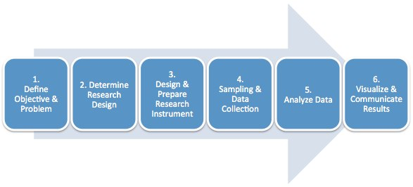

- Define objective and problem
What are the goals of Swansea sharks swim club? Is there a problem SSSC needs to overcome or is there an opportunity the club needs to act upon to achieve their goals? In order for successful market research this first step is crucial in determining the success of the research.

- Determine research design
This stage will provide the direction and landscape of the approach. The best market research method will be identified which may include surveys, questionnaires or focus groups etc. this process is not limited to one method but the most relevant. Three categorisations of research design are; Exploratory research for a more broad insight, Descriptive for a specified area of research most commonly formulated in a quantitative way such as questionnaires and casual research for a more hands on experimental approach through trial and error.

- Design and prepare research instrument
In this stage, the SSSC will need to develop questions for their surveys or focus groups. It is the formulation of their instrument in order to put the plan to action. It would be advised to test the instrument prior to combat any predicaments well in advance.

- Sampling and data collection
This is the activity of collecting data via the research instrument. All results are often documented via spreadsheets. All findings from interviews or field experiments will be gathered here to accurately determine the result of the findings. No stone would be unturned during this stage as every portion of data is crucial.

- Analyse data
Upon the completion of stage four, all data needs organising. Previously operating in a spreadsheet form is often favoured as at this stage it would save a lot of time. Results can be transferred into graphs, charts and tables and divided by demographics of the subjects e.g. age or gender to identify trends in the market.

- Visualize and communicate results
In the final stage of the process, the questions or challenges raised in stage one will be highlighted and answered based on the findings through the processes carried out in order to achieve answers. Data will be presented in a digestible fashion within the report for SSSC to fully comprehend the findings.

RESEARCH METHODOLOGIES

The marketing environment is continuously changing therefore requires a versatile approach to the research methods carried out.

Primary Research
Primary research is predominantly focused on an organisations specific need and is either conducted internally or by an external research group tailored for the organisations requirements. Interviews, observations, focus groups and surveys are key methods used here and for Swansea swim sharks club it would be a recommended place to begin research as current potential can be maximised based on how they are currently operating, it would be more specific to what the organisation wants to obtain and it can explore more opportunities. G, DeVault (2017) Difference Between Primary and Secondary Research, Online available at; https://www.thebalance.com/differences-primary-and-secondary-research-2296908

Secondary Research
Secondary research is conducted by external sources such as government agencies; trade associations etc. and are already obtainable through sources such as public, commercial and educational. Secondary research is significantly faster and less expensive due to the time it takes to acquire primary data. Although SSSC would save time and money, the club may be subject to certain drawback such as the accuracy of the data collected and how relevant it may be to the main questions asked of SSSC. This can often lead to the method retracing back to primary for a more specified approach. Wilson, A (2012) Marketing Research: An Integrated Approach, Third Edition, Harlow: Pearson

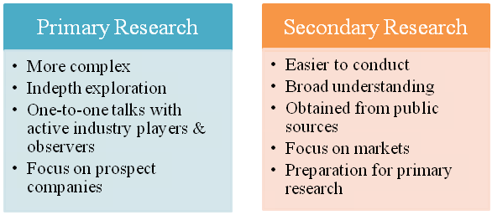

Observation Research
Observation is the first hand monitoring of behaviours which can be objects, organisations or people. Social media is a useful tool to obtain such behaviours but wouldn’t offer explanations. If SSSC were to use this method, the club would have to be made aware of the ethical issues surrounding the way in which observations are carried out for example, hidden cameras.

Qualitative Research
Qualitative research aims to discover further understanding of reasons, unexplained behaviours and motivations. It’s predominantly obtained through interviews, focus groups and observations of smaller groups.

Quantitative Research
Quantitative research is the formulation of statistics and figures to best develop an understanding of behaviours. SSSC would use quantitative research for a more organized approach and can retrieve a wider scope as the sampling pool would be much larger. Surveys, telephone interviews and online polls are some methods of attaining quantitative research. Wilson, A (2012) Marketing Research: An Integrated Approach, Third Edition, Harlow: Pearson

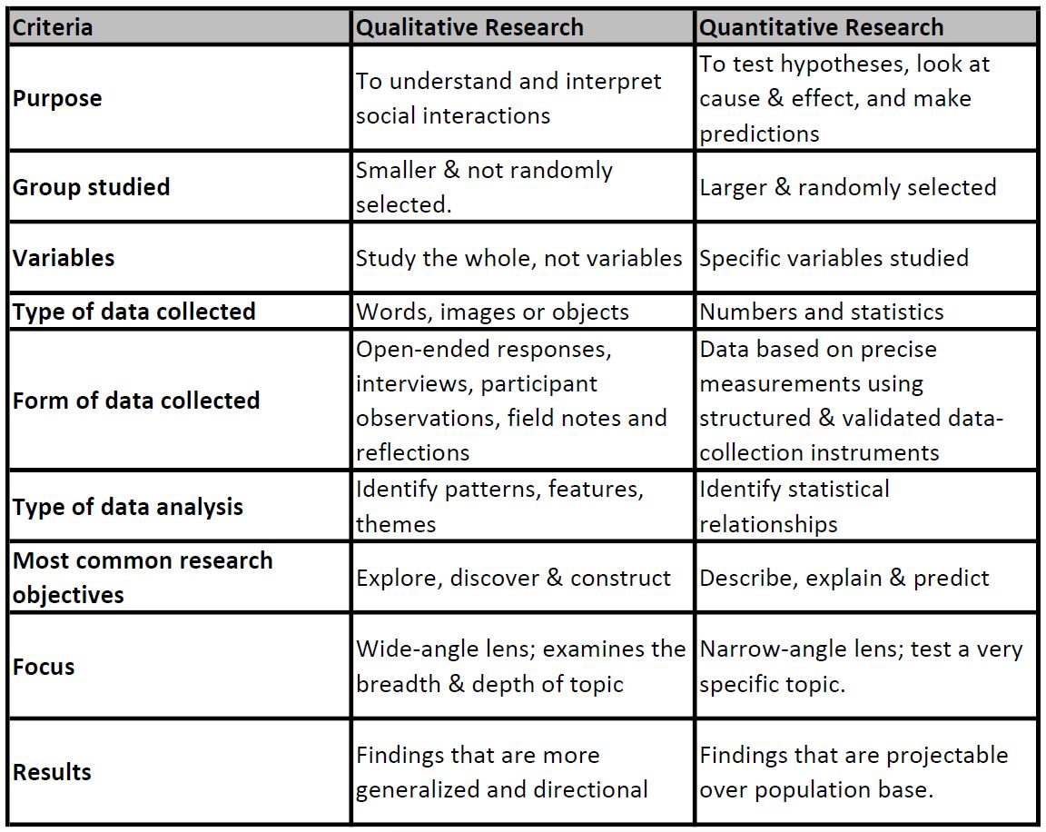

ETHICAL ISSUES

The integrity of an organisation is a reflection of the moral compass guiding the behaviours when conducting market research. In order for Swansea swim sharks to adhere to these ethical guidelines, they must consider the following when piloting their research

Goodwill- All information submitted is in a conscious nature of the volunteer. Any misleading acquirement of such information would make future research in this method problematic.
Trust- The offering of truthful information is bounded on the trusting relationship between the marketing decision makers and researchers. Lack of trust would lead to loss of time and reputation of the source. Information is most often submitted anonymously to encourage accuracy.
Professionalism- Acquired information must be used for professional means based on organisational purposes.
Confidentiality- to highlight the anonymous submission of information, confidentiality would also eliminate the prospect of their information being shared for example, sales calls.

Legislation was enforced in 1998 which has since been an ethical platform for market research. Although widely regarded to protect the privacy of individuals, this is not the case in the United Kingdom specifically, as it is only the processes of which the data is acquired which are subject to protection. Tapp, A, I, Whitten & M, Housden (2014) Principles of Direct, Database and Digital Marketing, Fifth Edition, Harlow: Prentice H

The eight principles of the data protection act 1998

- Personal data shall be processed fairly and lawfully.
- Personal data shall be obtained only for one or more specified and lawful purposes.
- Personal data shall be adequate, relevant and not excessive in relation to the purpose or purposes for which they are processed.
- Personal data shall be accurate and, where necessary, kept up to date.
- Personal data processed for any purpose or purposes shall not be kept for longer than is necessary for that purpose or those purposes.
- Personal data shall be processed in accordance with the rights of data subjects under this Act.
- Appropriate technical and organizational measures shall be taken against unauthorized or unlawful processing of personal data and against accidental loss or destruction of, or damage to, personal data.
- Personal data shall not be transferred to a country or territory outside the European Economic Area

The eight principles are key legislation for data protection but it imperative to note that this is not the only regulations that are required to adhere to. There are numerous codes of conduct outside of the data protection act which are worth considering. Tapp, A, I, Whitten & M, Housden (2014) Principles of Direct, Database and Digital Marketing, Fifth Edition, Harlow: Prentice Hall

PRESENTATION OF RESEARCH RESULTS

Presentation of results is important as it culminates the research findings and offers the clientele understanding and satisfaction that the questions which were the basis of the research have been answered. In order to produce an impressive impression on the client, tables, pie charts, line graphs, bar charts can be used to make the research more digestible. Communication is the focal point at this stage and internet reports could certainly back up further understanding by the client.

CONCLUSION

To conclude this report we must return to the questions first asked for the basis of this research. Swansea Sharks Swim Club harbour aspirations of becoming the best swim club but in order to achieve this, extensive research must be conducted. It is recommended to start with primary research as the club needs to acknowledge its successes and failures. This process may take more time, but in return more accurate results will be ascertained. Secondary research is always an approach which can be introduced for speedy resolutions in the future but the organisation needs to fully understand all ethical issues as well as legislative regulations. There are many methods and complications within the research process but with strong communication techniques in presenting results throughout, any challenges can be met with successes.

BIBLIOGRAPHY

BOOKS

Tapp, A, I, Whitten & M, Housden (2014) Principles of Direct, Database and Digital Marketing, Fifth Edition, Harlow: Prentice Hall

Wilson, A (2012) Marketing Research: An Integrated Approach, Third Edition, Harlow: Pearson

V L, Sauter (2011) Decision Support Systems for Business Intelligence, Second Edition, Wiley-Blackwell 4th Jan 2011.

Houdsen, M (2007) CIM Coursebook: Marketing Research and Information, Oxford: Butterworth Heinemann

McGivern, Y (20013) The Practice of Market Research: An Introduction, London: Financial Times Press

Brace, I (2013) Questionnaire Design: How to Plan, Structure and Write Survey Material for Effective Market Research, London: Kogan Page

JOURNALS

L, Buchanan & A, O’Connell (2006) A Brief History of Decision Making, Harvard Business Review, Jan 2006 Harvard Business Review Group.

A, Safari (2011) International Journal of Business and Management, 2011, Vol. 6, No. 7; July 2011 Page 165, Canadian centre of science and education
WEBSITES

G, DeVault (2017) Difference Between Primary and Secondary Research, Online available at; https://www.thebalance.com/differences-primary-and-secondary-research-2296908

