Dimitrina Petrova Dissertation
Date: 05.09.2022

Submission date: 5 Sep 2022 – 23:59
Submission ID: 1905516
File name: Dimitrina Petrova Dissertation 05.09.2022 (LCBB600)
Word count: 11 578

DISSERTATION
By Dimitrina Petrova



Course: BA Business management

Dissertation on
Analyzing the adoption of Cryptocurrency from an economic perspective and its impact on developing countries.

Student’s name: Dimitrina Petrova
Student’s number: 1905516

Acknowledgments:
First and foremost, I would like to thank my supervisor, Dr. Gladius Kulothungan for their consistent guidance and support during the semester. Moreover, I would like to express my sincere gratitude to the rest of my lecturers over the years because without their support and collaborative effort I would not have had the opportunity to reach this level of my education. Furthermore, I would like to acknowledge all people for participating in my research. With their help, I managed to collect up-to-date information that increased the quality of my project significantly.

Abstract:
The proportion of electronic transactions in international payments is increasing all around the world. In the past decade, governments, politicians, and practitioners throughout the world have paid close attention to cryptocurrencies which are also known as electronic payment systems. (Nadeem, et al, 2021) Cryptocurrencies are expected to bring a massive revolution in the near future from an economic perspective. The reason for that is the innovative method of exchanging funds as there is no existing physical form of it. The transactions are faster and there is no need for cross-border usage, fees are less, high security, transparency, and privacy. In this project, I will emphasize the main economic factors that may affect the adoption of cryptocurrency by developing countries. (Ntelly Path, 2022) The investigation that was conducted aims to provide a better understanding of the adoption factors and how different countries may strengthen their economic situation by implementing cryptocurrency. There will be answers to very important questions on how the nation will accept or deny such innovation. Will this modernization manage to gain people’s trust in cryptocurrency? Would this be enough in order to support the country’s economy? There are a few examples of how different developing countries achieved success by utilizing the option of electronic payments.
This study is based on many kinds of research that were analyzed and examined to develop all existing hypotheses regarding the subject. Primary research was used in order to collect actual data.108 participants got involved with the online survey which is included in the report.
All chapters of the paper are clearly divided into separate sections. Each of the sections include a detailed analysis of the study where more information alongside examples is presented. Chapter one is introducing the background and rationale of the study as well as the aims and objectives. Furthermore, chapter two includes a literature review where the main analysis takes place. All gained information is presented in this chapter with some facts on how cryptocurrencies affect the global economy and mainly within developing countries. There is a comparison between some countries in order to emphasize the visibility of the impact of digital assets.
Chapter three shows all facts and data collection from the survey which is in form of questionnaire. A detailed overview of the collected information is presented alongside graphs and tables. All factors have been considered as per the methodology point of view, timeframes were met, research methods were followed, and the result was carefully described within chapter four. Chapters five and six provide more analysis of the findings and a detailed discussion of the result. Based on the collected results, the final chapter includes the limits, implications as well as the conclusion of the investigation. The project was conducted during the summer of 2022 and some of the results may be affected by the current market situation. However, these results may be subject to change in the future.

Keywords: cryptocurrency, digital assets, electronic transactions, adoption, social trust, developing countries, global payments, economic perspective, blockchain technology.

Table of content:

Chapter One: Introduction……………………………..………………...………9
- Research background…………………………………………………….….9
- Rationale of the study……..………………………………………………..10
- Research question, Aims, and Objectives……………….…………..……..11
- Research structure………………………………………………...………..12
- Dissertation outline and chapter overview…………………………………13
Chapter Two: Literature review…………………………………………..……14
- Introduction of the chapter…………………………………………………14
- Critical analysis of cryptocurrency adoption by developing countries………………………………………………………...………….15
- Economic perspective of cryptocurrency…………………………………..24
- Impact of cryptocurrency adoption (positive or negative)……………..…..26
- Consequences…………………………..………………………..…………32
Chapter three: Methodology……………………………………..………..……33
- Introduction.………………………….…………………………….………33
- Research philosophy……………….……………….………...……………34
- Research approach……………….……………….……………….…..……34
- Research strategy………………….………………………………..………34
- Research techniques…………………………………………………..……35
- Type of investigation……………….………………………………………35
- Time horizons……………….…………………………………………...…37
- Data collection methods……………………………………………………37
- Data sampling……………….……………………………………………...37
- Questionnaire.……………….………………………………………..……38
- Primary research obstacles ……………………..……….…………………38
- Ethical consideration ……………….……………………...………………38
- Overview……………….…………………………………………..………39
Chapter Four: Analyzing data………………………………………………….40
- Introduction.……………….……………………………………….………40
- Inclusion and exclusion criteria………………………….…………………40
- Questionnaire analysis……………….…………………………………..…41
Chapter Five: Findings and Discussion………………………………………...52
- Introduction……………….……………………………………………..…52
- Findings……………….……………………………………………………52
- Discussion……………….…………………………………………………54
Chapter Six: Limitations, Implications and Conclusion……….……………..56
- Limitations……………….…………………………………..……………56
- Implications …………………………………………….…………………57
- Conclusion………………………………………..………………………..59
Reference list………………………………………………………………..……61
Appendix………………………………………………………………………….65
- Questionnaire ……………………………………………………...……... 65
- Tables and graphs ……………………………………….…………………69
- Timetable……………….………………………………….……………… 79
Topic: Analyzing the adoption of Cryptocurrency from an economic perspective and its impact on developing countries.

Chapter One: Introduction

- Research background
A modern form of private money, cryptocurrencies are based on high technological properties owning a global transparent transactions network that is fast and relatively safe. Furthermore, it provides them with decent forecasts for further growth. Nevertheless, virtual currencies are outstanding and unlikely to contest the dominant position of the central banks and sovereign currencies. As being an innovation for not many years, crypto currencies’ anonymity and trans-border character posture a challenge to all financial regulators. (Dobrowski and Janikowski, 2018)
Virtual currencies are digital money that is generated via electronic payment systems without requiring government backup. In 2008 was invented the first cryptocurrency by an unknown programmer named Satoshi Nakamoto where users were able to transfer funds for digital equivalent value. These transfers are validated by decentralized systems and protocol, therefore no financial institutions such as banks are involved. Nowadays, the estimated size of the cryptocurrency space was developed over the past decade with a collective market capitalization of $1.75 trillion and above. (Hayes, 2022) Given such rapid growth and volatility, the attention of the public has been drawn by virtual currencies.
Society has been changing over the years and therefore the habits have changed, too. Since money is a developing concept and is strictly related to the community and environment new forms and demands have arisen. After the implementation of digital money, technology has become very crucial as progressive growth must be adopted worldwide. There are countries that still have inefficient financial sustainability that has the potential to be improved. With the introduction of cryptocurrencies, transactions have become more convenient, instant, and safe. Due to their digital nature and global distribution, these currencies clearly show the potential for challenging the long-standing financial systems within countries where the formal payment system is more advanced than others. (Russo, 2020)

- Rationale of the study
The actual purpose of this project is to cover all aspects of virtual currencies’ nature and explore the investments as part of the economic situation of developing countries. The investigation has brought up to my attention that it is crucial for every country to consider the significance of cryptocurrency and how it can benefit the monetary system. The role of electronic assets is important, and it is imperative that everyone understands this innovative way of exchanging funds. The impact of adopting such currencies must be carefully analyzed alongside the conditions worldwide. Since cryptocurrencies are a modern way of investment, governments must be able to focus on developing their own virtual currency that can increase financial growth.

- Research question, Aims, and Objectives
The current aim of this study is about providing deep information concerning cryptocurrencies and their impact globally. Considering the factors of virtual currency investments will shed more light on an economic perspective and mainly it will line the benefit for the financial situation in developing countries. On other hand, the social trust in cryptocurrencies can also be investigated and analyzed by reviewing the results of the questionnaire below.
The objectives of the study are as per following:
- Understanding the significance of digital currencies
- Identifying the role of cryptocurrency investment on the economic state of developing countries
- Analyzing all factors that may affect the investments
- Providing recommendations that can improve the economic situation of the developing countries
The research questions are:
- What is the significance of digital currencies?
- What is the role of cryptocurrency investment on the economic state of developing countries?
- What are the factors that affect the investments?
- What strategies can be used to improve the economic situation of developing countries?

- Research structure
A detailed description of the research structure could be seen below:
Chapter One: Introduction
This chapter is the beginning of the project. It is essential to include the research background of the topic in order to give a context of the main idea as well as to provide the aim, objectives, and research questions of the study.
Chapter Two: Literature review
This chapter is highlighting all information that has been previously researched. All data will be investigated and analysed accordingly.
Chapter Three: Methodology
The research onion that was introduced previously in the proposal will be developed. Also, the results gathered during the data collection will be described and examined in this chapter.
Chapter Four: Analyzing data
Detailed feedback will be provided in this chapter in relation to the questionnaire and the interview.
Chapter Five: Finding and Discussion
This chapter includes all results of the newly collected information.
Chapter Six: Limitations, Implications and Conclusion
After performing the above investigation steps, the last chapter will conclude the final outcome by providing further analysis to strengthen the main idea about cryptocurrency acceptance.

- Dissertation outline and chapter overview
In general, the outline of this topic is to deliver thorough knowledge regarding cryptocurrencies and their utilization across the world. Considering the relevant questions and developing the main objectives stated in this chapter, the idea of virtual currency adoption may bring more opportunities for economic expansion and increase the financial level of every country. By analyzing the benefits of cryptocurrency implementation worldwide and comparing the countries with stronger financial systems to countries with weak financial systems, we can clearly understand how supportive it could be.
Reviewing the background of cryptocurrencies and their purpose is understandable that not every country would go ahead with such innovation when it comes to cryptocurrencies. There are a lot of aspects to be reviewed and analyzed. Therefore, the next chapters will provide more evidence and explore the benefits of virtual currency adoption for developing countries.

Chapter Two: Literature Review

- Introduction of the chapter
In this chapter, the key examination will cover the role of cryptocurrencies in developing countries. Briefly, in this section, the theoretical background of the topic will be analyzed in depth as well as exploring the concept of different money forms and their influence over developing countries. A detailed inspection of all past literature is established by filling the gap with alternatives in order to avoid some restrictions imposed by financial institutions within these countries. Additionally, there is a need to observe all potential risks and limitations in relation to the adoption of cryptocurrencies. The relationship between digital currencies and evolving country’s economy plays an important role and more specifically with financial inclusion that may have a positive or negative effect.
There are a lot of existing challenges in terms of the developing country’s financial schemes. The trust for growth and every opportunity for innovation that may arise can predict and discover different alternatives for increasing socio-economic inclusion. Therefore, building an accelerating growth for electronic transactions will be advantageous because of the political and social context of the country. (Currie, 2009). For developing countries, it is beneficial to look at the experience of the mistakes that the West has made in terms of system production, governance infrastructure, and financial services, or more specifically how to build a strong and relative blockchain technology.
Via these virtual currencies, consumers are avoiding the physical use of banks. To exclude any further risks, developing countries may easily invest in the newest technology infrastructure achieving quick results which have taken a lot of time for other countries in the past decade. (Grinberg, 2011). By implementing cryptocurrencies, emerging countries will have their own leadership position over the adoptions and will create a new traditional system for online payments that will be triggered by the ability to eliminate the need for a reliable third party.

- Critical analysis of cryptocurrency adoption by developing countries
Cryptocurrency – definition, blockchain technology, developing countries, adoption, and risk.
“What is needed is an electronic payment system based on cryptographic proof instead of trust, allowing any two willing parties to transact directly with each other without the need for a trusted third party.” (Nakamoto 2008).
Definition
The European central bank has classified cryptocurrencies as such, and they can be bought or sold against traditional money as well as being used for purchases. (Houben, 2018) Virtual currencies will replace the financial structures and will foster different monetary systems where secrecy, confidentiality, and autonomy will be leading. (Bashir, Strickland & Bohr 2016). An analysis of the past ten years of cryptocurrencies’ lifetime, we can see that the long-term technology has been challenging the fiscal payments on fiat currencies.
There are three types of utilizing cryptocurrency. The first type of crypto purchase is for virtual goods such as online games. The second type is related to the real economy, and this is when purchasing cryptocurrency with real money. A conversion rate applies here which is in contribution to the real economy. And the third type is buying cryptocurrency with another cryptocurrency. There is also a bidirectional relationship with the real economy because there is a conversion rate when buying the virtual currency as well as when selling it. Of course, the value of the CC is exclusively driven by the market and therefore it involves a high risk of exchanging the currency at a lower price. Such cybernetic currencies are not controlled by any international or national authorities. (ECB, 2015)
Blockchain technology
To look more specifically at this, according to McLeay and Thomas’s article, systems that do not include the conversion of fiat currencies will need a precise payment scheme alongside a ledger to record the value. Furthermore, to avoid any ‘’double charges’’ for a single transaction there is a need for a system that can detect duplicated payments. Such a system is the blockchain, where non-cryptographic currency depends on a centralized balance sheet. The blockchain is an electronic ledger that makes sure all transfers are maintained securely and have been distributed efficiently by taking ownership. (Arjaliès 2020)

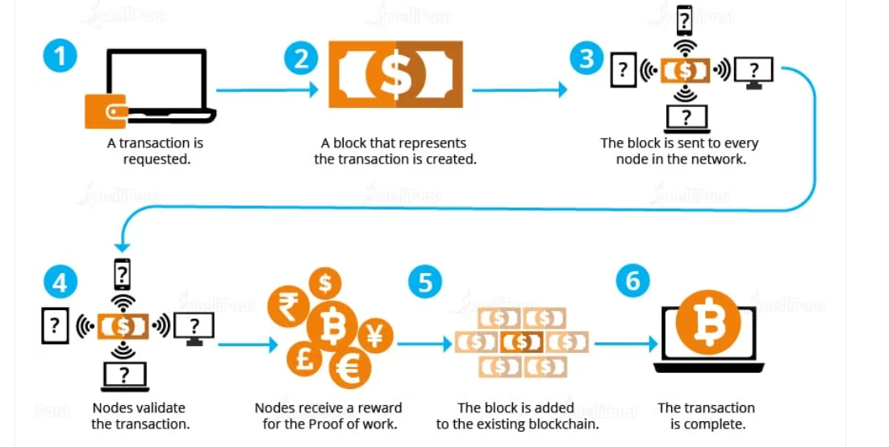
FIGURE 1: Transaction Process Through Blockchain

As per Figure 1, every transaction begins from a sole network node which is being sent to other network nodes. Each transaction must be verified before it is sent. For example, each block gets added only once the computational power of the network's nodes reaches consensus, which is done with the aid of the proof of work method. As a result, the transaction, along with previous transactions, generates a fresh data block for the register. Individual lines in transaction blocks involve the sole identifier that is connected to the one before it. The preceding block's unique identification is utilized to calculate the identifier for the next block, forming a mathematical connection between the blocks in the chain. (Kewell, 2017) Because all entries in the chain must be changed, erasure or removing rows in the record is nearly impossible. Inserting additional rows to the table needs the node's consent, which is gained by the work verification procedure, which all nodes must use. As a result, as long as the software is running, blockchain will continue to be produced and maintained, unaffected by anyone withdrawing.
Cryptographic technology protects and transparently preserves transaction information on a communal, distributed, dovetailed, everlasting, and transparent ledger. As a result, each participant is entitled to a list of the transactions where need to confirm if upcoming purchases are genuine or an effort to double spend. To decompose the blocks, the permission or "proof of work" should be completely re-performed for each block added after the altered one, which is computationally incredibly demanding. (Dierksmeier, 2020). All cryptocurrency transfers are being sent from and to electronic ‘’wallets’’ which on other hand are secured by encryption. Thus, it allows 100% anonymity of use as well as ownership. Therefore, this is one of the negative parts of these transfers because of the full anonymity creates an area for illegal trades. The good part is that not all virtual currencies are classified as fully anonymous. For instance, cryptocurrencies such as Bitcoin can hypothetically be tracked back to the owner’s wallet, however, the information still can remain anonymous for the basic purpose. Consequently, the value may be kept and exchanged in cryptocurrencies without revealing one's personal name to the public. (Dierksmeier, 2018). Additionally, the digital currency price is determined by supply and demand which is favorable in countries where the currency is heavily influenced by inflation; nevertheless, it impacts the riskiness of the currency, which is vulnerable to considerable value changes.
There are currently over 1000 existing electronic currencies. However, there are about 10 currencies that lead the market by representing 80% of the total value in the cryptocurrency market. Although, cryptocurrencies such as Bitcoin or Ethereum only take around 55% of the market value. (Claeys, 2018) The overall industry value of the 100 biggest digital tokens is believed to have surpassed the equivalent of EUR 330 billion internationally by early 2018, while the total capitalization of virtual currencies peaked at an even greater USD 728 billion during the same time (Bratspies, 2018).

Developing countries
The adoption of digital currency in developing countries will face a lot of challenges due to the complex economic and socio-cultural context that is deeply controlled by the formal financial scheme. In such countries, where the Human Development Index (HDI) and industrial base are low, there is a basic association between human wellbeing and income that is flawed. (UNDP Human Development Report Office 2015).
There are several factors that can measure the effectiveness of the development. Mostly, development rest on the resources made by savers and investors. Direct fiscal transactions between debtors and investors would be available in a world without market obstacles and uncertainty. Though, in everyday life, where transactions have unpredictable outcomes and most agents are risk-averse, risk diversification and risk management services command a premium. On other hand the financial system may affect economic development positively as per a few factors (Afonso et al. 2002):
- Ability to manage financial resources.
- Savings deployment
- Decreasing information cost
- Decreasing investments cost projects
- Risk diversification
The main purpose of financial inclusion is to ensure individuals or businesses are able to access affordable products or services in order to meet their needs. (Russo, 2020) However, some financial institutions are not able to offer people with opening bank accounts or provide an effective way of managing their finances. This of course causes a global market crisis because of the incapability to offer proper financial services.
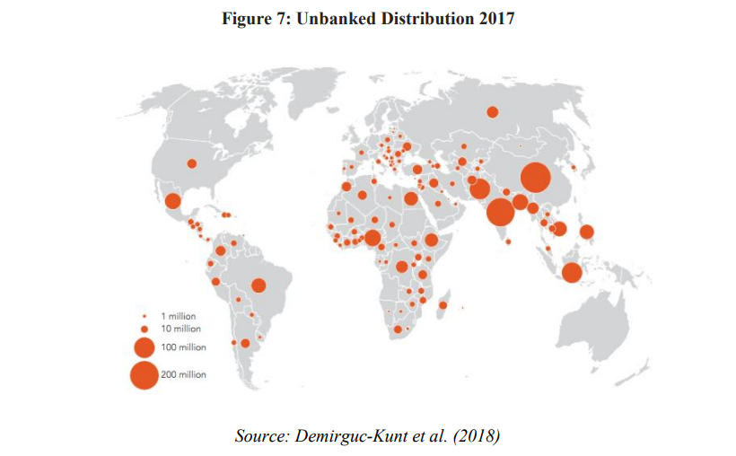

FIGURE 2:
Unbanked
Supply
(Source: Online by Kunt
et al. (2022))
From the figure above it is visible that the population within developing countries is unbanked. In 2022, the majority of African and Asian regions are unbanked which means that people do not possess a bank account which in percentage is 17% on the global aspect. (Kunt, et al 2022).
According to Stopl (2022), formal financial accounts have only 26% of the population worldwide. In Jamaica, the percentage has increased up to 59%, however, this percentage includes the whole country, not specific cities or urban areas. The usage of financial bank accounts in most other developing countries does not exceed 30%.

Adoption
Dissimilarly to traditional forms of money, cryptocurrencies have the potential of becoming more pervasive due to their digital nature and global distribution. They are designed for swift transfers and frictionless which makes them the most preferable financial alternative for developing countries. An example is that according to the most recent statistic (Fig. 3), the bulk of cryptocurrency transactions take place in nations where the typical payment infrastructure is well established. According to data from the Statista website, trade volume in evolving and boundary economies much outnumbers that in the developed world, and the digital currency is also less sensitive to price changes. (also visible in Fig. 3)

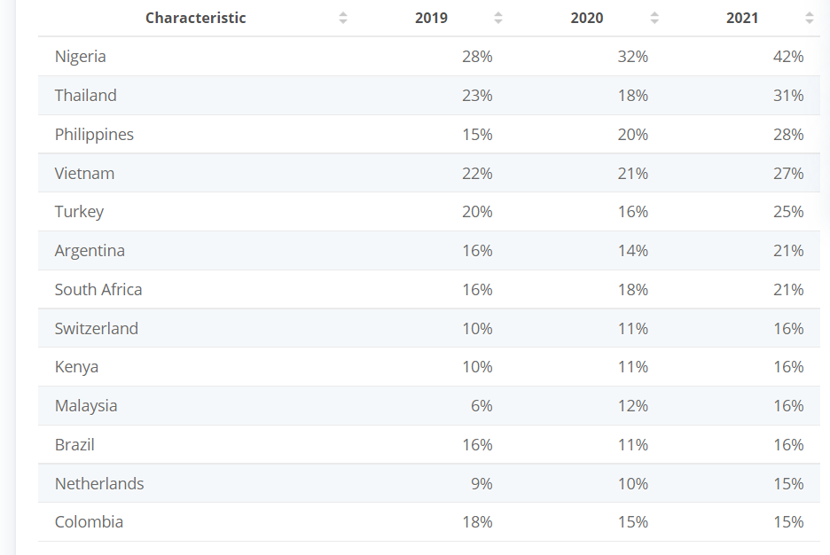

FIGURE 3,
Source: Statista
2019-20220

Reflecting on the most recently collected data from the figure above, the top emerging countries that have adopted digital currencies are Nigeria, Thailand, Philippines, Vietnam, Turkey, Argentina, and South Africa which are above 20% globally. The survey shows that the percentage of people who own cryptocurrency has significantly increased over the years and the utilization and adoption of digital assets have become more popular.
As per the CEO of Wala, Tricia Martinez, in countries such as Africa cash is the king, however, if crypto is designed properly, the adoption will be aggressive. There is a nature of interest in virtual currencies between developed and developing countries because of the unique reflection of the profound difference between them. There are two main aspects in defining the potential of cryptocurrencies:
- These currencies can be seen as a new payments instrument where no relatively cross-border transaction costs are presentable. These are also an independent form of governments or monetary authorities.
- Digital currencies can also be seen as speculative trading instruments. There are a lot of opportunities in relation to cryptocurrency portfolios. These can be exchanged for fiat currencies, commodities such as gold, or stocks without prevaricating the economic uncertainty. (Baur et al, 2017)
The variety of cryptocurrencies could be an option for developing countries to be able to use as a speculative instrument. The standard financial system does not offer such a service and the adoption of cryptocurrencies will be beneficial. For instance, Africa’s population and businesses are not able to perform cross-border payments due to local restrictions. However, the utilization of digital currencies mainly for transfers will be much helpful for Africa to expand its economic scheme as it is a country with the fastest-growing population. (Baur et al, 2017)
As a matter of fact, the formal financial system within evolving countries plays the role of obligating the growth prospects. Furthermore, they represent alternatives for some innovations, too. It is not surprising that emerging countries should think about the best options to find alternative methods for increasing socio-economic inclusion by accelerating electronic payments. In order to develop a new payment system, it should be considered a political and a social process. (Currie 2009). It is advantageous for those countries to analyze the mistakes of The west when developing their own production system or monetary services by building a technological infrastructure such as blockchain technology. Online users are avoiding physical banks by using peer-to-peer digital money instead. (Greenberg, 2019). In fact, rather than evaluating all prior variants of technology to create the infrastructure, emerging countries have the ability to skip to the most recent form, getting rapid results that would have taken decades in more industrialized countries, saving time and money. Emerging nations are gradually gaining the lead in cryptocurrency adoption as an economic substitute to the typical payment system, owing to the potential of these cryptocurrencies to eliminate the usage of other payment instruments.

Risk
The utilization of cryptocurrencies involves a dozen of risk that rests on the real connection with the economy, the issued volume, and trading volume. (ECB, 2015) For example, if all developing countries depend on this economy, the danger of exposing and transaction electronic currencies will affect them. Particularly, the virtual currencies value depends on the investor’s demand as well as the market volume and if it drops then the value of the currency drops, too. (Peria, 2015). Nevertheless, this currency value in emerging countries will not respond to the price variation because the more developed markets are driven by the more resistant currency rather than hypothetical reasons.
Cryptocurrencies are affecting developing countries such as Zimbabwe or Venezuela in a positive way due to the hyperinflation that eats every paycheck as soon as it is issued. Therefore, owning virtual currency plays a crucial role as an invisible peer-to-peer controlling spine that is safe by comparison. Moreover, banks refuse to help illiterate people that are unable to manage or understand the banking system. This leads us to think that unbanked people are low educational attainment. (Kunt, 2018)
Because of expanded financial inclusion, virtual currency adoption leads to speculative democratization. Moreover, monetary knowledge is demonstrated to underpin financial inclusion and boost the utilization of monetary services. For the adoption of complicated financial innovations such as bitcoins, it is expected that a high degree of economic knowledge and presence will be necessary. (Klühs & Menkhoff 2018). Furthermore, according to research, families who recognize their own limitations may shun financial methods for which they feel unqualified, such as the implementation of digital assets. Cryptocurrencies emerged as a response to the rise in private value buildup by financial mediators at the cost of eventual savers. (Campbell, 2006).
On other hand by preventing financial intermediaries, virtual currency transactions are not very clear whether their appropriation value is distributed equally between the involved investment chain. In fact, everybody can own electronic currency, however, not everyone is capable of actually understanding and engaging with them. According to West (2015), the innovative financialized inclusion of the worldwide economy has the potential advantage of adopting cryptocurrency in order to boost further.

- Economic perspective of cryptocurrency
In order to help the population of virtual currencies across the developing countries there is a need of advanced technology and devices. This will help the nations to easily transfer fund over mobile phones globally. (Raymaekers 2015) Exanimating the traditional payment system the transactional cost is very high. Moreover, comparing electronic currencies and their cost-effective decentralized ledgers plays a crucial role in emerging countries’ economies. However, the lack of digital identity may affect access to such institutions. (Cheng, 2019) According to Waters (2016) the investment capital in most developing countries is limited because of the financial inclusion across the population. Traditional payment schemes cannot provide an adequate service and therefore the adoption of cryptocurrencies will reduce all economic barriers as we as reducing the monopolistic influence. (Honohan and Beck, 2017)
As a most important benefit for emerging countries is considered the improvement of financial inclusion. Nowadays, the innovation of technology is very popular, and everyone can have mobile device. This is another benefit that considers how educated a particular population is. The ability to operate a mobile device can also connect people with adopting and utilizing cryptocurrencies’ blockchain. (Darlington, 2014). Such investment opportunity can drive the entire world by providing availability to anyone to manage their own assets. For example, virtual currencies reflect on people beliefs by replacing the traditional financial system. (Raymaekers 2015). The cryptocurrency technology allows people to freely exchange funds in digital form globally and district the fiscal system by being cost-effective. (Cohen, 2017)
Logically, transacting electronic currencies offers an alternative because of the lower fees that occur. From an economic point of view, comparing virtual funds to the traditional financial system is more beneficial for developing countries. Decentralized ledgers have the potential to avoid any fee-related transactions, however, in practice, many crypto exchange platforms are charging small fees in order to maintain the security standard of the currencies. (Tachizawa & Wong 2014) On other hand, facilitated via blockchain low-cost transfers are an incentive for opening an account by preventing billion people from opening bank accounts. (Lichtfous, Yadav & Fratino 2019). Blockchains can help with identity solutions by providing a decentralized approach to identity management. Theoretically, users can have accounts based on their facial recognition where no passport or identity document is required.

- Impact of cryptocurrency adoption (positive or negative)
The utilization of electronic currencies is an attractive fixture of day-to-day life, particularly in countries with a history of financial uncertainty or where access to usual monetary instruments such as bank accounts is difficult. For instance, in Brazil crypto investors are keeping their savings in an exchange-traded monthly investment basket that is very popular on the local bourse. In the US or Europe, the danger of trading crypto is warning users in relation to the regulators, however, these currencies are building deeper roots in emerging countries. (Klasa, 2021)
As per Weathley’s article in Financial Times, investors in Vietnam do trade or transact in cryptocurrencies, therefore the nation from South-East Asia is classified as the world’s highest rate of crypto adoption for 2021.
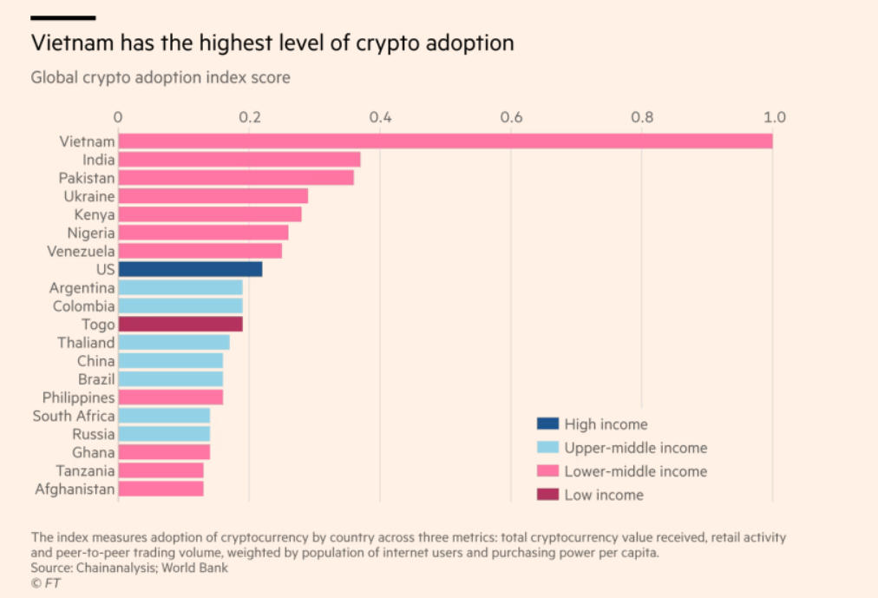

FIGURE 4, (Source
Chainanalysis, 2021)

According to Kim Grauer, it is very powerful for emerging markets to adopt cryptocurrencies, as it is a massive footprint for many entrepreneurial opportunities. Vietnam is ranked by Chainalysis (Fig.4) as the first top crypto adopter on a global basis. On other hand, following up on the crypto transactions, sub-Saharan Africa leads the trading platforms with the highest volume of crypto activity across the world. Even North America seems to stay behind comparing the transactions made over last year.
Another example is El Salvador, a small central American country with 6.4 million population which is about to become one of the first global tenders of cryptocurrency. (Klassa, 2021) A project was considered to accept cryptocurrencies as payment methods everywhere in the country, so people can use digital currencies as new payment instruments. Since the developing countries’ economy seems to be a fertile ground for electronic currencies, unpredictable regulatory uncertainty and financial inflation can become a thread of capital control. (Domjan, 2021)
Let’s take a look into Africa’s most occupied country Nigeria. Due to the numerous unemployment, capital control, and whims of the black market, the youthful nation is facing a lot of challenges and concerns. In fact, after the pandemic, the main export of petrol dropped, and this led the business towards bankruptcy. (Wheatley, 2021) In such circumstances, it is important that the economy of the country can implement a flexible way of providing individuals or businesses with alternative payment instruments such as electronic payments.
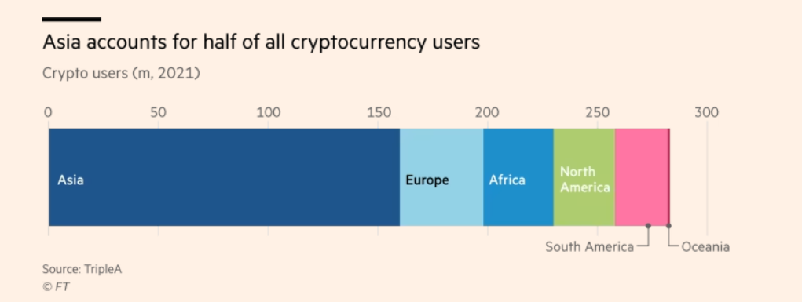
Transactions range in scale from retail investors purchasing modest quantities of cryptocurrency for less than $100 to merchants clearing invoices to financial services organizations created on these platforms and employing hundreds of people. Moreover, importing goods between China and Nigeria using virtual currencies helps entrepreneurs to get into international trade. Because of the expense and complexity of legacy banking systems in countries such as Venezuela and Brazil, many individuals are more comfortable testing with and moving among different tokens. (Klassa, 2021)

FIGURE 5 (Source: Chainanalysis, 2021)

Coinbase and Binance are two of the biggest exchange platforms that provide services to emerging countries. More than 80% of bitcoins by value moved to Africa, America, and South Asia and passes through exchanges. Binance delivered over $14 billion in cryptocurrency to Eastern Europe in the fiscal year ending June 2020, accounting for 20% of all monies moved through the exchange internationally. (Klassa, 2021)
As per World Bank, the shipping cost of funds to Sub-Saharan Africa is 9% of the whole transfer, which is considered the highest of any world area. According to Statista, these costs are normally about 2-5 percent on peer-to-peer crypto networks.
However, some commentators argue that using bitcoins for remittances or other payments poses significant risks. According to Paola Subacchi, professor of international economics at the University of London's Queen Mary Global Policy Institute, lowering the cost of remittances would be a better option for migrant workers. "This is a poor solution to an issue that should be tackled with existing technology. Cryptocurrencies and crypto businesses pitch themselves as financial inclusion devices, but those excluded from regular financial facilities are precisely those who can least afford to take any risks with their money," she says. Increased mainstream investment as with counterparts in wealthy economies, there is a lot of speculation about bitcoin in sections of the evolving world, particularly in middle-income countries.
Regulators in nations such as Zimbabwe have been harsh on crypto businesses, only to flip their attitudes. After prohibiting local banks from trading with cryptocurrencies in 2018, Zimbabwe's central bank has stated that it is preparing a regulatory outline for adapting them. (RBZ, 2022) In Nigeria, the central bank barred commercial banks from working with electronic currency businesses, which swiftly devised a workaround via third-party accounts. (CBN, 2021)
The Central Bank of Nigeria is afraid that unskilled investors may lose their little funds by betting on an extremely speculative token. "Small retail and unskilled investors also risk a significant chance of loss due to the current high volatility of investments," the bank stated as it moved to rein in the transaction. (CBN,2021) However, while most crypto services claim to want to comply with regulations, they feel that excessive bureaucracy will push individuals to seek their services.
Instead of cracking down on cryptocurrency, El Salvador's government has decided to embrace it. Whether the project succeeds or fails, Domjan (2021) believes it has reformed the game. Indeed, El Salvador is considered a true state because it is not sanctioned, it is a part of the IMF, and it is a part of the world monetary structure.

- Consequences
Without broad access, the ensuing financial limitations severely limit the capacity of both families and small businesses to fund high-return projects, decreasing the effectiveness of source distribution and impeding participation in global commerce. People and businesses who are not part of the official financial system are given a variety of options that are neither well-organized nor equitable. Consequently, unbanked parts of the community are stuck in a never-ending sequence of economic inequity, deprived of the essentials of financial empowerment. Furthermore, financial market frictions have been highlighted as crucial in perpetuating economic disparity or poverty. (Peachey & Roe 2004)

Chapter Three: Methodology

- Introduction
The research technics outline the approaches I used to investigate the collected data. This chapter is focused on examining the collected information from the questionnaire as well as developing the idea supported by facts in regard to cryptocurrency adoption in emerging countries. The chapter will be divided into small sections where a detailed explanation will be provided. The analysis of the research technique is conducted according to the figure below of the research onion:
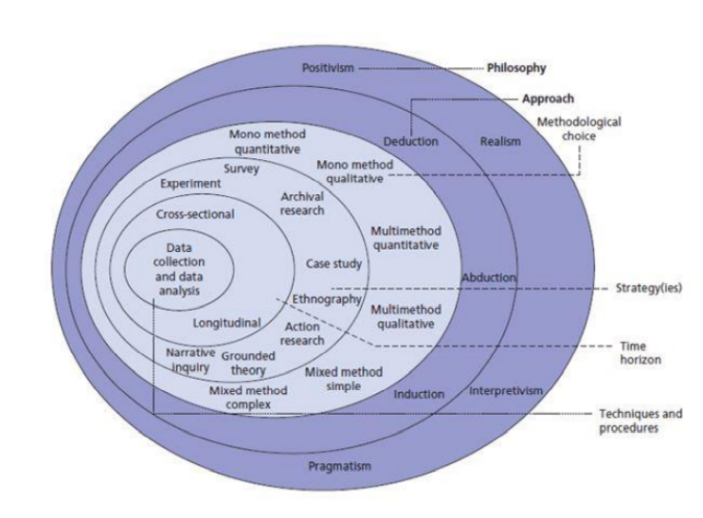

FIGURE 6

- Research philosophy
In this paper, the research philosophy is related to the ontology method because of the already existing data I have examined about cryptocurrency. To evaluate the research reliability and validity I did use the research paradigm – positivism as it is based on the objectives of the report by providing facts and observations based on the collected responses from the questionnaire.

- Research approach
The research approach that will help test my theory is deductive. All concepts have been clarified and developed into a detailed analysis where an up-to-date information is presented in an understandable way to the reader.

- Research strategy
In terms of the research strategy, I have decided to include the explanatory and descriptive approach in order to elaborate further on the collected data by providing facts and figures.
The participants of the survey were provided with the ability to access the form and see the actual results of all collected data for their reference. This section used descriptive technique in order to allow better subject description without it being affected by the validity of the sampling method. Giving an opportunity for multiple respondents will aid the survey by giving a better understanding on the subject.

- Research techniques
In this paper, quantitative research was implemented and utilized in order to give choice to all participants to answer honestly. The structure included a form of a questionnaire (11 questions) providing more details on the scope. There were more than 100 participants involved and a copy of the questions was attached in the appendixes section of the report.
The quantitative method is based on numbers and statistics that help understand the averages and frequencies of the subject. By using this method, the interpretation of the collected information can happen during the experiment or by using sampling methods. (Gentles et al, 2016). The collected data was already reviewed and an analysis of it is provided in the next chapter. Also, the statistical results have been standardized and shared for visibility.

- Type of investigation
Primary research
Primary research was one of the tools I used in order to support this report. The collected information was conducted by creating a questionnaire where everyone is able to participate. The research is meant to gather first-response insight from people and their thought about cryptocurrencies. The primary research generally aims to provide information collected straight from the respondents and once it is investigated a conclusion will follow with the outcome.
Advantages: In the primary research, the issue is normally addressed in order to gather the information firsthand. It is more effective because the collected data comes straight from the original source, and it can be analyzed accordingly. The subject of the research gives an opportunity to understand the issue more specifically that researching general information. The analysis of data becomes essential because it needs to provide actual feedback on the researched problem.
Disadvantages: In this section, I would confess, that one of the main disadvantages of primary research is time-consuming. The ability to conduct professional research is not only related to the time, but it is related to a variety of sources, too. Conducting primary research involves a lot of resources as well as providing recommendations for resolving a particular problem is important. The lack of time or resources may lead to an inappropriate conclusion when analyzing the collected data.
Secondary research
Secondary research is another tool that helped me proceed with researching my subject. Based on already researched information, I managed to develop my paper by providing a lot of examples of how the adoption of virtual currencies will aid developing countries.
Advantages: Using secondary research delivers a lot of options where a particular subject has been developed. No time-consuming thread exits as all information is easily accessible and does not require any additional costs. There are many articles and sources that provide already existing evidence.
Disadvantages: When developing your own subject that brings more interest, some of the secondary research may not be fully focused on the same subject and therefore the researcher will be forced to seek more information in order to gain a better understanding. I have used multiple resources related to my subject and finally managed to create a good quality paper with interesting facts about cryptocurrency adoption.
- Time horizons
To collect all information, of course, I had the responsibility to manage my time. Each section was given a particular time frame to be completed. For instance, with primary research, I allowed myself more time in order to collect as many responses as possible. For the secondary research, the time needed was also significant because it is essential that all information is analyzed and delivered with all supported facts.

- Data collection methods
In order to collect reliable data, the utilization of primary and secondary sources was very helpful. With primary data, it is imperative to consider the objectives of the study before selecting the right tools when collecting information. By primary data, the collected information is not published, however by secondary data the collected information is already published. The study includes a survey with 11 questions via Google form. There is no time limit for completing the questions and all participants were able to give an honest opinion about cryptocurrencies and their impact on developing countries.

- Data sampling
Sampling is a method that allows a selection of people in a population to perform statistical inference by observing their characteristics. (Snyder, 2019) There are different sampling methods that can be used widely for market research as it helps collect actionable insights.
For this research, I concentrated on the probability sampling method where every member of the population will get a chance to be selected. This technique is most suitable for my quantitative research because the results I generated were represented by the whole population. Therefore, I choose a random simple sampling in order to give an equal chance for everyone to be selected. Participants were chosen on a random basis and had the opportunity to contribute to the questionnaire.

- Questionnaire
The questionnaire was published online, and everyone can participate. The collected responses are 108 and by looking into the statistics, most of the people are familiar with cryptocurrencies, however, not all of them own such. The questionnaire is attached in the appendix section for further reference. The time frame for collecting responses was 5 weeks and the form was available until the end of the survey.

- Primary research obstacles
Some issues have also occurred when completing the research. It has taken more time to create the questions. Also, the collection of responses consumed most of the time. The original time frame for the primary research was 3-4 weeks, however I had to extend it because the responses were not sufficient in order to conclude the report.

- Ethical consideration
Ethical consideration is connected to the principle of collecting data where no harm to society or individuals is created. (Zyphur and Pierides, 2017) Ethical consideration is one of the most important parts of the study. There is a set of principles that are used for collecting the needed information. It must be ensured that participants’ rights are protected by anonymity, the validity of the research must be enhanced, and to show good maintaining scientific integrity. The research was processed by providing participants with access to an online questionnaire form as well as they need to fill out a consent form stating they agree to be part of the research. Data Protection Act (1998) protocols was also followed in order to complete the research accordingly.

- Overview
According to the research onion, this report was created by following the main research techniques, approaches, strategy, design, and methodology. This chapter emphasizes the plan I followed in order to cover each section and explain the methods that took place. Overall, the chapter delivers an insight of the methodology I used and explains the research types. The sampling method was selected on random basis and the questionnaire was provided in online form. For collecting all responses, ethical considerations were examined by avoiding any further conflicts.

Chapter Four: Analyzing Data

- Introduction
The main part of the study is to analyze all collected information from the questionnaire. All responses are inspected and evaluated, therefore an overview of the positives or negatives from the participants was obtained and concluded in this section. The collected data is included in an Excel sheet formulating the result and creating a pie chart that will show the public outcome. The importance of this chapter is related to a valid data transformation and presenting all figures in a wat that the reader can understand.

- Inclusion and exclusion criteria
All collected information via secondary research was read and analyzed. There are multiple articles, journals, and books that were recently published. The selected subject was also examined according to the most recent economy conditions and the current market of cryptocurrency. The final outcome was based on the long-time research due to the more specific title I choose, however the result and the knowledge I received is more than satisfying.

- Questionnaire analysis

In this section, I will include all responses and the collected data followed by a detailed analysis of the result. There are also screenshots and tables created in order to visualize the participation of all people. Each screenshot was created by me using a Google form and will be followed by a table also created by me with the exact amount of all recipients. An overview of the results will be explained under each table.

Question 1
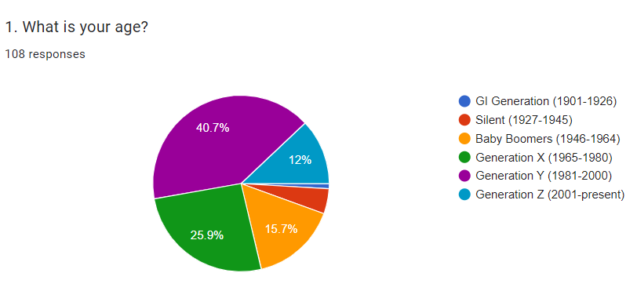

Question 1
Answers: | Participants:
GI Generation (1901-1926) | 1
Silent (1927-1945) | 5
Baby Boomers (1946-1964) | 17
Generation X (1965-1980) | 28
Generation Y (1981-2000) | 44
Generation Z (2001-present) | 13

The majority of the respondents are aged Generation Y (1981-2000), which means that 40,7% of the participants are young people. Therefore, all people that participated are technology educated and were able to access the form via tech device. There is only one respondent of GI Generation (1901-1926) that were happy to review and fill out the questionnaire. 28 people classified as Generation X represent 25,9 % and 17 people of Baby Boomers (1946-1964) represent 15,7% of the total participants. The youngest generation seems not very interested in taking participation in surveys as they are only 12% in total. Silent generation (1927-1945) respondents are only 5 which overall takes 4,6% of the survey.

Question 2
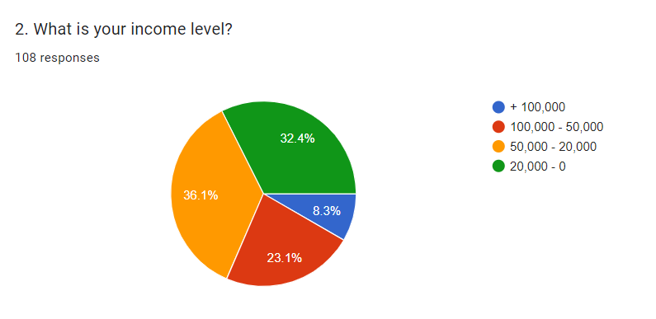

Question 2
Answers: | Participants:
20,000 - 0 | 35
50,000 – 20,000 | 39
100,000 – 50,000 | 25
+ 100,000 | 9

This question was answered by 108 people and according to the responses the majority of them have quiet high-income level. 36,1% of the contributed people are taking between £20,000 and £50,000. Not very far behind are people with an annual income of £0-£20,000 which represents 32,4%. There are some wealthy people that take between £50,000-£100,000 yearly showing 23,1% of the total participants. However, there is a small percentage (8,3%) of people that fill out the survey with an income above £100,000 per annum.

Question 3
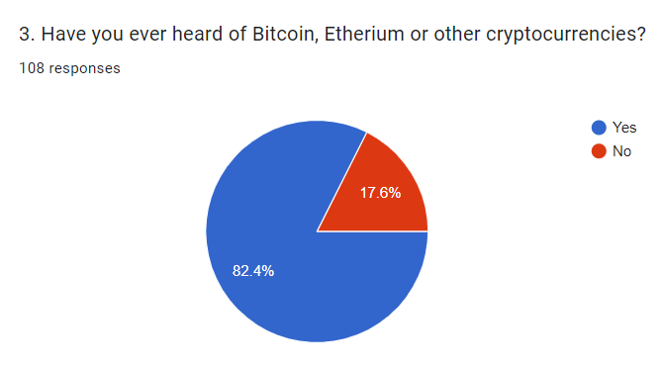

Question 3
Answers: | Participants:
Yes | 89
No | 19

As per question 3, we understand that most of the participant are aware of what cryptocurrency is as well as what are the top gainers of them. As some of the most known cryptocurrencies, Bitcoin and Ethereum highlight that our participants are familiar with them and probably have own or still own some. 89 out of 108 people have heard of cryptocurrency which takes 82,4% in total of the whole survey. A small amount of people (19) has never heard of cryptocurrency at all.

Question 4
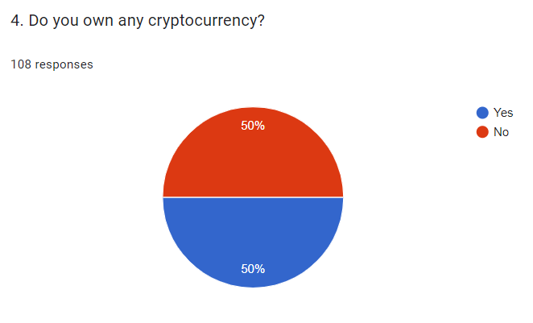

Question 4
Answers: | Participants:
Yes | 54
No | 54

An interesting fact is that 50% of the participants currently own cryptocurrency. Consequently, this means that 54 out of 108 people of different ages are crypto owners. The income of the participants does also affect their choice of preferable crypto tokens and potential investments in the future.

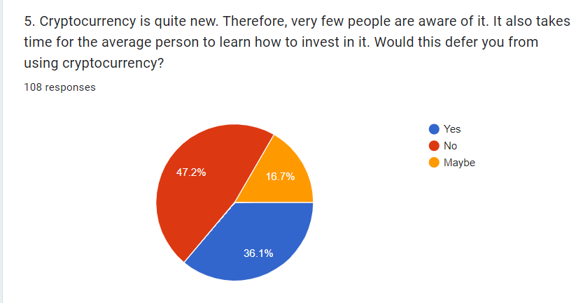
Question 5

Question 5
Answers: | Participants:
Yes | 39
No | 51
May be | 18

As a result of this question, we can clearly see that the majority confess that the innovation of cryptocurrency will not deter them from using it further. 47,2% of these people are ready to invest with no concerns about whether the crypto industry is new or not. These people tend to believe that the innovation of electronic payments will benefit them and the funds they invest in such platforms will increase its volume in future. The more people interested in virtual currency the better market sustainability is in a long-term goal. On other hand, 36,1% of the participants are stating that the innovation is not comfortable to them when it comes to their budget. Such people are choosing to stay on the safety side and wait until the market become more sustainable. There is 16,7% of the respondents that are not very sure whether the innovation of crypto market will affect their choice by joining crypto world or not. Such people are in doubt, and they will probably need more time to understand how the market and investments work.

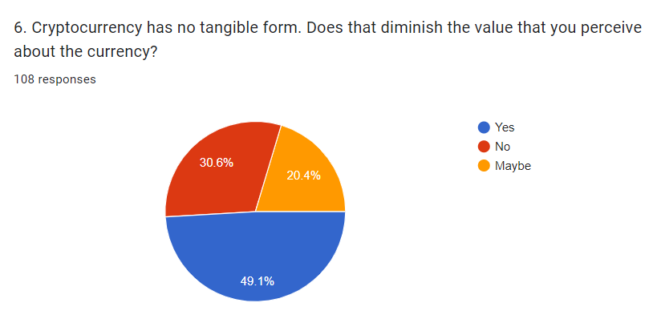
Question 6

Question 6
Answers: | Participants:
Yes | 53
No | 33
May be | 22

Question 6 tends to find out what people think about the crypto currencies and their intangible form. As per the responses above we can see that 53 out of 108 (49,1%) people do believe that due to the intangible form of electronic currencies the value of it seems difficult to perceive. The rest 30,6% of the respondents do not face an issue with this and 20,4% of them are also not sure if this would affect their choice of joining the market. Analyzing these figures, social trust in cryptocurrency is still an issue for people worldwide and this might be the main problem when adoption takes place.

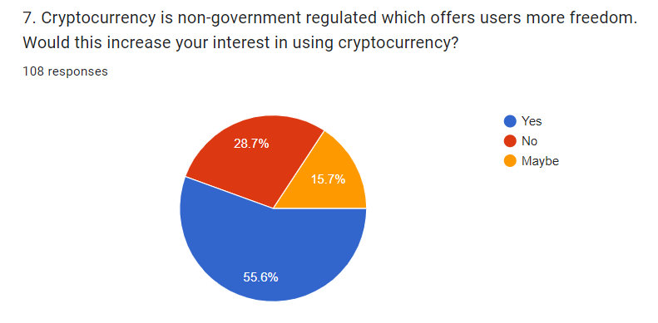
Question 7

Question 7
Answers: | Participants:
Yes | 60
No | 31
May be | 17

In this section of the survey, participants were provided with more details on cryptocurrencies freedom. Potentially this question has made a lot of the respondents to re-think if owning crypto will benefit them from saving money when making transfers as per usual financial system. Clearly, the mainstream of them (55,6%) agree that virtual money will increase their interest due to being feeless. Another 31 people said no, and this makes me believe that 28,7% in total do not trust non-government regulated transfers. Gaining their trust is a difficult task and this needs to be address further. 15,7% of the respondents do not think that their interest will increase due to the freedom of crypto transfers globally.

Question 8
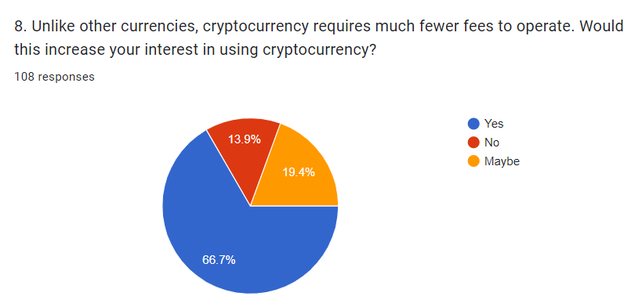

Question 8
Answers: | Participants:
Yes | 72
No | 15
May be | 21

By asking such a question, I was focusing to understand how many people would change their minds if they knew that transferring virtual money can cost less that standard bank transfers. 72 people are positive and tend to increase their intersect in crypto investment if there will be fewer fees. 15 of them would not change their mind and prefer to stick with the standard financial system transfers. 21 people do not mind if the crypto transfers are costing less to transfer than usual payment transactions. Overall, 66,7% of the participants are likely to increase their interest in cryptocurrency.

Question 9
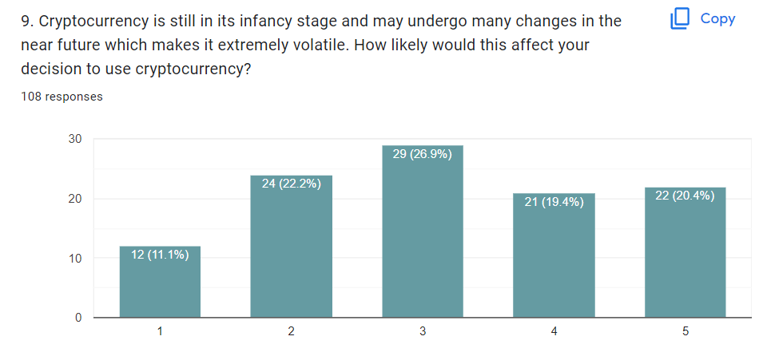

The collected responses to this question are very close to each other. Some of the people’s decisions will be affected by the volatile market conditions of the currencies. However, some of them are not very concerned about the market situation. Based on these responses I can conclude that almost an equal amount of the participants has different understanding in crypto industry and its nature may affect or not user’s decision in future.

Question 10
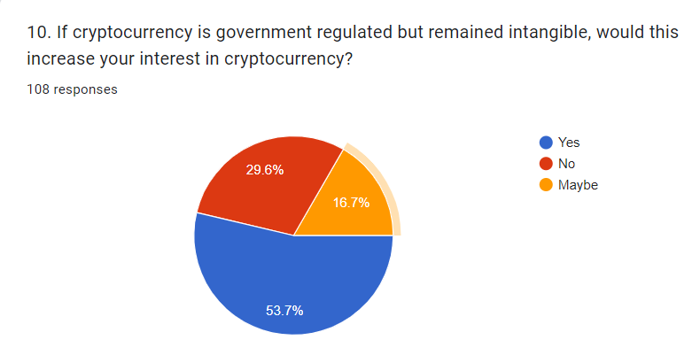

Question 10
Answers: | Participants:
Yes | 58
No | 32
May be | 18

Question 10 is tending to understand whether people trust governmental regulated currencies and whether is that the factor that may increase their interests in the future. In total, 53, 7% of the participants say that they will be more interested if cryptocurrencies are regulated by the government and still being intangible. It seems that when the law exists, people are more trustworthy. 29,6% think the opposite, and they do not believe that the interest in cryptocurrencies will increase significantly if these are controlled by the government. There are also 16,7% that do not mind if crypto will be regulated or not as this will not change their position regarding the virtual currencies.

Question 11
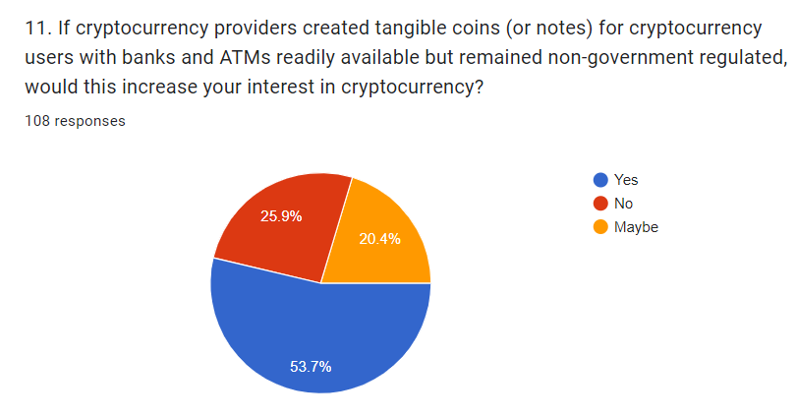

Question 11
Answers: | Participants:
Yes | 58
No | 28
May be | 22

In this section, participants were asked if they will still be interested if cryptocurrencies are tangible but not government regulated. The majority answered with ‘’Yes’’ which is 53,7% of the total of all respondents. 28 people of them state that their interest will not get increased due to the regulation and the rest 22 are not bothered as their interest will remain unchanged.

In conclusion of the results, I would have to disclose that many people are still not familiar with the actual purpose of cryptocurrencies. The questions were designed in a way to understand how such innovation is affecting the people’s mindset and therefore, how would they act in cases when virtual currencies appear in their daily basis. Of course, the questions provided more information to the participant that were not aware of what cryptocurrencies are and this of course shed more light to them. As per the outcome of the survey, many young people are open for accepting these currencies as part of their lifestyle. Moving forward, the new generation will set the new expectations worldwide and such payment methods will soon become essential.

Chapter Five: Findings and Discussion

- Introduction
This chapter provides insight into the research findings on the subject. The aims and objectives will be discussed by covering all key aspects regarding cryptocurrency adoption in emerging countries. Furthermore, an analysis of existing research will be developed and examined to give more details on how significant these virtual currencies could be.

- Findings
As per Silinskyte’s research article, the intention of digital currency adoption has been deliberated in many other adoption acceptance models. The Unified Theory of Acceptance and Use of Technology (UTAUT) model describes all factors that can affect people’s behavior when adopting cryptocurrency. Of course, when accepting such an innovative payment instrument in a whole country, there is a need to investigate how this will affect the nation first. Will this be accepted or not?
By collecting 108 responses from people who own and people that do not own crypto tokens via an online survey, I managed to gather more information regarding the individual’s correlation with the crypto industry. By analyzing the collected data, people’s interactive intention to adopt digital currency is influenced by their age, income, and social views.
According to the UTAUT, there is partial support where crypto adoption is indicated. For instance, in Malaysia, the examinate factors that affect user’s behavioral intention for crypto usage are based on the social influence and facilitating conditions. (Silinskyte, 2021) To analyze this further, the sample used in this study included non-experienced and experienced users. In conclusion, the findings of the study released that non-experienced individuals tend to accept cryptocurrency systems which allows them to achieve the desired result effectively. The consistency of the finding provides a sense of strong expectations that is important in users’ intention of crypto adoption in Malaysia. On other hand, gender and age are playing a significant role in moderating social influence. (Silinskyte, 2021)
Findings suggest that monetary expertise understanding and social impact help to reduce apparent risk and enhance consumers' readiness to utilize digital currencies, but risk aversion and the presence of regulatory backing raise cryptocurrencies' perceived risk. The findings show that achieving a good technology prospect is important in order to discover considerable effects when adopting crypto. (Davis, 2019) An important indicator for adopting useful and suitable technology is seen as a key predictor of perceived usefulness. (Bhatiasevi & Yoopetch, 2015).

- Discussion
The main goal of this report was to explore the reasons and implications if developing countries decide to adopt cryptocurrencies. Considering this market as innovative its acceptance of it may perform direct enable solutions when transacting funds worldwide. Transfers are less time-consuming when depending only on cryptocurrency. To become a legitimate alternative to fiat currencies, cryptocurrencies must progress beyond their worth to stand as an extensively recognized payment option. For example, even though virtual currencies are on the edge of becoming a widespread substitute payment opportunity, nowadays it is also early for deploying these currencies on a large gage.
The investigation value of the paper provides specific elements that can prevail in emerging countries’ contexts by accepting crypto. (Acemoglu, 2009). I have highlighted the main dimensions that each country needs to consider democracy, education, inflation, corruption index, economic freedom, and human development. This study signifies the potential link of virtual currency with emerging countries and the developmental relations for economic macro-level growth.
Revealing some of the facts about virtual currencies in emerging countries, it is understandable that if adoption takes place the economy will significantly increase. However, governments would have to improve the financial situation and propose a developed strategy where all factors of influence are well considered.
The examples given of some of the developing countries and their action of adopting crypto was given in order to disclose a piece of evidence that such a plan is possible even where the market is not established. Considering the given aspects, once virtual currencies are accepted, it will not only increase the level of economy for the particular country, but it will significantly increase the level of education across the nation as well as changing the social status. I am very positive that in circumstances where the nation is educated and skilled, the prosperity of the country is guaranteed.

Chapter Six: Limitations, Implications and Conclusion

- Limitations
As a result of the research, there is a need to address some challenges that emerging countries may face in order to adopt cryptocurrency. To be able to maximize the benefit of blockchain innovation, emerging countries should ensure that proper policymaker and government management is skilled to proceed. Moreover, it is required that the regulatory guidelines are transparent so the initiation and implementation of the blockchain system is on a wider scale.
Another limitation is the prediction of social trust and behavior towards the acceptance of virtual currencies. It is essential that by introducing such innovation there is a need to construct a habit across the nation as well as provide full access to crypto platforms. To make this happen, a lot of research and surveys will take place and once the problem is investigated and considered as resolved, the implementation may start.
The finding from the survey in Malaysia provides a better understanding of the behavioral differences in a holistic manner. Because worldwide governors have different perspectives on virtual currency issues, the degree of openness to bitcoin usage varies, which affects citizens' adoption behavior. Furthermore, prospective research might investigate if the varied properties of various types of cryptocurrencies influence people's adoption patterns. In fact, various virtual tokens utilize different types of consensus methods, which can affect transaction speed.
- Implications
The primary objective of this report proposes an innovation model that can be determined by many influential factors that may affect the cryptocurrency community in the developing world. To provide a better acquaintance, the individual’s adoption behavior towards virtual currencies must be built on the emerging country blockchain technology. Research needs to take place in order to accelerate the factors that affect crypto adoption within those countries. Given the importance of communal effect in shaping an entity's intention to use cryptocurrency, blockchain-based financial services providers could use social media to leverage the power of word-of-mouth to explain how the arrival of digital currencies is modern and potentially troublemaking old-style encounters.
The secondary objective proposes the significant factors of the intention of individuals when it comes to adopting cryptocurrencies. The findings of the paper show that governments and financial institutions enhance their services to be provided via blockchain technology with effective security measures. Therefore, a misunderstanding or lack of knowledge and skills will be vital in order to shape the perception of security standards when accepting digital currencies. (Andras, 2019). It is imperative that knowledge, skills, and understanding are very well considered before taking any actions.
Third, a cryptocurrency system requires low costs and resources in order to operate successfully. Moreover, the adoption of such transactions as are cost-effective payment instruments in developing countries, especially where the undeveloped banking system is very unsecure. There are several countries in the EU, USA, or ASIA that have announced a regulatory policy on cryptocurrency. Therefore, this paper suggests that governments manage digital assets by following cues from nations where these have been used.
Fourth, it is essential that privacy and security concerns for online payments are considered, too. As a decentralized system, the digital market requires very strong attention for guiding individuals to take effective measures when using cryptocurrencies. (Alshamsi, 2019). Considering the innovative way of transactions, it is important that users are guided accordingly with tutorial videos, or some additional courses provided by government to educate the nation.
It is understandable that the rise of cryptocurrency has urged disagreements, with some demanding that virtual currencies represent the future of money, swapping fiat currency, while others understand it as a speculative bubble with no essential worth. As a result, any unfavorable news or comments may discourage users from utilizing cryptocurrencies. As a result, bitcoin aficionados should educate those around them about the benefits of using cryptocurrency over traditional payment methods such as debit and credit cards.
Fifth, risk management or financial loss is one of the main factors when adopting cryptocurrencies. It is important to create a more specific approach to this issue in order to ensure that such assets are kept safe. Referring to reports, after a hacker’s attack on virtual currency, around 1.7 billion US dollars was stolen. (Zoe, 2019) Of course, crypto platforms are offering extra protection against such breaches by providing insurance agreements or policies that can keep users’ trust. As a new phenomenon, virtual currencies are very challenging to be verified against theft claims. (Abramova and Bohme, 2016). So, in this study, a proposed plan or a strategy must be developed by taking suggestions from policymakers or insurance companies.

- Conclusion
“Money is a social artifact which evolved to facilitate market trading between individual agents who were not so otherwise bound together by family, tribal or social ties that an immediate exchange of equivalent values in trade was unnecessary” (Goodhart, 1989).
In conclusion, the idea of money is not inert but rather changes in tandem with society. The evolution of society depends on a number of consistent fundamentals, including the success of systems that allow transferring funds between debtors and creditors, individuals and businesses. It is known that reducing the ability of financial transactions causes market friction globally and more specifically when there are irregularities between knowledge and contract enforceability. Although, to achieve a resourceful and operational market level, every country must ensure that some informant obstacles are overwhelmed. Such obstacles are the transaction cost, knowledge, skills, development, and enforcement.
In this report, I have demonstrated how the substantial constraints are particularly destructive and moreover how the great majority of individuals and business are unable to rely on conventional financial institutions. Nonetheless, the deployment of novel forms of money in the recent decade has lowered the financial hurdles existing in many developing nations, beginning with the execution of cryptocurrencies. Therefore, each country must be prepared for guaranteeing the possibility of a new payment environment when the implementation of virtual money happens. Since these currencies are not financial equivalent by centralized organization, it is a great opportunity for a global economic expansion.

The connection between financial growth and inclusion with virtual currencies plays a vital role in benefiting emerging countries. Due to the relatively low-cost transactions, digital currencies are independent of the traditional financial scheme, and moreover, to increase financial inclusion across firms and individuals, it is given free access. Therefore, such development greatly increases investments and, as a result, the growth of the nations in the issue. Furthermore, while digital money has clearly driven a revolution in the usual reimbursement structure, it is inferred that an entirely new payment system is required to encourage the nation’s development.
In conclusion, virtual currencies will face significant limitations. The report directs to establish that accepting cryptocurrency within emerging countries is not a thread, but it has to be observed as a potentially powerful instrument leading toward global economic inclusion and growth. It tends to benefit not only the world environment but the individual’s lifestyle, too. Besides, the key barriers that appear are mitigated with the importance of fiat money. This will trigger the economic presence and will reduce the countries impact. In reality, combining mobile money with cryptocurrencies via mobile wallets is an effective and viable way to encourage bitcoin use at the moment.

Reference List

- Abramova, S., & Böhme, R. (2016, December 11–14). Perceived benefit and risk as multidimensional determinants of Bitcoin use: A quantitative exploratory study. In 2016 International conference on information systems. Dublin.
- Acemoglu, D. (2009), ‘’Introduction to modern economic growth. Introduction to Modern Economic Growth’’ Princeton University Press (2009), 10.1111/j.1475-4932.2011.00816.x
- Afonso, A. et al. (2002), “Intermediaries, Financial Markets and Growth: Some More International Evidence”
- Alshamsi, A., & Andras, P. (2019). User perception of Bitcoin usability and security across novice users. International Journal of Human-Computer Studies, 126, 94–110.
- Arjaliès, D. (2020), “At the Very Beginning, There’s This Dream.’ The Role of Utopia in the Workings of Local and Cryptocurrencies.”
- Bashir, M., Strickland, B. & Bohr, J. (2016). “What motivates people to use bitcoin?” In E.
- Baur, A. et al. (2015) “Cryptocurrencies as a Disruption? Empirical Findings on User Adoption and Future Potential of Bitcoin and Co.” 14th Conference on e-Business, eServices and e-Society (I3E), Delft, Netherlands
- Bhatiasevi, V., & Yoopetch, C. (2015). The determinants of intention to use electronic booking among young users in Thailand. Journal of Hospitality and Tourism Management, 23, 1–11.
- Bratspies, R.M. (2018) "Cryptocurrencies and the Myth of the Trustless Transaction"
- CBN, (2022), Central Bank of Nigeria, available at: https://www.cbn.gov.ng
- Cohen B. (2017) “International Political Economy” Routledge
- Cheng, X. et al. (2019) “Data Science” 5th International Conference of Pioneering Computer Scientists, Engineers and Educators
- Currie, J. (2009) Healthy, Wealthy, and Wise: Socioeconomic Status, Poor Health in Childhood, and Human Capital Development” Journal of Economic Literature, Volume 47, issue 1
- Claeys G., Demertzis M., Efstathiou K. (2018) “Cryptocurrencies and monetary policy”, Monetary Dialogue July 2018
- Darlington, J. K (2014). “The Future of Bitcoin: Mapping the Global Adoption of World’s Largest Cryptocurrency Through Benefit Analysis” University of Tennessee, Knoxville
- Dierksmeier, C. & Seele, P. (2018). “Cryptocurrencies and Business Ethics” Journal of Business Ethics
- Dobrowski, M. and Janikowski, L. (2018), ‘’ Virtual currencies and their potential impact on financial markets and monetary policy’’, CASE – Center for Social and Economic Research, Warsaw, 2018, Available at: http://www.case-research.eu/files/?id_plik=5708
- European Central Bank (2015), Virtual Currency Schemes
- Gentles, S., Charles, C., Nicholas, D., Ploeg, J., and McKibbon, K. (2016), ‘’Review the research methods literature: principles and strategies illustrated by a systematic overview by sampling in qualitative research’’, Available at: https://systematicreviewsjournal.biomedcentral.com/articles/10.1186/s13643-016-0343-0
- Grinberg, R. (2011) “Bitcoin: An Innovative Alternative of Digital Currency” Yale Law School
- Grohmann, A. Klühs, T. & Menkhoff, L. (2018) “Does financial literacy improve financial inclusion? Cross country evidence” World Development, Volume 111
- Hayes, A. (2022), Investopedia, [online] ‘’10 important cryptocurrencies other than Bitcoin’’ , Available at: https://www.investopedia.com/tech/most-important-cryptocurrencies-other-than-bitcoin/
- Honohan, P. and Beck, T. (2007) “Making Finance Work For Africa” Washington, DC: World Bank
- Houben, R. (2018) "Bitcoin: there two sides to every coin", ICCLR, Volume 26, Issue 5
- J. Wang, X. Li, P. Wang, Q. Liu, Z. Deng, J. Wang
- Research trend of the unified theory of acceptance and use of technology theory: a bibliometric analysis
- Sustainability, 14 (1) (2022), p. 10
- Kewell, B. Adams, R. & Parry, G. (2017) “Blockchain for Good? Digital Ledger Technology and Sustainable Development Goals”
- Klassa, A., (2021), Financial Times, ‘’Cryptocurrency: Developing countries provide fertile ground’’, Available at: https://www.ft.com/content/1ea829ed-5dde-4f6e-be11-99392bdc0788
- Kunt, A. et al. (2018). The global findex database 2017: measuring financial inclusion and the fintech revolution. The World Bank
- Lichtfous, M. Yadav, V. and Fratino, V. (2019) “Can blockchain accelerate financial inclusion globally?” Inside magazine issue 19, issue 2
- Martinez, T. 2021, ‘’How we made it in Africa’’, Article, Available at: https://www.howwemadeitinafrica.com/tricia-martinez-where-things-went-wrong-for-africa-focused-cryptocurrency-dala/63483/
- McLeay, Amar & Thomas (2014) “Mobile Payments Go Viral: M-Pesa in Kenya” Bill and Melinda Gates Foundation
- McWaters, R.J (2016) “A Blueprint for Digital Identity, The Role of Financial Institutions in Building Digital Identity” World Economic Forum
- Nadeem, M., Lui, Z., Pitafi, A., Younis, A., and Xu, Y., (2021), ‘’Investigating the adoption of cryptocurrencies – A case of Bitcoin: Empirical evidence from China’’, Available at: https://journals.sagepub.com/doi/10.1177/2158244021998704
- Nakamoto, S. (2008) “Bitcoin: A Peer-to-Peer Electronic Cash System”
- Ntelly Path, (2022), ‘’How does Blockchain work?’’, Available at: https://intellipaat.com/blog/tutorial/blockchain-tutorial/how-does-blockchain-work/
- Peachey, S. and Roe, A. (2004) “Access to Finance: A Study for the World Savings Banks Institute”
- Peria, M.S (2005) “Reaching Out: Access to and use of banking services across countries”
- Raymaekers, W. (2015) “Cryptocurrency Bitcoin: Disruption, challenge and opportunities” Journal of Payments Strategy & Systems, Volume 9, issue 1
- RBZ (2021), Reserve Bank of Zimbabwe, Available at: https://www.rbz.co.zw
- Russo, E. (2020), ‘’ Cryptocurrencies’ Adoption in Developing Countries’’, LUIIS, Department of Economics and Finance Chair of Money and Banking, Available at: http://tesi.luiss.it/28102/1/218631_RUSSO_ELENA.pdf
- Silinskyte J, “Understanding Bitcoin adoption: Unified Theory of Acceptance and Use of Technology (UTAUT) application (Master Thesis),” University Leiden, 2014.
- Sprio & Y. Ahn (Eds.), Lecture Notes in Computer Science Social Informatics, 2016
- Statista, 2022, Web page, Available at: https://www.statista.com/statistics/1202468/global-cryptocurrency-ownership/
- Stolp, J. Perumall, A. and Selfe, E. (2018), “Blockchain and Cryptocurrency in Africa” Baker McKenzie
- Subacchi. P. (2020), University of London's Queen Mary, Available: https://www.project-syndicate.org/commentary/risks-of-el-salvador-adopting-bitcoin-by-paola-subacchi-2021-06
- Tachizawa, E.M. and Wong, C.Y (2014) “Towards a theory of multi-tier sustainable supply chains: A systematic literature review. Supply Chain Management: An International Journal, Volume 19
- Venkatesh V, Morris MG, Davis GB, Davis FD, “User acceptance of information technology: Toward a unified view,” MIS Quarterly, pp. 425–478, 2003.
- West, D.M. (2015) “Digital Divide: Improving Internet Access in the Developing World Through Affordable Services and Diverse Content” Brookings Institution Center for Technology Innovation
- Wheatley, J. (2021), Financial Times, ‘’Cryptocurrency: Developing countries provide fertile ground’’, Available at: https://www.ft.com/content/1ea829ed-5dde-4f6e-be11-99392bdc0788
- Zoe, S. (2019). Frequent cryptocurrency theft gives rise to new area of insurance. https://www.rollcall.com/news/policy/frequent-cryptocurrency-theft-gives-rise-new-area-insurance

Zyphur, M., and Pierides, D., (2017) ‘’ Is Quantitative Research Ethical? Tools for Ethically Practicing, Evaluating, and Using Quantitative Research’’, Springer link [online], Available at: https://link.springer.com/article/10.1007/s10551-017-3549-8

Appendix

- Questionnaire
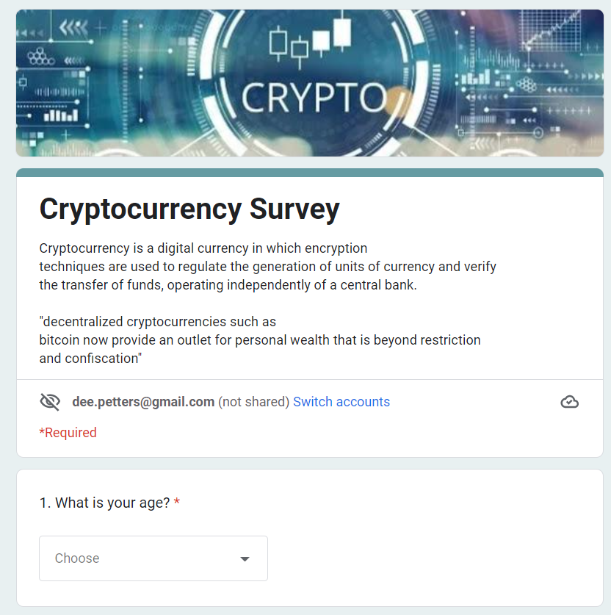
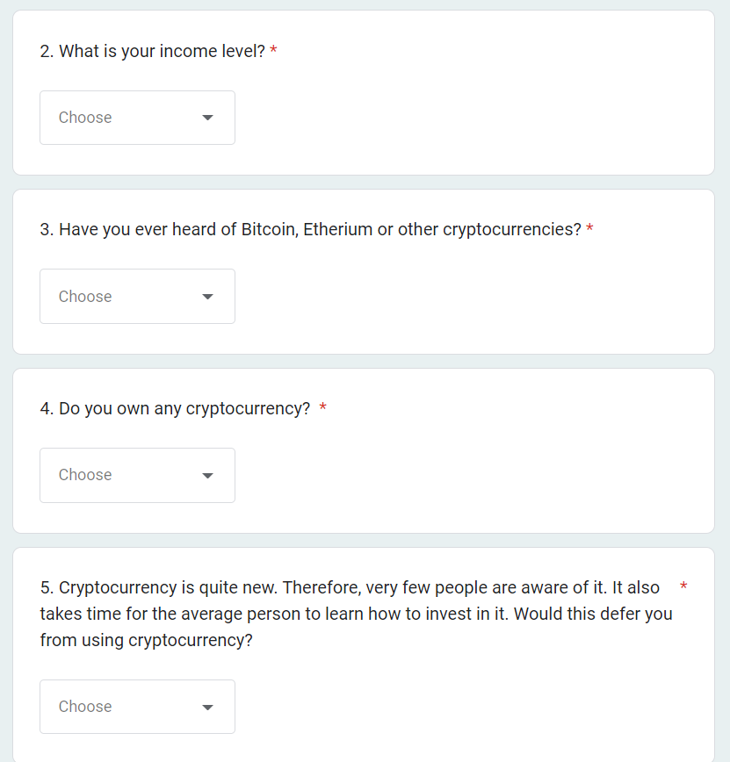
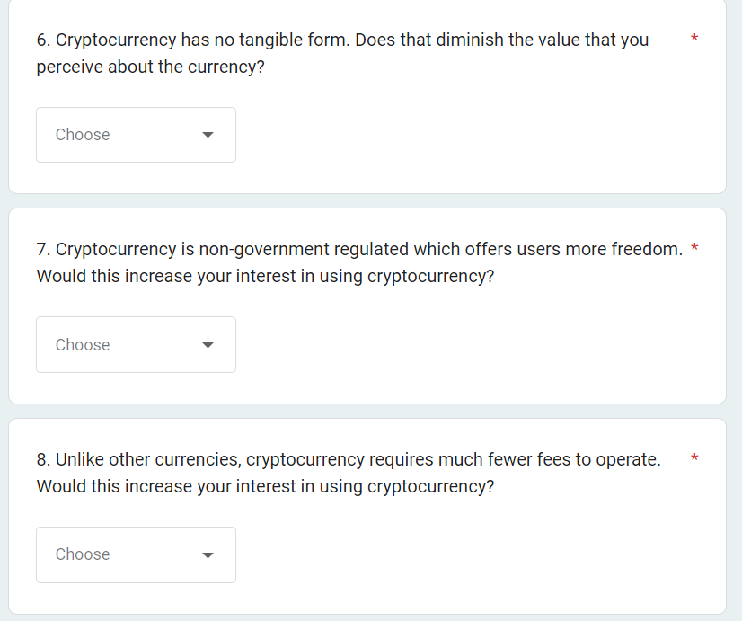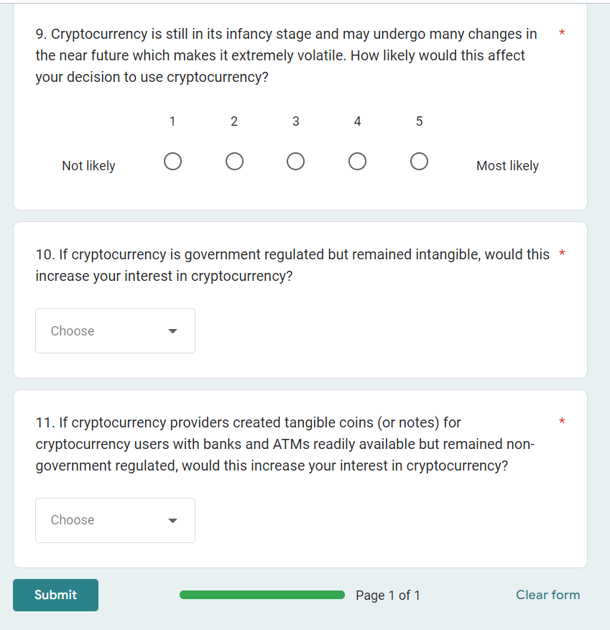

- Tables and graphs
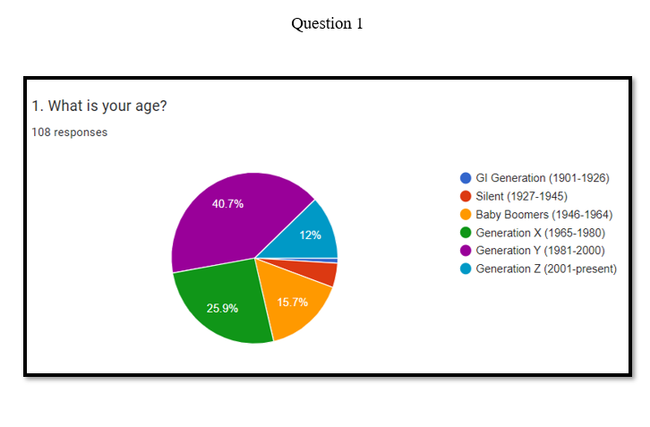
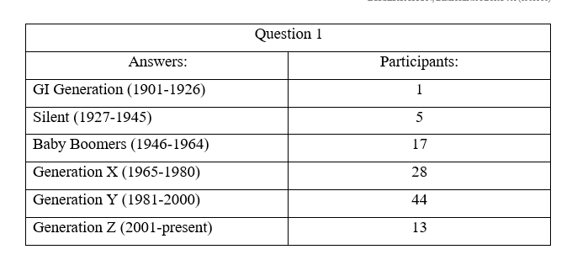
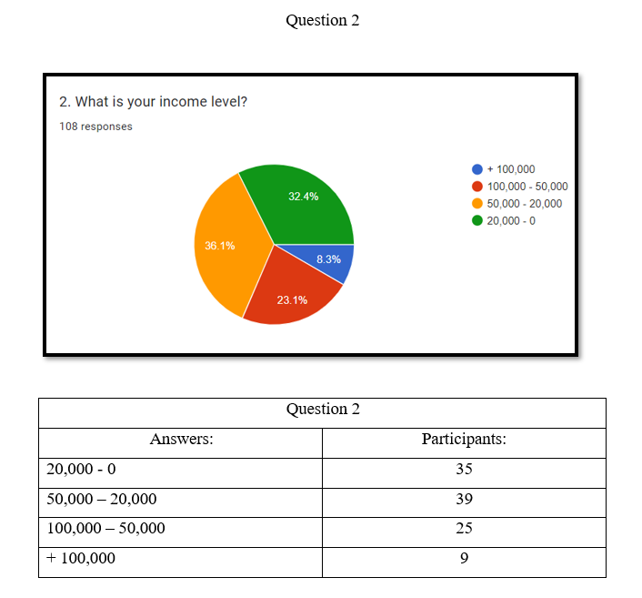
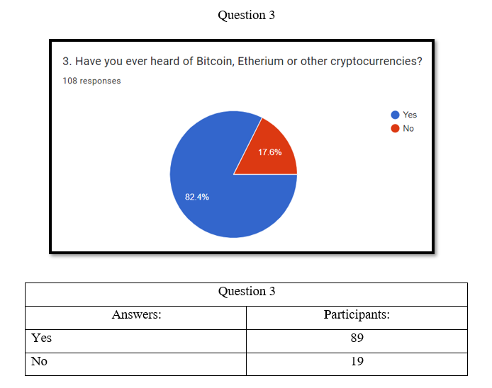
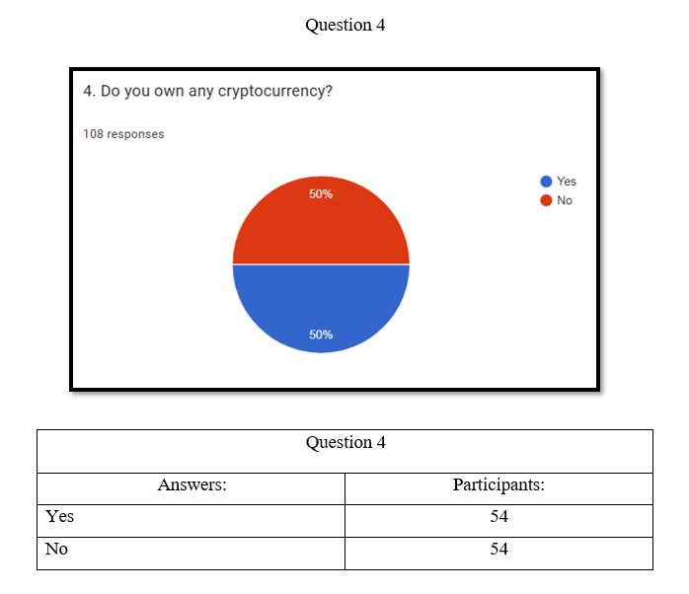
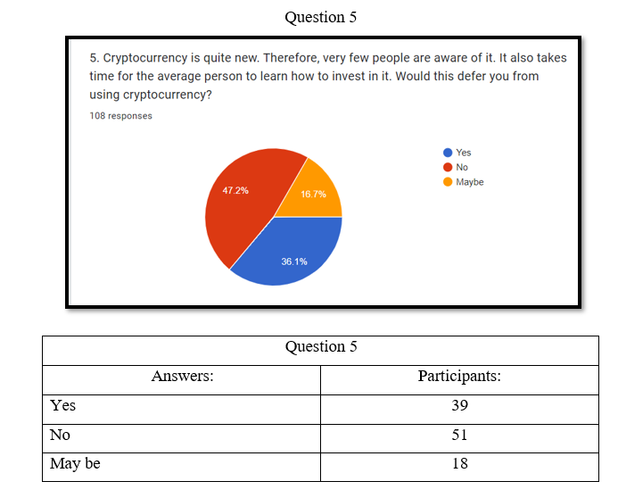
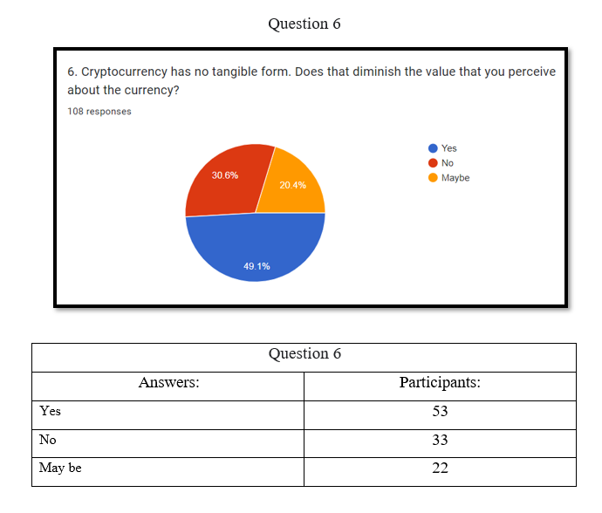
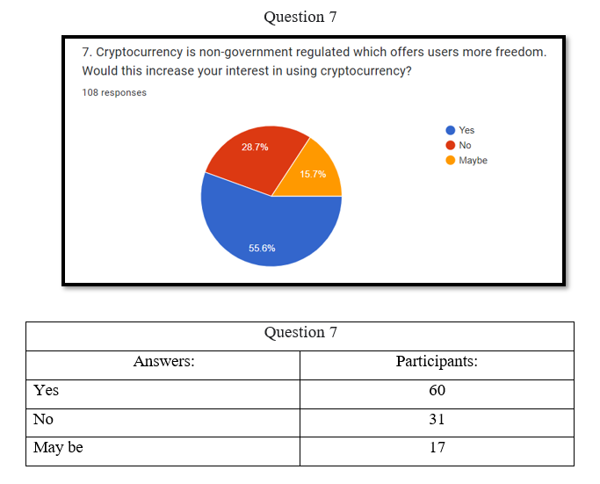
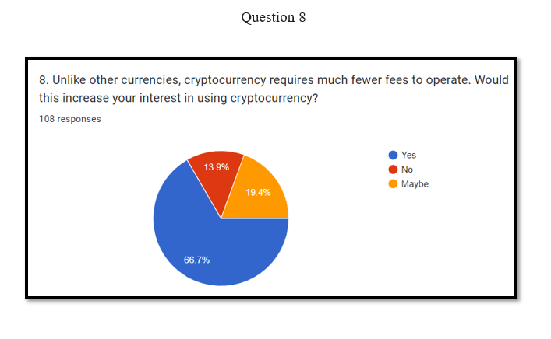
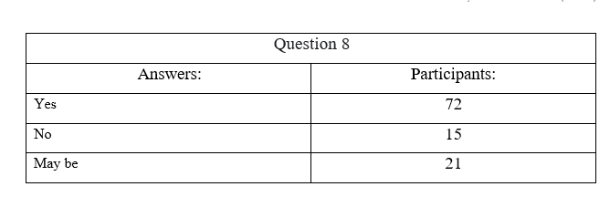
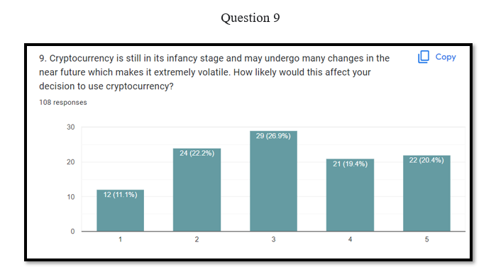
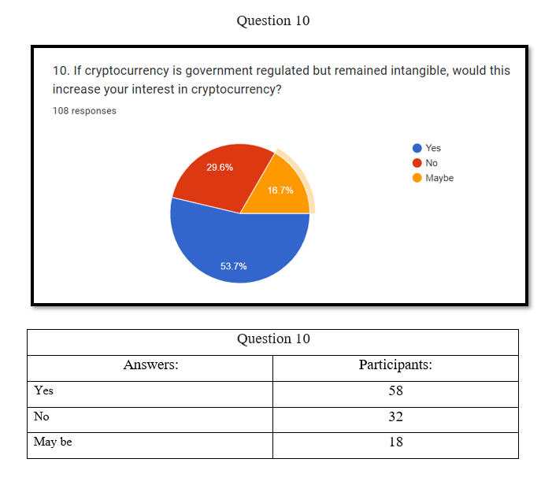

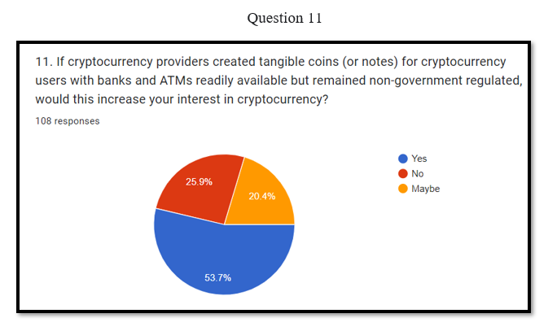
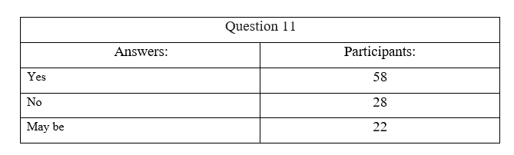

- Timetable
 | Week1 | Week2 | Week3 | Week4 | Week5 | Week6 | Week7 | Week8 | Week9 | Week10
Introduction (background, rationale of the study, aim, research objectives, research questions)
Literature Review

Research methodology

Creating the questionnaire/interview questions

Collection of data from the survey
Analysing data from the survey
Discussion and interpretation of data
Conclusion and Recommendation
Final Submission

