Student name: Samuel Riley Student ID number: 1807467

Programme: BA Computer Games Design

Module: Critical Review

Module code: ADFM6001

Contents:
Showreel
Business card
Production and research:
Bibliography

Link to Show Reel:
https://www.youtube.com/watch?v=AHsMmrmnM00

Contents

Business Card:
Front cover,
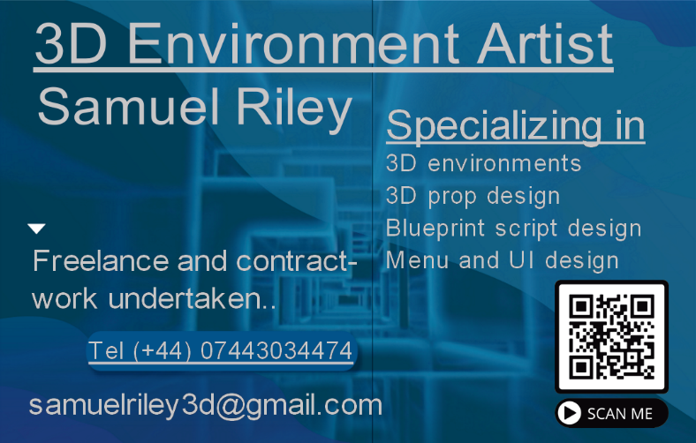
Back cover,

Contents
Production and research:
- I researched other showreels done by other Environment Artists and found most of them to be about 2 mins long which is over the recommended 1 min 30 sec given in the brief, My Showreel ended up being 2 mins 16 secs, I decided not to shorten mine.
- I researched examples of business cards on google.
- I used Calibri and Calibri light fonts for my business card and Showreel, I find them easy to read, professional-looking, and slightly less informal than Arial and other fonts which are as easy to read.
- I added a QR code to my business card which links to my Showreel and personal WordPress page.
- I made a new email and added it to my showreel and business card, I have also included my phone number.
- The information slides in my showreel and my business card have coordinated backgrounds.
- The music is designed to have an epic sci-fi feel, the pad sounds represent the natural environment, and the sci-fi synth represents the sci-fi environment, the dramatic drums help emphasise the3D assets.
- The music is at 120 bpm to make editing smoother, each bar is 2 seconds.
- I made the music for the project because it is a good opportunity to also show my musical talent.
- I made a PowerPoint and added all my pictures videos and slides to it, I then tested the order and when I was happy with it, I remade it in premiere pro.

Contents

Bibliography:
[1]Game Environment and Prop Artist - Showreel 2018. 2022.
[2]BRTechArt -Ben Russell, UE4 - Technical Artist Showreel - BRTechArt. 2022.
[3]E. Olson, "Showreel", Artstation, 2022. [Online]. Available: https://www.artstation.com/artwork/0nJzDG. [Accessed: 14- May- 2022].
[4]Vistaprint, 2022. [Online]. Available: https://www.vistaprint.co.uk/hub/business-card-design-rules. [Accessed: 07- May- 2022].
[5]V. Opra, Premiere Pro Tutorial for Beginners 2022 - Everything You NEED to KNOW!. 2022.
[6]Bring your own laptop, Free Adobe Premiere Pro Essentials Tutorial Course - Video Editing Basics. 2022.
[7]"Google", Google.com, 2022. [Online]. Available: https://www.google.com/. [Accessed: 10- May- 2022].

Contents

