Please add your targets from the previous assignment (Only relevant if you have completed an assignment)
Target 1 | Proofread your work to ensure accuracy of spelling, punctuation and clarity of expression.  I will proofread my work and ask someone else to read through before I submit.
Target 2 | Further develop your critical thinking and synthesise your ideas.  I will ensure I am thinking critically and analysing my ideas but then ensuring they are synthesised to make a valid point.
Target 3 | Learn how to use possessive apostrophes accurately.  I will ensure I check my work for any apostrophe errors, and I will refresh my memory on the use of apostrophes.

Critically reflect on your pedagogical progress demonstrated through required elements of the Professional Learning Passport, identifying a specific area for professional development and justifying next steps for improvement.

Contents Page
Part one: Professional learning passport
Reflection on subject knowledge development (Tab 5)
Asset one, related to Digital Competence………………………………………………………… 3
Asset two, related to Numeracy …………………………………………………………………… 5
Asset three, related to Literacy ……………………………………………………………………..7

Reflection on planning for progress (Tab 7)
Professional learning template 1, related to languages, literacy and communication (Welsh) ………………………………………………………………………………………………………… 8
Professional learning template 2, related to mathematics and numeracy…………………….10

Reflection on planning for the four purposes (Tab 7)
Professional learning template 1, related to ambitious capable learners …………………….12
Professional learning template 2, related to ethically informed citizens ……………………...14

Part Two:
Critical reflection…………………………………………………………………………………….16

References ………………………………………………………………………………………….21
Appendices ………………………………………………………………………………………….24

Part one: Professional Learning Passport
Nearpod allows you to add different content and activities. There are a range of choices to create an engaging synchronous session.
Upon discussion with my senior mentor, it was advised to use ‘Time to climb’ at the end of every Nearpod session, as assessment for learning (AFL) and some fun for the children.
Reflection on subject knowledge development (Tab 5)
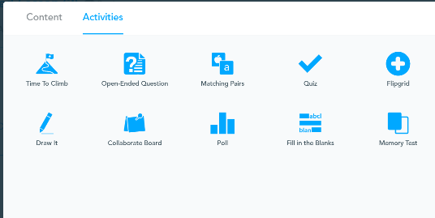
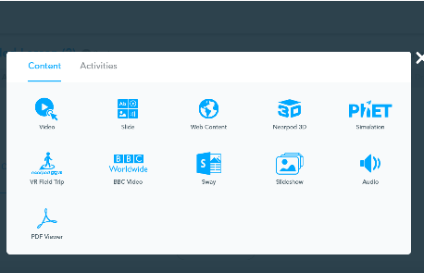
Digital Competence

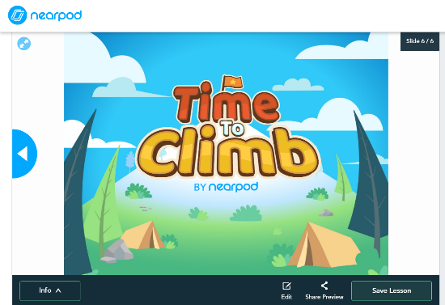
All your lessons are stored in the Nearpod site. You can then re-use these lessons. To start a synchronous lesson, you press ‘Live participation’. This then gives me a code to allow the pupils access. If pupils are not available at the time, I can set it to student paced where it will give me a code and pupils can access the lesson in their own time.
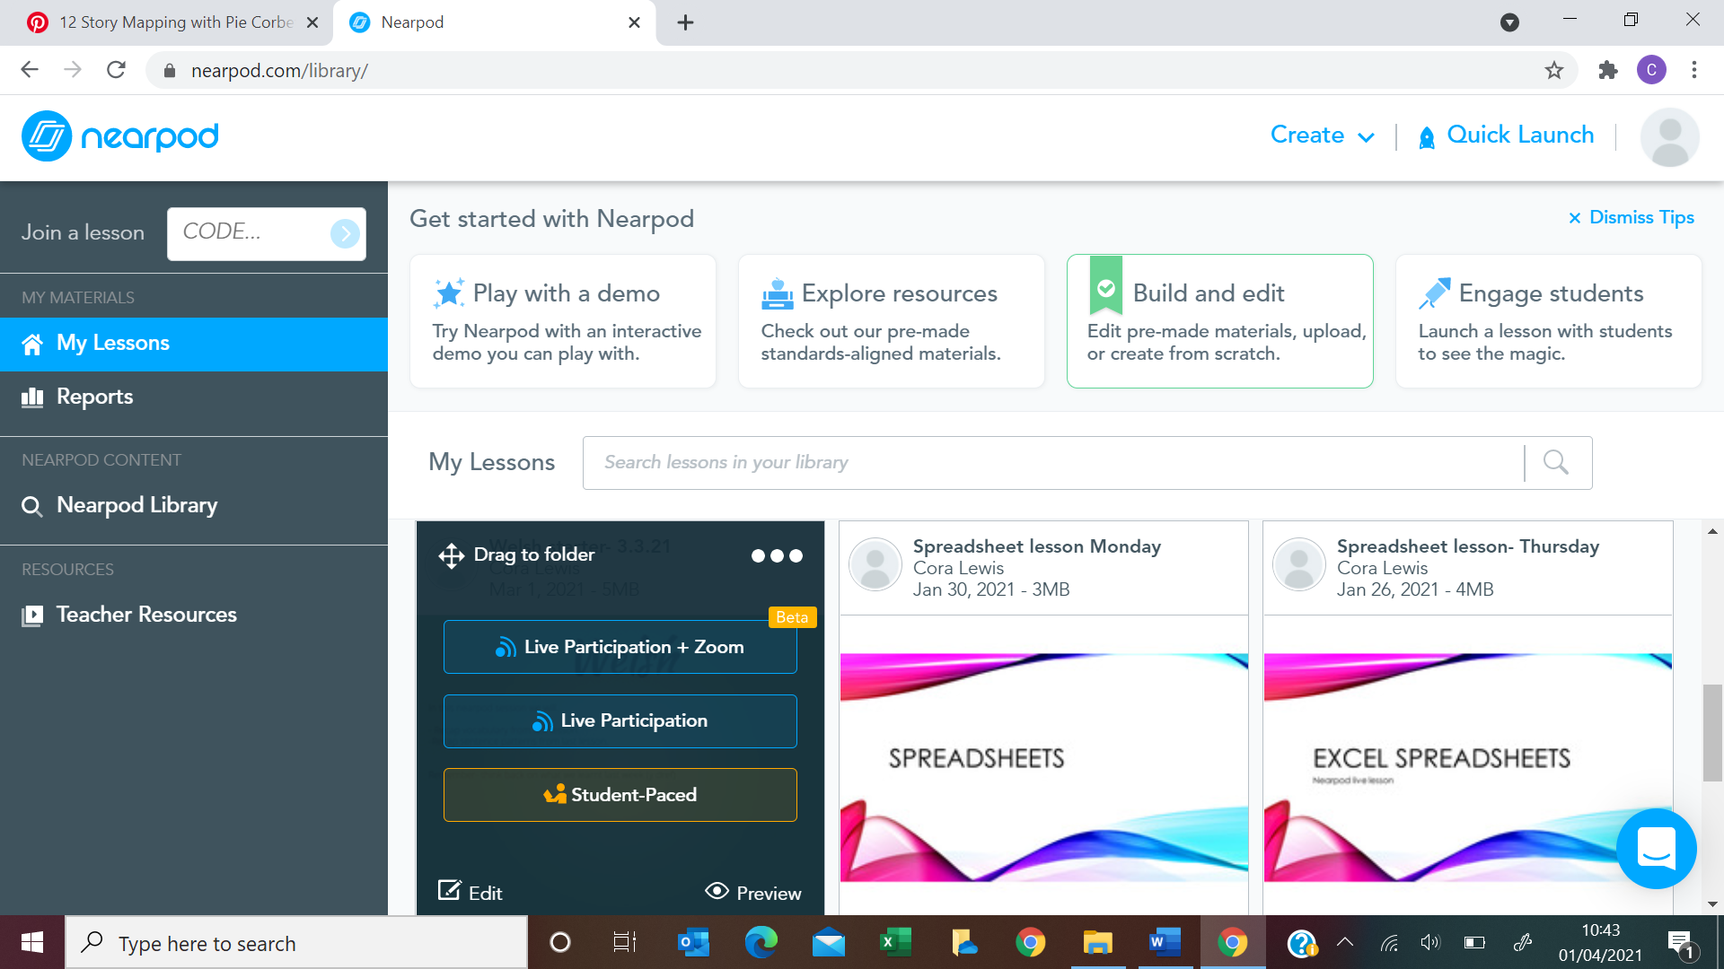

During my PTE3 placement, covid-19 restrictions meant that the teaching took place online. I wanted to ensure I used online software to the best of my ability, looking for new and innovative ways to engage pupils in their online learning and aid progression. I decided before placement I would research some software and applications to use on my placement within my class. I came across Nearpod. I was unfamiliar with Nearpod, I investigated this, enquiring what it was about and how it is used within the classroom online.
I found the platform to be very interesting and could see that many other teachers were using this within their teaching successfully, so I decided this was an aim of mine to use within my PTE3 practice.

PTE3 involved asynchronous lessons, however, I knew with Nearpod I could incorporate a synchronous lesson, whilst following the online teaching guidelines. After suggesting the use of Nearpod, my mentor directed me to my senior mentor who used it in their class. I then went to my senior mentor to seek some advice and support on how to use the platform to its maximum potential. I took onboard the advice and was able to create short starters for pupils to engage in and set the flow of the lesson. In seeking advice and support, I feel I have developed my ability to teach online and use new platforms confidently. This has contributed to digital competence framework (DCF) skills, as I am more confident in trying new platforms.

With the pupils in mind, I decided I would mainly use Nearpod for my starters of my Welsh lessons. These engaged the learners and aided their progression. Their Welsh language and vocabulary improved, and they were using it more incidentally.

This experience has shown me that I can be confident enough to search for new innovative platforms to engage my learners and trial these with them. I have also been able to develop my DCF skills as well as the pupils. They independently found themselves on Nearpod and were able to access the learning. This is something I want to continue to use within my teaching, even face to face. I feel it will allow me to develop my DCF skills as well as pupils’ independence.

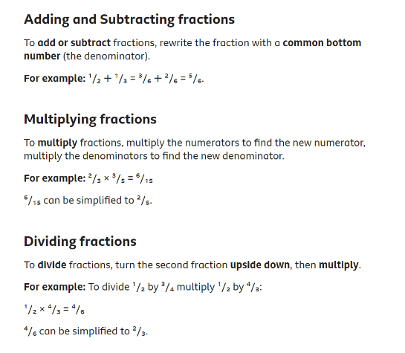
Numeracy

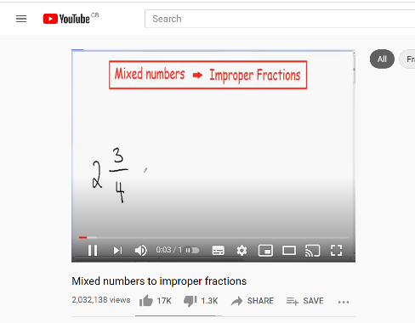
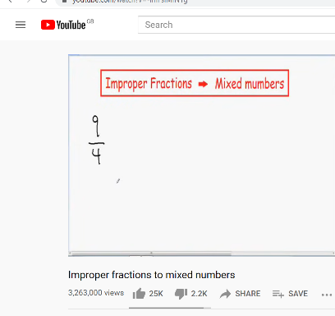

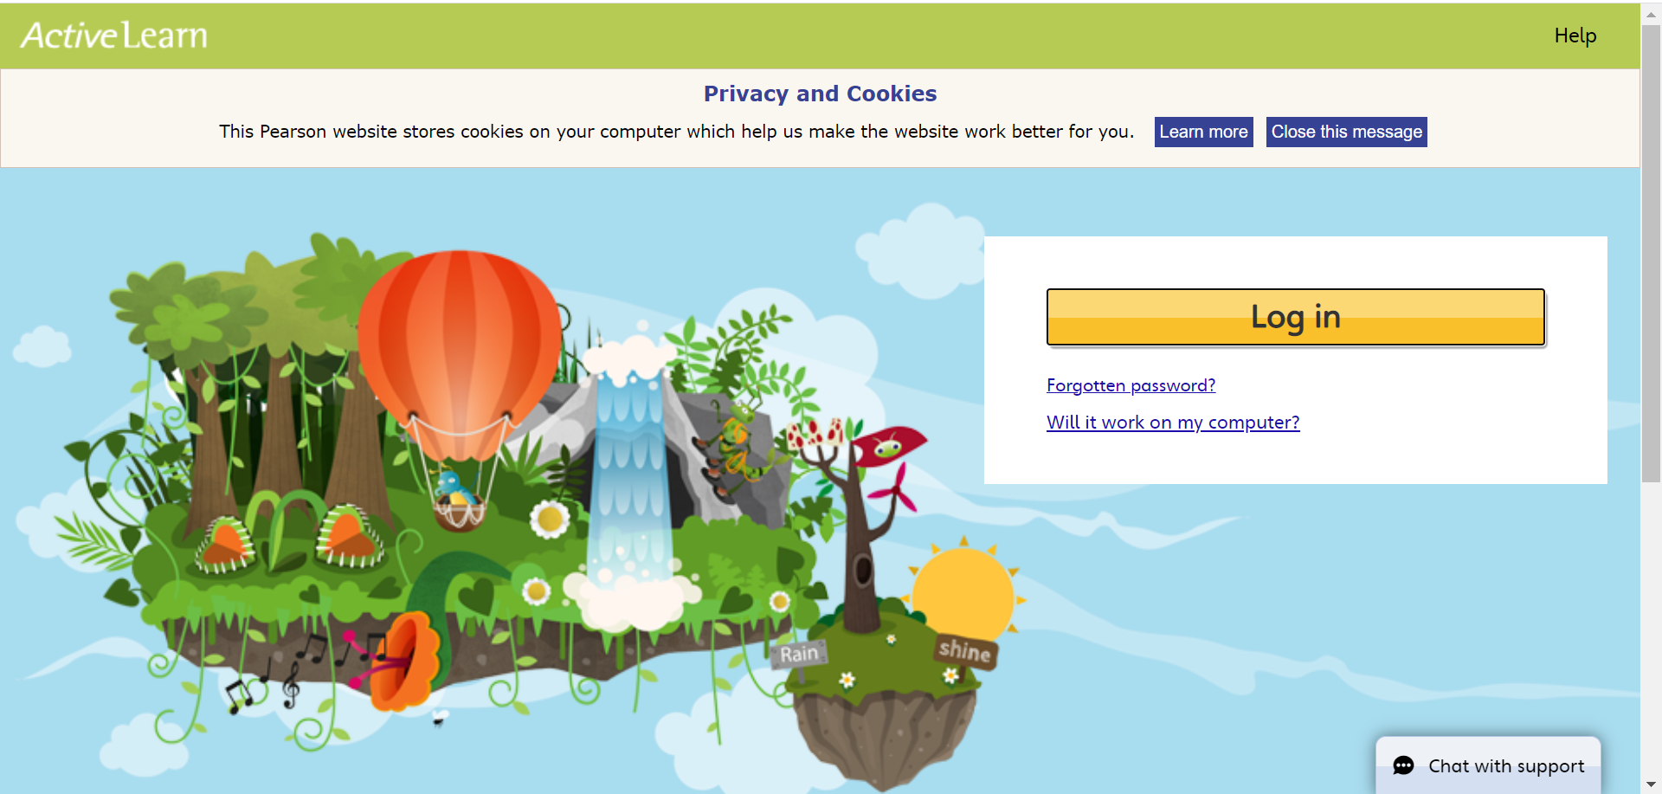

During PTE3 I had to teach fractions to my year 5 class online. I identified this as a weakness of mine, due to not having taught fractions to upper KS2 before, and last did them when I was at school. After a discussion with my mentor, I went away and researched fractions and the basic skills of fractions, as I wanted to be able to get the concept of fractions across coherently to my class. I took the advice of my mentor and used Abacus, which is the scheme of work the school uses to understand the types of fractions we would be looking at. I then independently brushed up on my skills, using videos and BBC bitesize to understand how to figure out the problems.

After the research I undertook some sums myself to check and test my knowledge. Whilst researching fractions, I took notes and made a step-by-step guide for each method we would be used to ensure instructions were basic and understandable for the pupils and their parents at home.

After conducting the research, I was able to teach fractions confidently to my class online. I used the abacus (Active learn) scheme of work, following the school’s systems. I pre-recorded videos on how to work out fractions, showing the pupils step by step. In researching the fractions and consolidating my learning, it allowed me to pass on my subject knowledge to the pupils effectively. Most of the pupils understood the fraction lessons and were happy with my explanations.

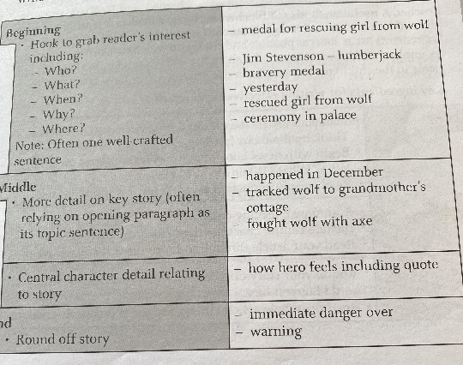
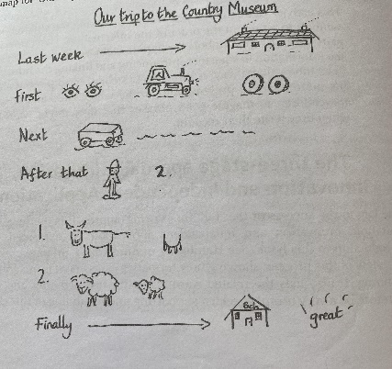
Literacy
Then, the pupils broken it down in to the beginning, middle and end as another way of planning.
Firstly, pictures were used to recount the story.

During my PTE3 placement, my literacy lessons were focused on the book ‘Oranges in no man’s land’. Once we had finished reading the book, my mentor asked me to set a series of lessons where pupils could build on their knowledge of the book and retell the story through another character’s point of view.

To do this it was suggested I used Pie Corbett’s strategies of retelling a story and building upon this with KS2. I was familiar with Pie Corbett’s retelling a story through imagery with foundation phase, but I needed to undertake some reading and research around story mapping which is what I would be teaching the pupils to do.

I used a literacy book from school which was written by Pie Corbett. It explained step by step how the retelling of the story works and how the pupils could use this to plan out retelling the story from another character’s point of view.

After reading the book and looking on the internet at some ideas of how to present the lessons, I was able to plan a series of lessons following Pie Corbett’s retelling of the story. Firstly, we started by mapping the story out in imagery form. The next lesson led us to consider the beginning, thinking of the 5 W’s, the middle and the end. The pupils then wrote their introduction. Finally, they were able to retell the story from a different character’s point of view, using the work they had produced throughout the week.

Using Pie Corbett’s retelling the story idea was a success and pupils produced high quality work. This is something I would like to continue to use across both phases and develop my knowledge further in his work.

Reflection on planning for progression (Tab 7)
Pedagogy Standard: Advancing: Progression in Learning
Title: Progression in year 5 Welsh
What did you do and why?
During PTE3, I took on the role of delivering all the Welsh lessons and was in charge of delivering engaging lessons, to develop pupils Welsh language skills. My PTE3 placement was online. I wanted to ensure pupils could still show progress in the development of their Welsh language. I ensured I made the Welsh lessons engaging and fun. However, I wanted them to be using what they had learnt previously and build on their prior knowledge.
I felt it was important for me in final placement to be able to take on a role such as ensuring Welsh learner progression, as it built my confidence in delivering Welsh lessons. I had to ensure that my lessons were engaging, fully prepared and accessible for all learners. I ensured my lessons were differentiated to be accessed by all learners. Each Welsh lesson was planned with progression in mind. The pupils were building on prior knowledge from the previous lesson, in order to support them in the next lesson. The choice behind building on prior knowledge came from the constructivist theory of learning where "prior knowledge influences what new or modified knowledge an individual will construct from new learning experiences (Phillips, 1995). This allowed me to meet the 'Progression in learning' QTS standard, (Welsh Government, 2020a).

I also ensured I followed the central south consortium scheme of work to ensure all aspects of the topic were covered for the correct age group. The central south consortium scheme of work was followed in line with the schools wishes.

The pupils started with basic phrases for the topic 'y dref' (the town) and built up to be able to use the past tense in relation to the topic of the town, as you can see in these two lesson plans, the pupils made significant progress.

First lesson plan (see appendix 1)
Towards end of the topic (see appendix 2)

What have you learned?
After overseeing all the Welsh lessons and ensuring learner progression in Welsh, it has allowed me to reflect on my practice. I can plan lessons, that follow progression and build on prior knowledge. After considering the constructivist theory within my lessons, to build on prior knowledge. I could see that information can be received, however, to be fully understood and it needs to connect with prior knowledge, (McLeod, 2021). I could see this happening within my lessons. The pupils who previously accessed lessons were able to build on their knowledge and expand on their answers in Welsh. Whereas those who were not attending the lessons, struggled to make connections and build on their Welsh language.

During my Welsh lessons I tried to support the pupils online as best as I could. I ensured I pre-recorded the lessons beforehand, ensuring my oral Welsh was clear to help with pupil's Welsh oracy skills. My written Welsh language was always checked to ensure good written Welsh from the pupils too. This was all a form of scaffolding, which is a key feature to the constructivist approach, whereby pupils build on their prior knowledge. I was there to facilitate for different levels of learners to support their progression, (McLeod, 2021).

I can consider differentiation and accessibility for all learners. Being able to plan for learner progression is key to develop our pupils and ensure they are learning well. It also ensures a positive outlook for learners as they are seeing how they can develop and push themselves. I believe my lessons met my intended outcome to show learner progression in Welsh year 5. The pupils produced significant pieces of writing and were able to use the past tense in some cases.

I have learnt a lot from managing the Welsh lessons independently. I feel I ensured my Welsh lessons to be more innovative, especially to keep the learners engaged during online learning. I was able to share what new innovative ideas I used for my Welsh lessons with other teachers within the school and my class mentor. The Welsh lessons were recognised to be engaging and aid progression.

What next?
As a result of this learning experience, I now feel more confident in helping learners progress their Welsh language skills. I am confident to scaffold my lessons and build on prior knowledge using the constructivist approach. This is something I would like to continue to do in other areas of learning and experience. Building on prior knowledge in the classroom is an important skill to have, as the new curriculum for Wales 2022 takes a spiral approach to learning. This is something I would like to gain further insight to. To understand the effect, it has on learner progression.

Reflection on planning for progression (Tab 7)
Pedagogy Standard: Advancing: Progression in Learning
Title: Year 5 fraction lesson- confirming the learning

What did you do and why?
During my PTE3 placement I was asked to teach fractions online to my year 5 class. I started with the basics to understand my pupils’ knowledge of fractions and developed on their skills throughout the week. After a discussion with my class mentor, it was clear that I was going to need to explain how to work out fraction sums step by step and progress them slowly with their development.

To ensure the pupils fully understood the topic of fractions, I started with the basics. I prepared each lesson based on the pupils’ abilities from the previous lesson. I wanted to ensure the pupils tangibly built on their knowledge and secured their understanding at each stage. I managed to achieve this through AFL strategies to check pupils understanding. As you can see, I have included in my lesson plan.
I have used AFL at the end through reflection (See Appendix 3).
Then, I also use it to check pupil’s knowledge (See Appendix 4) from previous lesson and the understanding of the current lesson.

The use of AFL allowed pupils to reflect on their work, taking a humanist approach, and if looked at in relation to Maslow's hierarchy of needs, the pupils can decide where they need to go to achieve and push themselves. In relation to the humanist approach, it is "looking at the whole person, and the uniqueness of each individual" (McLeod, 2020). I would always ensure I considered the AFL and looked at what pupils were struggling with, to support their individual needs and differentiate appropriately.

At the start of each my lessons, I would allow pupils time to recap previous lessons, during my pre-recorded video. They were then allowed the opportunity to refresh themselves and complete a few starter sums.

As part of this experience, I recognised pupils needed an extra couple of days on this topic in order to secure their knowledge of fractions, I wanted to secure their learning through word problems in order to check their understanding.

What have you learned?
From this experience, I have learnt that using AFL is a good tool to understand where your learners are with their learning. It allowed me to prepare my lessons accordingly to move the pupils on in their learning tangibly. I was able to see where they were struggling and recap this within the next lesson to clear up any misconceptions.

Due to this learning experience being online, I also interacted with parents. They were able to tell me that their child was not fully understanding the topic of fractions, and from this I was able to implement new ideas and ways to teach the topic of fractions until they understood it. It was very good to build a good rapport with parents, as they are experts of their children and it helped me to support them whilst online learning.

Also, in using AFL within my lessons it allowed for a clear progression of learning for my learners. This was again differentiated according to pupils needs and abilities. In differentiating my work and allowing pupils to pick their own level of challenge, I was seeing more pupils going for the higher and medium ability work and pushing themselves. This was due to them building their confidence with fractions and working progressively, considering different strategies to secure knowledge.

I was also able to understand that pupils needed extra time to work on their knowledge of fractions, and for those pupils whose understanding was firm, I introduced word problems to secure their knowledge in a real-life context. Adding an extra couple of days to the topic allowed everyone to understand fractions to a good degree, and all were able to attempt a word problem.

What next?
Within future practice I will continue to use AFL to support my lessons and work to the pupils’ abilities. I will consider recapping parts of lessons, to confirm the knowledge. I feel I planned for progression well and would continue to differentiate my tasks according to where the pupils are at with their understanding. I am also more confident in understanding that a time constraint does not need to be put on a topic in Maths such as fractions and can flow through to the next week to ensure and secure the knowledge.

To develop myself further, I would like to develop my rapport with partners in learning (parents/ carers etc.). Especially with online learning, I would like to be able to understand their views on how best we can support their children to progress their learning and get the maximum potential from the lesson.
Reflection on planning for the four purposes (Tab 7)
Pedagogy standard: Advancing: Four purposes for learners
Title: Ambitious capable learners, STEM - building a chocolate bridge lesson.

What did you do and why?
During this learning experience the class topic was STEM (Science, Technology, Engineering and Maths), this lesson allowed them to exercise themselves as ambitious capable learners. The pupils had been looking at the idea of structures and buildings within the topic of STEM, this learning experience involved the pupils having to create a bridge using chocolate. Thinking about its structure which we had considered in previous lessons, which links in with being an ambitious capable learner, as they are "building up a body of knowledge and have the skills to connect and apply that knowledge in different contexts" (Donaldson, 2015).
I wanted the pupils to have the opportunity to connect what they had learnt to a real-life scenario. Also linking in with the qualified teacher standard of creating authentic contexts for learners (Welsh Government, 2020a). In creating a real-life scenario, it allowed the pupils to consolidate their learning, by using the knowledge and skills they had built up and putting it into action.
Using real life scenario and contexts is suggested by Kurt (2021) that it allows for some of the best learning as the pupils must act like the experts and think through it independently. I feel the pupils showed this within the lesson, as a quality learning experience was had.

What have you learned?
I feel the pupils showed themselves to be ambitious capable learners in many forms during the lesson, they were able to undertake an experiment and evaluate their findings and re-consider how they might do it differently next time. Showing them to be capable to recognise mistakes and move forward, or to find a better solution. All pupils challenged themselves this lesson and thought outside the box. They produced a high-quality science investigation.
This was all planned within the lesson (See Appendix 5).
I feel this lesson supported me to support the learners to be ambitious and capable. They were able to consider what type of learner they were being during the lesson and achieve high quality work whilst being focused. It allowed me to see a clearer picture of how the four purposes can drive a lesson.
This is a lesson I would like to share with colleagues and complete with another class again. It allowed many learning opportunities and pupils were able to build on prior knowledge to inform their experience.

What next?
After seeing how well a lesson driven by ambitious capable learners went, I want to be able to encourage more of this throughout more lessons. Ensuring pupils are challenging themselves and considering what type of learner they need to be, in order to be focused on the right direction for the lesson.

However, I would like to make it more clear to my learners what each purpose is and how they can achieve and be the best learner for the purpose. This is something I intend to research and implement further within my own practice.

Reflection on planning for the four purposes (Tab 7)
Pedagogy standard: Advancing: Four purposes for learners
Title: Four purposes for learners- Ethical informed citizens (Fairtrade lesson)

What did you do and why?
During PTE3 I was involved in 'Fairtrade Fortnight'. The pupils engaged in Fairtrade activities, some of which I planned. I found the link between the four purposes and Fairtrade straight away with the purpose of 'Ethically informed citizens of Wales and the wider world' (Donaldson, 2015). I wanted pupils to be aware of the wider world. I planned a lesson which allowed them to think about their actions and consequences, this also led to the Health and Well-being AOLE, which included descriptions of learning that learners should recognise their actions and consequences. Especially in consideration to " I can recognise that some decisions I make will have a long-term impact on my life and the lives of others" (Welsh Government, 2020b). I planned my lesson based on this. Please refer to Appendix 6 for the lesson plan.

During the lesson, the pupils had to consider their choice in life, they watched a video stimulus provided by Fairtrade in order to engage them and get them thinking about the lesson. They then completed a matching activity where the action needed to match the consequence. This got them thinking about the wider world and where things come from e.g., cotton.
After the matching game I posed the following questions:
Who was affected by these choices?
What countries were impacted by these choices?
Can you identify the choices that were about buying choices?
Can you identify the choices that were made after buying the product?

This discussion got pupils thinking and considering their impact upon the world, enabling them to be ethically informed citizens. As an extension/ plenary I wanted the pupils to consider the negative impact they might have.

What have you learned?
From this experience it has shown me children are very adaptable and want to contribute in a good way to the world. In developing their understanding of actions and consequences from a wider world perspective we are allowing the pupils the opportunity to be ethically informed and make the right choices in life.

The pupils showed a great understanding and empathy towards this lesson and were able to consider and recognise negative impacts. This is something I would like to develop further allowing the pupils the time to reflect on the four purposes.

The use of a short film explaining and showing actions and consequences in a real-life context allowed pupils to connect with the lesson. During the plenary I asked the pupils what type of learner they had been today, and the majority of pupils were understanding they had be ethically informed.

What next?
During my future practice I will always look to include the four purposes within pupils learning and ensure they have a firm understanding. I feel that this lesson was driven in influencing the pupils to think about being ethically informed citizens of Wales and the wider world. Pupils were given the change to reflect on their actions and consequences.

I would like to further my knowledge on how ensure the four purposes are drivers of pupil’s experiences.

Part two: Critical Reflection
Introduction
I have chosen to research and further my knowledge into implementing the four purposes as drivers of learner’s experiences as part of the curriculum for Wales. I feel this will be beneficial for me in future practice, it can support my professional development in both foundation phase and KS2. During my PTE3 placement this was something I tried to implement alongside school policy, but I would like to develop my confidence and knowledge in this area.

The four purposes are drivers of the curriculum for Wales. The four purposes are as follows:
“ambitious capable learners, healthy confident individuals, enterprising creative contributors and ethically informed citizens” (Donaldson, 2015, p. 29). They are used to influence a learner’s experience. The four purposes are also emphasised in the twelve pedagogical principles “focus on the 4 purposes” (Impact Wales, 2018, p.1). Through understanding and considering strategies to implement the four purposes alongside curriculum for Wales, it will support my professional development alongside the qualified teacher standards “four purposes for learners” (Welsh Government, 2020a, p.29), as well as learners experiences.

Welsh Government (2020c) say that the four purposes are a shared vision, and this is where all children and young people should aspire to be. It is further stated that “A school’s curriculum is everything a learner experiences in pursuit of the four purposes. It is not simply what we teach, but how we teach and crucially, why we teach it.” (Welsh Government, 2020c, p.1). This is showing how the curriculum for Wales will be a purposeful curriculum built around the centre of the four purposes. As a practitioner, I believe this is an important concept to understand and develop my professional practice.

Critical reflection

The Four purposes are key drivers for the curriculum for Wales. Welsh Government (2020d), emphasise they are a starting point and should encourage all learners to be in line with the four purposes. In considering the four purposes in action in a variety of schools, School A (2021) describes the use of the four purposes to be starting points enabling an enriching experience for the pupils. School B (2021) also suggest that the four purposes will ensure an enriched learning experience for the pupils. This shows a common ground that the four purposes are already driving the curriculum at many schools.

The four purposes are intending to enrich learning experiences for pupils. Donaldson (2015) had a clear vision from the start that Curriculum for Wales should promote coherence, be connected for pupils, ensuring connections are made across different aspects of their learning. It is said “The four purposes are the shared vision…in fulfilling these we set high expectations for all” (Welsh Government, 2020e, p.1). However, Gatley (2020) suggests that the four purposes and areas of learning and experiences (AOLE), are to work together. But, Gatley (2020) poses a tension as the four purposes and curriculum for Wales are subject to interpretation and can risk the common framework idea of the curriculum for Wales, therefore not ensuring coherence for all. This must be a consideration when planning for the curriculum for Wales, that not all learners will have the same experience.

As the four purposes are the centre of the curriculum for Wales along with the learner, it considers how learners will progress. Welsh Government (2020f) suggest it is for the school to ensure the curriculum they adopt is suitable to allow the learners to realise the four purposes and progress in their learning. Curriculum for Wales encourages schools to work “collaboratively in their clusters and, where appropriate, across wider networks” (Welsh Government, 2020f, p.1). It is seen that pupil progression will be a matter of each individual school and how they will implement and adopt the curriculum for Wales in their setting. Welsh Government (2015) suggested that local authorities should have discussions around how they can implement the four purposes and strengthen their practices as a cohort. In ensuring fluency as a cohort and network of schools, it supports that “all young people between the ages of 14 to 16 should continue to have experiences and opportunities to study that promote the four purposes of education” (Donaldson, 2015, p. 61). Collaborating and sharing ideas in relation to the four purposes, will ensure fluency of learning for learners, even those who are finishing statutory education.

In considering the approach the curriculum for Wales is taking, it is looking at a spiral approach to learning. This is a well know approach of Bruner (1960), it is the process of information being structured in its simplest form at first to be revisited and built upon at a more complex level later. However, Jensen (1990), suggests the spiral curriculum can prohibit progression for some pupils, as if a pupil has mastered a concept, they are unnecessarily repeating it, and it can demotivate. On the contrary, the idea of spiral curriculum is already being implemented across the foundation phase curriculum in Wales. Welsh Assembly Government (2008, p.33) say “the connections between cells are established through multisensory experiences and repeated use, but without stimulation many cells die off”. The science is used in the foundation phase, a spiral curriculum where we revisit topics can support pupils learning and progression. The four purposes will be at the heart of this and allow pupils to build on prior knowledge and skills in line with the four purposes, which are driving the experience.

Curriculum for Wales has been recognised by many companies, ‘BSquared’ has taken the curriculum and created an assessment framework for schools to use ahead of the full use of the curriculum for Wales. Pickles (2021) has recognised the spiral curriculum in their plans ensuring skills are embedded over a period. This is shown in their assessment frameworks, where they also realised the importance of schools planning with the four purposes in mind. Although this company has created an assessment framework ready for the full roll out of the curriculum for Wales, there are concerns for some. Hughes, Makara & Stacey (2020) have suggested there to be four tensions in relation to progression within the curriculum for Wales. The curriculum for Wales is looking at future learning, unlike the national curriculum where we would be summarising what has gone before. Hughes, Makara & Stacey (2020) further suggest this will make it difficult to signal progression due to the spiral curriculum notion.

In contrast of the uncertainty of how progression in learning will be measured with the curriculum for Wales, a school in Cardiff has suggested they have been using a “hidden” curriculum for several years ESTYN (2018a). It was concluded that to have a meaningful and authentic context it should be dynamic as well as a hands-on experience. Most of all it “provide planned opportunities to revisit and embed skills in different ways so that learning becomes almost subconscious” (ESTYN,2018a). This was taking place alongside the national curriculum, showing that learners can still progress, and the progression can be tracked.

The curriculum for wales ensures that the four purposes drive learners experience in each AOLE. As set out by Donaldson “each of the Areas of Learning and Experience should make distinct and strong contributions to developing the four purposes of the curriculum” (Donaldson, 2015, p.38). This is shown within the curriculum for Wales framework. Looking at the languages, literacy and communication framework, it provides statements for each of the four purposes. This tells us how it should influence the learning in this area, for example, “lifelong interest in the languages of Wales and the languages of the world; and thus, to make them ambitious, capable learners, ready to learn throughout their lives.” (Welsh Government, 2020g. p.1). Having this guidance supports practitioners in making sure the learning experiences the pupils are getting are influenced by the four purposes and supporting learner progression.

In considering the four purposes and their impact on learner’s experiences, the curriculum for Wales underwent feedback. Looking at the feedback analysis report, “when asked whether or not the curriculum would achieve its objective of helping children to develop against the four purposes, the respondents were mostly in agreement” (Wavehill, 2019, p.11). However, there was a concern brought to light by a teaching union respondent, “there needs to be funding and training opportunities to match the ambition”. (Wavehill, 2019, p.15). In response to this concern, it can be considered due to the different opinions and authorities understanding the four purposes, it may affect each learner’s opportunity depending on their school’s visions.

However, many schools have been working towards implementing the four purposes into their curriculum. Many strategies are being used and trialled. Many schools have named the four purposes. To ensure maximum learner understanding. School C (2020) promoted learning ambassadors within the school who designed characters in accordance with the four purposes. The aim of this is to learn about the new curriculum (School C, 2020). Not only has school C taken this approach school D has a similar approach, the four purposes have been named (School D, 2020). However, they have also created a guide for parents.

Another method used in planning for the new curriculum with the four purposes in mind is pupil planning. ESTYN (2018b) suggest a school in Newport involves pupils in planning for the new curriculum. Pupils and staff have been involved in the new curriculum largely and prepared displays in the hall, this helps pupils understanding and how they can move forward in the curriculum. In addition to this the school offered ‘Wow’ days for pupils, that would ensure an enriching experience for learners, for example a Tudor banquet (ESTYN, 2018b). Pupil’s planning can be criticised as Fraleigh, (2013, p.37) suggests many misconceptions, “pupils have the entire say on what they are to do and how they are to do it”. Another misconception suggested by Fraleigh (2013) is having time spent of teacher- pupil planning, could prohibit better time spent in instruction and activity, however it supports pupils as they will be more interested and motivated in the work.

In further looking at the approach of pupil planning for the new curriculum with the four purposes in mind. They used a shared online tool, to plan a topic as a class with their teacher, this was suggested to work effectively and captured the pupils’ interests, (ESTYN, 2018b). Fraleigh (2013) promotes the notion of cooperation between pupil and teacher, it is suggested when students and teacher evaluate collaboratively it shows progress. This is shown by the school in Newport, “The four purposes were drivers and staff were asked to review these half termly reflecting on the skills coverage” (ESTYN, 2018b). Further to this they created a Four core purposes displays, staff and pupils captured how the purposes were being met. ESTYN (2018b) say “learning has become thoughtful and relevant, with pupils showing a good understanding”. Allowing pupils to plan with the teacher, seems to work very well in the new curriculum and pupils understanding of the four purposes is clear to see, they are able to demonstrate what type of learner they have been and present this.

Conclusion
Having the four purposes as drivers of the curriculum for Wales, has been found to beneficial to our learners as ESTYN (2018b) suggest their learning is more thoughtful and they better concept of understanding. However, whilst conducting research I found there were not many methods on implementing the four purposes, as the curriculum is not being fully implemented until 2022. But this does fall in line with the idea that the curriculum for Wales is to be suited to each individual school’s needs, (Welsh Government, 2020e).

After looking at different methods to implement the four purposes into practice, I will continue to develop pupil planning as a way forward to ensure that the four purposes drive learner experience. I have chosen to implement this within my practice as, I found it is useful to promote pupil’s enthusiasm as suggested by Fraleigh (2013), it gives pupils a chance to collaborate with their teacher and show their progression through evaluating choices.

However, Fraleigh (2013) suggested some say that pupil- teacher planning takes away from valuable teaching time, as well as given pupils the say in what we do and how we do it. In order to mitigate this, I will ensure a fair balance, reminding the pupils of the skills we should be looking towards and considering as a class how we could do this, allowing equal opinion from both teacher and pupil.

In my opinion using the method of pupil planning will benefit both myself as a practitioner and the learner’s progress. It also fits in line with the curriculum for Wales, Welsh Government (2020d) suggest schools must ensure they are considering the four purposes and learners at the core of the curriculum. So, in allowing pupils opinion to influence lessons and topics it is in line with the curriculum for Wales.

Overall, I feel the four purposes fulfil Donaldson’s (2015) vision of a coherent, and connected curriculum. I believe using pupil planning it will ensure the curriculum is coherent and connected for all pupils.

Reference List:
- Bruner, J. (1960). The Process of Education. Cambridge, MA: The president and fellows of Harvard College.
- Donaldson, G. (2015) Successful Futures [online] Available at: https://gov.wales/sites/default/files/publications/2018-03/successful-futures.pdf (Accessed on: 12th April 2021)
- ESTYN (2018a) Matching the curriculum for Wales to school values and teacher aspirations, Estyn. [online] Available at: https://www.estyn.gov.wales/effective-practice/matching-curriculum-wales-school-values-and-teacher-aspirations (Accessed on: 20th April 2021)
- ESTYN (2018b) Preparing to implement the new curriculum through involving pupils. [online] Available at: https://www.estyn.gov.wales/effective-practice/preparing-implement-new-curriculum-through-involving-pupils (Accessed on 27th April 2021)
- Fraleigh, W. P, (2013) ‘Better Teaching through Teacher-pupil Planning’ Journal of Health, physical education, Recreation, 28(4) pp.37-73. Available at: https://shapeamerica.tandfonline.com/doi/abs/10.1080/00221473.1958.10630330?journalCode=ujrd18#.YIpvirVKg2w (Accessed on: 27th April 2021)
- Gatley, J. (2020) ‘Can the New Welsh Curriclum achieve its purposes?’, The Curriculum Journal, 31(2), pp.202-214. Available at: https://bera-journals.onlinelibrary.wiley.com/doi/full/10.1002/curj.26 (Accessed on 25th April 2021)
- Hughes, S., Makara, K., & Stacey, D. (2020). Learning progression in the humanities: Identifying tensions in articulating progression in humanities in Wales. Curriculum Journal, 31(2), 276–289. Available at: https://www.bera.ac.uk/blog/learning-progression-in-the-humanities-identifying-tensions-in-articulating-progression-in-the-humanities-in-wales (Accessed on 17th April 2021)
- Impact Wales (2018) Donaldson’s 12 Pedagogical Principles. [online] Available at: https://www.impact.wales/wp-content/uploads/2018/01/12-Pedagogical-Principles-1.pdf (Accessed on: 19th April 2021)
- Jensen, R. J. (1990). One point of view: The spring is wound too tight on our spiral curriculum. The arithmetic teacher, 38(1), pp. 4-5
- Kurt, S., (2021). Situated Learning Theory - Educational Technology. [online] Educational Technology. Available at: https://educationaltechnology.net/situated-learning-theory/ (Accessed on: 9th April 2021)
- Mcleod, S., (2020). Humanistic Approach | Simply Psychology. [online] Simplypsychology.org. Available at: https://www.simplypsychology.org/humanistic.html (Accessed on 8th April 2021)
- Mcleod, S., (2021). Constructivism as a Theory for Teaching and Learning | Simply Psychology. [online] Simplypsychology.org. Available at: https://www.simplypsychology.org/constructivism.html (Accessed on: 5th April 2021)
- Phillips, D. C. (1995). The good, the bad, and the ugly: The many faces of constructivism. Educational researcher, 24(7), 5-12. (Accessed on: 5th April 2021)
- Pickles, D. (2021) ‘Introduction to our New Curriculum for Wales Assessment Frameworks’ BSquared [blog]. 5 February. Available at: https://www.bsquared.co.uk/resources/blog/article/introduction-to-our-new-curriculum-for-wales-assessment-frameworks (Accessed on 19th April 2021)
- School A (2021) The 4 purposes. [online] Available at: https://www.gladstoneprimarycardiff.co.uk/the-4-purposes/ (Accessed on: 21st April 2021)
- School B (2021) The four purposes. [online] Available at: https://www.morristonprimaryschool.co.uk/the-four-purposes/ (Accessed on: 21st April 2021)
- School C (2020) Four purposes of the new curriculum. [online] Available at: https://www.prendergastcpschool.org.uk/four-purposes-of-the-new-curriculum/ (Accessed on 20th April 2021)
- School D (2020) Developing a transformational curriculum for all learners at Penllergaer Primary School. [online] Available at: https://penllergaerprimary.co.uk/wp-content/uploads/2020/11/Parent-4-Purposes-Leaflet.pdf (Accessed on: 20th April 2020)
- Wavehill (2019) Curriculum for Wales 2022- Feedback Analysis. [online] Available at: https://gov.wales/sites/default/files/consultations/2019-10/curriculum-wales-2022-feedback-analysis.pdf (Accessed on: 23rd April 2021)
- Welsh Assembly Government (2008) Learning and teaching pedagogy. [online] Available at: https://hwb.gov.wales/api/storage/8f0b360f-f1f6-4bec-b11a-df88168007f9/learning-and-teaching-pedagogy.pdf (Accessed on 10th April 2021)
- Welsh Government (2015) A curriculum for Wales – a curriculum for life. [online] Available at: https://dera.ioe.ac.uk/24680/1/151021-a-curriculum-for-wales-a-curriculum-for-life-en_Redacted.pdf (Accessed on: 20th April 2021)
- Welsh Government (2020a) Professional Standards for teaching and leadership. [online] Available at: https://hwb.gov.wales/api/storage/19bc948b-8a3f-41e0-944a-7bf2cadf7d18/professional-standards-for-teaching-and-leadership-interactive-pdf-for-pc.pdf (Accessed on: 9th April 2021)
- Welsh Government (2020b) Curriculum for Wales Health and well-being. [online] Available at: https://hwb.gov.wales/curriculum-for-wales/health-and-well-being/ (Accessed on: 9th April 2021)
- Welsh Government (2020c) Introduction to the Curriculum for Wales Guidance. [online] Available at: https://hwb.gov.wales/curriculum-for-wales/introduction#:~:text=The%20four%20purposes%20are%20the,encourage%20critical%20and%20civic%20engagement. (Accessed on: 19th April 2021)
- Welsh Government (2020d) Developing a vision for curriculum design. [online] Available at: https://hwb.gov.wales/curriculum-for-wales/designing-your-curriculum/developing-a-vision-for-curriculum-design (Accessed on: 20th April 2021)
- Welsh Government (2020e) Curriculum for Wales: overview. [online] Available at: https://gov.wales/curriculum-wales-overview (Accessed on 14th April 2021)
- Welsh Government (2020f) Supporting learner progression: assessment guidance. [online] Available at: https://hwb.gov.wales/curriculum-for-wales/supporting-learner-progression-assessment-guidance#:~:text=To%20support%20individual%20learner%20progression,order%20to%20reflect%20on%20practice. (Accessed on: 14th April 2021)
- Welsh Government (2020g) Curriculum for Wales- Languages, Literacy and Communication. [online] Available at: https://hwb.gov.wales/curriculum-for-wales/languages-literacy-and-communication/ (Accessed on: 23rd April 2021)

Appendices
Appendix 1:
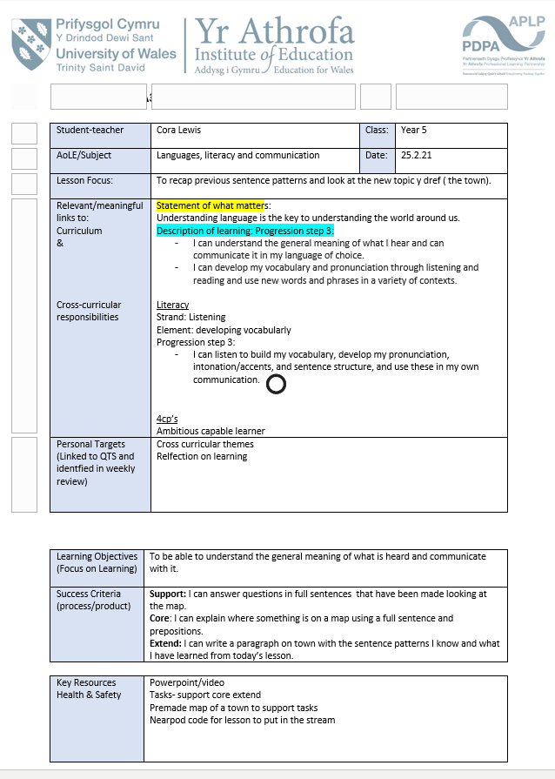
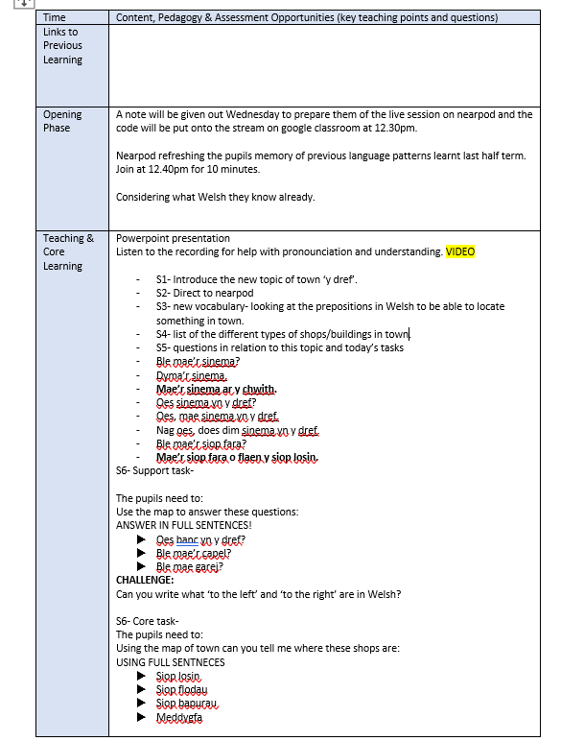

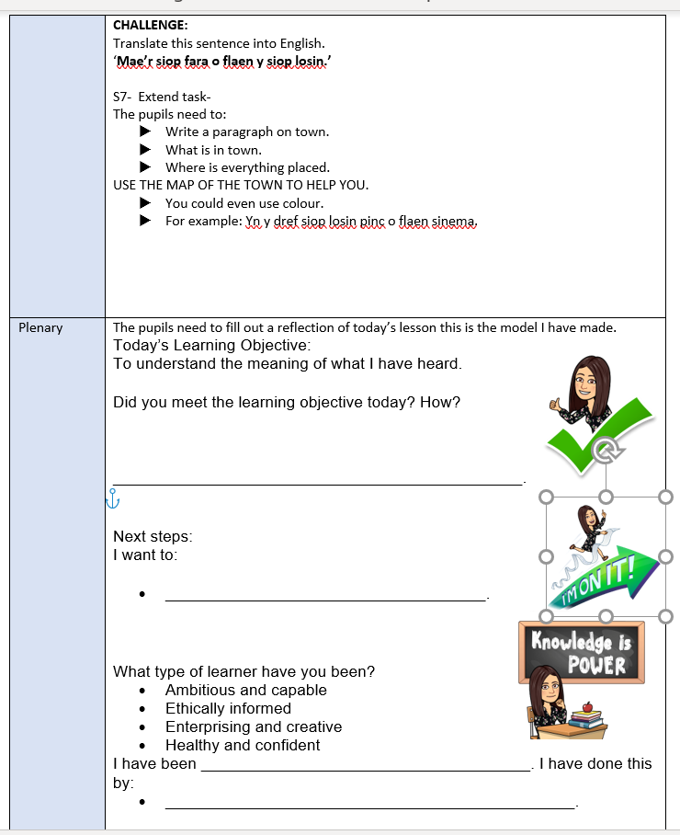

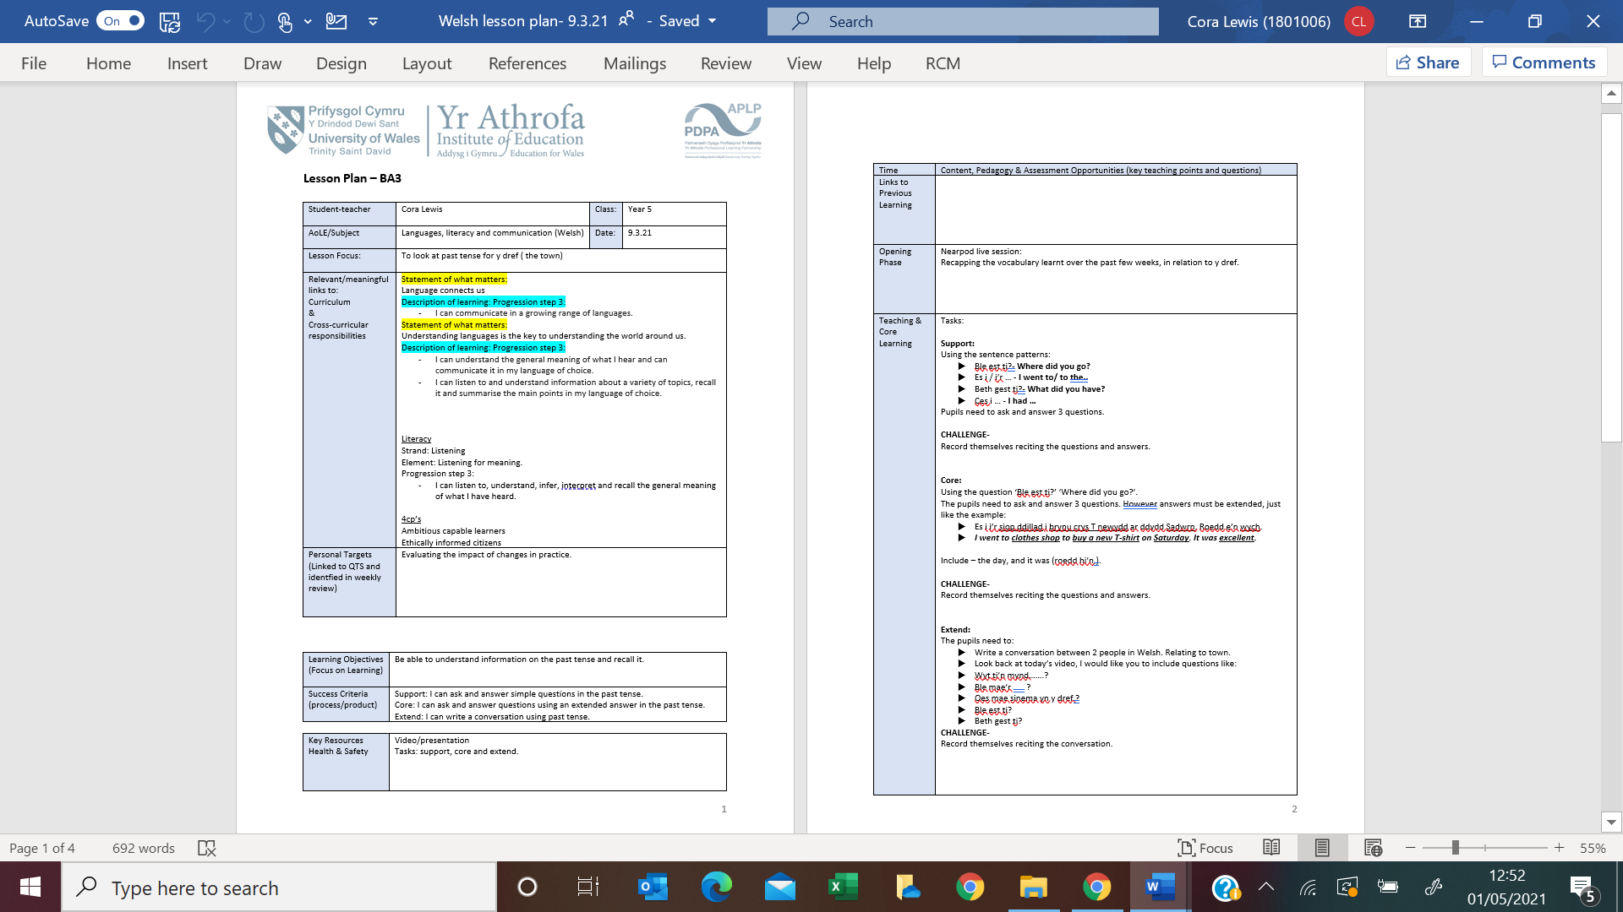
Appendix 2:

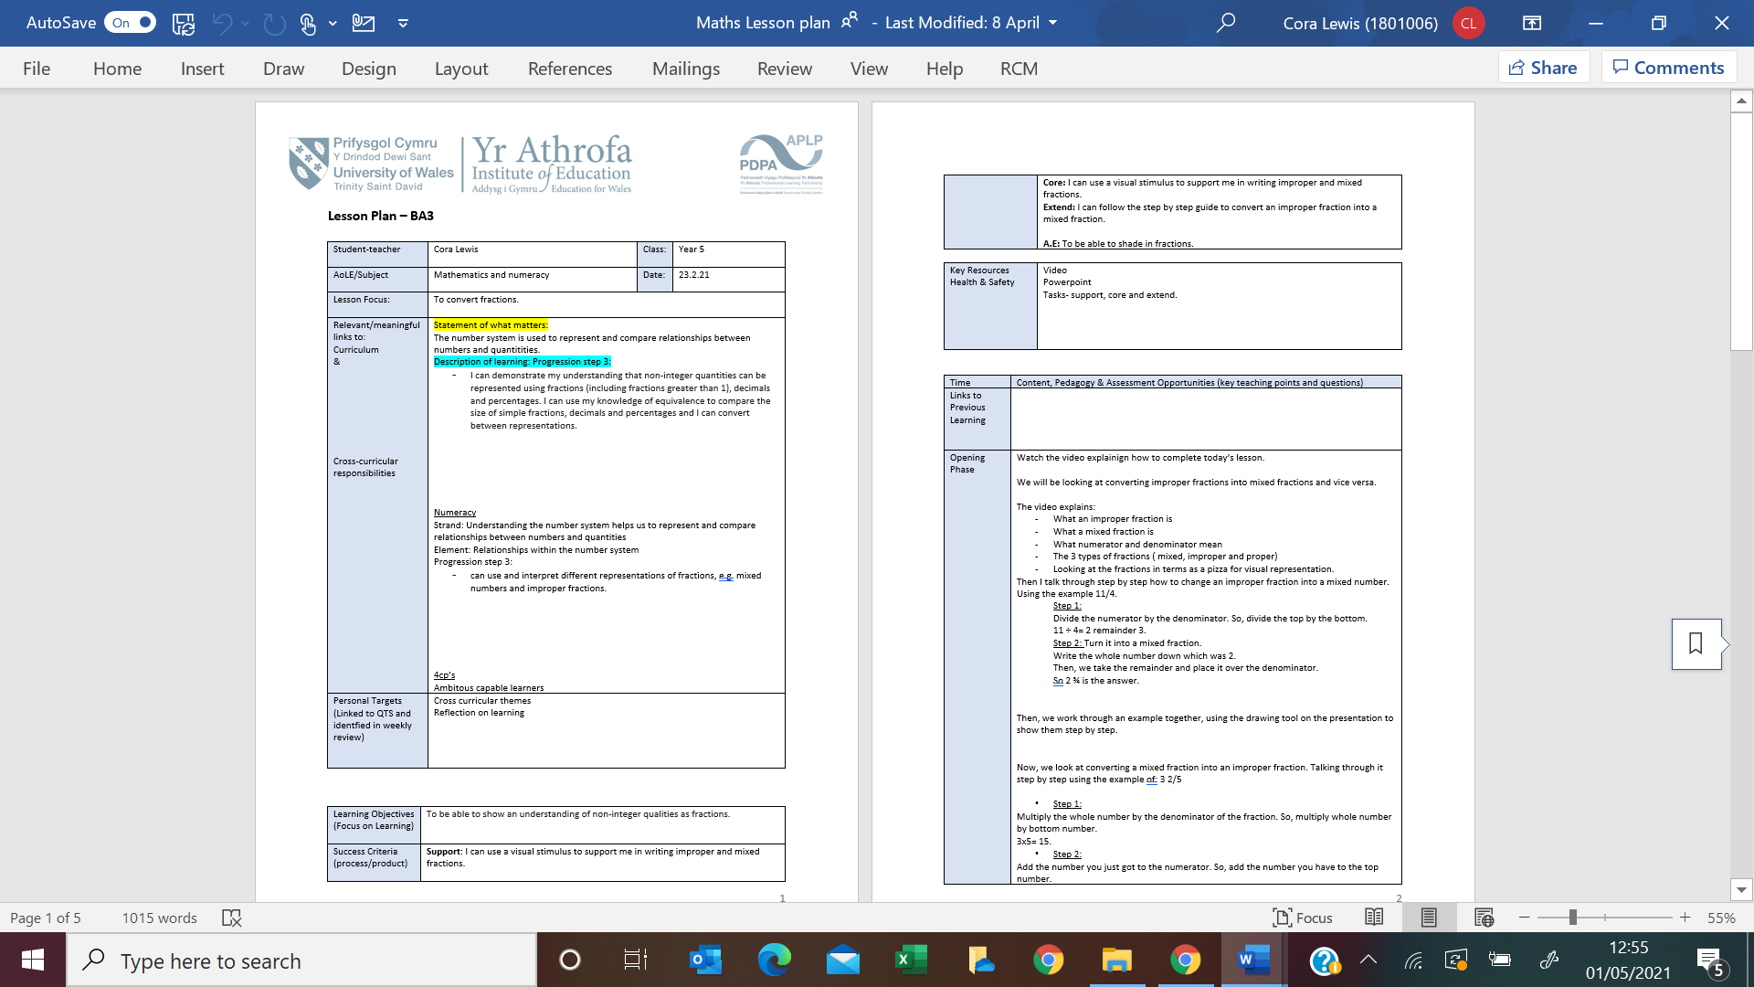
Appendix 3:

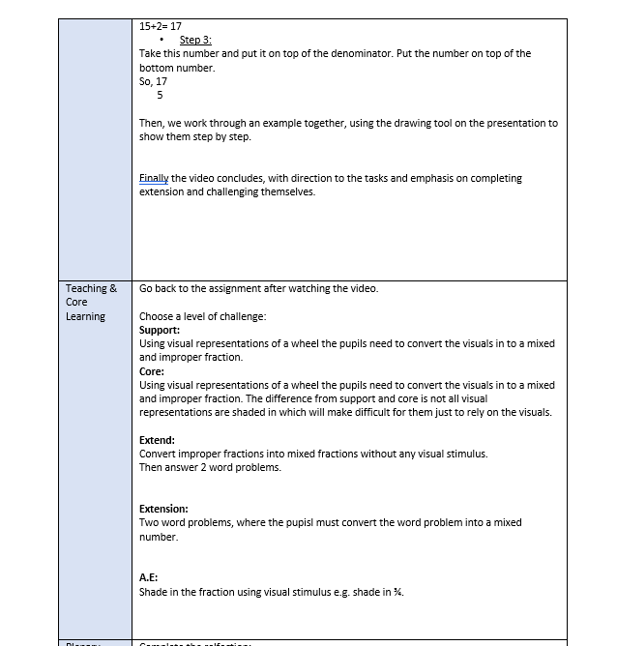

Appendix 4:
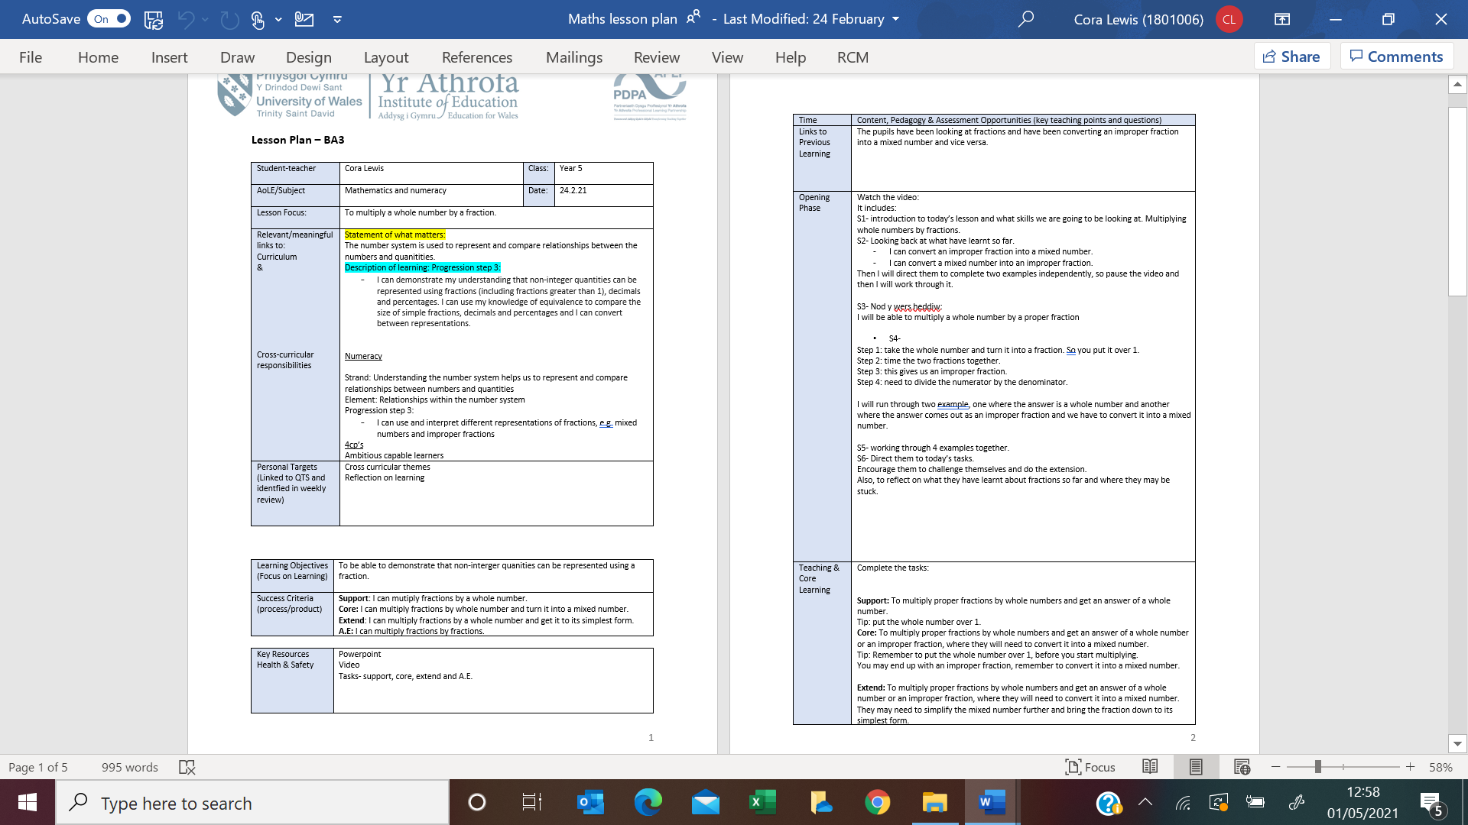

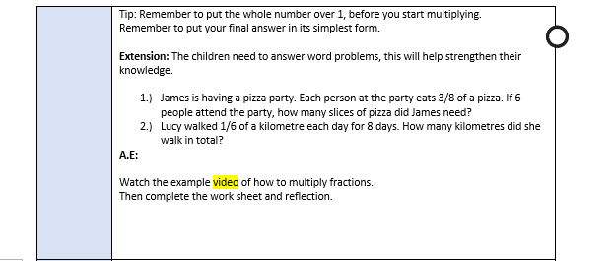

Appendix 5:
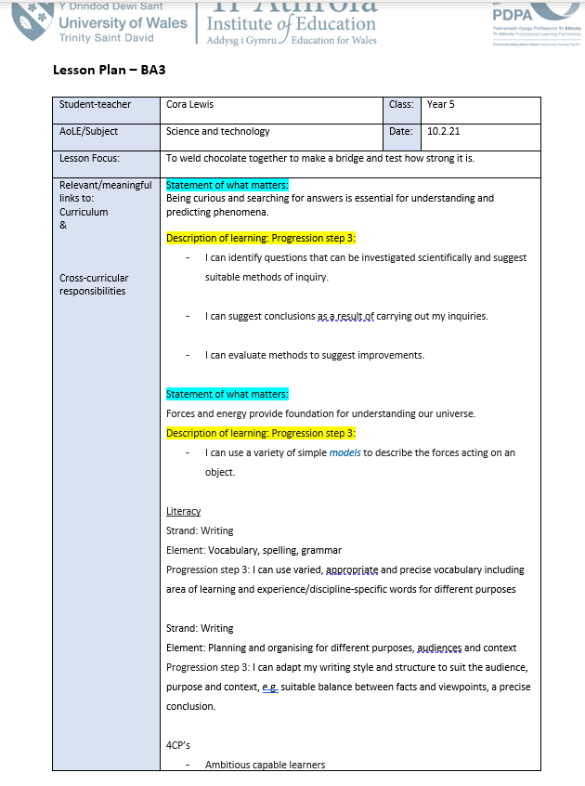

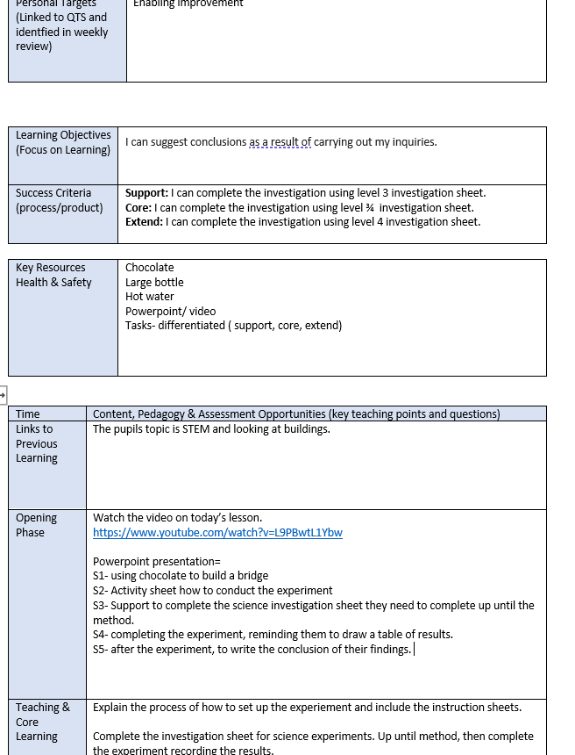

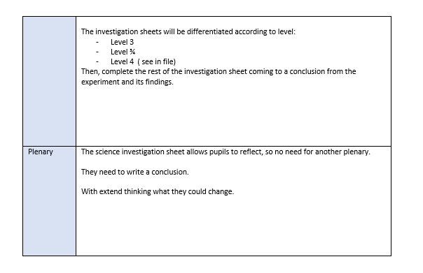

Appendix 6:


