Student name: shazia Malik
Student number: 2127945

Module name: Methodology poster

Child Poverty and Access to Mental Health Services in Urban UK Areas: A Thematic Analysis of Secondary Research

01 Introduction and Research Aim  This study examines how child poverty influences access to mental health services in urban UK settings. The aim is to identify barriers, policy/service gaps, and socioeconomic inequalities by critically analyzing secondary data. | 02 Search Strategy  A search strategy is a systematic process used to identify and retrieve relevant research. Databases included Google Scholar, PubMed, PsycINFO, JSTOR, NHS Digital, gov.uk. Boolean operators were applied: “child poverty” AND “mental health services” AND “UK urban”. Filters: English language, 2013–2024, UK-focused.
03 Searching for Information  - Step 1: Broad keywords (e.g., child poverty, CAMHS, urban deprivation).  - Step 2: Narrowed with Boolean logic and filters.  - Step 3: Duplicates/irrelevant studies removed.  - Step 4: Abstracts screened; full-text review conducted.  A PRISMA diagram was used to document the process. | 04 PRISMA Model  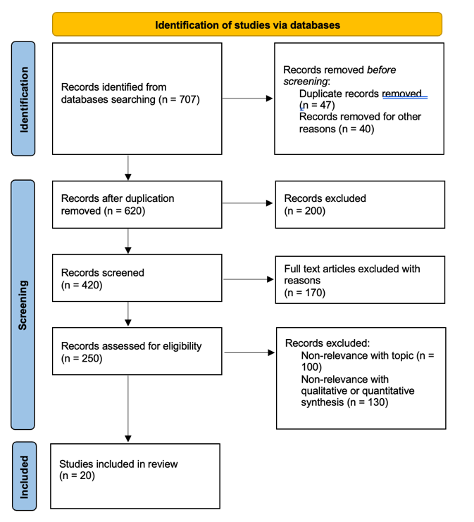
  Database | Keywords | Filters Applied | Number of Hits
  Google Scholar | "child poverty" AND "mental health services" AND "UK urban areas" | 2013–2024, peer-reviewed, English | 250
  PubMed | "child poverty" AND CAMHS AND UK | 2013–2024, UK-based, English | 120
  PsycINFO | "urban deprivation" AND children AND mental health | 2013–2024, peer-reviewed, children (0–18) | 90
  JSTOR | "poverty" AND "mental health access" AND "United Kingdom" | 2013–2024, English, social sciences | 80
  NHS Digital | "child poverty" AND NHS AND mental health | 2013–2024, UK data, reports/statistics | 100
  gov.uk | "child poverty" AND "mental health policy" | 2013–2024, UK focus, government policy | 67
05 Research Validation and Analysis
Validation ensures credibility and reliability of evidence. Only peer-reviewed journals, government reports, and NGO publications were included. Cross-checking data reduced bias.
Analysis was conducted using thematic analysis (Braun and Clarke, 2006), identifying three themes:
- Barriers to Access
- Policy/Service Gaps
- Socioeconomic Inequalities
06 Inclusion Criteria  - UK-based research (2013–2024).  - Peer-reviewed journals, government/NGO reports.  - Focus on children (0–18) and poverty/mental health. | 07 Exclusion Criteria  - Non-UK or non-English sources.  - Older than 10 years (unless seminal).  - Non-peer-reviewed or inaccessible sources.  - Irrelevant age groups.
08 Ethical Considerations
- Ethics in secondary research involve responsible, transparent use of published data.

References
Braun, V., and Clarke, V. (2006). Using thematic analysis in psychology. Qualitative research in psychology, 3(2), 77-101.
Bell, E., Harley, B., and Bryman, A. (2022). Business research methods. Oxford university press.
Creswell, J. W., and Poth, C. N. (2016). Qualitative inquiry and research design: Choosing among five approaches. Sage publications.
Hart, C. (2001). Doing a literature search: A comprehensive guide for the social sciences. Sage.
James, N., and Busher, H. (2015). Ethical issues in online research. Educational Research and Evaluation, 21(2), 89-94.

