Student name: Remus Nicolae Pirvu
Student Id: 2112416
Module: Management Economics
Module Code: LCBB5008
Table of Contents
Introduction 3
1. Chosen product and business for this assessment 3
Name of the business, product and market 3
The reason behind choosing the business and the product 4
2. Market equilibrium and factors of demand 4
Demand and Market Equilibrium of iPhone: 4
Different factors affecting the demand of the iPhones: 5
3. Elasticity of demand and pricing strategy of the business 11
Price elasticity of demand for the iPhones: 11
Income elasticity of demand for the iPhones: 13
Pricing policy to be employed by Apple Inc. 14
Conclusion 15
References 16

Introduction
This assessment will provide a complete assessment of Management Economics and its various concepts. In this context, a business and a certain product produced by that business will be chosen first. The industry in which the business operates and the reason behind choosing the business will be discussed in this report. Then, the market equilibrium of that product will be identified through a relevant diagram. Various factors that influence the demand for the product will also be discussed to show the shift and movement of demand for the product. In the next section, the price elasticity of demand and factors affecting the price elasticity of demand for the product will also be addressed. The concepts like substitution effect and income effect will be used in this context. The effective pricing strategy that the business may use in this context will be stated as well.

1. Chosen product and business for this assessment

Name of the business, product and the market
The business which is considered for this analysis is Apple Inc. The product of the business that will be used for the analysis is the iPhone. Now talking about the business, Apple Inc. was first set up in 1976 by Steve Jobs, Steve Wozniak, and Ronald Wayne. The company is headquartered in Cupertino in California, USA. The company operates in the Consumers Electronic goods & software services industry. Apart from the iPhone, the company produces various other electronic goods like AirPods, iPad, Macbook, Apple Watch, etc. Tim Cook is the CEO of the company while Arthur D. Levinson is the Chairman of the company (Levy, 2023). There are around 526 retail stores and 164,000 employees work for the company around the world. In 2022, the company secured a net profit of 99.80 billion USD while the total assets of the company include 352.76 billion USD. The speciality of the iPhone compared to Android smartphones is that the iPhone has an iOS operating system. Apart from these products, the company is said to provide various services as well like iCloud, Apple Store, Apple Pay, Apple Card, etc.

The reason behind choosing the business and the product
Apple is one of the most recognised brands in the electronics and software services industry. Among various products, the iPhone is the most popular item of the business that consumers of different parts of the world desire to purchase. But in recent years, the company has seen fewer sales of iPhone in spite of having a persistent demand. Hence, the company is adopting different pricing strategies as well to recover its sales frequency (Singh and Balu, 2022). This will be therefore interesting to make an assessment on how various factors are affecting the demand for the iPhones.

2. Market equilibrium and factors of demand

Demand and Market Equilibrium of iPhone:
In the books of economics, market equilibrium is a certain situation of the market in which both the demand and supply of a product are equal. This kind of market equilibrium is generally visible in a perfectly competitive market in which there are multiple buyers and multiple sellers as well. The point of equilibrium in a market generates an equilibrium price and an equilibrium quantity. This equilibrium point is where the supply curve interacts with the demand curve of that particular product. This market equilibrium is affected by sudden changes in demand or supply of the product, i.e., surplus or shortage (Mankiw, 2021).
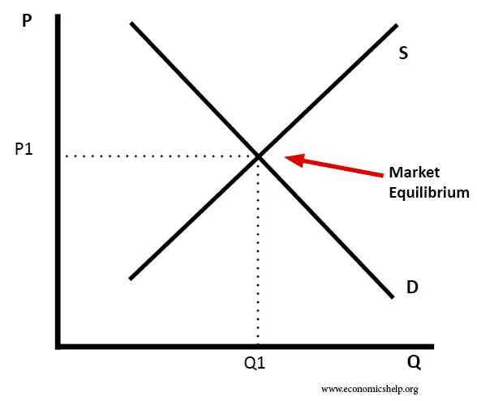
Fig. A: Market Equilibrium
(Source: Pettinger, 2019)
Looking at Figure 1, the market equilibrium scenario of Apple Inc's iPhone can be discussed. As the iPhone is a normal good, the demand curve of the product is negatively sloped and the supply curve of the product is positively sloped. The pointer of an arrow is the point of equilibrium at which the demand curve and the supply curve have intersected each other. P1 seems to be the market clearing price of the iPhone at which the seller wants to sell and the consumer wants to purchase Q1 units of iPhones.

Different factors affecting the demand for the iPhones:
i. Price of substitutes:
In general, the substitute's price does affect the demand for the original product. When the substitute's price increases, consumers move away from the substitute good towards the original good. Therefore, the demand for the original goods increases. Diagrammatically speaking, a higher price of substitute goods increases the demand and pushes the demand curve of the original product rightwards. Similarly, a lower price of the substitute good will shift the demand curve towards the left.
Android smartphones are the main substitute for the iPhone. In the UK, the price of top-brand Android smartphones has increased. So, this will lead to an increase in demand for iPhones. Therefore, the demand curve for iPhones will shift towards the right.
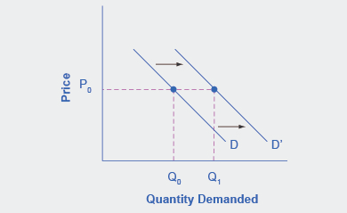
Fig. B: Rightward shift of demand curve for iPhones
(Source: Lynham, J. and OpenStax, 2018)
From this figure, it is observed that because of the increase in demand, a higher quantity of iPhones is demanded at the same price P₀.
ii. Price of the complements:
Complements are the products that are consumed together. So, if the price of a complement increases, the demand for the complement will fall. So, people will also look to consume less of the primary good. Hence, the demand for the main product will fall. This will lead to a leftward shift of the demand curve for the good. Again, the fall in the price of the complement will lead to a rightward shift of the demand curve for the actual item (Ellickson, 2013).
Apple App is one of the main complements of the iPhone. The prices of the Apple store have increased in recent times (Apple Newsroom, 2022). This will lower the demand for iPhones, so the demand curve for iPhones will move to the left as shown in the following figure.
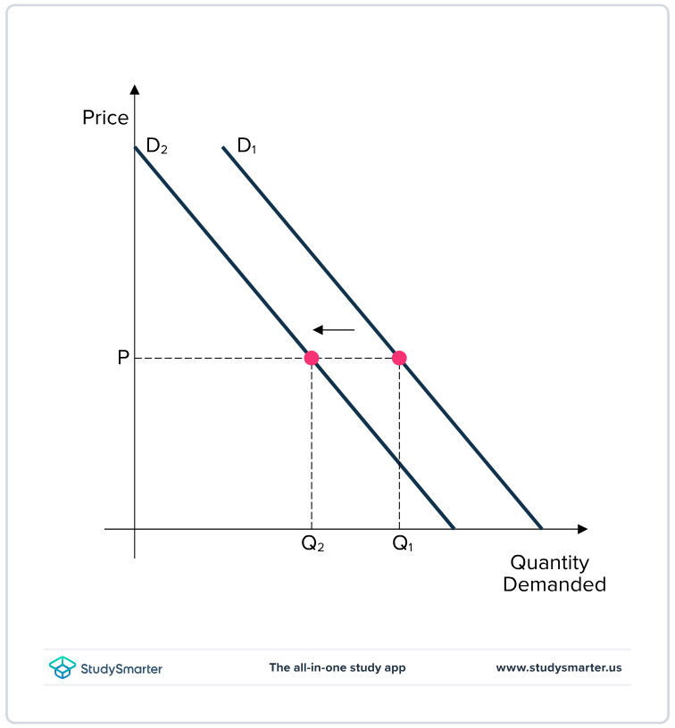
Fig. C: Leftward shift of demand for iPhones
(Source: StudySmarter UK, 2023)
At price P, less number of iPhones are demanded by customers now-a-days.
iii. Income of the consumers:
The income of the consumer is said to affect the demand for a normal product directly and positively. With higher income, consumers demand more of a normal good so the demand curve for the good shifts rightward. Because an increase in income increases the purchasing power of the consumers. So, people consider themselves richer. Similarly, if income falls, the demand curve of the goods shifts leftward.
In the UK, the mean disposable income of UK households has fallen in 2022 compared to 2021 (Office for National Statistics, 2023). This means that the demand for iPhones will fall. So, the demand curve for iPhones will shift to the left.
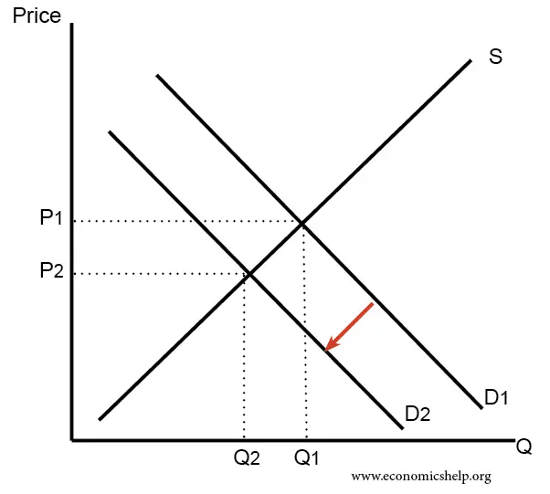
Fig. D: Leftward shift of demand because of a fall in income
(Source: Pettinger, 2017)
As discussed above, the lower average income of the consumers will shift the demand curve from D1 to D2. This will move the market equilibrium as well. Both the equilibrium price and quantity of iPhones will fall.
iv. Consumer tastes & preferences:
If the tastes and preferences of the consumer change, the demand for a good is said to be affected as well. If the consumers prefer a different good over the initial one, then the demand for the initial goodwill fall irrespective of the change in prices. If the consumer's taste and preference remain the same, then the demand for the specific good will not change.
In the UK, iPhones are still preferred more by UK consumers over smartphones. This is visible from the fact that from 2023 till now, the market share of the iPhones is around 51% while smartphones have a market share of 49% (Statista, 2023). This entails that the demand for iPhones will stay high and the demand curve for iPhones is expected to move to the right (Shapiro, 1987).
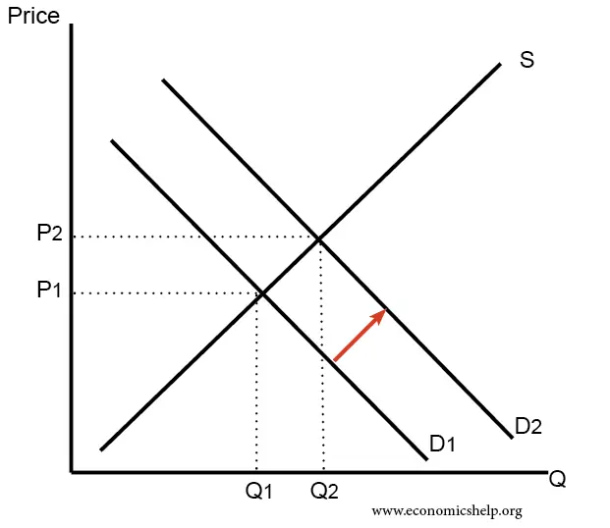
Fig. E: Rightward shift of demand for iPhones
(Source: Pettinger, 2017)
v. Consumer expectations of price:
If the consumers expect the price of a good to be increased in the future, they will look to purchase that good at this point. Therefore, the demand for goods will increase now and the demand curve will shift to the right. Again, an expected fall in price in future will reduce the demand for goods in the present.
As per the reports, the price of the iPhones is expected to increase in the future. So, the current demand for iPhones will increase and the demand curve will move to the right.
Fig. F: Rightward shift of demand for iPhones
(Source: Pettinger, 2017)
Higher demand for iPhones will move the equilibrium point to the right as well, leading to an increase in the equilibrium quantity and price of the iPhones.
vi. Demographics:
If the number of customers for a product increases, the demand for that product is expected to increase as well and if the number of customers falls, then demand for the product will fall as well.
In 2022, the number of customers of the iPhones have increased compared to 2021. The increased sales revenue is a signature of the increased customer base for the iPhones (Field, 2023). So, the demand for the iPhones is said to have increased and the demand curve of the iPhones has moved to the right. In the coming financial year, the demand for iPhones is expected to increase further. This scenario has been shown in the figure below.
Fig. G: Rightward shift of demand for iPhones
(Source: Pettinger, 2017)

3. Elasticity of demand and pricing strategy of the business

Price elasticity of demand for the iPhones:
Price elasticity of demand is another microeconomic phenomenon used to assert the response of a consumer to the change in the price of a good. How the quantity demanded of a good changes due to a unitary change in price is projected by the price elasticity of demand (Cigliano, 1980). If the change in quantity demanded is higher than the change in the price of the good, then that good is said to be price elastic. If the response is not quite high against the change in price, then the good is said to be price inelastic. If the changes in quantity demanded and price are equal, then the product is said to be unitary price elastic.
The concept of substitution effect can be used to address the price elasticity of demand for a good. The substitution effect entails that when the price of a good increases, consumers may switch to cheaper substitutes that provide the same utility. Therefore, the product will be considered a price-elastic good and will see a fall in quantity demanded by higher numbers.
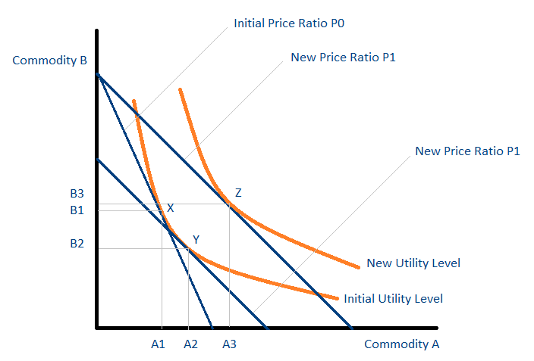
Fig. H: Substitution effect & price elasticity of demand
(Source: Corporate Finance Institute, 2023)
The above diagram shows that the fall in the price of commodity A shifts the utility level higher to the right. So, the consumer will purchase more of A and less of B at the point Y. The iPhone has a lot of substitutes available. There are different brands of Android smartphones in the market. Also, an iPhone is a luxurious commodity from the consumer's point of view. So, the price elasticity of demand for the iPhones will be greater than 1, i.e., the demand for iPhones will be price elastic. But it doesn't have a high price elasticity as the iPhones are not considered as a purely luxurious item.

Income elasticity of demand for the iPhones:
Income elasticity of demand shows the change in quantity demanded of a good because of the change in income of the consumers. The income elasticity of demand is generally positively valued except for the inferior and Giffen goods (Cigliano, 1980). If the change in quantity demanded of a good is higher than the change in income of the consumers, the good can be considered highly income elastic. High-income elasticity is generally seen for normal and luxurious items. Income elasticity is observed when the quantity demanded of a good doesn't increase as much as the income. Highly essential goods like medicines are said to have income inelastic demand.
In this discussion, the concept of income effect comes into play. The income effect shows the impact on the quantity demanded of a good by the consumer when her income increases or falls. For a normal item, the direction of the income effect and the substitution effect will be the same.
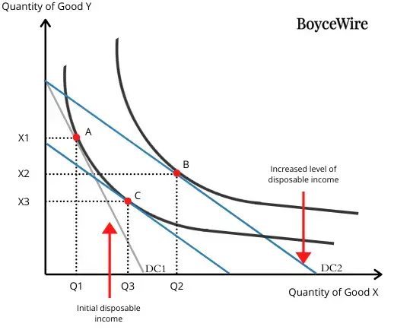
Fig. I: Income effect and Income elasticity of demand for iPhones
(Source: BoyceWire, 2023)
The figure shows that the increase in income of the consumer has led to an increase in quantities for both commodities. Q3Q2 is the amount of income effect. So, the price effect, i.e., the total substitution effect and income effect will be (Q1Q3 + Q3Q2).
So, the iPhone being more of a luxury item will have a positive income effect and the income elasticity of demand for the iPhone will be positive as well. Because, the consumers after having higher purchasing power will look to move away from less expensive alternatives, which are the android smartphones. Again, when their income decreases, they will move from the iPhone to those Android smartphones. So, the purchase of an iPhone represents a large proportion of the income of the consumers. Which is also a reason the iPhone is income elastic.

Pricing policy to be employed by Apple Inc.
Apple Inc. generally uses a Minimum Advertised Pricing policy so that the retailers are prevented from lowering the price below the MAP or Minimum Advertised Price. The objective of following this pricing policy is to maintain the popularity and brand value of the company (Agarwal, 2021). The premium prices set by the company are much higher compared to the prices of its competitors. But because of the changing trends of the consumers and lowering demand, Apple Inc. has reduced the premium price range of its iPhones. Psychological pricing is also used to some extent to perceive customers that iPhones are cheaper considering their attributes and features (Two Teachers, 2023).
It is not possible to initiate a competitive pricing policy by Apple Inc. as it will hurt the brand image of the company (Baker, 2003). Instead, the company can use a skimming pricing policy. Using this policy, the company can sell its newly launched iPhones at higher prices and with time may look to reduce the prices of those items when launching new and updated handsets or new competitors entering the market. This will help the company to maintain its brand image and premiership and the demand for the new items will remain higher and the customers will remain interested in purchasing the new handsets of Apple Inc.

Conclusion
The demand and factors affecting the demand of iPhones have been discussed in this report. Also, the price and income elasticity of demand of the iPhones have been assessed in this report to evaluate the economic aspects of the business and the product. This assessment will help the management of the company to make relevant business decisions to increase sales and profit and set pricing strategies accordingly.

References
Agarwal, I. (2021). Slicing the Apple: An analysis of Apple’s pricing strategy. [online] The St Andrews Economist. Available at: https://standrewseconomist.com/2021/11/17/slicing-the-apple-an-analysis-of-apples-pricing-strategy/#:~:text=Apple%20utilizes%20a%20minimum%20advertised.
Apple Newsroom. (2022). Apple announces biggest upgrade to App Store pricing, adding 700 new price points. [online] Available at: https://www.apple.com/newsroom/2022/12/apple-announces-biggest-upgrade-to-app-store-pricing-adding-700-new-price-points/ [Accessed 17 Aug. 2023].
Baker, J. (2003) Competitive Price Discrimination: The Exercise of Market Power Without Anticompetitive Effects (Comment on Klein and Wiley). Articles in Law Reviews & Other Academic Journals. Paper 278. Available at: https://digitalcommons.wcl.american.edu/cgi/viewcontent.cgi?article=2130&context=facsch_lawrev.
BoyceWire. (2023). Income Effect Definition | Examples and Graph | BoyceWire. [online] Available at: https://boycewire.com/income-effect-definition/.
Cigliano, J. (1980) Price and Income Elasticities for Airline Travel: The North Atlantic Market, Business Economics, pp. 17–21. Available at: https://www.jstor.org/stable/23482366.
Corporate Finance Institute. (2023). Substitution Effect. [online] Available at: https://corporatefinanceinstitute.com/resources/economics/substitution-effect/.
Ellickson, P. B. (2013). Market structure and performance. International Encyclopedia of the Social and Behavioral Sciences,, 14, 9211-9216. Available at: https://www.academia.edu/download/49573072/MarketStructure.pdf.
Field, M. (2023). Apple’s British sales bounce back to record £1.5bn after Covid slump. The Telegraph. [online] 13 Jul. Available at: https://www.telegraph.co.uk/business/2023/07/13/apples-british-sales-bounce-back-record-15bn-covid-slump/#:~:text=Apple [Accessed 17 Aug. 2023].
Levy, S. (2023). Apple Inc. In: Encyclopedia Britannica. [online] Available at: https://www.britannica.com/topic/Apple-Inc [Accessed 17 Aug. 2023].
Lynham, J. and OpenStax (2018). 3.2 Shifts in Demand and Supply for Goods and Services. pressbooks.oer.hawaii.edu. [online] Available at: https://pressbooks.oer.hawaii.edu/principlesofmicroeconomics/chapter/3-2-shifts-in-demand-and-supply-for-goods-and-services/ [Accessed 17 Aug. 2023].
Mankiw, N. G. (2021). Principles of Microeconomics 9e. Cengage Learning Asia Pte Limited. Available at: https://www.sobtell.com/images/questions/1493954637-eco365_wk1_book_ref.pdf.
Office for National Statistics (2023). Average household income, UK - Office for National Statistics. [online] www.ons.gov.uk. Available at: https://www.ons.gov.uk/peoplepopulationandcommunity/personalandhouseholdfinances/incomeandwealth/bulletins/householddisposableincomeandinequality/financialyearending2022#:~:text=Main%20points [Accessed 17 Aug. 2023].
Pettinger, T. (2017). Diagrams for Supply and Demand | Economics Help. [online] Economicshelp.org. Available at: https://www.economicshelp.org/1811/markets/diagrams-for-supply-and-demand/ [Accessed 17 Aug. 2023].
Pettinger, T. (2019). Market equilibrium - Economics Help. [online] Economics Help. Available at: https://www.economicshelp.org/microessays/equilibrium/market-equilibrium/ [Accessed 17 Aug. 2023].
Shapiro, M. (1987) Measuring Market Power in U.S. Industry, NBER Working Paper, No. 2212. Available at: https://www.nber.org/system/files/working_papers/w2212/w2212.pdf.
Singh, M. and Balu, N. (2022). Apple falls on fears of slowing iPhone 14 demand. Reuters. [online] 28 Sep. Available at: https://www.reuters.com/technology/apple-worsens-selloff-beleaguered-growth-stocks-2022-09-28/ [Accessed 17 Aug. 2023].
Statista. (2023). U.K.: mobile OS market share 2011-2021. [online] Available at: https://www.statista.com/statistics/262179/market-share-held-by-mobile-operating-systems-in-the-united-kingdom/#:~:text=Mobile%20OS%20market%20share%20in [Accessed 17 Aug. 2023].
StudySmarter UK. (2023). Demand Curve: Definition, Types & Shift | StudySmarter. [online] Available at: https://www.studysmarter.co.uk/explanations/microeconomics/supply-and-demand/demand-curve/ [Accessed 17 Aug. 2023].
Two Teachers. (2023). The Power of Psychological Pricing: How Apple Tricks Your Brain. [online] Available at: https://www.twoteachers.co.uk/post/the-power-of-psychological-pricing-how-apple-tricks-your-brain#:~:text=One%20well%2Dknown%20example%20is [Accessed 17 Aug. 2023].

