Academic and Employability Skills
BMSW4001

Table of contents

Introduction 3
Gibbs’s Reflective Cycle Model 4
1) Description: 4
2) Felling 4
3) Evaluation: 4
4) Analysis 4
5) Conclusion: 4
6) Action plan: 4
1) Time management 5
2) Summarizing 7
3) CV writing 8
4) Public speaking and giving presentation 9
Conclusion 11
References 12

Introduction
There are a wide variety of or models of reflection that enables one to reflect his or her thoughts. Among them I have chosen Gibbs’s Reflective Cycle which is one of the one of the effective and most famous models of reflection incorporating six particular steps or stages. In this particular report, I would like to apply this famous model of reflection into my selected topic such as Time management, Summarizing, CV writing and Public speaking and giving presentation and at the same time, I would like to create some sort of reflection in term of making how much usefulness they have been creating for me by taking into consideration what I already knew and any learning I undertook outside of the classroom. At the very beginning I will discuss in short about the Gibb’s Reflective Cycle then I will incorporate each topic with this particular model.

Gibbs’s Reflective Cycle Model
I have already stated that this particular model of refection incorporates six of distinctive steps that might be helpful to work through learning with continuous experiences and applying them into real life platform. Gibbs’s Reflective Cycle model of reflection was first developed by Graham Gibbs in 1988 to provide with a basic structure through learning from real-life experiences (Bassot, 2015). This famous model possesses 06 separate stages for instances Description, Felling, Evaluation, Analysis, Conclusion and Action plan.
1) Description: This is the very first step of this particular model which incorporate a basic description of a certain experience that might be gained from a real-life experience. In this particular part people are much more willing to accept a particular change or experience.
2) Felling: Felling is the 2nd step of this particular famous model. Felling is some sort of inner insights of an individual that might allow him or her to describe a things more specifically. In this particular step, people sometimes might get much more reluctant to express a certain experience.
3) Evaluation: At this particular step, people tend to start evaluating a particular experience in term of their knowledge and experiences. Evaluation might be positive or negative that is largely determined by nature of experiences and feedbacks (Lee, 2018).
4) Analysis: In this particular step people are much more willing to analysis a specific experiences with the help of their prior expectation and knowledge. Analysis sometimes calls for paralysis that is call analysis of the paralysis (Forster, 2017). So, one should devoid himself from over analysis.
5) Conclusion: In this particular step, some sort of conclusions might be drown by considering above discussed 04 steps. Conclusion is important because it helps to generate a basic guidelines regarding the effectiveness of a particular experiences.
6) Action plan: This is the final step of this particular step whereas necessary action plans are designed and reformulated. These particular action plans would help a firm or an individual to take some sorts of strategic plans in the long run. Action plan would induce and devoid some sorts of rational expectations.

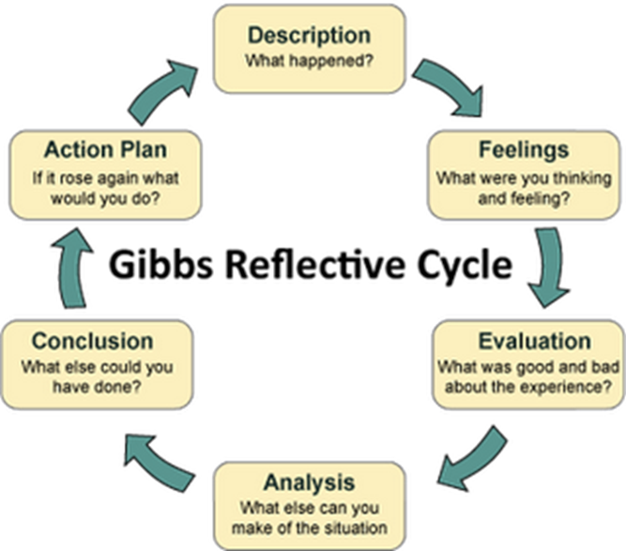

Figure 01: Gibbs’s Reflective Cycle Model (Velleman, 2017)

In this particular section of this report, I will apply above discussed model into my selected topic such as Time management, Summarizing, CV writing and Public speaking and giving presentation and at the same time, I would like to create some sort of reflection in term of making how much usefulness they have been creating for me by taking into consideration what I already knew and any learning I undertook outside of the classroom.

1) Time management
Time management is such an important factor that there is no need to over-discuss it because everybody must and should know the necessities of managing time properly. In fact, the individual Academic and Employability Skills largely dependent on this particular virtue. Productive performance is one of keys to proper time management. Actually, I have been benefitted a lots with the proper management of my time. Proper time management always help me to learn both inside and outside of the classroom especially outside my class room. Whenever, I might be outside of the class I can better earn and better communicate with the help of proper time management. In classroom, better time management also helps me to understand my studies and to communicate with my lecturers more effectively. I can apply and relate Gibbs’s Reflective Cycle Model to Time management in terms of communication and action plan more especially to action plan. As earlier stated that better time management help to create better communication thus an individual should always focus on managing time more effectively. Gibbs’s Reflective Cycle Model‘s one of step is Action Plan, according to (Sintu, 2016) time management helps firm to take timely and accurate action plan. So, this particular model is much more relevant in this ground. There are a lot of other benefits of managing time properly.

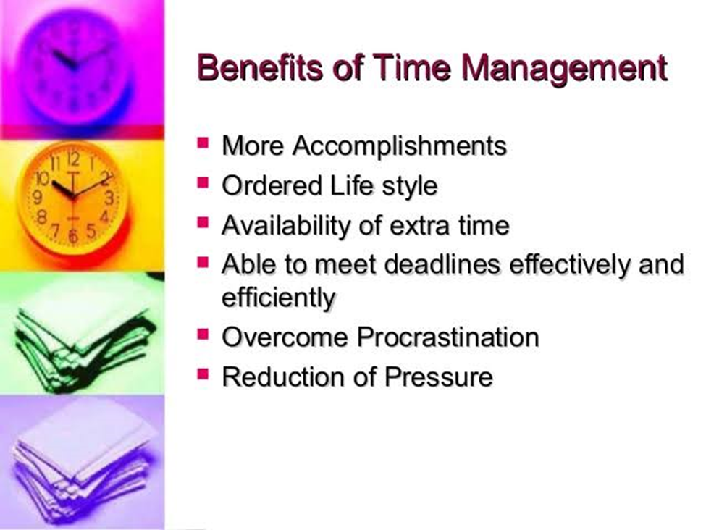
Figure 02: Benefits of time management (Bride, 2017)

These benefits are might be physical and spiritual. Figure 02 encompasses some of fundamental benefits of managing time properly. So, I think everybody should must be careful about managing their time and also should focus on the best and proper usages of single bit of time.

2) Summarizing
Summarizing is a wonder academic skill which allow an individual to sum-up the main points more specifically and more precisely (Agio, 2013). Often it might be impossible for executives and business people to read and to understand a broad issue. For solving this particular problem, making a meaningful summary might help a lot. So individual should know how to make a summary this is particularly much more relevant to whose currently who are studying because I firmly believe that it might help people to acquire some sort of academic as well as employability skills. When individual might go for leading a business firm she or he should be able to summarize any details because when she or he will communicate with employees if she or he would delivery and guide them in details, it might be create some sort of misunderstanding. So, she or needs to guide and deliver in more summarize way. This particular virtue can be easily applied and related to Gibbs’s Reflective Cycle Model’s conclusion step. While making and drawing any conclusion it must be bared in mind that conclusion must be in a more specific and summarize way. So, in this ground this particular step of this famous model is much more pertinent. There are a plenty of benefits of making summary instead of describing in details. These popular benefits are as follows.
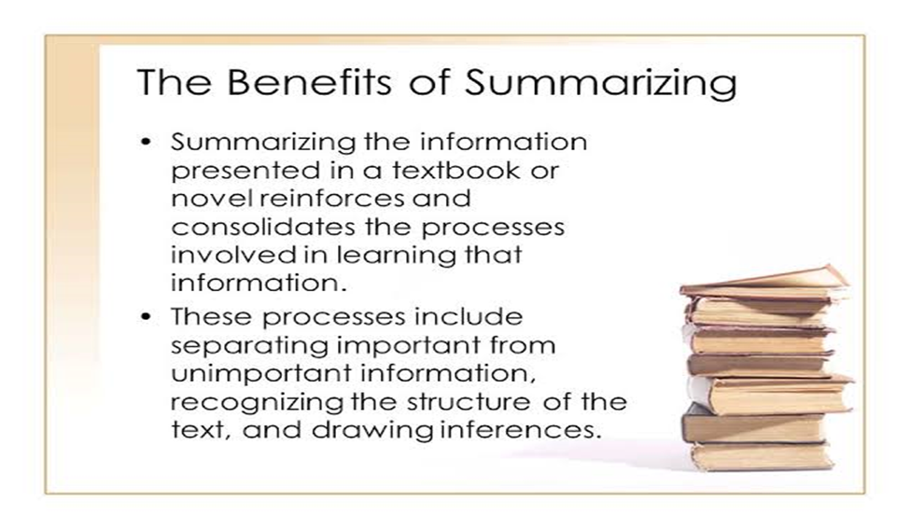
Figure 03: Benefits of summarizing (Allender, 2017)
In this regard, as there are a lot of benefits of making summary so, naturally I personally got benefitted by using this particular approach. Especially, summarizing helps me a lot to make and draw conclusion for in time of class time and outside of the classes and I believe eventually at a time this particular virtue will help me a lot in terms of acquiring both of my Academic and employability skills. So, I suggest every individual to be more specific and precise in terms of expressing information both for oral and written formats.

3) CV writing
After the successful completion of one’s academic life it is much more mandatory and important for any individual to write a well-defined and informative CV to draw the attention of the employers (McGee, 2017). So, I think knowing how to write a CV is must for every individual. Fortunately, I have already learnt how to write a CV and I have already tried to draw attention from the employers who would like to offer jobs in term of intern basis. This particular approach has already helped me a lot to understand the real-life work environment. This particular virtue can easily be applied and be related to the famous model of Gibbs’s Reflective Cycle Model’s description part. Description part of this particular model would allow individual to deal with major description what are normally written on CV. A well-furnished CV must attempt to describe all the necessary information in a descriptive way. There are a lot of guidelines for describing a CV that might possess the quality of a good CV.

So, I think everyone should try to develop the information and skills that might be required to develop a well-furnished CV. These particular skills must be generated from the very beginning of one’s academic life. There are always some sort of opportunities always prevail around us. We should capture these opportunities so that in near future we might incorporate these opportunities in our CVs. There are some basic guidelines behind developing a good CV. These basic guidelines for describing or writing a CV is given below.
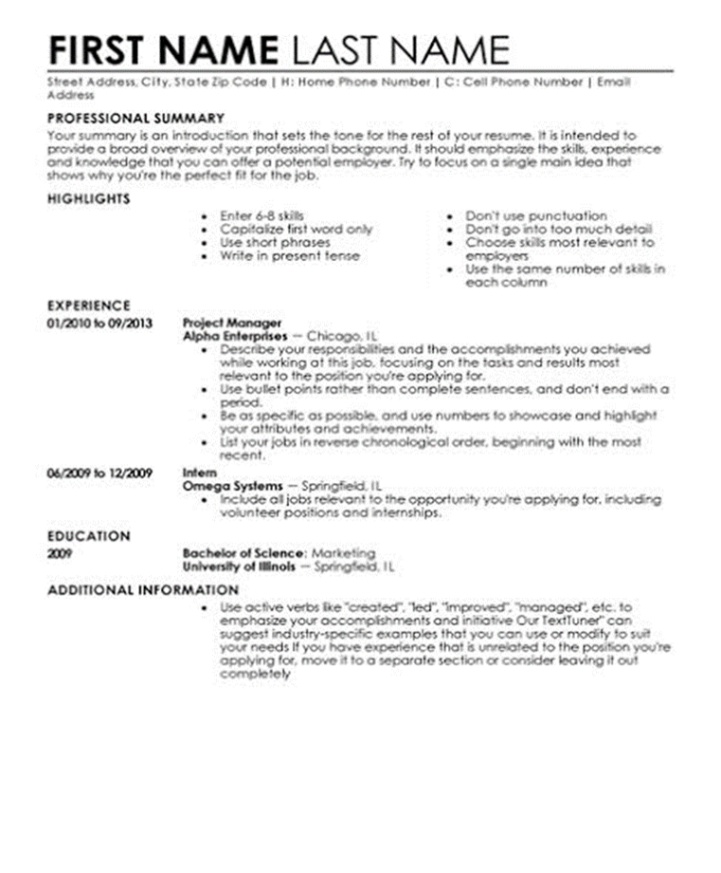
Figure 04: Guidelines for writing a CV (Kirkpatrick, 2017)

4) Public speaking and giving presentation
Honestly writing, public speaking and giving spontaneous presentation is kind of art. Public speaking allow a person for getting much more confident towards his words and thoughts. Fortunately, I have become to achieve this particular way of communication which has already allowed me to be much more confident to my words and thoughts than that of any earlier time. Beside public speaking, giving presentation more spontaneously is another form of academic and employability skill that allows an individual to present him/her more spontaneously in front of mass people. Giving spontaneous presentation might individual to draw the attention of the employers in some extents. I have already developed some sort of software skills that have already allowed me to prove the potential skill of giving public presentation. These two particular virtues have already helped me both of classroom and outer places to speak more confidently and more spontaneously. I think everyone should try to acquire this particular skills because these two particular skills are more prominent and effective for getting a good job. These particular virtues can easily be applied and correlated with that famous Gibbs’s Reflective Cycle Model’s evaluation and analysis step. If any information is expressed in the form of power point slides they get much catchier and people easily can understanding the meaning of that information easily. Evaluating information and giving presentation on that information for providing some sort of analytical insights would definitely allow individuals to understanding the underlining principles. As there are a lots of benefits for providing basic information into power point form every individual can develop their understanding of this particular matters. As there are a lot of benefits for developing this particular virtue, I think there should be some sorts of guidelines for this purposes. These guidelines are particularly important for those who wants to develop their academic and employability skills. These particular guidelines are as follows:
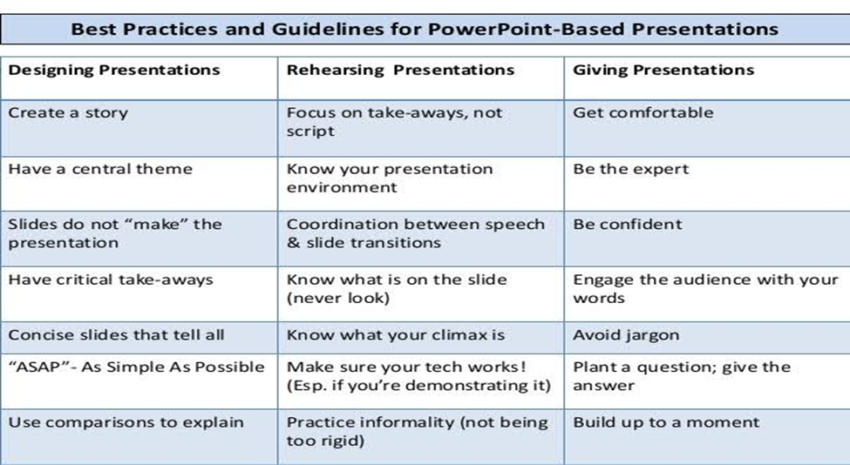
Figure 05: Guidelines for presentation (Harolds, 2016)

Conclusion
This particular report concludes several points first of all Gibbs’s Reflective Cycle Model is a wonderful tool to analyze any situation derived from real-life experiences. So, firms and individuals might be benefited by using this particular model of reflection. Thus, the mass usages of this particular approach is always welcomed. Then there are a lot of tools that helps firms and individual to acquire some sorts of both academic and employability skills. Proper time management, making a short summary, writing a well-defined and descriptive CV and speaking and making presentation spontaneously in front of mass people are most important skills required for developing some sorts of academic and interpersonal skills. So, individual should focus on to acquire all these good virtues and quality from the very beginning of their academic life. These 04 aspects of interpersonal skills can easily be related to Gibbs’s Reflective Cycle Model in term of its usages and effectiveness. Finally, this particular report has also provided some sorts of basic guidelines to acquire all these qualities in term of academic and employability skills.

References
- Agio, M., 2013. Summary. [United States]: Business Book Summaries.
- Allender, S., 2017. Report Writing. BACIE.
- Bassot, B., 2015. The Reflective Practice Guide. Florence: Taylor and Francis.
- Bride, M., 2016. Time Management. London: Hodder Education.
- Forster, O., 2017. Analysis.
- Harolds, J., 2016. Tips for Giving a Memorable Presentation, Part III. Clinical Nuclear Medicine, 37(9), pp.872-873.
- Kirkpatrick, H., 2017. How To Write A CV (Curriculum Vitae) And Cover Letter. Middletown, DE: CreateSpace Independent Publishing Platform.
- Lee, L., 2018. Evaluations.
- McGee, P., 2018. Writing A CV That Works.
- Velleman, J., 2017. Practical Reflection. Princeton, N.J.: Princeton University Press.
- Peshi Sintu, R., 2016. How to manage time. Princeton, N.J.: Princeton University Press.

