

Student Name: Meet Shantibhai Dholiya
Student ID: 2532977

Module Name: Financial Management
Module Code: LCMB7002

Lecturer’s Name: Shengfeng Mei

Word Count: ( 6900 Including References & Appendices )

Term 1

Table of Contents
1. Introduction 3
2. Financial Health Check 3
2.1 Five-year performance and profitability 3
2.2 Liquidity 5
2.3 Efficiency and cash-flow performance 6
2.4 Gearing, equity and shareholder distributions 8
2.5 Overall financial strengths and threats 10
3. Working Capital Management Analysis 10
3.1 Cash operating cycle and liquidity position 10
3.2 Recommended working-capital reforms 11
3.3 Short-term versus long-term financing 12
4. Strategic Financial Restructuring Plan 12
4.1 Restructuring objective 12
4.2 Debt and shareholder distributions 13
4.3 Selective divestiture and asset-light expansion 14
4.4 Acquisitions and equity financing 14
4.5 International, taxation, currency and inflation considerations 15
4.6 Ethical and CSR considerations 16
5. Investment Appraisal and Capital Budgeting 16
5.1 Investment appraisal approach 16
5.2 Payback Period and Accounting Rate of Return 18
5.3 Net Present Value and Profitability Index 18
5.4 Internal Rate of Return 19
5.5 Financial and non-financial evaluation of Project C 20
5.6 Capital rationing under the £100 million constraint 21
5.7 Final investment recommendation 21
6. Conclusion 22
References 23
Appendices 25
Appendix A: Marriott International Five-Year Ratio Tables (2021-2025) 25
Appendix B: Ratio Tables and Graphs 25
Appendix C: Investment Appraisal Calculations (Excel Output) 26
Appendix D: Capital Rationing under the £100 Million Maximum Investment 27
Appendix E: Methodological Notes 28

1. Introduction
From the viewpoint of a chief financial officer, this paper assesses Marriott International, Inc. over the five-year period from 2021 to 2025. Because it starts amid the recovery from the COVID-19 interruption and concludes with Marriott operating at a considerably greater scale, producing better fee revenue and cash flows but simultaneously holding a more leveraged balance sheet, the period is financially significant. The five-year financial workbook created from Marriott's audited annual reports serves as the primary foundation for the research. While working-capital discipline is examined during the cash conversion cycle, profitability, liquidity, efficiency, gearing, investment performance, and cash production are evaluated thru ratio analysis. These methods are suitable as financial statements offer an organized framework for evaluating performance; nevertheless, specific ratios must be understood within the framework of the business model of the organization, not in relation to general standards (Atrill and McLaney, 2022).
The main contention is that Marriott's financial structure has gotten more aggressive while its operational recovery has been robust. Between 2021 and 2025, there were significant increases in revenue, operating income, and operational cash flow; yet, the current ratio stayed below one, debt climbed, and book equity turned negative. Therefore, before assessing the three suggested projects and the £100 million capital-rationing limitation, the study presents a CFO strategy based on tighter working-capital control, modest deleveraging, conditional shareholder payouts, and selected asset-light development.

2. Financial Health Check

2.1 Five-year performance and profitability
Marriott's operating scale has significantly improved during the last five years. From $13.857 billion in 2021 to $20.773 billion in 2022, $23.713 billion in 2023, $25.100 billion in 2024, and $26.186 billion in 2025, total revenue grew. Higher owned-hotel activity is not the only reason for the growth. From $2.694 billion in 2021 to $5.438 billion in 2025, gross fee income increased, demonstrating the growing impact of management and franchise relationships. During that time, operating income more than quadrupled to $4.141 billion from $1.750 billion. Additionally, net income increased from $1.099 billion in 2021 to $2.601 billion in 2025. However, the trend was nonlinear, with a higher $3.083 billion result in 2023, a decline to $2.375 billion in 2024, and a recovery in 2025 (Marriott International, 2022; Marriott International, 2024; Marriott International, 2025; Marriott International, 2026). Therefore, the overall trend points to a robust recovery, but the decline in net income in 2024 shows why revenue growth by itself can not be interpreted as proof of steadily increasing bottom-line profitability.
When analyzing profitability, Marriott's asset-light approach is crucial. The hotel system can grow without Marriott owning the bulk of the underlying real estate because to the company's significant franchise, base-management, and incentive-management fees. This reasoning is supported by recent study in the hotel industry. Even tho owned properties may result in stronger operating measures at the property level, Mulet-Forteza et al. (2024) find that non-ownership expansion strategies like franchising and management contracts can offer greater economic efficiency and lower financial exposure than ownership-intensive expansion. Marriott can expand its room network and charge base without investing the same amount of money in actual hotel facilities, which makes this distinction important. It also illustrates why return metrics should not be understood as if Marriott were a typical property owner, but rather in conjunction with fee growth and cash creation.
The workbook's return on assets was roughly 10.18% in 2021, 9.57% in 2022, 12.01% in 2023, 9.01% in 2024, and 3.99% in 2025. Because ratio results rely on the precise definitions of the numerator and denominator, the apparent fall in 2025 calls for caution. More significantly, Marriott maintained its profitability and increased its operational cash flow. This demonstrates a more general drawback of ratio analysis: if a measure is isolated from changes in asset composition, acquisitions, intangible assets, and the timing of earnings, it may give an incomplete image. Therefore, rather than interpreting the five-year trend using a single ratio, multiple measurements should be used. Another view is offered by EPS, which increased from $3.34 in 2021 to $9.51 in 2025. Stronger profits account for a portion of this improvement, but share repurchases also lower the number of shares over which earnings are spread, thus EPS growth cannot be considered a sole indicator of operational progress.

Figure 1: Marriott revenue, net income and operating cash flow, 2021-2025
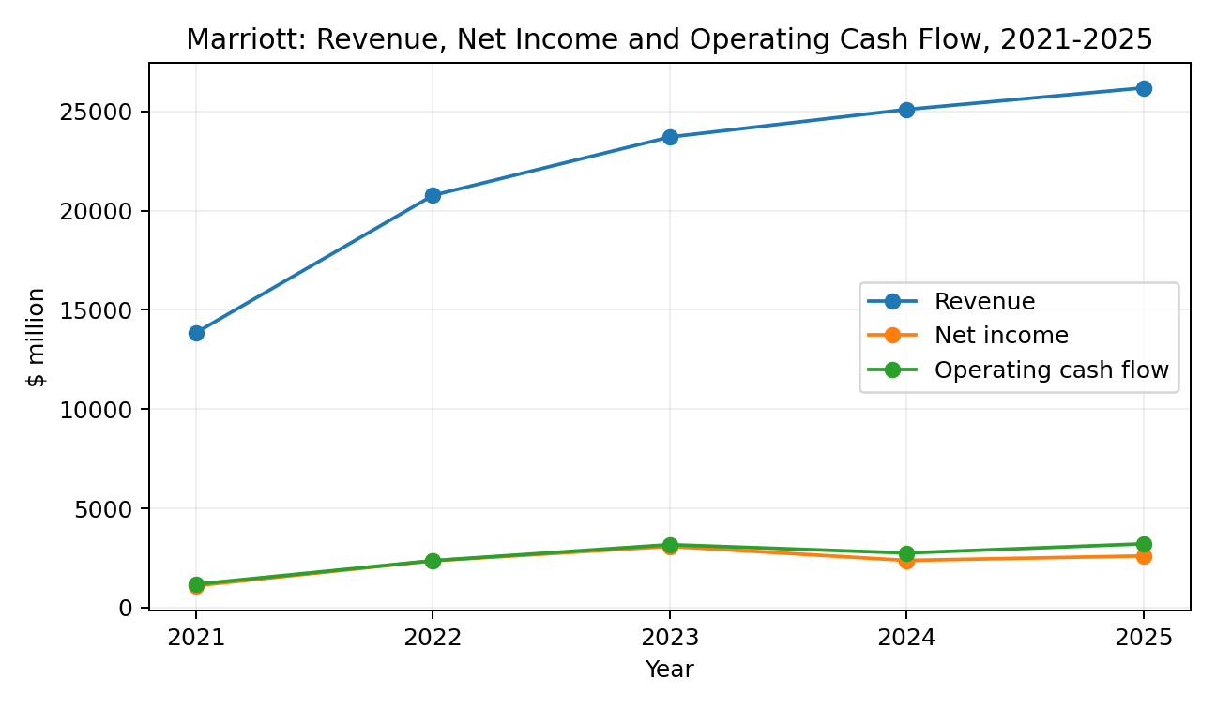
Source: Author's analysis based on Marriott International annual reports (2022-2026) and uploaded five-year workbook.

2.2 Liquidity
The most obvious area where Marriott's poor traditional ratio position contrasts with its excellent operating performance is liquidity. Before somewhat improving to 0.43 in 2025, the current ratio fell from 0.57 in 2021 to 0.45 in 2022, 0.43 in 2023, and 0.40 in 2024. By 2025, the cash ratio had dropped from 0.22 in 2021 to just 0.04. If current assets alone were used to satisfy all current liabilities, the current ratio would typically be less than one. In light of this, the tendency seems alarming. At year-end 2024 and 2025, Marriott claimed that its current assets were around 0.4 times its current liabilities. It also said that it had substantial borrowing capacity available for further working-capital requirements (Marriott International, 2026). As a result, although acknowledging the low ratio, the corporation does not use it as proof of an urgent financial crisis.
Because Marriott's existing obligations are different from those of a manufacturing corporation, a more careful interpretation is required. By the end of 2025, there were $3.584 billion in current assets and $8.398 billion in current liabilities, of which $3.497 billion was related to the current share of the guest loyalty program liability. According to Marriott International (2026), there was $358 million in cash and $2.909 billion in accounts and notes receivable. Unlike bank debt or past-due supplier accounts, loyalty liabilities imply anticipated future redemption requirements rather than the same kind of immediate payment demand. Therefore, the low current ratio should not be viewed mechanically, rather it is a real signal concerning balance-sheet constraint. Additional financial assistance is provided by Marriott's operational cash flow of $3.212 billion in 2025 and its availability of credit facilities. Therefore, the question for the CFO is not whether Marriott can presently fulfilll its obligations, but rather whether such a lean liquidity structure is still suitable in light of growing debt and ongoing shareholder dividends.
Figure 2: Marriott liquidity ratios, 2021-2025
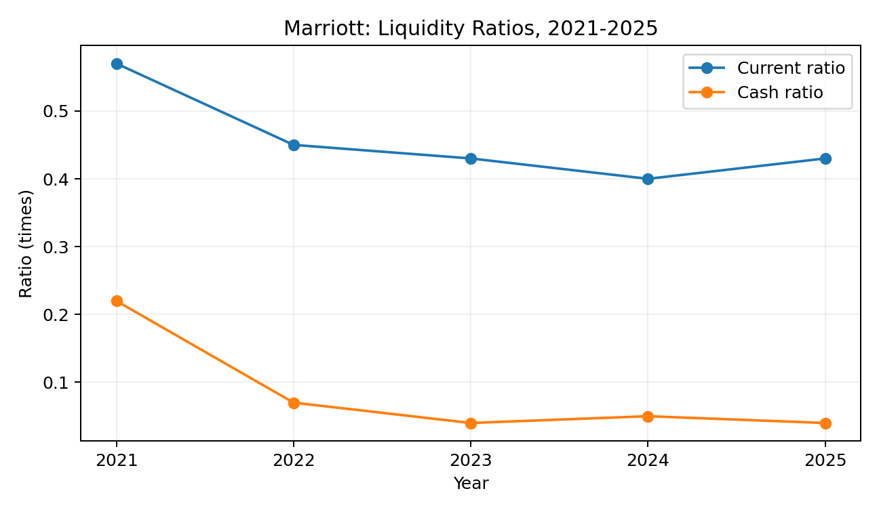
Source: Author's calculations from Marriott International annual reports (2022-2026).

2.3 Efficiency and cash-flow performance
According to the efficiency analysis, Marriott's operational cycle stabilized after substantially improving from the 2021 recovery year. A cash conversion cycle of around 30.5 days in 2021, 24.5 days in 2022, 27.0 days in 2023, 27.2 days in 2024, and 26.7 days in 2025 is calculated by the worksheet. Over the same period, receivable days decreased from around 49.4 days to 39.8 days, showing a quicker conversion of reported revenue into receivables collections. The significance of working-capital discipline is largely supported by academic research. While Zeidan and Shapir (2017) emphasize that working-capital decisions can create value when they are integrated with operational decision-making, Jaworski and Czerwonka (2024) find a general negative relationship between the cash conversion cycle and profitability in a meta-analysis covering a large international evidence base. The Marriott outcome must be viewed inside the hotel industry rather than in opposition to manufacturing standards since the connection is not the same across industries.
Because Marriott does not individually publish a material inventory balance at the group level, inventory days have been regarded as zero in the worksheet. This is a methodological constraint as well as a sensible practical adjustment for a hotel management and franchising firm with little assets. As a result, the resultant cash conversion cycle is essentially a measure of receivables minus payables and should not be directly compared to a manufacturer or retailer. This constraint shows that financial procedures necessitate contextual judgment, which improves rather than diminishes the study. Net cash from operations rose from $1.177 billion in 2021 to $2.363 billion in 2022 and $3.170 billion in 2023, before declining to $2.749 billion in 2024 and rebounding to $3.212 billion in 2025, supporting the more general conclusion that operational efficiency improved. The brief drop in 2024 highlights the necessity for liquidity buffers and flexible financing as cash generation might change even while revenue increases.

Figure 3: Marriott cash conversion cycle, 2021-2025
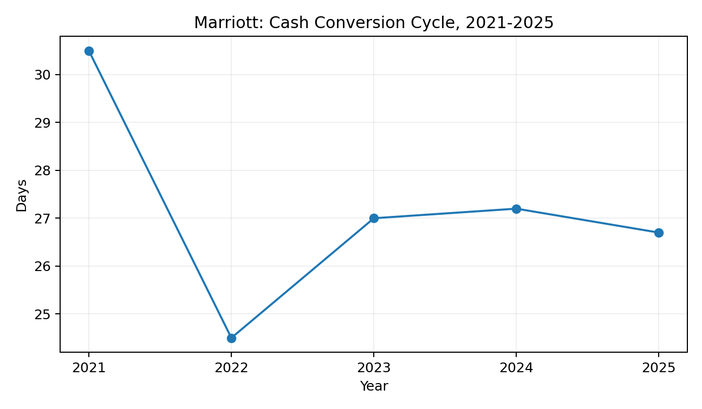
Source: Author's calculations based on the uploaded five-year workbook.

2.4 Gearing, equity and shareholder distributions
The shift in capital structure poses the most long-term financial risk. The percentage of total debt to total assets rose from around 39.7% in 2021 to 40.6% in 2022, 46.2% in 2023, 55.2% in 2024, and 58.8% in 2025. Marriott reported $1.209 billion in current long-term debt and $14.995 billion in long-term debt by the end of 2025, for a total debt of around $16.204 billion. The weighted-average interest rate on long-term debt was around 4.5%, and the weighted-average duration was roughly 5.4 years, according to management's disclosure that debt had grown by $1.757 billion in 2025 (Marriott International, 2026). Although the direction of leverage still limits future financial flexibility, the maturity profile and primarily fixed-rate structure offer some protection against short-term interest-rate volatility.
Marriott's capital-return strategy and the decline in book equity are closely related. From $1.414 billion in 2021 to $568 million in 2022, total equity dropped to a deficit of $682 million in 2023, $2.992 billion in 2024, and $3.771 billion in 2025. In 2025, the balance of Treasury stock fell by $27.900 billion. In addition to rising dividend payments, the cash-flow statements show purchases of treasury shares totaling $2.566 billion in 2022, $3.953 billion in 2023, $3.762 billion in 2024, and $3.300 billion in 2025. Empirical data shows that buyback activity reacts to liquidity, leverage, and other company factors. Share repurchases may be a flexible strategy to transfer excess capital and can enhance EPS (Kulchania and Sonika, 2023). However, Marriott's stance involves a trade-off: although substantial repurchases benefit shareholders now, prolonging them while debt increases may weaken resilience and borrowing capacity in the event of a future travel slump.
The utility of return on equity is likewise constrained by negative shareholders' equity. The workbook shows extremely high positive ROE in 2021 and 2022, followed by negative ROE. Because the denominator itself turns negative, these figures should not be regarded as a straightforward fall in profitability. In 2023, 2024, and 2025, Marriott continued to turn a profit. In this case, comparing ROE between years or against businesses with positive equity becomes economically challenging. More significant supplementary data is provided by ROA, operating margin, cash generation, EPS, and leverage. Acknowledging this constraint is crucial since Level 7 financial evaluation calls for judgment regarding the suitability of a strategy in addition to precise formula computation.
Figure 4: Marriott capital structure indicators, 2021-2025
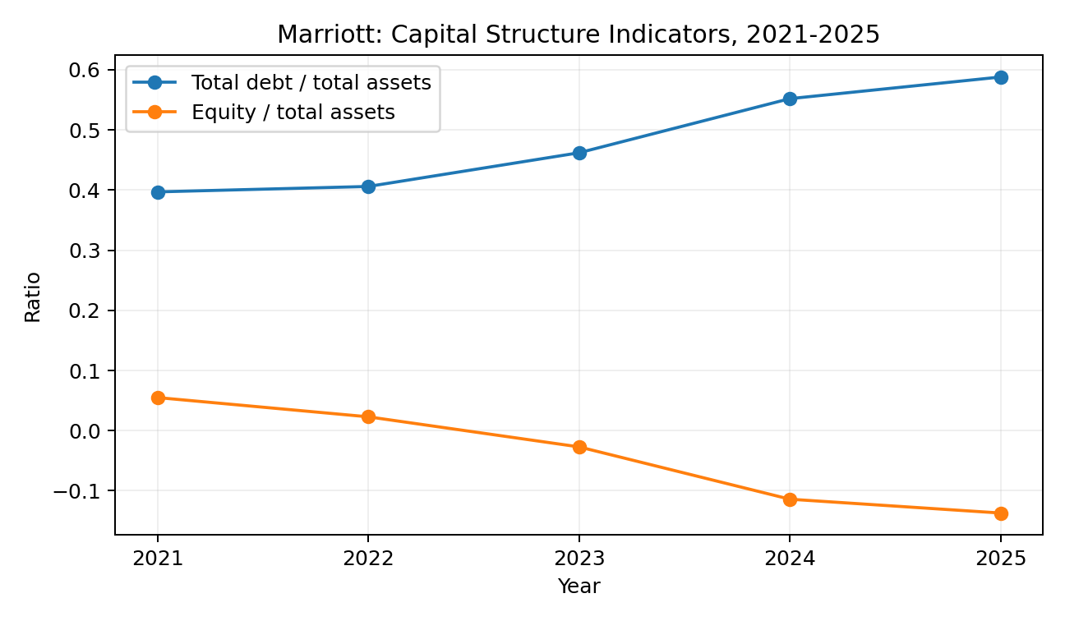
Source: Author's calculations from Marriott International annual reports (2022-2026).

2.5 Overall financial strengths and threats
Overall, Marriott is financially more aggressive than the income statement alone indicates, while having robust operations. Fee growth, operating cash generation, and a scalable asset-light approach are its key advantages. The main risks include negative book equity, growing indebtedness, and limited conventional liquidity. Rebalancing capital allocation is consequently the CFO's top task in order to prevent shareholder dividends from impairing Marriott's ability to finance expansion or withstand a future travel shock.

3. Working Capital Management Analysis

3.1 Cash operating cycle and liquidity position
Controlling short-term assets and liabilities is the focus of working-capital management, which helps the company fulfilll its commitments without having too many idle resources. The trade-off between liquidity and profitability is highlighted by Atrill and McLaney (2022). While an aggressive working-capital policy can increase efficiency while raising susceptibility, retaining more cash might minimize financial risk but may lower profits. Marriott's stance serves as an example of this conflict. While receivable days decreased by nearly ten days, the cash conversion cycle improved from 30.5 days in 2021 to 26.7 days in 2025. This implies increased effectiveness in collecting. Nevertheless, current liabilities continued to be much higher than current assets, indicating that operating-cycle efficiency has not resulted in a traditionally high current ratio.
This outcome can be somewhat explained by Marriott's organizational structure. Significant sums related to hotel owners, franchisees, credit card partners, and the Bonvoy reward program are received and settled by the group. Liabilities may arise prior to the completion of the associated economic service due to deferred income and loyalty commitments. Due in part to member points and the delay of revenue recognition, Marriott stated in 2024 that current and non-current deferred revenue had climbed to $1.299 billion and the guest loyalty liability had increased to $7.519 billion (Marriott International, 2025). This indicates that some of the claimed working-capital difficulties is not due to poor trading but rather to the timing of customer and loyalty commitments. However, those commitments still need to be managed, and while liabilities and debt deadlines exist, a sharp decline in travel demand might reduce cash inflows.

3.2 Recommended working-capital reforms
Strengthening receivables control without jeopardizing ties with hotel owners and franchisees is the first suggestion. With automated escalation of past-due amounts and more transparent accountability for collection, Marriott should divide its receivables by counterparty, geography, age, and risk. Since owners are strategic partners whose financial well-being influences Marriott's own system growth, the goal shouldn't be to arbitrarily reduce credit periods. Rather, the CFO should set different conditions for strong and weak counterparties and utilize rolling projections to find instances in which fee increase does not match receivable growth. According to recent research on working-capital management, the cash conversion cycle and its elements can have an impact on business performance, however the impacts differ depending on the component and economic environment (Jaworski & Czerwonka, 2024). This encourages a focused strategy as opposed to a strictly mechanical one.
Establishing clear internal liquidity criteria that affect discretionary capital disbursements is the second reform. Cash, committed undrawn facilities, near-term debt maturities, and stress-tested operational cash flow should all be used to determine Marriott's minimal amount of immediately accessible liquidity. Share repurchases should naturally slow down before crucial operating or strategic investment is cut if liquidity drops below the internal threshold. This would acknowledge that distributions are optional while maintaining the flexibility of repurchases. The strategy is in line with data showing that companies respond to debt and liquidity constraints by varying their buyback activity (Kulchania and Sonika, 2023). Additionally, it would resolve the conflict between substantial shareholder payments and a current ratio that stays close to 0.4.
The third change relates to spatial treasury management and cash forecasting. Due of its global reach, Marriott's cash flows are subject to various banking systems, currencies, and economic situations. Therefore, rolling short-term cash predictions by major location and currency should be maintained by a central treasury function, including with scenario analysis for unexpected travel disruptions, owner default, or limited capital mobility. While local liquidity buffers should be kept in places where currency restrictions or geopolitical threats might cause transfers to be delayed, surplus balances should be concentrated where it is both legally and tax-efficiently viable. Without forcing Marriott to maintain needlessly high cash reserves in every market, these changes would increase visibility and lessen the need for emergency borrowing.

3.3 Short-term versus long-term financing
For brief changes in operating capital, short-term financing is still suitable. Marriott makes use of commercial paper and credit facilities, which offer flexibility in situations when cash transactions and payments are made at different times. According to the company's 2023 annual report, its leverage covenant was being met, and its credit facility, access to capital markets, and anticipated operational cash production were sufficient to fulfill liquidity requirements (Marriott International, 2024). When cash sources improve, short-term borrowing might be more affordable and swiftly repaid. Refinancing risk is one of its weaknesses since market confidence might decline at the very moment when a business most needs funding. For long-term investments or structural finance requirements, relying solely on short-term funding would be unsuitable.
Long-term debt is more in line with investments that pay off over a number of years and offers more certainty regarding maturity. Although Marriott has access to this market thru its current senior-note structure, further long-term borrowing would raise leverage from an already high position. While Marriott is still profitable and cash-generating, equity financing seems unneeded and potentially dilute current owners while lowering financial risk. Therefore, a maturity-matching approach is the recommended financing strategy: long-term debt should be saved for projects with long-term cash advantages and positive risk-adjusted value, while commercial paper and revolving facilities should support short-term working-capital needs. Until leverage levels down, a greater portion of investments should be financed by retained operational cash flow. Liquidity is safeguarded by this well-balanced structure without producing an undue cash drain.

4. Strategic Financial Restructuring Plan

4.1 Restructuring objective
Due to its continued profitability and significant operational cash flow, Marriott does not need a crisis restructuring. Instead, the necessary reorganization is a deliberate change in how growth, leverage, and shareholder dividends are balanced. Rebuilding financial flexibility while maintaining Marriott's asset-light expansion approach should be the goal. While aggressive debt repayment might limit alluring brand and technology investment, abruptly stopping dividends or repurchases could give investors an unduly negative signal. Therefore, the suggested strategy includes disciplined acquisitions, conditional share repurchases, selective asset divestiture, and mild deleveraging. The plan's integration is what makes it valuable; each action promotes flexibility and liquidity without needing Marriott to give up its current business model.

4.2 Debt and shareholder distributions
Redirecting a portion of the yearly free cash flow from share repurchases toward debt reduction is the first restructuring step. Rather than being absolute, this should be done gradually. There is no proof that an emergency repayment plan is necessary because Marriott's long-term debt includes a significant fixed-rate component and a comparatively lengthy duration. However, according to the income statement, debt rose to almost $16.204 billion in 2025, and interest costs were $809 million. Lowering incremental borrowing would safeguard interest coverage and maintain the ability to make smart investments in the future. A sensible strategy might permit greater repurchases when leverage and liquidity are comfortably within goal, but prioritize debt reduction when leverage exceeds a Board-approved range or when operational cash flow dramatically declines.
It is important to recognize the mixed impact on shareholder value. The short-term rate of EPS growth and cash distributed to shareholders may be slowed by fewer repurchases. lessen debt, however, can lessen financial risk and the likelihood that Marriott will have to limit investment during a downturn. Because businesses may adjust the timing and number of buybacks in response to financial conditions, repurchase flexibility is advantageous in and of itself (Kulchania and Sonika, 2023). Therefore, rather than rejecting shareholder payouts, the proposed policy makes them contingent on the health of the balance sheet. This matches discretionary payouts with the company's ability to absorb risk, making it more defendable than funding distributions indirectly by increasing debt.

4.3 Selective divestiture and asset-light expansion
Because selective divestiture aligns with Marriott's current strategy, it is especially appropriate for the firm. According to Marriott International (2026), the company has sold lodging facilities in the past, frequently while maintaining long-term management agreements. Over time, it aims to reduce the amount of capital involved in the firm thru asset sales subject to management or franchise agreements. While maintaining recurring revenue connections, selling capital-intensive assets might free up funds for debt repayment or higher-return strategic investments. Non-ownership structures can offer higher economic efficiency and lower financial risk than ownership-heavy development, according to research on hotel expansion methods (Mulet-Forteza et al., 2024). Therefore, both Marriott's own practices and broader hospitality facts support the financial logic.
However, divestiture has its limitations. While a very asset-light structure increases reliance on owners' willingness and capacity to invest, ownership can offer direct control over property standards, refurbishment schedules, and operational choices. Therefore, Marriott should refrain from making careless disposals. The projected return on invested capital, strategic significance, brand demonstration value, and the likelihood that a management agreement can be maintained should all be taken into consideration when evaluating assets. Disposing of assets when ownership requires a large amount of cash without yielding a return high enough to offset the increased risk and capital intensity is the recommended course of action.

4.4 Acquisitions and equity financing
Future purchases should be carefully chosen and concentrated on brands, clientele groups, or geographical capacities that can be expanded via the Bonvoy ecosystem and Marriott's distribution. In addition to adding properties to the system, the 2025 citizenM acquisition resulted in a financial outflow of almost $350 million (Marriott International, 2026). This demonstrates how Marriott can speed up growth thru brand purchases without having to buy every underlying hotel property. Large debt-funded acquisitions, however, ought to be subject to further scrutiny given the current leverage position. After taking execution risk into account, acquisition bids should show a return above the applicable cost of capital, increased fee generation, and genuine integration advantages.
Under the current circumstances, a significant equity infusion is not advised. Marriott continues to turn a profit, has access to financial markets, and produces a sizable amount of operational cash flow. At a time when internal funds and selective asset sales offer other sources of cash, issuing a significant amount of new shares might dilute current shareholders. Instead of being a regular source of capital, equity should continue to be a backup plan in case of a transformational deal or a significant decline in leverage. The incompleteness of book-equity metrics in Marriott's case is also acknowledged by this ruling: negative accounting equity is mostly impacted by treasury stock and does not always indicate that the business lacks financial resources or economic worth.

4.5 International, taxation, currency and inflation considerations
Exposure to other countries makes the reorganization strategy more difficult and scalable. Foreign subsidiaries of Marriott often utilize the currency of their core economic environment as their functional currency. Marriott works across numerous geographies and currencies. Period-end rates are used to convert assets and liabilities into US dollars, whereas average rates are used to translate income-statement items. Therefore, even when local operations remain unaffected, translation movements have an impact on reported equity and performance (Marriott International, 2022). Currency impacts can vary greatly across years, as seen by the fact that foreign-currency translation adjustments were notably negative in 2024 and positive in 2025 (Marriott International, 2026). When feasible, the CFO should match local currency revenues, expenses, and financing to employ natural hedging. Financial hedging should be utilized sparingly when risks are significant and predictable.
Wages, energy, renovation, building, and finance expenses all increase due to inflation. Although Marriott's asset-light structure gives hotel owners a lot of exposure at the property level, increased owner expenses may still cause growth and renovations to be delayed. Therefore, the CFO should maintain the ability to fund strategically significant projects without permitting loans or guaranties to regularly replace owner capital. Additionally, since short-term tax benefits may be outweighed by reputational and regulatory expenses, international tax strategy should continue to be economically sound and comply with the law.
Capital allocation is also impacted by geopolitical and political issues. Demand may be rapidly changed by travel restrictions, sanctions, conflicts, changes in government expenditure, and local regulatory choices. While international RevPAR growth was greater overall and Greater China continued to be impacted by tougher macroeconomic conditions, Marriott observed softer demand in several U.S. select-service hotel areas in 2025, which was partially linked to weaker government travel (Marriott International, 2026). Regional diversification lessens reliance on a single market, but it also necessitates that investment choices take nation risk and the capacity to repatriate funds into account. Therefore, in areas where political or capital-control risk is high, international expansion should be phased gradually and rely more on franchise or management contracts.

4.6 Ethical and CSR considerations
Additionally, the reorganization strategy must to be morally sound. Marriott's Serve 360 framework offers a formal framework for environmental and social priorities and connects its sustainability and social impact goals to the Sustainable Development Goals of the United Nations (Marriott International, 2025b). These concerns shouldn't be viewed as distinct from financial strategy from the standpoint of a CFO. Operating expenses, regulatory exposure, brand reputation, and consumer loyalty may all be impacted by energy efficiency, ethical sourcing, employe practices, human rights restrictions, and data protection. Additionally, Marriott said that by 2025, it had surpassed a total goal of 15 million volunteer hours (Marriott International, 2026). The durability of cash flows can be impacted by ethical performance, which is why it should be included in long-term risk assessment even if community involvement does not directly justify an investment with a negative net present value.
Overall, the reorganization is purposefully balanced: Marriott should use more internally produced cash to decrease leverage while continuing asset-light global expansion. Conditional repurchases, selected disposals, and additional long-term borrowing should all be connected to investments that generate long-term value.

5. Investment Appraisal and Capital Budgeting

5.1 Investment appraisal approach
An organized method for determining whether long-term projects are anticipated to produce enough financial returns to warrant the cash invested is investment evaluation. This is especially crucial for Marriott International since, despite the company's impressive cash creation and operating recovery, its balance sheet has grown more leveraged. As a result, Marriott must differentiate between initiatives that foster strategic expansion and those that deplete financial resources without producing a sufficient return. Each of the three suggested initiatives will bring in money over a five-year period and require an initial expenditure of £50 million. A 10% discount rate is used, and straight-line depreciation to zero is assumed in compliance with the assessment brief. As a result, each project has an annual depreciation of £10 million.
Payback Period (PBP), Accounting Rate of Return (ARR), Net Present Value (NPV), Profitability Index (PI), and Internal Rate of Return (IRR) are the five evaluation methods that are employed. Because each method focuses on a different area of financial performance, using many approaches allows for a more comprehensive examination. Whereas ARR takes accounting profitability into consideration, payback focuses on how quickly the initial investment is recouped. Because they take into account the time value of money, NPV, PI, and IRR are more suited for evaluating the financial appeal of longer-term investment choices. Since NPV calculates the predicted increase or decrease in shareholder value after accounting for the necessary rate of return, it should be given special consideration (Atrill and McLaney, 2022).
Table 5.1: Summary of Investment Appraisal Results
Appraisal method | Project A | Project B | Project C | Relative preference
Payback Period | 4.50 years | 4.55 years | 3.60 years | C
ARR | 1.60% | 2.00% | 6.00% | C
NPV at 10% | -£8.68m | -£8.31m | -£1.98m | C
Profitability Index | 0.826 | 0.834 | 0.960 | C
IRR | 2.64% | 3.26% | 8.59% | C
Source: Author's calculations based on project information provided in the assessment brief. Detailed calculations are presented in Appendix C.

5.2 Payback Period and Accounting Rate of Return
The payback calculation determines the rate at which undiscounted cash inflows replenish the initial £50 million investment. By the conclusion of the fourth year, Project A had brought in a total of £46 million. A payback term of 4.50 years results from recovering the remaining £4 million from the £8 million received in year five. Project B needs around 0.55 of the £11 million inflow for the fifth year, resulting in a payback period of roughly 4.55 years, as it earns £44 million by the end of the fourth year. Because cumulative inflows total £35 million at the end of year three, Project C performs significantly better. A payback period of 3.60 years is achieved by recovering the remaining £15 million from the £25 million received in year four.
Because Marriott would return its original investment nearly a year sooner under Project C than under Projects A or B, PBP believes that Project C is better. In situations when liquidity and financial flexibility are issues, a quicker recovery is especially important. Payback, however, shouldn't make the choice on its own. Any cash flows received beyond the repayment date are disregarded, as is the time value of money. As a result, it measures liquidity exposure more accurately than total shareholder value generation.
The similar project ranking is produced by ARR. The £50 million investment will depreciate by £10 million annually if straight-line depreciation is applied over a five-year period. With total cash inflows of £54 million, Project A makes an average yearly profit of £0.8 million and a total accounting profit of £4 million. An ARR of 1.60% is obtained by using the original investment as the denominator. Project B generates an ARR of 2.00% with total inflows of £55 million and an average yearly accounting profit of £1 million. Project C generates £15 million in total accounting profit and £65 million in total cash inflows, which translates to an average annual profit of £3 million and an ARR of 6.00%. As a result, Project C offers the highest accounting return. However, ARR should be regarded as supporting evidence rather than the primary investment criteria because it does not discount future returns and employs accounting profit rather than cash flow.

5.3 Net Present Value and Profitability Index
Because each future cash stream is discounted at Marriott's projected 10% needed return, NPV offers a more thorough evaluation. Project A's projected cash inflows have a present value of around £41.32 million. Its net present value (NPV) is around -£8.68 million after subtracting the initial investment of £50 million. Project B generates an NPV of around -£8.31 million and a present value of about £41.69 million. With a present value of around £48.02 million and an NPV of roughly -£1.98 million, Project C performs significantly better.
The fact that all three NPVs are negative is the crucial point. Despite being far superior to Projects A and B, Project C is still unable to provide enough discounted cash flows to cover the investment and yield the necessary 10% return. Thus, it is crucial to distinguish between the best project and an acceptable project. Although Project C is the best of the three options, if Marriott has the choice not to invest, then all three should be rejected according to standard NPV decision principles. Because it indicates the expected value gained or destroyed by the investment, net present value (NPV) is especially pertinent to this decision (Atrill and McLaney, 2022).
This finding is supported by the profitability index. The PI for Projects A, B, and C is around 0.826, 0.834, and 0.960, respectively. If the present value of future cash inflows is greater than the initial investment, the PI is over 1.0; if it is less than 1.0, the discounted benefits are insufficient. Each of the three projects fails the standard acceptance criterion since their PI values are less than one. Project C yields the best relative result once more, but under the given assumptions, its PI of around 0.960 indicates that each £1 invested only produces about £0.96 in discounted cash inflows.

5.4 Internal Rate of Return
The discount rate at which a project's net present value (NPV) drops to zero is represented by IRR. IRRs for Projects A, B, and C are around 2.64%, 3.26%, and 8.59%, respectively. None of the projects satisfy the IRR approval criterion since the necessary return is 10%. Project C outperforms the alternatives once more, although its anticipated return is still below The anticipated hurdle rate for Marriott.
The financial conclusion is very solid because NPV, PI, and IRR concur. At a needed return of 10%, all three discounted appraisal techniques reject the projects. While NPV is still more instructive for shareholder-value analysis since it shows the real monetary value predicted to be produced or lost, IRR is helpful because a percentage return is intuitive for decision-makers. Therefore, when both Project C's NPV and PI stay below the necessary levels, its comparatively high IRR should not be utilized to support adoption.

5.5 Financial and non-financial evaluation of Project C
Project C should be suggested if the Board only allows one project to be chosen, as it is ranked highest across all assessment methods. However, this suggestion must be taken into account in addition to Marriott's financial situation. In 2025, Marriott produced $3.212 billion in operational cash flow and maintained a high level of profitability, demonstrating significant internal investment capacity (Marriott International, 2026). The company's overall debt rose to about $16.2 billion, although its current ratio stayed at about 0.43. These requirements imply that financial capability and a duty to invest are not the same thing. Before investing more money, a corporation with increasing leverage and comparatively little traditional liquidity should demand that prospective initiatives show compelling risk-adjusted returns.
However, if significant advantages are not included in the provided cash flows, non-financial factors may change the economic result. For Marriott, customer loyalty is very important. Longer-term gains beyond the five-year projection might result from an investment that fortifies Marriott Bonvoy, enhances customer satisfaction, or boosts customer retention. In a similar vein, a strategically significant initiative might enhance Marriott's competitive positioning or facilitate entry into a developing market. These elements would only make Project C's argument stronger if management could offer solid proof that they produce more financial gains in the future.
The reverse is also true. Actual cash flows from an overseas enterprise may be lowered by political unrest, geopolitical conflict, fluctuations in foreign currencies, changes in regulations, and limitations on capital transfers. These risks are significant because of Marriott's international activities. Therefore, it is also important to take into account implementation risk, cybersecurity, brand reputation, and the financial stability of local owners or partners. Rather than immediately encouraging investment, these dangers make the case for caution. Instead of depending just on qualitative reasons, management should quantify the incremental advantages thru updated cash-flow scenarios prior to final approval if strategic benefits are anticipated to turn Project C's net present value from negative to positive.

5.6 Capital rationing under the £100 million constraint
Capital rationing is the last prerequisite. Marriott may potentially take on two projects because each project needs £50 million and there is a maximum of £100 million available. The combined net present value (NPV) of Projects A and B is around -£16.98 million. around -£10.66 million is produced when A and C are combined, and around -£10.29 million is produced when B and C are combined.
Table 5.2: Capital Rationing Analysis
Project combination | Total investment | Combined NPV
A + B | £100m | -£16.98m
A + C | £100m | -£10.66m
B + C | £100m | -£10.29m
Source: Author's calculations based on project information provided in the assessment brief.
Because the B+C combination generates the highest, or least negative, combined NPV, Marriott should choose it if it must choose between two projects. This does not imply that B+C generates value for shareholders, nevertheless. Instead of mandating that the whole £100 million be spent, the brief states that a maximum of £100 million can be expended. The financially better capital-rationing choice is to spend £0 in each of the three initiatives and save the money for a future positive-NPV opportunity since each individual project has a negative net present value. The goal of disciplined capital allocation would be undermined by spending the available budget just because it existed..

5.7 Final investment recommendation
Out of the three suggested investments, Project C is unquestionably the best overall. It has the lowest negative net present value (NPV) at around -£1.98 million, the greatest ARR at 6.00%, the highest PI at roughly 0.960, the best IRR at roughly 8.59%, and the shortest payback period at 3.60 years. Even yet, it is not a financially viable option just because it is the strongest. Under the given cash-flow assumptions, its negative NPV and IRR below the 10% necessary return show that it is anticipated to decrease rather than increase shareholder value.
Therefore, the main advice is that Marriott should reject all three initiatives and save its money for investments that can provide a positive net present value. Subject to additional proof that customer loyalty, market entrance, or other strategic advantages may offset Project C's negative net present value (NPV), Project C should be chosen if the Board mandates that only one project be executed for strategic reasons. B+C is the best option if two projects must be chosen within the £100 million cap, but it shouldn't be chosen intentionally due to its negative combined net present value. Given Marriott's combination of strong profitability and cash generation with growing leverage and weak conventional liquidity, this recommendation is especially appropriate. It shows that capital-budgeting decisions should concentrate on sustainable value creation rather than just using up all available investment funds.

6. Conclusion
Strong operating recovery and a more aggressive finance structure are both evident in the five-year examination. Marriott's asset-light business is scalable, as seen by the significant improvements in revenue, fee income, and operational cash flow. Therefore, Marriott is not in financial difficulty; the strategic goal is to maintain these operational capabilities while regaining financial flexibility.
Instead, the relationship between capital allocation, leverage, and liquidity is the main focus of CFOs. While total debt increased to almost $16.2 billion and shareholders' equity grew more negative, the current ratio stayed below one over the time and was roughly 0.43 in 2025. Marriott also made significant investments in dividends and share repurchases. Therefore, maintaining the asset-light model while making shareholder distributions more dependent on liquidity and leverage, utilizing a portion of free cash flow for moderate deleveraging, continuing selective asset sales where management or franchise agreements can be retained, and restricting large debt-funded acquisitions to opportunities with clearly demonstrated strategic and financial returns are the suggested restructuring strategies. Risks related to international currency, inflation, taxes, politics, and ethics should all be taken into consideration while making judgments.
The investment appraisal emphasizes how important it is to allocate resources in a systematic manner. Despite being the strongest of the three ideas, Project C's NPV is still negative by around £1.98 million, and its IRR is about 8.59%, which is less than the 10% necessary return. Therefore, if the Board is free to decide not to invest, all three projects should be turned down. Despite having a negative combined NPV, B+C is the optimal combination under a forced two-project option. Therefore, rather than expansion at any costs, the overarching CFO approach is one of selective growth: While restoring financial flexibility and only authorizing new investments where the anticipated risk-adjusted return supports sustainable long-term shareholder value, Marriott should safeguard the cash-generating aspects of its business model.

References
Atrill, P. and McLaney, E. (2022) Accounting and Finance for Non-Specialists. 12th edn. Harlow: Pearson.
Jaworski, J. and Czerwonka, L. (2024) 'Profitability and working capital management: a meta-study in macroeconomic and institutional conditions', Decision, 51(1).
Kulchania, M. and Sonika, R. (2023) 'Flexibility in share repurchases: Evidence from UK', European Financial Management, 29(1), pp. 196-246. doi: 10.1111/eufm.12359.
Marriott International, Inc. (2022) 2021 Annual Report. Bethesda, MD: Marriott International, Inc.
Marriott International, Inc. (2023) 2022 Annual Report. Bethesda, MD: Marriott International, Inc.
Marriott International, Inc. (2024) 2023 Annual Report. Bethesda, MD: Marriott International, Inc.
Marriott International, Inc. (2025a) 2024 Annual Report. Bethesda, MD: Marriott International, Inc.
Marriott International, Inc. (2025b) 'What is Serve 360?'. Available at: https://help.marriott.com/s/article/marriott-serve-360-sustainability (Accessed: 10 August 2026).
Marriott International, Inc. (2026) 2025 Annual Report. Bethesda, MD: Marriott International, Inc.
Mulet-Forteza, C., Ferrer-Rosell, B., Martorell Cunill, O. and Linares-Mustarós, S. (2024) 'The role of expansion strategies and operational attributes on hotel performance: a compositional approach'. arXiv:2411.04640.
Sokolov, M.V. (2023) 'NPV, IRR, PI, PP, and DPP: a unified view'. arXiv:2302.02875.
Talreja, S. (2023) 'The systematic literature review: an overview on working capital management and profitability', Journal of Business Administration and Management Sciences, 5(1), pp. 21-30. doi: 10.58921/jobams.5.1.87.
Zeidan, R. and Shapir, O.M. (2017) 'Cash conversion cycle and value-enhancing operations: Theory and evidence for a free lunch', Journal of Corporate Finance, 45, pp. 203-219.

Appendices

Appendix A: Marriott International Five-Year Ratio Tables (2021-2025)
Table A1: Five-year ratio analysis extracted from the Excel appendix
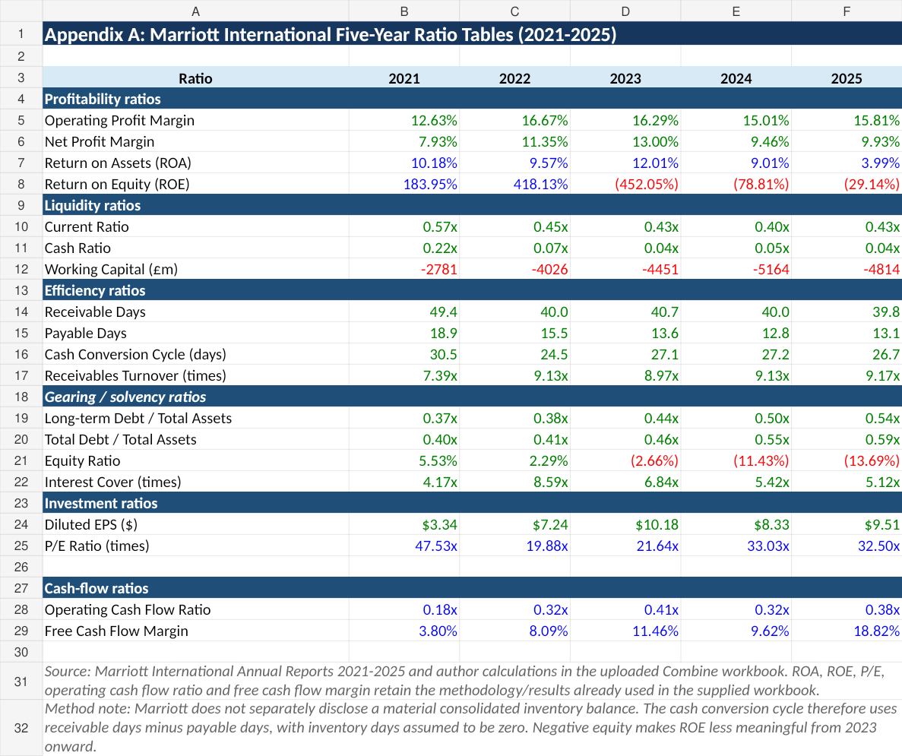
Source: Marriott International Annual Reports 2021-2025 and author's calculations in the uploaded Combine workbook. The table preserves the calculation methodology used in the supporting Excel appendix.

Appendix B: Ratio Tables and Graphs
Figure B1: Five-year ratio trends: profitability, liquidity, capital structure and cash conversion cycle
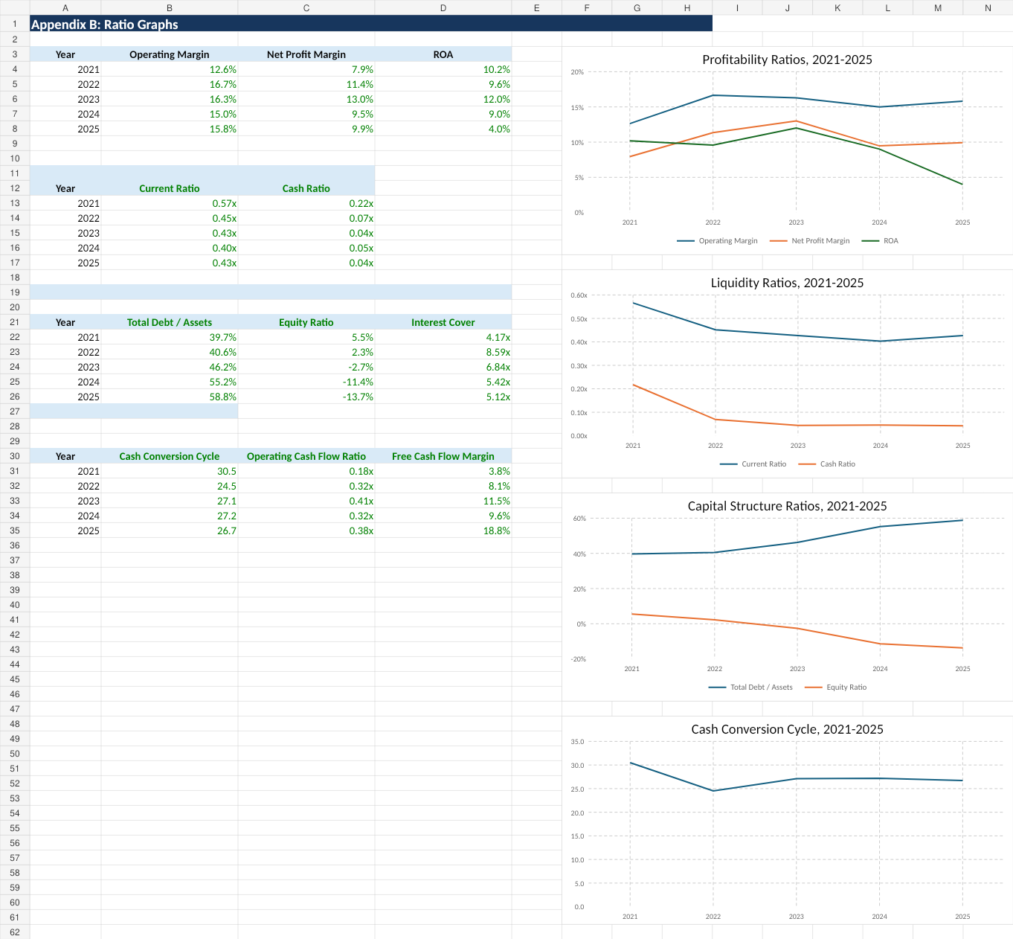
Source: Author's Excel analysis based on Marriott International Annual Reports 2021-2025 and the uploaded five-year workbook.

Appendix C: Investment Appraisal Calculations (Excel Output)
Table C1: Project cash flows, discount factors, present values and appraisal results
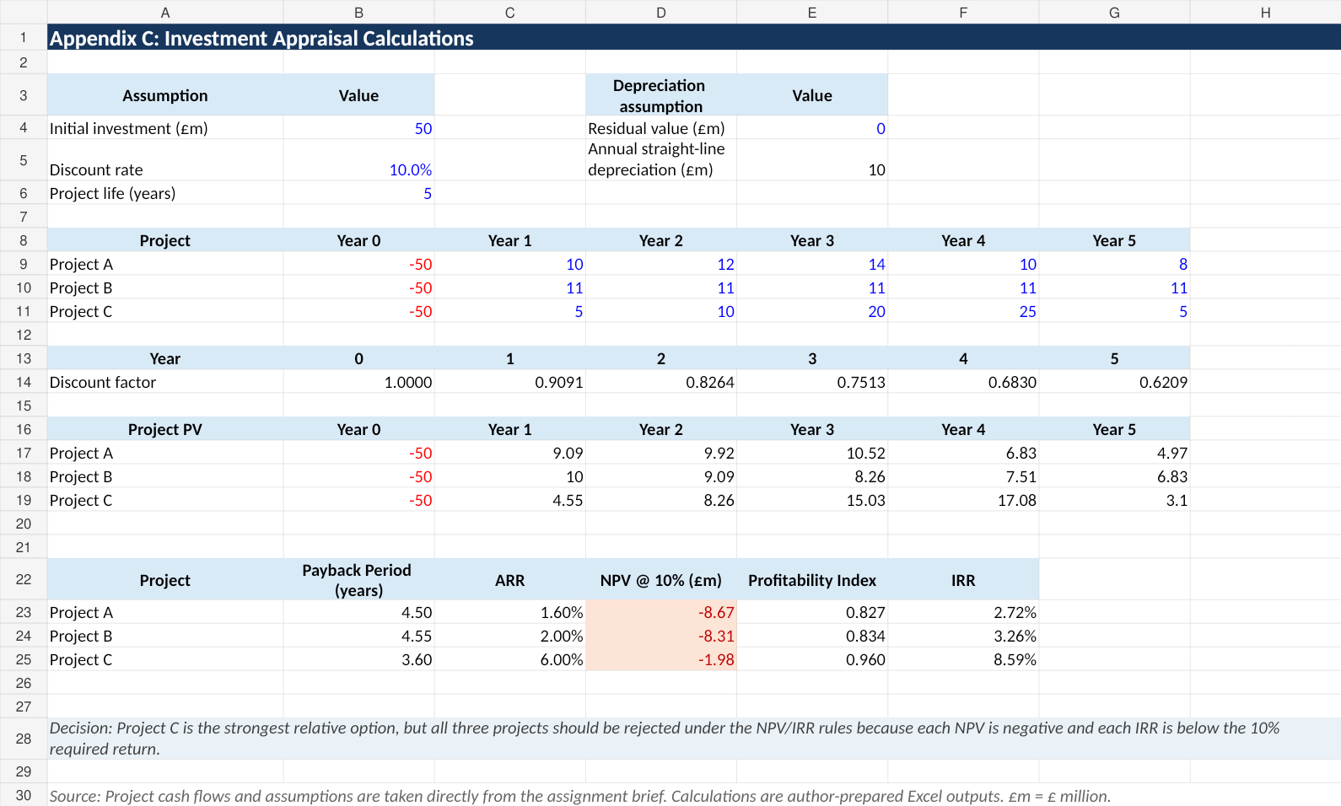
Source: Project cash flows and assumptions are taken from the assessment brief. Calculations are author-prepared Excel outputs. £m = £ million.
A five-year project life, a 10% discount rate, and straight-line depreciation of £10 million annually to a zero residual value are all applied in the Excel result. With the shortest payback period, best ARR, highest profitability index, highest IRR, and least negative net present value, Project C is the strongest comparable alternative. However, at the necessary 10% return, all three proposals fall short of the absolute NPV and IRR acceptability criteria.

Appendix D: Capital Rationing under the £100 Million Maximum Investment
Table D1: Two-project combinations and combined NPV
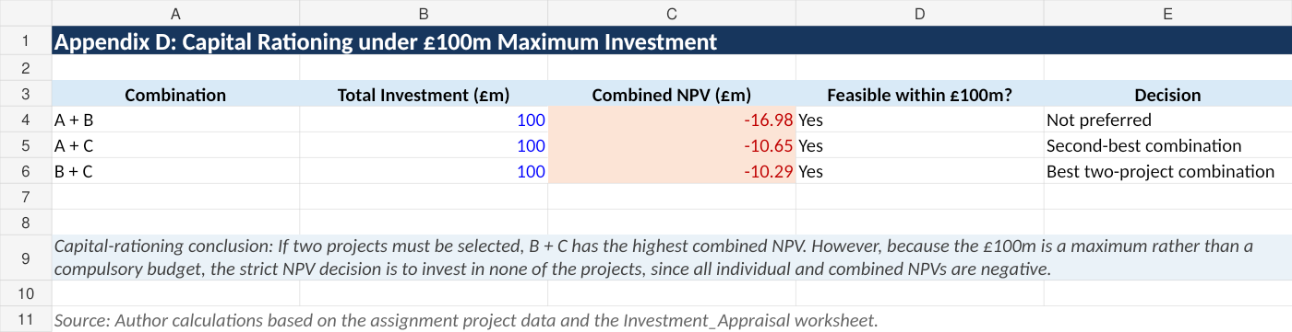c
Source: Author's calculations based on the assessment project data and the investment-appraisal Excel worksheet.

Appendix E: Methodological Notes
Marriott's annual reports and the downloadable five-year workbook are the sources of the ratio numbers. The cash conversion cycle is computed using receivable days less payment days, with inventory days assumed to be zero, as Marriott does not independently declare a meaningful consolidated inventory balance. From 2023 forward, return on equity is read conservatively as shareholders' equity turns negative. The investment evaluation makes the following assumptions: there is no terminal value, the £50 million expenditure happens at time zero, yearly project cash inflows happen at year-end, and the cash inflows listed in the assessment brief reflect the pertinent project cash flows. In accordance with the Excel appendix's straight-line depreciation assumption, ARR is computed by dividing the average yearly accounting profit by the initial investment.

