The main focus of this task is the comparison of the difference in two groups that are the young students and the mature students to the satisfaction of university experience. In details, the scores of Mature students in test are 45, 38, 52, 48, 25, 39, 51, 46, 55, 46 and the Young students are 34, 22, 15, 27, 37, 41, 24, 19, 26, 36.

The principle of T test is to use the theory of t-distribution. Because the T test is used to test the distribution with small size, and the σ(standard deviation) does not know, so I decided to use T test to analyze this task.

I．Two-Tailed Test
The steps and the details are followed:

- The first step is to come up with a question of two groups:
Is there a significant difference between two groups?

- An appropriate set of testable hypotheses for the experiment:
- The H₀ is : $μ_{1}= μ_{2}$
- The H₁ is : $μ_{1}≠$ $μ_{2}$

- Select $α$(significant level):
- $α$₁ = 0.10
- $α$₂ = 0.01
- $α$₃ = 0.02

- Calculate t_{obt} :
$$t_{obt}=\frac{{\overline{X}}_{1}-{\overline{X}}_{2}}{\sqrt{\frac{{SD}_{1}^{2}+{SD}_{2}^{2}}{n}}}$$
n₁ = 10 n₂ = 10
$${\overline{X}}_{1}=\frac{45+38+52+48+25+39+51+46+55+46}{10}=44.5$$
$${\overline{X}}_{2}=\frac{34+22+15+27+37+41+24+19+26+36}{10}=27.9$$
SD2 1 = 68.18
SD2 2 = 65.73
t_{obt =} 4.5363

- Find $t_{crit}$:
- degrees of freedom, which is simply df = n-2 = 10 + 10 – 2 = 18
- $α$₁ = 0.10
$α$₂ = 0.01
$α$₃ = 0.02
- Cross-referencing the figure1 with df = n-2 = 18(the degree of freedom) and
$α$₁ = 0.10 (the level of significance) gives us: $t_{crit}$₁ = 1.734
- Cross-referencing the figure1 with df = n-2 = 18(the degree of freedom) and
$α$₂ = 0.01 (the level of significance) gives us: $t_{crit}$₂ = 2.88
- Cross-referencing the figure1 with df = n-2 = 18(the degree of freedom) and
$α$₃ = 0.02 (the level of significance) gives us: $t_{crit}$₃ = 2.552

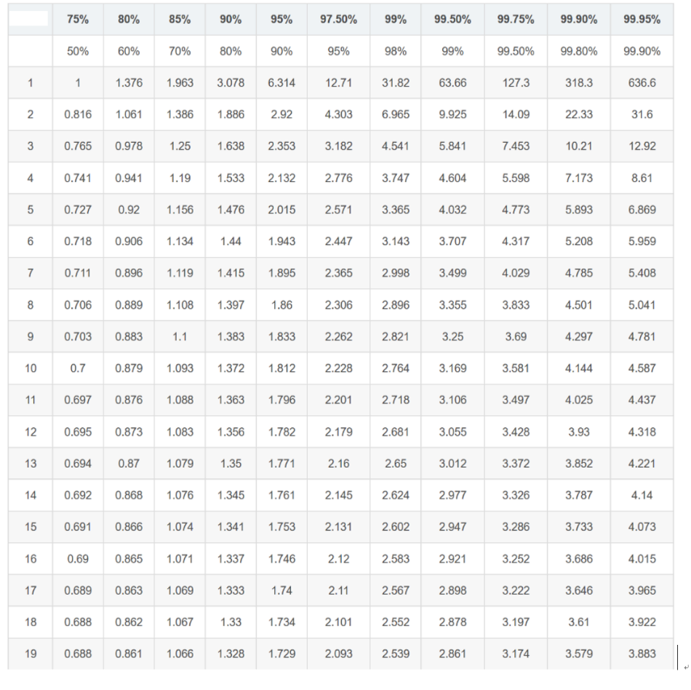
Figure 1

- Compare t_{obt} = 4.5363 and $t_{crit}$
- The result of 4.5363 is higher than $t_{crit}$₁ = 1.734, so p(H₀)<$α$₁ and we can reject H₀ & accept H₁. Therefore, there is a significant difference between two groups.
- The result of 4.5363 is higher than $t_{crit}$₂ = 2.88, so p(H₀)<$α$₂ and we can reject H₀ & accept H₁. Therefore, there is a significant difference between two groups.
- The result of 4.5363 is higher than $t_{crit}$₃ = 2.552, so p(H₀)<$α$₃ and we can reject H₀ & accept H₁. Therefore, there is a significant difference between two groups.

- Outliers in the data:
- In the Mature students group, there is a score, 25 that can be seen as a outlier duo to the big difference compared to others’ scores.
- If we discard this value: ${\overline{X}}_{1}=\frac{45+38+52+48+39+51+46+55+46}{9}=46.667$
SD2 1 $=33.51$
Note : Obviously, the value with outlier is of distinct difference to the value without the outlier in the Mature students group.
- Furthermore, t_{obt} = 5.744
- Compare tobt = 5.744 and $t_{crit}$
The result of 4.5363 is higher than $t_{crit}$1 = 1.33, so p(H0)<$α$1 and we can reject H0 & accept H1. Therefore, there is a significant difference between two groups.
The result of 4.5363 is higher than $t_{crit}$2 = 2.90, so p(H0)<$α$2 and we can reject H0 & accept H1. Therefore, there is a significant difference between two groups.
The result of 4.5363 is higher than 2.88 > $t_{crit}$3, so p(H0)<$α$3 and we can reject H0 & accept H1. Therefore, there is a significant difference between two groups.
- In conclusion, without the outlier value there is not a significant change in outcome.

- Note the factors on hypothesis testing:
(1) There must be a rigorous sampling study design; the samples must be randomly selected from the homogeneous population. To ensure the balance between the groups and the comparability of the data, the other factors that may have impact to the results that is supposed to be as much as similar and same between the two groups.
(2) Correctly select the test method; choose the proper test method based on the existing data type, design type, analysis purpose, sample content and other factors to collect and organize. If the conditions are not met, the appropriate conversion can be made.
(3) Correctly understand the meaning of “no difference in significance”. The difference is statistically significant. It cannot be understood that the difference between the two is large, and it cannot be understood that the analyzed index has a “significant effect” in practical application.
(4) The inferred conclusion of the test hypothesis is a probabilistic conclusion, which cannot be absolute: the test level is artificial, and it is relative. The exact range of test statistic and P value should be listed when reporting the conclusion.
(5) Note whether it is a one-sided test or a two-sided test.

- During the investigation of the dataset, I found some features quite interesting:

$${\overline{X}}_{1}=\frac{45+38+52+48+25+39+51+46+55+46}{10}=44.5$$
$${\overline{X}}_{2}=\frac{34+22+15+27+37+41+24+19+26+36}{10}=27.9$$
SD2 1 = 68.18
SD2 2 = 65.73
The data we can see above shows that even though there is a significant difference between ${\overline{X}}_{1}$ and ${\overline{X}}_{2}$, but the SD2 1 is very similar to the SD2 2, which means, in my perspective, people in two groups may have the same criteria of evaluation to some extent while in terms of overall scores, people in Mature students group may more likely meet the satisfaction to the university experience.

$II$．One-Tailed Test
The steps and the details are followed:

- The first step is to come up with a question of two groups:
Is there a significant difference between two groups?

- An appropriate set of testable hypotheses for the experiment:
- The H₀ is : $μ_{1}≤ μ_{2}$
- The H₁ is : $μ_{1}>$ $μ_{2}$

- Select $α$(significant level):
$\left(1\right) α$₁ = 0.10
$\left(2\right) α$₂ = 0.01
$\left(3\right) α$₃ = 0.02

- Calculate t_{obt} :
$$t_{obt}=\frac{{\overline{X}}_{1}-{\overline{X}}_{2}}{\sqrt{\frac{{SD}_{1}^{2}+{SD}_{2}^{2}}{n}}}$$

n₁ = 10 n₂ = 10
$${\overline{X}}_{1}=\frac{45+38+52+48+25+39+51+46+55+46}{10}=44.5$$
$${\overline{X}}_{2}=\frac{34+22+15+27+37+41+24+19+26+36}{10}=27.9$$
SD2 1 = 68.18
SD2 2 = 65.73
t_{obt =} 4.5363
- Find $t_{crit}$:
- degrees of freedom, which is simply df = n-2 = 10 + 10 – 2 = 18
- $α$₁ = 0.10 $α$₂ = 0.01$α$₃ = 0.02
- Cross-referencing the figure1 with df = n-2 = 18(the degree of freedom) and
$α$₁ = 0.10 (the level of significance) gives us: $t_{crit}$₁ = 1.33
- Cross-referencing the figure1 with df = n-2 = 18(the degree of freedom) and
$α$₂ = 0.01 (the level of significance) gives us: $t_{crit}$₂ = 2.552
- Cross-referencing the figure1 with df = n-2 = 18(the degree of freedom) and
$α$₃ = 0.02 (the level of significance) gives us: $t_{crit}$₃ > 2.101 and $t_{crit}$₃ < 2.552

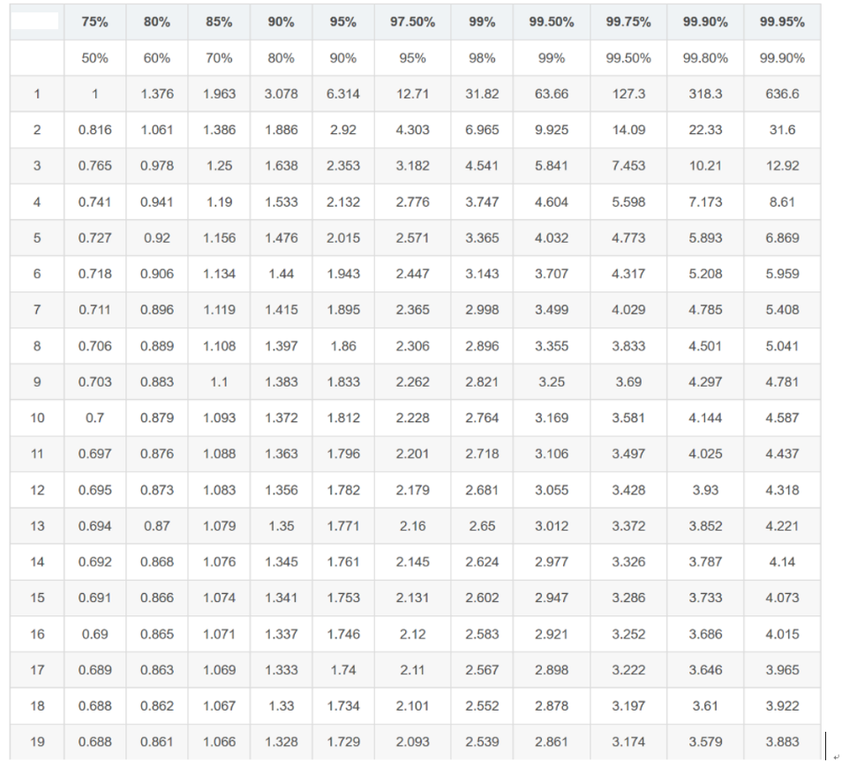
Figure 1

- Compare t_{obt} = 4.5363 and $t_{crit}$
- The result of 4.5363 is higher than $t_{crit}$₁ = 1.33, so p(H₀)<$α$₁ and we can reject H₀ & accept H₁. Therefore, the mean of Mature students group is higher than the younger students group and there is a significant difference between two groups.
- The result of 4.5363 is higher than $t_{crit}$₂ = 2.552, so p(H₀)<$α$₂ and we can reject H₀ & accept H₁. Therefore, the mean of Mature students group is higher than the younger students group and there is a significant difference between two groups.
- The result of 4.5363 is higher than 2.552 > $t_{crit}$₃, so p(H₀)<$α$₃ and we can reject H₀ & accept H₁. Therefore, the mean of Mature students group is higher than the younger students group and there is a significant difference between two groups.

