Elliot Jenkins 2029907

An investigation into the efficiency and power draw of compressed air within the Coal Injection Plant
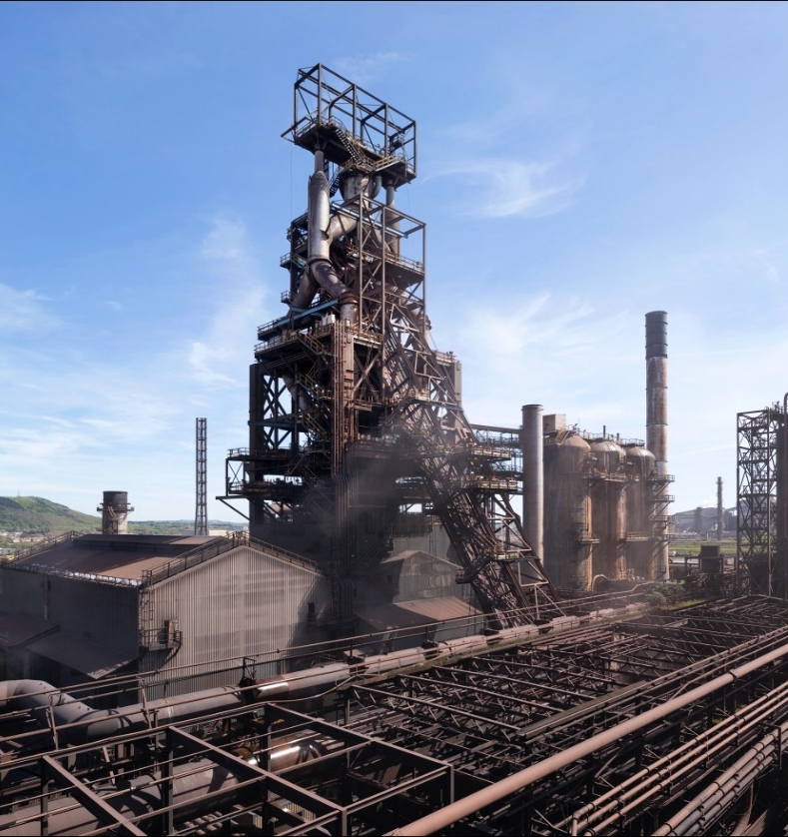

Abstract

This dissertation investigates the compressed air system's energy efficiency and power draw within the coal injection plant at Tata Steel's Port Talbot facility. The research aims to identify opportunities to enhance operational efficiency, reduce energy consumption, and improve the reliability of the coal injection process.

The study employs a comprehensive approach, including an air leak survey using ultrasonic detection and an airflow study utilising flow transmitters and power monitoring. The findings reveal significant inefficiencies, such as excessive air leakage from intentionally open drain valves, resulting in an estimated annual cost of £432,672, and severely underperforming compressors with an average efficiency of 66.44 kW/m³/min, far exceeding the target of 6.0 kW/m³/min.

Based on the research, the study provides actionable recommendations, including installing advanced Programmable Logic Controllers (PLCs), integrating desiccant dryers, and implementing a comprehensive leak detection and repair program. Additionally, the potential for heat recovery systems is explored, which could contribute to further energy savings.

The expected outcomes of this research align with Tata Steel's "Drive to Save" initiative, aiming to enhance operational efficiency, reduce energy consumption, and ensure the reliability and sustainability of the coal injection process. The findings and recommendations set a benchmark for sustainability and operational excellence in the steel industry.

‘This thesis is the result of the author’s original research. It has been composed by the author and has not been previously submitted for examination which has led to the award of a degree.’

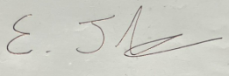
Signed: Date: 19/05/2024

Contents
1. Introduction 4
1.1 Aims and objectives of the project. 5
2. Timing plan 6
3 Research/literature survey. 8
3.1 Fundamentals of Compressed Air Systems 8
3.2 Effects of Moisture in Compressed Air Systems 10
3.3 Moisture management within compressed air. 14
3.4 Energy Efficiency Strategies in Compressed Air Systems 16
Current Challenges in Coal Injection Plants 16
Proposed Energy Efficiency Strategies 16
4 Work carried out. 19
4.1 Overview: The Need for Comprehensive Surveys. 19
Selected Surveys Based on Research: 19
4.2 Air Leak Survey: 19
Process Description for Conducting Air Leak Survey Using Ultrasonic Detection 19
4.3 Air Flow Study: 21
Process Description 21
Installation of Flow Transmitters, 21
5. Results. 25
5.1 Results from Air leak survey. 25
5.2 Results from the Airflow Survey 26
6. Discussion 31
7. Limitations. 33
8. Conclusion. 34
9. Further work, recommendations, and research. 35
9.1 Further work and recommendations. 35
9.2 Analysis of Preferred Option (Option 2) 36
9.3 Further Research. 37
10 References 38

Introduction

In the competitive steel production landscape, the efficiency of coal injection plants plays a pivotal role in determining the overall productivity and cost-effectiveness of operations, particularly within the critical blast furnace area. At Tata Steel Port Talbot, optimising compressed air services is essential for successfully executing various plant operations.

Compressed air is indispensable for transporting crushed, dried coal from the coal driers to the coal silos and for delivering product coal to the tuyeres essential for the iron-making process. However, the moisture content in the compressors' compressed air presents a significant operational challenge. The absence of dryer’s post-compression, as shown in Figure 1, leads to excessive moisture within the compressed air system, which poses several operational problems, including the dampening of product coal during transportation, which leads to blockages in the system, particularly within the coal lances. These blockages are disruptive and costly, with downtime estimated at £40,000 per hour (Tata Steel 2024).
To mitigate the impact of moisture within the compressed air, the current strategy involves using small drain ball valves placed under several air receivers. These drain valves are intentionally left slightly open to allow air and moisture to escape, which results in increased demand for compressed air and significant energy wastage as the compressors continue to operate unnecessarily.

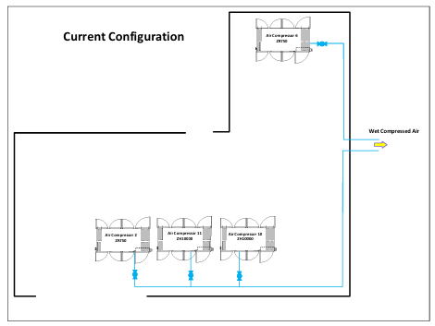
In alignment with Tata Steel's 'Drive to Save' initiative, it is imperative to undertake a comprehensive investigation into the efficiency and power draw of the compressed air system within the coal injection plant. The research will identify the extent of compressed air loss resulting from the use of open drain valves, analyse the reasons behind the moisture content in the compressed air, explore potential solutions for drying the air, and assess the impact of these valves on compressor power draw. By addressing these issues, the study seeks to enhance operational efficiency, reduce energy consumption, and ensure the reliability and sustainability of the coal injection process.
Figure 1 Current system set up of compressors.(Tata Steel, 2023)

The expected outcomes of this research include a set of actionable recommendations that could significantly improve the efficiency of the compressed air system. These improvements are anticipated to align with Tata Steel's 'Drive to Save' initiative, setting a benchmark for sustainability and operational excellence in the steel industry

Aims and objectives of the project.

The main objective is to investigate the underlying reasons behind the moisture content in the compressed air. This will entail analysing the compressor systems, air treatment processes, and environmental factors contributing to moisture accumulation.

- Explore Air Drying Solutions: A crucial aspect of this research is exploring potential solutions for effectively drying compressed air. This may involve evaluating the feasibility and effectiveness of installing air dryers or alternative moisture removal techniques within the compressed air system.

- Quantify Compressed Air Loss: The primary aim of this study is to quantify the amount of compressed air lost due to the open drain valves under the air receivers. This will involve conducting a thorough assessment of the current drainage system and measuring the volume of air drained along with moisture.

- Assess Impact on Compressor Power Draw: This study also aims to assess the impact of open drain valves on compressor power draw. By monitoring compressor performance under different operating conditions, we aim to quantify the energy wastage resulting from the constant operation of compressors due to open drains.

- Recommendations for Optimisation: Based on the investigation's findings, the ultimate objective is to provide actionable recommendations for optimising the efficiency and power draw of compressed air within the coal injection plant. These recommendations will be aligned with Tata Steel's "Drive to Save" initiative, focusing on enhancing operational efficiency, reducing energy consumption, and minimising environmental impact.

- By achieving these aims and objectives, seeking to address the operational challenges posed by moisture in compressed air, enhance the reliability and sustainability of the coal injection process, and contribute to the overall success of Tata Steel's manufacturing operations at Port Talbot Steelworks.

Timing plan

The research project is scheduled to be completed over nine months, starting in September, and concluding in June. The structured timeline is crucial as it provides a systematic approach to managing the various phases of the research, ensuring that each task is allocated sufficient time for thorough investigation and analysis. Adhering to this timeline is essential for maintaining project momentum and ensuring that objectives are met within the designated time frame, which is critical for the success of any project.

Applying Kerzner's (2017) project management principles of Effective scheduling are crucial, and techniques like the critical path method (CPM) or Gantt charts, as demonstrated in your Excel Gantt chart, are instrumental. These tools help determine dependencies and estimate task durations. It is important to note that the lice plant operations will be running concurrently with the project, which means that not 100% of the time or resources can be dedicated exclusively to the project. This concurrent activity must be factored into the resource allocation and risk management plans to adjust timelines and expectations accordingly. Figure 2 illustrates the Gantt chart used for this project.

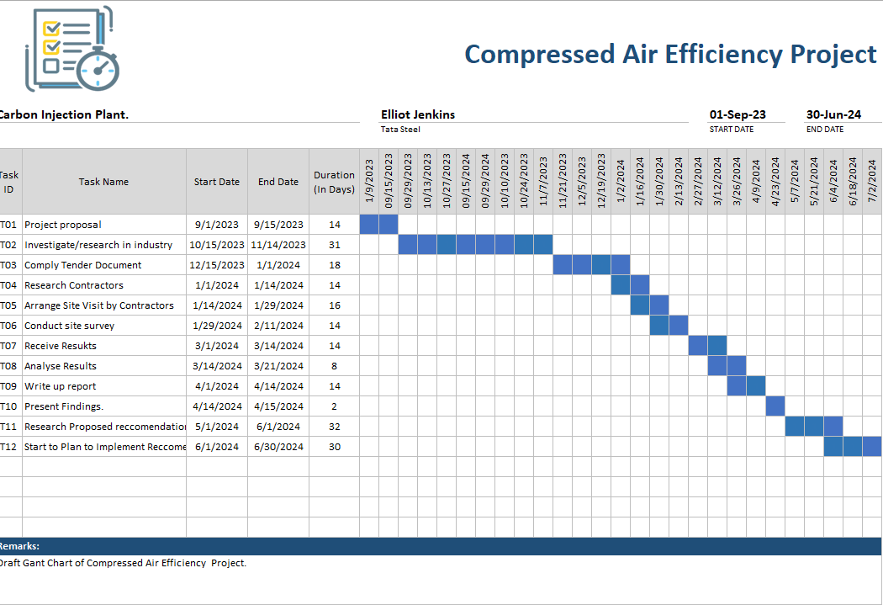
Figure 2 Gantt Chart first draft(Tata Steel, 2023)
The project begins in September with the finalisation and submission of the project proposal. Concurrently, a thorough investigation into existing research related to compressed air systems in the industry will be conducted, extending into November. In November and December, the focus will be gathering internal data specific to Tata Steel's compressed air systems. By December, preparation, and compliance with the necessary tender documents for contractor engagement will be completed.

Early January will be dedicated to researching and identifying potential contractors, followed by arranging and conducting site visits for these contractors in mid-to-late January. The selected contractors will conduct site surveys from late January through February. The survey results will be received by early March, and the entire month will be devoted to analysing these results to identify critical issues and potential improvements.
April will be a critical month, starting with drafting a comprehensive report detailing the findings and analyses. Late April will see the presentation of these findings and initial recommendations to Tata management. Further research will be conducted in May to refine and validate the proposed recommendations.

The project will conclude in June with the initial planning and steps for implementing the validated recommendations. Adhering to this timeline ensures a focused and efficient approach to the research, helps manage resources effectively, avoids project overruns, and ensures timely results delivery, which is crucial for Tata Steel's strategic objectives.

3 Research/literature survey.

Compressed air is a versatile and widely used utility in various industrial applications, including manufacturing, construction, and mining. Its importance as an energy source for powering pneumatic tools, controlling processes, and transporting materials cannot be overstated. However, the efficient generation, distribution, and utilisation of compressed air present significant challenges, particularly regarding energy consumption, reliability, and moisture management.

This literature review aims to provide a comprehensive overview of existing research and literature related to compressed air systems, moisture control methods, and energy efficiency strategies in industrial settings. By synthesising and analysing key concepts, findings, and insights from relevant studies, this review seeks to inform and contextualise the subsequent investigation into the efficiency and power draw of compressed air within the coal injection plant at Tata Steel Port Talbot.

3.1 Fundamentals of Compressed Air Systems

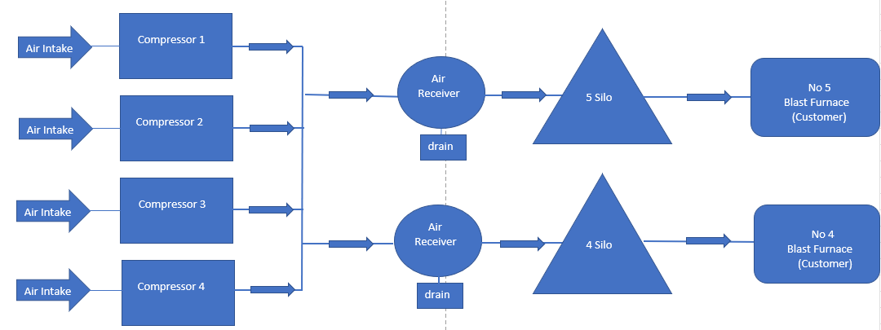
To understand the complexities of compressed air systems, it is essential first to examine the fundamental principles governing their operation. Compressed air systems typically consist of components, including compressors, air receivers, distribution piping, and end-use devices. Compressing atmospheric air to higher pressures generates heat and moisture, which must be effectively managed to ensure optimal system performance. Compressed air systems' four most important components are production, treatment, distribution, and consumption. To achieve the desired result, these elements must be matched carefully: high air pressure, the proper flow level or air volume, or optimal energy performance.(British Compressed Air Society Ltd., 2024). Figure 3 shows a visual process map of how the system is currently laid out.
Figure 3 Process Map of compressed air system within coal injection plant.

Presently the compressors intake air that is compressed via pipework are transported to the air receivers for storage, then sent to the silos where they are used for injection product coal to the Blast Furnaces. The drains below the air receivers are open slightly to allow moisture to drain out of them due to the build of water, thus letting air out in tandem, as shown in Figure 4.

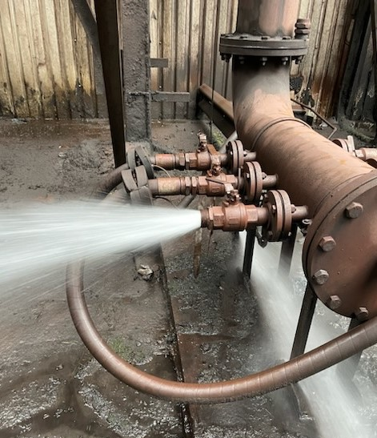
Figure 4 Excessive water in compressed air lines.(Tata Steel, 2023)

Effects of Moisture in Compressed Air Systems

Moisture is a ubiquitous byproduct of the compression process and poses significant challenges to the efficient operation of compressed air systems. Excessive moisture can lead to corrosion, fouling, and malfunctioning of pneumatic equipment and impair the quality of end products in manufacturing processes. Therefore, effective moisture control strategies are essential to maintaining the reliability and performance of compressed air systems.
When analysing the delays for 2023 to 2024 for N04 Blast Furnace, as shown in Figure 5 and Figure 6, the most significant cost delay for the period was £648,228.37 due to frequent coal blockages. As the coal lines required unblocking on a large scale, the furnace would have charged an all-coke burden for stability to the process, incurring costs of £40,000 per hour.
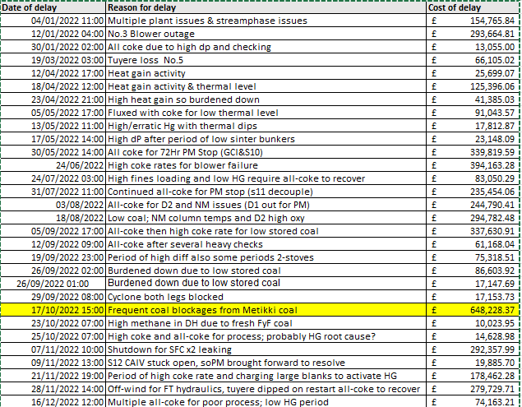
Figure 5 Delays for N04 Furnace 2022/2023

Figure 6 Pareto analysis of N04 Blast Furnace

Atlas Copco (2023) shares that not only can moisture within compressed air cause disruption within product pipelines, but it can also :
- Disturb instrument readings or functionality and lead to overall instrumentation malfunctions.
- Impair air tools by hindering proper lubrication.
- Trigger water hammer incidents, damaging equipment, and piping.
- Compromise product quality and undermine product integrity.
- As previously mentioned, direct impacts on processes occur when water infiltrates from the air stream.

Moreover, eliminating moisture to prevent blockages and corrosion is crucial for both the equipment utilising the air and the air system itself. Rust and scale particulates can form and obstruct lines while damaging air system components. In extreme cases, corrosion may induce pipework failure, causing leaks and hindering air delivery to the necessary processes.
Most manufacturers employ compressed air dryers as a means of moisture removal. Air discharged from compressors is heated and fully saturated with water. As the air cools, liquid water starts to condense. Since air tends to cool as it progresses through the system (often passing through cold environments like outdoors before reaching the process), pre-drying the air before entering the air network is significantly more effective. Although filters and separators can eliminate liquid moisture droplets from a system, they cannot remove water vapour. To address water vapour, a dryer must be utilised.

In the context of coal injection plants, where conveying air is utilised to transport coal to the product silos, the presence of moisture within the compressed air can lead to significant operational challenges. Progressive Products Inc. (2019) provides a pertinent analysis of these issues, noting that excessive moisture in the system's pipelines can cause material particles to become sticky, adhering to the walls of the conveying lines. This adhesion results in blockages and increases pressure drops within the system. (Progressive Products Inc, 2019). These findings are particularly relevant to this dissertation's argument that moisture in compressed air negatively impacts the efficiency and reliability of pneumatic conveying systems, especially in critical applications such as coal injection plants.

A study titled "Effect of moisture content on dense-phase pneumatic conveying of pulverised lignite under high pressure" discusses how moisture content significantly impacts the conveying characteristics of dense-phase pneumatic conveying systems, which is critical for maintaining the integrity and quality of the product coal (Zhou et al., 2015). The results of this study show that as the moisture level increased, the coal became more viscous and started to stick to pipework, especially bends; this study supports evidence found by Liu, Li and Zhang (2021)

In addition to the theoretical and empirical analyses previously discussed, practical evidence from operational data further corroborates the detrimental effects of moisture in compressed air systems within coal injection plants. Figure 7 illustrates a significant operational issue when Mitikki coal, known for its high Hargrove index indicating a softer and more moisture-susceptible nature, was introduced into the system. The graph shows a marked increase in line pressure from 3 bar to almost 5.5 bar, signalling the onset of blockages in the coal lines. This increase in pressure coincides with a dramatic decrease in coal rate, as depicted by the grey dot in the graph, indicating severe disruptions in coal conveyance due to the accumulation of moist coal (Tata Steel, 2023).
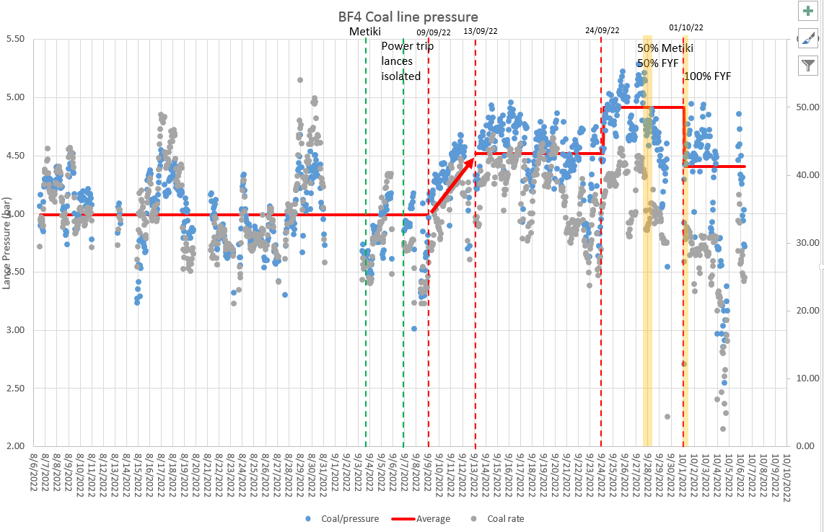
Figure 7 Metiki Coal Blend line pressures.(Tata Steel, 2023)

Furthermore, the data on injector trips presented in the same figure underscore the operational challenges. The introduction of Metikki coal led to a surge in injector trips from 500 to 3000, necessitating frequent isolations and cleanouts of the injector vessel. This period of heightened injector trips disrupted operations and incurred substantial costs, exceeding £650,000, as detailed in Figure 8.

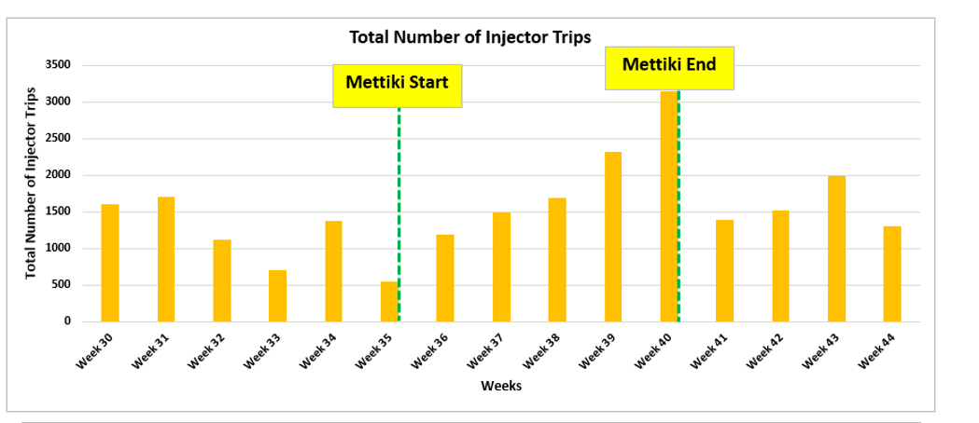
Figure 8 Metiki Injector Trips data.(Tata Steel, 2023)

The susceptibility of Metikki coal to moisture absorption due to its finer size fractions highlights the critical need for effective moisture management strategies in the pneumatic conveying systems used in coal injection plants.

These practical observations provide compelling evidence that supports this dissertation's thesis. They underline the critical impact of moisture in compressed air on the efficiency and reliability of coal injection systems, emphasising the necessity for rigorous moisture control measures to mitigate these adverse effects.

Moisture management within compressed air.

Moisture management is critical to maintaining the efficiency, reliability, and longevity of compressed air systems, particularly in applications such as conveying product coal. Excessive moisture in compressed air can lead to a variety of operational challenges, including coal blockages and the increased man hours required to unblock them, as well as the cost burden of all affected coke. Therefore, effective moisture management strategies are essential to ensure optimal system operation and performance (Russ Jones, 2021).
There are several methods to manage moisture in compressed air systems, including the use of filters, automatic drains, and air dryers such as desiccant or refrigerated dryers. Filters can remove particulates and contaminants, including moisture, though they are generally used in conjunction with other systems for optimal moisture removal (Compressed Air Best Practices, no date). Automatic drains are essential for removing accumulated water and preventing it from re-entering the air stream. Air dryers, particularly desiccant and refrigerated types, are the most effective way to combat moisture in these systems (Russ Jones, 2021).

Effective moisture management strategies are indispensable to ensure the coal injection plant's seamless operation and optimal performance. Within the GCI system, moisture management primarily relies on manual coal sampling at various stages of coal preparation. Initially, raw coal typically contains around 8% moisture content. After the crushing and drying processes, the moisture content decreases to approximately 5% for crushed coal. The goal is to achieve a moisture content below 1% for the final product coal, aligning with the key performance indicators required for efficient iron-making processes. Figure 9 shows an example of the data inputted every twelve hours by production operators using the moisture analyser.
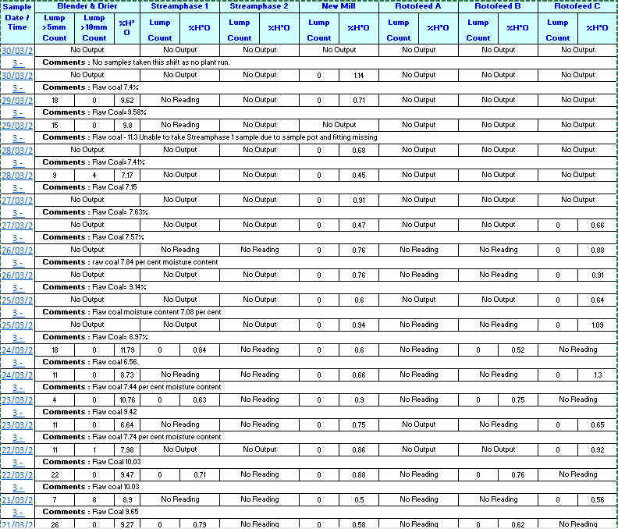
Figure 9 Coal moisture content samples.(Tata Steel, 2023)

As previously mentioned, desiccant dryers are one solution to drying air; they operate by adsorbing moisture from the air and can achieve shallow dew points, typically below -40°C, making them particularly effective in environments where shallow moisture content is crucial. Desiccant air dryers have proven their value in various industrial settings by enhancing air quality and operational efficiency. Two notable examples in the industry are:

- Food and Beverage Production Enhancement

A leading American food and beverage producer implemented regenerative desiccant air dryers in their factories to improve air quality. These dryers were crucial in removing moisture from compressed air used in packaging and labelling processes, significantly reducing the risk of contamination, and enhancing product quality. The low maintenance requirements of the dryers allowed the staff to allocate more time to other production tasks, simultaneously reducing energy costs and increasing operational efficiency (Air & Vacuum Process, 2024).

- Automotive Component Manufacturing Efficiency

One of Europe's top automotive component manufacturers switched to desiccant air dryers to enhance the efficiency of their compressed air systems and reduce costs. Giampieri et al. (2020) share that dryers effectively dehumidify the compressed air used in assembly and finishing operations, ensuring a consistent supply of high-quality air. This was essential for protecting sensitive machinery from corrosion and other damage. The transition to energy-efficient desiccant dryers resulted in significant savings on energy bills and improved overall production efficiency.

By addressing the root causes of moisture ingress and adopting proactive moisture management strategies, such as implementing desiccant dryers, the coal injection plant can significantly enhance operational efficiency, minimise downtime, and ultimately optimise the utilisation of compressed air resources in conveying product coal (Liu et al., 2021).

3.4 Energy Efficiency Strategies in Compressed Air Systems

Current Challenges in Coal Injection Plants

In coal injection plants, a common practice involves leaving ball valves slightly open under air receivers to release excess moisture from the compressed air lines. This method, while straightforward, leads to significant inefficiencies primarily due to the continuous loss of compressed air. This loss not only wastes the compressed air itself but also imposes an additional energy burden on the compressors. These compressors are forced to operate continuously to maintain the necessary system pressure of 7.5 bar, even when actual demand does not justify such an operation. The resultant pressure drops from open valves compel compressors to work harder to compensate, thus remaining loaded and consuming energy that could otherwise be saved.

Moreover, the absence of a Programmable Logic Controller (PLC) exacerbates the issue, as compressors cannot be automatically turned off when not needed. Instead, they stay unloaded, consuming about 40% of the energy they would use while fully loaded.(Compressed Air & Gas Institute, 2021) This operational inefficiency highlights a critical area for improvement in energy management within the plant.

Proposed Energy Efficiency Strategies

- Installation of Advanced PLC Systems:

Implementing advanced Programmable Logic Controllers (PLC) systems can significantly enhance energy efficiency. These systems enable automated control of compressors, allowing them to shut down entirely rather than remaining unloaded. This change alone can reduce energy consumption substantially, as compressors will only operate when there is a genuine demand for air pressure. According to a study by the Compressed Air and Gas Institute (CAGI), implementing PLC systems combined with Variable Speed Drives can reduce energy usage by up to 50% in industrial compressed air systems(Compressed Air & Gas Institute, 2021). Currently, there are no PLCs controlling the efficiency of demand, resulting in compressors being unloaded for prolonged periods of time.

- Use of Desiccant Dryers:

Integrating desiccant dryers can help efficiently remove moisture from the air, thus eliminating the need to keep valves open. Desiccant dryers are highly effective in drying compressed air, which can reduce corrosion and other moisture-related issues in the system. This integration improves the quality of compressed air and enhances the overall energy efficiency of the compressed air systems. Research published in the Journal of the Chinese Society of Mechanical Engineers highlights that desiccant dryers, when used in conjunction with heat recovery units, can enhance system efficiency by up to 30%, primarily by reducing the load on compressors and leveraging waste heat (Venkatachalam et al., 2023).

- Leak Detection and Repair Programs:

Regularly scheduled leak detection and repair can prevent significant energy loss. A study by Mitchell (2017 )indicates that, on average, 20-30% of compressed air is lost to leaks. Mitchell (2017) adds that implementing a robust leak detection program can significantly reduce unnecessary compressor load and energy usage. Marginean et al. (2023) carried out a study over fifteen days at an industrial unit, which revealed twenty-four defects in air preparation, thirteen defects in air couplings, eleven defects in solenoid valve islands, eight defects in air distributors, and six defects in air quick couplers. These defects resulted in a total energy loss of approximately 13,098.4 kWh, which incurred a cost of approximately £3405.58, based on the current UK electricity rate of 0.26 £/kWh, over the 15-day monitoring period. These findings prove the case for conducting an air leak survey within the department, highlighting other potential savings, and calculating the total air loss by having the valves open. These findings will then be evaluated later in the report.

- Heat Recovery Systems:

Currently, there are no heat recovery methods for compressed air generation within the coal injection plant; using heat recovery systems can reclaim much of the heat generated by compressors. Broniszewski and Werle (2018) explain that to produce compressed air, approximately 10-20% of electricity transferred to the compressor is used; the rest is lost due to lack of tightness and heat losses. This recovered heat can then be used for space heating or pre-heating boiler feed water, thus reducing overall energy costs. Broniszewski and Werle (2018) highlight that Bulten Poland SA, a factory specializing in producing fasteners for the automotive industry, utilizes a significant amount of compressed air in its manufacturing processes, essential for maintaining high production standards. The company has successfully implemented heat regeneration through heat exchangers and drum dryers, enabling the recovery of approximately 65-75% of the energy transferred to the compressor drive. This recovered heat can be effectively used for space heating or pre-heating boiler feed water applications, significantly reducing overall energy costs. This process boosts energy efficiency, yields considerable cost savings, and diminishes the environmental impact, demonstrating a proactive approach to sustainable manufacturing.

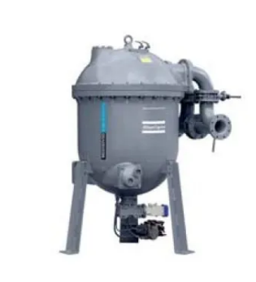
Heat recovery from heat drum dryers in compressed air systems offers several significant benefits. Firstly, it leads to substantial energy savings by capturing waste heat from the compressor and using it to regenerate the desiccant in the drum dryer, thereby reducing the need for additional energy sources. According to a study by the U.S. Department of Energy (2003), implementing heat recovery systems in compressed air systems can save up to 50% of the energy used for drying air. This energy efficiency translates into cost reductions, as the operational costs associated with running additional heating equipment are minimized, leading to lower overall energy bills. The same study found that the payback period for heat recovery systems is typically less than two years, making it a cost-effective solution. Additionally, heat recovery enhances system efficiency by maintaining optimal operating temperatures, which improves the performance and reliability of the compressed air system. An example is shown in figure 10 supplied by Atlas Copco.
Figure 10 Drum Dryer by Atlas Copco(Atlas Copco, 2024)

Environmental benefits are also notable, as utilising waste heat reduces the carbon footprint of industrial operations, contributing to sustainability goals. U.S. Department of Energy (2023) highlights that heat recovery systems can significantly reduce greenhouse gas emissions. Furthermore, by reducing the thermal load on the compressor and associated equipment, heat recovery systems enhance the reliability and longevity of the compressed air system, leading to reduced maintenance costs and extended equipment life. This is supported by Chou and Yeh (2015), who notes that heat recovery systems can lead to reduced maintenance costs and extended equipment life. Overall, the integration of heat recovery systems in compressed air operations presents a compelling case for both economic and environmental benefits.

Work carried out.

Overview: The Need for Comprehensive Surveys.

The initiative to optimise the compressed air system at Tata Steel was primarily driven by the findings from initial research, which underscored a significant potential for enhancing operational efficiency and reducing energy consumption. This research revealed that it was challenging to accurately quantify losses or identify specific inefficiencies within the compressed air system without precise and comprehensive data. As a result, the decision to conduct targeted surveys became a foundational step in our approach to system optimisation.

Importance of Data Collection:

Data collection is crucial as it provides the empirical basis for all subsequent analyses and interventions. In the context of compressed air systems, understanding where, how, and why air and energy losses occur is essential for formulating effective solutions. Accurate data helps in pinpointing problem areas, assessing the severity of issues, and tracking the performance of implemented solutions over time.

Selected Surveys Based on Research:

- Air Leak Survey.
- Airflow Survey.

Air Leak Survey:

This survey was prioritised because leaks are a common and significant source of energy waste in compressed air systems, as Mitchell (2017) indicated. Identifying and quantifying the air lost through leaks, particularly at critical points where the eight ball valves are known to be cracked open, can directly address one of the most straightforward inefficiencies to quantify and then correct.

Process Description for Conducting Air Leak Survey Using Ultrasonic Detection

The air leak survey at Tata Steel utilised ultrasonic detection technology to identify and quantify leaks in the compressed air system. This method is highly effective due to its ability to detect the high-frequency sounds produced by escaping air. Atlas Copco (2024) boldly states that this audit "always pays for itself in savings," a sentiment echoed by Elliott (2018).

Preparation and Planning:

Before beginning the survey, a thorough assessment of the compressed air system layout is conducted. This helps in planning the survey route and identifying critical areas where leaks are most likely to occur; the contractor will be given a process map of the area where the eight valves are located. Ensure all safety protocols are in place, considering the survey involves interacting with operational machinery and high-pressure systems. To carry out the leak test, the compressed air system must be operational to expose the leaks and the quantity of leaking air.

Deployment of Ultrasonic Leak Detectors:


Equipment Setup:

Technicians equip themselves with ultrasonic leak detection devices, such as the UE Systems Ultraprobe 100, displayed in figure 11. This state-of-the-art device is specifically designed to detect ultrasonic frequencies generated by the escape of compressed air through leaks.
Device Features: The Ultra probe 100 is equipped with a sensitive directional microphone, an amplifier, and headphones, which help in identifying the high-frequency sounds that are inaudible to the human ear. The device also features a meter display that visually represents the leak rate, which is crucial for quantifying the severity of leaks.
Figure 11 Ultraprobe 100 example.(CMP, 2015)
Survey Execution:

The contractor will monitor each drain point where ball valves are cracked open to reduce moisture, as shown in Figures 12 and 13. These locations are critical as they represent potential high-loss points. The Ultra probe 100 will measure how much compressed air is being lost at these eight locations. The contractor will monitor each location using the ultrasonic leak detection device over a specified period to gather comprehensive data.

Quantifying Losses and Reporting

The data collected will be used to quantify and calculate the cost of wasted air. This analysis will help understand the leaks' financial impact. A comprehensive report detailing all findings from the leak survey will be prepared. This report includes recommendations for repairs, estimated savings from fixing the leaks, and suggestions for system improvements.

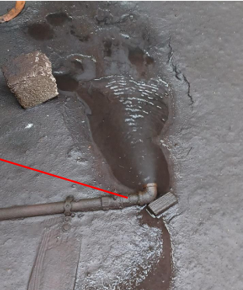
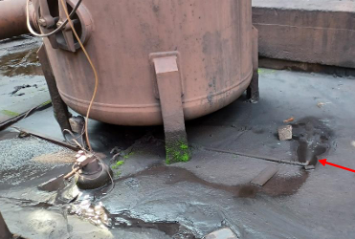
Figure 12 Receiver cracked valve.(Tata Steel, 2023)
Figure 13 Air Receiver with open valve.(Tata Steel, 2023)

Air Flow Study:

Understanding compressed air flow through the system is vital for assessing its efficiency. This study focuses on measuring the actual flow of air and comparing it to the operational demands placed on the system. It helps identify the differences between air supply and demand, which can lead to unnecessary compressor operation and energy wastage. Historically, the pressure required to run the process is set at 7.5 bar; however, with no recent data on the system, the system could require a lower pressure, resulting in a cost saving.

Process Description

These surveys were designed to provide a comprehensive overview of the system's current state and to establish a baseline for measuring improvements. By focusing on these critical areas, the project aims to develop a detailed understanding of the system's dynamics, which is essential for any subsequent optimisation efforts.

The airflow study to be conducted within the Coal Injection Plant will need to involve a series of meticulously planned steps to measure and analyse the flow of compressed air through the system. This is mainly due to the safety aspect; due to working on the live plant, several barriers and perimetry will need to be in place, although hot tapping, as later discussed, can be done when operations need to be live. Access to electrical substations requires electrical authorisation. An electrician will be needed to install the Chauvin clamps that were previously mentioned.

Installation of Flow Transmitters,

Procedure

Initially, the contractor must install flow transmitters into the live compressed air pipelines. This involves a process known as hot tapping.
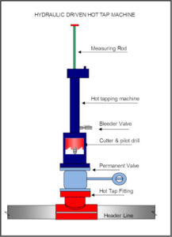
Figure 14 Hot tapping example(Bstech, 2021)
Hot Tapping.
Hot tapping is a method used to connect new pipe connections or install devices like transmitters into an existing pipeline without interrupting or shutting down the flow of air or fluid. It involves drilling or cutting into the pipeline while it is still operational. Marginean et al. (2023) explain that this technique is crucial for maintaining system uptime and is particularly useful in critical operations where shutdowns are not feasible. Figure 14 displays a typical set up when hot tapping a pipeline.

Once the flow transmitters have been strategically placed in the main compressed air lines, it becomes possible to quantify the amount of compressed air the compressors are producing compared to what they are designed to produce.

Monitoring Setup and data collection.

Following the installation of flow transmitters, Chauvin Arnoux clamps are installed into the compressors' electrical subsystems. By attaching these clamps, the contractor can examine the power required to operate the compressors. Figure 15 shows a visual representation of a Chauvin clamp.

Figure 15 Chauvrin Clamp (Tata Steel, 2023)

The contractor will then leave the devices in place for two weeks to allow for adequate data collection. This duration is essential to capture various operational scenarios, such as demand-driven compressor activation, duration of compressor operation, and the power draw required to run the compressors.

Data Analysis and Reporting

Continuous Monitoring: The flow transmitters and Chauvin Arnoux clamps continuously monitor the volume of air and the power consumption, respectively. This constant monitoring is crucial for identifying trends, patterns, and anomalies in air usage and energy consumption.

The collected data is analysed to determine the efficiency of air usage and energy consumption. This analysis helps pinpoint inefficiencies such as over-pressurisation, leaks, or mismatched compressor output to air demand.

The data collected generates regular reports that provide insights into the compressed air system's operational status. These reports help inform decisions about maintenance, upgrades, and operational adjustments.
This structured approach to the air flow study ensures that every aspect of the compressed air system’s performance is monitored and analysed, providing a solid foundation for ongoing optimisation efforts. This methodology not only enhances the system's efficiency but also supports Tata Steel's commitment to sustainable and cost-effective operations

  - Tender Process

Tender documents were prepared and distributed to all contractors on the approved list via Tata Steel's internal tender process, with a one-month deadline for submitting interest or quotes. Poor-quality tender documents are a source of inaccurate estimates, claims, and contract disputes. This view is supported by Laryea (2011), who reports that, based on interviews with 12 US contractors, 'unclear contract documents' were one of the factors that caused contractors to increase contingency markups in bids. Due to Tata's policy of paying contractors after 90 days, only two contractors responded. Rubix expressed interest in conducting the air leak survey using ultrasonic detection devices at eight locations with cracked open valves. Air Compression Technology, the only contractor on the approved list, was selected for the air flow survey. The limited number of responses restricted competitive pricing options. However, both contractors agreed to Tata Steel's terms, allowing the surveys to be scheduled and completed efficiently.

  - Conclusion

The surveys conducted at Tata Steel, particularly the airflow study, have been instrumental in enhancing the understanding and management of the compressed air system. While ultrasonic leak detection provided valuable insights into unintentional leaks, the airflow survey has sparked considerable interest and excitement due to its broader implications on system performance and efficiency.

The airflow survey at Tata Steel stood out as a particularly crucial study due to its comprehensive approach to evaluating the entire compressed air system. Unlike leak detection, which primarily focused on pinpointing specific leak sites—many of which were already known due to historical practices of leaving certain valves open—the airflow survey offered a holistic view of the compressor system's operational dynamics.

This survey went beyond leak detection to assess how air flows through the system. It examined the efficiency of compressors, the integrity of distribution lines, and the effectiveness of end-use applications. This comprehensive analysis helped identify losses and opportunities to enhance the system's performance.

Focusing on how air is compressed, transported, and used throughout the facility, the survey pinpointed bottlenecks that could be causing inefficiencies. These could be underperforming equipment, suboptimal pressure settings, or even inappropriate uses of compressed air.

The detailed data from the airflow survey provided a foundation for recommending optimisations. These included compressor operation schedule adjustments, system layout enhancements to reduce pressure drops, and upgrades to more efficient equipment, as later discussed in the report.

The results from the airflow survey were fascinating as they opened numerous possibilities for strategic interventions. These interventions could lead to significant energy savings, reduced operational costs, and improved sustainability practices.

Additionally, the survey data can be used to implement predictive maintenance strategies. By understanding the typical performance parameters, maintenance can be scheduled based on actual needs rather than on a fixed schedule, preventing unexpected breakdowns and optimising maintenance resources.

The airflow survey, with its extensive and detailed examination of Tata Steel's compressed air system at Tata, highlighted existing inefficiencies and charted a path for substantial improvements. The excitement surrounding the results stems from the potential transformative impact on the plant's operations, making it a focal point of interest and a critical component of Tata Steel's energy management and operational excellence strategy. This survey underscores the importance of comprehensive system assessments over targeted leak checks, especially in complex industrial environments where efficiency is paramount.

5. Results.

This section presents the findings from two critical surveys conducted at Tata Steel: The Air Leak Survey and the Air Flow Survey. These surveys were integral to our research objective of optimising the compressed air system within the facility, a key component in reducing energy consumption and enhancing operational efficiency.

The Air Leak Survey utilised advanced ultrasonic leak detection technology to identify and quantify unintentional air leaks, some historically known due to valves being intentionally left open. This survey provided precise data on each leak's location, size, and impact, offering insights into potential energy savings and system improvements.

Conversely, the Air Flow Survey focused on assessing the overall efficiency of the air compression system. This survey was particularly anticipated as it provided a comprehensive analysis of how air moves through the system, highlighting areas where performance could be optimised. The results from this survey are expected to inform more targeted interventions and contribute to a more efficient use of resources.

Together, these surveys furnish a detailed picture of Tata Steel's compressed air system's current state, setting the stage for the detailed results discussed below.

Results from Air leak survey.

The air leak survey conducted at the facility revealed significant leakage issues, particularly highlighted by severe cases involving a 1/2-inch pipe venting directly to the atmosphere with noise levels exceeding 50 decibels. This severity led to the conclusion that the initially employed leak detection equipment was inadequate for the task(Reynolds, 2024).

Upon further evaluation, as detailed in Figure 16 (Leak Severity Table), it was determined that a flowmeter installation was necessary to accurately monitor and measure the air leaks. This decision was supported by the data presented in the Leak Severity Table, which categorises leaks into scales based on their flow rates in CFM (Cubic Feet per Minute) and corresponding energy costs(Reynolds, 2024).

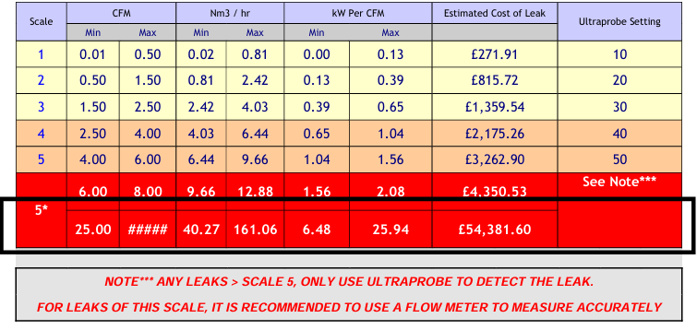

Figure 16Leak Severity Table. (Reynolds, 2024)

The table illustrates escalating costs associated with increasing leak severity, emphasising the financial impact of unaddressed leaks. For the most severe leaks (above Scale 5), a flowmeter is recommended for precise measurement, as standard detection tools like the Ultraprobe are only suggested for initial detection.

This survey underscores the critical need for appropriate detection and measurement tools to manage air leaks effectively, highlighting the potential for significant cost savings and efficiency improvements through targeted interventions. Although Rubix's scope of work did not include the supply and fitting of flow meters, they were able to use the data supplied for Airflow Technology in section 5.2 of the report to calculate the volume and cost of air being lost to the atmosphere.

5.2 Results from the Airflow Survey

Airflow Technology attended the site for two weeks, and the key findings
are shown below. All calculations are based on the following assumptions:

- Electrical energy cost = £0.26/kWh
- Gas energy cost= £0.023/kWh
- Annual operating hours = 8,760

Flow meters were set up strategically and installed on the compressed lines using the hot tapping method, and data collected over the two-week period were analysed. Figure 17 shows the operating pressures over this period, with Figure 18 visually illustrating the real-time pressures
recorded.

 | Average | Min | Max
Blue pipe | 7.50 | 4.80 | 7.95
Stainless pipe | 7.48 | 4.79 | 7.95
Compressor 6 | 7.51 | 4.81 | 7.98
Remote receiver | 7.28 | 0 | 7.88
Buffer silo | 7.34 | 4.76 | 7.92
Coal Conveying | 4.34 | 0 | 6.60
Figure 17 Average compressed air pressures(Air Compression Technology. and Halliwell, 2024).

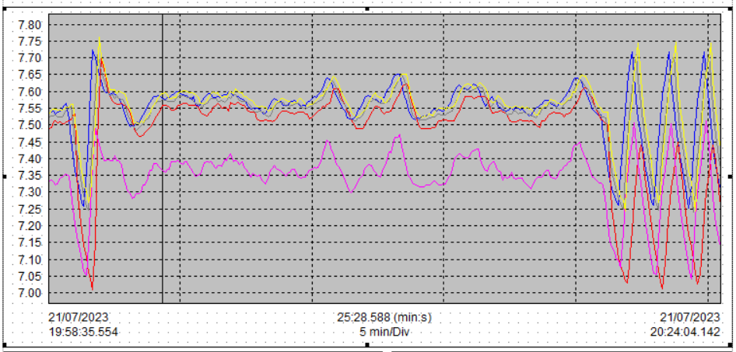
Figure 18 Real time recorded pressures. (Air Compression Technology. and Halliwell, 2024)

Air Compression Technology ( ACT) reported that no current heat recovery system is
installed within the compressor house. No current compressor controller is in use.
an old Energair compressor controller was situated on the house wall. During the
audit, this was disconnected, forcing all compressors to run on their pressure
switches.
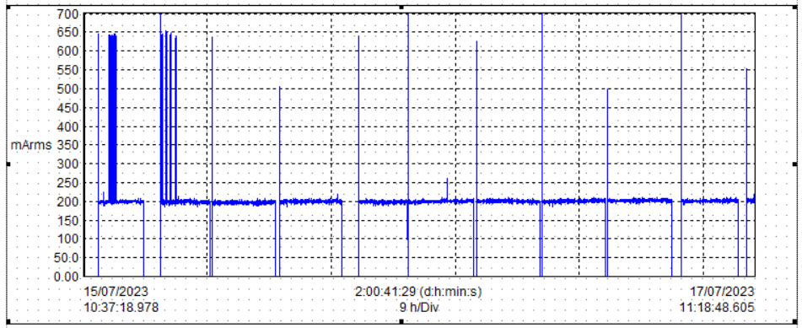
Figure19 Current data draw from compressors.(Air Compression Technology. and Halliwell, 2024)

By using the Chauvin clamps, ACT was able to gather data on the current being
drawn by the compressors when being used, as shown in Figure 19.

The unloading state of a screw compressor is necessary to prevent damage to the machine by stopping it from going over pressure; it remains unloaded for a period (determined by the run-on timer) to limit motor starts and increase the working life of components before shutting down and stopping.

However, every time a compressor runs unloaded, it consumes 40% of the total power without making any air. Putting energy into any system without getting any work out is obviously inefficient and must be reduced wherever possible.

When analysing the current (Arms) being drawn by compressor 2 (ZR750) at Tata, it is clear
that the machine is currently unloading most of the time. Figure 14 shows how the
compressor ran for two days without properly loading up; much of this time was spent
unloading in very short periods when the machine stopped. During the audit
period, compressor 2 spent 86% of the time on, of which 95% of this running time hours was
time spent unloaded (Figure 20); thus, 81.7% (86% x95%) of the whole audit duration was
unloaded.

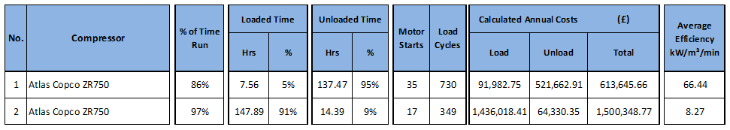

Figure 20 – Compressor 2 Key Performance Indicator(Air Compression Technology. and Halliwell, 2024).
This results in an abysmal average efficiency of 66.44kW/m³/min. (Target efficiency for a two-stage oil-free screw is ≤ 6.0kW/m³/min) There is no pattern to the unload to determine if it's the run-on timer or the compressor is receiving a remote ready signal, which is overriding the run-on timer from shutting down the compressor.

The data logger is reading mA on the compressor ammeter; therefore, to convert to true Amps, the graph must be multiplied by the 250 coil ratio. Air Compression Technology and Halliwell (2024) rationalise always trying to run fixed-speed compressors loaded and having a predictive compressor management system with transducer control linked to all the compressors.

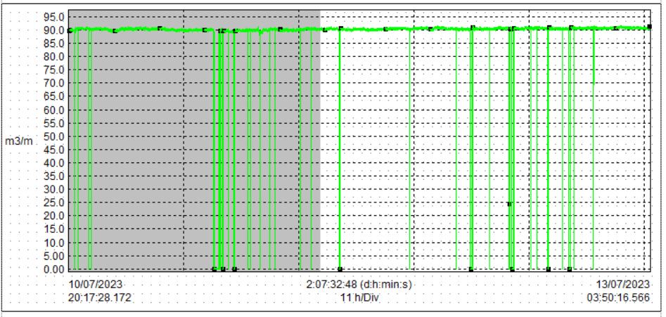
From the flow graph below in Figure 21, the ZR750 No6 compressor is only putting out 90m³/min, as opposed to Atlas's rated flow of 111m³/min or Tata's assumed flow of 129m³/min (4565scfm), which could be due to its age 1999.
Figure 21 Compressor efficiency (Air Compression Technology. and Halliwell, 2024)

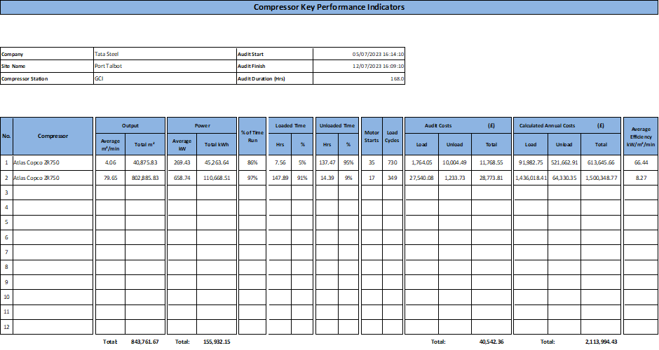
This leads to a poor specific efficiency of 8.27kW/m³/min for the No6 ZR750, which, when considered alongside the No2 ZR750's extremely poor efficiency of 66.44kW/m³/min, is not good, as shown in Figure 22.

Figure 22 N02 and N02 Compressor efficiency (Air Compression Technology. and Halliwell, 2024).
However, the poor efficiencies are not helped by how the ZH10000 turbos are being operated, as they are both on all the time, leading to a combined efficiency for the two of 8.606 kW/m³/min when they could have a specific efficiency of <5.8 kW/m³/min.

The turbo's poor efficiency is due to them throttling and venting air as the average demand for the period 5-15/07/2023 is 331m³/min when Furnaces 4 and 5 are both on (See figure 23 Below). Each ZH10000 can be over 180m³/min, so 360m³/min, without Comp2 or Comp4 being on. Air Compression Technology. and Halliwell (2024) predicts from the data reviewed that currently, the average flow of 331m³/min x 8.94kW/m³/min = 2959.14kW at an annual cost of £6,739,737

A Turbo machine ideally needs to be run flat out to maintain its specific efficiency. ACT has measured an Ingersoll Rand turbo compressor that was putting out 54% of its maximum output but pulling 97% of the full load power as it was throttling and venting.

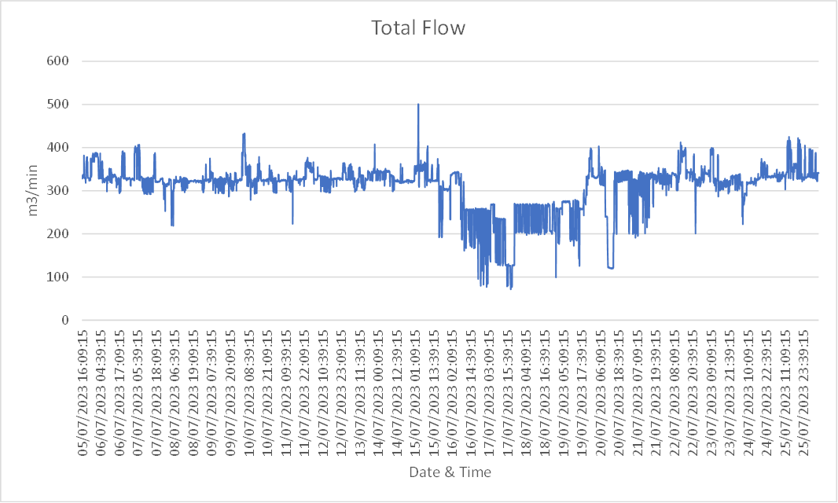
Figure 23
Figure 23 Total Flow (Air Compression Technology. and Halliwell, 2024)

Air Compression Technology. Moreover, Halliwell (2024) identifies that using compressed air to convey powders can often become a concern. With Tata using pneumatic conveying air to move coal from silos into the blast furnace, if the coal dust gets wet, it can cause blockages and issues in the pipes. Naturally, with over three megawatts of installed compressor power, there is bound to be a significant volume of water that needs to be removed.

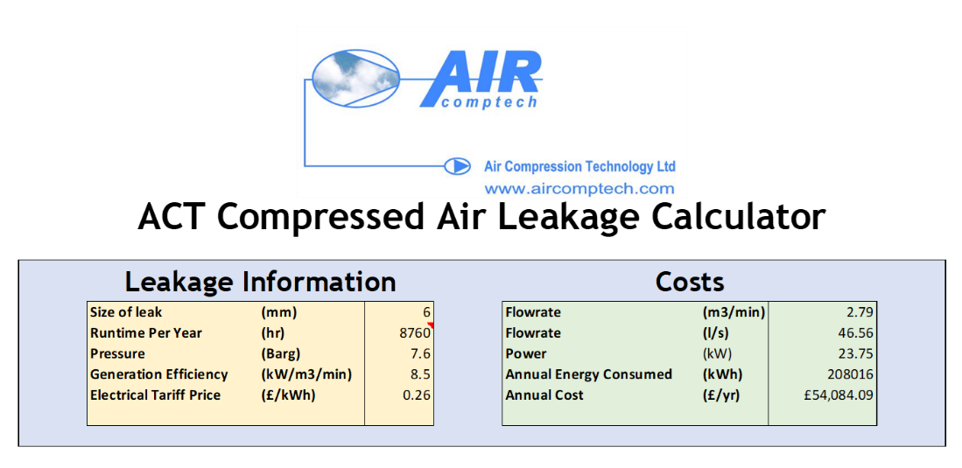
The current method of removing water from the compressed air system is to crack open receiver drain valves. ACT noticed eight drain valves open in this manner, it is estimated that each is equivalent to at least a 6mm hole. With the data acquired, ACT provided the following calculator based on their results.
Figure 24 ACT compressed air leakage calculator.

Using the ACT compressed air leakage calculator, it is shown that one of these valves wastes 2.70m3/min, which results in an annual cost of £54,084. Across all eight observed drains, this is a cost of £432,672 per year.

6. Discussion

The dissertation aimed to investigate the energy efficiency and power draw of compressed air within the coal injection plant. One main drive for this was Tata's current " drive to safe " initiative to try to bring savings to the company. The GCI Compressed air system consists of two fixed-speed oil-free screw compressors, ZR750, and two centrifugal screw compressors (ZH1000). As mentioned, none of these units have associated assets for compressed air treatment once generated. Hence, no filtration or drying of the compressed air is undertaken. As the compressed air is used to convey the granular coal dust for injection into the Blast Furnaces, this has an immediate impact on the overall system's effectiveness. Hence, there is a requirement to drain the excess moisture from the said system at gathering points, which have been identified through non-standard engineering practices, and this method of moisture removal results in a large volume of compressed air being underutilised. Due to air being intentionally released from the system to reduce moisture, it was assumed that there would be an inefficiency in the compressed air system, which was the focus of conducting the report.

When examining the previous research, such as Tata's Steels data on the effects of coal pipeline blockages injector trips ( Figure 8) alongside the data on N04 Furnace delays (Figure 5 ) with costs of up to £650,000 it is evident that there is a significant impact on the iron making process. Tata Steels data, coupled with both Liu, Li and Zhang (2021) and Progressive Products Inc. (2019) studies on moist coal becoming sticky and adhering to the walls of conveying lines, echoes the point of moisture within a conveying dust or coal process proving disastrous. Having a high moisture level also limits the coals being processed, as shown when Metikki coal was trialled; due to the susceptibility of coal and finer size, it could not be used longer than three weeks, costing the business further costs.

Moisture management was repeatedly one of the fundamental requirements when using compressed air in industries, especially in the automotive and food processing industries. Desiccant dryers were essential to producing high-quality air, reducing the machine's risk of corrosion, and minimising downtime, as reiterated by Liu et al. (2021). Giampieri et al. (2020) shared that implementing desiccant dryers resulted in significant savings on energy bills and improved overall production efficiency, points from which Tata Steel would benefit significantly.

Investigating the moisture within the compressed air highlighted the inferior energy efficiency of the compressed air system. ACT found that the N02 Compressor spent most of the time unloaded within the two-week investigation. Figure 14 shows that for two days, the compressor did not correctly load, with very short periods where the compressor stopped 81.7% of the time unloaded. This results in an extremely poor average efficiency of 66.44kW/m³/min. A target efficiency for a two-stage oil-free screw is ≤ 6.0kW/m³/min. A point in which (Compressed Air & Gas Institute, 2021) concurs that an unloaded state consumes about 40% of the energy it would use while fully loaded. This operational inefficiency highlights a critical area for improvement in energy management within the plant. This drives the need for a PLC system. This fact was highlighted in the findings by Airflow technology, as it was also pointed out that the other two turbo compressors also run efficiently as they are both on all the time, leading to a combined efficiency for the two of 8.606 kW/m³/min when they could have a specific efficiency of <5.8 kW/m³/min. The report also found that the turbo's poor efficiency is due to them throttling and venting air, as the average demand for the audit period was 331m³/min when Furnaces 4 and 5 were on.

One of the critical aspects found by Airflow technology was that there was no form of heat recovery within the system. Broniszewski and Werle (2018) highlighted that introducing drum dryers would recover approximately 65% - 75% of the energy to the compressive drive. Air Flow technology recommends that retrofitting drum dryers to the existing compressors can capitalise on the waste heat from the compressors to complete the regeneration process if desiccant dryers were to be installed.

One of the main reasons for carrying out this report was to quantify the amount of air being lost through the eight ball valves cracked open by having both the flow transmitters and Chauvin clamps installed and monitored over two weeks, and an assumption was calculated. Assuming that the size of the hole was 6mm, it was generated using the compressed air leakage Calculator figure 24 that the compressors were running 8760 hours a year, at 46.56 Litres/second, generating 207,016 KWh costing £ 54,084.09 a year per valve open. Rubix was able to price £5000 for auto drains to be fitted onto the eight cracked valves; these could be a potential barrier to improving the compressed air efficiency, as previously pointed out by Russ Jones (2021).

7. Limitations.

Although the energy results were astonishing, one of the study's main limitations was that it took over two weeks; this needed to be more of a period to take an actual period. A production stop or compressor maintenance may have been carried out during this time. Poor weather could have affected the temperature, thus increasing/ decreasing the moisture within the compressed air lines. Only some of the compressed air lines were captured within the study, thus not giving a 100% accurate reflection of the study.

Due to Tata Steel's policy of paying contractors 90 days after work is completed, only certain contractors will deal with Tata Steel. This reduces the number of contractors we can choose from to conduct the audit. Tata Steel will only use contractors that have been vetted and are on the approved list of contractors. When the tender document went out with the scope of work required, the two contractors, Rubix and ACT, responded. Although ACT carried out a thorough and informative report, Rubix, in contrast, needed help to fulfil what was asked. Due to the volume of the air leaks exceeding 50 dB, they were unable to quantify any data. They were able to use Air Flow Technology data to provide a calculation, but this was done as part of ACT's original report, thus deeming Rubix's involvement unnecessary. Rubix could quote and give a cost of £5000 for eight auto drains to help reduce the approximately £400,000 cost of air leaks.

The report was heavily reliant on the sole report of Air flow technology due to the lack of response shown by other contractors. To make this report more efficient, the tender could have gone out to a wider range of contractors, who could have carried out the results over a longer period, during ambient temperature, and lastly, monitored all the compressed air lines within the department, not just those that were easily accessible.

During this study, it was noted that Air Compressor Technology (ACT) has a close working relationship with Atlas Copco, often recommending their products for system enhancements and improvements, as shown in Section 9. While such recommendations are based on the proven efficiency and reliability of Atlas Copco's solutions, this relationship could introduce a potential bias in the recommendations provided.

The preference for Atlas Copco products might not solely stem from their performance superiority but could also be influenced by the existing commercial relationships between ACT and Atlas Copco. This scenario presents a potential conflict of interest, where the recommendations might favour Atlas Copco over other potentially equally viable solutions. To mitigate this bias and ensure a comprehensive evaluation of all available options, it would be prudent for future studies or project implementations to include a comparative analysis of multiple equipment manufacturers. This step is corroborated by Hayes (2022), who discusses how organisational biases and decision-making processes can impact change management, which can be related to supplier selection in procurement. This approach would help assess each option's relative merits in an unbiased manner, ensuring that recommendations are based on the most effective solutions rather than pre-existing business relationships.

Conclusion.

In this study, we conducted a comprehensive investigation into the energy efficiency of compressed air systems at Tata Steel, identifying significant opportunities for reducing energy consumption through targeted interventions. Using the ACT compressed air leakage calculator revealed that each of the observed valves wastes approximately 2.70m³/min, resulting in an annual cost of £54,084. Collectively, across all eight observed drains, this amounts to a staggering annual cost of £432,672.

Further analysis highlighted severe compressor inefficiency, with an alarming average efficiency of 66.44kW/m³/min, far exceeding the target efficiency for a two-stage oil-free screw compressor, which should be less than or equal to 6.0kW/m³/min. The study also uncovered that there is no discernible pattern to the compressor's unload phase, making it unclear whether it is due to the run-on timer or if the compressor is receiving a remote ready signal that overrides the timer, preventing the compressor from shutting down efficiently.
Although the energy results were astonishing, one of the study's main limitations was that it was taken over two weeks. This duration was insufficient to accurately represent the system's performance, which could be affected by production stops or maintenance activities. Additionally, not all compressed air lines were included in the study, which may not wholly reflect the system's inefficiencies.

During this study, it was noted that Air Compressor Technology (ACT) has a close working relationship with Atlas Copco, often recommending their products for system enhancements and improvements, as shown in Section 9. While such recommendations are based on the proven efficiency and reliability of Atlas Copco's solutions, this relationship could introduce a potential bias in the recommendations provided. To mitigate this bias and ensure a comprehensive evaluation of all available options, it would be prudent for future studies or project implementations to include a comparative analysis of multiple equipment manufacturers.

By carrying out research to warrant the investigation, with internal data on delay costs and industry research on compressed air, alongside the independent survey by ACT, it's evident that the current compressed air system needs to be overhauled. This overhaul is necessary to keep up with competitors within the steel industry and meet Tata Steel's drive to save scheme.

Ultimately, this research underscores the critical role of comprehensive system analysis in industrial sustainability and offers a blueprint for other enterprises aiming to enhance their energy performance. Future research should explore the long-term impacts of these interventions across multiple industrial settings to validate and refine the proposed strategies, ensuring that recommendations are based on the most effective solutions rather than pre-existing business relationships.

9. Further work, recommendations, and research.

9.1 Further work and recommendations.

After the data was analysed and presented to the senior team at Tata Steel, it was evident that further research needed to be conducted into the potential improvements that could enhance our compressed air system. Atlas Copco, identified as a world-leading company in compressed air equipment, conducted a further site study to explore the potential possibilities to improve the system indefinitely.

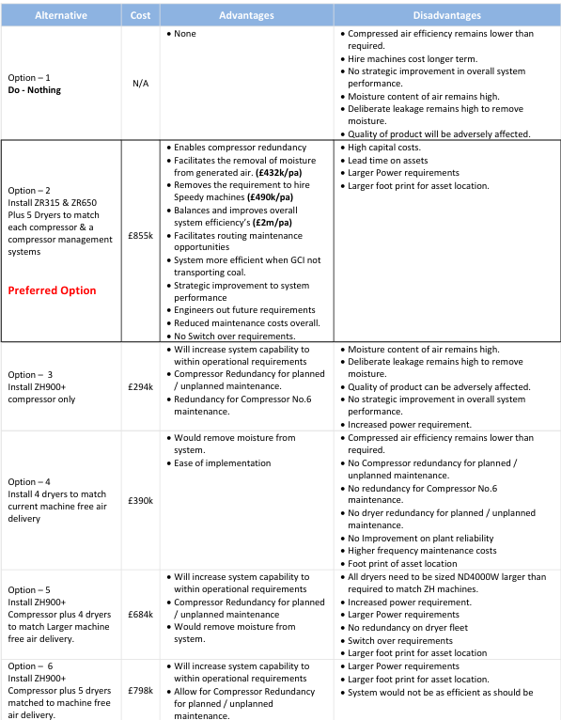
Multiple improvement options were evaluated to enhance the efficiency of the compressed air system at Tata Steel's coal injection plant. These options were assessed based on their potential impact on system efficiency, moisture removal, product quality, and cost-effectiveness. The table highlighted in Figure 25 summarises six considered options, detailing the advantages and disadvantages of each, with a particular focus on why Option 2 is the most viable solution.
Figure 25 Option 2 by Atlas Copco

9.2 Analysis of Preferred Option (Option 2)

Option 2 involves strategically removing the older, less efficient Unit No.6 (ZR750) and introducing two newer models, ZR630 and ZR315. This change optimises the airflow and significantly enhances the overall system efficiency from 8.94 kW/m³/min to 6.2 kW/m³/min. Additionally, by installing energy-efficient heat compression dryers, the system can close valves previously left open for moisture removal, further contributing to energy savings. Implementing this option is projected to reduce the annual running costs from £6,739,737 to £4,674,090, generating total annual savings of £2,065,647.

This comprehensive analysis and structured presentation will clarify the decision-making process and demonstrate the thorough evaluation and strategic planning involved in optimising Tata Steel's operations. This approach ensures that the recommendations are technically feasible and economically beneficial, aligning with Tata Steel's long-term sustainability and efficiency goals.

To ensure the recommendations by Atlas Copco are robust and actionable, a detailed risk assessment, cost-benefit analysis, and environmental impact assessment should be included. Feedback from key stakeholders such as the Blast Furnaces will align the recommendations with organisational goals. A straightforward implementation timeline with key milestones and a comprehensive monitoring and evaluation plan will facilitate effective planning and assessment of the implemented changes. This holistic approach will align the recommendations with Tata Steel's strategic and operational goals, ensuring long-term sustainability and efficiency improvements.

9.3 Further Research.

After conducting research and analysing the data from the surveys, it was imperative to research the following subjects to understand how to benefit the current compressed air system truly:

- Predictive Compressor Management System: Explore implementing a system linked to all compressors to improve load management and reduce operational inefficiencies.

- Heat of Compression Drum Dryers: Investigate the introduction of drum dryers that utilise waste heat from compressors, offering a cost-effective solution for moisture control.

- Financial and Environmental Impact: Assess the potential for significant energy and cost savings and the corresponding reduction in carbon emissions.

- Future Research and Implementation Challenges: Consider the operational disruptions during implementation and develop a phased strategy that minimises downtime.

- Strategic Implications: Evaluate the benefits of enhanced operational reliability and compliance with environmental regulations through improved energy management.

- Long-Term Strategic Vision: To support long-term sustainability goals, focus on continuous monitoring and iterative improvements in compressor technology and energy management.

10 References

Air & Vacuum Process (2024) The Benefits Of Using Regenerative Desiccant Air Dryers: Improved Air Quality, Energy Efficiency, And More. Available at: https://airvacuumprocess.com/blogs/the-benefits-of-using-regenerative-desiccant-air-dryers-improved-air-quality-energy-efficiency-and-more/ (Accessed: 7 May 2024).
Air Compression Technology. and Halliwell, J. (2024) Summary report of the Assessment of the Operational Performance Of the Compressed Air System at GCI, Tata Steel.
Atlas Copco (2023) How to remove moisture from compressed air? Available at: https://www.atlascopco.com/en-uk/compressors/air-compressor-blog/challenger/how-to-remove-moisture-from-compressed-air (Accessed: 6 May 2024).
Atlas Copco (2024) Rotary Drum Dryer. Available at: https://www.atlascopco.com/en-uk/compressors/products/air-dryers/desiccant-air-dryers/mdg-md-nd-rotary-drum-dryers (Accessed: 19 May 2024).
British Compressed Air Society Ltd. (2024) Compressed Air at-a-Glance. Available at: https://www.bcas.org.uk/knowledge-base/compressed-air-at-a-glance.aspx#:~:text=The%20four%20most%20important%20components%20of%20compressed%20air,volume%20of%20air%2C%20or%20for%20optimal%20energy%20performance.https://www.bcas.org.uk/knowledge-base/compressed-air-at-a-glance.aspx#:~:text=The%20four%20most%20important%20components%20of%20compressed%20air,volume%20of%20air%2C%20or%20for%20optimal%20energy%20performance. (Accessed: 6 May 2024).
Broniszewski, M. and Werle, S. (2018) ‘The study on the heat recovery from air compressors’, E3S Web of Conferences, 70, p. 03001. Available at: https://doi.org/10.1051/e3sconf/20187003001.
Bstech (2021) Hot Tapping . Available at: https://bstech.co/hot-tapping/ (Accessed: 19 May 2024).
Chou, J.-S. and Yeh, K.-C. (2015) ‘Life cycle carbon dioxide emissions simulation and environmental cost analysis for building construction’, Journal of Cleaner Production, 101, pp. 137–147. Available at: https://doi.org/10.1016/j.jclepro.2015.04.001.
CMP (2015) Condition Monitoring. . Available at: https://www.conditionmonitoringproducts.com/all-products/product/2031-ultraprobe-100.html (Accessed: 19 May 2024).
Compressed Air & Gas Institute (2021) Compressed Air & Gas Handbook. 7th edn. Cleveland: Compressed Air & Gas Institute. Available at: https://www.cagi.org/assets/documents/pdfs/handbook/Chapter%204%20handbook_Final2021.pdf?updated=1659534959 (Accessed: 8 May 2024).
Giampieri, A. et al. (2020) ‘A review of the current automotive manufacturing practice from an energy perspective’, Applied Energy, 261, p. 114074. Available at: https://doi.org/10.1016/j.apenergy.2019.114074.
Hayes, J. (2022) The Theory and Practice of Change Management. Bloomsbury Publishing.
Kerzner, H. (2017) Project Management A Systems Approach to Planning, Scheduling, and Controlling. 12th edn. Available at: https://www.perlego.com/book/994604/project-management-a-systems-approach-to-planning-scheduling-and-controlling-pdf (Accessed: 15 May 2024).
Laryea, S. (2011) ‘Quality of tender documents: case studies from the UK’, Construction Management and Economics, 29(3), pp. 275–286. Available at: https://doi.org/10.1080/01446193.2010.540019.
Liu, Z., Li, Q. and Zhang, J. (2021) ‘Effect of moisture content on flow behavior and resistance characteristics of dense-phase pneumatic conveying’, Powder Technology, 387, pp. 1–8. Available at: https://doi.org/10.1016/j.powtec.2021.03.057.
Marginean, L.-I. et al. (2023) ‘New Methods of Tracking Compressed Air Leaks Used in the Production Processes of an Industrial Hall to Improve Energy Performance’, in, pp. 747–761. Available at: https://doi.org/10.1007/978-3-031-22375-4_60.
Mitchell, S. (2017) Compressed Air Leak Surveys: Gateway to Industrial Efficiency .
Progressive Products Inc (2019) ‘How to Minimize Pressure Drops in Your Pneumatic Conveying System’. Available at: https://blog.progressiveproductsinc.com/minimize-pressure-drop-in-pneumatic-conveying-system (Accessed: 6 May 2024).
Reynolds, D. (2024) Air Leakage Survey – GCI Compressed Air Drains.
Russ Jones (2021) Proactively Maintaining Desiccant Dryers Yields Efficiencies and Reliable Service. Available at: https://www.airbestpractices.com/technology/air-treatmentn2/proactively-maintaining-desiccant-dryers-yields-efficiencies-and-reliable (Accessed: 7 May 2024).
Tata Steel (2023) BF4 Coal Line Pressures.
U.S. Department of Energy (2023) Improving Compressed Air System Performance. Available at: https://www.energy.gov/sites/prod/files/2014/05/f16/compressed_air_sourcebook.pdf (Accessed: 19 May 2024).
Venkatachalam, S. et al. (2023) ‘Performance comparison of heat regeneration modes in adsorption dryers for ultra-low dew point compressed air production.’, Journal of the Chinese Society of Mechanical Engineers, pp. 473–480.

