Ryan Jones
2009252@student.uwtsd.ac.uk
Date
Tuesday 3rd May @3pm
Bsc/hnd computing. cyber security and networking
L4 Introduction to Web and Database Concepts ACCA4023

Table of Contents

Introduction 2
Requirements 2
Implementation and validation 3
a) Implementation 3
b) Validation 4
Evaluation 5
A. Website usability, accessibility, and search engine 5
Website Usability 5
Website accessibility 7
Search Engine optimization 9
B. Evaluation of completed website 11
Usefulness 11
Search Engine Optimisation (SEO) 12
Accessibility 13
References 15
Appendices 16
Index4.html 16
About.html 18
Contact.html 22
Gallery.html 24
Weather.html 28
Index4CSSlink.CSS 29

Introduction

This report accompanies a website I have created using a html code. I have undertaken this task using my own design and customisation. I chose to create a website about my local park. The reason I chose this theme was due to visiting the park on a regular basis, it is something I enjoy doing with my family, and is somewhere I have a positive affiliation with. The Index.HTML and the CSS page are based on the framework that was outlined by lecturer, Gareth Jones as part of this academic course. Using web standards, I then went on to create a website containing five pages using HTML codes. These pages consisted of what I considered to be the most relevant information that people who wanted to visit the park may want to see or read about. I informed my decision making based on what information was available on various other websites which contained information about Brynmill Park. In creating the website, I accessed two websites that provided current and historical information and images which I utilised in addition to my local knowledge, experiences, and own photography. I have referenced these within this report as opposed to the website itself and have detailed this as a separate reference list. I tested and validated my design using various online tools to reflect upon how to improve my webpage.
Contained within this report is wire diagram of the design and screenshots of the finished product. I have highlighted the errors found following validation and how these were rectified. Finally, I provide a detailed explanation using academic literature of the aspects of website usability, accessibility and search engine optimisation and then applied this to evaluate my website design. Whilst there are many aspects of my design that were positive the evaluation of these concepts enabled me to comment on how to improve my design to make my website more user friendly and increase its useability, optimisation, and accessibility.

Requirements

The website I designed was about my local park, Brynmill. The website design focused on key aspects of the park, and I used the five pages to furnish people with what I considered the most relevant information they would want when visiting the park. I included an introduction page outlining the parks facilities, a page around the weather (albeit fictional for the assignment purposes), gallery of pictures I took myself of various parts of the park, a page detailing the history of the park and historical pictures that I sourced, and finally a contact page to provide a facility for any reader to get further information. The park is visited by many local families but has facilities and attractions for all members of the public to enjoy. The information I included was to highlight the many attractions the park has to offer its local community and how it can appeal to people of all ages and backgrounds.

Implementation and validation

Implementation

I have used the ‘snip tool’ to include screen grabs of each page of my website design. I have included the wire diagram of each page to show how I envisaged the page to be structed and then placed the finished product page adjacent to this. These are shown below:

Wire Diagram: Web Page:
Home page
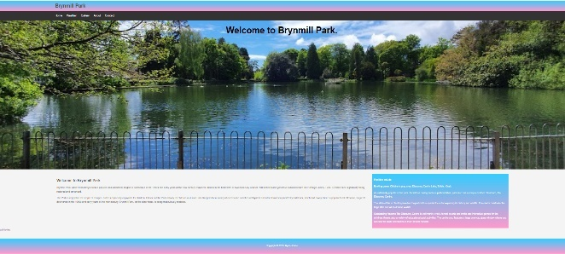
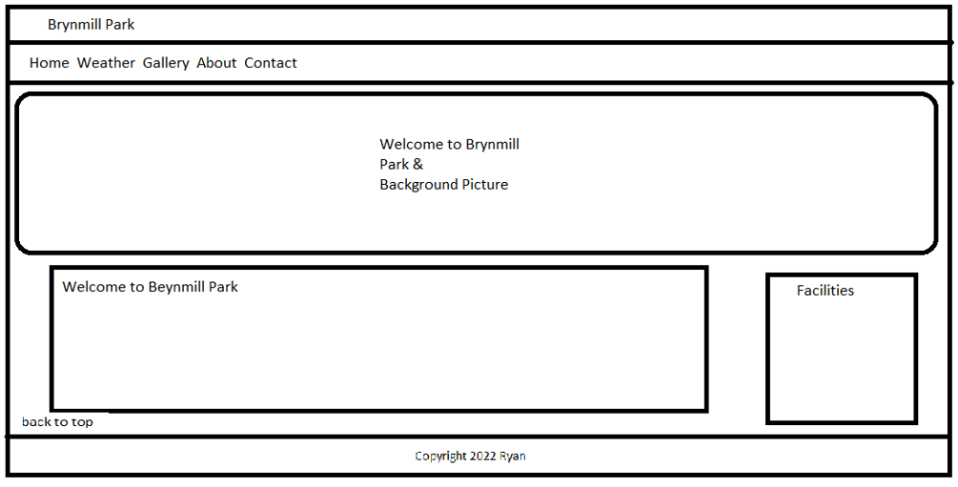
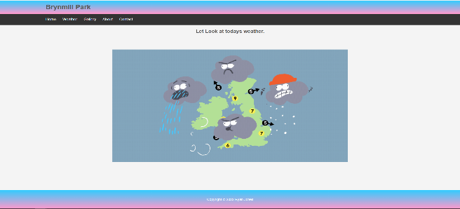
Weather Page
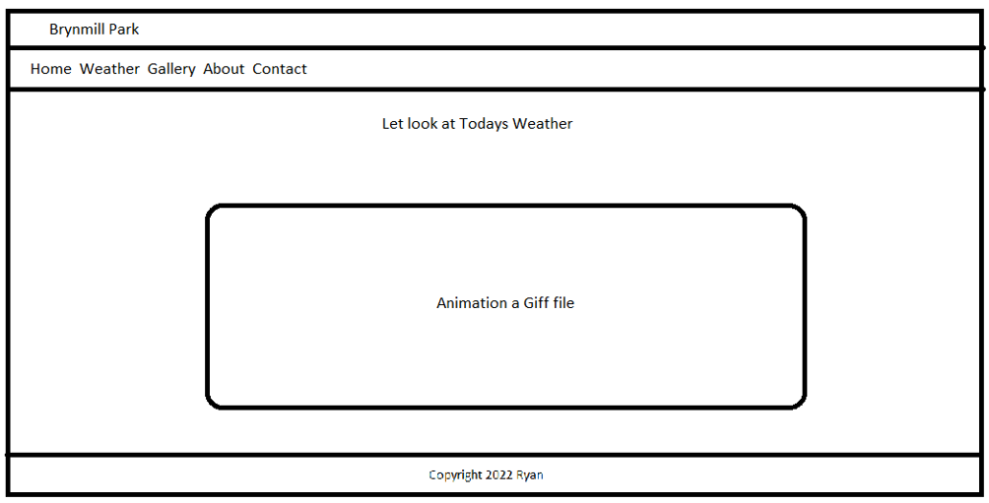
Gallery Page
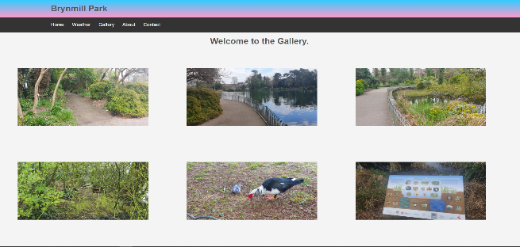
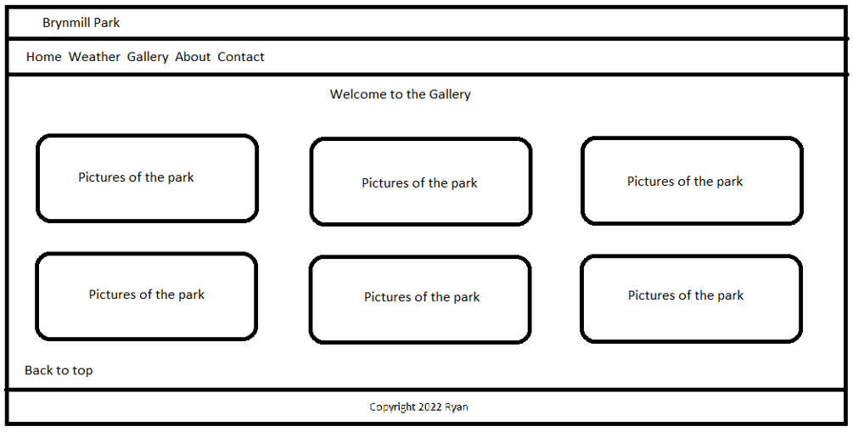

About Page
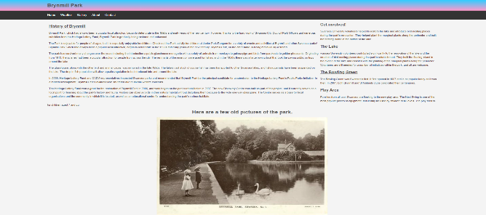
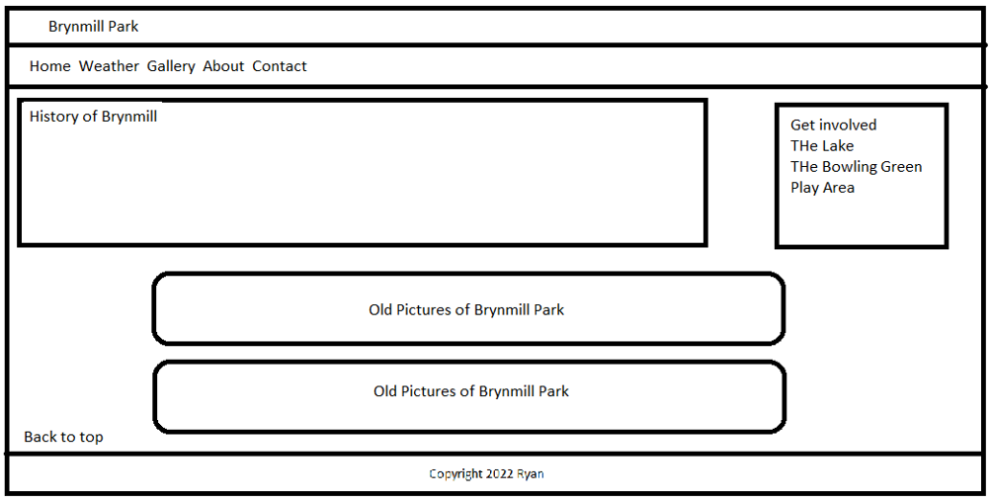

Contact Page
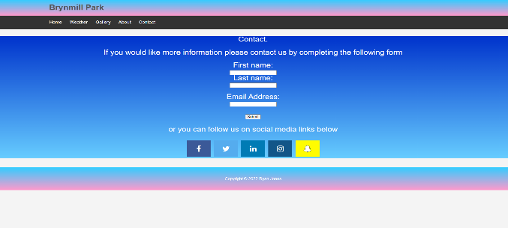
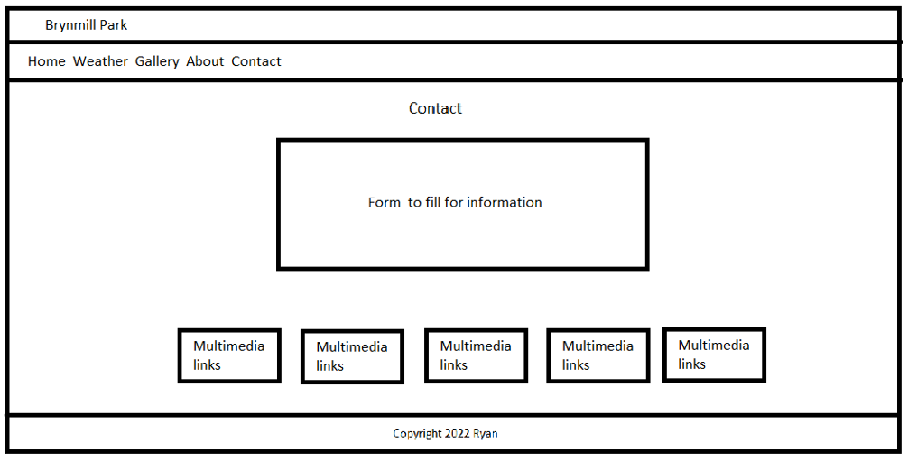

b) Validation

To ensure my website design is fit for purpose I used validation to check the coding I used within its build to check for errors.
I used the following website: HTTP://validator.w3.org to run the named index4.html through. This was to validate HTML codes within the design to search for any errors that needed correcting. As a result of doing this I was given some warnings and errors as listed below:
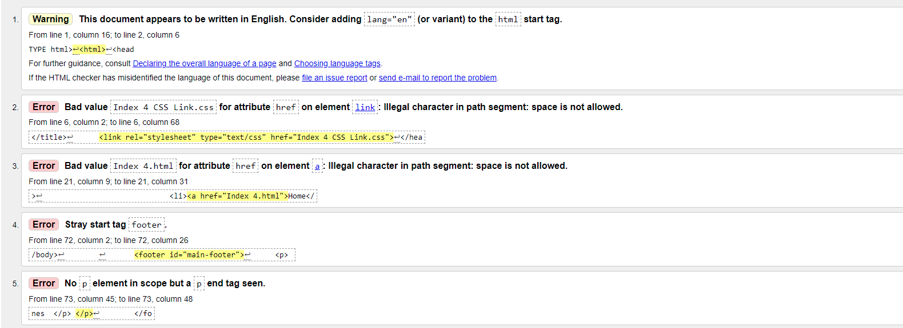
Line 1. I added <html lang="en"> to set the language
The error which was highlighted was that I had not set the code to the language used within the website. In order to correct this, I inputted the above code so that this was then in place.
Line 2. I had to rename the .CSS file so it had no spaces
To remove what was referred to as a ‘bad value’ I renamed the file as above.
Line 3. I had to rename the. HTML file so it had no spaces
I also renamed this file to remove the ‘bad character’ which highlighted that I had put an additional space in when this was not required.
Line 4. I had to move the <footer> within the <body>
The error highlighted in this section indicated that my footer code was placed incorrectly and by undertaking the above this was rectified.
Line 5. I had two <p> I removed one of them
This error indicated unnecessary duplication which was deleted.
After applying the above changes, I re-ran the validation test, and no errors were highlighted with the coding. This positive outcome is shown below:
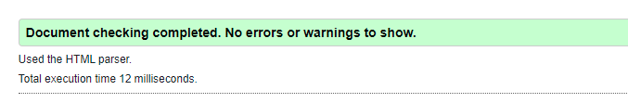
When validating my CSS file named index4CSSlink.css I used the following website: The W3C CSS Validation Service. The outcome of this indicated that I had no errors in my CSS file as shown in the below screen shot of the results:


Evaluation

Website usability, accessibility, and search engine

Website Usability

In simple terms Website usability refers to the ease in which someone can navigate around a site and achieve their intended outcome. “A person of average (or even below average) ability and experience can figure out how to use the thing to accomplish something without it being more trouble than it’s worth” [1]. The most important aspects of website usability are a clear and simple navigation system, clear, and relevant information, and good corporate branding that acts as an advertisement for a company.
“Something is usable if it is effective, efficient and satisfying to use” [2]. It is important to acknowledge that not all websites can be measured the same as they have different purpose and audience. Understanding this and a specific websites context can assist with designing them to target their intended audience more effectively.
It is outlined that “One can categorise the intentions and motivations for visiting websites” [3] in four categories as follows:
• exploration
• information
• entertainment
• shopping.
It is indicated within [3] that whatever an individual’s motivation is to access a website it is the user’s experience that is a result of the usability and the quality of the information that is provided by the developer. Upon completing a search for one of the above reasons it is important to remember that a visitor to any site may have never been there before and therefore will have no knowledge of what is contained in each headline, subfolder, or menu item. Because of this, each link should be helpful and detailed in whatever format they come in to enhance the usability of the website. It is outlined that “poor navigation is one of the main reasons that someone exits a website” [4]. As a result, the navigation elements need particular attention including the use of the back button or the breadcrumbs on the keyboard
Search usability is another element of overall usability that cannot be ignored. This is highlighted in [4] as the function that users will utilise if they have not managed to get what they need via traditional navigation. “Additionally, users will use the search functionality if they are looking for a particular product in e-commerce websites” [4].
The balance of text, visuals and graphics need to be considered when considering a website’s usability. “Content should be clear, precise and well formatted” [4]. Clutter can be off putting and therefore if a site has a lot of information, it is advised that this is split under headings and links. Getting this balance right can also avoid being ‘text heavy’ and images can add interest as detailed in [4]. It is also applied to the use of videos. The appeal of a website and it’s useability is important as “Users typically spend between 10 and 20 seconds on a web page unless the content grabs their attention” [4]. In line with this timeframe if the content loads slowly then this will undoubtably be related with how long someone remains on any given website.
The importance of usability within website development is critical to the user in achieving their goal for visiting the website but also for commercial purposes. “Website owners and designers put in a lot of effort and money, to develop, promote and maintain a website” [4]. Therefore, attention is required to the various aspects of usability around navigation, Search functionality, content, visuals, and speed.
An academic journal which title is: An Investigation into Usability Aspects of E-Commerce Websites Using Users’ Preferences, focuses upon some of the problems that occur in respect of usability and in doing so highlight the importance of some of the factors detailed above. The study refers to Usability as “one of the most important attributes for any user interface, which measures how easily a user can use the interface” [5]. The study focuses on ten e-commence websites and highlights the importance of usability when using any device capable of accessing websites. To determine certain areas that have undergone or require improvement evaluation methods have been deployed using three methods. These are:
Firstly, User testing method which includes users from both ends of the spectrum and looks for usability problems that have been experienced using interviews and questionnaires. The study aimed to determine whether different users (dependent upon skill) judge usability differently within the research. Secondly, Heuristic testing which looks for usability problems that are present as part of the design process through a small number of set evaluation tools. One of the aims of the study being to develop important evaluation features for this purpose. And finally, Tool based Testing looks at the software and whether this performs in line with the principles and guidelines aligned with usability. This is automatically assessed and will help with the research objective to identify the importance of websites in usability features.
The study highlights that navigation was the most important factor when looking at usability, something which other research studies has indicated, and which importance is referred to above. “Navigation feature was getting the highest weights in aspects of users, which are the most important design features for the usability of websites” [5]. The other factors highlighted as strengths as part of the results of the study are well recognised factors that are linked with positive features of useability across the board. These are navigation, content, and design. All of which have been referred to as important aspects when considering the importance of useability irrespective of subject topic. Poor maintenance of the websites resulting in language options, download speeds and lack of clarity were some of the weaknesses associated in the study outcome. These points have been cited earlier as some of the problems which can affect the appeal and usability of any particular website.

Website accessibility

In its most simplistic terms Website Accessibility means “websites, tools, and technologies are designed and developed so that people with disabilities can use them” [6].
The Internet has dramatically changed the way we approach our work and personal life. Today, information about the services business offer or social activities are made available to the public by what is published on websites.
When designing a website, it needs to be accessible to all visitors, including those with disabilities. Following key design principles for web accessibility ensures that persons with disabilities or restrictions have the same or similar experiences as those who do not. Website accessibility is a critical goal, “Accessibility is essential for developers and organizations that want to create high-quality websites and web tools, and not exclude people from using their products and services” [6].
To assist with making this subject simple there are 4 principles that need to be applied when making a website accessible and are detailed as follows: perceivable, operable, understandable, and robust [7]. These were most recently defined in the updated guidelines of the Web Accessibility Initiative (WAI) in 2018 as referred to in [8].
Perceivable:
Anybody accessing a website should be able to process the information. “Information that is not presented in a processable format is not accessible” [7]. It is therefore critical that the website must accommodate those with hearing or sight disabilities for everyone to be able to take full advantage of this mode of communication. Although websites are primary visual, assisted technology can ensure that the content is perceivable. If this is missing the standard around perceivability will not be met.
Operable:
For a website to be operable it must be providing a variety of tools in which it its audience can operate it. Every aspect of the site's functionality is accessible to all visitors, from browsing a page to selecting a link from a menu. Human errors occur and it is recommended in addition to offering alternatives to ensure navigation around the web page but that a website should “Offer second chances, instructions, cancellation options, and warnings to help all users” [7].
Understandable:
The Content and language within a website should be easy to follow and easy to understand for all users with guidance provided. There should be flow to the navigation which should be logical to the user. Ultimately by making a website understandable you are making the website customer friendly. A lot of description is relevant to usability because ultimately “usable websites are inherently more accessible” [7].
Robust:
Any website should be compatible with different browsers and devices. This should be in line need and choice. “One of the best ways to meet the principle of robustness is to follow development standards and conventions” [7]. It is also recommended that websites avoid using large images as this can cause longer downloading times often resulting in visitors not returning to the site.
Whilst every website may not be able to anticipate and account for every aspect effecting accessibility, “Accessibility guidelines, standards, and techniques ensure that the wide range of issues are adequately covered” [8]. Whilst those who build the website have a requirement to comply and make websites accessible it also becomes a morale requirement in that failing to consider and account for accessibility issues is essentially excluding members of society access to services and information. The research study: perceptions of web accessibility guidelines by student website and App Developers highlights that this is still lacking in the research they reviewed as part of this study.
It is outlined that one of the reasons that accessibility is lacking from websites, “is related to training, or a lack thereof” [8]. Their research therefore focuses upon how familiar this group is with accessibility guidelines and whether training and education play a part in improving this understanding and perceptions. If courses include reference to accessibility, it may through education, make those students and developers more aware of the diversity issues of those who may be accessing a website and therefore be more likely to implement features to increase accessibility. The study adopts the approach of the perception of web accessibility present in a website as to whether the student/app developer has had education and training on the subject. This in essence is the predictor in the study; the higher evidence of awareness of diverse disabilities, accessibility provided and embedded guidelines the more exposure/education that individual has had. This is captured in the below diagram.

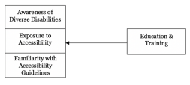
Figure 1 Theoretical Framework [8].
The research study adopted a mixed method approach in the research to generate both quantitative (questionnaires) which focused on experiences and perceptions around accessibility guidelines and qualitative data (voluntary interview post questionnaire) focusing on experience of this area. Binary logistic regression model was utilised to establish the link between the outcome of the study and the level of training/education that the participants had received. The research aims to contribute to further research but builds on exiting research highlighting the important link to this area. “Understanding the basic Accessibility Principles and using them for developing and evaluating early prototypes helps the development team provide basic accessibility in the earliest stages” [6]. This highlights the fact that this is needed and reinforces the need for understanding these principles in order to apply them in the first place.

Search Engine optimization

In its most basic of terms this can be described as the “process of improving your site to increase its visibility when people search for products or services related to your business in Google, Bing, and other search engines” [9].
Off-page optimisation occurs of the main website and “involve attracting links from other websites, shares on social media, and mentions across the web” [10]. This is external promotion that impacts on the rating and search engine measure a site’s credibility by this. 3 types of links are highlighted in [10] namely, natural, built and created. A natural link will occur by the reader who will link your website due to finding the content valuable. Built links are created by exposure often via promotion and are the most popular in optimising a site off page. “Links are also the simplest way to measure the expertise, authority, and trust of a site” [10] as reputable sites are effectively endorsing the content of a website. Advertisement via social media is also another off-page optimisation strategy.
Whilst some of off-page optimisation is out of the control of the website creator, on-page optimisation is within their control. On- page optimisation outlines its aim as “to make your website more usable and valuable to users to improve your rankings or visibility in search results” [11]. This process covers many aspects from understanding how to make a website as easy to use for a targeted audience and how including key words and phrases can increase numbers of people which visit your website, ultimately increasing its value. It is therefore important to understand your intended audience however it is not just this that is needed to achieve optimisation. “If knowing your audience’s intent is one side of the SEO coin, delivering it in a way search engine crawlers can find and understand is the other” [9]. A crawler creates what Lieb [12] explains as an index which then enables it to become familiar with words and phrases that appear on certain sites which then in turn produces the results from the given search. Increasing optimisation by use of specific keywords in title tags “makes it easier for search engine crawlers to understand your website” [11]. Using keywords throughout the site which helps the target audience search what they are looking for and match this with a specific website. It is also vital to update the content of a website to achieve optimisation – it makes it relevant and motivating for the user to visit the site. Content can be described as something that “provides the users with answers and search engines with context” [11] and therefore it can be considered critical when considering optimisation.
Lieb [12] describes how with the advances in technology is has become embedded into human practice that when we seek answers, have an interest, or want more information on newsworthy items we simply go online and search. The desire to have this information quickly is also a factor and it is highlighted in [7] highlighting how page speed is used as a ranking factor by some search engines as is mobile friendliness aa over half of the searches will be from mobile devices. It also outlines how changes occur as more content is considered within searches. With the mass market expanding and more search engines competing the search encompasses visual, sound, and written results. “Optimizing your site will help deliver better information to search engines so that your content can be properly indexed and displayed within search results” [9]. This plays a huge part in marketing and can sustain businesses from the business that it creates and maintains. It is highlighted however that volume of traffic is one important aspect but returning to the point highlighting the importance of the need to understand your audience and create honest results in line with search requests. “There’s little use in ranking if no one is clicking through to your site, and there’s little use in increasing your traffic if that traffic isn’t accomplishing a larger business objective” [9]. Application of strategy using on-page optimisation does not create results overnight but once your on-page SEO strategy gets off the ground, it can make your online rankings and sales soar [11]. This refers to meta description as it helps users understand and be able to learn more about the content of a website.
Factors that On-page optimisation should focus upon are detailed within [11] as including URL, Meta Description, heading tags, keywords, speed, content, images amongst others. Being aware of such factors then assist with including these when creating your website. Using URL as an example it is important that include a keyword that gives an induction of the website topic. “Including your keyword in your URL instead of a long string of jumbled numbers also makes your site easier to navigate and gives people a better idea of your page topics” [11]. Heading tags assists in separate content and providing context to a website when including keywords within these and alt tags indicate images and multimedia that is present on a website.
In referring to a study: Application Marketing Strategy Search Engine Optimisation in which the research’s focus was to use SEO to improve product marketing. Due to the dynamic nature of internet web and internet designs certain factors were focused upon that were classified as the most important despite any changes. Whilst the study makes it clear that a high ranking cannot be guaranteed due to the highly developed algorithms it states, “using keywords effectively can secure a higher-ranking website and increase site traffic and popularity” [13]. The study itself analysed market strategies on a company called Mountain Grounds Coffee and Eatery and used observation and interview methods of the literature. The research concluded that there is a process that much be gone through for the benefit of SEO to be realised including that of volume of traffic and ranking before this results in increased custom as indicated by the figure below:
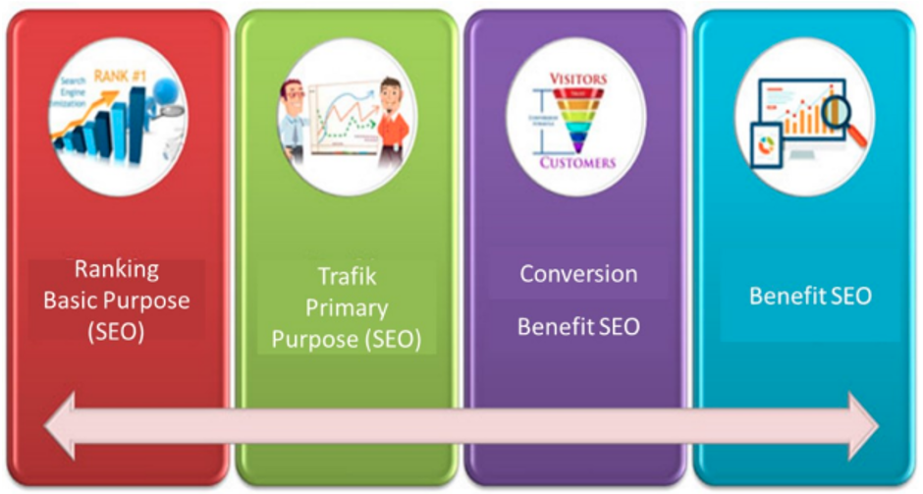
Fig 2. Cycle Achievement SEO [13].
The results of the study show that whilst custom is generated for those who live locally via word of mouth (40%) the remaining custom was generated via social media. Given these results the study concluded that applying SEO would have a positive impact upon this business for consumers both locally and otherwise.

Evaluation of completed website

Usefulness

The design of my website functions as I intended it to. The home page is mainly visual which I consider to be eye catching and not overly text heavy from the initial access point. The pertinent information around the park’s facilities is provided in the initial text and sets out who these are aimed at. This would enable the reader from the outset to determine whether they wish to remain on the website and if this is an area of interest to them and in line with what topic they were searching for. It’s design also encourages the user to read more as the information is across several pages and under relevant headings. The pages provide the details indicated by the headings so that anyone who was to view it would know where to access specific information and the design of the website means that the design is simple but delivers what it says it will. Navigation around the site I feel can be done with ease which as has been highlighted as a positive factor as referenced in the earlier academic and research which I have referred to around this topic area.
The pages load quickly, not risking losing the reader due to taking too long and all links are working effectively. The website can be accessed on different internet search browsers. The content and readability of my website is laid out in a readable font and the colour of text, backgrounds and visuals used ensure these stand out and are easy to read. The overall design makes it easy for the reader to find the content in the different heading tabs.
However, upon reflecting on my website and evaluating its usefulness I consider that several improvements could be made.
A search button could have been used to provide an option to the reader to access specific information that they wanted to search. It is noted that such a function is associated with businesses that have a financial element, but it could still be considered beneficial on this site.
When I have referred to further information around park activities and how to get involved with the restoration as a volunteer it would have been a further improvement to provide the information or links to the relevant sites. It is highlighted that “internal linking helps crawlers explore your site, discover new content, and understand the context of different pages” [11]. This is a function that is lacking and the inclusion of this would undoubtably be advantageous.
The pictures I took and included on the website could have focused more on the facilities I have detailed so that people get a visual rather than just a text description. This would have also been a nice contrast to some of the historical images I included.
A location map and/or directions would have also been beneficial and could lead the reader missing vital information on how to access the facility. This would have enabled people locating the park and planning their visit if they wished to visit.
Making the website accessible on mobile devices given how most people access sites in this way this would improve access and traffic to my website and increase the overall usability. “Mobile compatibility isn’t a suggestion anymore. It’s a requirement, especially if you want to rank well for your keywords” [11].

Search Engine Optimisation (SEO)

On Page optimisation techniques have been applied to my website and I have cross referenced these techniques using examples of their application when evaluating my website.
The first technique I have looked at was the use of keywords and associated phases and how this would assist with my website being ranked highly within a search on Brynmill Park. “You should research and compile keywords for each page on your site” [11]. To evaluate how effective, I consider my site would be I have looked at each page and its content and have detailed what are the keyword and phases which would have a positive search result:
“Brynmill, Brynmill Park, Brynmill Weather, Brynmill Facilities, Brynmill Pictures, Brynmill Park Bowling Green, Brynmill Discovery Centre, Brynmill Park Lake, Brynmill Park Kiosk, Brynmill History, Brynmill Play Area”
By using these key words across the more than one page of the website would again assist in my website being relevant to online searches and achieving a positive result.
I have used title tags within my website which again is an example of how using these is an on-page optimisation technique. Each title tag contains the word ‘Brynmill’ as this is the most relevant word and then attached to this is an additional word around a particular page content, such as weather would be shown in the header tag as ‘Brynmill weather’.
Image Alt tags are another form of on page optimisation and I have used these within the gallery page. “Search engines can’t see multimedia, so they depend on alt attributes to tell them what multimedia is” [11]. The tags have been used on the images I included and therefore should be effective in having a positive result if searched on the image name.
Heading tags are a form of on-page optimisation and it is recommended websites “use heading tags throughout your content to break it up and make it more readable and skimmable for users” [11]. I have applied this to my website giving clear indication of what the content of each page contains. Where necessary when the information provided covers a number of topics/details I have broken these down into several header tags on a page to ensure the user is able to locate the relevant information they are searching for as easily as possible. An example of my application of heading tags within the website is as follows:
h1> Brynmill Park</h1>
Whilst meta description isn’t necessarily directly linked to optimisation it is however considered to be a technique that can be applied to have a positive impact. “The fact that Google will bold user search terms that appear in your meta description is another reason to optimize your meta description for on-page SEO” [11]. I have applied meta tags to keywords, author name and content to apply this technique to my website as illustrated below in the following 2 examples:
<meta name="Brynmill Park" content="History of Brynmill Park"/>
<meta name="author" content="Ryan Jones"/>
I have applied multiple content to my website in line with using on-line optimisation techniques using both images and text. As illustrated on the history page of my website I have provided an overview of this in text and additionally provided some historical pictures to add context and interest. The look and design of my website I consider to be aesthetically pleasing and delivers the information it sets out and promises to, making it consistent and honest in its content. This always helps with optimisation as does the speed in which my website loads.

Accessibility

In order to evaluate my website in relation to its accessibility I benchmarked this against WCAG 2.1 and the four main principles outlined above, namely; perceivable, operable, understandable and robust. Due to the way in which the website was created and not being hosted I was unable to use testing tools that required URL’s. I was however able to use and test my website using the following; Juicy Studio: Luminosity Colour Contrast Ratio Analyser and WebAIM: Contrast Checker.
These were used to assess accessibility in relation to the colour contract on my main page. I have used background colour #f4f4f4 and the results are detailed below:
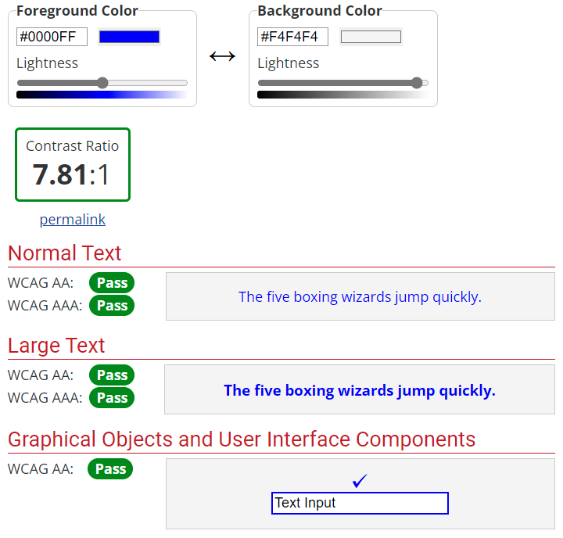
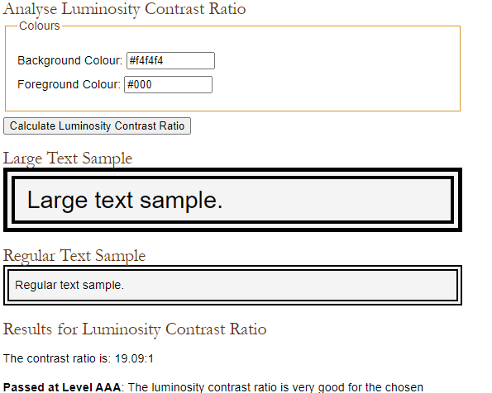

The shows that the background colour and visual were acceptable in line with the required standards. Whilst my site does not have any assisted technology to enable those with sight or hearing impairments the visuals are bright and the text, I would assess to be easy to read. Although by lacking this it would be deemed to be lacking perceivability.
In terms of being operable, the website itself can be navigated easily and the headers and tabs provide clear instruction of how to access relevant information. Although there is not a back button as such errors cannot be made and the user can simply click on the correct tab if they have clicked on the wrong one in error.
The website I have created is easy to follow and I would argue has a logical flow containing relevant information to the subject content. The website is created to be user friendly and therefore I would conclude that the principle of understandability has been met.
In reference to assessing how robust my website is I have avoided using large images which would slow the download time of the website. I can prove that the website can be accessed via different Browser sites enabling a variety of access routes, however due to it being local I cannot demonstrate that it is compatible with a mobile device. As such this would have a negative impact of the website being able to satisfy this principle.

References
[1] S. Krug, Don’t make Me Think, Revisited : A Common Sense Approach to Web Usability, Berkeley: New Riders, 2014.
[2] T. Stewart, "Websites - Quality and Usability," Behaviour & Information Technology, vol. 31, (7), pp. 645-646, 2012. . DOI: 10.1080/0144929X.2012.707372.
[3] Anonymous (). Fusing website usability and search engine optimisation : original research. Available: https://journals.co.za/doi/epdf/10.4102/sajim.v16i1.577. DOI: 10.4102/sajim.v16i1.577 [Accessed Apr 17, 2022].
[4] Anonymous (-03-12T12:00:58+00:00). A 7 Step Guide To Website Usability. Available: https://usabilitygeek.com/a-7-step-guide-to-website-usability/ [Accessed Apr 17, 2022].
[5] S. K. Panda, S. K. Swain and R. Mall, "An investigation into usability aspects of E-Commerce websites using users’ preferences," Advances in Computer Science: An International Journal, vol. 4, (1), pp. 65-73, 2015.
[6] (WAI), W3C Web Accessibility Initiative. (). Accessibility Principles. Available: https://www.w3.org/WAI/fundamentals/accessibility-principles/ [Accessed Apr 19, 2022].
[7] Anonymous (). The Four Principles of Accessibility. Available: https://www.willowtreeapps.com/craft/the-four-principles-of-accessibility [Accessed Apr 19, 2022].
[8] S. Cao and E. Loiacono, "Perceptions of web accessibility guidelines by student website and app developers," Behaviour & Information Technology, pp. 1-19, 2021. . DOI: 10.1080/0144929X.2021.1940278.
[9] Anonymous (). What Is SEO / Search Engine Optimization?. Available: https://searchengineland.com/guide/what-is-seo [Accessed Apr 16, 2022].
[10] Anonymous (). What Is Off-Page SEO? | Your Guide to Off-Page Optimization. Available: https://www.webfx.com/seo/glossary/what-is-off-page-seo/ [Accessed Apr 20, 2022].
[11] Anonymous (). What Is On-Page SEO? (And How to Do On-Page Optimization). Available: https://www.webfx.com/seo/glossary/what-is-on-page-seo/ [Accessed Apr 20, 2022].
[12] Lieb, Rebecca. The Truth About Search Engine Optimization. United Kingdom, Pearson Education, 2009.
[13] M. S. Iskandar and D. Komara, "Application Marketing Strategy Search Engine Optimization (SEO)," IOP Conference Series.Materials Science and Engineering; IOP Conf.Ser.: Mater.Sci.Eng, vol. 407, (1), pp. 12011, 2018. . DOI: 10.1088/1757-899X/407/1/012011.
Website references:
[1] P. a. G. (en). (). Brynmill Park - Swansea. Available: https://www.parksandgardens.org/places/brynmill-park [Accessed Mar 28, 2022].
[2] Anonymous (). Brynmill Park. Available: http://www.fieldsintrust.org/FieldSite/Brynmill-Park [Accessed Mar 28, 2022].

Appendices

Index4.html

ml lang="en">
<head>
<meta charset="utf-8" />
<meta name="Brynmill Park" content="History of Brynmill Park"/>
<meta name="keywords" content="Brynmill,Brynmill Park,Brynmill Weather,Brynmill Facilities,Brynmill Pictures,Brynmill Park Bowling Green,Brynmill Discovery Centre,Brynmill Park Lake,Brynmill Park Kiosk,Brynmill History,Brunmill Play Area " />
<meta name="author" content="Ryan Jones"/>
<title>Brynmill park</title>
<link rel="stylesheet" type="text/css" href="Index4CSSLink.css">
</head>

<body>
<p id="topPara">
<header id="main-header">
<div class="container">
<h1> Brynmill Park</h1>
</div>
</header>

<nav id="navbar">
<div class="container">
<ul>
<li><a href="Index4.html">Home</a></li>
<li><a href="weather.html">Weather</a></li>
<li><a href="Galery.html">Gallery</a></li>
<li><a href="About.html">About</a></li>
<li><a href="Contact.html">Contact</a></li>
</ul>
</div>
</nav>

<section id="showcase">
<div class="container">
<h2> Welcome to Brynmill Park.</h2>
</div>
</section>

<div class="container">
<section id="main">
<h2>Welcome to Brynmill Park</h2>

<p> Brynmill Park, based in Swansea, is a popular local attraction appealing to members of the community of all ages and backgrounds.
The park has been maintained and restored thanks to the dedication and hard work of local park officers and funding via the Heritage
Lottery fund. </p>

<P> The Park has also benefited from being enhanced and the facilities offer lots of fun filled activities aimed particularly at children
and families. Further information can be found by checking out Junior Park Rangers.</p>

<p>The Park has a management committee which was successful in securing the funds to restore the Park when it has fallen into disrepair.
Community involvement is encouraged as new ideas are always welcomed given the facilities available are for the benefit of the community.</p>
</section>

<aside id="sidebar">

<p>Facilities in this popular urban Park include:</p>
<p>Bowling green, Children's play area, Discovery Centre Lake, Toilets and Kiosk</p>
<p>The park also has a unique outdoor classroom, the Discovery Centre. This is well worth a visit as it offers state-of-the-art facilities providing
the park with a special focus for exploring its history and wildlife. The centre overlooks the large lake and all its diverse wildlife. </p>
<p>You can purchase bird seed from the Kiosk in addition to your refreshments to feed the many different species of birds. The information boards
around the lake provides information to help you identify these different species and the other wildlife in the park.</p>
<p>The Discovery centre offers arts and crafts and interactive games for the children and a variety of educational adult activities.
The centre also features a large one-way glass window where you can see the birds and wildlife in their natural habitats.</p>
</aside>

</div>
<a href="#topPara" style="color:purple"> Back to top</a>

<footer id="main-footer">
<p>Copyright &copy; 2022 Ryan Jones</p>
</footer>
</body>

</html>

About.html

<html>
<head>
<meta charset="utf-8" />
<meta name="Brynmill Park"content="Hystory of brynmill Park wiv some Victorian pictures"/>
<meta name="keywords" content="Brynmill,Brynmill Park,Brynmill Weather,Brynmill Facilities,Brynmill Pictures,Brynmill Park Bowling Green,Brynmill Discovery Centre,Brynmill Park Lake,Brynmill Park Kiosk,Brynmill History,Brunmill Play Area " />
<meta name="author" content="Ryan Jones"/>
<title>Brynmill park About</title>
<link rel="stylesheet" type="text/css" href="Index4CSSLink.css">
</head>

<body>
<p id="topPara">
<header id="main-header">
<div class="container">
<h1> Brynmill Park</h1>
</div>
</header>

<nav id="navbar">
<div class="container">
<ul>
<li><a href="Index4.html">Home</a></li>
<li><a href="weather.html">Weather</a></li>
<li><a href="Gallery.html">Gallery</a></li>
<li><a href="About.html">About</a></li>
<li><a href="Contact.html">Contact</a></li>
</ul>
</div>
</nav>
<div class="container">
<section id="main">
<h1><u>History of Brynmill</u></h1>

<p>Brynmill Park is a Victorian urban Park which has been maintained and restored over the years since it was established in 1872.
Showing signs of deterioration in the 1990s and around the millennium hard work and funding streams have ensured the Parks existence
over the years to its present day.</p>

<P>Some of the key changes that the park has seen over the years include the introduction a public glasshouse menagerie with housed a
variety of animals ranging from monkeys to golden pheasants! Aviaries that originated from 1913 were a popular feature and attracted
many local people to visit. The remnants of the reservoir were used for fishing and in the 1950’s there was a large rowing boat that
took the paying public on trips around the lake.</p>

<p>The 1990’s saw the removal of the glasshouse, along with the bird and animal cages. Fishing permits were ceased and the stock of
course fish dispersed to various other lakes in the area. This resulted in a reduction of the fish population which then allowed
aquatic vegetation to be introduced in and around the lake.</p>

<p>In 2000, Brynmill Park was identified as the most suitable candidate in Swansea where an application to the Heritage Lottery Fund
should be submitted as part of the Public Parks initiative. The closure of the Park's aviaries due to animal welfare concerns
coincided with this application.</p>

<p>The Heritage Lottery Fund grant was awarded for the restoration of Brynmill Park in 2006 and work began on the park's restoration
the following year. As part of the plans the new Discovery Centre was built and remains as a focal point for learning about the park's
history and its wildlife. The educational aspect of this allows visitors to observe birds via a glass panel in their natural habitat
without disturbing them. In addition to the educational facilities the centre serves as a base for local organisations and the community.</p>

</section>
<div>
<h2><u>The Lake</u></h2>
<p style="margin-bottom: 0;">As part of the refurbishments undertaken it is volunteers from Swansea University who have contributed significantly to its renovation.
The creation of bird nesting areas, marginal planting and the floating island in the middle of the lake we see today are a result of
these efforts. Volunteers have been vital to the Parks current design and in its maintenance. They continue to be key regarding a
number of initiatives within the park, and all are welcome to get involved.
<h2><u>The Bowling Green</u></h2>
The Bowling Green is celebrated and recognised as the first one in Swansea. It opened in 1907 and its popularity has not waivered.
In 2007, both Brynmill and St Gabriels clubs celebrated their centenaries.

<h2><u>Play Area</u></h2>
Families from all over Swansea are drawn to the play area. It’s facilities including the most popular Nest Swing cater for children up to the age of 7.
</p>
<span class="box">
<h1 style="text-align:center;">Here are a few old pictures of the park.</h1>

<img src="Images/BMhistorypic.jpg" alt="Victorian pictures of the park" width="1000" height="1000%"></iframe>
<img src="Images/BMhistorypic1.jpg" alt="Victorian pictures of the park" width="1000" height="1000%"></iframe>
<img src="Images/BMhistorypic3.jpg" alt="Victorian pictures of the park" width="1000" height="1000%"></iframe>
<img src="Images/BMhistorypic4.jpg" alt="Victorian pictures of the park" width="1000" height="1000%"></iframe>

</div>
</body>
</div>

<a href="#topPara" style="color:purple"> Back to top</a>

<footer id="main-footer">
<p> Copyright &copy; 2022 Ryan Jones </p>
</footer>
</html>

Contact.html

html>
<head>
<meta charset="utf-8" />
<meta name="author" content="Ryan Jones"/>
<meta name="Brynmill Park" content="Contact Page"/>
<meta name="keywords" content="Brynmill,Brynmill Park,Brynmill Weather,Brynmill Facilities,Brynmill Pictures,Brynmill Park Bowling Green,Brynmill Discovery Centre,Brynmill Park Lake,Brynmill Park Kiosk,Brynmill History,Brunmill Play Area " />
<meta name="author" content="Ryan Jones"/>
<title>Brynmill park Contact</title>
<link rel="stylesheet" type="text/css" href="Index4CSSLink.css">
<link rel="stylesheet"href="https://cdnjs.cloudflare.com/ajax/libs/font-awesome/4.7.0/css/font-awesome.min.css">
</head>

<body>
<header id="main-header">
<div class="container">
<h1> Brynmill Park</h1>
</div>
</header>

<nav id="navbar">
<div class="container">
<ul>
<li><a href="Index4.html">Home</a></li>
<li><a href="weather.html">Weather</a></li>
<li><a href="Gallery.html">Gallery</a></li>
<li><a href="About.html">About</a></li>
<li><a href="Contact.html">Contact</a></li>
</ul>
</div>
</nav>

<section id="showcase1">

<p>Contact.<p>

<p>If you would like more information please contact us by completing the following form </p>
<form action="/action_page.php" target="_blank">
<div c <label for="fname">First name:</label><br>
<input type="text" id="fname" name="fname" value=""><br>
<label for="lname">Last name:</label><br>
<input type="text" id="lname" name="lname" value=""><br><br>
<label for="lname">Email Address:</label><br>
<input type="text" id="lname" name="lname" value=""><br><br>
<input type="submit" value="Submit"
</form>
<p>or you can follow us on social media links below<p>
</div>

<a href="#" class="fa fa-facebook"></a>
<a href="#" class="fa fa-twitter"></a>
<a href="#" class="fa fa-linkedin"></a>
<a href="#" class="fa fa-instagram"></a>
<a href="#" class="fa fa-snapchat-ghost"></a>
</section>

</body>

<footer id="main-footer">
<p> Copyright &copy; 2022 Ryan Jones </p>
</footer>
</html>

Gallery.html

<html>
<head>
<meta charset="utf-8" />
<meta name="Brynmill Park" content="History of Brynmill Park"/>
<meta name="keywords" content="Brynmill,Brynmill Park,Brynmill Weather,Brynmill Facilities,Brynmill Pictures,Brynmill Park Bowling Green,Brynmill Discovery Centre,Brynmill Park Lake,Brynmill Park Kiosk,Brynmill History,Brunmill Play Area " />
<meta name="author" content="Ryan Jones"/>
<title>Brynmill park Gallery</title>
<link rel="stylesheet" type="text/css" href="Index4CSSLink.css">
</head>

<body>
<p id="topPara">
<header id="main-header">
<div class="container">
<h1> Brynmill Park</h1>
</div>
</header>

<nav id="navbar">
<div class="container">
<ul>
<li><a href="Index4.html">Home</a></li>
<li><a href="weather.html">Weather</a></li>
<li><a href="Gallery.html">Gallery</a></li>
<li><a href="About.html">About</a></li>
<li><a href="Contact.html">Contact</a></li>
</ul>
</div>
</nav>
<section id="showcase3">
<h1 style="text-align:center;"> Welcome to the Gallery.</h1>
<div class="row"> </div>
<div class="column">
<img src="images/BM3.jpeg" alt="Brynmill Park Bushes" style="width:100%">
</div>
<div class="column">
<img src="Images/BM4.jpeg" alt="Brynmill Park Lake with path1" style="width:100%">
</div>
<div class="column">
<img src="Images/BM5.jpeg" alt="Brynmill Park Lake with path" style="width:100%">
</div>
<div class="row"> </div>
<div class="column">
<img src="images/BM6.jpeg" alt="Brynmill Park Ducks" style="width:100%">
</div>
<div class="column">
<img src="Images/BM7.jpeg" alt="Brynmill Park Ducks" style="width:100%">
</div>
<div class="column">
<img src="Images/BM12.jpeg" alt="Brynmill Park Lake Info" style="width:100%">
</div>
<div class="row"> </div>
<div class="column">
<img src="images/BM9.jpeg" alt="Brynmill Park Bushes" style="width:100%">
</div>
<div class="column">
<img src="Images/BM10.jpeg" alt="Brynmill Park Lake with path" style="width:100%">
</div>
<div class="column">
<img src="Images/BM11.jpeg" alt="Brynmill Park Ducks" style="width:100%">
</div>
<div class="row"> </div>
<div class="column">
<img src="images/BM13.jpeg" alt="Brynmill Park Lake with path" style="width:100%">
</div>
<div class="column">
<img src="Images/BM14.jpeg" alt="Brynmill Park Lake with path" style="width:100%">
</div>
<div class="column">
<img src="Images/BM15.jpeg" alt="Brynmill Park Lake with path" style="width:100%">
</div>
<div class="row"> </div>
<div class="column">
<img src="images/BM16.jpeg" alt="Brynmill Park Bushes" style="width:100%">
</div>
<div class="column">
<img src="Images/BM17.jpeg" alt="Brynmill Park Lake with path" style="width:100%">
</div>
<div class="column">
<img src="Images/BM18.jpeg" alt="Brynmill Park Lake with path" style="width:100%">
</div>
<div class="row"> </div>
<div class="column">
<img src="images/BM19.jpeg" alt="Brynmill Park Bushes" style="width:100%">
</div>
<div class="column">
<img src="Images/BM20.jpeg" alt="Brynmill Park Lake with path" style="width:100%">
</div>
<div class="column">
<img src="Images/BM2.jpg" alt="Brynmill Park Lake with path" style="width:100%">
</div>
<div class="row"> </div>
<div class="column">
<img src="images/Brynmillparksplash.jpg." alt="Brynmill Park Bushes" style="width:100%">
</div>
<div class="column">
<img src="Images/fog.jpg" alt="Brynmill Park Fog" style="width:100%">
</div>
<div class="column">
<img src="Images/fog2.jpg" alt="Brynmill Park Fog" style="width:100%">
</div>
</section>
<a href="#topPara" style="color:purple"> Back to top</a>
</body>

</html>

Weather.html

<html>
<head>
<meta charset="utf-8" />
<meta name="Brynmill Park" content="Weather Giff fictional weather page"/>
<meta name="keywords" content="Brynmill,Brynmill Park,Brynmill Weather,Brynmill Facilities,Brynmill Pictures,Brynmill Park Bowling Green,Brynmill Discovery Centre,Brynmill Park Lake,Brynmill Park Kiosk,Brynmill History,Brunmill Play Area " />
<meta name="author" content="Ryan Jones"/>
<title>Brynmill park Weather</title>
<link rel="stylesheet" type="text/css" href="Index4CSSLink.css">
</head>

<body>
<header id="main-header">
<div class="container">
<h1> Brynmill Park</h1>
</div>
</header>

<nav id="navbar">
<div class="container">
<ul>
<li><a href="Index4.html">Home</a></li>
<li><a href="weather.html">Weather</a></li>
<li><a href="Gallery.html">Gallery</a></li>
<li><a href="About.html">About</a></li>
<li><a href="Contact.html">Contact</a></li>
</ul>
</div>
</nav>

<section id="showcase2">
<h1 style="text-align:center;">Let Look at todays weather.</h1>

</section>

</body>
<footer id="main-footer">
<p> Copyright &copy; 2022 Ryan Jones </p>
</footer>

</html>

Index4CSSlink.CSS

body{
background-color:#f4f4f4;
color:#555;
font-size: 100%;
font-family: Arial, Helvetica, San-serif;
font-size:16px;
line-height:1.6em;
margin:0;
}

.container{
width:80%;
margin:auto;
overflow:hidden;
}

#main-header{
background: linear-gradient(to bottom, #33ccff 0%, #ff99cc 100%);

}

#navbar{
background-color:#333;
color:#fff;
}

#navbar ul{
padding:0;
list-style:none;
}

#navbar li{
display:inline;
}

#navbar a{
font-size:18px;
padding-right:25px;
}

a{
color:white;
text-decoration:none;
}

a:hover{
color:yellow;
}

#main-footer{
background: linear-gradient(to bottom, #33ccff 0%, #ff99cc 100%);
color:#fff;
text-align:center;
padding:20px;
margin-top:40px;

}

#main{
float:left;
width:70%;
padding:10px;
box-sizing:border-box;
}

#sidebar{
float:right;
width:30%;
background: linear-gradient(to bottom, #33ccff 0%, #ff99cc 100%);
color:#fff;
padding:10px;
box-sizing:border-box;
}

#showcase{
background-image:url("Images/Brynmillparksplash.jpg");
background-size:cover;
opacity:1.0;
background-position:center;
min-height:950px;
margin-bottom:30px;
text-align:center;
color:black;
font-size: 40px;

}
#showcase1{
background: linear-gradient(to bottom, #0033cc 0%, #66ccff 100%);
opacity:1.0;
background-position:center;
min-height:500px;
margin-bottom:40px;
text-align:center;
color:white;
background-size:5000px;
font-size: 30px;

}
#showcase2{
background: linear-gradient(to bottom, #0033cc 0%, #66ccff 100%);
background-image:url("Images/weather.gif");
background-repeat: no-repeat;
background-position:center;
min-height:800px;
margin-bottom:40px;

}
#showcase3{
background:FFFFFF;
background-repeat: no-repeat;
background-size:500px;
opacity:1.0;
background-position:bottom;
min-height:400px;
margin-bottom:30px;
text-align:center;
color:black;
font-size: 40px;
}
img {
display: block;
margin-left: auto;
margin-right: auto;
}

@media (max-width:600px) {
#main {
width:100%;
float:none;
}

#sidebar{
width:100%;
float:none;
}

#navbar li{
display:block;
}

}

.fa {
padding: 20px;
font-size: 30px;
width: 50px;
text-align: center;
text-decoration: none;
margin: 5px 2px;
}

.fa:hover {
opacity: 0.7;
}

.fa-facebook {
background: #3B5998;
color: white;
}

.fa-twitter {
background: #55ACEE;
color: white;
}

.fa-linkedin {
background: #007bb5;
color: white;
}

.fa-snapchat-ghost {
background: #fffc00;
color: white;
text-shadow: -1px 0 black, 0 1px black, 1px 0 black, 0 -1px black;
}

.fa-skype {
background: #00aff0;
color: white;
}
.fa-instagram {
background: #125688;
color: white;
}

.column {
float: left;
width: 25%;
padding: 70px;
}

.row::after {
content: "";
clear: both;
display: table;
}
title {
display:Ryan Assignment Page;
}

