
Title: Image classification using Artificial Neural Networks
Programme: MSc Data and Artificial Intelligence
Module: L7 – Application of Machine Learning
Module code: ACCA7025
Student name: Sravanthi Sangam
Student ID number: 2536458
Lecturer: Dr Aliyu Sambo
Date of Submission: 17-07-2026

Abstract
Research presented in this report focused on the development and optimization of an Artificial Neural Network that is specifically engineered to automate multi-class plant pathology classification from complex leaf imagery. Subset of the Plant Pathology 2021 resized 512 × 512 dataset was utilized in the study and it targeted the five most sample-dense diagnostic categories of healthy, scab, frog_eye_leaf_spot, rust and powdery_mildew. Custom CNN was built via TensorFlow/Keras to exploit spatial feature hierarchies and local pixel dependencies without excessive computational overhead.
Training of the custom-built network was done over 10 continuous epochs with the inclusion of an early stopping monitoring loop. Adam optimization function was also used and initialized at a learning rate of 0.001. Dropout regularization techniques were further incorporated in the network to limit internal covariate shifts. Results achieved by the model showed that the network systematically converged at Epoch 9 before weight restoration routines were initialized and achieved a definitive global Test Accuracy of 70.79% and a Test Loss of 1.3117 over an independent and unseen evaluation partition of 1,568 images. Findings from the study demonstrate that streamlined and custom-built deep vision framework can successfully establish classification boundaries across biological conditions.

Table of Contents
Abstract 2
Introduction 5
Literature Review 5
Core ANN Theory and Optimization 5
RNN vs. CNN Use Cases 7
Justification for Using a CNN over an RNN 9
Methodology 10
Dataset Preparation and Preprocessing 10
Baseline Model Architecture 10
Hyperparameter Tuning and Optimization Strategy 11
Results 12
Training and Convergence Metrics 12
Test Set Evaluation and Class-Specific Metrics 13
Confusion Matrix Heatmap 14
Discussion 15
Interpretation of Training Curves and Overfitting Dynamics 15
Evaluation of Hyperparameters and Optimization Choices 15
Model Simplicity vs. Classification Effectiveness Trade-off 15
Conclusion 16
References 17
Appendix A: Source Code 18

Table of Figures
Figure 1: ANN optimization using SGD 6
Figure 2: Adam optimizer in action 7
Figure 3: RNNs' structure 8
Figure 4: CNN Architecture 8
Figure 5: Data subsets after split 10
Figure 6: Model Architecture Summary 11
Figure 7: Training process results 12
Figure 8: Training History curves 13
Figure 9: Test set results 13
Figure 10: Classification report 14
Figure 11: Confusion Matrix Heatmap 14

Introduction
Diseases which affect different types of plants pose a severe threat to global food security and agricultural sustainability and also to the economic livelihoods of farmers because they drastically reduce crop yields and quality [1]. Methods that have been traditionally used for detecting of plant pathology mainly rely on manual visual inspection by agricultural experts. Methods like these are very slow and usually prone to human error and therefore they are ineffective and difficult to scale across large farming operations [2]. With improved technology now available plant pathology can be effectively detected by the use of automated systems which are capable of enabling early and highly accurate identification of crop diseases and this would allow for targeted and timely interventions.
Artificial Neural Networks and particularly Deep Learning architectures have heve been determined to be powerful tools in precision agriculture because of their unparalleled ability to automatically learn and extract complex visual features from images [3]. ANNs make use of deep layer structures and therefore they have the ability of distinguishing subtle and intricate visual patterns of infection that might otherwise be missed or misidentified by human eyes. Primary objective of this report is to develop and evaluate a simple but yet highly effective image classifier capable of diagnosing plant health. Dataset that will be used by the study is a subset of the Plant Pathology 2021_resized 512x512 dataset and the scope will be narrowed to the five most prevalent classes: healthy, scab, frog_eye_leaf_spot, rust and powdery_mildew. Systematic hyperparameter tuning and optimization will additionally be applied with the aim of striking a balance between architectural simplicity and high classification performance.

Literature Review

Core ANN Theory and Optimization
Structure of ANNs is similar to that of biological neural structures and they learn through a cyclinical process of forward propagation, loss calculation and backpropagation. During forward propagation input features are multiplied by weights and adjusted by biases and then passed through non-linear activation functions e.g., ReLU to generate a prediction [4]. Error that occurs between predicted and actual values is measured through a loss function. Operation of backpropagation is by using the chain rule of calculus to calculate the gradient of this loss function with respect to each weight and in this way it determines the direction and magnitude needed to minimize error.
Optimization algorithms that are used by ANNs are SGD and Adam. Stochastic Gradient Descent or SGD is used for updating parameters by the use of a single or small batch of samples and this leads to the introduction of stochastic noise which is helpful but can lead to erratic and slow convergence in complex loss landscapes [5]. Rules followed by the optimization algorithm are demonstrated in figure 1.
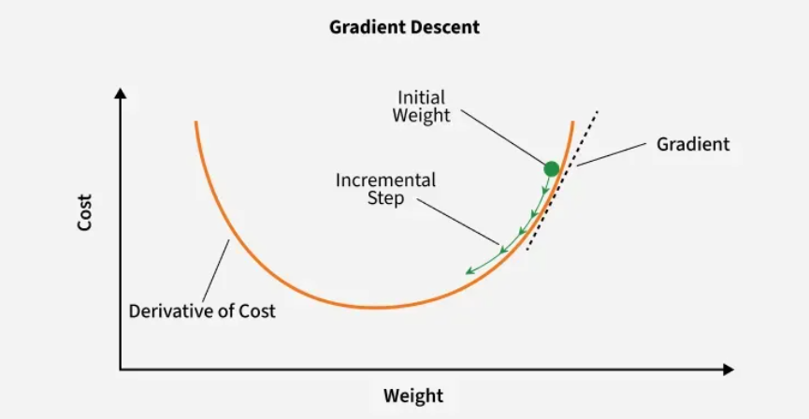
Figure 1: ANN optimization using SGD
Adam optimizer is an improvement of SGD as it calculates adaptive learning rates for each parameter and thus utilizes both the first moment and the second moment to achieve faster and more stable convergence [6]. Learning rate is an important hyperparameter controlling step size because if it is too high the model diverges and if too low training stalls. Adam optimizer in operation is presented by figure 2.
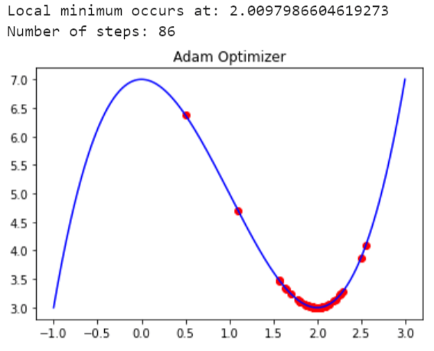
Figure 2: Adam optimizer in action
Schedulers like ReduceLROnPlateau or Cosine Annealing are able to dynamically reduce the learning rate during the training process which allows the model to make large leaps initially and fine-tune its weights when it comes near global minima. Overfitting is very likely to occur in ANN models whereby a model memorizes training noise rather than generalizing patterns and this is prevented by applying dropout [7]. It is a technique that randomly deactivates a specified percentage of neurons during each training forward pass and in this way is forces the network to learn redundant and robust feature representations.

RNN vs. CNN Use Cases
Recurrent Neural Networks are designed for specifically processing sequantial or ordered data where the context of previous inputs matters [8]. They feature feedback loops that form memory state to allow information to persist across sequantial steps as seen if figure 3. Variations of RNN that are more advanced such as LSTMs usually resolve the vanishing gradient problem in long sequences [8].
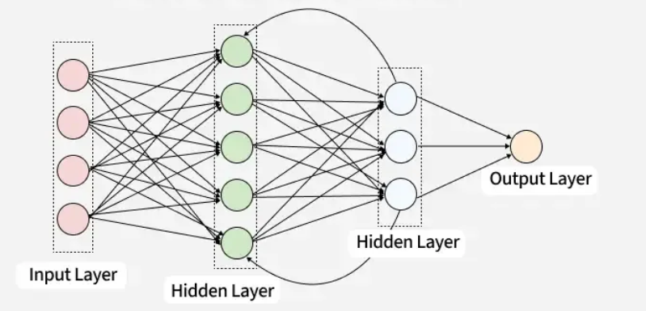
Figure 3: RNNs' structure
RNNs are majorly used for Natural Language Processing for tasks like machine translation and sentiment anaysis. In addition they are used for numerical forecasting tasks like stock market or weather prediction.
CNNs are basically engineered for processing grid-like spatial topologies and therefore they are the gold standard for computer vision and image processing. Their operation mechanism utilizes spatial weight-sharing through convolutional kernels that slide across an image to extract local visual features followed by pooling layers to downsample spatial dimensions and enforce translation invariance [9].
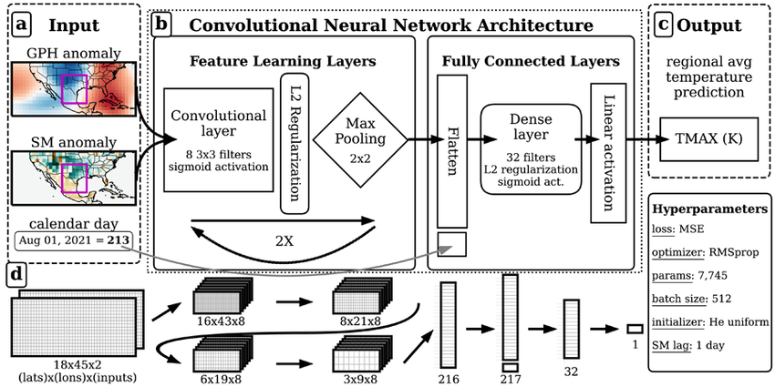
Figure 4: CNN Architecture
CNNs are effective for tasks related to image classification and object detection. There have also been successfully been used for facial recognition and medical imaging diagnostics.

Justification for Using a CNN over an RNN
Identification of plant pathology is entirely reliant on analyzing two-dimensional spatial arrangements which are color gradients and textures of leaf damage [10]. Recurrent loops of an RNN are architecturally useless for this task because an image has no inherent temporal or sequential order. Vital spatial relationships between neighboring pixels are instantly destroyed if an image is flattened into a 1D vector to feed into a traditional RNN or standard ANN. CNNs however natively preserve this 2D grid structure. Parameter efficiency was also a major contributing factor for choosing CNN for the task presented in this paper. Images in the Plant Pathology dataset are large with a size of 512 x 512 pixels. A fully connected network or an RNN trying to parse this data would suffer from an explosion of trainable parameters which would lead to leading to computational gridlock. CNNs make use of shared weights and local receptive fields to dramatically reduce parameters while remaining highly effective. Therefore CNN is uniquely and optimally suited for the Plant Pathology 2021 dataset because it is able to natively extract the spatial visual biomarkers that are necessary to differentiate between the five classes.

Methodology

Dataset Preparation and Preprocessing
Class filtering was the initial step in preparation of the dataset which ensured that only five classes that had the highest samples were selected. Pandas helped with this filtration process and the five target plant pathology classes that were successfully isolated were healthy, scab, frog_eye_leaf_spot, rust and powdery_mildew.
Stratified Data Split was then applied to maintain precise class distributions across subsets. Train_test_split of Scikit-Learn was applied with a stratification flag which dynamically split the data into an 80% training set, a 10% validation set and a 10% test set. Once the split was applied there were a total of 12540 images in the train set and 1567 and 1568 in the validation and test sets respectively.
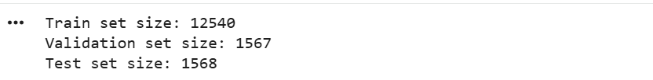
Figure 5: Data subsets after split
Resolution downsampling was very crucial in the preparation of the dataset. Images that were in the original dataset had a size of 512 X 512 pixels. Downsampling was applied to make them 256 x 256 pixels within the ImageDataGenerator pipeline and this ensured optimization of system RAM usage and the training time was accelerated without making sacrifice to structural feature visibility. Pixel intensities were normalized from their native integer range of [0, 255] down to a floating-point range of [0, 1] via a 1/255 rescaling factor with the aim of establishing stable numerical gradients for the neural network. Data streams were configured to process image inputs in structural batches of 32 using categorical mode mapping to match the multi-class objective and this ensured memory-efficient gradient updates.

Baseline Model Architecture
CNN model that was developed was constructed using three progressive convolutional blocks followed by a dense classification head as the goal here was to make it as computationally simple as possible. Layers for extracting features from the images consisted of three sequential Conv2D layers mapping 32, 64 and 128 filters with a standard 3×3 kernel size which utilized ReLU activation functions to model complex and non-linear visual leaf features. Each convolutional operation was then immediately followed by a 2 x 2 MaxPooling2D layer to downsample the feature maps amd this drastically reduced spatial dimensions and still maintained translation invariance. Overfitting in the small architecture was combated by introducing BatchNormalization after every convolution to stabilize internal covariate shift and step-wise Dropout layers were implemented to dynamically drop redundant node dependencies. Localized 2D features were flattened into a 1D vector and passed through a fully-connected Dense layer of 128 units with a strong 0.50 dropout rate and terminated with a 5-unit softmax output layer to yield probability distributions across the five target pathologies.
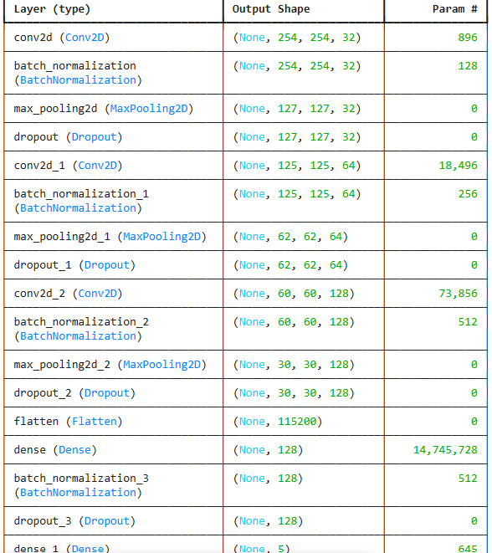
Figure 6: Model Architecture Summary

Hyperparameter Tuning and Optimization Strategy
Adam optimizer which is highly adaptive was used to compile the model and a standard base learning rate of 0.001 was used for initializing it. Thus the model was to ensure parameter-specific parameter adjustments during backpropagation. Categorical_crossentropy was explicitly selected as the objective loss function because of the mutually exclusive nature of the stratified 5-class target space. ReLu callback was introduced for monitoring validation loss which was configured to drop the learning rate by an aggressive factor of 0.2 if performance stagnated for more than 3 consecutive epochs. Execution script for Early stopping was also included to halt training if validation loss failed to improve over a strict patience window of 5 epochs and this would automatically restore the absolute best-performing historical weights to protect against late-stage overfitting. Network execution was limited to a baseline run of 10 epochs with performance metrics being rigorously assessed using comprehensive metrics including a classification_report and a visual confusion_matrix heatmap which was plotted on the unseen validation and test partitions.

Results

Training and Convergence Metrics
Neural network model that was created was able to complete 10 full training iterations whereby each apoch processed 392 steps (figure 7). Tracking logic of the training process triggered a weight restoration routine from epoch 9 as this was identified to be the structurally optimal epoch during the run.
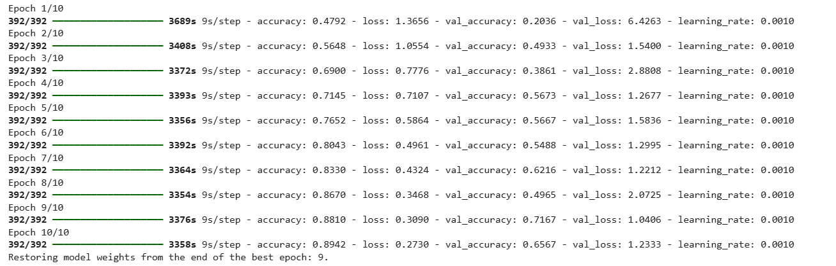
Figure 7: Training process results
Training categorical cross-entropy loss systematically decreased from an initial value of 1.3656 in Epoch 1 down to 0.2730 by Epoch 10 as shown in figure 8. Validation loss was seen to have high volatility by fluctuating from a peak of 6.4263 at Epoch 1 and hitting its lowest point at 1.0406 in Epoch 9. Then it rose back to 1.2333 in Epoch 10.
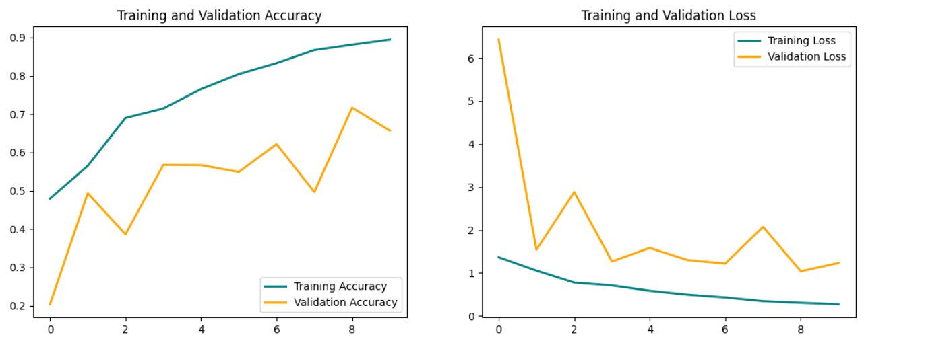
Figure 8: Training History curves
Accuracy for the training set was able to increase sequentially from 47.92% to 89.42% as seen in figure 7. Validation accuracy reached its peak benchmark of 71.67% during Epoch 9 and then experienced a downward shift to 65.67% in the 10th and last epoch.

Test Set Evaluation and Class-Specific Metrics
Final cross-evaluation that was performed on the unseen test partition of the dataset consisting of 49 processing steps across 1,568 distinct target tokens was able to record an overall test accuracy of 70.79% and a final Test Loss of 1.3117.
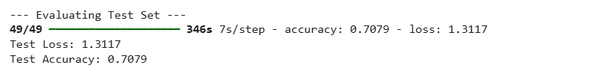
Figure 9: Test set results
Results obtained from the classification report showed that two of the selected classes achieved a high precision. rust had the highest overall predictive precision at 0.96 but recall generated by the class was significantly lower at 0.48 across its 186 test instances. frog_eye_leaf_spot was seen to achieve the highest diagnostic recall rate at 0.90 with an associated precision score of 0.73 on a sample footprint of 318 images.
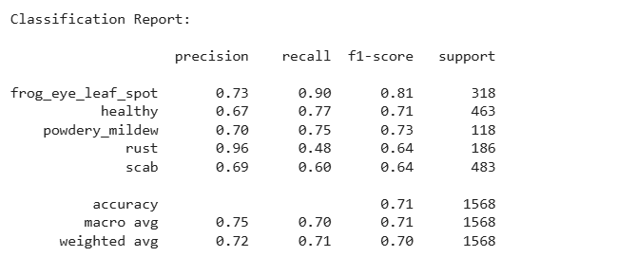
Figure 10: Classification report
The three other remaining classes had mid-range performance as seen in the classification report. powdery_mildew class had a stable feature extraction balance because it achieved a precision of 0.70 and a recall of 0.75. F1 score of the class was also balanced at 73. Structures in the healthy class recorded a precision of 0.67 and a recall of 0.77 and established an F1-score of 0.71 over 463 target samples. Precision for the scab class was 0.69 and its recall 0.60 and an F1-score of 0.64 across the highest individual sub-population footprint of 483 samples. On average, the developed CNN model achieved an unweighted macro average precision of 0.75, a macro average recall of 0.70 and a global weighted F1-score average of 0.70.

Confusion Matrix Heatmap
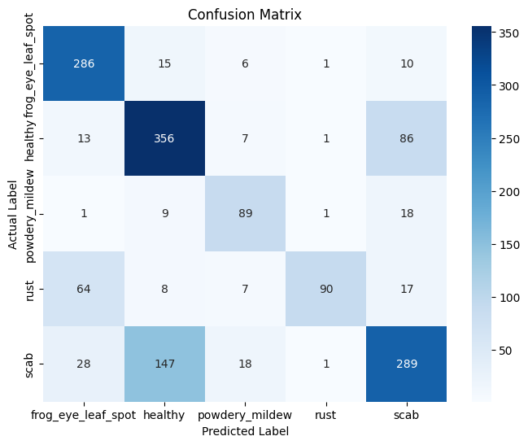
Figure 11: Confusion Matrix Heatmap
healthy class scored the absolute highest count of true positive classifications with 356 leaves accurately identified. scab followed closely with 289 correct classifications to show that the model was able to strongly recognize this class despite major background distractions. frog_eye_leaf_spot and powdery_mildew classes both displayed solid true positive localization and locked in 286 and 89 correct classifications respectively. Absolute true positive count of the rust class was at 89 correct predictions out of its 186 total test images.

Discussion

Interpretation of Training Curves and Overfitting Dynamics
Training history curves showed that there was distinct overfitting behavior starting after Epoch 4. From this point training loss declined steadily to 0.2730 and training accuracy climbed to 89.42%. Validation loss thus became very volatile and hit the floor at Epoch 9 when it reached 1.0406 and then degraded. Divergence in this way means that after the first few iterations during training the network began to memorize specific pixel backgrounds or training artifacts instead of abstracting generalized features of plant pathologies. Implementation of an early stopping mechanism that restored weights from Epoch 9 was highly justified. Mathematically it prevented the final deployment of a degraded model from Epoch 10 and the network was captured at its maximum generalization capacity with 71.67% validation accuracy.

Evaluation of Hyperparameters and Optimization Choices
Adam optimizer was used with a learning rate of 0.001 and this enabled rapid initial feature convergence which was shown by the sharp drop in loss during the first two epochs. Static learning rate may however have been way too aggressive in the later epochs which led to the observed validation volatility. Including dropout layers in the network played an important role in forcing the dense layers to learn distributed representations. Without the dropout structural gap between the training accuracy and test accuracy would have been substantially wider given the visual complexity of the dataset.

Model Simplicity vs. Classification Effectiveness Trade-off
Scaling of the original pathology images which had a size of 512 x 512 pixels to a smaller resolution contributed to drastic simplification of the computational footprint and prevented Out-Of-Memory errors. Aggressive down-sampling in this way however directly explains the mid-range performance because textures that were fine-grained which needed to distinguish lesions were smoothed out. Structural simplicity of the developed model made it to struggle in handling real-world overlapping visual traits. For instance in the rust class there was a high precision of 0.96 but a very poor recall of 0.48 to show that the model was certain when it spotted rust but it missed more than half of the instances. In most instances it classified them as healthy of frog_eye_leaf_spot mainly because of the shared structural spot patterns on the leaf surfaces.

Conclusion
Work presented in this paper presented a custom and streamlined CNN model that is capable of performing multi-class plant pathology classification across five prominent biological categories. Architectural approach of the model developed proved that a low-complexity network could extract meaningful local patterns without requiring excessive depth. CNN model that was developed showed a good balance between structural simplicity and diagnostic capability. Despite the fact that downsampling was performed on the high-resolution input files to reduce the overall computational footprint and processing overhead, the model maintained high classification effectiveness across distinct categories like powdery_mildew and healthy. Final test performance for the developed model was a definitive test accuracy of 70.79% and a final test loss of 1.3117.
Therefore there is a room for improving the performance of the model such as by the implementation of explicit data augmentation pipelines to expose the network to varying light conditions which would directly target the high validation volatility and reduce overfitting. Custom scratch-built architecture of the model can also be migrated to a pre-trained feature extractor for it to be able to effectively exploit deep semantic representations and hence resolve resolve the fine-grained visual ambiguities between overlapping lesion classes like scab and frog_eye_leaf_spot.

References
[1] Ekwomadu, T.I. and Mwanza, M., 2023. Fusarium fungi pathogens, identification, adverse effects, disease management, and global food security: A review of the latest research. Agriculture, 13(9), p.1810.
[2] Dhavale, M.C., Aiwale, H.N. and Sarnobat, D.H., 2025. Modern Diagnostic Techniques in Plant Pathology. Plant Health and Disease Management: A Modern Approach, 184.
[3] Upadhyay, A., Chandel, N.S., Singh, K.P., Chakraborty, S.K., Nandede, B.M., Kumar, M., Subeesh, A., Upendar, K., Salem, A. and Elbeltagi, A., 2025. Deep learning and computer vision in plant disease detection: a comprehensive review of techniques, models, and trends in precision agriculture. Artificial Intelligence Review, 58(3), p.92.
[4] Thakur, A. and Konde, A., 2021. Fundamentals of neural networks. International Journal for Research in Applied Science and Engineering Technology, 9(VIII), pp.407-426.
[5] Andreyev, A. and Beneventano, P., 2024. Edge of stochastic stability: Revisiting the edge of stability for sgd. arXiv preprint arXiv:2412.20553.
[6] Shao, Y., Weng, S., Sun, H., Gao, Q., Zhang, L., Mao, Z., Xu, S., Zhang, Z. and Xing, L., 2025. BDS-Adam optimizer integrating adaptive variance rectification with semi-adaptive gradient smoothing. Scientific Reports, 15(1), p.36906.
[7] Sheppert, A.P., 2026. Techniques for mitigating overfitting in machine learning: a comprehensive review, taxonomy, and practical guide. Frontiers in Artificial Intelligence, 9, p.1794271.
[8] Mienye, I.D., Swart, T.G. and Obaido, G., 2024. Recurrent neural networks: A comprehensive review of architectures, variants, and applications. Information, 15(9), p.517.
[8] Ghojogh, B. and Ghodsi, A., 2023. Recurrent neural networks and long short-term memory networks: Tutorial and survey. arXiv preprint arXiv:2304.11461.
[9] Mei, D., Gong, J., Qu, M. and Bian, S., 2025. The Evolution of Convolutional Neural Network Architectures: A Review. IEEE Access, 13, pp.200446-200496.
[10] Pimpalkar, A.P. and Jagtap, A.M., 2025. Plant Disease Detection: PyramidNet‐ICNN Architecture With Modified BIRCH Segmentation. Journal of Phytopathology, 173(3), p.e70068.

Appendix A: Source Code
#Initial Setup and Libraries
import os
import pandas as pd
import numpy as np
import matplotlib.pyplot as plt
import seaborn as sns
from sklearn.model_selection import train_test_split
from sklearn.metrics import classification_report, confusion_matrix

import tensorflow as tf
from tensorflow.keras.preprocessing.image import ImageDataGenerator
from tensorflow.keras.models import Sequential
from tensorflow.keras.layers import Conv2D, MaxPooling2D, Flatten, Dense, Dropout, BatchNormalization
from tensorflow.keras.callbacks import EarlyStopping, ReduceLROnPlateau
from PIL import Image

print("TensorFlow Version:", tf.__version__)

#Loading the dataset from Google Drive
from google.colab import drive
drive.mount('/content/drive')

# Defining dataset paths

DATASET_DIR = "/content/drive/MyDrive/archive"
IMAGE_DIR = os.path.join(DATASET_DIR, "images")
CSV_PATH = os.path.join(DATASET_DIR, "data.csv")
print("Dataset Folder :", DATASET_DIR)
print("Image Folder :", IMAGE_DIR)
print("CSV File :", CSV_PATH)

# Loading CSV file
df = pd.read_csv(CSV_PATH)
print("Dataset loaded successfully!")
print("\nDataset Shape:")
print(df.shape)
df.head()

# Displaying Random Sample Images
if 'train_df' not in locals() and 'train_df' not in globals():
train_df = df[df["data set"] == "train"].copy()
train_df['filepaths'] = train_df['filepaths'].apply(lambda x: os.path.join(IMAGE_DIR, x))
plt.figure(figsize=(15,8))
samples = train_df.sample(6, random_state=42)
for i, (_, row) in enumerate(samples.iterrows()):
# Corrected image path to use IMAGE_DIR
image_path = os.path.join(IMAGE_DIR, row["filepaths"])
image = Image.open(image_path)
plt.subplot(2,3,i+1)
plt.imshow(image)
plt.title(row["labels"], fontsize=11)
plt.axis("off")
plt.tight_layout()
plt.show()

# Defining the strict 5 classes
target_classes = ['healthy', 'scab', 'frog_eye_leaf_spot', 'rust', 'powdery_mildew']
# Filter rows where the 'labels' column exactly matches one of our target classes
df_filtered = df[df['labels'].isin(target_classes)].copy()
# Stratified split (80% train, 20% temp)
train_df, temp_df = train_test_split(
df_filtered,
test_size=0.2,
stratify=df_filtered['labels'],
random_state=42
)

# Split the temp 20% evenly into Validation and Test (10% / 10% overall)
val_df, test_df = train_test_split(
temp_df,
test_size=0.5,
stratify=temp_df['labels'],
random_state=42
)
print(f"Train set size: {len(train_df)}")
print(f"Validation set size: {len(val_df)}")
print(f"Test set size: {len(test_df)}")
#Data Pipelines (ImageDataGenerator)
IMG_SIZE = (256, 256) # Downsampled for faster training / RAM management
BATCH_SIZE = 32
# Create 'full_path' column for each dataframe
train_df['full_path'] = train_df['filepaths'].apply(lambda x: os.path.join(IMAGE_DIR, x))
val_df['full_path'] = val_df['filepaths'].apply(lambda x: os.path.join(IMAGE_DIR, x))
test_df['full_path'] = test_df['filepaths'].apply(lambda x: os.path.join(IMAGE_DIR, x))

# Only rescaling for Validation and Test to prevent data leakage
train_datagen = ImageDataGenerator(rescale=1./255)
val_datagen = ImageDataGenerator(rescale=1./255)
test_datagen = ImageDataGenerator(rescale=1./255)

train_generator = train_datagen.flow_from_dataframe(
dataframe=train_df,
x_col='full_path',
y_col='labels',
target_size=IMG_SIZE,
batch_size=BATCH_SIZE,
class_mode='categorical',
shuffle=True,
seed=42
)
val_generator = val_datagen.flow_from_dataframe(
dataframe=val_df,
x_col='full_path',
y_col='labels',
target_size=IMG_SIZE,
batch_size=BATCH_SIZE,
class_mode='categorical',
shuffle=False
)
test_generator = test_datagen.flow_from_dataframe(
dataframe=test_df,
x_col='full_path',
y_col='labels',
target_size=IMG_SIZE,
batch_size=BATCH_SIZE,
class_mode='categorical',
shuffle=False
)
#Simple & Optimized CNN Architecture
model = Sequential([
# Block 1
Conv2D(32, (3, 3), activation='relu', input_shape=(256, 256, 3)),
BatchNormalization(),
MaxPooling2D(2, 2),
Dropout(0.25),

# Block 2
Conv2D(64, (3, 3), activation='relu'),
BatchNormalization(),
MaxPooling2D(2, 2),
Dropout(0.25),

# Block 3
Conv2D(128, (3, 3), activation='relu'),
BatchNormalization(),
MaxPooling2D(2, 2),
Dropout(0.4),

# Classification Head
Flatten(),
Dense(128, activation='relu'),
BatchNormalization(),
Dropout(0.5),
Dense(5, activation='softmax') # 5 target classes
])

# Use the highly optimized Adam optimizer
model.compile(
optimizer=tf.keras.optimizers.Adam(learning_rate=0.001),
loss='categorical_crossentropy',
metrics=['accuracy']
)

model.summary()
#Training with Optimization Callbacks
callbacks = [
EarlyStopping(monitor='val_loss', patience=5, restore_best_weights=True, verbose=1),
ReduceLROnPlateau(monitor='val_loss', factor=0.2, patience=3, min_lr=1e-6, verbose=1)
]
EPOCHS = 10
history = model.fit(
train_generator,
validation_data=val_generator,
epochs=EPOCHS,
callbacks=callbacks
)

#Evaluating Performance
#Plot Training History
acc = history.history['accuracy']
val_acc = history.history['val_accuracy']
loss = history.history['loss']
val_loss = history.history['val_loss']

epochs_range = range(len(acc))

plt.figure(figsize=(14, 5))
plt.subplot(1, 2, 1)
plt.plot(epochs_range, acc, label='Training Accuracy', color='teal', lw=2)
plt.plot(epochs_range, val_acc, label='Validation Accuracy', color='orange', lw=2)
plt.legend(loc='lower right')
plt.title('Training and Validation Accuracy')

plt.subplot(1, 2, 2)
plt.plot(epochs_range, loss, label='Training Loss', color='teal', lw=2)
plt.plot(epochs_range, val_loss, label='Validation Loss', color='orange', lw=2)
plt.legend(loc='upper right')
plt.title('Training and Validation Loss')
plt.show()

# Evaluating on the unseen Test Set
print("\n--- Evaluating Test Set ---")
test_loss, test_accuracy = model.evaluate(test_generator)
print(f"Test Loss: {test_loss:.4f}")
print(f"Test Accuracy: {test_accuracy:.4f}")

# Predictions for Confusion Matrix
Y_pred = model.predict(test_generator)
y_pred = np.argmax(Y_pred, axis=1)
y_true = test_generator.classes
class_labels = list(test_generator.class_indices.keys())
# Classification Report
print("\nClassification Report:\n")
print(classification_report(y_true, y_pred, target_names=class_labels))

# Confusion Matrix Heatmap
cm = confusion_matrix(y_true, y_pred)
plt.figure(figsize=(8, 6))
sns.heatmap(cm, annot=True, fmt='d', cmap='Blues', xticklabels=class_labels, yticklabels=class_labels)
plt.ylabel('Actual Label')
plt.xlabel('Predicted Label')
plt.title('Confusion Matrix')
plt.show()

