Carmarthen School of Business Sustainable Venue Report
Jamie Moorman - 1802683
Dr Roisin Mullins, BSMP 4003

Abstract
This report is a summary of the process of and used in the designing of a database to choose a sustainable venue for the Carmarthen School of Business (CBS). In this report, details will be given on a step by step basis on the construction of said database. I will also be evaluating the database, focusing in particularly on how it has helped choose a venue in accordance with the Well-being of Future Generations (Wales) Act 2015, as well as the act’s relevance to this task, and which part of the Act I will be focusing on primarily.

Carmarthen School of Business Sustainable Venue Report

Introduction
As a database administrator, my duty is the ‘creation, maintenance, backups, querying, tuning and security’ ⁽¹⁾ of a database. Therefore, it was my job to design a database of venues. These venues would then be narrowed down until I found a venue that worked best in lieu with the Wellbeing of Future Generations Act 2015. The Wellbeing of Future Generations Act was established in 2015, and ‘requires public bodies in Wales to think about the long-term impact of their decisions, to work better with people, communities, and prevent persistent problems such as poverty, health inequalities and climate change.’ ⁽²⁾. There are 7 goals to this Act;
- A prosperous Wales,
- A Resilient Wales,
- A more Equal Wales,
- A Healthier Wales,
- A Wales of Cohesive Communities,
- A Wales of Vibrant Culture & Welsh Language,
- A Globally Responsible Wales,
It was then my job to focus on one of these points and incorporate its importance into the selection of a venue, as well as in the creation of the database. The point I decided to base my venue on was 3. ‘A more Equal Wales,’ and 7. ‘A Globally Responsible Wales.’ These are 2 very sensitive topics these days, and one I believe need to be considered in everyday life. Therefore, I will be basing my venue on Global Responsibility and Equality.
After taking all of these factors into account, I decided to choose The Park Plaza Hotel, as it has the highest conference capacity, highest number of conference rooms, disabled access, and although it is slightly more expensive than other venues on the list, it has waste management and recycling scores of 8 for both. It was the best all round venue to choose, and this report will show how and why I was able to make this decision.

Planning and Analysis
Initially, my first steps were deciding on how many tables (‘a collection of related data held in a structured format within a database.’) ⁽³⁾ I needed. After looking at the brief I was given, I decided that 3 tables would suffice; County, Town, and Venue. These three tables are the most logical, as these conference venues are easier to sort via county and town. ^{(Fig 1.1)}. The data for the tables needed to be added, meaning I had to do lots of research to find twenty different venues across 10 different counties in Wales. After this, I had to plan which attributes were going into the table. These attributes for County were;
- County Code,
- County Name English,
- County Name Welsh,
These attributes were selected due to their relevance. County names are needed, and as this database is intended for Welsh venues, that it is necessary to have bilingual naming. I invented my own County Code system for referencing.
The attributes for Town were as follows;
- Town Code,
- Town Name,
- County Code,
Town Code is used in this table for the same reason County Code is used in the County table, and Town name for obvious reasons. As stated above, and as shown in figure 2.1, County Code is in the Town table, however, in Town, County Code acts as the Foreign Key. ‘A foreign key is a column (or columns) that references a column (most often the primary key) of another table.’ ⁽⁴⁾ County Code is the Primary Key in County, but when represented in Town, it becomes the Foreign Key, a primary key in a foreign table.
The Venue table has many more Attributes, which meant more data;
- Venue Code,
- Town Code,
- Venue Location,
- Venue Name,
- Car Park,
- No. of Car Spaces,
- No. of conference rooms,
- Conference Capacity,
- Canteen,
- Cost per room,
- Cost per delegate,
- Cost for facilities,
- Disabled access,
- Waste management Score,
- Recycling Score,
- Photograph.
In this table, I created a Venue Code, like Town Code and County Code. Town Code is the Foreign Key of this table. I created attributes called Venue Location and Venue Name, so that anyone using the database would know the name and location of a specified venue. Car Park and No. of Car Spaces were added to give more information for anyone trying to pick a venue. Parking is important as it determines the number of people that can get to the venue. Therefore, I added these attributes. The addition of the Number of conference rooms and Conference Capacity attributes were added for a similar reason, to determine how many people can attend the conference. I had to add the cost attributes (room, delegate, facilities) ^{(Figure2.2)} for administrative purposes. Cost is a very important factor when considering which venue to use, a venue that is too expensive will not be used.
As mentioned earlier, I had to ensure that my database fit in with the Future Generations Act points I chose, and therefore I decided to add the attribute of ‘Disabled Access’. This not only means wheelchair access, but deaf and blind access too. ‘Offer deaf awareness training and BSL training for your staff, particularly on the front line,^{’ (5)} is a quote taken directly from the Act’s main website, and although there is no mention about blind and disabled access, I don’t see why I cannot include these as they are themed around equality.

Database Design.
The design dation of the phase came next, meaning that I could finally put all my planning into practice. First came the creation of the tables, the foundation of the database. As mentioned earlier, I decided to use three tables as all the data need only be categorized into three tables for simplicity and ease of use. After the three tables (county, town and venue), were created, it was time to add the attributes for each table. I went to work adding the data for 20 venues across 10 different Welsh counties, as well as the codes for each table, and county/town names. Once these were added, I had to add in the data for these venues. Each of these venues had its own unique data in each attribute. After adding all the data into all three tables ^{(Figure3.1.1, 3.1.2, 3.1.3)}, I created a form for the Venue table. The form’s purpose is ‘to create a user interface for a database application.^{’ (6)}. I only needed two forms ^{(Figure3.2, 3.3)} for venue as this was the only table that users would see and use, the other two tables are simply for my use as they have unique codes and county names, therefore it isn’t practical to create forms for those tables. The next step in the design was creating the queries. I chose to create 6 queries for diversity purposes. Each of theses queries contained data that I found the most important, figures 3.4 through 3.9 will show the queries.
Forms
Design view: ^{(Figure 4.1)} The design both forms had 8 text boxes. 4 of which can’t be edited, as they are only title boxes, but 3 others had data that changed with each venue I selected. Venue Name was a text box which allowed me to select the venue, with each venue selected, the Venue Code, Town Code and Venue Location comes up. This first form was solely for the selection of the venue. The second form ^{(Figure4.2)} was more descriptive, giving all the data such as costs, parking spaces and conference capacity, amongst other data too.
Queries
‘Databases store data in a structured format, which can be accessed using queries.’ ⁽⁷⁾ I created 6 queries, each to answer a different question. I chose 6 as I believed these six questions gave a wider variety of skills;
- Canteen,
- Conference Capacity,
- Cost per Room,
- County,
- Disabled Access,
- Environmental,
I chose the ‘Canteen’ query as this attribute was designed as a Yes/NO Data Type. Using a query for this attribute enables me to sort between venues that have a canteen and those that do not. ^{(Figure3.4).}
I chose the Environmental query, again, due to the data types and number of attributes. This query has two different attributes, which together help create an environmental score to base my decision on. I set the query to show all results with recycling and waste management scores of above 7, giving me two results ^{(Figure3.5)}
Another query I chose was a disabled access query. ^{(Figure3.6)} This query is one of the most important questions as there is no guarantee that no one will need this. This query again used a Yes/No data type and has narrowed down the 20 venues to 17 venues to choose from, as I am not choosing a venue without disabled access.
I also designed conference capacity and cost per room queries. These queries were designed to help me find the cheapest venues and the conference rooms with the highest capacity. Once I had these results, I could cross reference them with the results from the other queries to find the most suitable venue.
Report
The last step in the design of the database was creating a report ^{(Figure5.0).} ‘Reports offer a way to view, format, and summarize the information in your Microsoft Access database.’ ⁽⁸⁾ Creating a report was an easy way of seeing everything I had created laid out in a word document style view. The report looks tidier, is easier to read, and saves time looking through all different tables. The forms and queries are not included in the report, only the tables. The report goes alphabetically (Venue Code)

Implementation
The implementation of a database is ‘the process of installation of database software, configuration and customization, running, testing, integrating with applications, and training the users.’ ⁽⁹⁾ There are many, many different steps to implementation, doing each step would have taken up time I did not have, so I have chosen what I believe to be the most important steps, and categorized then into 6 easy steps;
- Defining the database projects scope,
- Organizing Database project,
- Selection of DBMS products,
- Planning,
- Designing,
- Testing and Review
First, I had to define what was needed in the database, for example I needed to include forms, queries, reports, to cover a wide range of database tools. Another point to clear before planning was who this was for – Carmarthen School of Business (CBS).
After this stage was completed, I was able to move along and organize the team, such as assigning team roles and the like, however being the only one designing the database, this task was not difficult and does not warrant discussing further.
Next was the selection of the DBMS I wanted to use. A DBMS is ‘system software for creating and managing databases.’ ⁽¹⁰⁾ After doing some research, and finding DBMS’s such as Oracle, MySQL and FoxPro, but ultimately I decided on using Microsoft Access, due to its ease of use for a first time database administrator. It was also easier to create a relational database, which was what I needed to create. Access is an SQL (Structured Query Language) DBMS, and, as the name would suggest, is used to ‘query, insert, update and modify data’ ^{(11).} Queries were a focal point in the design of my database, therefore SQL was ideal.
I have written entire sections on the planning and design at the beginning of this report, so no need to repeat myself.
Testing the database came with its challenges, for example I attempted to create a menu form to give the user of tidier interface ^{(Figure 6.0),} yet I found an issue in the code which did not allow me to create the menu.^{(Figure6.1)} I did not pursue this issue as my job was not in decoding errors, but in creating a database that work, which I have achieved. After around an hour or two, testing the basics, for example opening and closing the tables, selecting a venue in the forms, to narrowing results down using queries. ^{(Figures 3.4 – 4.2)} After my initial success, I asked a few friends to use the database. The results were promising, apart from one issue. I was told that the query forms I had created were corrupted, and nothing showed up on them, therefore they were blank forms, another fault at the code level. However, I was unable to find the fault, so I had to leave these query tables out of the database.
To conclude, based on my own results and the results of those who tested my database, other than two minor errors in some more advanced items, my database was a success. Everything that was needed worked, and the people who I’ve had test it were able to find the venues they needed with ease, yet another reason why Access was the better DBMS to use.
Maintenance
Database maintenance is described as ‘a set of tasks that are all run with the intention to improve your database’. ⁽¹²⁾ Even though the database works, there are still ways of making it better, such as adding in more advanced tools, including query forms, creating a main menu. I mentioned these earlier, stating that I tried to create these, but did not have the skills. I believe that having more of these skills would allow me to do this, therefore being able to update my database.
Updating is only one side of maintenance. The other side to database maintenance is looking at things that need to be fixed. This I encountered during my implementation, as mentioned above. A visual representation of this can be seen in figures 5.3 to 5.5. These issues lay in the code itself, therefore to be fixed I would need more skills, skills which lay in coding as opposed to database administration.
After these have been checked every time I use the database, before anyone else uses it. This makes sure that if there are any issues, I can fix them before anyone else uses it as I do not wish them to have any issues when using my database, other wise people will not want to use it in the future.
Conclusion
To conclude, personally I prefer the database in place of the prosumer file. This database is very useful in the selection of venues to use, due to all the tools used, such as forms, queries, tables and reports. If we compare this to the prosumer database file I had to produce, the prosumer file was very one dimensional and was very difficult to add data too as there were 4 different tables that were difficult to view and add data too. The database, although requiring more work and more knowledge, was easier to add data to, as well as having a user interface separate from the design interface, something the prosumer datafile lacked. Having two separate interfaces makes it tidier fir the user as the design interface isn’t tidy, meaning the user has to deal with a bad looking interface.

References
- What is Database Administrator (DBA)? - Definition from Techopedia. (2012). Retrieved from https://www.techopedia.com/definition/1187/database-administrator-dba (Accessed 21-12-18)
- Future Generations Act – Future Generations Commissioner for Wales. (2015). Retrieved from https://futuregenerations.wales/about-us/future-generations-act/
- Help - AnyLogic Simulation Software. (2012). Retrieved from https://help.anylogic.com/index.jsp?topic=%2Fcom.anylogic.help%2Fhtml%2Fconnectivity%2FCreating_Table.html
- SQL - Foreign Key | 1Keydata. (2016). Retrieved from https://www.1keydata.com/sql/sql-foreign-key.html
- Offer deaf awareness training and British Sign Language (BSL) training for your staff, particularly for those on the front line – The Future Generations Commissioner for Wales. (2015). Retrieved from https://futuregenerations.wales/aop/offer-deaf-awareness-training-and-british-sign-language-bsl-training-for-your-staff-particularly-for-those-on-the-front-line/
- Information Technology Services. (2010). Designing Forms in Access [Ebook] (1st ed.). London. Retrieved from https://www.uis.edu/informationtechnologyservices/wp-content/uploads/sites/106/2013/04/DesigningFormsinAccess2010.pdf
- Access 2016: Designing a Simple Query. (2015). Retrieved from https://edu.gcfglobal.org/en/access2016/designing-a-simple-query/1/
- Introduction to reports in Access. (2019). Retrieved from https://support.office.com/en-us/article/introduction-to-reports-in-access-e0869f59-7536-4d19-8e05-7158dcd3681c
- Database Implementation. (2014). Retrieved from https://www.chegg.com/homework-help/definitions/database-implementation-3
- What is database management system (DBMS)? - Definition from WhatIs.com. (2015). Retrieved from https://searchsqlserver.techtarget.com/definition/database-management-system
- What is Structured Query Language (SQL)? - Definition from Techopedia. (2014). Retrieved from https://www.techopedia.com/definition/1245/structured-query-language-sql
- Database Maintenance Explained - OfficeTools. (2013). Retrieved from https://www.officetools.com/knowledgebase/database-maintenance-explained/

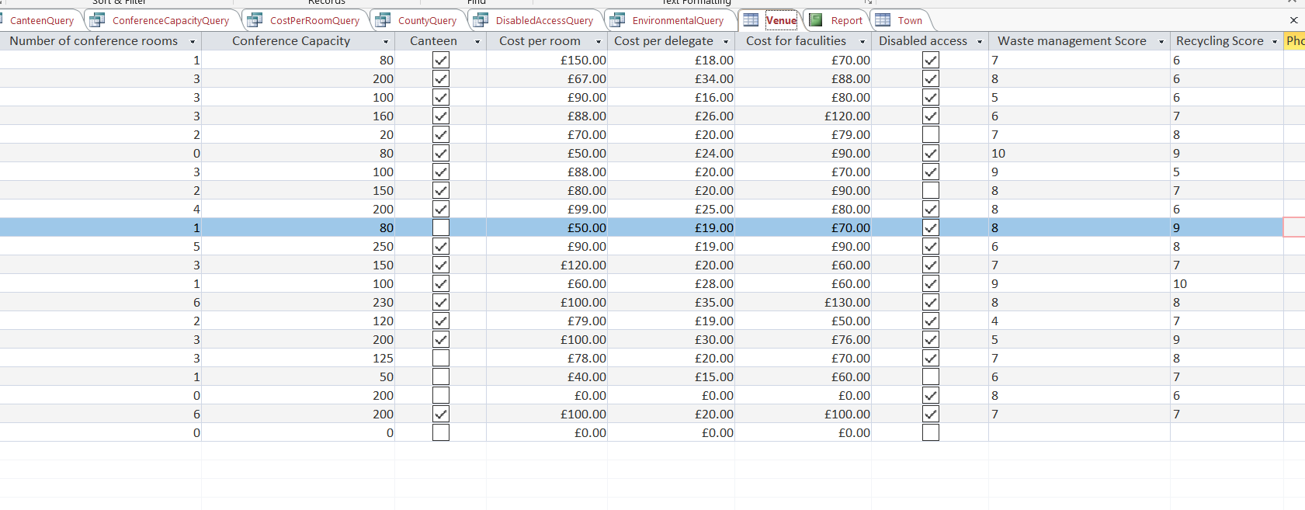
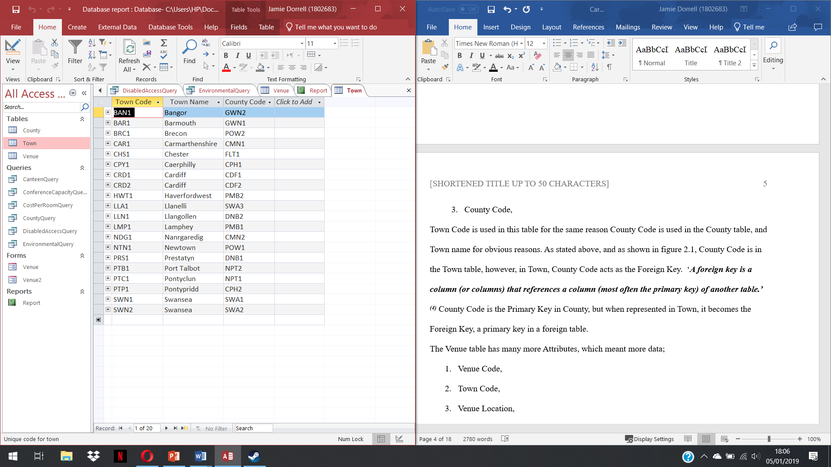
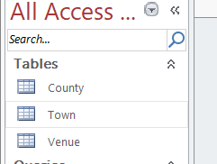
Tables
Figure 2.2
Figure 2.1
Figure 1.1

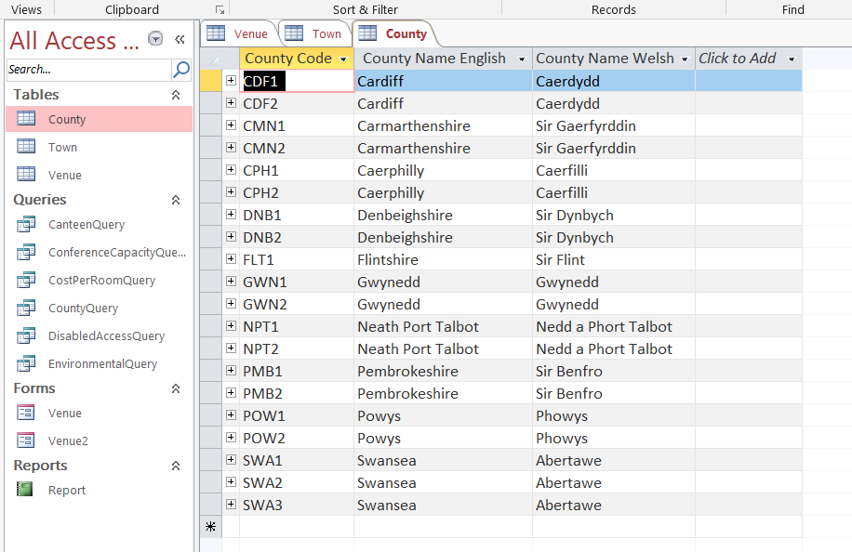

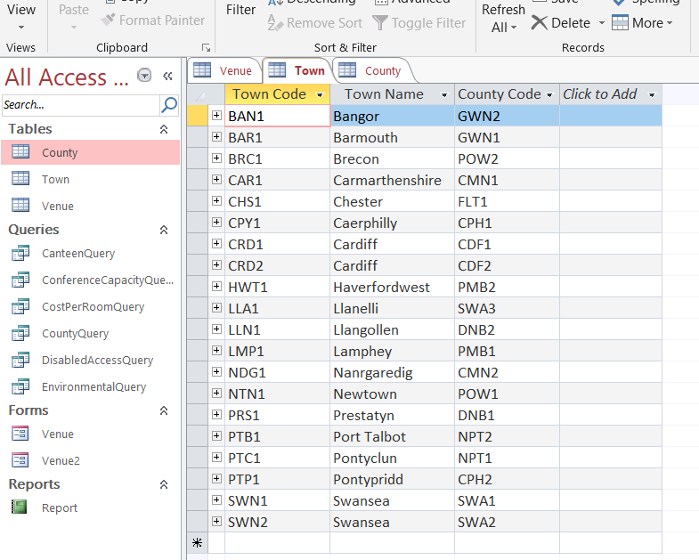
Figure 3.1.1
Figure 3.1.2
Figure 3.1.3

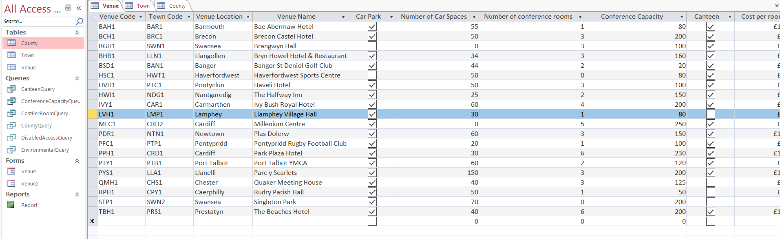

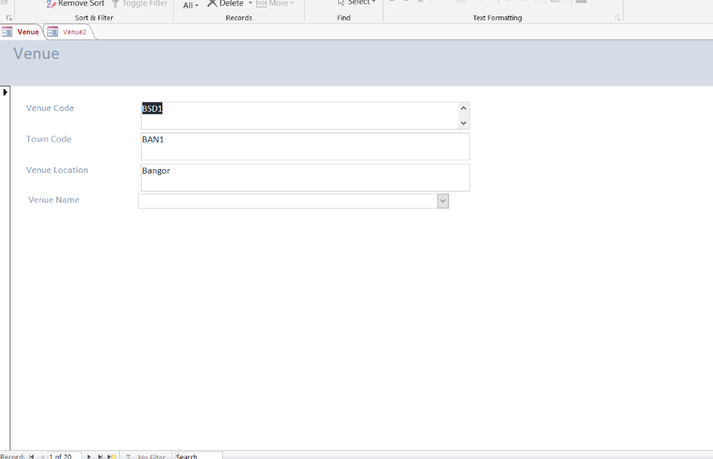
Figure 3.2

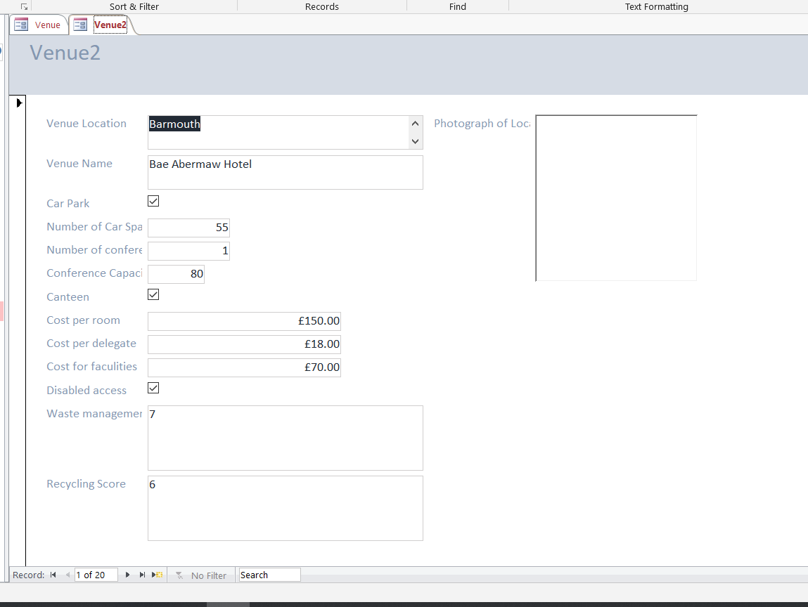

Figure 3.3

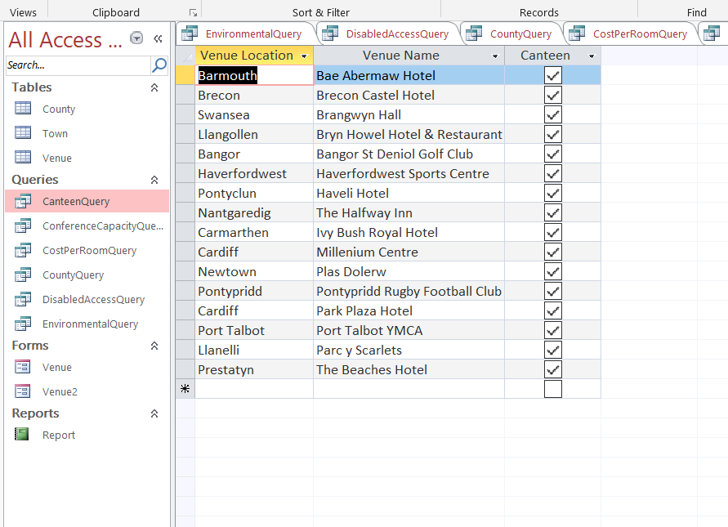
Figure 3.4

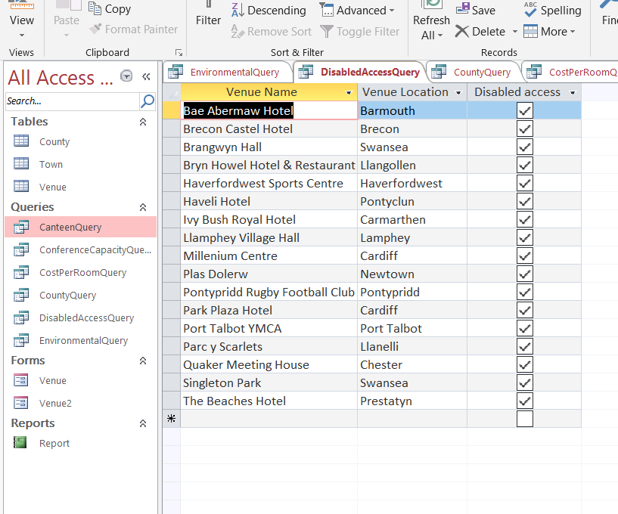

Figure 3.5

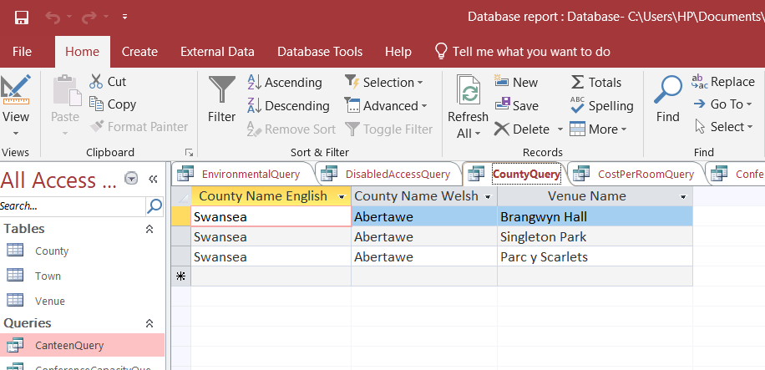

Figure 3.6

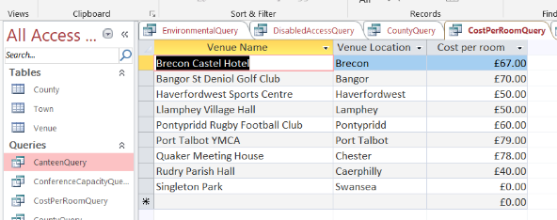
Figure 3.7

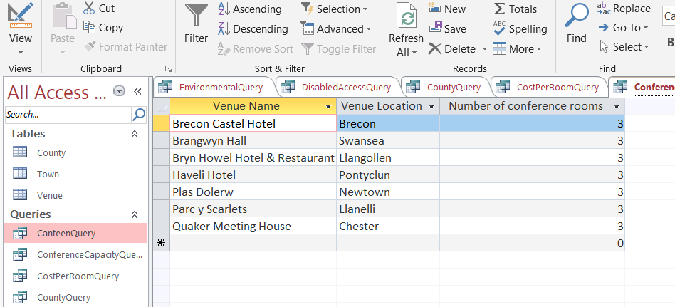

Figure 3.8

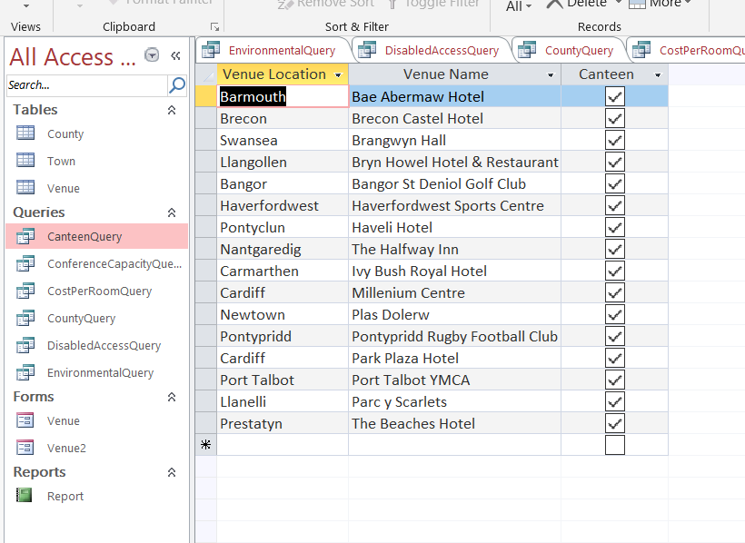

Figure 3.9

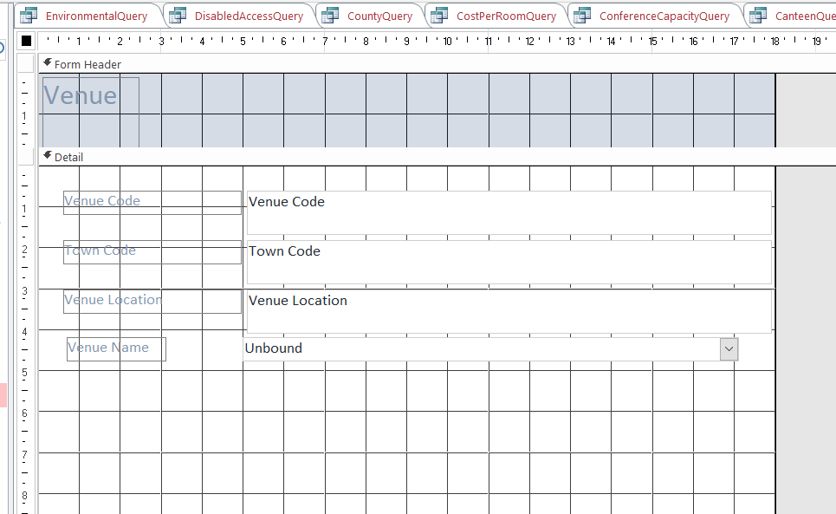

Figure 4.1

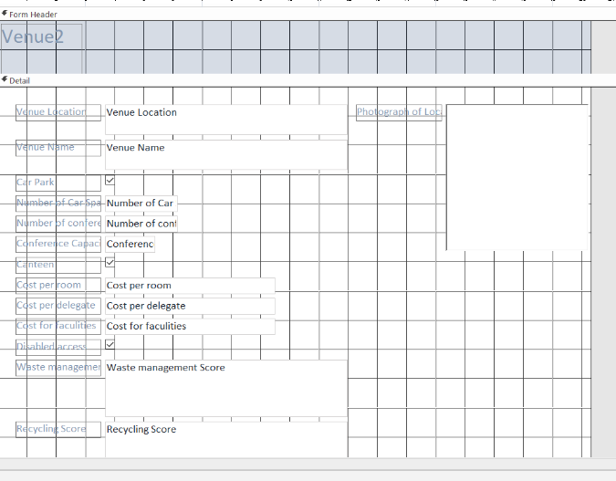

Figure 4.2

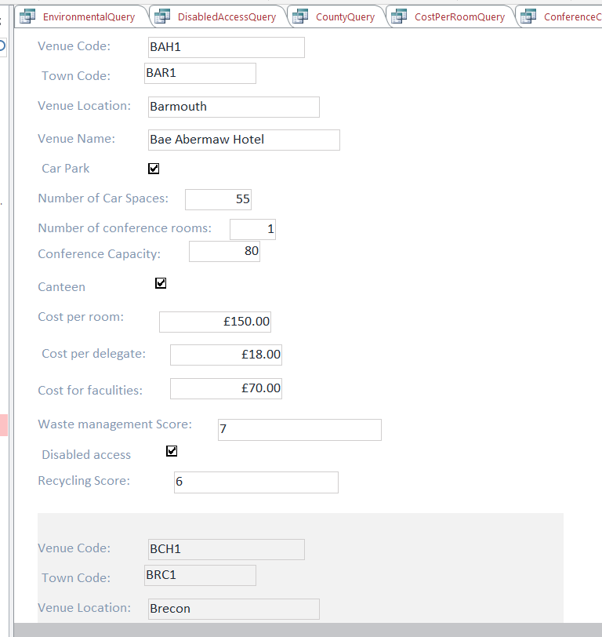

Figure 5.0

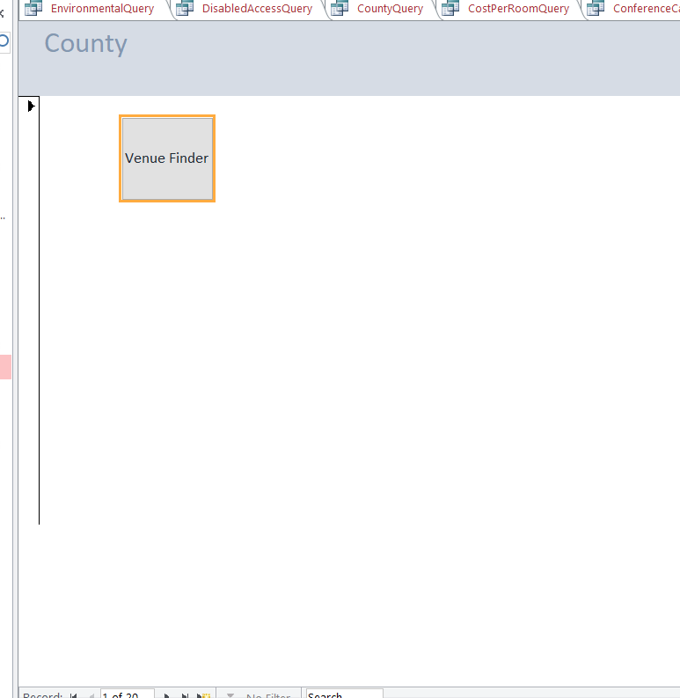
Figure 6.0 (A simple Menu Form)

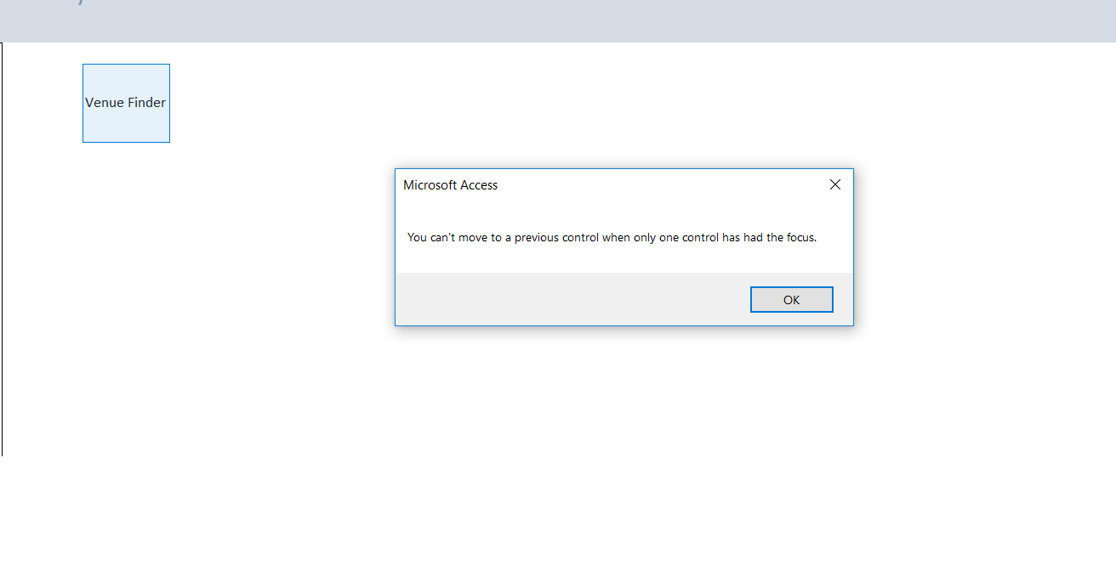

Figure 6.1

