

AI-INFLUENCED DIGITAL MARKETING STRATEGIES AND THEIR IMPACT ON CONSUMER BEHAVIOUR IN THE UK FASHION RETAIL INDUSTRY

STUDENT NAME: Patel Mayankkumar Bharatkumar
STUDENT ID: 2418666
MODULE LEADER: Hoang Nguyen
MEETING SUPERVISOR: Dr Laila Maazouz
MODULE CODE: 7035

Declaration
I hereby declare that the dissertation titled “AI-Influenced Digital Marketing Strategies and Their Impact on Consumer Behaviour in the UK Fashion Retail Industry” is the result of my own original research and has not been submitted, either in whole or in part, for any degree or qualification at any other university or academic institution. Every information source, data and academic material that will be employed throughout this work have been fully recognised and cited as necessary according to the academic requirements. None of the dissertation has been developed by unauthorised help, misrepresentation of authorship, and unethical data handling. I assume complete responsibility of integrity, authenticity and accuracy of the work presented here in.

Student signature: Mayank patel
Date: 29/01/2026
Acknowledgement
I wish to take a moment and thank each and every person who helped to make this dissertation a successful one. Of great help to me during the research process was the guidance, positive feedback, and intellectual support of my academic supervisor, Dr Laila Maazouz. I will also like to thank the respondents who took their time generously to fill in the questionnaire otherwise I would not have been able to carry out the empirical part of this study. I would also like to appreciate the faculty and administrative personnel of the institution to the support offered in the form of academic resource, research infrastructure and administrative support. And finally, I also credit the support of my family, friends and peers, who showed a lot of patience, motivation as well as belief in me, and who supported me in the research and writing process of this dissertation.

Abstract
Purpose: This dissertation aimed at exploring the influence of digital marketing strategies resulting because of AI on consumer behaviour in the UK fashion retail industry in particular in regards to purchase intention, trust, engagement, satisfaction, loyalty and advocacy. The objective of the study was to fill a research gap in the body of literature concerning behavioural reactions to artificial intelligence personalisation, as well as artificial intelligence-mediated service functions in a digitally mature retail environment.
Methodology: Within the framework of the research, the philosophy was positivist, deductive methodology and mono-method design based on the quantitative research. The primary data were measured using a web-based questionnaire of 150 valid answers of UK fashion consumers having the knowledge of AI-enabled retail technologies. Patterns with regards to personalisation, trust formation, engagement and loyalty outcomes were analysed by frequency analysis with the help of Microsoft Excel to interpret them.
Results: The results showed that personalisation through AI has been shown to have a significant positive effect on consumer purchase intention, less cognitive search effort, and more shopping efficiency. Customer service interfaces that were supported with AI helped to build trust, whereas experiential features that are enhanced with AI increased satisfaction and reinforced loyalty and advocacy. The attitude of some respondents was mediated by ethical concerns, especially transparency and privacy of data.
Practical implication: The findings show that UK fashion retailers will be able to use AI to optimise the conversion, improve the experience and develop long-term value in a form of a relationship. Nevertheless, long term loyalty needs accountable data quality management, open communication and customer oriented strategies of personalisation.

Table of Content
Chapter 1: Introduction 8
1.1 Research background 8
1.2 Problem statement 9
1.3 Research aim and objectives 9
1.4 Research questions 10
1.5 Research rationale and significance 10
1.6 Dissertation structure 11
1.7 Theoretical framework 11
Chapter 2: Literature review 13
2.1 Introduction 13
2.2 Theoretical framework 13
2.3 AI-driven digital marketing and consumer purchase intentions 15
2.4 AI personalisation, customer trust, and brand loyalty 17
2.5 Factors driving consumer engagement with AI-based campaigns 19
2.6 Effectiveness of AI marketing strategies in enhancing consumer experience and loyalty 20
2.7 Research gap 22
2.8 Summary 23
Chapter 3: Research methodology 24
3.1 Introduction 24
3.2 Research onion 24
3.3 Research philosophy 25
3.4 Research approach 26
3.5 Research choice 26
3.6 Research strategy 27
3.7 Data collection method 27
3.8 Data analysis procedure 28
3.9 Ethical consideration 29
3.10 Summary 29
Chapter 4: Data analysis 30
4.1 Introduction 30
4.2 Data analysis 30
4.3 Summary 40
Chapter 5: Discussion 41
5.1 Introduction 41
5.2 Discussion and analysis 41
5.3 Summary 50
Chapter 6: Conclusion 51
6.1 Introduction 51
6.2 Conclusive remark 51
6.3 Recommendations 53
6.4 Contribution of the results 54
6.5 Limitations of the study 55
6.6 Future prospective 55
References 56
Appendix 1: Survey questionnaire 69

List of Figures
Figure 1.1: Dissertation structure 11
Figure 3.1: Research onion 24
Figure 4.1: Age group distribution of survey respondents 30
Figure 4.2: Gender distribution of the participants 31
Figure 4.3: Distribution of occupation of the participants 31
Figure 4.4: Frequency of online fashion shopping 32
Figure 4.5: Influence of AI-based advertisements on consumer interest in fashion products 33
Figure 4.6: Perceived impact of personalised product recommendations on shopping convenience 33
Figure 4.7: Effectiveness of AI-driven chatbots in resolving online shopping queries 34
Figure 4.8: Influence of AI-based pricing and promotional offers on purchasing speed 35
Figure 4.9: Consumer trust in AI systems for fashion product recommendations 35
Figure 4.10: Consumer confidence in personal data security on AI-driven fashion platforms 36
Figure 4.11: Perceived transparency of AI-driven marketing practices 37
Figure 4.12: Impact of AI personalisation on likelihood of online fashion purchasing 37
Figure 4.13: Relationship between AI-driven personalisation and brand satisfaction 38
Figure 4.14: Influence of AI-enhanced digital experiences on consumer loyalty 39
Figure 4.15: Willingness to recommend AI-driven fashion retail platforms 39

Chapter 1: Introduction

1.1 Research background
The blistering adoption of artificial intelligence in the digital marketing context has redefined the operation and strategic backbone in the UK fashion retail sector. In an increasingly competitive, technologically advanced market, fashion brands have found interest in AI as a key instrument to improving interaction with customers, evaluating their behavioural patterns, and segmenting content delivered by marketing agents more than ever before (Ganesh, 2024). The large-scale implementation of AI-based solutions, including personalised recommendation engines, predictive analytics, chatbot and automated content creation, is the sign of the transition to the old marketing paradigm towards marketing based on data and with consumers in mind (Sharma et al., 2023). The innovations have transformed the process of communicating value, building trust, and sustaining a long-term relationship with consumers through the brands (Islam et al., 2024). Consumers now have an environment of an individualised marketing experience, with customisation of marketing experience, browsing history, and previous purchases (Bieńkowska, 2024). This change is not only conducive to more effective decision-making but helps increase the power of the brand on the intentions to buy and the loyalty trends. Nevertheless, the growing interdependence of AI provokes fundamentally significant inquiries concerning the transparency, privacy, and consumer autonomy. Although AI-personalisation will become more convenient and feel more emotional, the doubts about using data and algorithmic biases can lead to lack of trust and reduce the willingness to engage. The modern retail environment, therefore, is both challenging and open: companies have the opportunity to become more complex and provide more real-time experiences, but they also have to protect ethical norms and trust at the same time (Gkikas and Theodoridis, 2021). The analysis of these dynamics is crucial within the framework of the UK fashion market, where consumers are highly demanding and competition between brands like Zara, H&M, and other major retailers is very high (Jobe, 2024). The interaction between AI-inspired marketing and consumer behaviour can be studied to understand more deeply how the technology will influence the perception, motivation and buying behaviour (Silva and Bonetti, 2021). This study thus leads to a more profound interpretation of the strategic importance of AI in contemporary retailing and provides an insight into how one can use intelligent systems to improve consumer experience, confidence and devotion.

1.2 Problem statement
Despite the fact that artificial intelligence has become a mainstream element of digital marketing strategy in the global retail business, UK fashion retailers are unsure about what exactly it means behaviourally towards the consumer (Goti et al., 2023). The industry is in this transition period towards AI-based personalisation to stimulate trust, engagement, and purchase decisions; however existing studies majorly focus on the technical ability of the service instead of studying consumers-side response. As a result, the question remains as to how UK consumers interpret and evaluate what AI enabled advertisements, recommendations and support tools, and whether these technologies are effective in strengthening the consumers satisfaction, purchase intention, loyalty and advocacy (Sidlauskiene, Joye and Auruskeviciene, 2023). This lack of behavioural clarity is strategic, as the adoption of AI in UK fashion retail continues at a pace in response to competitive pressures and because of rising digital consumption and post-pandemic restructuring within the fashion retail market. Yet, without empirical knowledge about consumer perceptions, retailers are at risk of misalignment between AI investments and consumer expectations, and as a consequence failing to create meaningful commercial or relationship outcomes. Therefore, further empirical research is required to explain the impact of AI-based digital marketing on consumer behaviour in the context of the UK fashion retail setting.

1.3 Research aim and objectives
Research aim:
The aim of this research is to critically investigate the impact of AI-influenced digital marketing strategies on consumer behaviour in the UK fashion retail industry, focusing on purchase intention, trust, and loyalty.
Research objectives:
- To analyse how AI-driven digital marketing strategies shape consumer purchase intentions in the UK fashion retail sector.
- To evaluate the influence of AI personalisation on customer trust and brand loyalty.
- To identify key factors driving consumer engagement with AI-based marketing campaigns.
- To recommend effective AI marketing strategies that enhance consumer intention and loyalty.

1.4 Research questions
- How do AI-driven digital marketing strategies influence consumer purchase intentions in the UK fashion retail sector?
- How does AI personalisation affect customer trust and brand loyalty?
- What are the key factors influencing consumer engagement with AI-based marketing campaigns?
- What AI marketing strategies can enhance consumer experience and foster long-term loyalty?

1.5 Research rationale and significance
The rationale of this research is that with the increasing use of AI (artificial intelligence) in redefining digital marketing operations in the UK fashion retail market. With the growing dependence on AI-based personalisation, predictive analytics, and consumer data modelling using by the retailers to know about consumer insights and how the technologies impact consumer perceptions, behaviours, and long-term loyalty (Ribeiro, Rivero and Abrantes, 2025). Despite the significant advantages of AI in improving marketing accuracy and improving customer experience, the issue of AI in terms of trust, transparency, and responsible use of information has not been thoroughly analysed (Yin, Qiu and Wang, 2025). This research is important in the sense that it gives an evidence based insight into the behavioural implications of AI-driven marketing. The findings will assist retailers to make more efficient and ethically sound strategies as they delve into the effect of AI on purchase intention, trust, engagement, and loyalty. In addition, as the competition between fashion brands increases, the insights obtained in the course of this research will be utilised in the decision-making process, enhancing customer relationships management and promoting long-term relations between the brand and the consumer. Finally, the research helps to fill a gap in the current literature that is severely important and enhance applied knowledge that is applicable to modern digital marketing.

1.6 Dissertation structure
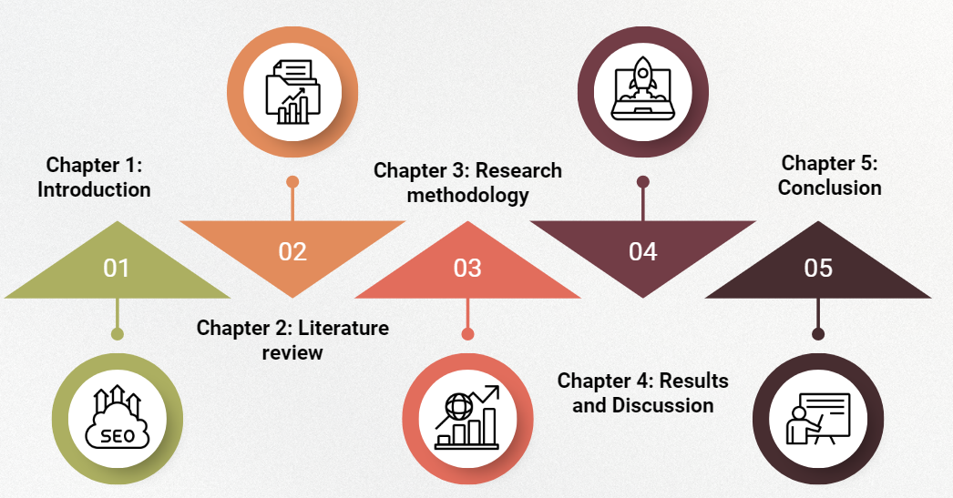
Figure 1.1: Dissertation structure
(Self-developed)
The dissertation consists of five logical chapters that lead the reader, together, to the conceptual foundations to analytical conclusions. Chapter 1 presents the background and gap of the research, problem statement, rationale, aims, objectives, and questions which define the contextual basis of the research. Chapter 2 contains a critical literature review, where the author discusses the main theories, the results of research, and theoretical discussions on the subject of AI-driven digital marketing and consumer behaviour. Chapter 3 discusses the methodology structure, where the philosophy of the research, research design, sampling plans, data collection tools, and data analysis tools are discussed. The chapter 4 summarises and analyses the empirical results based on statistical analysis. Chapter 5 is the final part of the study, which includes implications, recommendations, and future studies.

1.7 Theoretical framework
The theoretical basis of this study is the Technology Acceptance Model (TAM) and the AIDA framework, both of which together shed light on the consumption of AI-enabled digital marketing practices by consumers. TAM offers technological acceptance approach, which explains how the perception of usefulness and the feeling of ease of use determine the willingness of consumers to interact with AI tools including personalised recommendation systems, virtual stylists, and chatbots (Aburbeian, Owda and Owda, 2022; Al-Nuaimi and Al-Emran, 2021). These constructs form the main role in comprehending the role of AI in developing trust, perceived value and behavioural involvement. Simultaneously, the AIDA model adds another behaviour-marketing aspect, describing how AI-produced content attracts Attention by hyper-personalisation of messages, generates Interest by offering context-specifically relevant messages, evokes Desire by curating products according to a specific customer, and causes Action in the shape of purchase intent and loyalty (Chahed et al., 2023; Pratiwi et al., 2021). TAM and AIDA combine in providing a complementary theoretical approach linking technology acceptance and marketing persuasion to have a comprehensive perspective of how AI-driven strategies can impact consumer behaviour within the UK fashion retail industry.

Chapter 2: Literature review

2.1 Introduction
This chapter critically examines the theoretical and conceptual foundations underpinning the relationship of AI-driven digital marketing and consumer behaviour in the UK fashion retail sector. It synthesises key theories and thematic debates in order to create a structured understanding of how AI affects purchase intentions, trust, engagement and loyalty.

2.2 Theoretical framework
The theoretical underpinning of the research is informed by three core models which in combination shed light on consumers' interpretation, evaluation and response towards AI-enabled digital marketing within the UK fashion retail industry (Haque et al., 2024). These models include Technology Acceptance Model (TAM), AIDA model and Consumer Trust Theory (Song, Ruan and Jeon, 2021; Lee and Trim, 2022). Together, they form an all-encompassing analytical shell for understanding the behavioural, psychological and ethical dynamics to the AI-mediated consumer experience.
The Technology Acceptance Model (TAM) is one of the most influential models for evaluating user adoption of new technology (Rejali et al., 2023; Al-Rahmi et al., 2021). Developed by Davis, TAM supposes that two central concepts called perceived usefulness and perceived ease of use justify the intention of an individual to interact with a technological system (Khaleel and Hilal, 2023). Within the context of AI driven fashion marketing, these constructs are important in order to understand consumer judgement about tools such as personalised recommendation engines, AI powered chatbots, virtual fashion assistant and automated content curation platforms (Nair and Kumar, 2024). When consumers feel that these AI systems help make life easier, offer them relevant product suggestions and help them find their way, this shows a greater tendency of them to interact with them. The strength of TAM is that it is predictive and it is very highly empirically-validated in digital environments (Li et al., 2025). However, critics have claimed that TAM is reductionist, failing to acknowledge the role of emotional, ethical and contextual issues such as privacy concerns, algorithmic fairness and data transparency that have been growing in relevance in AI-enabled marketing. Nevertheless, TAM does provide a good basis on which to explore consumer acceptance of AI-enabled interactions.
Complementary to the functional nature of TAM is the AIDA model, which takes a behavioural and psychological view on the role of marketing communication in developing the response of consumers (Sarfraz, Kurdi and Rafiq, 2025). AIDA which is an acronym for Attention, Interest, Desire, and Action--is a set of stages by which persuasive stimuli are processed. In AI enhanced digital marketing, personalised advertisements, dynamic product recommendations and automated styling suggestions are all aimed at capturing attention with content that matches their browsing patterns or their demographic profiles (Gowri, 2024). Once attention is acquired, AI systems maintain interest using relevance or novelty and convenience. As AI delves into deeper personalisation it stimulates Desire as consumers envisage ownership or product fit (Raian et al., 2025). Ultimately, when consumers see high utility and low risk, consumers proceed to Action, in the form of purchase intention or brand loyalty. The main advantage of the AIDA model is that it is very clear and intuitive (Rakibul et al., 2025). Yet, its premise of linear interactions does not sufficiently account for the cyclical and interactive character of engagements where AI technologies improve through co-creation of experience with the users through feedback loops. Despite this limitation, AIDA, however, is still very useful when it comes to conceptualising AI's persuasive capacity in digital fashion marketing.
While the two models of TAM and AIDA handle technological acceptance and persuasive influence, the Consumer Trust Theory introduces a very important form of ethics and relationship (Zhang and Jae Joon Hwang, 2023). Trust is one fundamental factor in whether consumers are comfortable with interactions mediated by AI or not. In this framework, trust is affected by perceptions of competence, integrity and benevolence (Hiatt et al., 2023). Applied to AI-powered marketing of fashion, while competence may be seen through the accuracy and relevance of AI recommendations; integrity may be linked to transparent data practises; and benevolence may be linked to whether the system is respectful of consumer autonomy or if it exploits behavioural data. As fashion consumers become more aware of data privacy and algorithmic bias, trust becomes a cut and dry variable for engagement, loyalty and long-term brand relationships (Escoz-Roldán, Gutiérrez-Pérez and Ángel, 2019). Consumer Trust Theory's strength is that it explains the rejection of technologically sophisticated systems that have failed to meet ethical expectations. It has, however, the limitation that it does not sufficiently address the issue of algorithmic opacity - a defining challenge of AI technologies (Buhmann and Fieseler, 2021). Collectively, these three theoretical frameworks enable the multidimensional understanding of AI driven marketing. They draw attention to acceptance (TAM), persuasion (AIDA), and ethical-relational evaluation (Consumer Trust Theory), allowing for intense research of the impacts of AI in consumer behaviour in the UK fashion retail industry.

2.3 AI-driven digital marketing and consumer purchase intentions
According to Yeo et al., (2022), Artificial intelligence has become a core mechanism by which fashion retailers shape and stimulate consumer purchase intentions in the digital marketplace in the present day. In the UK fashion retail sector, which has consumers demanding ever-faster, personalised, and aesthetically relevant interactions, AI-enabled marketing practices have become a part of influencing the cognitive and emotional processes that support the purchase decision process. In this contrast Moodley and Sookhdeo, (2025) stated that over dependency effective creating core trust issues regarding the actual product or services.
A main channel whereby AI can affect the purchase intention is the delivery of highly personalised marketing content. According to Barde et al., (2025) by analysing browsing behaviour, purchases made, demographic indicators and engagement patterns, AI systems forge an amazingly precise identification of individual preferences. Retailers can thus see recommendations straight from the style, size tastes, or past choices of a consumer. This targeted relevancy lightens consumers' effort in running through amazing product inventories and they are shown the way of recognising appropriate choices quickly (Patil et al., 2024). As a result the decision-making process is more efficient and the likelihood of purchase is a natural consequence. Personalised suggestions also provide a feeling of the consumer being understood by the brand, which integrates the consumer in a subtle emotional connection that often enhances movement towards buying (Wang et al., 2025).
AI also leads to improving purchase intentions via predictive analysis, which look ahead to what consumer needs are even before they are verbally stated (Bhagat, Chauhan and Bhagat, 2022). By noticing the trends in seasonal interests, current fashion trends, and a consumer's own browsing rhythms, predictive modelling methods enables retailers to stock their products in crucial micro-moments of consumer attention. When a consumer finds an item that corresponds to both his or her implicit preferences and the larger fashion cycle, the perception of the value of timeliness ensues, which makes the purchase more compelling. In contrast Mahdavian, Moradi and Behnam Bahrak, (2025) stated that, over personalisation influence the customers to feel that the specific organisation is collecting data which directly influence their data security perception, which also leads to customer lose. As a consequence, this ability to predict and respond to consumer needs in real time reduces consumer's passivity in browsing and increases their ability to form an intention.
Additionally, AI-driven service features play an important role in eliminating barriers typically ending up being utilised to oppress procure choices. Chatbots and virtual assistants, powered by natural language processing, are able to give instantaneous responses to consumer queries relating to fit, stock availability, delivery times or returns policies (Mah, Skalna and Muzam, 2022). Immediate assistance reduces uncertainty which is one of the most common barriers to buying fashion through the web. When consumers feel supported well enough in their digital experience, they have much more confidence in their decisions, which reinforces purchase readiness. Smooth, uninterrupted interactions of service communicate the reliability and reinforce the willingness of consumers to proceed with transactions.
It has been revealed that AI-based applications can enhance the intention to buy through the development of emotionally involved and fanciful shopping experiences. Digital styling or mood-based suggestions coupled with virtual try-on systems enable a customer to imagine how the products would fit in his or her day-to-day life, increasing enthusiasm and decreasing doubt (Elmashhara et al., 2023). Because fashion buying has many times been an identity and expression of aesthetics, these types of immersive tools have bridged the psychological difference in the intention to purchase and think of a product (Gusti and Muhammad, 2021).
Conversely, according to Sebastian Fassiaux (2023), AI personalisation is not always associated with the growth of purchasers motivation, particularly when consumers believe that technology was over intrusive or manipulative. Likewise, the issue of data privacy, transparency and fairness can cause scepticism, proving that AI affects the behavioural aspect not automatically but conditionally. In line with this argument, Nair and Manohar (2024) postulated purchase intention was enhanced whenever the consumers were made by the AI systems leading them in their digital shopping experience.
In sum, the effect of AI-driven digital marketing is powerful to influence the intention to purchase behaviour based on personalisation, prediction, responsiveness to improved service, and emotionally engaging experiences. Its impact is the greatest when it saves effort on decision-making efforts, creates a higher relevance and helps in enriching the overall shopping journey. However, its positive effects are contingent on ethical and transparent implementation which supports consumer trust and maintains autonomy in the digital retail environment.

2.4 AI personalisation, customer trust, and brand loyalty
The field of digital marketing has been profoundly changed by artificial intelligence that allows companies to react to the needs, preferences, and behavioural inclinations of specific consumers in a highly personalised and resonant way (Alfouzan, Lu and Ullah, 2024). In the UK fashion retail sector where expediency of the service delivery system interact with both the emotional and identity-based factors, AI-driven personalisation has become an especially potent tool determining the establishment of trust and brand loyalty. As a result, the interaction between personalisation, trust and loyalty has remained a key area of concern to comprehend the modern consumerbrand relations in digital fashion ecosystems.
The AI personalisation works based on the individual consumer profiles to personalise marketing messages, product suggestions, website designs, promotional offers and styling tips (Potwora et al., 2024). In line with this view of behaviour, Lou and Xie (2020) reasoned that this kind of personal relevance creates the perception that the brand appreciates the identity of the consumer and motivations and aesthetic tastes. This enhances interaction through making it meaningful instead of generic, and decision fatigue through simplifying product discovery processes. Psychologically, this enhanced experiential quality acts as a basis of trust since the consumers start seeing the brand as reliable, intuitive and as per the expectations.
Customer trust is hence placed in-between as the key factor defining whether personalised AI experiences can yield loyalty (Chen et al., 2022). Trust will surface when the consumers are in a position to think that brand intentions are good intention, systems are effective and operational practises are not a secret. To reinforce the point of view, Wong et al. (2023) have indicated that AI contributes to the development of trust when personalisation is perceived as beneficial instead of intrusion, whereas product recommendations that are sincere about the style of a consumer creates an impression that the brand is acting in the interests of the latter. On the same token, Sestino et al. (2025) indicated that chatbots with AI capabilities that deliver correct and prompt customer support affirm the perception of competence and reliability. Such a perception of the brand, based on the authentic and reliable artificial intelligence-mediated interactions, both builds positive views about the technological expertise and quality of the services offered, which promotes sustained interaction.
But contrary to these optimistic meanings, more researchers are highlighting that trust is very prone to the perceived risks related with data practises. According to Soni (2024), AI personalisation requires large amounts of data gathering, and the consumer must be concerned with whether a lot of information is being collected, processed correctly, and used in a responsible manner. In cases where transparency is lacking or in cases where the personalisation is too intrusive, the individual may develop the sense of loss of autonomy and may feel uncomfortable which will destroy trust instead of building it. Similarly, Raji et al. (2024) pointed out that issues surrounding personalisation and privacy (or manipulation, or algorithmic bias) do not support the shift towards long-term behavioural commitment and hence indicates that technological sophistication is not sufficient to create such a commitment.
Although this sceptical image highlights the conditionality of AI efficacy, researchers who are more consumer-oriented believe that personalisation, conducted in a transparent and respectful way is an extremely strong source of loyalty. Handique and Sarkar (2024) observed that repeat buying behaviour, increased involvement and emotional attachment of indiscriminate brands are more likely to manifest among the loyal consumers. AI also supersedes this line of loyalty by making sure that online experiences are consistent, painless and personalised along the consumer line. One-on-one recommendation, or virtual styling solutions and custom discount programmes create the perception of being acknowledged and appreciated in making customers feel that this is also a relational investment by the brand.
Furthermore, emotional satisfaction is another dimension that supports the loyalty. It has been shown that in the fashion industry where the buying process is closely intertwined with self-expression and identity construction, personalised styling recommendations, which resonate with individual aesthetics, boost inspiration and confidence (Qi, Cho and Ko, 2025). This emotional satisfaction paves the way to the repeat buying of preferred brands by the consumer in a manner that he or she activates the expectation of the same kind of value and the same kind of continuation. In the long term a series of good experiences cause brand loyalty that would be hard to break by rival firms.
However, Lou, Han and Xu (2025) cautioned that there needs to be a fine balance with personalisation. Over targeting or unclear governing is likely to create inconvenience and distrust hence loss of loyalty. Customers are also bases of brand clarity, data sovereignty, and moral guarantees which means individualisation driven by AI needs to be efficient in balancing utility and ethical data management.
In summary, AI personalisation serves to be a catalyst of greater levels of trust and brand identification for years to come if done with transparency, relevance, and an ethical sensibility. It improves the consumer experiences by providing meaningful interactions that feel personal, reliable and supportive. Trust, once achieved, turns these experiences into lasting loyalty that provides the basis of long-lasting competitive advantage in the UK fashion retail industry (Arshad, 2023).

2.5 Factors driving consumer engagement with AI-based campaigns
Considered relevance is underscored as one of the driving forces of engagement by many scholars. Customised recommendations, personalised messages and personalised product feeds develop the perception of alignment of individual preferences at that moment of digital interaction, aligning with personal preferences (Huang, Lu and Yang, 2023). Noguti (2022) states that, when content shows purchase history(s) or browsing behaviour, then it is perceived as more curated than generic, thus playing to a greater attentional investment. In line with this sentiment, Perez-Vega (2020) stated that the level of engagement increases with the predictiveness of AI since the consumers will feel that the content is made specifically to them. Conversely, as Oluwafemi et al. (2021) pointed, relevancy needs to be complemented by the ethical guarantee since consumers might turn off when they become suspicious of intrusive targeting or non-transparent personalisation tools. Is relevance, therefore, able to excite engagement it can at the same time make it diminish through lack of transparency. Similar contrast is also created with regards to interactivity. The interactive AI-based applications, chatbots and virtual assistants, can be used to offer real-time conversation and information care in the form of simulating in-store-help (Allouch, Azaria and Azoulay, 2021). The type of virtual try-on and personalised lookbooks only deepens the engagement via the implementation of virtual try-on features and personalised lookbooks, which enables consumers to be actively involved into the co-create experiences instead of passively consuming content (Sadat, 2023). These results describe the concept of interactivity as the process that makes digital spaces more human and enhances emotion and behavioural appeal.
On the other hand, critics argue that interactivity may also induce fatigue in a situation where there is too many, or too repetitive interactions, particularly where chatbots do not respond in a way contextually sufficient. This further suggests that interactivity may either humanise or frustrate, decided by the quality of execution, i.e. one cannot easily be engaged. The third area of similarity is the issue of convenience and efficiency. Ervits and Maintz (2025) noted the decrease of cognitive effort due to AI facilitating navigation and decision-making, whereas Haneefa and Singh (2025) pointed at the decrease of friction because of automated services of size prediction and delivery optimisation. In the same vein, Patel, Pandit and Sama (2023) suggested that efficiency is especially appreciated in the context of fashion because of the high product diversity and the possibility of being overwhelmed by it.
In comparison to this, novelty and experiential stimulation is a more hedonic type of engagement. Artificial intelligence for personal styling or gamified shopping experiences tend to be positively received by consumers as an example of immersive, creative artificial intelligence (Bin Kim and Jung Choo, 2023) will be welcomed well. Fang et al. (2019) hypothesised the entertainment value of novelty besides functional utility, whereas Garaus et al. (2025) associated this novelty with emotions and playfulness.
Nonetheless, novelty and efficiency do not implicate each other in the same way with efficiency (reducing cognitive load) and novelty (enhancing sensory and emotional stimulation). The two can be used to generate engagement, but in opposite psychological mechanisms. Lastly, transparency and fairness moderate the level of engagement as they would make consumers perceive AI as either empowering or intrusive. In the case of Aldboush and Ferdous (2023), data ethics is the crucial aspect of the UK consumers, meaning that the success of AI-based engagement is possible only in case the relevance, interactivity, and novelty saturate the situation with ethical clarity.
In summary, the factors that influence consumer engagement with AI-based campaigns, in one way or the other, include relevance, interactivity, convenience, novelty, and trust. AI boosts engagement through making experiences personalised, responsive and emotionally resonant; the most effective way to engage with AI is of course through ethics and transparency (Kaperonis, 2025). In these circumstances, however, AI is a powerful player that can be a catalyst for more in-depth and prolonged consumer participation in the digital fashion retailing scene (Prajapat, 2024).

2.6 Effectiveness of AI marketing strategies in enhancing consumer experience and loyalty
Artificial intelligence has profoundly emerged as a game-changer in the realm of digital marketing - and in the case of fashion retail, specifically - where retailers want to craft a great, immersive experience for their customers, and perhaps even promote long-term loyalty programs (Varshney and Chaudhary, 2024). AI marketing strategies from personalised recommendations, to predictive analytics, and virtual assistance--have redefined how consumers are discovering products, engaging with brands, creating emotional connections with brands, and experiences, all within the confines of the online environment (Rane et al., 2024). Increasing the quality, fluidity, and personal relevance of the consumer journey, while strengthening trust and commitment, is one way to understand the value of these strategies.
One of the most important ways that AI provides new consumer experiences is through hyper-personalisation (Singh and Singh, 2024). By analysing behavioural data, browsing habits and previous purchases, AI creates personalised product recommendations that appeal to one's taste. This tailoring decreases decision fatigue and enables consumers to easily move through collections as they are shown products that are tailored to their taste and likes. The feeling of being understood by a brand boosts that emotional satisfaction of shopping which makes the experience more personalised and meaningful. In time, such consistent relevance inspires loyalty, in that consumers tend to return to places where they feel recognised and valued (SAHUT and LAROCHE, 2025).
AI marketing strategies are also effective as they ease the customer journey. Tools like intelligent chat robots, automated sizing touch guides, virtual fitting rooms and predictive delivery updates allow for minimum friction and uncertainty (Umam, 2025). Consumers love quick responses and efficient support, especially in fashion retail where sizing, fitting, and product availability play a significant role in deciding whether to buy or not. AI-driven service improvements to create a seamless experience that adds convenience at every step in the journey (Umam, 2025). A positive and low effort experience breeds attachments of the emotions and supports the possibility for repetition.
Another factor that helps make AI work is because it helps to provide anticipatory experiences (Venkateswaran et al., 2023). Predictive analytics enable retailers to determine the needs of consumers before they know it. For example, AI can predict favourite colours, or up and coming categories of interest or seasonal gaps in their wardrobes, and serve them appropriate content at the right time (Rane, Choudhary and Rane, 2023). Consumers who encounter timely suggestions that feel intuitive about them, increase the brand's perception as being competent. This anticipation produces a feeling of trust as the brand seems able to improve the consumer's lifestyle and not simply to sell products (Nguyen, Quach and Thaichon, 2021).
In addition, AI marketing strategies create a better consumer experience by creating immersive and inspiring digital environments. Virtual stylists, mood-based look-books, and interactive visualisation tools can help consumers explore new styles and experiment with combinations of looks or see how clothes will look in a personalised context (Shahzad et al., 2024). These innovative functions appeal to the essentially expressive aspect of fashion, which allows consumers to relate to products creatively. Such experiential depth is more than transactional shopping but it encourages emotional engagement and it will strengthen one's loyalty in the long run (Omeish, Al Khasawneh and Khair, 2024).
However, the success of AI marketing strategies is highly dependent on ethical and transparency standards. Even the most sophisticated AI systems can have a negative impact on experience and loyalty if they are perceived to be intrusive or manipulative (Gao and Liu, 2022). Consumers are increasingly aware of the process of data collection and utilisation, and they expect brands to be transparent about such processes. When AI works openly, by being respectful and giving data control, and not over-enthusiastic about personalisation, consumer trust increases, and consumer loyalty is more resilient (Rane, Choudhary and Rane, 2023b).
Ultimately, artificial intelligence marketing approaches work best when they give a mix of innovation, individual relevancy and ethical responsibility. By improving convenience, intensifying the emotional connection, and showing respect for consumer choice, AI is all about restoring the experience and loyalty. In the context of UK fashion retail, where consumers prefer brands that bring digital sophistication and transparency, AI is also a strategic asset that companies need to maintain long-term competitive advantage.

2.7 Research gap
Despite the fact that the technological potential of AI in the area of personalisation, efficiency, and customer experience in digital marketing is already under extensive research, little empirical data is conducted on its short-term behavioural outcomes on trust, purchase intention, engagement and loyalty in the UK fashion retail setting specifically (Pereira et al., 2022; Bolesnikov et al., 2022). The current literature is more inclined to focus on technical performance instead of consumer perception or emotional reactions to AI-driven interactions and behavioural responses are underdeveloped (Ziakis and Vlachopoulou, 2023; Babu et al., 2022). Moreover, the majority of the works are general retail outlook rather than the industry-specific features of UK fashion, facing shifting trends, and competition (Zeng et al., 2023; Campbell et al., 2022). Such a lack of consumer-based behavioural evidence is the reason to conduct a survey-based research to record the main responses in the UK fashion market.

2.8 Summary
The literature shows that AI has a significant impact on how consumers are experiencing brands by driving personalisation, interactivity, convenience and emotional resonance. However, for doing this there needs to be transparency of ethics, and responsible use of data.) The chapter lays a strong conceptual foundation for the study, through a discussion of this creating both opportunity and challenges to leverage AI to influence consumer behaviour and loyalty. The next chapter outlines the methodological approaches adopted in this research.

Chapter 3: Research methodology

3.1 Introduction
This chapter defines the methodological context that will be used to investigate the effects of AI-based digital marketing practises on marketing consumer behaviour in the UK fashion retail market. It supports the adopted research philosophy, approach and design, sampling plan, data collection methods, analytical procedures and the ethics and brings about coherence in the research.

3.2 Research onion
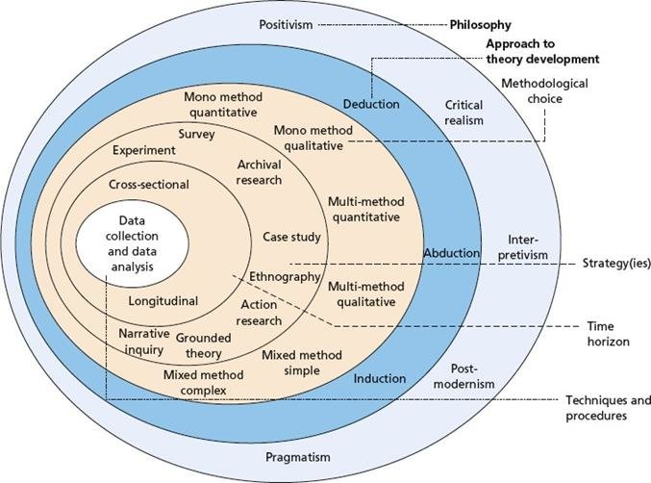
Figure 3.1: Research onion
(Source: Saunders, Lewis and Thornhill, 2023)
The research design of the current study is framed within the paradigm of the research onion that offers a systematic and logical framework on the research design by moving towards the philosophical assumptions and out to the analytical methods of research design (Saunders, Lewis and Thornhill, 2023). The research takes a positivist research philosophy, at the lowest point of the layer, which represents the objective position by studying observable and measurable relations between AI-influenced digital marketing strategies and consumer behavioural outcomes. It is thereafter succeeded by deductive research methodology, in which one takes a set of known theories like Technology Acceptance Model and AIDA framework, as guides to formulate the research objectives and inform empirical research.
At the decision of the methodology level there is a mono-method quantitative approach, which guarantees integrity of the philosophical orientation and the analytical direction of study. The chosen strategy is a survey-based one and it allows the revision of a structured data collection of a specific group of UK consumers engaged in the fashion retail segments that had previous experience with AI-based marketing tools. Going inward, the study time horizon is cross-sectional since the data was collected at one point in time to generate the current consumer perceptions and behaviours. The fundamental component of the research onion is the data analysis method, where the frequency analysis method was used with Microsoft excel to analyse the obtained data. This stratified methodology guaranteed methodological consistency, analytical transparency and scholarly rigour in the course of research.

3.3 Research philosophy
The philosophy of the research is positivism because it is the best suited mode to investigate the quantifiable and observable connexions between AI- affected digital marketing practises and consumer behavioural results in the UK fashion retail sector. Positivism is based on the belief that the world is objective and that it could be cognized based on empirical observation, statistical measurement and hypothesis testing (Mbanaso, Abrahams and Okafor, 2023). The philosophy of this research is in line with the objective of the study, which is to evaluate the effects of AI-based marketing on purchase intention, trust and brand loyalty in a systematic, evidence-based fashion. Since the study is aimed at outlining patterns, relationships, and behaviour response patterns within a specified group of consumers, positivism allows to apply systematic data gathering strategies and quantitative analysis in order to come up with generalisable results. The perceived usefulness, engagement, and behavioural intention, which are the constructs of the Technology Acceptance Model and AIDA framework are practically measurable, which once again justifies the appropriateness of a positivist philosophy. In addition, positivism upholds objectivity since researcher bias is minimised as well as the conclusion is drawn based on objective data and not subjective interpretation (Ali, 2024). In general, its implementation of positivism contributes to increasing the methodological rigour of the research and making sure that the aims of the research, theoretical framework, and method of analysis are aligned.

3.4 Research approach
The approach to research used in the current study is deductive because it aims to verify or otherwise refute the existing theoretical frameworks on the topic of AI-influenced digital marketing in the UK fashion retail industry. Induction is suitable whenever one has theories and models to inform research objectives and carry out empirical tests on the hypothesised relationships. Technology Acceptance Model, AIDA framework, and Consumer Trust Theory recognises a conceptual frame work in this study through which the behavioural expectations of purchase intention, trust, engagement, and loyalty are obtained.
The deductive method enables the research to make a logical decision on how to proceed in carrying out research basing the research or study on the theory to measurable variables (Hall, Hall and Shaw, 2022). These variables are empirically evaluated with the help of structured data collection techniques to show whether the obtained results are associated with theoretical assumptions. This is an especially appropriate methodology with regard to research conducted to determine any causational or associational relationships between technological interventions and consumer behaviour. Also, deduction fosters clarity in the analysis and consistency in methodology, which allows the determination that the results could be compared with the existing literature and would provide input in either their validation or refinement of theory (Proudfoot, 2022). Through a deductive approach, this study is coherent in its objectives, research questions, and its strategy of analysis and, therefore, enhances the reliability and academic credibility of the study in a positivist philosophical approach.

3.5 Research choice
The chosen research method is a mono-method quantitative research choice that will be suitable in terms of investigating the impact of AI-influenced digital marketing tactics on consumer behaviour in the UK fashion retail sector in a systematic way. A quantitative design, which is a mono-method, enables the study to concentrate on gathering numerical data and subsequently employing statistical software to establish relationships between most important variables of purchase intention, customer trust, and customer engagement as well as brand loyalty (Saunders and Darabi, 2024). This option has been very much compatible with the positivism research philosophy and deductive approach used in the study.
The quantitative research approach is specifically appropriate because the study will focus on a test of theoretical constructs established on the basis of the Technology Acceptance Model and the AIDA framework. The constructs can be measured through structured survey instrument, and standardised data collected on a greater sample through the operations of these constructs. This type of approach increases reliability, replicability, and generalisability of the findings with the target population. In addition, when necessary, complexity is minimised due to the necessity of having a single method design, methodological coherence and clarity of the analysis would be ensured (Vivek and Nanthagopan, 2021). It makes it possible to engage in a concentrated statistical assessment of hypotheses and to conduct a one-sided understanding of the behavioural patterns of the consumers. Hence, the methodological rigour and empirical validity of the research is enhanced by the adoption of a mono-method quantitative research choice.

3.6 Research strategy
A survey-based research strategy embraced in the current study is best suited to the investigation of consumer perceptions and behavioural reactions to AI-influenced digital marketing in the UK fashion retail sector. A survey strategy facilitate the methodical gathering of primary research data on a specific population, as this research aimed to gather quantifiable attitude, perception and purchase intentions desire in regards to purchase desire, trust, involvement and brand loyalty (Johannesson and Perjons, 2021).
The strategy fits the research due to the positivistic philosophy and deductive method employed in the study as it enables a test of hypothesis using structured and standardised data collection techniques. Through surveys, the operationalisation of theoretical constructs based on the Technology Acceptance Model and AIDA framework can be transformational into objective variables and, therefore, statistical analysis of the relationship between AI-mediated marketing practises and consumer behaviour becomes possible. Also, surveys facilitate the process of gathering information about a rather extensive sample in a short period, which contributes to increasing the applicability of the results (Goodfellow, 2023). Moreover, a survey-based will guarantee coherence, objectivity, and repeatability, minimise researcher bias, and enhance research findings. This strategy is an effective method of producing strong empirical evidence that will match the objectives of the research questions in the context of the UK fashion retail industry where consumer experience with AI tools is prevalent.

3.7 Data collection method
This paper was methodological by utilising a primary quantitative data-gathering design by use of a structured online survey, to investigate the consumer reactions to the AI-mediated digital marketing analysis in the UK fashion retail sector. The potential respondents were fashion retail clients in the UK aged 18 years and older and who had previously experienced AI-enabled marketing technologies, such as made-to-you suggestions, AI-based advertisement, or chatbot-mediated services at fashion retail sites. This gave sufficient experience to the respondents that was pertinent to the purpose of the research. The questionnaire was sent online through the social network (LinkedIn, Instagram, WhatsApp), and online communities related to fashion. A total of 180 survey responses had been first taken. After the data screening exercise 150 responses have been left to be analysed in the final stage as 30 responses were discarded either because of incomplete questionnaires, incongruence in patterns of response, or otherwise they did not fulfil the eligibility criteria. This option of cleaning up the data improved both the reliability and validity of the results as only the high-quality and usable data were analysed. The research have utilised non-probability purposive strategy of sampling where the respondents were chosen on the basis of their personal involvement in the digital marketing managed by AI as opposed to being chosen randomly (Stratton, 2023). This method was appropriate in capturing the informed consumer perceptions and behavioural information and enhanced the empirical applicability as well as the methodological soundness of the study.

3.8 Data analysis procedure
The analysis of data in this research was conducted by the frequency analysis with Microsoft Excel which is pertinent in recapping and inducting the entail and observed quantitative data in a understandable and customised way of surveys. After cleaning and screening data, 150 valid responses had been imported into Excel to be analysed. The frequency analysis was used in order to look at the distributions of responses in terms of most important variables, such as the perceptions of AI-driven personalisation, consumer trust, consumer engagement, purchase intentions, and brand loyalty. Frequencies, percentages, and cumulative distributions in relation to each of the survey items were calculated using in-built spreadsheet functions and pivot tables of excel (Kumar, 2023). In this way, it was possible to easily identify major patterns and trends of responses in the dataset. Frequency analysis was a very appropriate one especially considering the descriptive and exploratory nature of the research objectives which were to find out current attitudes of consumers and not to make any complex causal connexion. Microsoft Excel was chosen because it is free, open, and convenient to use in the processing of medium size data. On the whole, this analytical process guaranteed conciseness, validity, and useful interpretation of consumer behavioural patterns with consideration of the research objectives.

3.9 Ethical consideration
The issue of ethics was taken into account during the entire research process to help follow the requirements of academic research and to avoid breaching the rights of those who partake in it. The research was done using the principles of informed consent, voluntary participation, confidentiality, and data integrity. The objective of the research regarding its purpose (which was scholarly) was made clear to the respondents before the start of the study, as well as the nature of their participation, and their right to leave the research at any point without any sanction. All personal data were gathered in accordance with the Data Protection Act 2018 (UK) and the General Data Protection Regulation, i.e. lawfully, fairly, and transparently (Gov.uk, 2018). There was no request on any personally identifiable information and the responses were anonymised upon the data collection. The gathered information was saved in safe files in passwords and was solely applied to an academic review. The data was available to the researcher only and will be destroyed once dissertation is completed as per the institutional guidelines. Ethical responsibility outside the statutory requirement included ensuring that there were no deceptive practises, decreasing the load imposed on the participants as well as correctly representing the findings. Ethical sensitivities concerning AI and consumer privacy were also taken into consideration during the research, so questions were not to stimulate sharing of any sensitive personal information. All in all, these ethical considerations provided an integrity in the methodology, confidence among the participants and good academic practise.

3.10 Summary
In summary, the chapter has introduced an organised and strict methodological design in line with positivist and deductive orientation. The study is reliable and valid in findings due to its quantitative survey method of data collection and systematic data analysis. Chapter 4: Data Analysis, is the next chapter which states and interprets empirical results obtained out of the collected data.

Chapter 4: Data analysis

4.1 Introduction
The chapter provides a systematic review of primary surveys data to understand consumer perceptions of AI-based digital marketing within the UK fashion retail industry. It assesses the trend in terms of personalisation, trust, engagement, purchase intention, satisfaction, and loyalty using frequency analysis, which directly responds to the research objectives.

4.2 Data analysis
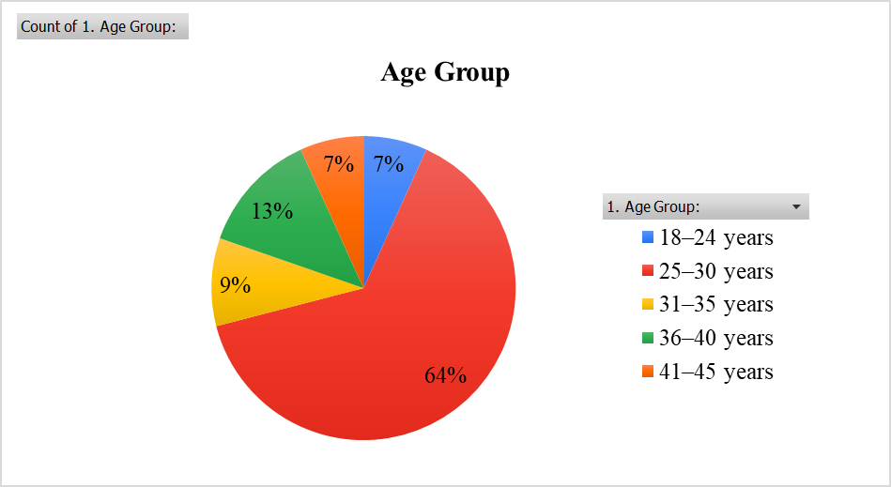
Figure 4.1: Age group distribution of survey respondents
(Self-developed)
The highest population of 64 percent is the age of 25-30 years with 13 percent of 36-40 years. The largest investors are 31-35 years (9 percent), 18-24 years (7 percent), and 41-45 years (7 percent) of the total participants, which means that young adults consume cosmetic products massively.

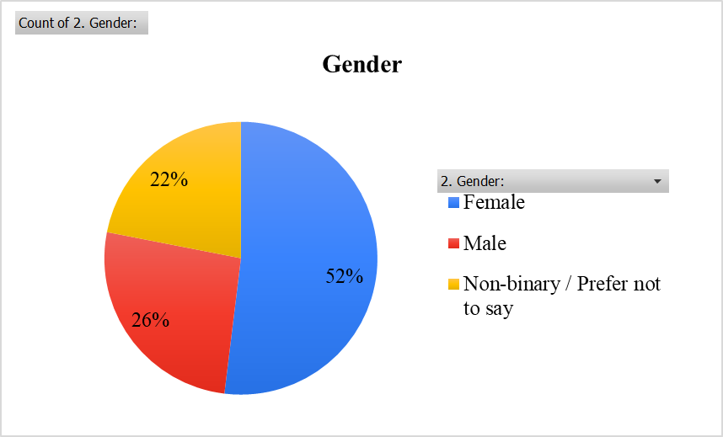
Figure 4.2: Gender distribution of the participants
(Self-developed)
The balance of the gender used is female skewed although equally balanced by having 52 percent of females, 26 percent of males, and 22 percent non-binary or undisclosed. Such diversity promotes the representativity of consumer attitudes in the evaluation of AI-based fashion marketing reactions.
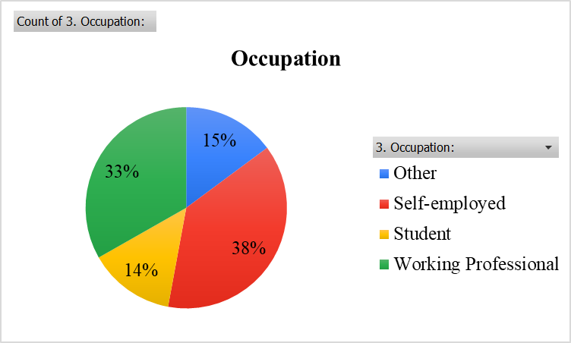
Figure 4.3: Distribution of occupation of the participants
(Self-developed)
The self-employing respondents at 38 percent and the working professionals right behind them at 33 percent head the occupational profile. Students make up 14 percent compared to 15 percent in the respondents in the category of other. This is in line with the distribution of a sample that is mostly economically active with pertinent purchasing power.
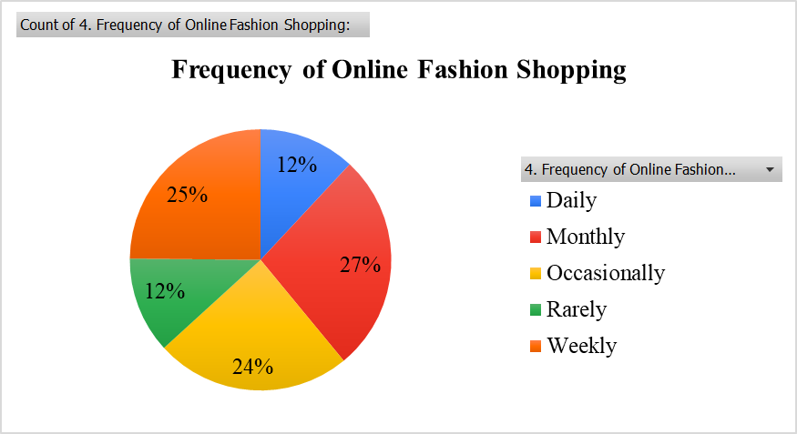
Figure 4.4: Frequency of online fashion shopping
(Self-developed)
The Internet fashion shopping is done at the highest frequency monthly 27 percent, then weekly shopping is done 25 percent. The occasional shoppers are 24 percent of the total while the daily and rare shoppers are 12 percent and 12 percent respectively. This tendency means non-compulsive but frequent visits to fashion websites on the Internet.

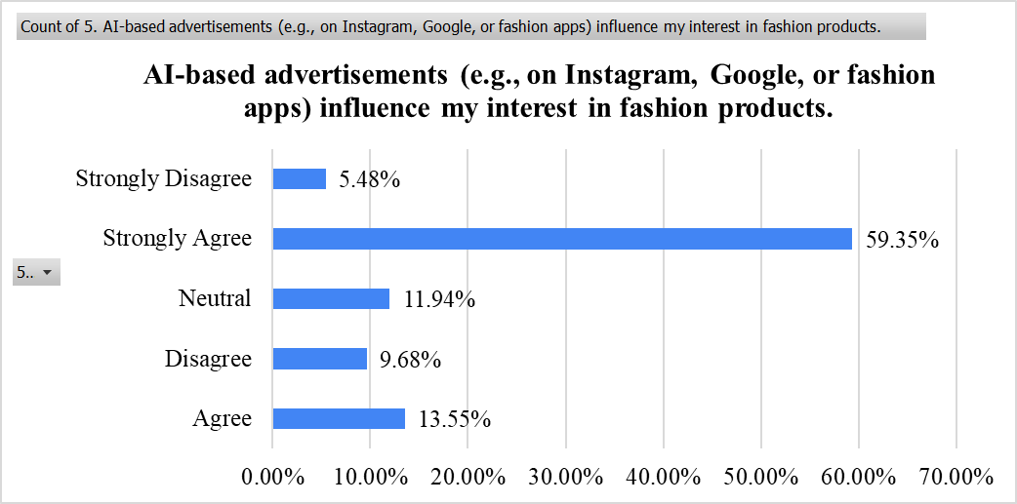
Figure 4.5: Influence of AI-based advertisements on consumer interest in fashion products
(Self-developed)
There is a high positive impression, and 59.35 percent of respondents thought strongly and 13.55 percent thought agreeably that AI-based advertisements affect their level of interest in fashion products. The percentage of neutral responses is 11.94, and the level of disagreement is not high, which suggests excellent persuasion power of AI-based advertising.
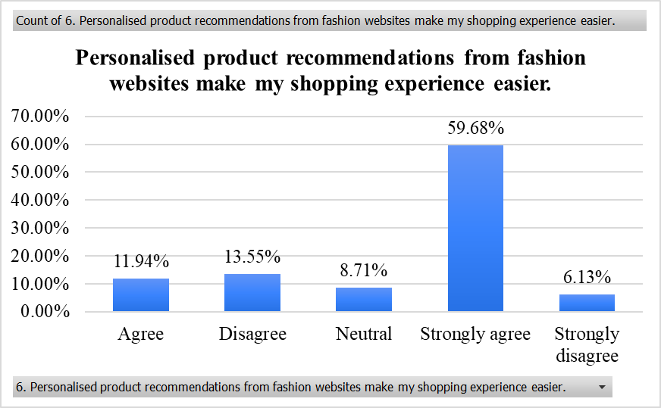
Figure 4.6: Perceived impact of personalised product recommendations on shopping convenience
(Self-developed)
Personalised recommendations are appreciated by a significant majority, 59.68 percent of them strongly agree and 11.94 agree that these features make shopping experience easier. The number of those who remain neutral is also quite low (8.71 percent), whereas disagreement is quite minimal, which shows the functional importance of AI-based personalisation.
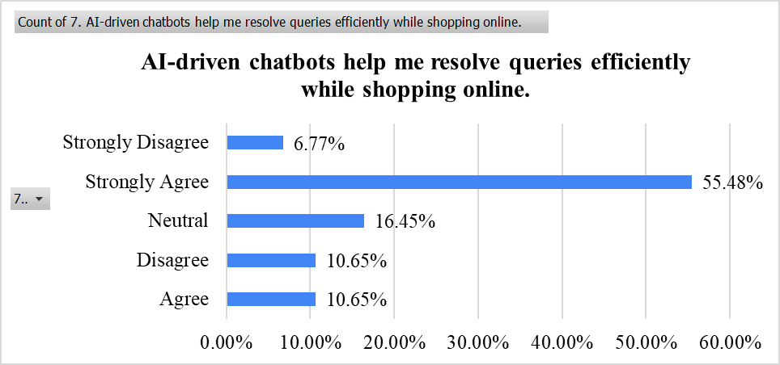
Figure 4.7: Effectiveness of AI-driven chatbots in resolving online shopping queries
(Self-developed)
There is an obvious majority view that chatbots helped by AI perform effectively, with 55.48 percent strongly agreeing and 10.65 percent agreeing that chatbots help through queries efficiently. The options of a neutral response are at 16.45 percent and a general lack of disagreement is minimal, which means that chatbots in customer service are widely agreed upon.
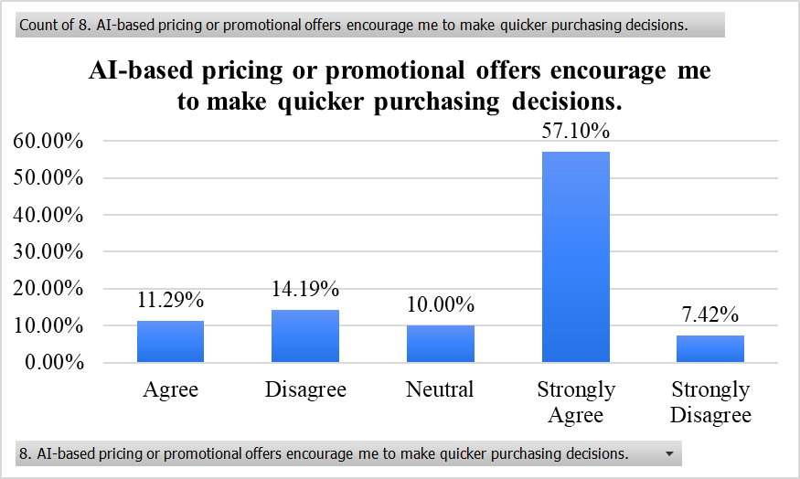
Figure 4.8: Influence of AI-based pricing and promotional offers on purchasing speed
(Self-developed)
There is a high magnitude of the acceleration effect, with 57.10 percent strongly agreeing with it and 11.29 percent agreeing that the artificial intelligence pricing or promotional offers facilitate faster decision-making in purchasing. Neutral answers are also moderate at 10 percent, whereas the level of disagreement is rather insignificant, implying that AI-based promotions have a beneficial effect on the speed of decision-making.
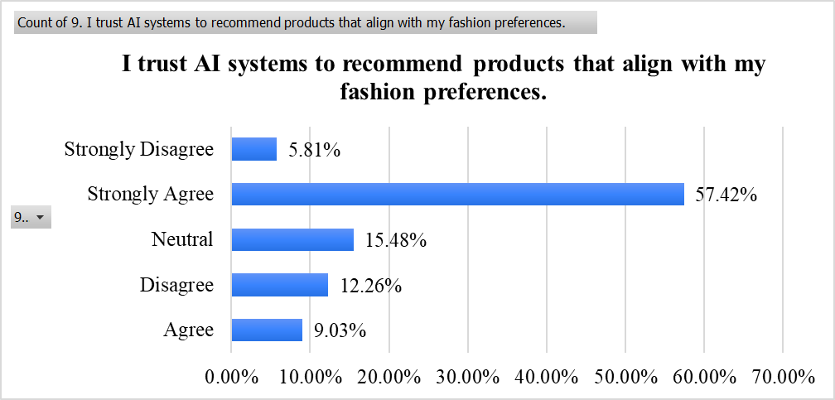
Figure 4.9: Consumer trust in AI systems for fashion product recommendations
(Self-developed)
There is also a high level of trust towards AI recommendation systems with 57.42 percent of respondents strongly agree and 9.03 percent agreeing that AI fits their fashion preferences. The level of neutrality (15.48 percent) is relatively small, with the measurement of the disagreement being relatively low as well, which demonstrates the general trust in the recommendations provided by AI.
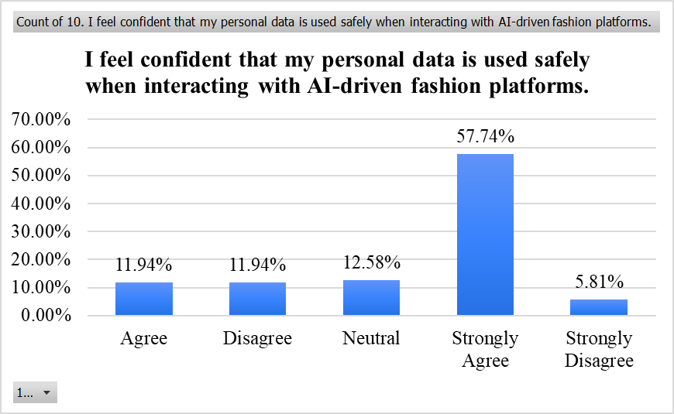
Figure 4.10: Consumer confidence in personal data security on AI-driven fashion platforms
(Self-developed)
There is a moderate level of trust in data privacy, with 57.74 percent strongly agreeing and 11.94 percent agreeing that personal information is handled safely on AI-based fashion sites. The proportion of neutral answers is 12.58 percent and the level of disagreement is moderate meaning that there is a cautiousness but a positive attitude towards the perception of data protection in general.
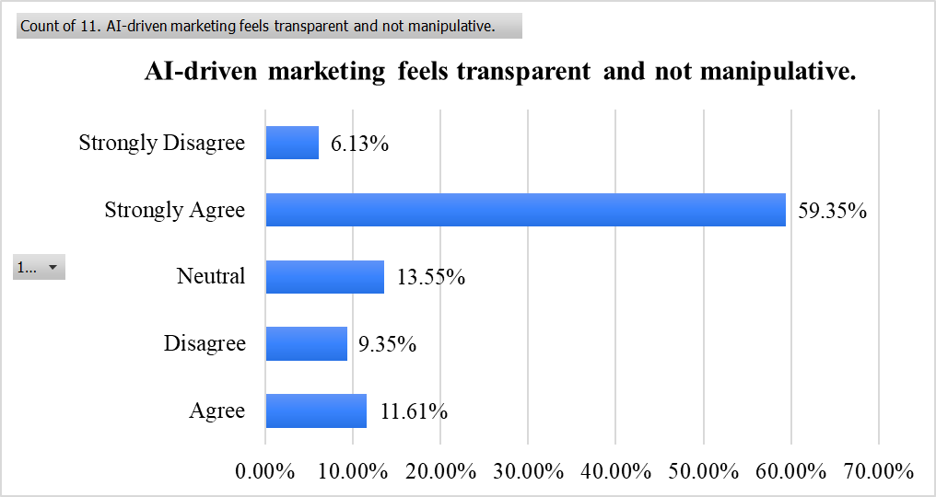
Figure 4.11: Perceived transparency of AI-driven marketing practices
(Self-developed)
The attitude towards transparency is both mostly positive and serves as a high percentage (59.35). The percentage of strong agreement is higher (59.35), whereas the percentage of agreeing (11.61) is lower. Neutral answers amount to 13.55 percent, whereas disagreement is not very high, which indicates the general acceptance of ethical AI marketing behaviour.
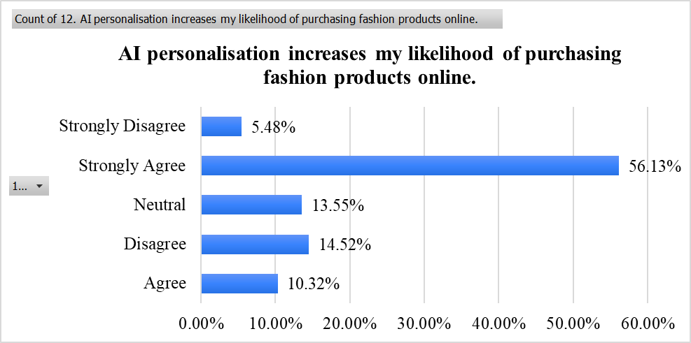
Figure 4.12: Impact of AI personalisation on likelihood of online fashion purchasing
(Self-developed)
There is a high impact of AI personalisation on the purchasing likelihood with 56.13 percent strongly agreeing and 10.32 percent agreeing that it positively impacts online fashion purchases. The number of neutral answers is 13.55 percent, and the level of disagreement is quite low, indicating positive behavioural change due to AI-oriented personalisation.
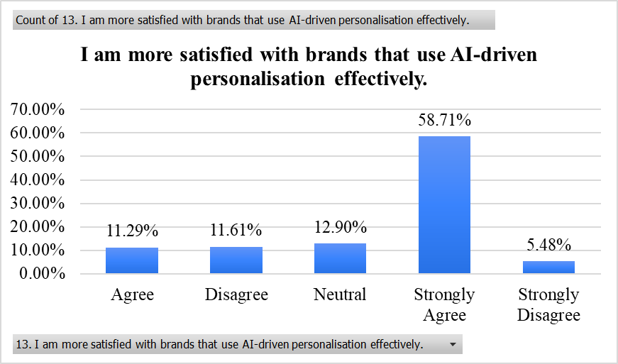
Figure 4.13: Relationship between AI-driven personalisation and brand satisfaction
(Self-developed)
Effective AI personalisation is most closely linked with brand satisfaction with 58.71 percent strongly agreeing and 11.29 percent agreeing this statement. The proportion of the neutral is 12.90 percent and the disagreement is low which means AI personalisation as one of the main determiners of customer satisfaction.
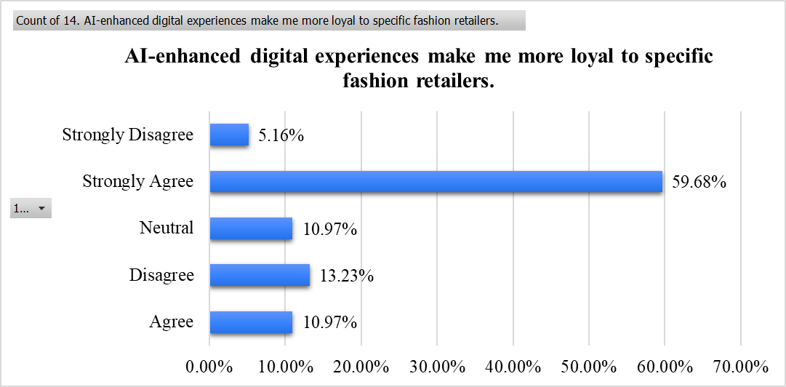
Figure 4.14: Influence of AI-enhanced digital experiences on consumer loyalty
(Self-developed)
AI-enhanced digital experiences have a great boost in terms of loyalty with 59.68 percent having a strong positive response and 10.97 percent having a positive response with the help of AI-enhanced digital experiences raising loyalty to particular fashion retailers. Neutral responses do not go much higher at 10.97 percent, and disagreement is quite insignificant, which is a sign of strong loyalty-building effect.
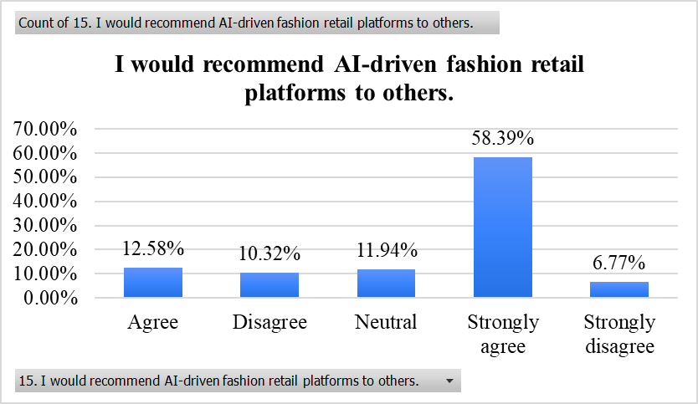
Figure 4.15: Willingness to recommend AI-driven fashion retail platforms
(Self-developed)
The intentions to advocate are also significant, as 58.39 percent of the participants strongly agree, and 12.58 percent agree that they would suggest AI-driven fashion retail platforms to other individuals. The share of neutral responses is 11.94 and the ratio of disagreement is the minimum which proves high word-of-the-mouth possibilities based on AI experiences.

4.3 Summary
In summary, the results show that AI-based marketing practises have a high positive consumer response. The significant amount of the agreement in terms of personalisation, trust, satisfaction, and loyalty indicators would indicate that AI has had a considerable positive effect on consumer experience and behavioural outcomes. Nevertheless, moderate neutrality and disagreement underscore the issue of continuing sensitiveness to transparency and data protection issues.

Chapter 5: Discussion

5.1 Introduction
This chapter provides critical interpretation of the findings of the empirical research in relation to the research aim, research questions as well as existing literature. It examines the effect of AI-driven personalisation, customer support, engagement mechanisms and enhanced experiences on consumer behaviour and evaluates whether the results of the survey confirm/expend/theoretically expected results establish the theory of the UK fashion retail context.

5.2 Discussion and analysis
AI-Driven Personalisation as a Trigger of Consumer Purchase Intention
The results of this research prove that AI-facilitated personalisation should be one of the focal points of development of purchase intention in the UK apparel retail sector in line with the latest trends identified in academic sources. Interest in fashion products and the desire to make a purchase are also factors that responder strongly agreed would be enhanced by AI-based advertisements, personalised product recommendations, and dynamic pricing strategies in the course of purchase across the dataset. As an example, 59.35 percent strongly concurred that advertising being fuelled by AI increased their interest in a product (Figure 4.5), whereas 59.68 percent strongly agreed that personalised product recommendations made shopping easier (Figure 4.6). Such a high degree of agreement supports the previous literature that suggest that personalisation makes the shopping process less effort-intensive and more relevant due to the high persuasive power of AI technologies (Barde et al., 2025). In this context, the current results confirm the larger theoretical hypothesis that AI enhances the cognitive and affective mechanisms, which result in purchase intention.
The fact of personalised recommendations in specific comes out as a forceful dictator in inspiring consumer action. Literature indicates that personalisation improves the sense of relevance and form of understanding an individual by a brand that consequently elevates the prominence of purchase behaviour by lessening selection-making (Patil et al., 2024; Wang et al., 2025). The data discussed in Chapter 4 is quite consistent with the following arguments: more than two-thirds of respondents stated that the responses offered by AI decreased the effort on decision-making and made the overall shopping process more efficient. This trend is connected to the Interests and Desire levels of the AIDA model where, in particular messages, the intensity of attention and emotional appeal to the consumer are more and more common (Pratiwi et al., 2021). The mirroring capability of AI towards individual fashion tastes may have served to bridge the consideration and action gap, hence confirming the theoretical suggestion that personalised content may move consumers to the action stage faster.
Also, the unanimity of views concerning AI-powered pricing methods indicates the depth of impacts of AI on time-based purchases. The result (57.10 percent strongly agreeing that AI-based promotional offers made them purchase faster (Figure 4.8)) confirms Bhagat, Chauhan and Bhagat (2022), who postulated that predictive price modelling and real-time discounts raise urgency in promoting as they match the promotion time with consumer behavioural patterns. Such a high degree of responsiveness proves the fact that AI uses data-driven services to interfere with the performance of critical decision-making, motivating consumers to take timely actions. Such targeted interventions are of particularly strategic importance in the UK fashion environment, where the phenomenon of trend is changing rapidly, and where promotion cycle development is rather brief. AI is a way to enhance purchase intention thus as retailers can make use of optimisation-based campaigns to be delivered at the point of need.
Besides, the results demonstrate that AI-generated content not only improves the functionality aspects of online purchasing, but also increases the emotional aspect. The sources highlight that virtual try-on and interactive product visualisation tools, as types of AI, generate exciting experiences that provoke the feeling of aspiration, imagination, and excitement (Elmashhara et al., 2023; Gusti and Muhammad, 2021). Although it is not directly stated that the current survey evaluated emotional immersion, the overall agreement on the convenience, clarity, and relevance of AI interactions is strong, which could indicate that the respondents felt AI content was immersive enough to pursue more significant intentions to buy. It is a similarity to the AIDA model focus on emotional triggers meaning that AI should not only be viewed as an efficiency-enhancing tool but as an engine that increases hedonic satisfaction in online fashion browsing.
Nonetheless, certain amount of neutrality of answers indicates to a subtle consumer experience. About 11 to 16 percent of the respondents in items that focused on personalisation took a neutral position which proved that a portion of the consumers may not find personalisation as a strong persuasive aspect. This can be indicative of the anxieties that are expressed by the existing literature on the topic of over-personalisation and what people perceive as invasiveness (Sebastien Fassiaux, 2023). Personalisation should not be taken too far as such that consumers will feel that their independence is being played with, which will also reduce their willingness to make purchases. Thus, even though most of the answers confirm the desirable behavioural impact of AI, the sceptical minority provides the information that the effective results of the personalisation are conditional. The revelation supports the viewpoint presented by Nair and Manohar (2024) that AI can only be effective when the technology achieves equilibrium between being relevant and respectful of the use of data.
The high acquisition of trust that is attained with the AI recommendation systems (Figure 4.9) means that purchase intention is also formed. Trust is also always mentioned in literature as a preliminary to purchase behaviour, particularly in an environment that relies heavily on data-driven algorithms (Chen et al., 2022; Wong et al., 2023). The attitude of the consumers to the recommendations made by the AI systems, when they believe that this system is accurate, reliable, and competent enough, is more likely to result in the change of the initial thought into the actual intention. The current results confirm the priority of trust that is developed in the Consumer Trust Theory and argue that AI-based personalisation is the most effective when consumers are certain that AI is not amassing personal gain at their cost.
AI-Enabled Customer Support and Trust Formation Mechanisms
The results of the present study emphasise the fact that AI-based customer support systems are central to consumer trust influences in the UK fashion retail setting. Confidence turned out to be an essential mediating variable that connects AI-driven personalisation to more realistic behavioural results including satisfaction, purchase interest and brand loyalty. The survey data showed high trust in AI-driven systems of recommendations, personal data monitoring, and chatbots. An example is, 55.48 percent of respondents had a strong agreement with the notion that chatbots had successfully answered online shopping questions and 57.42 percent had a strong agreement with the idea that AI suggestions matched their style preferences. This empirical trend supports the hypothesis developed in previous studies according to which AI-induced competences help consumers view fashion platforms as trustworthy, attentive, and useful (Chen et al., 2022). As per the Consumer Trust Theory, competence is one of the fundamental antecedents of trust which implies that AI systems are just starting to imitate and in a few situations even surpass the expectations of performance or operation that are common in human-operated retail outlets.
Chatbots play a significant role in the formation of trust, which is worth noting. It is suggested that literature has it that conversational agents eliminate consumer uncertainty by enabling them to access information instantly, reducing information benefits of in-store interactions (Allouch, Azaria and Azoulay, 2021). These assertions are substantiated by the high rates of agreement in the survey and they imply that AI-based service support serves a purpose of reducing perceived transactional risk by shedding light on questions about sizing and delivery times. stock availability or returns. This responsiveness is closely similar to the perceived usefulness and perceived ease of use constructs incorporated into the Technology Acceptance Model (TAM), and the level of willingness to use AI-mediated services is dependent on them (Al-Rahmi et al., 2021). The current findings can thus be used to validate literature because it demonstrates that AI-infused support systems raise levels of functional trust because of efficiency and the accuracy of information that builds credibility among retailers within online environments (Nguyen, Quach and Thaichon, 2021).
Nonetheless, the trust in AI does not only work in a functional level. The results show that the trust is also revealed as a relational phenomenon in which consumers view AI systems to be individuals who are in sync with their interests. More than half of the respondents were firm in the idea that their personal information was kept safe by the AI platforms showing a reasonably high level of confidence to farther handling of personal information. In part, these results do not align with the literature that cautions that privacy considerations are a significant obstacle to AI adoption and establishment of trust within a retail context (Aldboush and Ferdous, 2023; Perry et al., 2024). One possible explanation of this veer is that the population in the UK fashion market might have grown more accustomed to AI-mediated systems and will thus start to normalise data-driven interactions (especially those that deliver physical value like relevance of style or higher utility). Alternatively, the findings can also indicate a more implicit social contract in which data exchange is perceived as a transactional process, as opposed to an intrusive process. It implies that the formation of trust with AI-mediated aspects of fashion is somewhat dependent on the perceived justice of exchange of values, which enriches extant literature.
Regardless, although the overall perception is positive, the trend of neutrality in some of the survey items regarding trust shows that the trust is still yet to be gained across board. Neutral answers were also chosen by 10 to 15 percent of the respondents in connexion to data handling, transparency, and AI reliability. This implies that a segment of the consumer society will continue to be sceptical of the lack of transparency in the decisions of AI. The literature also emphasises the fact that algorithmic artificially intelligence poses a risk to integrity-based trust, producers have no control over how the decisions are made or how the information is used (Buhmann and Fieseler, 2021). The viewpoint of Consumer Trust Theory is that integrity is a determinant of trust foundation since it cannot be replaced only by assurances based on competence. Therefore, despite the fact that AI improves the support functionality, the long-term development of trust will probably depend on the improved level of transparency in terms of algorithmic thinking and data management tools.
Moreover, a number of researchers enjoy claiming that the trust towards AI personalisation lies on a scale between the sense of perceived empowerment and perceived manipulation (Raji et al., 2024). This research validates the empowerment side of this continuum since AI support was interpreted by consumers as supportive and not coercive. This is contrary to what has been argued about in the literature that hyper-targeting can lead to a loss of autonomy and a lack of trust (Sebastien Fassiaux, 2023). The UK fashion retail setting can thus become a realm where the AI assistance can be approached not so much as the manipulation of behaviour, but as the enhancement of consumers. This situational detail provides empirical specificity to the current discussion since it proves that consumer understandings of AI-related trust cannot be universalised across sectors but rather on the basis of sectoral standards and cultural orientations of familiarity with data-related services.
The means by which trust copulates to behavioural rewards were also empirically supported. The high levels of agreement with the satisfaction, willingness to recommend and statements related to loyalty imply that when the trust is created due to the effective AI support, consumers are more ready to continue engaging with fashion brands regularly. This is in line with Nguyen, Quach and Thaichon (2021) who reasoned that trust is the intermediary between the quality of AI and the brand relationship strength. This is further extended by the current results which indicate that the support provided by AI does not simply solve the transactional queries but develops a general impression of brand reliability that ultimately translates to a forerunner of behavioural commitments in the long-term.
Drivers of Consumer Engagement with AI-Based Digital Experiences
The empirical results of this study show that consumer interaction with AI-based digital experiences in the UK fashion retail industry is influenced by a combination of functional, cognitive, emotional and ethical factors. Engagement in this context does not mean referencing simply click-through behaviour or platform use, but having a wider spectrum of cognitive, emotional, and behavioural responses determined by the ability of AI to personalise, facilitate, and increase consumer-brand interactions. The quantitative results indicate substantial levels of agreement were measured against survey items relating to convenience, personal relevance, speed of retrieval of information and enjoyment of the shopping experience which show how AI has a positive contribution to facilitating a more immersive and responsive retail experience. These findings are broadly consistent with recent literature which suggest that engagement in AI-mediated environments is multidimensional and occurs when technological systems make people feel curiosity, make people's efforts harder, and increase value of the experience (Ma, Ou and Lee, 2022).
Personal relevance becomes a major motivator of engagement. The strong agreement with statements that refer to personalised recommendations indicates that consumers react positively to AI that curate’s content that resonates their tastes and browsing history. AI systems have the power to quickly analyse the behavioural data, to offer suggestions on the style of clothing to be worn and the way to combine the checked out clothes, and to propose special promotional content (a matter of how meaningful are the digital interactions). Huang, Lu and Yang (2023) propose that increased motivation to engage with a platform is facilitated through the activation of cognitive processing and increased platform interaction time. These current results lend support to this view - the respondents who felt that recommendations were relevant were more likely to indicate showing heightened interest and increased shopping attention. This validates the claim by Perez-Vega (2020) that relevance is a key engagement mechanism in AI-augmented communications for retail environment that transforms consumers from being a passive viewer to becoming an active explorer of the recommended content.
Interactivity is also a huge determinant of engagement for AI-enabled retail environments. Survey results indicated strong confidence in chatbot ability to resolve queries efficiently and reliably to achieve an outcome of customer service delivered interactively through AI. Literature argues that conversational agents are associated with higher levels of engagement, as they mimic aspects of interpersonal communication, so replaces the informational and relational benefits of in-store assistance (Allouch, Azaria and Azoulay, 2021). Virtual styling tools, size prediction systems and recommendation engines also foster behavioural engagement through co-creation processes, whereby people do not merely receive information but actively define their shopping outcomes. This dynamic is in line with the study of Garaus et al. (2025), which claims that novel technologies increase the human depth of experiences by providing incentive to experiment and create. Although the current survey did not explicitly test for measures of emotion like enjoyment or immersion, the almost universal agreement on the themes of convenience and assistance implicitly point to AI mediated interactivity causing less friction and encouraging longer engagement with the platform.
Convenience is another important engagement factor. The dataset revealed that respondents perceived AI enabled capabilities such as personalised recommendations and dynamic promotion systems as tools for improving efficiency (by decreasing the effort of searching for necessary information and the time it takes to make a decision). This finding is in line with Ervits and Maintz (2025), who suggest that consumers interact with systems that reduce cognitive demand and simplify routine tasks in a deeper way. The UK fashion retail environment is characterised by wide product assortments and high turnover cycle pace; as such, the ability of AI to make product discovery simplistic becomes strategically important. Convenience-based engagement is also a reflection of constructs in the Technology Acceptance Model where perceived ease of use influences sustained interaction (Al-Rahmi et al., 2021). The survey results thus support the concept that engagement is not an entertainment-driven phenomenon but one that is also based on utilitarian evaluations of efficiency and support for tasks.
Novelty and experiential stimulation were also indirect engagement drivers. Demonstrated in literature, consumers tend to show increased interest in technologies that provide new forms of sensory or experiential affordances, such as digital tries-on, immersive styling tools and AI-generated visualisations (Bin Kim and Choo, 2023). Although the survey did not specifically measure novelty, the high positive responses to AI-enabled personalisation and promotions suggest that the participants had experienced the technology as innovative rather than intrusive. This nuance questions old assumptions that the novelty effects short-lived, and by doing this, questions the possible scenario of AI institutionalisation of continued experiential engagement of the AI, constantly updating the production output in response to consumer patterns (Prajapat, 2024).
Despite these positive drivers, the findings have also shown ethical and transparency considerations to qualify an engagement. Approximately 12 to 15 percent of respondents donated to neutral positions on the matter of transparency and data safety, which may allude to a wary group of consumers that do not quite take on board AI as an unequivocal engagement stimulus. Literature knows that interaction with AI systems is influenced by perceived fairness, transparency, and responsible data use (Oluwafemi et al., 2021). If consumers see personalisation as intrusive rather than supportive then engagement may greatly reduce. Aldboush and Ferdous (2023) also criticize examples of data ethics in also serving as moderating variables in models of digital engagement, especially in technologically literate markets, such as the United Kingdom. The present findings therefore reinforce the case that engagement in the AI-mediated retail contexts is conditional in that while relevance and interactivity enhance engagement, ethical clarity is necessary in order to sustain engagement.
AI-Enhanced Customer Experience as a Foundation for Loyalty and Advocacy
The findings from this research showed that AI enhanced digital experiences are a structural base for consumer loyalty and advocacy for the UK fashion retail sector. Loyalty in this sense does not limit itself to repetitive buying but includes attitudes of loyalty, emotional attachment and willingness to promote brands in larger area consumer networks. The quantitative results showed huge agreements on the importance of AI personalisation and support systems based on AI to improve satisfaction, improve loyalties and motivate recommending behaviour. For example, 58.71 percent of respondents strongly agreed that AI personalisation increases brand satisfaction (Figure 4.13), and 59.68 percent strongly agreed that AI enhanced digital experiences increases loyalty to particular fashion retailers (Figure 4.14). The positive intentions of word of mouth were also shown, with 58.39 percent of the respondents strongly willing to recommend AI-driven platforms (Figure 4.15). These outcomes support the proposition of consumer experience as the major mechanism of relation between the AI implementation and long-term loyalty outcomes.
The literature recognises that artificial intelligence supports the customer experience by creating frictionless, personalised and emotionally resonating encounters across the journey of the consumer. Singh and Singh (2024) argue that the value of AI is the ability to curate their customer journeys according to each person's tastes, behavioural history and emotional expectations. The present results support this argument because consumers indicated that their satisfaction with a shopping experience was greater because of the way AI systems simplified their decision-making process and made online browsing more intuitive. Satisfaction, in turn, is widely recognised with its predecessor as transitive to loyalty as this constitutes a core part in psychological transition concerning from transactional conformity to relational commitment (Handique and Sarkar, 2024). In the case of the UK fashion retail industry where rapidly changing trends and proliferation of competition makes it hard to build a brand that stands out in the market, it seems that AI offers an alternative path to loyalty formation based on quality in experience, as opposed to price and/or product scarcity.
Another important aspect of AI enhanced experience has to do with predictiveness and pre-emptive service design. Literature suggests that predictive analytics the retailers are able to anticipate and fulfil the needs before they are expressed by the consumers thereby understanding the creation of perception of competence and benevolence (Venkateswaran et al., 2023; Rane, Choudhary and Rane, 2023). While the survey did not explicitly measure anticipatory fulfilment, the strong alignment between personalisation and satisfaction suggests that the respondents rewarded systems that "understood" them and their affinities for fashion. This result also links with Consumer Trust Theory where being benevolent and integrative increase loyalty in that a brand is seeking mutually beneficial value exchanges (Hiatt et al., 2023). AI-mediated anticipation thus promotes relational loyalty by showing the brand to be invested in the success of consumers, and not only in the transactions.
The data also brings out the emotional nature of artificial intelligence-enhancing experiences. Fashion consumption is innately expressive and identity based; therefore, tools that enable self-expression, discovery, and aesthetic experimentation go further and create attachment. Virtual styling platforms, personalised lookbooks and curation on taste contribute not only to functional convenience but emotional fulfilment (Omeish, Al Khasawneh and Khair, 2024). The strong quantitative support for loyalty and recommendation strengthens the case made by theory for the view that emotional resonance provides a lasting foundation for loyalty and advocacy. According to Nguyen, Quach and Thaichon (2021), consumers are advocates or cheerleaders for brands not only because they deliver well but also because they represent identity and social signalling. AI's ability to reinforce identity relevant value thus makes an important material contribution to advocacy behaviour.
Furthermore, it appears that for the AI to be helpful in terms of supporting loyalty, it appears to be mediated by trust. The survey revealed high levels of confidence in the recommendations (AI) and the safe handling of personal data which suggested the trust functioned as a structural precondition for experience-based loyalty. This provides support for the literature which suggests that trust is shaped by ethical transparency, competence and privacy assurance, and this trust then leads to sustainable patterns of loyalty (Chen et al., 2022; Wong et al., 2023). In particular, it is noteworthy to see the reciprocity between trust and advocacy: willingness to recommend was greatest for people who strongly trusted in AI systems. This pattern represents a wider marketing logic where advocacy behaviour occurs as an outward expression of trust as a mechanism of reputational transfer through social networks.
However, the results of this study also indicate conditional loyalty for a sub-group of consumers. Neutral responses around data transparency and privacy - between 10 and 15 per cent of respondents - suggests that while AI improves experiences for many, there seems to be a level of loyalty that could be restricted due to ethic ambivalence for others. This finding is in line with the study conducted by Perry et al. (2024), who identify that data ethics are at the centre of loyalty formation in digitally mediated industries. In markets where regulatory loads and consumer awareness of the ethics of AI usage is high, as it currently is in the UK, questionable practices of data usage and sacramental appropriation could undermine relational loyalty even when experiential benefits are seductive. So, the process of building loyalty and advocacy via AI must be seen as dependent on the ethical stewardship and not the technology sophistication alone.
Finally, customer experience enhances with AI looks like it may pivot the strategic basements that loyalty is built on in the digital retail ecosystem. Traditional loyalty levers such as loyalty cards, discount vouchers and customer clubs are increasingly being replaced by fluid, real-time initiatives mediated algorithms that recognise the consumer not as an undifferentiated segment, but as a unique profile. In this sense, AI allows to emerge a kind of loyalty based not on systems of mechanical rewards, but on personal relevance, ease and relational trust. The present findings support this paradigm shift by showing that consumers will reward retailers with their loyalty and advocacy if it feels like an experience is personalised, intelligent, and ethically based.

5.3 Summary
In summary, the discussion above validates that AI has a significant and profound impact on consumer purchase intentions, trust, engagement, satisfaction, loyalty, and advocacy. While results are mostly in line with literature, in a minority of cautious responses, the moderating role of data ethics and transparency is recognised. Overall, AI-centric approaches build up the consumer-brand relationships when they are implemented responsibly and sensitively.

Chapter 6: Conclusion

6.1 Introduction
This final chapter is the synthesis of the general findings of the dissertation and shows that the research objectives have been achieved and that the results are relevant towards the academic, methodological and practical spheres. It also gives recommendations, implications of practical means, constraints and future directions that can be taken up in further academic research.

6.2 Conclusive remark
The overall aim of this dissertation was to conduct a critical analysis of the effects of AI-involved digital marketing strategies on the current consumer behavioural outcome in the UK fashion marketing industry. The study under review was designed with four main objectives, which have been tackled using the empirical analysis, theoretical connexion and syntactic interpretation. The final discussions on each of the objectives can be found below.
Research Objective 1: To analyse how AI-driven digital marketing strategies shape consumer purchase intentions in the UK fashion retail sector.
The results showed that AI-based marketing could contribute to making the purchase intention significantly higher due to the involvement of more processes, such as heightened relevance, lesser mental exertion and making better choices. Respondents had expressed a high preference of AI-powered product suggestion and tailored advertisements, which they claimed was more in line with their personal preferences and fashion trends and purchasing habits by the season. AI also simplified the search engine of the products since it curated on selections that are aligned with the previous browsing history and consumption information. Also, there was dynamic pricing and personalised discounting which further provoked the willingness to make a purchase by developing the solution of value and urgency. The studied patterns confirm that the consumer decision-making models recognise perceived relevance, informational accuracy and utility as the primary factors of the purchase intention. Therefore, AI is not just a marketing tool, but it is a behavioural weapon incorporated in the process of making judgement and selecting actions during consumption.
Research Objective 2: To evaluate the influence of AI personalisation on customer trust and brand loyalty.
The findings showed that AI is a shaping factor in the development of trust based on the informational assurance measure, interactive responsiveness and predictive assistance. Respondents had confidence in AI-enabled virtual assistants, chat accomplishments and recommendation engines, claiming that they are reliable in answering inquiries associated with sizing, delivery approximations and attainability of products- problems that had effectively caused unease in online purchasing. Perceived competence and benevolence then led to increased perception of trust and consequent satisfaction and loyalty intentions. Respondents who viewed the interaction with AI as transparent, non-invasive, and helpful described relational facet of trust and were more likely to buy in the same brand again and refer others to the platform, which is the spill-over effect of trust. This is in line with the theoretical knowledge that the modern day loyalty is experiential and relational more than transactional only. This paper thus finds that AI-based personalisation solidifies brand attachment through less perception of risk and more after-purchase trust.
Research Objective 3: To identify key factors driving consumer engagement with AI-based marketing campaigns.
The empirical data found the novelty, personal relevance, convenience, interactivity and transparency to be the most dominant engagement drivers. Subscribers were inclined to respond to AI-enabled marketing stimuli when they provided individual fashion inspiration, contextual recommendation, and browsing experiences. Compared to the classical, AI is reducing consumers to merchandise consumers through the use of digital touchpoints, including lookbooks, a personalised style feed, and custom-scene creation algorithm. But neutral etc. and cautious answers to the questions on data privacy and algorithmic transparently were also documented by the study. This suggests that the engagement potential can be reduced when the strategies of AI act in the lack of transparency or when the personalisation shifts towards the perceived surveillance. As a result, the study emphasises the reliance of engagement on the tech value and ethically acceptable conditions, indicating that AI strategies have to find the balance between innovation and responsible data management.
Research Objective 4: To recommend effective AI marketing strategies that enhance consumer intention and loyalty.
As per the cumulative results, the research concludes that the retailers can reinforce behavioural intention and loyalty through focusing on the AI-driven personalisation, intelligent customer service interface and predictive promotional analytics. These tactics proved to have quantifiable impact on consumer intention, consumer satisfaction as well as continuity of the relationship. It is also highlighted in the findings that the competitive advantage of the AI adoption is conditional on the ethical deployment. Bright data communication, optional personalisation models and justifiable profiling instruments appeared to be the required complement to the improvement of the technology. Since the loyalty was demonstrated to be not only convenience-based but perceived integrity as well, AI plans should retain consumer agency, respect privacy limits and disclose the use of data transparently.
Summing up, the dissertation confirms the notion that AI is now a transformative element that alters the concepts of how consumers judge, engage, and devote themselves to fashion brands in the digital realm. AI is not merely the automatization of marketing processes, but rather the redesign of the experiential and relational space of consumption in UK fashion retail industry.

6.3 Recommendations
On the basis of empirical evidence and interpretive discourse of the paper, it is proposed that there are a number of strategic suggestions available to the UK fashion merchants to leverage AI-enabled digital marketing to achieve optimisation of behavioural and relational goals. To begin with, retailers ought to extend AI-based personalisation especially in product recommendation engines. The results of the survey showed that personalised recommendations significantly lowered cognitive load and enhanced the purchase intention as well as behaviour that showed that consumers would reward relevance with intention and action. Thus, the improvement of granular preference modelling by refinement using behavioural, contextual as well as aesthetic data would achieve better conversion and satisfaction.
Second, customer service interfaces that are supported by AI should become more visible on digital touchpoints by retailers. It was demonstrated that chatbots and virtual assistants solve queries and minimise the uncertainty in the area of sizing, delivery, and stock availability. Since uncertainty is identified to be one of the obstacles to online fashion shopping, the investment in conversational service systems will be used to restore the real risk of transactions and improve the formation of trust, which, in its turn, facilitates loyalty and advocacy.
Third, pricing and promotional analytics needs to be enhanced in the strategic use of AI. The results showed that dynamic pricing and targeted offers would speed up the process of making decisions by consumers, which is in line with the fashion consumption temporal factor. The revenue could be maximised and at the same time keeping consumer satisfaction in terms of a perceived value and timeliness since predictive promotional strategies are focused on fulfilling the fashion cycles, the pattern and purchase cycle of browsing.
Fourth, the retailers have to institutionalise clear data norms to deal with ethical ambivalence among a segment of consumers. Despite the usual high level of trust in AI, the lack of trust towards data processing and openness to data show that loyalty results are still contingent. Communication about the data use, opt-ins, explanation of algorithm logic and guarantees of privacy would enhance the integrity-based trust to create a stronger loyalty and word-of-mouth promotion of more robust loyalty.
Lastly, AI usage must focus on enriching the experience, including virtual styling, look books and visualisation tools, since emotional satisfaction was revealed to be the basis of the long-term loyalty. This set of recommendations, combined with the data-driven finding that AI can deliver competitive advantage when relevant, less frictional, and ethical consumer agency, converges.

6.4 Contribution of the results
The outcomes of the study make contributions to the theoretical discussion and practical knowledge in the realms of digital marketing and consumer behaviour. Theoretically the results can be generalised as the suggestions of the classical theory of decision-making choices, being the idea that utility as well as its relevance are evaluated by cognitive, and thus affective, means, e.g. constructs like trust, satisfaction or relational attachment. It contributes to theoretical knowledge by establishing a connexion between AI-stimulated stimuli and experiential loyalty processes to address a gap in the literature concerning the relationship between personalised digital interventions and the implementation of the same in longer-term behavioural changes, as observed in the context of fashion retail. Moreover, the paper outlines the conditional significance of the ethical perception and transparency as moderating factors, which expands the modern debates on digital consumer psychology.
Practically, the study provides business applicable information on the ways through which fashion retailers may use AI to stimulate purchasing will, operation efficiency and retention performance. The findings prove that AI-powered recommendation engines, virtual assistants and predictive promotion tools can be measured in conversion and engagement improvements, in the case when matched with the expectations of consumers. Also, the designation of transparency and data governance as the requirements to the ongoing loyalty development can be added to the emergent managerial discussion about responsible AI adoption. Taken altogether, the results can guide both the strategic implementation as well as the ethical stewardship in the field of AI-enhanced retail.

6.5 Limitations of the study
Although the study yields significant empirical and theoretical findings, there are a number of limitations that can be discussed. To start with, the study employed a mono-method quantitative survey design which although suitable in quantifying behavioural trends is not representative of the rich interpretive tones and emotional rationale that qualitative research would provide. Two, data have been gathered cross-sectionally, i.e. responses were based on perceptions at one point in time, not permitting a shift in the attitude toward the behavioural changes as AI technologies continue to advance. Third, the research was based on non-probability purposive sampling, which could restrict external validity of results on other digitally active consumers who already have knowledge about AI-based retail interfaces. Fourth, the research was conducted only in the fashion retail sector in UK; as such, the findings cannot be directly applied to other industries or cultural markets where they are not the same in matters of technology confrontation or consumer demands. Lastly, the study failed to measure the long-term behavioural success, including the loyalty or satisfaction after purchase in the long run.

6.6 Future prospective
The current study may be furthered in the future by adopting longitudinal designs that monitor how trust, buying intentions and customer loyalty on continuous exposure to AI is changing because a retail digital world is dynamic and not in static. The implementation of qualitative tools in the form of interviews or ethnographic digital observation would enable the researcher to get the emotional, psychological and ethical facets of AI-mediated consumption that the surveys can at best estimate. It would also be interesting to conduct comparative research between industries or between cultural markets since the expectations of customers about personalisation, privacy and automation vary among industries e.g. luxury or fast fashion and the FMCG, as well as between different markets with different rates of digital literacy level. Moreover, the subsequent research can consider more explicitly the concept of algorithmic transparency and data ethics, as their acceptance and loyalty are conditional. Lastly, with the advancement of AI technologies to generative and autonomous capabilities, the studies ought to explore how co-creation, virtual embodiment and AI styling agents will affect identity, self-expression and brand attachment in digital retail ecosystems.

References
Aburbeian, A.M., Owda, A.Y. and Owda, M. (2022). A Technology Acceptance Model Survey of the Metaverse Prospects. AI, 3(2), pp.285–302. doi:https://doi.org/10.3390/ai3020018.
Aldboush, H.H.H. and Ferdous, M. (2023). Building Trust in Fintech: an Analysis of Ethical and Privacy Considerations in the Intersection of Big Data, AI, and Customer Trust. International Journal of Financial Studies, [online] 11(3). doi:https://doi.org/10.3390/ijfs11030090.
Alfouzan, M., Lu, K. and Ullah, A. (2024). The Effects Of Artificial Intelligence On Business Marketing Quality And Factors That Positively Influence Marketing. International Journal for Quality Research, [online] 18(4), pp.1021–1034. doi:https://doi.org/10.24874/ijqr18.04-07.
Ali, I.M. (2024). A Guide for Positivist Research Paradigm: from Philosophy to Methodology. Idealogy Journal, 9(2), pp.187–196. doi:https://doi.org/10.24191/idealogy.v9i2.596.
Allouch, M., Azaria, A. and Azoulay, R. (2021). Conversational Agents: Goals, Technologies, Vision and Challenges. Sensors, 21(24), p.8448. doi:https://doi.org/10.3390/s21248448.
Al-Nuaimi, M.N. and Al-Emran, M. (2021). Learning management systems and technology acceptance models: A systematic review. Education and Information Technologies, 26(5). doi:https://doi.org/10.1007/s10639-021-10513-3.
Al-Rahmi, A.M., Shamsuddin, A., Alturki, U., Aldraiweesh, A., Yusof, F.M., Al-Rahmi, W.M. and Aljeraiwi, A.A. (2021). The Influence of Information System Success and Technology Acceptance Model on Social Media Factors in Education. Sustainability, [online] 13(14), p.7770. doi:https://doi.org/10.3390/su13147770.
Arshad, F. (2023). Building Lasting Connections: Cultivating Brand loyalty through Relationship and Commitment. iRASD journal of management, 5(3), pp.116–135. doi:https://doi.org/10.52131/jom.2023.0503.0112.
Babu, M.M., Akter, S., Rahman, M., Billah, M.M. and Hack-Polay, D. (2022). The role of artificial intelligence in shaping the future of Agile fashion industry. Production Planning & Control, 35(15), pp.1–15. doi:https://doi.org/10.1080/09537287.2022.2060858.
Barde, S., Jain, A., Singh, N., Patel, S. and Barde, A. (2025). Artificial Intelligence and Machine Learning in Marketing. Advances in Computational Intelligence and Robotics, [online] pp.1–32. doi:https://doi.org/10.4018/979-8-3373-3476-9.ch001.
Bhagat, R., Chauhan, V. and Bhagat, P. (2022). Investigating the Impact of Artificial Intelligence on Consumer’s Purchase Intention in e-Retailing. Foresight, [online] 25(2). doi:https://doi.org/10.1108/fs-10-2021-0218.
Bieńkowska, J. (2024). The Effects of Artificial Intelligence on the Fashion Industry—Opportunities and Challenges for Sustainable Transformation. Sustainable Development. doi:https://doi.org/10.1002/sd.3312.
Bin Kim, W. and Jung Choo, H. (2023). How virtual reality shopping experience enhances consumer creativity: The mediating role of perceptual curiosity. Journal of Business Research, 154, p.113378. doi:https://doi.org/10.1016/j.jbusres.2022.113378.
Bolesnikov, M., Popović Stijačić, M., Keswani, A.B. and Brkljač, N. (2022). Perception of Innovative Usage of AI in Optimizing Customer Purchasing Experience within the Sustainable Fashion Industry. Sustainability, [online] 14(16), p.10082. doi:https://doi.org/10.3390/su141610082.
Buhmann, A. and Fieseler, C. (2021). Tackling the Grand Challenge of Algorithmic Opacity Through Principled Robust Action. Morals & Machines, 1(1), pp.74–85. doi:https://doi.org/10.5771/2747-5174-2021-1-74.
Campbell, C., Plangger, K., Sands, S., Kietzmann, J. and Bates, K. (2022). How Deepfakes and Artificial Intelligence Could Reshape the Advertising Industry. Journal of Advertising Research, 62(3), pp.241–251. doi:https://doi.org/10.2501/jar-2022-017.
Chahed, H., Usman, M., Chatterjee, A., Bayram, F., Chaudhary, R., Brunstrom, A., Taheri, J., Ahmed, B.S. and Kassler, A. (2023). AIDA—A holistic AI-driven networking and processing framework for industrial IoT applications. Internet of Things, [online] 22, p.100805. doi:https://doi.org/10.1016/j.iot.2023.100805.
Chen, Y., Prentice, C., Weaven, S. and Hisao, A. (2022). The influence of customer trust and artificial intelligence on customer engagement and loyalty – The case of the home-sharing industry. Frontiers in Psychology, [online] 13(13). doi:https://doi.org/10.3389/fpsyg.2022.912339.
Elmashhara, M.G., Roberta De Cicco, Costa, S., Hammerschmidt, M. and Evelyn, M. (2023). How gamifying AI shapes customer motivation, engagement, and purchase behavior. Psychology & Marketing, 41(1). doi:https://doi.org/10.1002/mar.21912.
Ervits, I. and Maintz, J. (2025). The trade-off between convenience and Privacy: Sharing personal data with intelligent vehicles in exchange for convenient driving. Entertainment Computing, [online] p.100950. doi:https://doi.org/10.1016/j.entcom.2025.100950.
Escoz-Roldán, A., Gutiérrez-Pérez, J. and Ángel, P. (2019). Water and Climate Change, Two Key Objectives in Agenda 2030: Assessment of Climate Literacy Levels and Social Representations in Academics from Three Climate Contexts. Repositorio institucional da Universidade de Santiago de Compostela (University of Santiago de Compostela). doi:https://doi.org/10.20944/preprints201911.0233.v1.
Fang, Y.-H., Li, C.-Y., Arain, G.A. and Bhatti, Z.A. (2019). How does participation and browsing affect continuance intention in virtual communities? An integration of curiosity theory and subjective well-being. Behaviour & Information Technology, 40(3), pp.221–239. doi:https://doi.org/10.1080/0144929x.2019.1685002.
Ganesh, A. (2024). The Impact of Social Media on Consumer Behavior: An AI-Enhanced Approach to Marketing Strategies. [online] doi:https://doi.org/10.2139/ssrn.4985407.
Gao, Y. and Liu, H. (2022). Artificial intelligence-enabled Personalization in Interactive marketing: a Customer Journey Perspective. Journal of Research in Interactive Marketing, [online] 17(5), pp.1–18. doi:https://doi.org/10.1108/JRIM-01-2022-0023.
Garaus, M., Treiblmaier, H., Garaus, C. and Wagner, U. (2025). Innovating the experience economy: How novel technologies transform customer experiences. Digital Business, p.100134. doi:https://doi.org/10.1016/j.digbus.2025.100134.
Gkikas, D.C. and Theodoridis, P.K. (2021). AI in Consumer Behavior. Learning and Analytics in Intelligent Systems, [online] 22, pp.147–176. doi:https://doi.org/10.1007/978-3-030-80571-5_10.
Goodfellow, L.T. (2023). An Overview of Survey Research. Respiratory Care, 68(9), p.respcare.11041. doi:https://doi.org/10.4187/respcare.11041.
Goti, A., Querejeta-Lomas, L., Almeida, A., de la Puerta, J.G. and López-de-Ipiña, D. (2023). Artificial Intelligence in Business-to-Customer Fashion Retail: A Literature Review. Mathematics, 11(13), p.2943. doi:https://doi.org/10.3390/math11132943.
Gov.uk (2018). Data Protection Act 2018. [online] legislation.gov.uk. Available at: https://www.legislation.gov.uk/ukpga/2018/12/contents [Accessed 25 Dec. 2025].
Gowri, D.P. (2024). Impact of AI in Personalized Digital Marketing: Boosting Customer Engagement through Tailored Content. Journal of Communication and Management, 3(03), pp.216–221. doi:https://doi.org/10.58966/jcm2024334.
Gusti, R. and Muhammad, A. (2021). How Product Innovation and Motivation Drive Purchase Decision as Consumer Buying Behavior. Journal of Distribution Science, [online] 19(1), pp.49–60. doi:https://doi.org/10.15722/jds.19.1.202101.49.
Hall, J.R., Hall, S.S. and Shaw, E.H. (2022). A Deductive Approach to a Systematic Review of Entrepreneurship Literature. Management Review Quarterly, 73(1), pp.1–30. doi:https://doi.org/10.1007/s11301-022-00266-9.
Handique, K. and Sarkar, S. (2024). The Impact of Brand Love on Customer Loyalty: Exploring Emotional Connection and Consumer Behaviour. International Research Journal of Multidisciplinary Scope, 05(04), pp.1104–1120. doi:https://doi.org/10.47857/irjms.2024.v05i04.01723.
Haneefa, K.V. and Singh, H. (2025). Enhancing Quick Commerce Service Experience Through AI Marketing. IGI Global eBooks, pp.203–228. doi:https://doi.org/10.4018/979-8-3693-9561-5.ch007.
Haque, A., Akther, N., Khan, I., Agarwal, K. and Uddin, N. (2024). Artificial Intelligence in Retail Marketing: Research Agenda Based on Bibliometric Reflection and Content Analysis (2000–2023). Informatics, [online] 11(4), p.74. doi:https://doi.org/10.3390/informatics11040074.
Hiatt, M.S., Lowman, G.H., Maloni, M., Swaim, J. and Veliyath, R. (2023). Ability, benevolence, and integrity: The strong link between student trust in their professors and satisfaction. The International Journal of Management Education, 21(2), p.100768. doi:https://doi.org/10.1016/j.ijme.2023.100768.
Huang, A.Y.Q., Lu, O.H.T. and Yang, S.J.H. (2023). Effects of artificial Intelligence–Enabled personalized recommendations on learners’ learning engagement, motivation, and outcomes in a flipped classroom. Computers & Education, 194(104684), p.104684. doi:https://doi.org/10.1016/j.compedu.2022.104684.
Islam, T., Miron, A., Nandy, M., Choudrie, J., Liu, X. and Li, Y. (2024). Transforming Digital Marketing with Generative AI. Computers, 13(7), pp.168–168. doi:https://doi.org/10.3390/computers13070168.
Jobe, N. (2024). How AI is ‘amplifying creativity’ in the fashion world. The Guardian. [online] 8 Feb. Available at: https://www.theguardian.com/fashion/2024/feb/08/ai-london-fashion-week [Accessed 10 Nov. 2025].
Johannesson, P. and Perjons, E. (2021). Research Strategies and Methods. An Introduction to Design Science, 1(1), pp.41–75. doi:https://doi.org/10.1007/978-3-030-78132-3_3.
Kaperonis, S. (2025). AI-Powered Personalization. Advances in Marketing, Customer Relationship Management, and E-Services, [online] pp.253–278. doi:https://doi.org/10.4018/979-8-3693-3799-8.ch013.
Khaleel, M. and Hilal, M.A. (2023). Toward Improving BIM Acceptance in FM: A Conceptual Model Integrating TTF and TAM. Maǧallaẗ al-handasaẗ, 29(7), pp.86–105. doi:https://doi.org/10.31026/j.eng.2023.07.06.
Kumar, D.M.D. (2023). A Study On Importance of Microsoft Excel Data Analysis Statistical Tools in Research Works. Journal of Management & Educational Research Innovation, [online] 1(3), pp.25–33. doi:https://doi.org/10.5281/zenodo.10449150.
Lee, Y.-I. and Trim, P.R.J. (2022). Enhancing Marketing Provision through Increased Online Safety That Imbues Consumer Confidence: Coupling AI and ML with the AIDA Model. Big Data and Cognitive Computing, 6(3), p.78. doi:https://doi.org/10.3390/bdcc6030078.
Li, J., Rosalam Che Me, Ahmad, F.A. and Zhu, Q. (2025). Development and validation of an ageing-oriented smart products design framework based on technology acceptance model (TAM). Disability and Rehabilitation Assistive Technology, pp.1–27. doi:https://doi.org/10.1080/17483107.2025.2591867.
Lou, C. and Xie, Q. (2020). Something social, something entertaining? How digital content marketing augments consumer experience and brand loyalty. International Journal of Advertising, 40(3), pp.1–27. doi:https://doi.org/10.1080/02650487.2020.1788311.
Lou, X., Han, W. and Xu, Y. (2025). Navigating the AI Customization Landscape: An Exploratory Study of Consumer Perceptions. Journal of Internet Commerce, pp.1–23. doi:https://doi.org/10.1080/15332861.2025.2487769.
Ma, L., Ou, W. and Sian Lee, C. (2022). Investigating Consumers’ Cognitive, Emotional, and Behavioral Engagement in Social Media Brand Pages: a Natural Language Processing Approach. Electronic Commerce Research and Applications, 54, p.101179. doi:https://doi.org/10.1016/j.elerap.2022.101179.
Mah, P.M., Skalna, I. and Muzam, J. (2022). Natural Language Processing and Artificial Intelligence for Enterprise Management in the Era of Industry 4.0. Applied Sciences, [online] 12(18), p.9207. doi:https://doi.org/10.3390/app12189207.
Mahdavian, A., Moradi, H. and Behnam Bahrak (2025). Product Recommendation with Price Personalization According to Customer’s Willingness to Pay Using Deep Reinforcement Learning. Algorithms, [online] 18(11), pp.706–706. doi:https://doi.org/10.3390/a18110706.
Mbanaso, U.M., Abrahams, L. and Okafor, K.C. (2023). Research Philosophy, Design and Methodology. Research Philosophy, Design and Methodology, 1(1), pp.81–113. doi:https://doi.org/10.1007/978-3-031-30031-8_6.
Moodley, K. and Sookhdeo, L. (2025). The role of artificial intelligence personalisation in e-commerce: Customer purchase decisions in the retail sector. South African journal of information management, 27(1). doi:https://doi.org/10.4102/sajim.v27i1.1926.
Nair, A.J. and Manohar, S. (2024). Green Service Consumption: Unlocking Customer Expectations on Technological Transformations Enhancing Purchase Experience in Retail Store. International Journal of Information Management Data Insights, [online] 4(2), pp.100277–100277. Available at: https://www.sciencedirect.com/science/article/pii/S2667096824000661.
Nair, P. and Kumar, S. (2024). Crafting Couture. Advances in marketing, customer relationship management, and e-services book series, [online] pp.199–222. doi:https://doi.org/10.4018/979-8-3693-5340-0.ch007.
Nguyen, T., Quach, S. and Thaichon, P. (2021). The effect of AI quality on customer experience and brand relationship. Journal of Consumer Behaviour, 21(3). doi:https://doi.org/10.1002/cb.1974.
Noguti, V. (2022). Consumption of marketer-generated content: consumers as curators of marketing messages that they consume on social media. European Journal of Marketing, 56(12). doi:https://doi.org/10.1108/ejm-09-2020-0695.
Oluwafemi, I.O., Clement, T., Adanigbo, O.S., Gbenle, T.P. and Adekunle, B.I. (2021). A Review of Ethical Considerations in AI-Driven Marketing Analytics: Privacy, Transparency, and Consumer Trust. International Journal of Multidisciplinary Research and Growth Evaluation, [online] 2(2), pp.428–435. doi:https://doi.org/10.54660/.ijmrge.2021.2.2.428-435.
Omeish, F., Al Khasawneh, M. and Khair, N. (2024). Investigating the Impact of AI on Improving Customer Experience through Social Media Marketing: An Analysis of Jordanian Millennials. Computers in Human Behavior Reports, [online] 15, pp.100464–100464. doi:https://doi.org/10.1016/j.chbr.2024.100464.
Patel, V., Pandit, R. and Sama, R. (2023). Understanding the impact of fashion app emotional attachment on consumer responses: the role of e-servicescape, customer experience and perceived value of online shopping. Journal of Fashion Marketing and Management, 28(3). doi:https://doi.org/10.1108/jfmm-05-2023-0113.
Patil, R., K, S., Porapur, S.M. and Kagawade, S. (2024). ‘The role of ai-driven social media marketing in shaping consumer purchasing behaviour: An empirical analysis of personalization, predictive analytics, and engagement’. ITM Web of Conferences, 68, p.01032. doi:https://doi.org/10.1051/itmconf/20246801032.
Pereira, A.M., Moura, J.A.B., Costa, E.D.B., Vieira, T., Landim, A.R.D.B., Bazaki, E. and Wanick, V. (2022). Customer models for artificial intelligence-based decision support in fashion online retail supply chains. Decision Support Systems, 158(113795), p.113795. doi:https://doi.org/10.1016/j.dss.2022.113795.
Perez-Vega, R. (2020). Reshaping the contexts of online customer engagement behavior via artificial intelligence: A conceptual framework. Journal of Business Research, 129.
Perry, P., Osburg, V.-S., Huq, F.A. and Diallo, M.F. (2024). Fashionable Ethics: Exploring Ethical Perspectives in the Production, Marketing, and Consumption of Fashion. Journal of Business Ethics, [online] 196(4). doi:https://doi.org/10.1007/s10551-024-05913-7.
Potwora, M., Vdovichena, O., Semchuk, D., Lipych, L. and Saienko, V. (2024). The use of artificial intelligence in marketing strategies: Automation, personalization and forecasting. Deleted Journal, [online] 2024(2), pp.41–49. doi:https://doi.org/10.53935/jomw.v2024i2.275.
Prajapat, R. (2024). AI-Powered Ecommerce: How Machine Learning Is Transforming Online Shopping. 1st ed. New York: Springer Nature.
Pratiwi, N., Maman, U., Junaidi, Danapriatna, N., Mukri, R. and Hejazziey, D. (2021). The Effect of AIDA Model to Purchasing Decision: The Case of HappyFresh Instagram Promotion. [online] IEEE Xplore. doi:https://doi.org/10.1109/CITSM52892.2021.9589023.
Proudfoot, K. (2022). Inductive/Deductive Hybrid Thematic Analysis in Mixed Methods Research. Journal of Mixed Methods Research, [online] 17(3), pp.308–326. doi:https://doi.org/10.1177/15586898221126816.
Qi, L., Cho, M. and Ko, E. (2025). Emotional and Functional Values of Generative AI in Fashion: Effects on User Satisfaction and Continued Use. International Journal of Human–Computer Interaction, pp.1–18. doi:https://doi.org/10.1080/10447318.2025.2560517.
Raian, Hasan, M., Chowdhury, K.Z. and Md Zubayer (2025). The AI Advantage: Revolutionizing Personalization in Digital Marketing. Business & Social Sciences, [online] 3(1), pp.1–9. doi:https://doi.org/10.25163/business.3110281.
Raji, M.A., Olodo, H.B., Oke, T.T., Addy, W.A., Ofodile, O.C. and Oyewole, A.T. (2024). E-commerce and Consumer behavior: a Review of AI-powered Personalization and Market Trends. GSC Advanced Research and Reviews, 18(3), pp.066–077. doi:https://doi.org/10.30574/gscarr.2024.18.3.0090.
Rakibul, M., Islam, Z., Faraji, M.R., Koushik Bandapadya, Abedin, M.Z., Ali, M.H. and Amin, A. (2025). Unveiling the Theoretical Foundations and Practical Applications of Key Conceptual Research Models in Marketing, Management, Technology, and Information Systems: A Systematic Review. Journal of Posthumanism, 5(5), pp.3280–3311. doi:https://doi.org/10.63332/joph.v5i5.1727.
Rana, N. (2024). Ethical AI Integration in Marketing Strategies for Sustainable E-Commerce Fashion Designing. Advances in logistics, operations, and management science book series, pp.218–233. doi:https://doi.org/10.4018/979-8-3693-1273-5.ch013.
Rane, N., Choudhary, S. and Rane, J. (2023a). Metaverse for Enhancing Customer Loyalty: Effective Strategies to Improve Customer Relationship, Service, Engagement, Satisfaction, and Experience. Social Science Research Network. [online] doi:https://doi.org/10.2139/ssrn.4624197.
Rane, N., Choudhary, S. and Rane, J. (2023b). Metaverse Marketing Strategies: Enhancing Customer Experience and Analysing Consumer Behaviour Through Leading-edge Metaverse Technologies, Platforms, and Models. [online] Social Science Research Network. doi:https://doi.org/10.2139/ssrn.4624199.
Rane, N., Paramesha, M., Choudhary, S. and Rane, J. (2024). Artificial Intelligence in Sales and Marketing: Enhancing Customer Satisfaction, Experience and Loyalty. Social Science Research Network, [online] 2(2). doi:https://doi.org/10.2139/ssrn.4831903.
Rejali, S., Aghabayk, K., Esmaeli, S. and Shiwakoti, N. (2023). Comparison of technology acceptance model, theory of planned behavior, and unified theory of acceptance and use of technology to assess a priori acceptance of fully automated vehicles. Transportation Research Part A: Policy and Practice, 168, p.103565. doi:https://doi.org/10.1016/j.tra.2022.103565.
Ribeiro, A., Rivero, A.J.L. and Abrantes, J.L. (2025). The impact of artificial intelligence on consumer behavior towards brands: a systematic review. Electronic Commerce Research. doi:https://doi.org/10.1007/s10660-025-10063-7.
Sadat, A. (2023). Digital Fashion Innovations: Advances in Design, Simulation, and Industry. 1st ed. CRC Press.
SAHUT, J.M. and LAROCHE, M. (2025). Using artificial intelligence (AI) to enhance customer experience and to develop strategic marketing: An integrative synthesis. Computers in Human Behavior, [online] 170, pp.108684–108684. doi:https://doi.org/10.1016/j.chb.2025.108684.
Sarfraz, M., Kurdi, B.A. and Rafiq, M. (2025). How Digital Marketing Shapes Consumer Decision-Making Employing (AIDA) Model with Respect to Consumer Knowledge and Consumer Experience. International Journal of Management and Marketing Intelligence, [online] 2(1), pp.39–48. doi:https://doi.org/10.64251/ijmmi.66.
Saunders, M., Lewis, P. and Thornhill, A. (2023). Research Methods for Business Students. 9th ed. Pearson.
Saunders, M.N.K. and Darabi, F. (2024). Using multi- and mixed methods research designs. Edward Elgar Publishing eBooks, pp.71–87. doi:https://doi.org/10.4337/9781035313891.00018.
Sébastien Fassiaux (2023). Preserving Consumer Autonomy through European Union Regulation of Artificial Intelligence: A Long-Term Approach. European journal of risk regulation, pp.1–21. doi:https://doi.org/10.1017/err.2023.58.
Sestino, A., Rizzo, C., Irgang, L. and Stehlíková, B. (2025). Redesigning healthcare service delivery processes through medical chatbot integrations: balancing chatbot features and patients’ individual differences. Business Process Management Journal. doi:https://doi.org/10.1108/bpmj-07-2024-0655.
Shahzad, M.F., Xu, S., An, X. and Javed, I. (2024). Assessing the impact of AI-chatbot service quality on user e-brand loyalty through chatbot user trust, experience and electronic word of mouth. Journal of Retailing and Consumer Services, [online] 79(1), p.103867. doi:https://doi.org/10.1016/j.jretconser.2024.103867.
Sharma, M., Hinika Shail, Pramod Kumar Painuly and Kumar, S. (2023). AI-Powered Technologies Used in Online Fashion Retail for Sustainable Business. Advances in marketing, customer relationship management, and e-services book series, pp.538–561. doi:https://doi.org/10.4018/979-8-3693-0019-0.ch028.
Sidlauskiene, J., Joye, Y. and Auruskeviciene, V. (2023). AI-based chatbots in conversational commerce and their effects on product and price perceptions. Electronic Markets, 33(1). doi:https://doi.org/10.1007/s12525-023-00633-8.
Silva, E.S. and Bonetti, F. (2021). Digital humans in fashion: Will consumers interact? Journal of Retailing and Consumer Services, 60(1), p.102430. doi:https://doi.org/10.1016/j.jretconser.2020.102430.
Singh, P. and Singh, V. (2024). The power of AI: enhancing customer loyalty through satisfaction and efficiency. Cogent Business & Management, [online] 11(1). doi:https://doi.org/10.1080/23311975.2024.2326107.
Song, H., Ruan, W.J. and Jeon, Y.J.J. (2021). An integrated approach to the purchase decision making process of food-delivery apps: Focusing on the TAM and AIDA models. International Journal of Hospitality Management, [online] 95(1), p.102943. Available at: https://doi.org/10.1016/j.ijhm.2021.102943.
Soni, V. (2024). AI and the Personalization-Privacy Paradox: Balancing Customized Marketing with Consumer Data Protection. International Journal of Computer Trends and Technology, 72(9), pp.24–31. doi:https://doi.org/10.14445/22312803/ijctt-v72i9p105.
Stratton, S.J. (2023). Population Sampling: Probability and Non-Probability Techniques. Prehospital and Disaster Medicine, [online] 38(2), pp.147–148. doi:https://doi.org/10.1017/s1049023x23000304.
Torres-Moraga, E. and Barra, C. (2023a). Does destination brand experience help build trust? Disentangling the effects on trust and trustworthiness. Journal of Destination Marketing & Management, 27, p.100767. doi:https://doi.org/10.1016/j.jdmm.2023.100767.
Torres-Moraga, E. and Barra, C. (2023b). Does destination brand experience help build trust? Disentangling the effects on trust and trustworthiness. Journal of Destination Marketing & Management, 27, p.100767. doi:https://doi.org/10.1016/j.jdmm.2023.100767.
Umam, M.K. (2025). The Influence of AI-Based Marketing Strategies on Customer Experience and Loyalty in the Age of Personalization. Journal of Strategic Marketing and Applied Economics, 1(1), pp.1–6. doi:https://doi.org/10.59261/jsmae.v1i1.1.
Varshney, R. and Chaudhary, N.R. (2024). Metaverse: A Game Changer for Reshaping the Fashion Industry. Emerald Publishing Limited eBooks, pp.205–222. doi:https://doi.org/10.1108/978-1-83797-524-220241012.
Venkateswaran, P.S., Muyldermans, D., Agarwal, S., Himani Oberai, Ila Mehrotra Anand and S. Suman Rajest (2023). The Role of Artificial Intelligence (AI) in Enhancing Marketing and Customer Loyalty. pp.32–47. doi:https://doi.org/10.4018/979-8-3693-0049-7.ch003.
Vivek, R. and Nanthagopan, Y. (2021). Review and Comparison of MultiMethod and Mixed Method Application in Research Studies. European Journal of Management Issues, [online] 29(4), pp.200–208. Available at: https://www.ceeol.com/search/article-detail?id=1018520 [Accessed 25 Dec. 2025].
Wang, M., Marsden, J., Oguz, E. and Thomas, B. (2023). Exploring Sustainable Retail Experiences: Shall We Make It Fashionable? Sustainability, [online] 15(23), p.16478. doi:https://doi.org/10.3390/su152316478.
Wang, Z., Azhar, A., Rehman, N. and Javaid, M.U. (2025). Role of traditional vs social media on purchase intention: A sequential mediation model. Acta Psychologica, 260, pp.105510–105510. doi:https://doi.org/10.1016/j.actpsy.2025.105510.
Wong, L.-W., Garry Wei-Han Tan, Ooi, K.-B. and Dwivedi, Y.K. (2023). The role of institutional and self in the formation of trust in artificial intelligence technologies. doi:https://doi.org/10.1108/intr-07-2021-0446.
Yeo, S.F., Tan, C.L., Kumar, A., Tan, K.H. and Wong, J.K. (2022). Investigating the impact of AI-powered technologies on Instagrammers’ purchase decisions in digitalization era–A study of the fashion and apparel industry. Technological Forecasting and Social Change, [online] 177(177), p.121551. doi:https://doi.org/10.1016/j.techfore.2022.121551.
Yin, J., Qiu, X. and Wang, Y. (2025). The Impact of AI-Personalized Recommendations on Clicking Intentions: Evidence from Chinese E-Commerce. Journal of theoretical and applied electronic commerce research, [online] 20(1), pp.21–21. doi:https://doi.org/10.3390/jtaer20010021.
Zeng, N., Jiang, L., Vignali, G. and Ryding, D. (2023). Customer Interactive Experience in Luxury Retailing: The Application of AI-Enabled Chatbots in the Interactive Marketing. The Palgrave Handbook of Interactive Marketing, pp.785–805. doi:https://doi.org/10.1007/978-3-031-14961-0_34.
Zhang, Y. and Jae Joon Hwang (2023). Dawn or Dusk? Will Virtual Tourism Begin to Boom? An Integrated Model of AIDA, TAM, and UTAUT. Journal of Hospitality & Tourism Research. doi:https://doi.org/10.1177/10963480231186656.
Ziakis, C. and Vlachopoulou, M. (2023). Artificial Intelligence in Digital Marketing: Insights from a Comprehensive Review. Information, [online] 14(12), p.664. doi:https://doi.org/10.3390/info14120664.

Appendix 1: Survey questionnaire
Section A: Demographic Information
1. Age Group:
- 18–24 years
- 25–30 years
- 31–35 years
- 36–40 years
- 41–45 years
2. Gender:
- Male
- Female
- Non-binary / Prefer not to say
3. Occupation:
- Student
- Working Professional
- Self-employed
- Other
4. Frequency of Online Fashion Shopping:
- Daily
- Weekly
- Monthly
- Occasionally
- Rarely
Section B: AI-Driven Digital Marketing Experiences
5. AI-based advertisements (e.g., on Instagram, Google, or fashion apps) influence my interest in fashion products.
- Strongly Disagree
- Disagree
- Neutral
- Agree
- Strongly Agree
6. Personalised product recommendations from fashion websites make my shopping experience easier.
- Strongly Disagree
- Disagree
- Neutral
- Agree
- Strongly Agree
7. AI-driven chatbots help me resolve queries efficiently while shopping online.
- Strongly Disagree
- Disagree
- Neutral
- Agree
- Strongly Agree
8. AI-based pricing or promotional offers encourage me to make quicker purchasing decisions.
- Strongly Disagree
- Disagree
- Neutral
- Agree
- Strongly Agree
Section C: Consumer Trust and Perception
9. I trust AI systems to recommend products that align with my fashion preferences.
- Strongly Disagree
- Disagree
- Neutral
- Agree
- Strongly Agree
10. I feel confident that my personal data is used safely when interacting with AI-driven fashion platforms.
- Strongly Disagree
- Disagree
- Neutral
- Agree
- Strongly Agree
11. AI-driven marketing feels transparent and not manipulative.
- Strongly Disagree
- Disagree
- Neutral
- Agree
- Strongly Agree
Section D: Consumer Behavioural Outcomes
12. AI personalisation increases my likelihood of purchasing fashion products online.
- Strongly Disagree
- Disagree
- Neutral
- Agree
- Strongly Agree
13. I am more satisfied with brands that use AI-driven personalisation effectively.
- Strongly Disagree
- Disagree
- Neutral
- Agree
- Strongly Agree
14. AI-enhanced digital experiences make me more loyal to specific fashion retailers.
- Strongly Disagree
- Disagree
- Neutral
- Agree
- Strongly Agree
15. I would recommend AI-driven fashion retail platforms to others.
- Strongly Disagree
- Disagree
- Neutral
- Agree
- Strongly Agree

