Assessment 1: For a global issue of your choice, write an article for a media outlet (e.g. newspaper, website, etc) which explores the issues involved.

The purpose of this article is to explore how animal agriculture is contributing to one of the leading global issues today, climate change. It will identify both historical and contemporary factors that have subsequently led up to now where today, human civilisation is faced with an unprecedented challenge to reduce the impact that human actions have had on the planet, and attempt to mitigate the effects of climate change (Met Office, no date; IPCC, 2021). It will delve into the specifics of the meat and dairy industry, using quantitative data to shed a light on the sheer scale and resources that are required to provide for a growing population worldwide (Gerber et al, 2013; Ritchie, Rosado & Roser, 2017; IPCC, 2014). In doing so, it will highlight the worrying, and unsurprisingly large contribution that it is adding to an already complex and severe problem that is climate change. Finally, and on a more positive note, this article will aim to provide lifestyle methods and strategies that could be implemented that have the potential to make a significant difference to the survival of planet earth (United Nations Environment Programme, 2022; Brügger, Marinova and Raphaely, 2016).
The Met Office (no date) describes climate change as a process that relates to a shift in the planet's weather patterns and average temperatures which occurs over an extensive period and on a large-scale basis. Historically, the Met Office (no date) states that in the eleven thousand years prior to the industrial revolution which began in the 1800s, the planets temperature was consistently stable across the globe at 14 ˚C. Since then, however, evidence suggests that the average temperature of the planet has risen by around 1˚C, over a much shorter time span, primarily due to the rapid increase of greenhouse gas emissions (Met Office, no date). According to the IPCC (2021), there is absolutely no doubt that human activity has warmed the planet, and if this rate of global warming persists, each additional 0.5˚C temperature increase will intensify the occurrence of hot extremes, including heatwaves and both agricultural and ecological droughts.
According to a report published by Gerber et al (2013) under the Food and Agriculture Organisation of the United Nations, 14.5 percent of all anthropogenic Greenhouse Gas (GHG) emissions are caused by global livestock. In particular, the cattle industry (for both beef and dairy) is responsible for 65 percent of the livestock’s industry emissions, making it the main culprit (Gerber et al, 2013). Further to this, quantitative data shows that the global meat production has more than quadrupled since 1961, with 80 billion animals being slaughtered annually for meat (Ritchie, Rosado & Roser, 2017). In the same report produced by Ritchie, Rosado & Roser (2017), it is recorded that around 800 million tonnes of milk are produced worldwide, doubling the amount it was fifty years ago. Despite these large statistics however, they almost seem unsurprising when considering that in November 2022, the human population surpassed 8 billion from an original estimate of 2.5 billion people in 1950. Further to this, it is predicted that the population could increase to a staggering 9.7 billion people by 2050 (United Nations, no date). This suggests that as the population continues to grow, it is possible that so too will animal agriculture, potentially by almost double by 2050 (National Academy of Sciences, 2015), giving an indication of the quantities, on a global scale, of just how much food is needed to feed an ever-growing population, and really highlights how there needs to be a drastic shift in food production that is more ecological than its current state.
The graph below was published by the IPCC in 2014 and shows the Greenhouse Gas emissions per sector. As evidenced in the graph, Agriculture, Forestry and Other Land Use (AFOLU) accounts for 24 percent of the emissions, which is almost a quarter of all emissions combined. This only adds to the notion of how much of a role and responsibility these industries must play in starting to incentivise new methods that are more sustainable.
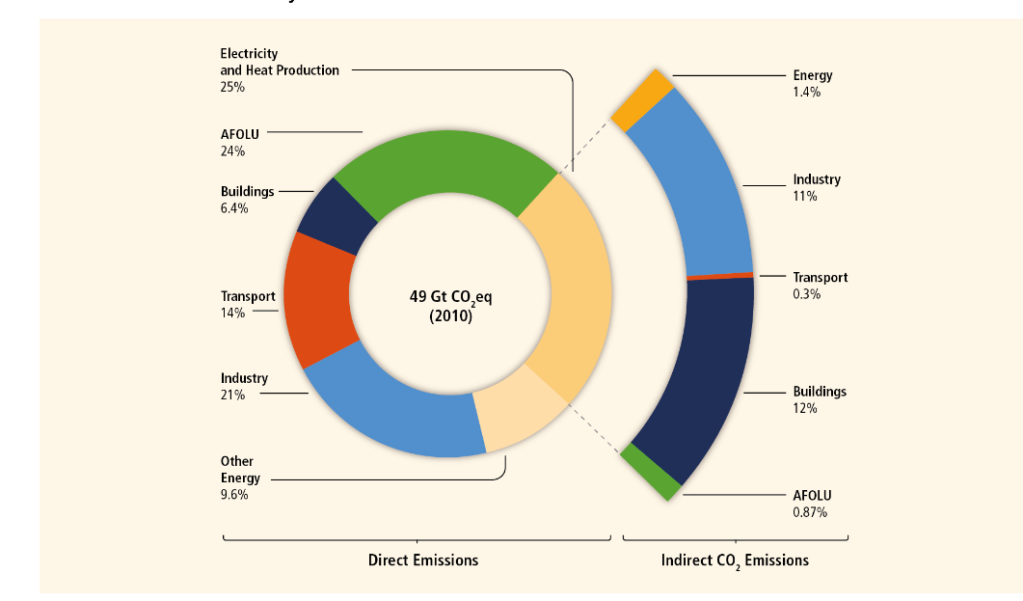
Image 1: Greenhouse Gas Emissions by Economic Sector
(IPCC, 2014)
The National Academy of Sciences (2015) suggests that the magnitude of population growth alongside the demand for meat is likely to place huge pressures on already struggling resources, particularly land, water and the energy required for both crops and animal agriculture. In terms of land, extensive research carried out by Our World in Data shows that half of the globe’s habitable land is currently being used for agriculture, and what’s even more concerning is that livestock makes up 77% of all agricultural land globally, including grazing pastures and crop land used to grow animal feed (Ritchie and Roser, 2019). These statistics imply that this scale of land use is simply not viable in its current form, before even considering the quantity of food that would be required to feed the population projections of 2050. What’s more, the high demand for meat and this extensive use of habitable land is having disastrous consequences for the world’s forests and the eco systems that exist within (Gonzaga, 2021). The image below demonstrates the importance of forests and the vital role that they play in mitigating climate change. Based on this, it seems evident that forests must be maintained and protected, not continually cut down to pave way for agriculture.
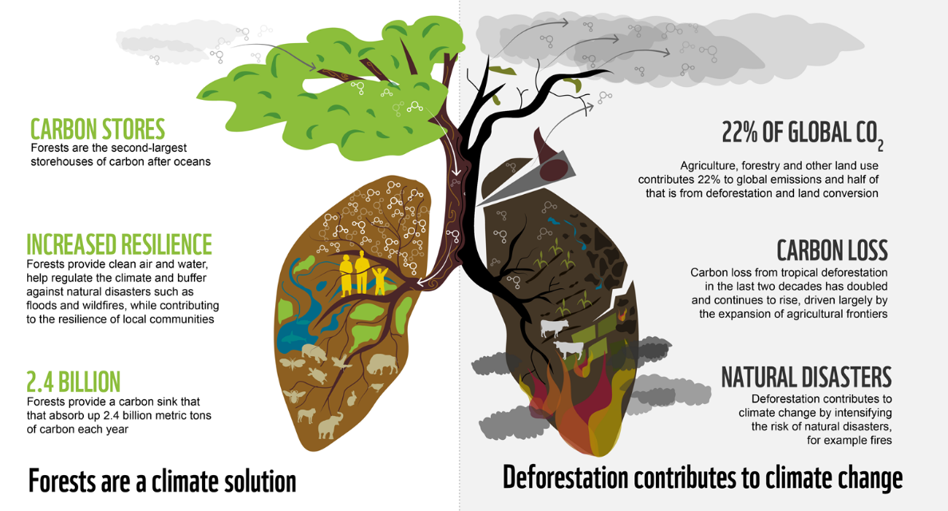
Image 2: Why forests are so important for the climate.

(World Wildlife Fund, 2020)
The World Wildlife Fund (2018) states that much of the reasons behind forest destruction is primarily due to the production of beef and soy, making it responsible for two-thirds of habitat loss in Brazil and Argentina. Furthermore, it is estimated that around 70%- 75% of soy ends up becoming feed for livestock (World Wildlife Fund, 2018), which based on this, makes it appear extremely uneconomical. In relation to this, one argument is that the crops being used to grow food to feed livestock, could be used instead for human consumption, therefore reducing the vast quantities of land required to keep up with the demand for meat and in turn reducing the livestock within the supply chain, removing some of the strain that animal agriculture is inflicting on Earth’s scarce land (Paola, Rulli and Santini, 2017).
Based on the evidence presented so far, it seems apparent that a reduction in animal agriculture as well as agriculture used to grow feed for livestock is essential, primarily in the production of beef. Ultimately however, the need for protein in human diets is also a necessity and the top contributors for protein intake tends to lean towards meat and dairy, although it seems worthwhile to note that meat is not the only source of protein (British Nutrition Foundation, 2021; Ranganathan and Waite, 2016). Interestingly, Ranganathan and Waite’s (2016) findings show that many regions on average are over-consuming on protein suggesting that there needs to be a drastic shift in people’s eating habits. The graph below produced by the World Resources Institute (2016) shows the amount of land and water it takes to produce both animal-based food and plant-based foods, including GHG emissions also. Based on the statistics in the graph below, it is highly evident that animal-based foods are much more resource intensive than plant-based foods in all areas, suggesting that a reduction in people’s meat-eating habits could have huge benefits in mitigating global warming and lessening the effects of climate change. In support of this, Ranganathan and Waite (2016) claim that the average American has the potential to cut their environmental impact through food by almost half, simply by reducing their consumption of meat and dairy. Even more astonishingly, research suggests that the reduction of animal-based foods in areas where meat and dairy consumption is highest, could drastically increase the amount of land available, and by 2050, it may be possible to feed 10 billion people without further agricultural expansion into forested areas (Ranganathan and Waite, 2016).

Image 3: Animal-Based Foods Are More Resource-Intensive than Plant-Based Foods
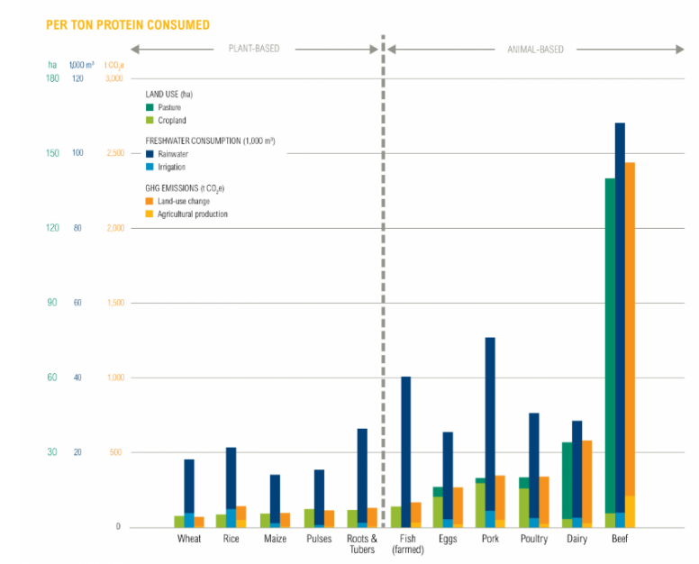

(Worlds Resources Institute, 2016)

The need to scale back on meat and dairy products seems certain therefore it seems fair to question how this can be done on a large scale, when the demand for meat is only getting higher in a time when it needs to be lessening. Macdiarmid, Douglas and Campbell (2015, p.487) in their research into public awareness of the environmental impact of food, state that the concept of sustainable diets is both ‘complex’ and ‘multifaceted’. This seems particularly relevant when considering there are multiple factors as to why people choose to consume meat, primarily based around cultural and social values (Macdiarmid, Douglas and Campbell, 2016). Interestingly, the study discovered that there was a lack of knowledge about the environmental impact of meat (Macdiarmid, Douglas and Campbell, 2016), suggesting that not enough awareness is being issued around this subject area. Given that global warming and climate change is an extensively known issue in which meat and dairy plays such a significant role, this seems peculiar. Further to this and in the same study, what’s more concerning is that upon being presented with information surrounding the topic of the environmental impact and meat, it is noted that there was a ‘general resistance’ to the notion of consuming less meat (Macdiarmid, Douglas and Campbell, 2016, p.491), highlighting just how much of a commodity meat is to many people. In light of this demand, and on a macro level, one possibility for meat and dairy industries is to move towards methods that incorporate sustainable agriculture practises. As maintained by the United Nations Environment Programme (2021, para 3), sustainable farming relates to ‘farming that meets the needs of existing and future generations, while also ensuring profitability, environmental health and social and economic equity’. Whilst this sounds promising, a lack of understanding and poor legislation by policy makers means that the incentive for these sectors to change their methods is low (United Nations Environment Programme, 2021). On a micro level, one of the most obvious and easiest solutions for individuals to incorporate into their routines is simple; eat less meat and dairy (United Nations Environment Programme, 2022; Brügger, Marinova and Raphaely, 2016).
To conclude, the research gathered in this article underlines how incomprehensively vast the meat and dairy industry is and suggests that urgent action needs to be taken. The emissions produced by animal agriculture are alarming and are only set to rise alongside population growth (Gerber et al, 2013; National Academy of Sciences; 2015; United Nations, no date). The immense quantities of essential resources that are being used to keep up with this demand for meat and dairy, primarily in relation to land, seem nothing short of catastrophic (Ritchie and Roser, 2019, World Wildlife Fund; 2018). However, despite this endless quantitative data showing just how much of an environmental impact animal agriculture is having on the planet (IPCC, 2014; Worlds Resources Institute, 2016), some research suggests that meat holds so much value in people’s lives, so much so that people are hesitant to reduce their meat intake (Macdiarmid, Douglas and Campbell, 2016), regardless of how damaging it is. This signifies that perhaps the consciousness surrounding this issue is lacking and more needs to be done to raise awareness, particularly through people’s eating habits (United Nations Environment Programme, 2022; Brügger, Marinova and Raphaely, 2016). Having said that, it seems that it cannot solely be down to the consumer to change their eating habits. Instead, changes must be made on a large scale that incorporates sustainable farming methods though research suggests that there is a long way to go to incentive this and make it viable in practise (United Nations Environment Programme, 2021). Ultimately, changes must be made that benefit everyone, but most importantly, the planet.
Reference List
British Nutrition Foundation. (2021). ‘Protein’. Available at: Protein - British Nutrition Foundation (Accessed: 30 May 2023).
Brügger,P., Marinova,D. and Raphaely,T. (2016) ‘Meat Production and Consumption: An Ethical Educational Approach’, in Raphaely, T., Marinova, D. and Balcombe, J. Impact of meat consumption on health and environmental sustainability. Hershey, Pennsylvania: Business Science Reference.
Gerber, P.J., Steinfeld, H., Henderson, B., Mottet, A., Opio, C., Dijkman, J., Falcucci, A. & Tempio, G. (2013) Tackling climate change through livestock – A global assessment of emissions and mitigation opportunities. Food and Agriculture Organization of the United Nations (FAO). Rome: FAO. Available at: Tackling Climate Change through Livestock: A global assessment of emissions and mitigation opportunities (fao.org) (Accessed: 18 May 2023).
Gonzaga,D. (2021). ‘To Fight the Climate Crisis, We Need our forests standing’. Greenpeace. Available at: To fight the climate crisis, we need our forests standing - Greenpeace International (Accessed: 21 May 2023).
IPCC (2021) Climate Change 2021: The Physical Science Basis. Contribution of Working Group I to the Sixth Assessment Report of the Intergovernmental Panel on Climate Change [Masson-Delmotte, V., P. Zhai, A. Pirani, S.L. Connors, C. Péan, S. Berger, N. Caud, Y. Chen, L. Goldfarb, M.I. Gomis, M. Huang, K. Leitzell, E. Lonnoy, J.B.R. Matthews, T.K. Maycock, T. Waterfield, O. Yelekçi, R. Yu, and B. Zhou (eds.)]. Cambridge, United Kingdom and New York, NY, USA: Cambridge University Press. Available at: Climate Change 2021: The Physical Science Basis (ipcc.ch). (Accessed: 18 May 2023).
Macdiarmid, J.I., Douglas, F. and Campbell, J. (2016) ‘Eating like there’s no tomorrow: Public awareness of the environmental impact of food and reluctance to eat less meat as part of a sustainable diet’, Appetite, 96, pp. 487–493. Available at: https://doi.org/10.1016/j.appet.2015.10.011 (Accessed: 31 May 2023).
Met Office (no date) What is Climate Change? Available at: What is climate change? - Met Office (Accessed: 21 May 2023).
Paolo,A.D., Rulli,M.C.,Santini,M. (2017) ‘Human food vs. animal feed debate. A thorough analysis of environmental footprints’, Land Use Policy. 67, pp. 652-659. Available at: Human food vs. animal feed debate. A thorough analysis of environmental footprints - ScienceDirect (Accessed: 30 May 2023).

Ranganathan,J. & Waite,R. (2016) ‘Sustainable Diets: What You Need to Know in 12 Charts’. Worlds Resources Institute. Available at: Sustainable Diets: What You Need to Know in 12 Charts | World Resources Institute (wri.org). (Accessed: 30 May 2023).
Ritchie,H.Rosado,R and Roser,M. (2017) Meat and Dairy Production. Available at: Meat and Dairy Production - Our World in Data (Accessed: 19 May 2023).
The National Academy of Sciences. (2015) Critical Role of Animal Science Research in Food Security and Sustainability. Washington: National Academies Press. Available at: Bookshelf_NBK285722.pdf (nih.gov) (Accessed: 18 May 2023).
United Nations (no date) Global Issues: Population. Available at: Population | United Nations (Accessed: 18 May 2023).
United Nations Environment Programme. (2021) ‘A Beginner’s Guide to Sustainable Farming’. Available at: A beginner’s guide to sustainable farming (unep.org) (Accessed: 31 May 2023).
United Nations Environment Programme. (2022) ’10 Ways You Can Help Fight the Climate Crisis’. Available at: 10 ways you can help fight the climate crisis (unep.org) (Accessed: 31 May 2023).

World Wildlife Fund (2018) ‘What Are the Biggest Drivers of Tropical Deforestation?’. Available at: What are the biggest drivers of tropical deforestation? | Magazine Articles | WWF (worldwildlife.org). (Accessed: 18 May 2023).

Image Reference List
IPCC (2014) Climate Change 2014: Mitigation of Climate Change. Contribution of Working Group III to the Fifth Assessment Report of the Intergovernmental Panel on Climate Change [Edenhofer, O., R. Pichs-Madruga, Y. Sokona, E. Farahani, S. Kadner, K. Seyboth, A. Adler, I. Baum, S. Brunner, P. Eickemeier, B. Kriemann, J. Savolainen, S. Schlömer, C. von Stechow, T. Zwickel and J.C. Minx (eds.)]. Cambridge University Press, Cambridge, United Kingdom and New York, NY, USA. Available at: ipcc_wg3_ar5_full.pdf (Accessed: 21 May 2023).
World Wildlife Fund (2020) Why forests are so important for the climate [ONLINE]. Available at: Importance of Forests | WWF (panda.org) (Accessed: 25 May 2023).
Worlds Resources Institute. (2016) Animal-Based Foods Are More Resource-Intensive than Plant-Based Foods. Available at: Sustainable Diets: What You Need to Know in 12 Charts | World Resources Institute (wri.org) (Accessed: 30 May 2023).

