  Component One: Student Journal (learning log) 750 words +/- 10%  Contribution to Overall Module Assessment: 25% | Student No: | 2245345
 | Module Title: | Operating Hotel Facilities
 | Module Code: | BMIH4006
 | Lecturer: | Natalie Brailsford
Reflective Journal Entry: My Placement Experience in the Housekeeping Department
During my placement in the housekeeping department, I was tasked with a variety of responsibilities aimed at maintaining cleanliness and orderliness within the hotel. These tasks included cleaning guest rooms: restocking amenities, vacuuming, dusting, mopping, changing bedsheets, sanitizing light switches and overall ensuring that all areas met the highest standards of cleanliness. Each day, I worked diligently to ensure that every room was prepared to welcome guests, contributing directly to their overall satisfaction with their stay.
One of the key lessons I learned during my placement was the critical importance of attention to detail in maintaining cleanliness. Every aspect of a guest's experience, from the appearance of their room to the cleanliness of public areas, contributes to their overall impression of the hotel (Cetin and Walls 2016). By paying close attention to even the smallest details, such as ensuring that all amenities are neatly arranged and surfaces are spotless, we can create a welcoming and comfortable environment for guests.
Throughout my placement experience, I encountered a range of feelings and emotions. Initially found the fast-paced environment to be challenging. For instance, we have a twenty-five minute window to clean each room efficiently – this was very overwhelming and demanding. Moreover, I have experienced difficult situations where a bed has been soiled with urine or vomit, this made me feel uncomfortable and frustrated, yet these are challenges that have made me more patient. Ultimately, I quickly became accustomed to my routine and therefore adapted and began to thrive in the dynamic atmosphere. Collaborating with staff members is imperative yet this also has it’s own challenges as we all have a difference in opinion and mannerisms. Therefore, I sometimes felt undermined and overlooked being a new member as they were all familiar with each other. Ultimately, over time working with my team members and meeting deadlines has become easier, rewarding and more fulfilling as we worked together to ensure that every guest received the highest level of service possible.
Reflecting on my performance in the housekeeping department, I identified several strengths, including effective communication, time management, and problem-solving skills. I was able to communicate effectively with both guests and team members, ensuring that all tasks were completed efficiently and to the highest standards. Additionally, my strong time management skills allowed me to prioritize tasks effectively and meet deadlines consistently. However, I also recognized areas for improvement, such as refining my cleaning techniques to work more efficiently and effectively.

My placement experience provided valuable insights into the crucial role that the housekeeping department plays in guest satisfaction. The cleanliness and appearance of a hotel directly impact guests' perceptions of their stay, influencing their likelihood to return in the future and recommend the hotel to others. This ensures customer loyalty and directly impacts a hotel’s success – as hospitality and cleanliness is how a hotel gains a reputation (Kandampully and Suhartanto 2000). By ensuring that every aspect of the hotel is maintained to the highest standards, the housekeeping department contributes significantly to the overall success of the hotel (Carbone 2010).

In conclusion, my placement experience in the housekeeping department has been incredibly rewarding and has provided me with valuable insights into the hospitality industry. I have gained a deeper understanding of the importance of attention to detail, effective communication, and teamwork in providing exceptional guest service. This experience has not only enhanced my perception of the hospitality industry but has also contributed to my personal and professional development.

Moving forward, I plan to continue building on the skills and knowledge I have gained during my placement in the housekeeping department. To enhance my skills further, I will seek out additional training opportunities to refine my cleaning techniques and learn new methods for improving efficiency. Additionally, I will continue to actively seek feedback from both guests and supervisors to identify areas for improvement and ensure continuous growth and success in my hospitality career.

Component Two: Health and Safety Guide
Contribution to Overall Module Assessment: 25%
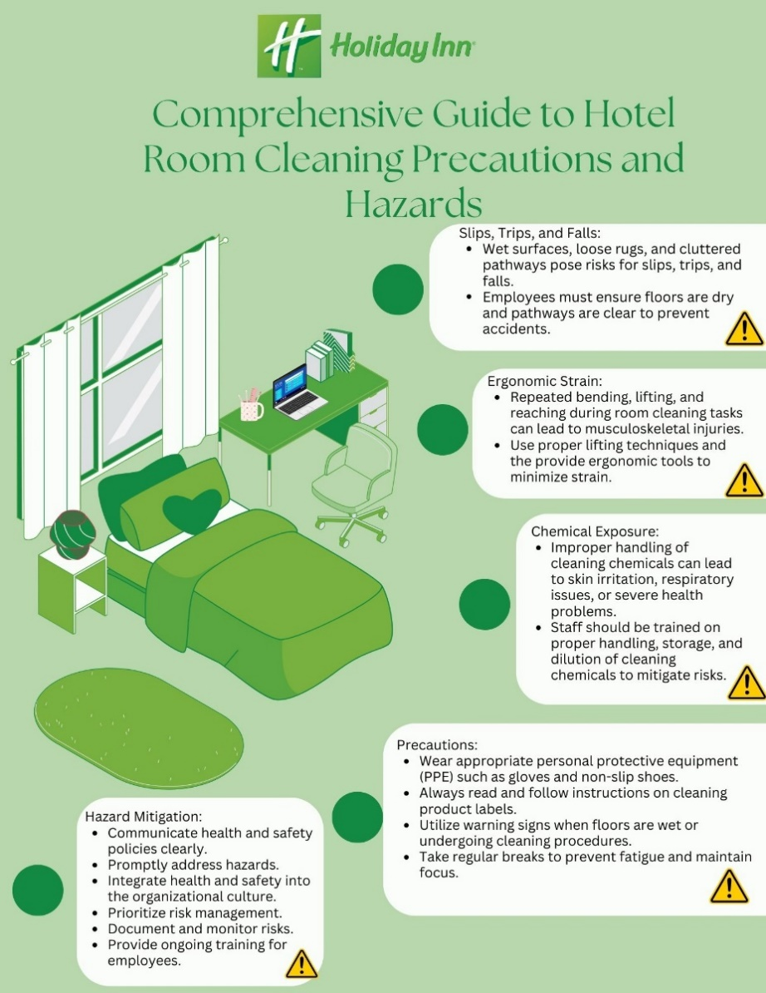

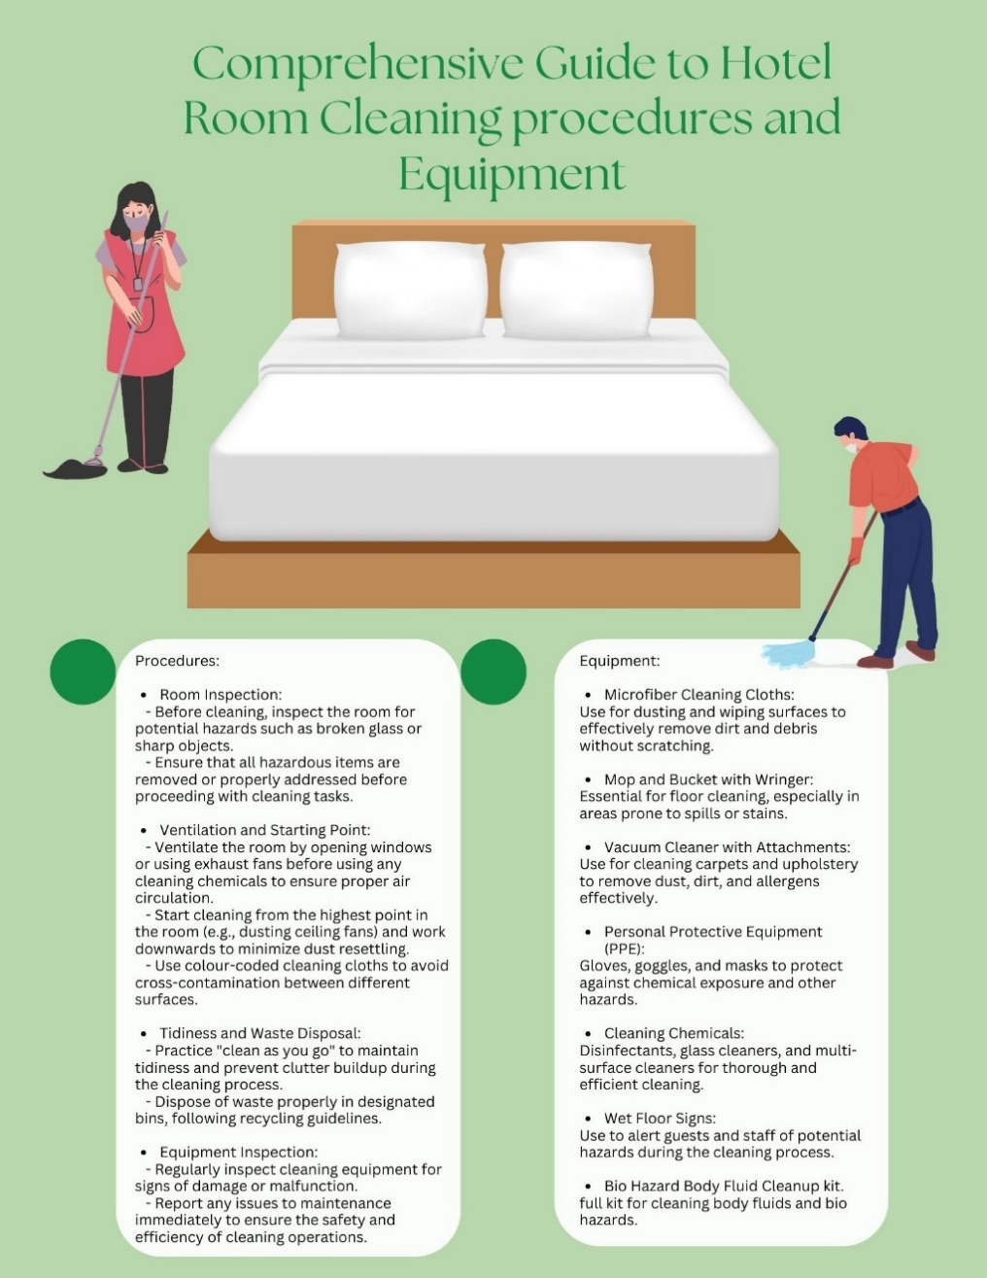

Reference List

Bednarska, M., 2004. Risk control methods in a hotel operation. Economics and Business Review, 4(1), pp.43-51.
Carbone, L. (2010) Clued In: How to keep customers coming back again and again. Financial Times Prentice.
Cetin, G. and Walls, A. (2016) “Understanding the customer experiences from the perspective of guests and hotel managers: Empirical findings from luxury hotels in Istanbul, Turkey” , Journal of Hospitality Marketing and Management, 25(4), pp. 395-424.
IHG, 2024. Clean Promise. [online] Available at: https://www.ihg.com/content/gb/en/customer-care/clean-promise-gc [Accessed 20 February 2024].
Independent Cottages, 2024. Coronavirus considerations for reopening your holiday home to guests. [online] Available at: https://www.independentcottages.co.uk/holiday-blog/coronavirus-considerations-for-reopening-your-holiday-home-to-guests/ [Accessed 20 February 2024].
Jones, L. (2023). Jones, ’10 Common Safety Risks In Hospitality’. Pilla [blog]. 16th May. Available at: https://yourpilla.com/blog/hospitality-risks. [Accessed: 21/02/2024]
Jusoh, Z., Abd Shattar, N., Abd Majid, H.A.M. and Adenan, N.D., 2016. Determination of hazard in captive hotel laundry using semi quantitative risk assessment matrix. Procedia-Social and Behavioral Sciences, 222, pp.915-922.
Kandampully, J. and Suhartanto, D. (2000), "Customer loyalty in the hotel industry: the role of customer satisfaction and image", International Journal of Contemporary Hospitality Management, Vol. 12 No. 6, pp. 346-351.
Kline, S., Almanza, B. and Neal, J., 2014. Hotel guest room cleaning: a systematic approach. Food Safety: Researching the Hazard in Hazardous Foods, pp.303-322.
Main, P. (2023) ‘Gibbs’ Reflective Cycle’, Stuart learning [blog]. 09 May. Available at: https://www.structural-learning.com/post/gibbs-reflective-cycle [Accessed: 20th February 2024]
Quore, 2024. IHG & Quore COVID Checklist. [online] Available at: https://www.quore.com/blog/ihg-quore-covid-checklist/ [Accessed 20 February 2024].
Wami, S.D., Dessie, A. and Chercos, D.H., 2019. The impact of work-related risk factors on the development of neck and upper limb pain among low wage hotel housekeepers in Gondar town, Northwest Ethiopia: institution-based cross-sectional study. Environmental health and preventive medicine, 24, pp.1-10.#

