Workplace Culture and its Impact on Organisational Efficiency BMSK5005_BIRM

Student: Jomir Ullah 1708855
Lecturer: Dr Eric Osei

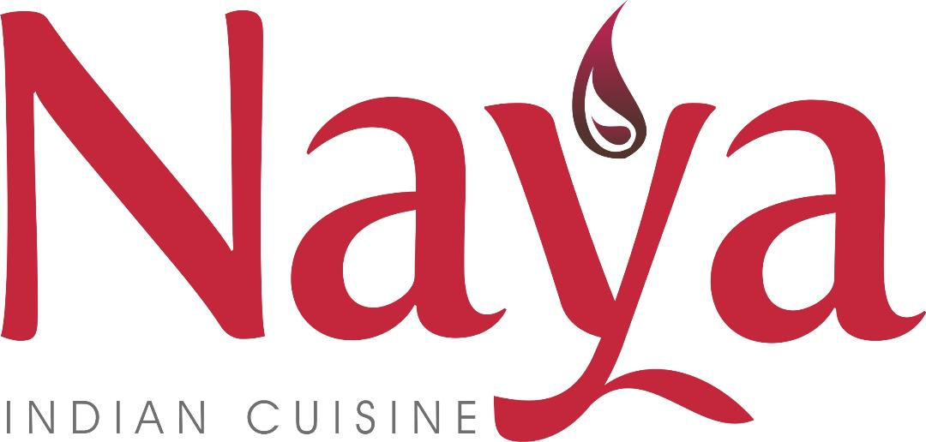

Executive Summary

The food industry is currently worth £37 billion (Luty, 2019). The need to sustain profitability and workplace culture is now ever more important. This report critically analyses the business environment of Naya Indian Cuisine. Using theoretical models and framework this paper will examine how certain constraints may impact workplace culture and performance of the individual within an organisation.

Contents

Introduction 4
Organisation and The Business Environment 5
Micro-Environment 6
Porter’s 5 Forces 6
Internal Environment 9
Mckinsey’s 7S Framework 9
What is Organisational Culture? 12
Functions of Culture: 12
How Does Organisational Culture Impact The Efficiency Of The Business? 14
Analysis of Ethical Stance and Corporate Social Responsibility 15
Comparison of Competitors Culture 17
Recommendations / Future Strategic Options 19
Conclusion 20
References 21
Appendix. 23

Figure 1 Stastica.com UK Food Industry 4
Figure 2 Overview of the Business Environment 5
Figure 3 Porters External Forces 6
Figure 4 Tom Peters and Robert Waterman Mckinsey Model 9
Figure 5 Organisational Hierarchy chart for Naya Indian Cuisine 10
Figure 6 Carroll’s Ethical and CSR Pyramid 16
Figure 7 Definitions for Hofstede’s Cultural Dimensions 17
Figure 8 Hofstede’s Country Analysis for Bangladesh 18

Introduction

Naya Indian Cuisine is a high-end restaurant located in Warwickshire. It has been trading for the past ten years. According to statistics, a new business fails within the first year of operation (statista.com, 2009). To create and sustain a positive environment and increase performance organisations need to be aware of the business environment that they operate in. Organisations also need to be aware of how the culture within their place of work and leadership style can have an impact on behaviour in the workplace and ultimately on productivity and performance.
Businesses do not operate in a vacuum and internal and external variables can directly hinder the success of the business. This report will use external and internal analysis tools to deduce the factors that can exhibit a great force on the survival of the business. To analyse these forces Porters Five Forces, the Mckinsey 7S framework will be used for a thorough analysis. Studies into organisation culture by Charles Handy, Gert Hofstede, and others suggest that culture plays a key role in the success of any business. By creating and sustaining a strong work culture, managers and owners can ensure their profitability and good performance.

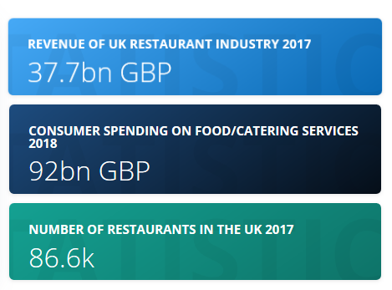
Figure 1 Stastica.com UK Food Industry

Organisation and The Business Environment

Mullins (2005) stated that an organisation follows the basic economic school of thought to mobilise resources to satisfy the needs of the customer. It is a group of people who come together and share a common purpose to provide a service to society.
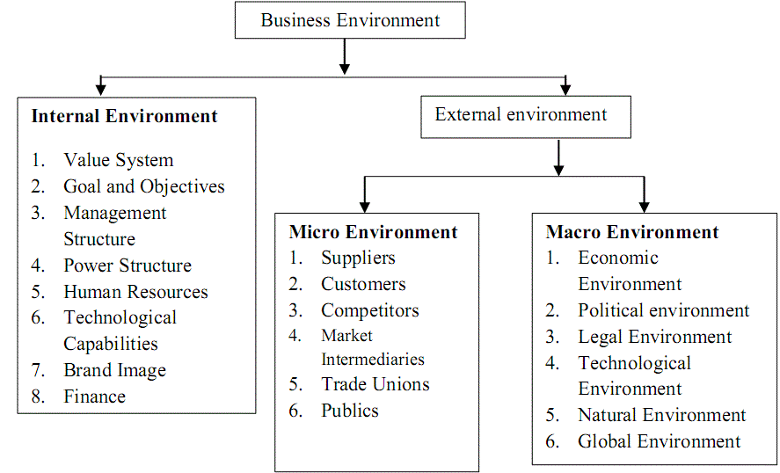
Figure 2 Overview of the Business Environment
Source: http://ignited.in/a/57614

Micro-Environment

Porter’s 5 Forces:
Harvard Professor Michael Porter's theory refers to external factors that the business has very little control over (Porter, 2008). Fig 3. It is focused on the competition the business will face and how to counter these forces. (BMi Research, 2015)
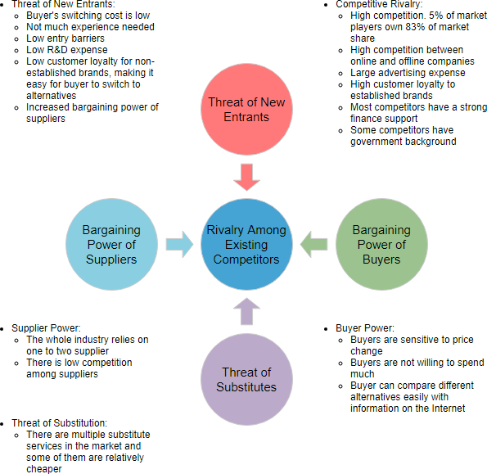
The rivalry is very high as other businesses already operate within the area. Product differentiation is low, and similar products are sold nearby. This has led to Price wars as competitors are providing a regular promotion to attract new customers. (Davcik and Sharma, 2015)

Figure 3 Porters External Forces

Currently, this business has reached its maturity. There is a high degree of current customers but not so many new customers. Naya Indian Cuisine has responded to these concerns by providing a unique taste of Indian food and highly a professional customer experience.
The buying power of the customers is very high. Customers have a high disposable income. Most residents and customers are retired and they have options available to them. Therefore, employees have made an emotional attachment to their customers. This encourages repeat business. Exceptional customer service skills, high quality and tasty food are distinguishing factors that attract the customer.
Businesses require resources to operate. Where scarcity of resources is high. The suppliers may demand higher prices. Resources are widely available so the business can save money and gain on cost leadership (An and Lifen, 2017). If there is a threat to resources difficulties may arise. Such as Brexit. If this results in higher prices for goods. The business may lose its profit margin and advantage as the cost of goods is much higher. To counter this effect a value chain analysis can help to identify areas for improvement and investment (Lee, Hallak and Sardeshmukh, 2016).
The entrance of similar business’s to gain entry in Henley high street is low as the start-up cost of setting up requires a high capital investment in the affluent town of Henley-in-Arden. This may discourage others to invest. Also, the business has been operating for a long time and gained valuable cumulative experience. Customer loyalty is high. However easy access to finance from banks allows new entrants to get setup.
In the marketplace, other competitors may provide a much cheaper substitute product. This could potentially attract customers away from the business. i.e. Co-op providing readymade Indian meals. Naya opposes this force by providing freshly made food for their customers. The business has low advertising costs and attracts customer by providing extra services such as Air Condition and Free Wi-Fi.
Eskandari et al., (2015) and Takata, (2016) assert to remain profitable business has to assess its competitiveness in the market. By conducting an industry analysis it can become aware of factors promoting or impeding its success. Furthermore, PESTEL and SWOT analysis can be used to analyse the macro environment thus allowing managers to understand the implication of these forces and how to develop strategies to stay ahead of the competition and reshape the industry structure.
Porters external constraints can create a ripple effect on the culture within the business. (Chan, Shaffer and Snape, 2004) e.g. If costs of running the operation are too high, or the business is not able to counter the forces and meet its projected profit margins, the business may choose to reduce costs in other areas such as employee costs this will inevitably have an impact on the culture and morale of the team.
Similarly, if the business is profitable it may choose to reward the employees' success with incentives, reward new and existing staff for their service. This will further unite the team and create an identity. This will improve the efficiency and working environment within the business.

Although this framework is successful critiques (Dalken, F, 2014) argues that this is very basic in nature. As it was based on organisational theory (Pollack, 2015) in the 1970s. Recently, advances in economics, telecommunications and certain regulation changes have made it easier to overcome these barriers and they are not as effective. Suggestions given for new forces could include government policies and digitalisation, as they are likely to change with time.

Internal Environment

Mckinsey’s 7S Framework

This model was developed by a business analyst to scrutinise the internal environment of the business which can impact the performance and culture. The management has the ultimate responsibility to adapt and tweak these functions. How they decide to carry out these functions will have a knock-on effect on other components.
The soft components are shared values, skill and staff. Again these functions are required by the management to offer the customers a valuable experience for repeat business and also favourable to the management as they will see more profit and customer satisfaction.
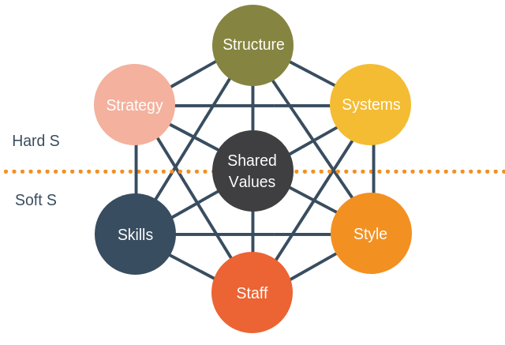
Naya has a functional structure to monitor employee behaviour, accountability, co-ordinate staff and increase social satisfaction. The structure is very organic, flexible and embraces change. It has clear rules and responsibilities set out for the staff. Often there are communication issues such as out of stock items are not relayed to waiters taking orders due to the noisy working environment.
Figure 4 Tom Peters and Robert Waterman Mckinsey Model
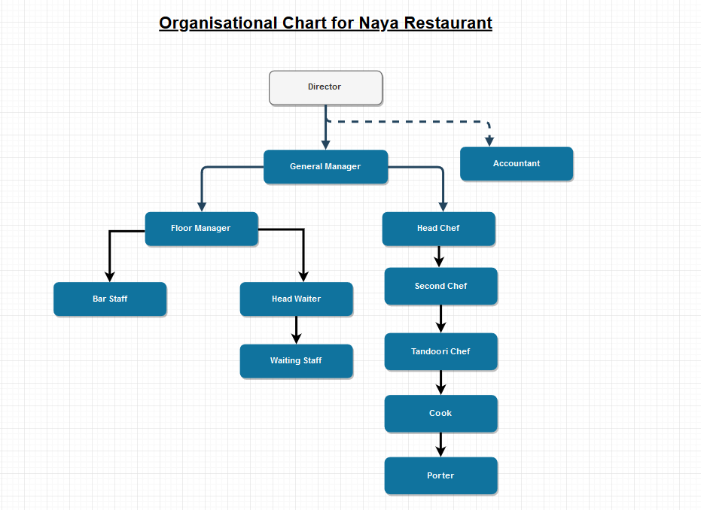
Figure 5 Organisational Hierarchy chart for Naya Indian Cuisine

Power is decentralised and departmentalised. Functional areas of the business can decide how to carry out their daily operations. This process has a positive impact on workplace motivation and overall morale.
Values are shared in the restaurant. These are core beliefs either fundamental or terminal. These values translate into activity and behaviour. Core values such as honesty, dedication to work and passion for food is what brings success to the business. Employees that are guilty of minor misdemeanours who speak the truth are rewarded. This further improves the relationship between managers and staff.
The strategy in place is to work efficiently and innovatively to reduce customer complaints and provide a professional and friendly service (Bae Mo, 2016). The reputation of the business is held in high esteem. Orders are taken swiftly and delivered to the chef. Customers are always informed of delays politely and professionally.

Highly skilled staff are required to provide quality service to customers. employees are always available to answer customer questions in person and on the phone. The culture dictates that staff must take responsibility to take customers' coats and other personal belongings. Also to open the door for the customer on arrival and exit from the restaurant. They are also trained to deal with disabled customers to enhance their customer experience.
Employees are highly experienced members working who have gained the trust and seniority due to the length of service and dedication to work. These members are responsible for training recruits. The cultural traits are passed on through socialisation and work shadowing.
Naya has a democratic management style during very busy times or when there are disputes and concerns amongst staff. The business is dependent on the skilled workforce and replacing them can be costly and time-consuming.
There is currently an electronic ordering system in place which has benefited the business. The business has taken steps to train each member on how to use the system and not feel left out. Taghiloo, Rostamy and Ali (2009) affirm that individual learning is essential for business development and growth. Also, this enhances productivity and profitability. Furthermore, this increases loyalty to the business as well as reducing staff turnover.
At the heart of the model is the values that the business upholds. Values are passed on through training, indoctrination and observation. By following these guidelines a dysfunctional organisation can enhance their business when they align each core component of this model.

What is Organisational Culture?

Research into organisational culture has gained popularity due to the globalisation of business, the formation of global alliances and the growing diversity of the workforce. (Acar and Acar, 2014). Many researchers have defined culture as the collective programming of the human mind which distinguishes them from one group to another.
According to Schein (1999); Handy (1985) and Hofstede (1984) culture is the patterned ways of thinking, feeling and reacting to social and business interactions. Where commonly shared values shape and manipulate the culture within. A precursor to culture is institutionalisation. Where each organisation chooses its personality and ways of working.

Functions of Culture:

- Provides unwritten rules for behaviour, the ethos for business employee’s which they conform to. In a strong culture, they will not deviate.
- It gives identity to members and increases social system stability.
- Develops a commitment to work.

Naya management dictates the ethos that they adhere and the style they want the business to adopt. However, within this setting, there is potential for informal culture or sub-cultures to be present. Kitchen staff may not bond with front staff as they don’t have much contact in the fast-paced environment.
There are pockets of employees who set their own informal cultures. Functional areas such as the kitchen where the employees choose their way of carrying out their responsibilities. Also if there is an age gap some members may change how they communicate when someone younger or older is present. These informal cultures are very significant and powerful.
Watkins (2013) describes culture as ‘the immune system’ A change in the culture or working pattern will have a considerable impact on the employees as they are accustomed to their preferred way of working. This could deny the business of valuable innovation and new knowledge.

Handy (1985) identified four classes of culture. These are:
- Power culture
- Role culture
- Task/team culture
- Person culture
The researcher asserts the team culture to be the most apparent. This is where teams get together to carry out a task which is to serve the customers food and drinks in a timely and professional manner.
There is no single power source in this culture as this may shift depending on who was in the team and their personality. This is a very dynamic type of culture. The task at hand determines the team dynamics. With the right selection of skills, personalities, strong ability and leadership styles. Effective teamwork is more productive and creative.

How Does Organisational Culture Impact The Efficiency Of The Business?

Strong cultures bind the employees to their position as they stay for longer and mature with the business. It can be said that culture impacts on the employees within the business and overall has implications if the employees are not happy in their roles. This will reduce motivation, increase employee turnover and customer satisfaction and loyalty to the business.
Culture can also be regarded as a liability. As values are entrenched. It makes it difficult to adapt to pressures from external constraints such as social and political changes. E.g. japan promised to look after staff but couldn't in recession. People lost jobs. (Divjak, 2009)
It can also be a barrier to diversity. A strong culture is known for regimentation and cloning. This is where individuals adopt similar behaviour. Culture demands it. As a result, there is a lack of innovation.
Culture can harm the work environment and output. Brettel, Chomik and Flatten,(2014) state that constituents of culture include risk-taking through innovation. Naya allows employees to make decisions through innovation. In our competitor's analysis, this is frowned upon. Naya has an egalitarian culture which is good as managers don’t treat inferiors harshly and don’t abuse the rank.
San Park and Hyun Kim, (2009) have stated that culture is very powerful and can influence the behaviour of the organisation and the employee. Therefore it is a combination of values beliefs and motivation in the workplace. Further, Yousef, (2016) describes how culture can impact on organisational change in government departments. As they hold onto strong rituals and stories (Johnson, 2015) and strictly follow the bureaucratic leadership style. There are minimal deviations from the chain of command.
Additionally, according to Martins and Terblanche (2003), the culture within the business environment will also have an impact on the leadership style adopted within the workforce. A competent leader will need to take onboard the situation at hand and show empathy and emotional intelligence to gain the support of the team. (Rezvani et al., 2016)
Culture can also impact on:
- Consumer Purchasing Trends
- Brand Identity
- Decision Making
- Business Negotiations

Analysis of Ethical Stance and Corporate Social Responsibility

In addition to being profitable, an organisation has an obligation and to act ethically. According to Carroll (1999) being ethical is to act lawfully and morally. Further, Caroll provides a model for a business’s to fulfil this obligation (Fig.6) Where the legal obligation is satisfied, corporate social responsibility begins as organisations have a wider role to play in the community that they are trading.
Maloni and Brown (2006) in their study look into ethical dilemmas faced by the food industry. Recently, due to social change, there are changes in people's diet. Customers may have a special dietary requirement such as those who are vegan, vegetarian and pescatarian or another specific requirement such as intolerance to certain foods. As a business, food must be prepared ethically to meet the cultural expectations of the customer.
Naya is always donating and helping the local community with projects to supports young children at the Henley Sports Pavilion. They regularly hold various charity events for the Parish Council. Used food and materials are disposed of ethically. Plastic and cardboard are recycled. Equipment used in the buildings has a high energy rating. The company is committed to reducing carbon footprint by commuting together to get to work and by obtaining resources that have been locally produced. The Installation of an electronic ordering system (EPOS) has eliminated to use of paper in the business.
Kolk (2016) describes how highly ethical organisation displays positive characteristics such as honesty, integrity and a focus on developing the individual as well as giving back to the environment where we source all our needs. Naya restaurant displays these characteristics frequently and openly.

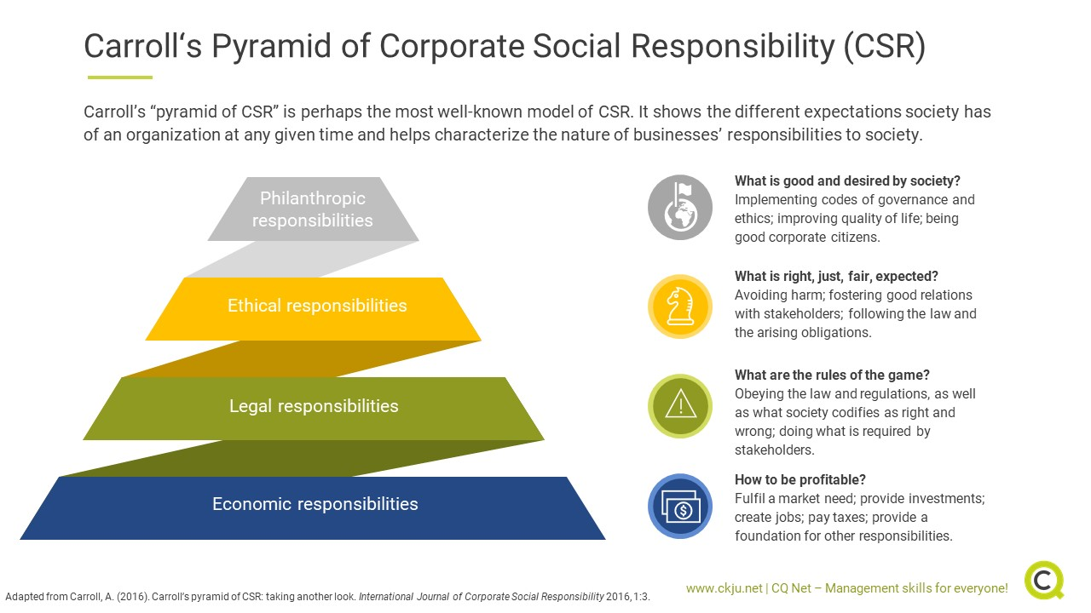
Figure 6 Carroll’s Ethical and CSR Pyramid
Source: https://www.ckju.net/en/blog/corporate-social-responsibility-why-and-how-committing-csr-drives-organizational-performance/28031

Comparison of Competitors Culture

The researcher sought permission from a rival competitor to observe how they work in the restaurant. Through observation, the researcher was able to draw on some critical conclusions. Although both business owners were from Bangladesh and had very strong national cultural identities Fig. 8. The way they managed the business is dissimilar.
Hofstede (1984), studies into international cultural dimensions for IBM employees globally produced a framework for the comparison of the cultures. The table in the appendix (1) outlines a record of the observation and defines the terms as well as identifying the deviations on the cultural dimension as proposed by Hofstede. Fig 7 below defines the two extremes of each cultural dimension.

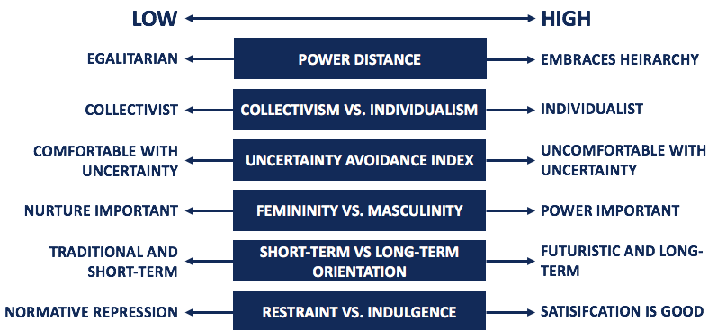
Figure 7 Definitions for Hofstede’s Cultural Dimensions

Source: https://corporatefinanceinstitute.com/resources/knowledge/other/hofstedes-cultural-dimensions-theory/

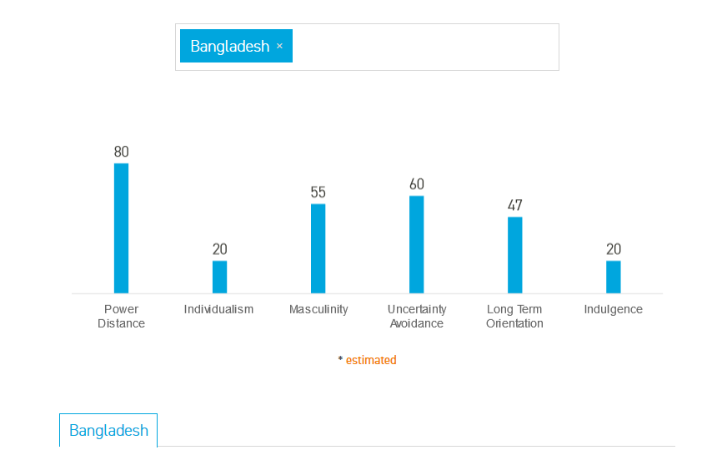
Figure 8 Hofstede’s Country Analysis for Bangladesh
Source: https://www.hofstede-insights.com/country/bangladesh/

Recommendations / Future Strategic Options

For a positive and strong cultural experience in the workplace certain strategies need to be implemented (Beer, 2013). Workers are responsible for culture change through positive socialisation in the workplace. This is done through their behaviour and actions they portray in their immediate work circle or lateral relationships with other sections.
A deficient structure will hamper the communication channels in the organisation leading to confusion in reporting grievances and concerns. This will result in the loss of profit and well-being of employees. Also management style and how the subordinates are treated will have a direct effect on the culture within the organisation.
How decisions are made from higher up in the organisation will also have a long-term impact on the lives of the employees on the operational level of the organisation. Some suggestion to improve culture and performance are below;
- Having a diverse workforce: This allows for new talent, competencies and innovation to enter the business. This can aid in problem-solving and decision making at work. (Trehan and Glover, 2018)

- Leadership Styles: Management should give others a chance to lead. They should adopt a situational approach when deciding on leadership style as this can have a direct effect on performance and culture within the workforce if employees do not subscribe to their style. (Bedrule-Grigoruta, 2012)

- Training: A well-trained workforce would be able to deliver better products and services. Gaps in employee knowledge should be bridged accordingly. Management should renew their employee's knowledge yearly to avoid any financial penalties for law enforcement agencies such as Food Regulation. (Adesokan, Akinseye and Adesokan, 2014)

Conclusion

Organisations have various models that they can follow to critically analyse the business environment that they operate in and take remedial steps to enhance the performance of the employees and gain a competitive advantage over their rivals.
Through indoctrination and socialisation managers can create and sustain a healthy and strong work culture. Employing like-minded individuals and using them to train new employees to distil their core company values. Stories and myths that are shared in the workplace are the binding thread of culture, symbols and rituals are components of organisational culture.
Although culture is intangible it can be sensed through perception. i.e. through socialisation, you can infer and deduce behaviour and actions simply by talking to others. A weak culture will breed behaviour which are inconsistent. Strong work culture will show consistency and be aligned to company values. Cultures within a business provide discipline not supervision from seniors.
Culture dictates more profoundly the expected behaviour and attitudes and expected goals more distinctly than regulations decreed by management.
Globalisation and national cultures have transcended organisation culture. Bangladeshi restaurant owners have set up business in England, the owners must adapt to the national culture to remain successful.
Organisations need to align all the seven components mentioned by Mckinsey Model. In the Indian Food Industry. The structure of the organisation can hamper the success of the business. Managers need to be aware that employee motivation levels have a direct effect on performance and culture. Strategic decisions made higher up the chain of command will have a considerable impact on the lives of the employees, this, in turn, will impact on the future success of the business.
.

References

- Acar, A. and Acar, P. (2014). Organizational Culture Types and Their Effects on Organizational Performance in Turkish Hospitals. EMAJ: Emerging Markets Journal, 3(3), pp.18-31.
- An, G. and Lifen, C. (2017). Explore the Integration of Cost Leadership Strategy and Differentiation Strategy. Proceedings of the 7th International Conference on Education, Management, Information and Computer Science (ICEMC 2017).
- Bae Mo, Y. (2016). The Effect of Industrial Organizational Culture Types Workers Organizational Commitment and Innovative Behavior. Public Policy Review, 30(1), pp.49-71.
- Bedrule-Grigoruta, M.V., 2012. Leadership in the 21st century: Challenges in the public versus the private system. Procedia-Social and Behavioral Sciences, 62, pp.1028-1032.
- Beer, M. (2013). High commitment high performance. San Francisco, Calif.: Jossey-Bass.
- BMi Research (2015). Mageu Feedback Report. Retail Pricing Strategies. [online] Johannesburg: BMi Research. Available at: https://www.bmi.co.za/wp-content/uploads/2016/04/2016-Category-Quantification-Mageu-Report-Media-Feedback.pdf [Accessed 5 Oct. 2019].
- Brettel, M., Chomik, C. and Flatten, T. (2014). How Organizational Culture Influences Innovativeness, Proactiveness, and Risk-Taking: Fostering Entrepreneurial Orientation in SMEs. Journal of Small Business Management, 53(4), pp.868-885.
- Carroll, A. (1999). Corporate Social Responsibility. Business & Society, 38(3), pp.268-295.
- Chan, L., Shaffer, M. and Snape, E. (2004). In search of sustained competitive advantage: the impact of organizational culture, competitive strategy and human resource management practices on firm performance. The International Journal of Human Resource Management, 15(1), pp.17-35.
- Dalken, F. (2014). Are Porters Five Competitive Forces still Applicable? A Critical Examination concerning the Relevance for Today’s Business: University of Twente. Faculty of Management.
- Davcik, N. and Sharma, P. (2015). Impact of product differentiation, marketing investments and brand equity on pricing strategies. European Journal of Marketing, 49(5/6), pp.760-781.
- Divjak, C. (2009). Poverty, unemployment and homelessness hit Japanese workers. [online] wsws.org. Available at: https://www.wsws.org/en/articles/2009/03/japa-m26.html [Accessed 03 Nov. 2019].
- Eskandari, M., Miri, M., Gholami, S. and Nia, H. (2015). Factors Affecting the Competitiveness of the Food Industry By Using Porters Five Forces Model Case Study in Hamadan Province, Iran. Journal of Asian Scientific Research, 5(4), pp.185-197.
- Handy, C. (1985). Understanding Organizations. 4th ed. Harmondsworth: Penguin.
- Hofstede, G. (1984). Cultural dimensions in management and planning. Asia Pacific Journal of Management, 1(2), pp.81-99.
- Hofstede, G. (2003). Cultures and Organisations: Intercultural Cooperation and Its Importance for Survival: Software of the Mind, London-UK, Profile Books Ltd
- Johnson, G. (2015). Cultural Web. Wiley Encyclopedia of Management, pp.1-2.
- Kolk, A. (2016). The social responsibility of international business: From ethics and the environment to CSR and sustainable development. Journal of World Business, 51(1), pp.23-34.
- Lee, C., Hallak, R. and Sardeshmukh, S. (2016). Innovation, entrepreneurship, and restaurant performance: A higher-order structural model. Tourism Management, 53, pp.215-228.
- Maloni, M. and Brown, M. (2006). Corporate Social Responsibility in the Supply Chain: An Application in the Food Industry. Journal of Business Ethics, 68(1), pp.35-52.
- Martins, E. and Terblanche, F. (2003). Building organisational culture that stimulates creativity and innovation. European Journal of Innovation Management, 6(1), pp.64-74.
- Morosini, P. (2005). Managing cultural differences. Oxford: Pergamon.
- Mullins, L. (2005). Management and organisational behaviour by Laurie J. Mullins. Harlow: Pearson Education Limited.
- Porter, M. (2008). Competitive Strategy. Riverside: Free Press.
- Rezvani, A., Chang, A., Wiewiora, A., Ashkanasy, N., Jordan, P. and Zolin, R. (2016). Manager emotional intelligence and project success: The mediating role of job satisfaction and trust. International Journal of Project Management, 34(7), pp.1112-1122.
- San Park, J. and Hyun Kim, T. (2009). Do types of organizational culture matter in nurse job satisfaction and turnover intention?. Leadership in Health Services, 22(1), pp.20-38.
- Schein, E. (1999). The corporate culture survival guide. San Francisco, Ca: Jossey-Bass.
- Taghiloo, H., Rostamy, A. and Ali, H. (2009). How types of organizational culture contribute in shaping learning organizations. Development and Learning in Organizations: An International Journal, 23(5), p.51.
- Takata, H. (2016). Effects of industry forces, market orientation, and marketing capabilities on business performance: An empirical analysis of Japanese manufacturers from 2009 to 2011. Journal of Business Research, 69(12), pp.5611-5619.
- Yousef, D. (2016). Organizational Commitment, Job Satisfaction and Attitudes toward Organizational Change: A Study in the Local Government. International Journal of Public Administration, 40(1), pp.77-88.
- Watkins, M. (2013). What Is Organizational Culture? And Why Should We Care?. [online] Harvard Business Review. Available at: https://hbr.org/2013/05/what-is-organizational-culture [Accessed 09 Nov. 2019].

Appendix.

