Ryan Morris – 1550957
1550957@student.uwtsd.ac.uk
Introduction to Web and Database Concepts (Database)
ACCA4023

Contents
Introduction 3
ERD 3
Database Design 5
Tables 5
Fields 5
Tables Relating 7
User Requirements 9
Conclusion 21
References 21

Introduction
In this assignment I will endeavour to create a database for Northern Lights pvt Ltd which satisfies the assignment specification, I will use techniques learnt in tutorials and through self learning. The database needs to be accessed by both customers and staff and have a user friendly interface on top of the raw tables and data. I will utilise relationships to create queries, forms and reports to suit the needs of the user.

ERD
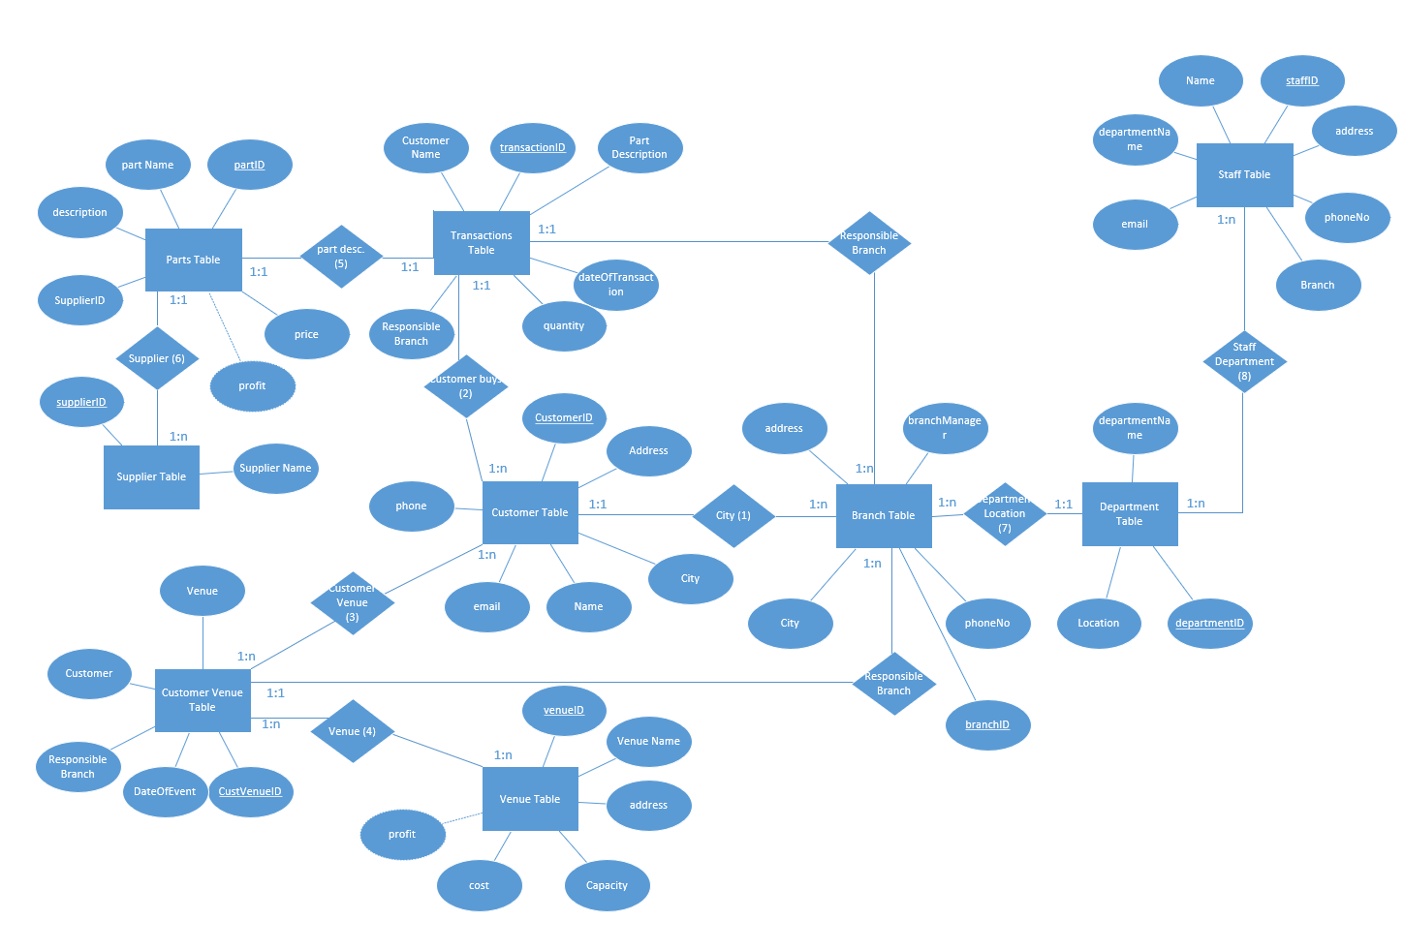
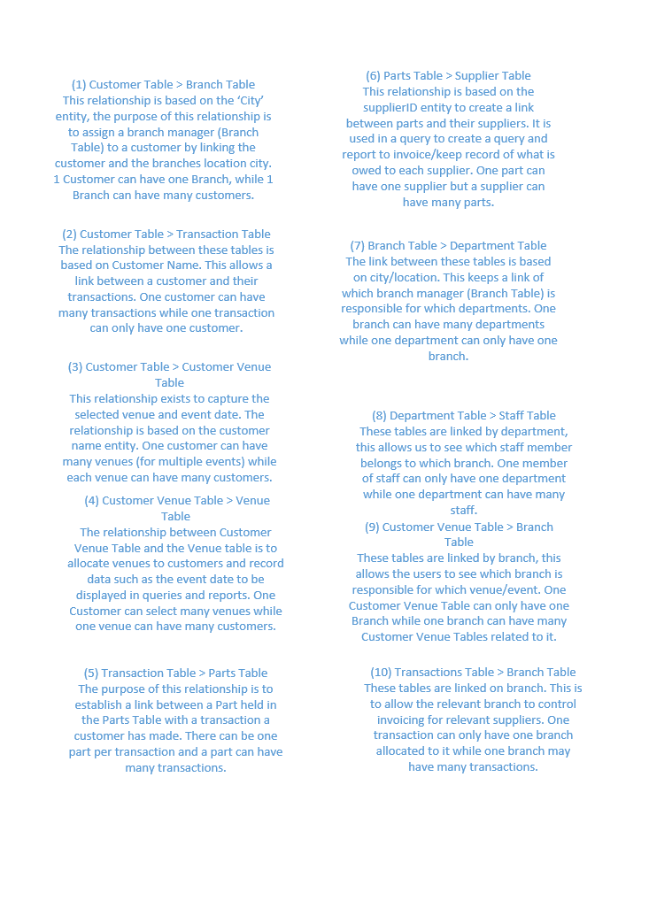

Database Design

Tables
After analysing the database requirements I have established that the database will require 9 tables. These tables are:
- Branch Table
- Customer Table
- CustomerVenue Table
- Department Table
- Parts Table
- Staff Table
- Supplier Table
- Transactions Table
- Venue Table

Fields
See below for fields, primary keys and foreign keys created:
Branch Table
PK – branchID
BranchManager
phoneNo
address
FK – city

Customer Table
PK – CustomerID
Name
Email
Phone
Address
FK - City

CustomerVenue Table
PK – CustVenueID
FK – Customer
FK – venue
FK – Responsible Branch
DateOfEvent

Department Table
PK – DepartmentID
DepartmentName
FK – Location

Parts Table
PK – partID
PartName
Description
FK – SupplierID
Price
Profit

Staff Table
PK – staffID
Name
FK – DepartmentName
Email
Address
phoneNo
FK – Branch

Supplier Table
PK – SupplierID
Suppplier Name

Transaction Table
PK – transactionID
FK – Part Description
FK – Resposnible Branch
DateOfTransaction
Quantity
FK – Customer Name

Venue Table
PK – VenueID
Venue Name
Address
Capacity
Cost
Profit

Tables Relating
I have created a series of queries in Microsoft Access which prove that my tables relate together correctly, here is a query to help generate an invoice for the entertainment/catering side of an event.
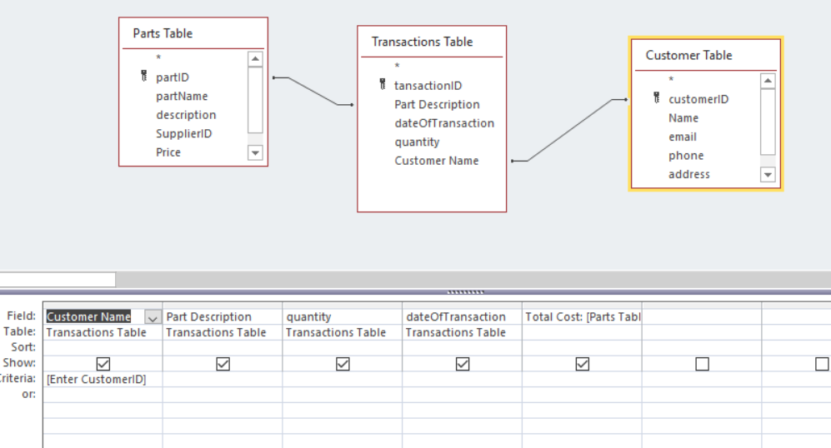
The following is the output when I run the above query:
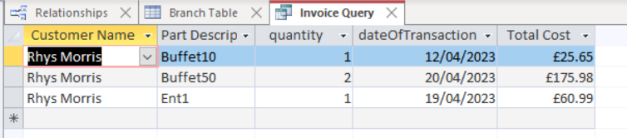

Here is another query which helps generate a report, the purpose of the query is to identify which parts a supplier has supplied:

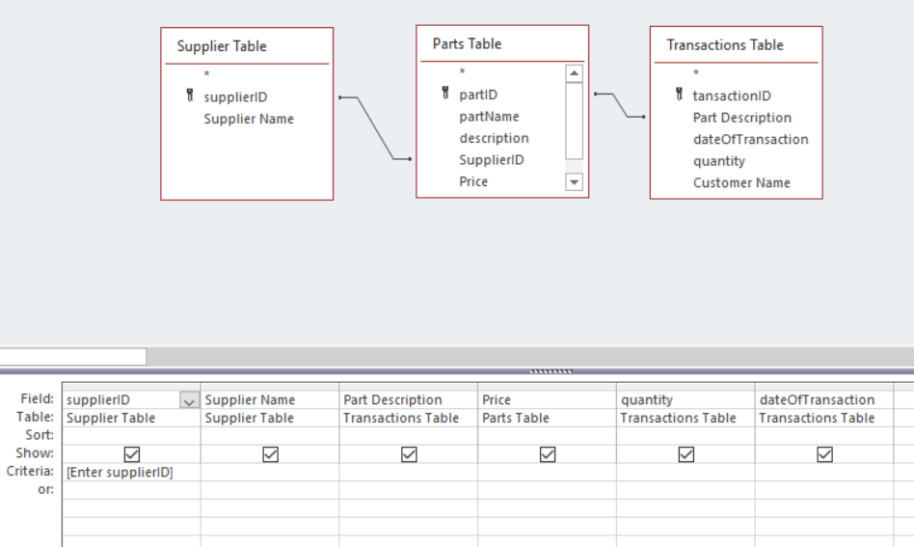

The output below shows that the tables are relating together as expected:
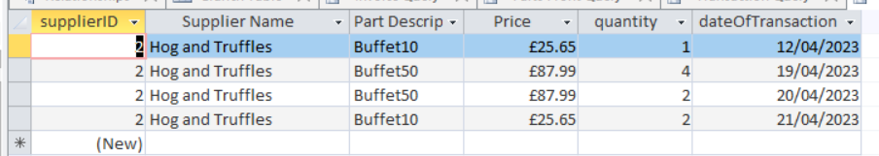

The following is a query utilising the CustomerVenue and Venue table to help generate a report on Customers Venue choice and cost. 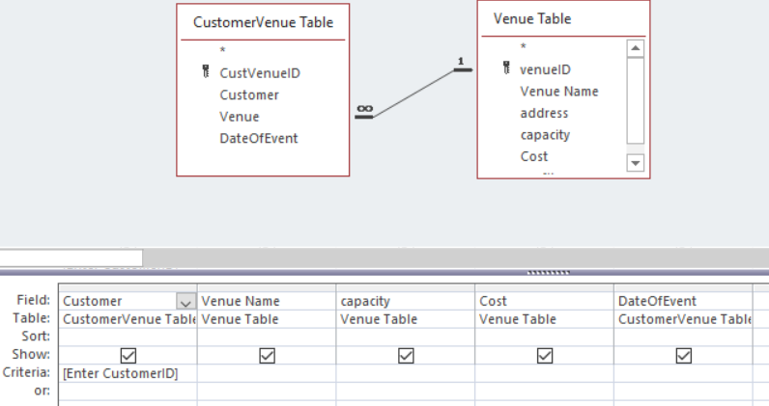

The output shows that these tables relate together correctly:
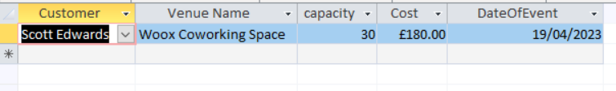

User Requirements

The user requires the database to be user friendly and easy to manoeuvre. To aid in this I have made it so upon opening the database the ‘Global Access’ form opens automatically. [1] The global access form contains button links to Customer Queries eg how much a customer has spent on Customer Additions as well as on venues. It also contains staff specific button links [2] to other forms, such as New Customer Form and Customer Purchases form as well as more queries to view information such as how much is owed to which supplier and venue. Lastly it contains button links to Queries to show how much profit has been generated from customer additional purchases and venues.
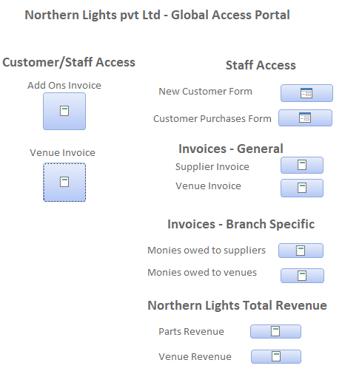

To further satisfy the user requirements I have made a series of Queries and Reports.
A sample of some of the queries which can be found in the access document:
Invoice Query – This query prompts the user to enter a customer ID to show only the transactions made by that particular customer. It links 3 tables together, Parts Table, Transactions Table and Customer Table. It utilises a calculated column to multiply the price (stored in the Parts Table) by the quantity (stored in the Transactions Table) to show the total value of the transaction.
Parts Profit Query – This query is used to generate a report on Northern Lights profit from each supplier and works by utilising the relationships between the Supplier Table, Parts Table and Transactions Table. 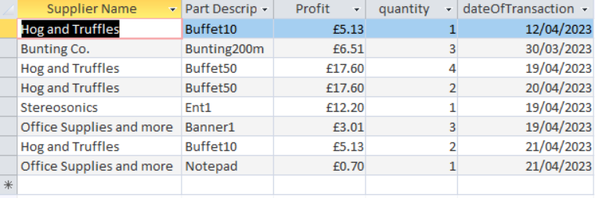
Supplier Query - This query prompts the user to enter a supplier ID. The query exists to generate a report containing how much money is owed to each supplier and also utilises the relationships between the Supplier Table, Parts Table and Transactions Table.
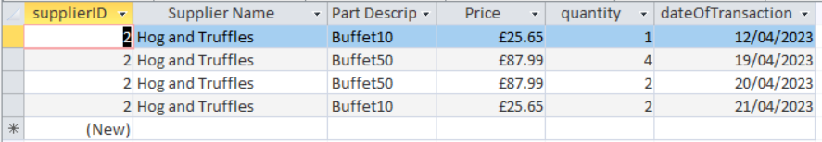
Transaction Query w Branch – This query stands to link Parts Table, Transactions Table, Branch and Customer Tables. The query works and displays the relevant information. 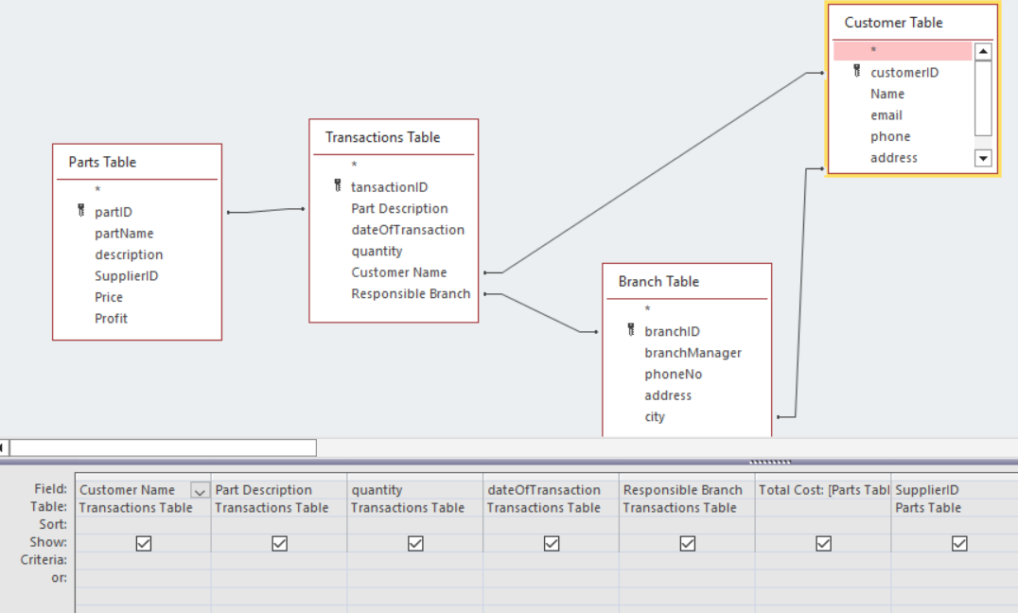
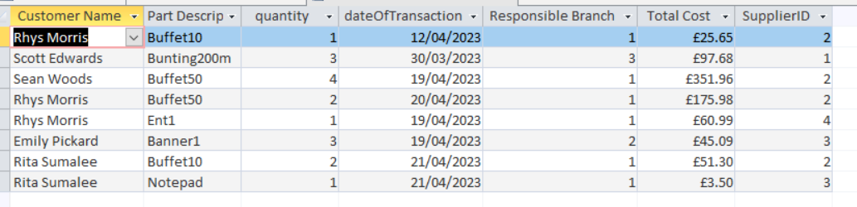

I have created 2 forms and 2 subforms to use in my database:
Main Transaction form – This form is used by Staff to input all customer purchase information, such as buffets or entertainment as well as the venue the customer has chosen. The form also gathers which city the customer is from and from there allocates a Customer Point of Contact by looking at the Branch Table and matching the cities before displaying the branch managers name, phone number and office location. This form utilises subforms to store and display this information.
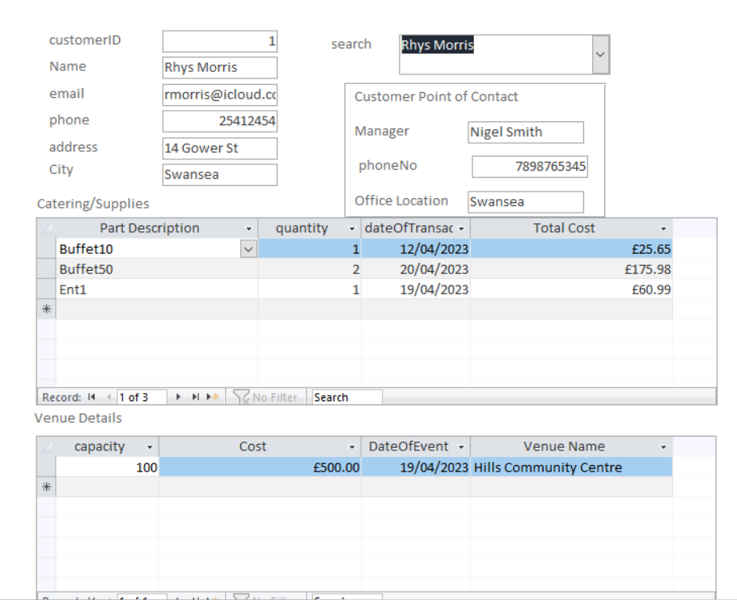

New Customer Form – This form would be the first port of call for a staff member once a customer is ready to place an order. The Staff member can open the New Customer Form and go to the last record of the form to enter the new customers information, this is to distance regular users from having to deal with tables to input data. 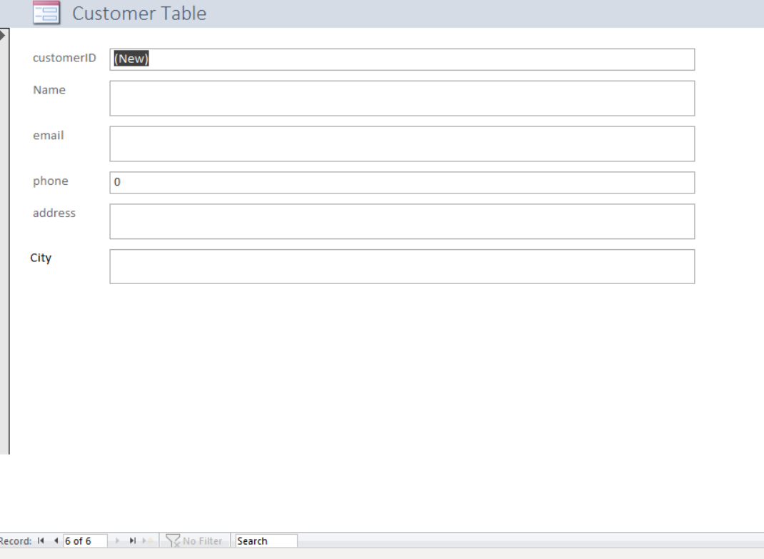

I have created a series of reports to display useful information, some of my reports include:

Customer Parts Invoice – This report prompts the user to enter a Customer ID, it then displays all part purchases a customer has made and utilises a sum held in a customerID footer to add all the individual purchases together to display a total, this constitutes the users part invoice. 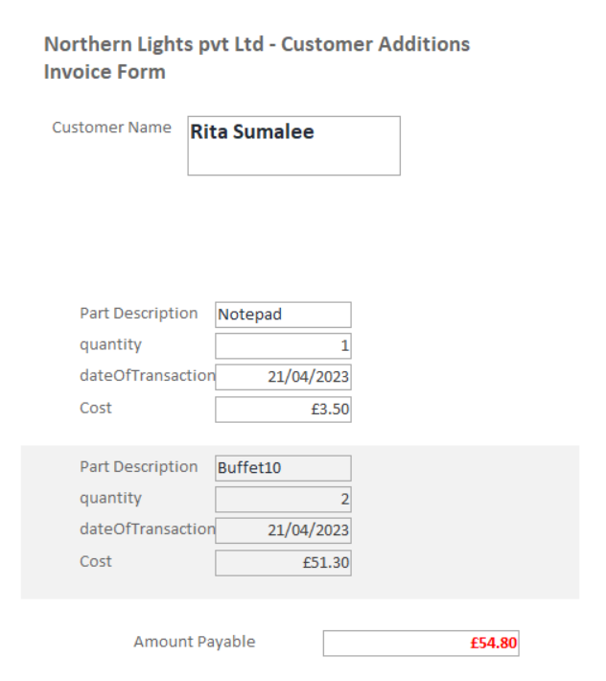

Customer Venue Invoice – This is much the same as customer parts invoice but stands to invoice the customer for their venue of choice. 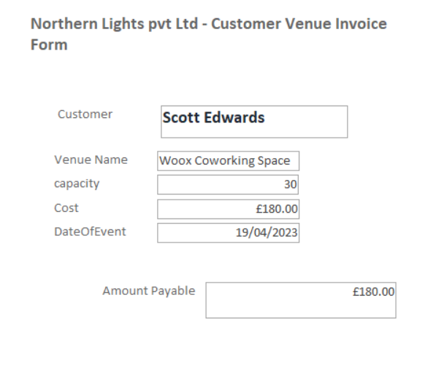

Supplier Invoice (general) – This report shows all the money owed by Northern Lights to a certain supplier:
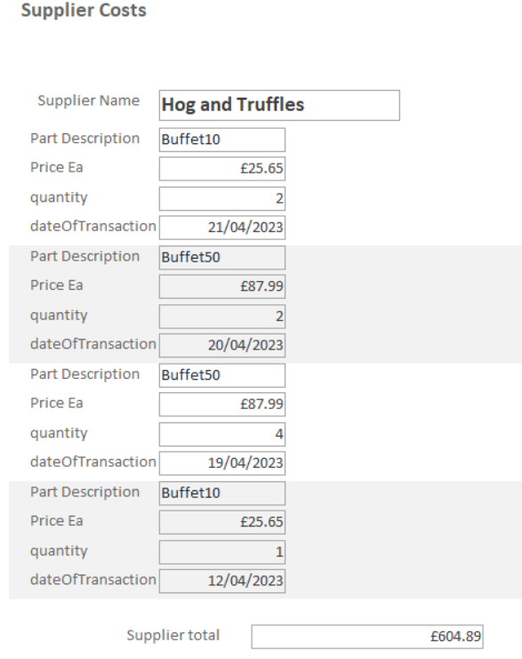
Venue Invoice (general) – This report shows what is owed to each Venue from Northern Lights. 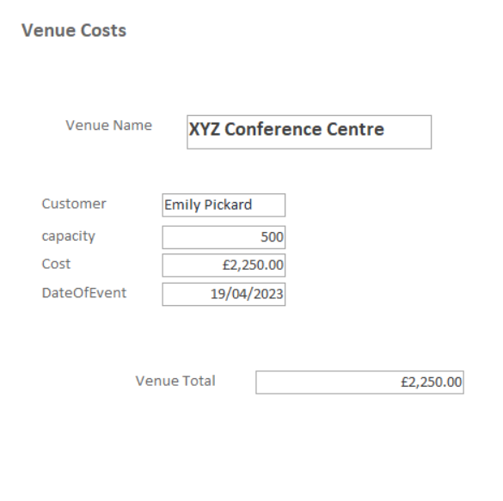

Monies owed to suppliers (Branch Specific) – this report details which branch is responsible for paying certain suppliers money, this works by linking the customer to a branch and then linking the customers purchase to that same branch. 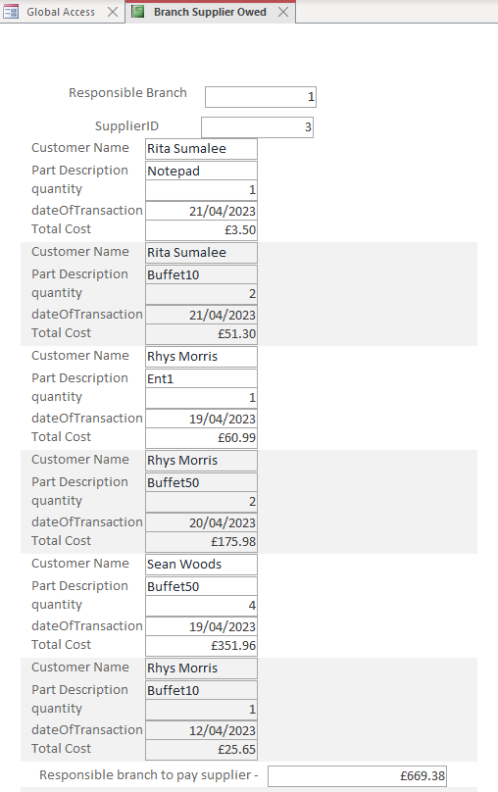

Monies owed to Venues (Branch specific) – this report details which branch is responsible for paying certain venues, again this is linked via a customers city linking them to a certain branch and then linking that branch to a customers purchase. 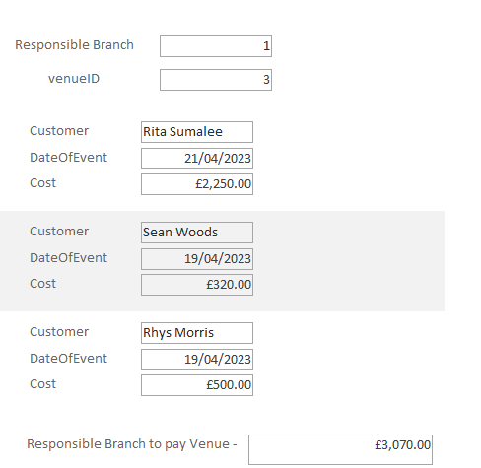

Parts Revenue report – This report details all profit made by Northern Lights Ltd from each supplier, the profit is calculated in the parts table by multiplying the part cost by 20% as shown: 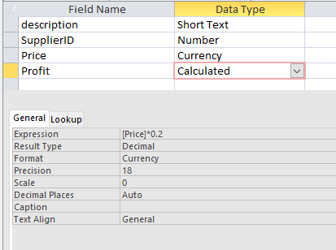
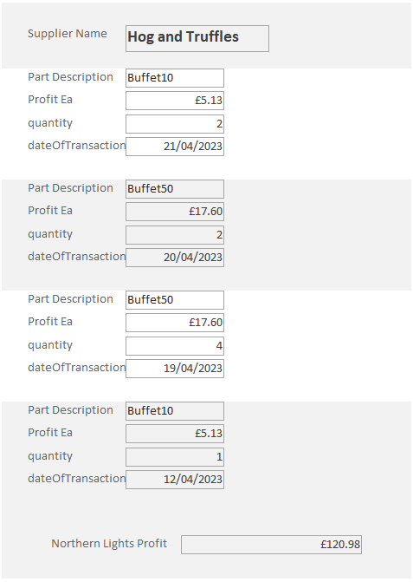

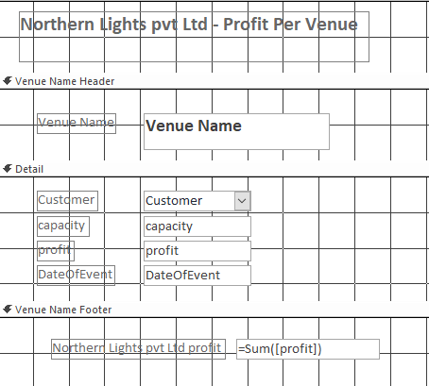
Venue revenue report – This report details profits made by Norther Lights Ltd from each venue. The profit is calculated in the same way as the Parts Revene above, by multiplying the cost by 20%. I have also utilised a grouped header and footer to make the report easier to read. [3] I have then used a sum in the footer as shown:
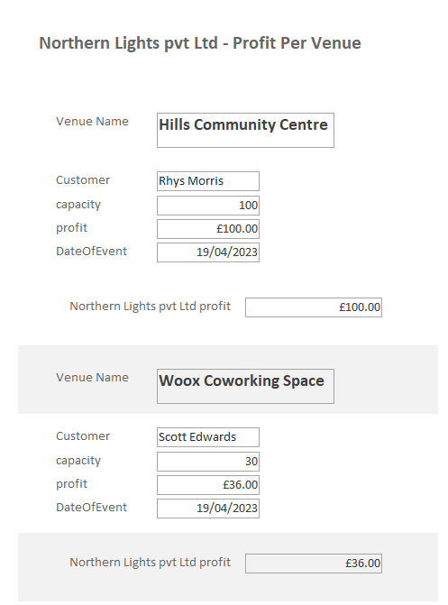

Conclusion

Overall I am pleased with the outcome of my database, completing this database has given me a much better insight into how databases are planned and created for a real world applications. I have satisfied many of the customer requirements and I think my database would be a useful asset to Northern Lights pvt Ltd. One shortfall of my database is the lack of utilisation of the branch and staff tables. If I were to undertake this assignment again from scratch, I would incorporate another report which stipulates which staff would need to be on hand at a given event.

References

[1] | Microsoft, “Set the default form that appears when you open an Access database,” Microsoft, [Online]. Available: https://support.microsoft.com/en-us/office/set-the-default-form-that-appears-when-you-open-an-access-database-94961011-392f-4c3b-8dbc-e5d5adbff1df. [Accessed 01 04 2023].
[2] | Microsoft, “Use a command button to start an action or a series of actions,” Microsoft, [Online]. Available: https://support.microsoft.com/en-us/office/use-a-command-button-to-start-an-action-or-a-series-of-actions-c7bf2827-2f3e-42b8-83d6-6c4f0de78990#:~:text=is%20not%20selected.-,On%20the%20Design%20tab%2C%20in%20the%20Controls%20group%2C%20click%20Button,comma. [Accessed 02 04 2023].
[3] | maryannrichardson, “Make Access reports easier to read with group headers and footers,” Tech Republic, 20 06 2006. [Online]. Available: https://www.techrepublic.com/article/make-access-reports-easier-to-read-with-group-headers-and-footers/. [Accessed 05 04 2023].

