

LEVEL 5

SEMESTER 1 and 2

MODULE CODE: SHSS5085
Personal Skills
aSSESSMENT TYPE: project
Assessment/Component: 1

COMPONENT WEIGHTING: 25 %

WORD COUNT: 1500 WORDS

MODULE TUTOR: Graham Harvey

SUBMISSION DETAILS:

Produce a benchmark statement of your personal skills in relation to an appropriate recognised standard. Also produce a detailed plan of progressive skill development towards attaining an appropriate higher point in relation to that standard. You must provide a rationale for the format of the logbook that you will use to record your skills development throughout this module.

Submit via Turnitin on 8th November 2019

School of Sport, Health & Outdoor Education

Assessment Feedback Sheet

Student No./Name: 1805509/ Elise Cox
Module: Personal Skills
Module Code: SHSS5085

Personal Evaluation – to support your academic progress please complete the section below BEFORE submitting your work.
What do you consider to be the best aspects of this work? |  |  | The research around smart goals
Which aspects do you consider could have been improved in this piece of work? |  |  | The recourses used
What have you found most satisfying whilst undertaking this submission? |  |  | Its made me see the value of thinking and planning ahead
ASSESSMENT CRITERIA | Learning  Outcomes |  | GRADE
ASSESSMENT CRITERIA |  |  | Poor  < 20% | Weak  20-29% | Unsatisfactory  30-39% |  | Satisfactory  40 – 49% | Good  50 – 59% | Very Good  60 – 69% | Excellent  70 – 84% |  | Exceptional  85– 100% | %
Select an appropriate NGB standard to benchmark your current skills against and provide a rationale for your selection. | 1 |  |  |  |  |  |  |  |  |  |  |  | 20%
With reference to the syllabus of your chosen award, produce a series of strategic short term SMARTER goals conducive to meeting the long term skill development plan | 1 |  |  |  |  |  |  |  |  |  |  |  | 30%
Outline a list of necessary resources and environments/ venues and explain how they might be employed to aid your skill development | 2 |  |  |  |  |  |  |  |  |  |  |  | 30%
Provide an example page of the logbook that you will use to chart your skill development with a brief explanation/ rationale of your chosen format and content. | 1  4 |  |  |  |  |  |  |  |  |  |  |  | 10%
Evidence of relevant research | 1  2 |  |  |  |  |  |  |  |  |  |  |  | 10%
It is expected that students will present work that is proof read, correctly referenced and adheres to the Assessment Checklist. Therefore a range of 0 – 10 marks will be deducted for non-completion of any of the points on the checklist below.
TUTOR COMMENTS:

Submission date:  via Turnitin |  | Return date:  (at least within 4 weeks) |  |  |  | Tutor: |  |  |  |  | Mark:

Assignment Checklist

- Please complete the Personal Evaluation section of the Assessment Feedback sheet, add your name and details, and paste the whole of this assignment document into the front of your assignment

- Submission is a single word file, clearly labelled with your name and module code
- Font style - Times New Roman, size -12 for text and 14 for headings
- Ink colour – black only
- Line spacing – 1.5 line spacing and 2cm- 2.5cm page margins
- Quotations more than three lines to be indented 1 line spacing
- One line space between paragraphs, paragraphs must be left aligned
- Pagination (your assignment should have page numbers)
- All tables and figures are internally referenced and have a title
- Word count checked and written at end of text (before references and any appendix)
- Assignment is within 10% of the word limit (excluding references and any appendices)
- All references in the text are included in the reference list
- Correct referencing following the Harvard style, as described in the Palgrave study skills book ‘Cite them Right’.
- Correct spelling using UK English
- Correct use of punctuation
- Grammar and syntax correct- double check anything that has a green line under it
- I have read my assignment out loud to myself and it makes sense and is easy to read
- Somebody else has read my work and it makes sense to him or her!
- I have checked and I have not plagiarised
Failure to follow these guidelines will cost you marks!

To develop my personal skills in paddling I have decided to use S.M.A.R.T.E.R goals. This requires me to break down my goal into smaller goals so that I can achieve my overall goal. Research shows that there are a number of variations of how to define S.M.A.R.T.E.R goals. Haughey (nd) shows many variations of each letter. I have followed Lawlor (2012) and University of California (nd) for my approach.

S- Specific, what I will accomplish?
M-measurable, how will I measure my progress?
A-attainable, is this goal achievable?
R-relevant, will it help me achieve my end goal?
T-time bound, will I be able to achieve this in the time I have set myself

The E and R aspects of S.M.A.R.T.E.R can only be analysed once the activities take place and these are ongoing and will be documented in my logbook.
E – evaluative, assessing my progress.
R- reflective, where can I improve or adapt my technique? (Haughey, 2014)

My overall goal is to gain the sea kayaking award while attending the sea kayak expedition that is taking place in Scotland in April. I have very little experience kayaking; however, I do have a basic understanding of safety in white water and I have decided to set my goals based on this. In preparation to achieve this I have decided to set myself more achievable goals so that I can gain the confidence I need to go on the expedition. I will be attending sessions with the course instructors to gain these goals, in the meantime I will be furthering my knowledge by reading Sea kayaking by John Dowd (1997) and Whitewater and sea kayaking by Kent Ford (1995).

Firstly, I would like to achieve the Paddle Start Award (British Canoeing Awarding Body, 2019). This is a basic award which will introduce me to paddling and give me a basic understanding of how to kayak. It will provide information on the equipment I will be using, how to safely put the kayak into the water without damaging it and how to get the boat moving and to bring it back safely to the return point. I will be able to measure my progress as I will have instructors teaching and assessing me in order to give me my Paddle Start Award. This goal is attainable as I have already had some experience in the water and I have a basic understanding of water safety. I feel this is a relevant goal as it would be a good way for me to start paddling and give me some confidence to complete further smart goals. The award is achievable in this time frame as according to the British Canoeing website I will be able to achieve this in one 90-minute session (Britishcanoeing.org.uk, 2019). We will be going out on sessions with the university where I will be able to complete this.

The second goal is to learn and perfect how to roll a kayak. This technique is an essential life saving skill (Ford, 1995). Knowing how to perform this move safely will be essential for the sea kayaking expedition in Scotland, especially as the water will be cold and it is important to get yourself out of the water fast; this will minimise the risk of getting hypothermia or drowning. I feel if I can perfect this technique then I will have more confidence in my own safety while on the water. I will be able to practice this technique with the guidance from instructors on the lake in Llandysul. I can use the time with instructors to practice this and while not on the water I can further my knowledge with reading and watching videos. According to Ford (1995) some people can learn this technique in one lesson and some people take more than a few lessons to perfect it. I have the time with the instructors to perfect this, however, if I have not mastered it, then in my own time I will take extra lessons from a local paddling club or friends.

My third goal is learning different strokes such as the forward sweep, reverse sweep and going forward; these are important on the sea kayaking expedition as I will need to be able to move on the water confidently. This will be measurable as the instructors will be able to correct me if my technique is wrong. This should be attainable as I have plenty of time with the instructors to perfect it and I have limited myself to the three basic strokes instead of trying to perfect all of them. It is relevant because I will need to be competent in a sea-going environment and be able to move the kayak confidently while on the expedition. This will be achievable in the time limit because I have limited myself to three basic essential strokes. However, if the instructors think I am competent in these three strokes, then I will challenge myself to learn further strokes such as draw stroke and reverse paddling.

The long term goal is to achieve the British Canoeing award for sea kayaking whilst on the sea kayaking expedition. This is the basic award for sea kayaking and it will help me challenge myself while on the expedition. This award goes into depth about kayaking in tides up to two knots and winds up to force 4. I will be taught a basic understanding about the equipment to be used at sea and how to cope with changing weather and being in water that is shared with other boat users. This will be measurable because I will be practising some of the aspects of this award during the six weeks as we will also be practising in a sea environment as well as a river. During the expedition the instructors will be able to measure my progress. It is attainable as I will have plenty of time to complete this and I will opportunity to practice after the six week course finishes. It is relevant because I want to set myself a challenge while on the expedition and for my own benefit. As it is a long term goal, I am not limiting myself to time, but I would aim to complete it by the end of the sea kayaking expedition.

I will be able to complete the sea kayaking award with the instructors on the expedition. I hope to gain a better understanding of navigation at sea, as not only is it important to learn, but I have been finding navigation on the hills interesting and I would like to be able to adapt the knowledge I already have to a sea environment.
I will be using venues such as Llandysul Paddlers for their lake to practice rolls and basic skills, as well as the use of the river which caters for people with different abilities. We will also be taken to a sea environment; however, the venue is unknown until closer to the time. For my own practice I could take extra lessons at Llandysul Paddlers and also go out with experienced friends as I live near the coast. I can develop my knowledge of navigation and kayaking skills by researching kayaking books such as Dowd (1997) and Ford (1995) and online resources such as Exeter canoe club (2014) and Kayarchy.co.uk (nd) which have in depth details about sea navigation. I am also aware that on the sea kayaking expedition I will need to be physically fit because we will be paddling everyday, therefore I will train at the gym using equipment such as rowing and cycling machines.
I will be using equipment such as kayaks, spay decks and buoyancy aids from the university, however, from previous experience in the water last winter I learnt that the wetsuits from university do not keep me warm enough in the water, therefore, I have purchased my own winter wetsuit to keep me warmer for longer.

I have decided to create a logbook for my paddling module based off logbooks I have used previously and have adapted these to suit my goal. This logbook will contain the E and R from S.M.A.R.T.E.R goals. This is where I shall evaluate and reflect upon the activity that has taken place. Last year I used a log book, which had a lot of detail about risk assessments (appendix 1). I feel risk assessing is an important habit for an outdoor practitioner to have. I will be including a brief risk assessment in my log book as I feel this will be good practice. Another example log book I have used is my diving logbook (Appendix 2). This logbook is issued by the Professional Association of Diving Instructors (PADI) (Padi, 2019). This logbook helped me see my progress with diving and I can take the weather recording aspect and apply it to my log book for paddling.
Date
Location
Description of activity
Weather | Windspeed:  Wind direction:  Temperature: actual: feels like:  Overall forecast:  If out at sea  Notes of tides:
Brief risk assessment
Technical terms learnt
E-Evaluation
R-Reflection
Word count:1475

Appendix 1
Example of paddling logbook.
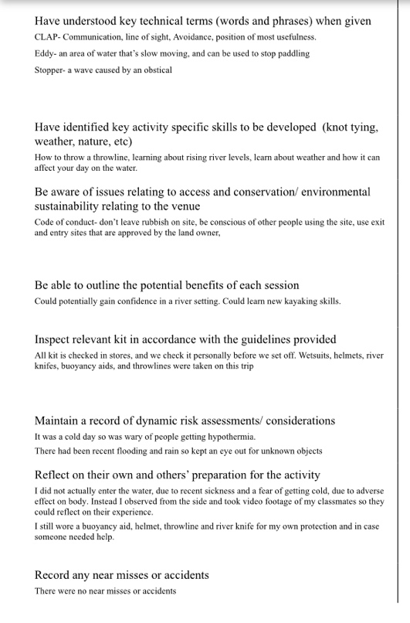
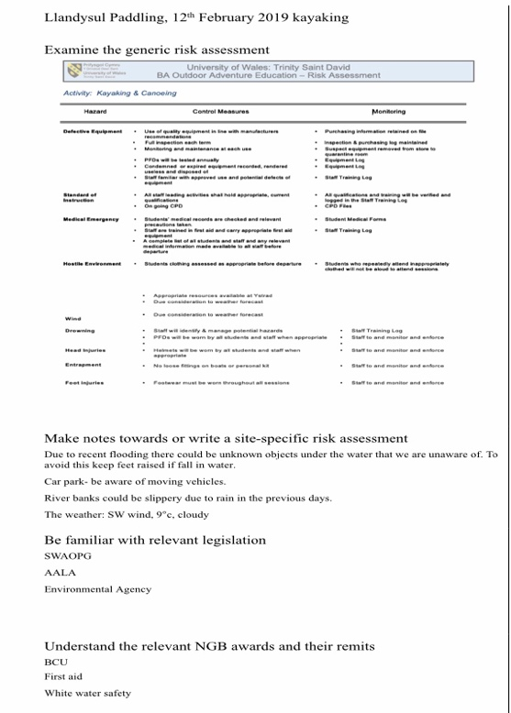

Appendix 2
Example of diving logbook used by PADI
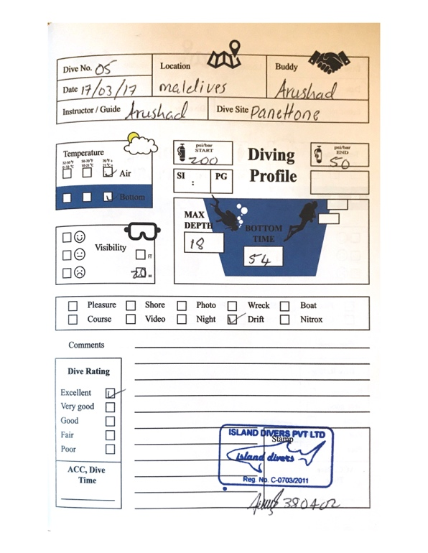

Referencing
British Canoeing Awarding Body. (2019) New Personal Performance Awards - British Canoeing Awarding Body, Available at: https://www.britishcanoeingawarding.org.uk/new-personal-performance-awards/ [Accessed 10th October 2019].

Britishcanoeing.org.uk. (2019) Homepage, Available at: https://www.britishcanoeing.org.uk [Accessed 10th October 2019].

Blaine Lawlor, K. and Hornyak, M. J. (2012) Smart Goals: How the Application of Smart Goals Can Contribute to Achievement of Student Learning Outcomes, Available at: http://dysgu.ydds.ac.uk/pluginfile.php/310292/mod_resource/content/0/SMART%20goals%20and%20student%20learning_Lawlor_2012.pdf [Accessed: 18th October 2019].

Ford, K., (1995). Whitewater and sea kayaking. Chapaign, Illinois: Human kinetics.

University of California. (ND) Smart goals: A how to guide, Available at: https://www.ucop.edu/local-human-resources/_files/performance-appraisal/How%20to%20write%20SMART%20Goals%20v2.pdf [accessed: ^{18th} October]

Haughey, D.(ND) Smart goals, Available at https://www.projectsmart.co.uk/pdf/smart-goals.pdf [Accessed: 18th October 2019]
Haughey, D. (2014) A brief history of smart goals, Available at https://moodle.uwtsd.ac.uk/pluginfile.php/71206/mod_resource/content/0/brief-history-of-smart-goals.pdf [Accessed: 18th October]
Exeter canoe club (2014) Navigation for kayakers, Available at:
https://www.exetercanoeclub.org.uk/wp-content/uploads/2014/11/Navigation-for-Kayakers-0814.pdf [Accessed: 19th October]

Kyarchy.co.uk. (no date) The sea kayakers free online handbook, Available at:
https://www.kayarchy.co.uk/html/02technique/005seakayaknavigation/001basics.htm [Accessed:19th October]

PADI. (2019). Professional Association of Diving Instructors PADI, Available at: https://www.padi.com [Accessed 22 Oct. 2019].

