BRITISH AIRWAYS ANALYSIS

Student’s Name: Dragos Preoteasa,Mihai Petrina,Ion Duluman,Stefania Prohnitchi,Daniel Mihai
University Name: University of Wales Trinity Saint David London

Executive summary
The purpose of this report is to provide detailed analysis of British Airways. It aims to determine the importance of goals and objectives in the business organization and states the current objectives and goals of the chosen business organization British Airways. The report begins by provide summary of the company background and the background of the research. It determines the management and leadership approach at British Airways with the implementation of management models and theories. The managerial theories and models will be used to determine the management approach and leadership styles implemented by British Airways. It also analyses the employee culture and team behaviour of the business organization. It determines the group and team behaviours as well as the motivation and perception of the employees. Lastly, it sums up the main points and concludes the report.

Table of Contents
Introduction 2
Background information 3
• Goals and objectives 5
Goal setting theory in organizations 5
Establishment of goals and objectives 5
Importance of goals and objectives 6
Goals and objectives of British Airways 6
• Leadership and management behaviours 7
Leadership and managerial approach at British Airways 9
• Group and team behaviours 11
• Motivation and perception of the employees 16
Maslow’s Hierarchy of needs 16
Employee motivation at British Airways 17
McGregor’s theory X and theory Y 19
Application of the theory Y on British Airways 19
Employee inclusion and diversity 19
Conclusion 20
References 22

Introduction
British Airways is an airlines business organization headquartered in United Kingdom. The business organization is set upon to be one of the biggest airlines company in United Kingdom based on number of international flights and international destinations. British Airways is formed with the collaboration to two airlines companies including British overseas airways corporation (BOAC) and British European Airways Corporation (BEA) and other two smaller airlines including Cambrian Airways Cardiff and Northeast Airlines Newcastle upon Tyne. British Airways has seen much growth and popularity since the past few years (Britishairways.com. 2020). Today, the business organization is the “world’s favourite airline”. British Airways has a fleet of more than 300 aircraft and operates fights to other international destinations in more than 70 countries. The aircraft of British Airways carries more than 40 million passengers every year. Therefore, are various opportunities as well as threats in the business environment in which British Airways operates. It has enjoyed profitable growth and enhances performance since past years. However, the company has been facing challenges both operational and strategic created by Brexit. It has a substantial impact on the operations and core activities of the business organization. The British Airways has been highly efficient in overcoming various challenges and threats from the external business environment through effective strategies and operational efficiencies (Airways 2017). The business organization has been planning to increase its visibility further by growing its international network. Henceforth, it has been investing in several areas including technology, employee satisfaction, customer satisfaction and customer experience. The company has been planning to make its fleet more fuel efficient and sustainable in the market. The business organization has been able to build strong brand recognition and continues to improve its performance strategically. It has been able to deal with the challenges from the external business environment and position the brand against the ongoing challenges (Airways 2017). The purpose of this report is to analyse the goals and objectives of the business organization. It determines the leadership and management behaviours within the British Airways. It provides detailed description of the group and team behaviours of the business organization. Further, it provides description and analysis of motivation and perception of the employees. It determines the employee culture with the management theories and models.

Background information

The report provides detailed information regarding the well-known and prominent organization of UK, British Airways. It is one of the largest international airlines with more than 550 destinations across the world. The business organization is known for its highest standards and is internationally recognized across the world as per the reviews by the airline’s critics and the potential customers of the business organizations (Airways 2017). Organizing and managing the internationally recognized business organizations requires high level of dedication and highly efficient management. It is crucial for the business organizations to monitor the external business environment and implement strategies as per the ongoing business trends, consumer preferences and the actions undertaken by the competitors in the market (Grundy and Moxon 2013). It is also essential for the business organizations to determine the appropriate leadership styles and managerial approaches suitable for the business organizations as per the changing business environment and the moves of the competitiveness. It is believed by Grundy and Moxon (2013), that different leadership styles and management approaches must be implemented based on the situation in which the business organizations are operations. It is crucial for the business organizations to provide valuable leadership guidance to the employees and ensure that they are provided with satisfactory work environment to boost their level of motivation and direct them towards achieving the organizations goals and objectives (Lange et al. 2015).
In United Kingdom, the aviation market is growing at a rapid rate. The aviation market contributes majority to the overall growth of the business organizations. It also facilitates the growth of travel and trade in the country. British Airways is one of the leading companies operating in UK. The employee’s culture, efficient of the company’s management contributes to the overall success of the business organization. However, British Airways faces stiff competition from easy JET, JET2, Flyby, American Airlines, United Airlines and Monarch Air group (Madar 2015). These are direct competitors of British Airways, offering similar services to the consumers at a cost-effective pricing. The revenue of British Airways is ranked 5th among the competitors in the market. The company alone employees 42,000 employees and is ranked 7th among its competitors in terms of number of employees. Easy Jet is one of the top competitors and is headquartered in Bedfordshire, England. The company operates in Airlines Field and generates 45% of revenue of British Airways. Jet 2.com is also one of the top competitors of British Airways headquartered in Leeds (Coller et al. 2016). The company generates 16% of British Airways revenue. Virgin is also one of the competitors and employees 27,000 more employees as compared To British Airways (Coller et al. 2016). The headquarters of Virgin is in London, England and is in diversified financial services field. These are direct competitors of British Airways. The indirect competitors of British Airways are Flyby, American Airlines, United Airlines and Monarch Air group who offers the services at a comparatively lower price (Coller et al. 2016). These competitors bring forth new innovations and might threaten the position of British Airways in the market.

• Goals and objectives

Goal setting theory in organizations
Goals and objectives are an essential part of conducting a business organization. Formulating and implementing well defined goals and objectives enables the business organization to choose, design and implement targets to achieve the desired results of the business organizations (Elmorshidy 2013). Goals and objectives provide motivation and direction to the business organization which is highly essential for ensuring growth and overall success of the business organization in different areas. The goal must include an accomplishment that must be attained by the business organization. There must be a measurable outcome in accordance with the surrounding situation (Les MacLeod EdD, M.P.H., 2012). There must be identifiable signs of success along with specific data and time for the accomplishment. Moreover, it is details such as money, time and resources are included which is required for attaining the desired goal and objective.

Establishment of goals and objectives
To formulate the goals and objectives, the business organization must be clear regarding the purpose of the business organization and the things that are to be accomplished by the business organizations (Tunnicliffe et al. 2020). The business objectives and goals must be SMART (specific, measurable, achievable/attainable, realistic and time bound). A well-defined goal and objective define the responsibility of every individual with the objectives that are specific in nature, are attainable, realistic, and measurable and time bound. To ensure that the goals and objectives are effective, the employees must be provided with feedback to analyse the progress of the business operations in relation with the present goals and objectives (Bixler et al. 2016). By measuring the progress of the business operations, the employee would have detailed knowledge about their progress and the effort required to attain the desired goal and objective of the business organization.

Importance of goals and objectives
Objectives enable the business organization to define the ultimate goals of the business organizations. It helps the organization to identify the conflicting activities and provides detailed guidance to the elements in the decision-making process. Furthermore, it enables the business organization to ensure accountability of personnel within a business organization (Bixler et al. 2016). In other words, it can be said that objectives of the business support decision making in the business organizations, while the objectives are formulated considering the goals and purpose of the business organizations. Considering these present goals and objectives, the overall operations of the business organization are taken into consideration. Well defined goals and objectives enable the business organization to support the activities of the business organizations (Bjerke and Renger 2017). It is believed that goal and objective setting are highly influenced by the values and the personal standards of the business organizations. This in turn influences decision making in the business organizations (Podgorodnichenko, Edgar and McAndrew 2020).

Goals and objectives of British Airways
The British Airways focuses on variety of goals and objectives for short term and long-term survival of the business organization in the highly competitive global market. The general objective of British Airways is to become the world’s largest airlines leaders in global premium airline (Coller et al. 2016). The goal of the business organization is to build on terminal strengths to upgrade customer experience and continue to make the business cost effective while ensuring corporate responsibility (Coller et al. 2016).
The business organizations continue to focus on customer service at every level of passenger’s journey. The general objectives of the business organization are divided into three main areas including (Ustaomer, Durmaz and Lei 2015):
- Global appeal to wide range of consumers for both leisure and business travel in order to ensure repeated sales
- To ensure premium services to the passengers and ensure that the passengers are provided with highest quality of services
- Focus on the maintain ace of the aviation with largest products, equipment’s, and services.
The strategic objectives of the British Airways are given below in details:
- To become an airline of top choice for international flights especially for premium customers, cargo, shorter flights and economy flights
- To provide top quality services to the customers and provide best customer service for the passengers for all routes
- To improve the company’s online services and ensure global city growth
- The objective is to expand its list of top tier countries through strategic airline partnership
- To meet the needs and demands of the consumers and enhance customer loyalty of the business organization

• Leadership and management behaviours

Effective leadership and management are highly essential in business organizations to plan, organize and coordinate the activities as well as controlling the affairs of the business. Management brings together the resources and motivates the employees to achieve the present goals and objectives of the business organizations. It is the development of people and the job of the management is to ensure co-operative endeavour to function properly (Harris and Jones 2018). On the other hand, leadership is the means of directing and influencing the employees of the business organization towards attainment of goals and objectives. It is a human factor which helps to motivate the employees towards the goals and objectives (Willis, Clarke and O'Connor 2017).
According to Henry Mintzberg there are ten management roles as described in his book “Mintzberg on Management: Inside our Strange World of Organizations” in 1990. The ten roles of the management are figurehead, leader, Laison, Monitor, disseminator, spokesperson, entrepreneur, disturbance handler, resource allocator and negotiator (Le and Lei 2018). These roles can be further divided into three main categories:
Category | Roles
Interpersonal - This category involves providing relevant information | Figurehead – (the manger must have social, ceremonial, and legal responsibilities)  Leader – (leadership is used to manage the performance and responsibilities of employees in organizations)  Liaison – (the managers needs must be able to communicate with internal and external contacts)
Informational – The managerial role is to process information | Monitor – (the manager monitors the team productivity, their wellbeing, and changes in environment)  Disseminator – (They communicate potentially useful information to the team and colleagues.)  Spokesperson – (they represent and speak as a representative for the business organization).
Decisional – this category involves utilizing the available information | Entrepreneur – (As a manger, they must control change in the organization while implementing new ideas.)  Disturbance Handler – (The mangers mediate disputes within the organization)  Resource Allocator (The available resources of the organizations are allocated among the employees and staffs)  Negotiator – (They undertake important negotiations within the business organizations)
Source: (Mintzberg 1989).

Leadership and managerial approach at British Airways
Alex Cruz the CEO of British Airways undertakes major decisions of the business organizations after discussion with the boards of directors. The leaders and managers of British Airways possess a persuasive type of leadership approach in the business. British Airways is bold in their leadership approach and occupied with high effective and potential leaders. The managers and leaders at British Airways work towards creating an inclusive culture within the organizations (Baker et al. 2014). They understand and respect the individual differences of the employees. The employees of diverse backgrounds are hired which leads to potential new ideas and innovation. The management ensures flexible working environment, gender equality, racial equality, and work environment free from harassment and bullying (Smith and McKee 2012). Flexible work environment is aimed to meet different types of work. The leaders of British Airways implement a transformational and situational style of leadership which reflects the company’s flexibility. The transformational leaders of the business organization work in teams to identify the required change in the organizations and guide the employees towards executing the change. The situational leadership style is implemented to ensure that organizational change is implemented as per the situational demand (Baker et al. 2014). This leadership approach enables the business organizations to cope up with the changing business environment while ensuring employee security and confidence.
Management plays an important role in ensuring the overall success of the business organizations. The managers at British Airways act as a figurehead who represents the overall business organization (Grugulis and Wilkinson 2014). They provide relevant information such as business goals and objectives at various levels of the business organizations. They also act as a leader, managing the performance of the employees and determining the progress of the business organizations as per the goals and objectives. The senior level managers and the senior executives of British Airways monitor the ongoing business operations as well as the changes in the external business environment (Harris and Jones 2018). The managers and the leaders of British Airways play different kinds of roles including interpersonal, informational, and decisional. The interpersonal roles of the mangers involve interaction with the staffs and the internal members of the business organizations (Knights and Willmott 2017). The information role of the mangers involves sharing, handling, and analysing different information within the business organizations. For instance, they determine the progress of each department and evaluate their progress as per the present goals and objectives of the business organization. The decision role of the management is to undertake decisions considering the ongoing changes in the business environment, changes in the needs and preferences of the passengers as well as the moves of the competitors in the local and global market(Ahmed et al. 2012). The decisions are undertaken by the senior level management and are finally approved by the CEO of the British Airways, Alex Cruz. These managerial and leadership approaches of the business organizations perform all the defined roles and responsibilities of the management as per the ongoing business situation (Mills 1995. All the decisions undertaken by the management contributes to the better results and attaining excellence in performance.

• Group and team behaviours

According to Hofstede’s, culture of the business organization provides guidance to the employees and their behaviour in the working environment. The employee culture of a business organization can be identified with the help of model of culture popularized by Charles Handy (1999). The approach of this model can be used to determine the type of culture within the business organization and the ways in which the employees behave within the work environment (Handy 1995).

Hendy’s four types of organizational cultures
There are mainly four types of organizational culture which directs the behaviour of the employees and supports the employees. The four types of culture are (Handy 1995).:
Power culture:

Power culture is like that of a spider’s web. The whole organization sits at the centre surrounded with ever widening circles of influence and intimates. The closer to the spider, the more influence an individual have (Handy 1995). However, in this type of culture, the overall success of the business organization is heavily dependent on the abilities of the people at the centre of the organizations (KANE‐URRABAZO, C.H.R.I.S.T.I.N.E. 2016). It tends to attract people who are power oriented and are more political minded. In this type of culture, the performance of the business organization is heavily dependent on the results. This leads to low morale and high rate of employee turnover.

Role culture:
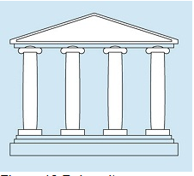
The role culture can be described as the building supported by beams and columns, each of the columns and the beams have specific role to be played to ensure that the building keeps standing. The individuals are role occupants (Hendry 1999). This is characterized by string functional and specialized areas coordinated with senior management at the top with high degree of standardization and formalization. The interactions among the employees and the members are controlled by the rules and procedures which define the job, mode of communication as well as settlement of disputes (Pheysey 2013).
Task culture:

Task culture can be described as job and project oriented. Some of the strands of the net are thicker and stronger among the others which indicate power and influence (Nikčević 2016). Task culture is associated with companies which adopt matrix or project-based structure designs. The focus is to get the job done and the culture seeks to bring together the right people with appropriate resources and at the right level to complete a tasks or projects. This success of the organization depends on the unifying power of the group to enhance the efficiency of the business organizations considering the objectives of the business organizations (Russo et al. 2013). The influence of the business organization is entirely based on expert power rather than position power. Task culture depends on the teamwork and group work.
Person culture:

Person culture can be described as a loose cluster or constellation stars. The individuals are the focal points, it exists only to assist and service the individuals within it (Handy 1995). Not many organizations exist in this type of culture as majority of the organizations form corporate objective and personal objective (do Carmo Silva et al. 2015).
Employee culture at British airways
The culture of the employees at British Airways is based on the hierarchy system where the information and the planning of the business organization is passed down from the boards of directors to the executive managers and their distributed among different departments of the business organizations(Mills 2017). The information is distributed from upwards to downwards. At British Airways, both role and task culture are implemented out of the four Charles Handy’s four types of culture. The structure at British Airways is well defined and shared learning is encouraged. The employees at the business organization are aware of their roles and responsibilities and who they must report to. Task culture is also implemented within the business organization (Madar 2015). Teamwork is one of the core values at British Airways. The employees work in close collaboration with the teammates leaded by the leader to complete a specific task. This culture benefits the employees and they remain motivated. The employees in the business organization are empowered to undertake decisions within the team. The employee culture at British Airways is to work in collaboration with every individual within the organization from diverse cultural background (Shukla 2013). The employees at the company treat each other fairly without any form of discrimination as per the core values of the company.
Employee behaviour at British Airways
Behaviour of the employees within the organization is an organization is an integral part of organizational behaviour in a collective manner (Le and Lei 2018). The employee behaviour is directly or indirectly related to the work environment. The personality of the employees defines the behaviour of the employee within the business organizations. It is mostly related to personal as well as professional development. The perception of the individual employees regarding the goals and objectives shapes the behaviour of the employees within the company (Le and Lei 2018). The attitude of the employees, the leadership styles, communication, and organizational structure also impacts the behaviour of the employees within the organization.
The employee behaviour of the business organization is guided by the core values and culture of the business organization (Grugulis and Wilkinson 2015). As mentioned earlier, every employee at the organization treats each other irrespective of the differences in culture background. The diverse workforce of British Airways remains motivated as they work in collaboration and cooperation with each other member in the business organization. The positive work environment provides maximum employee satisfaction (Grugulis and Wilkinson 2015). This creates a conducive environment for the employees and provides them maximize security at all the times. The cultural practice of the business organization carters an excellent environment for the employees as well as the customers. The effective teamwork within the business organization contributes to the overall success and profitability of the business organizations. The goals and objectives of the business organizations are achieved in effective and efficient manner (Mills 1995). There are various factors which promotes the creation of effective teamwork such as diversity. The presence of various people with different cultural background, languages and beliefs promotes creativity and innovation thinking within the business organizations. The individuals are aware of different kinds of culture at same places. The employees work in a flexible work environment which positively impacts employee behaviour and provides them freedom to undertake smaller decisions. This motivates them to be more responsible in their behaviour (Ahmed et al. 2012). The structure and the task/role culture provide freedom to the employees and certain rights towards their roles and responsibilities. The lower level employees are provided with a flexible work environment and they report directly to division head (Grugulis and Wilkinson 2014). Therefore, in such environment, the employees are encouraging to work flexibly whereas enabling them to work in a responsible manner. The structure and culture within the business organization has significant impact on the behaviour of the employees in the business organization. The behaviour of the employees also impacts the result of British Airways in a significant manner (Grugulis and Wilkinson 2014).

• Motivation and perception of the employees

There are various types of motivation theories that can be applied in the organizations to determine the motivation level of the employees within the business organizations. The motivational theories help the managers of the business organizations to determine the motivational factors suitable for different types of employees working in the business organization (Malhi 2013). The motivational theories enable the business organizations to increase the effectiveness and efficiency and motivate them to attain the goals and objectives of the business organizations. Some of the motivational theories are described below:

Maslow’s Hierarchy of needs
Maslow hierarchy theory helps to identify the potential needs and demands of the employees. These needs are designed in hierarchical manner and prioritize the needs of the employees. According to Maslow, there are various types of needs with the passing time. The individual, who has achieved the first second, aspires to attain the needs of the next level and so on. The different level of needs includes (Lester 2013):

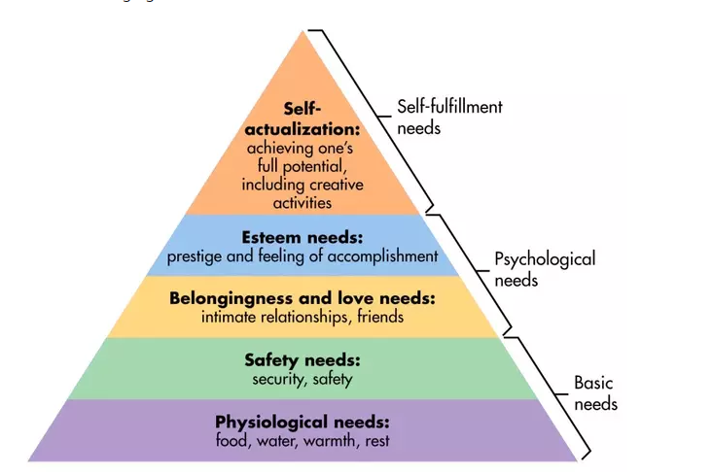
Description: Maslaw’s hierarchy of needs
Source: (Lester 2013).

Employee motivation at British Airways
First level – Physiological needs – These are most important needs of the employees. It includes emotional security, safe working environment, satisfactory salary, and incentives. The managers at British airways provide satisfactory salaries and wages with assured safe working environment which satisfies the basic needs of the employees (Malhi 2013).
Second level – Safety needs – this category of needs also falls under the basic needs and requirements of the employees. In business organizations the employees expect a stable working environment such as fair work practices, policies, pension. The employees at British Airways Are provided with flexible working environment, safe and secure working environment (Upchurch 2010). The employees are provided with benefits such as pension, incentives to meet their safety needs.
Third level – social needs – it determines the need for belongingness among the employees such as social acceptance. It implies friendship, trust, affective, acceptance and receiving. The employees at British Airways work in close collaboration with teams. This creates an opportunity to ensure belongingness in the business organizations thereby ensuring employees motivation and satisfaction (Kattara, Weheba and El-Said 2018). The employees at the business organization are highly inspired from leadership to educate and act.
Fourth level – self-esteem needs – These needs are self-fulfilment needs of the employees. It includes employee empowerment, public appreciation, and other types of employee recognition programs. The senior management of the British Airways ensures that every individual of the company are provided with adequate power and responsibility so that they feel empowered in the company (Kattara, Weheba and El-Said 2018).. Various employee empowerment schemes such as ‘employee of the year’ awards are used to motivate the employees. These actions and activities satisfy the esteem needs of the people and contribute to the ultimate success of the business organizations (Willis, Clarke, and O'Connor 2017). Moreover, the employees are provided with job titles, feedback of the job and position to ensure employee motivation and create a positive perception towards the business organization.
Fifth level – self-actualization needs – It also falls under the categories of self-fulfilment needs. It implies the desire of the employees for reputation, respect for others and sense of achievement. The management provided opportunities to the employees to think big and creative (Upchurch 2010). The employees are provided with innovative and flexible work environment to support innovation. They are further motivated through awards and rewards for best performance at work.

McGregor’s theory X and theory Y
According to the theory of McGregor, the human side of management recommends two main styles of management each retaining different needs of the employees. The two theories are mentioned below (McGregor 1960).:
Theory X- this represents the negative sight of human nature. The management depicts that the employees tend to avoid work and responsibility. They are considered as lethargic and un-ambitious people who tend to avoid work (McGregor 1960).
Theory Y- This represents the positive side of the employees. They ensure that the employees are self-motivated and self-disciplines. They employees are obliged to their work and desire accountability and inspire fulfilment (McGregor 1960).

Application of the theory Y on British Airways
British Airways implements theory Y style of management to ensure employee motivation. The management focuses on the types of employees and they are encouraged by job enhancement, job rotation and job expansion which enable the business organization to attain success and profitability in the long run. British Airways provides employees training and development programs, bonuses and pensions to keep their level of motivation high throughout their course of work (Kattara, Weheba and El-Said 2018). The employees are provided with certain flexibility, authority, and responsibility. They are expected to work self-reliantly and in a responsible manner. This creates a sense of responsibility among the individual employees and satisfies their self-actualization needs.

Employee inclusion and diversity
British Airways is one of the organizations which nurture variances. The business organization considers diversity and inclusion to be a major part of British Airways culture. The company provides extensive support and care to reduce provocation and forms of mistreatment in the workplace (Lester 2013). The company has selected highly skilled provocation advisors from various parts of the world considering the employees request for providing facilities where they can approach privately to the management regarding any workplace issues. The management provides outmost attention to resolve the issues and undertakes feedback from the concerned employee to ensure that the issues are resolved effectively. The advisors consider the queries and problems of the employees and provide effective solution, guidance, and practical knowledge to overcome the issues faced (Mohamed et al. 2013). Furthermore, British Airways provides training and development opportunities to increase their awareness and enable them to work effectively in diverse working environment. This reduces the problem to conflicts generates and keeps the employees highly motivated during working sessions. As per the surveys, it has been identified that the employees at British Airways are highly satisfied with the employee grievance procedures (Malhi 2013). The company also provides colleague involvement programs. The company also prioritizes face to face communication in meetings with the employees where they can communication and interact to share ideas and opinions with the senior management. It is also conducted through online forums to inspire wider discussions. This system keeps the employee motivated and increases the perception over the company (Kattara, Weheba and El-Said 2018). High motivation level among the employees also contributes to the overall success and profitability of the business organization.

Conclusion
Therefore, from the above analysis it can be concluded that British Airways has gained much success and profitability in the global aviation market with its highly efficient services, effective work environment and high level of employee satisfaction. The goals and objectives of the business organization are formulated based on the company’s mission and purpose. The formulated goals and objectives of the business organization are communicated across all the levels of the business organizations. The goals of the business organization are to make a global appeal to wide range of consumers across the world. It aims to provide premium services to the customers and focus on maintaining aviation with largest products and equipment’s. The report has identified the leadership and managerial behaviour at British Airways. The report has identified the roles and responsibilities of the managers at British Airways. The top-level managers act as a figurehead and leader who provide direction and guide the other employees towards attaining the present goals and objectives. They perform the function of monitoring the external business environment as well as the internal business environment. The leaders of the business organization implement a transformative and situational style of leadership in the business organization. The leadership approaches and styles enable the business organization to incorporate change in the organization as per the needs and demands of the ongoing business situation. The leaders of the business organization are highly supportive in nature. Further, the report has identified the group and team behaviour of the business organization. It has implemented management theories such as Handy’s four types of organizational culture to determine the employee culture within British Airways. It has been identified that the company has a combination of role and task culture. The employees prefer to work in collaboration and coordination with the team members. Teamwork is one of the core values of British Airways. The report has determined the level of motivation and the perception of the employees at British Airways. Motivation theories such as Maslow’s hierarchy theory and McGregor’s theory have been taken into consideration to determine the ways in which the management at British Airways ensures level of satisfaction among the employees of the business organization. The business organization ensures employee inclusion and diversity to increase innovation and creativity within the business organization. The employees are provided with adequate responsibility along with rewards and recognition to ensure high level of motivation.

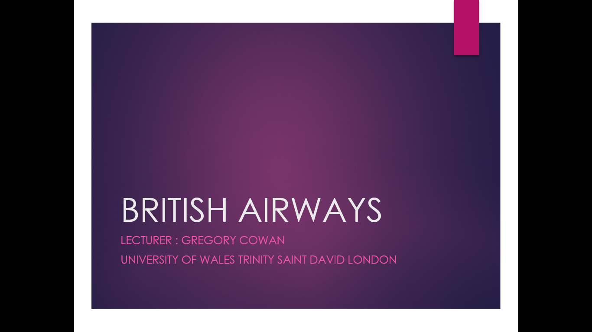

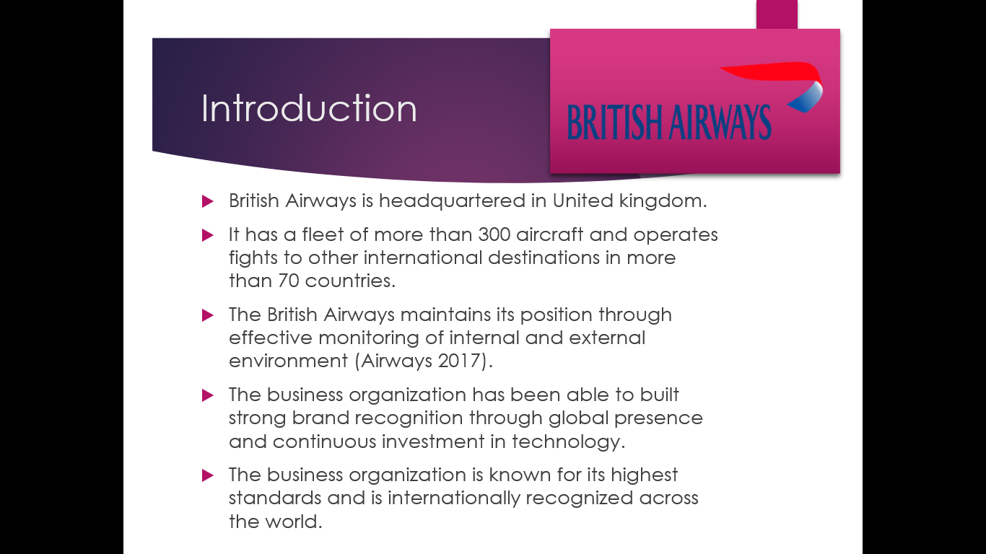
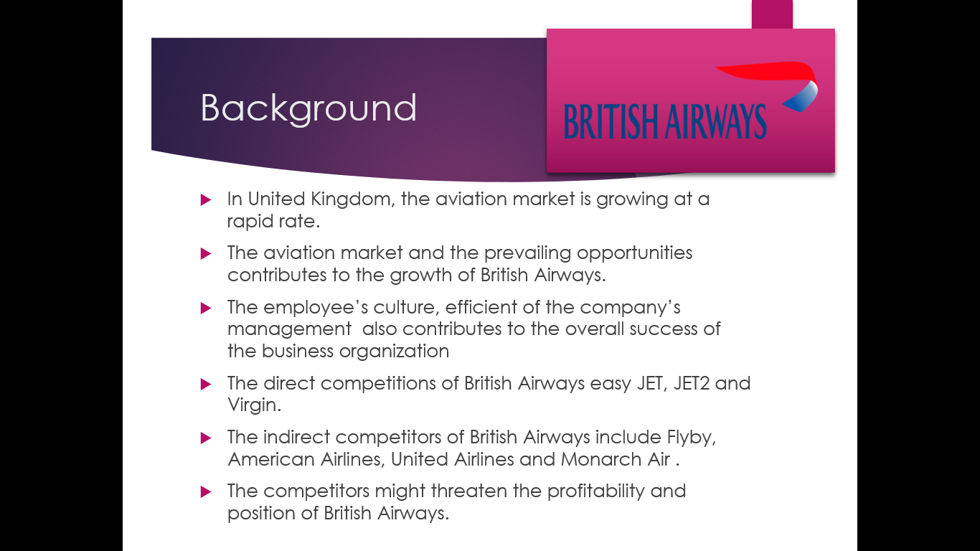

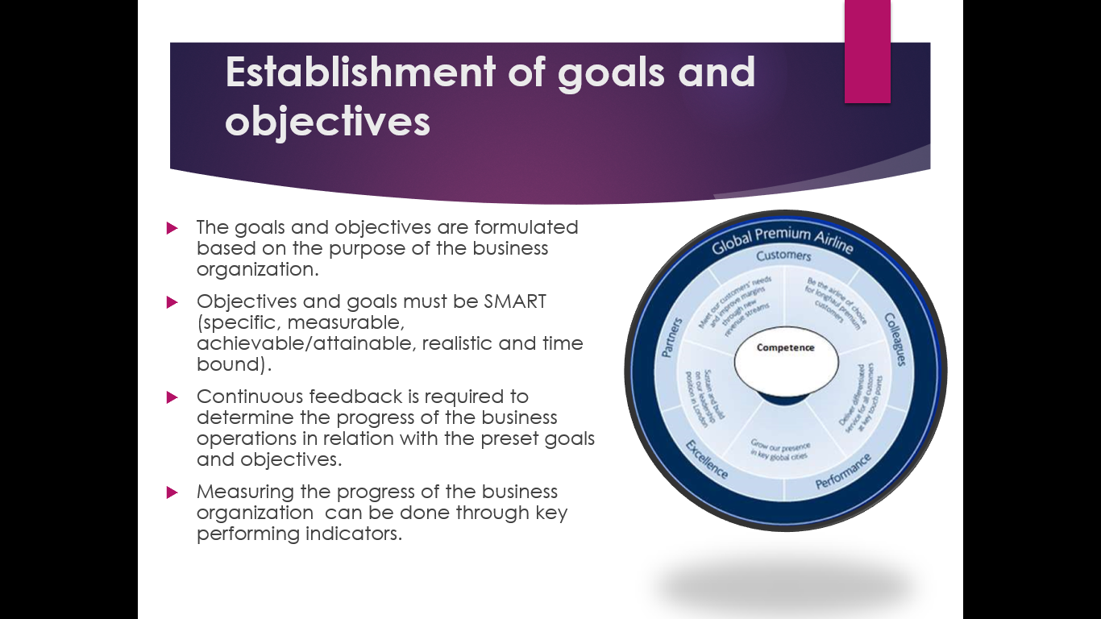
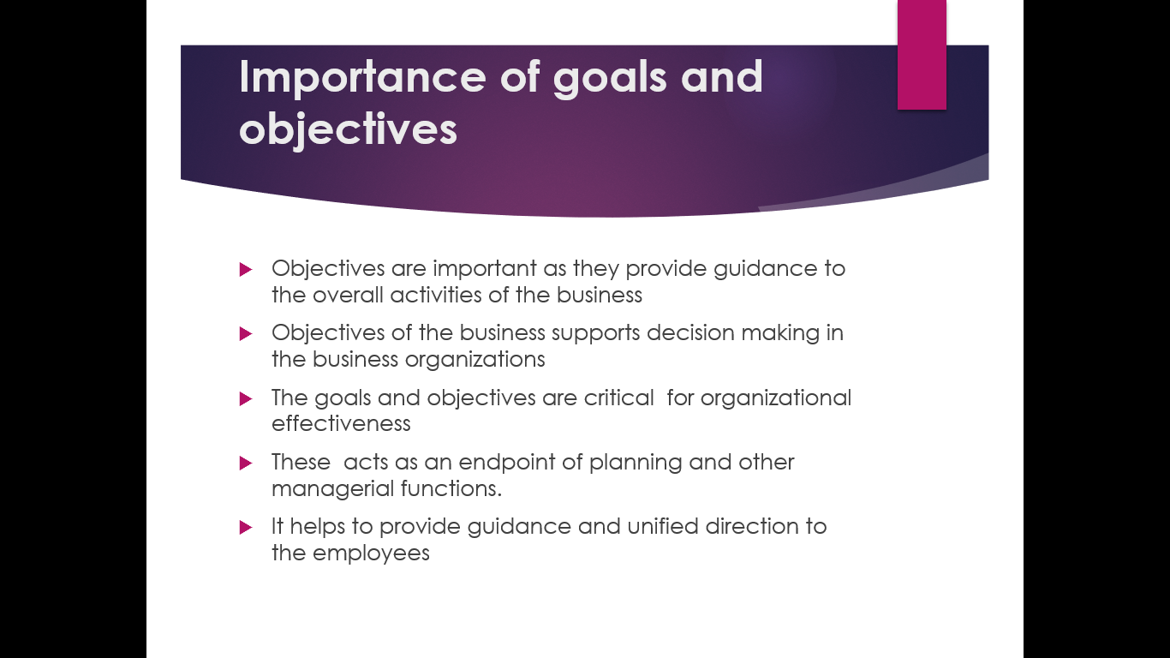
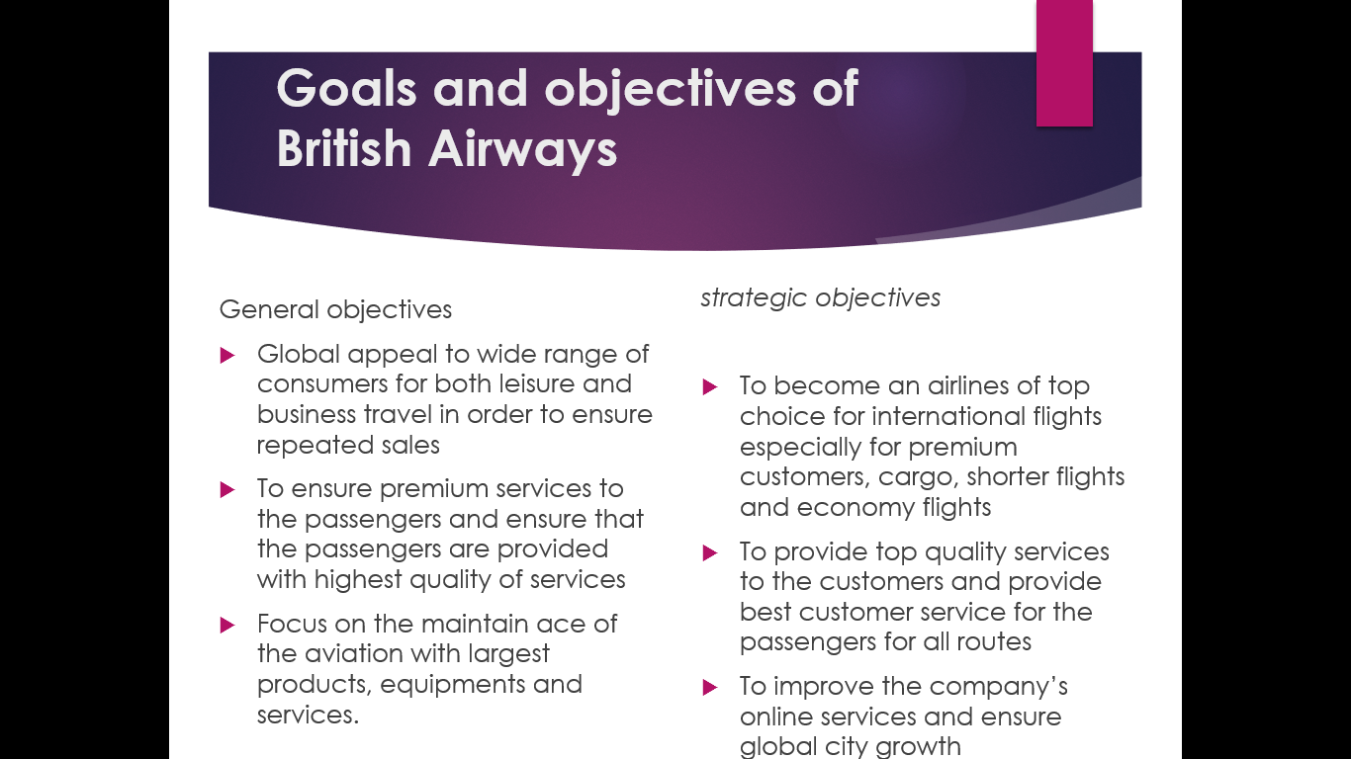

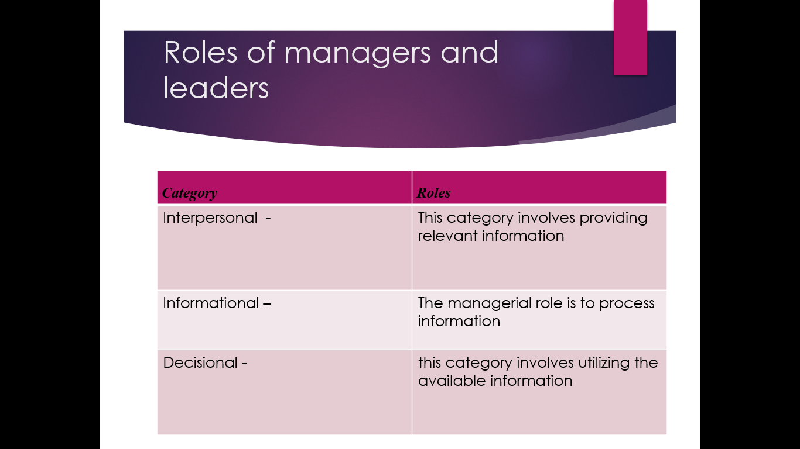
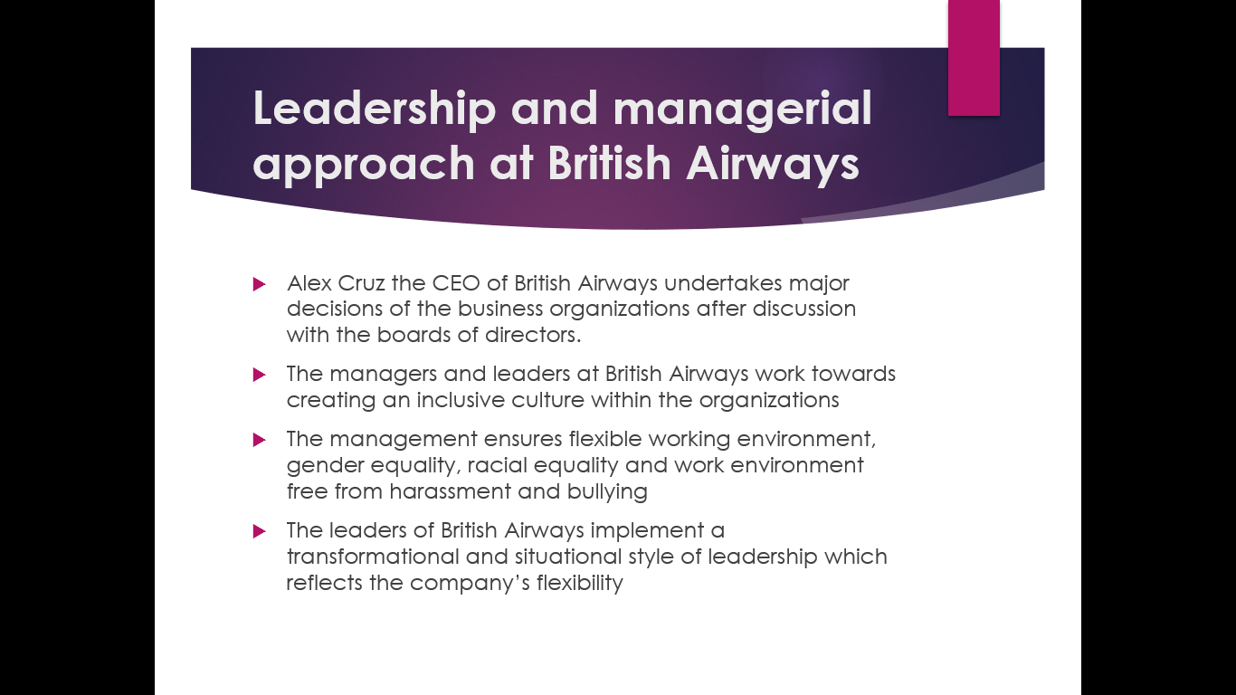
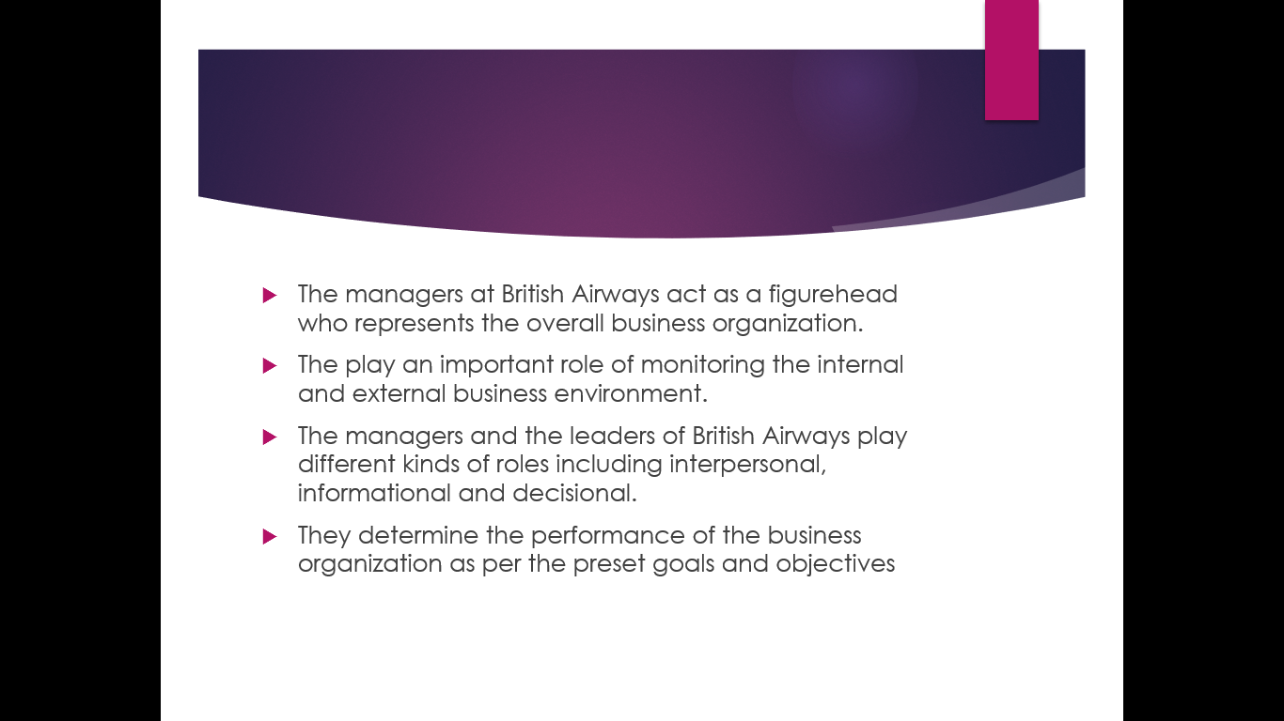

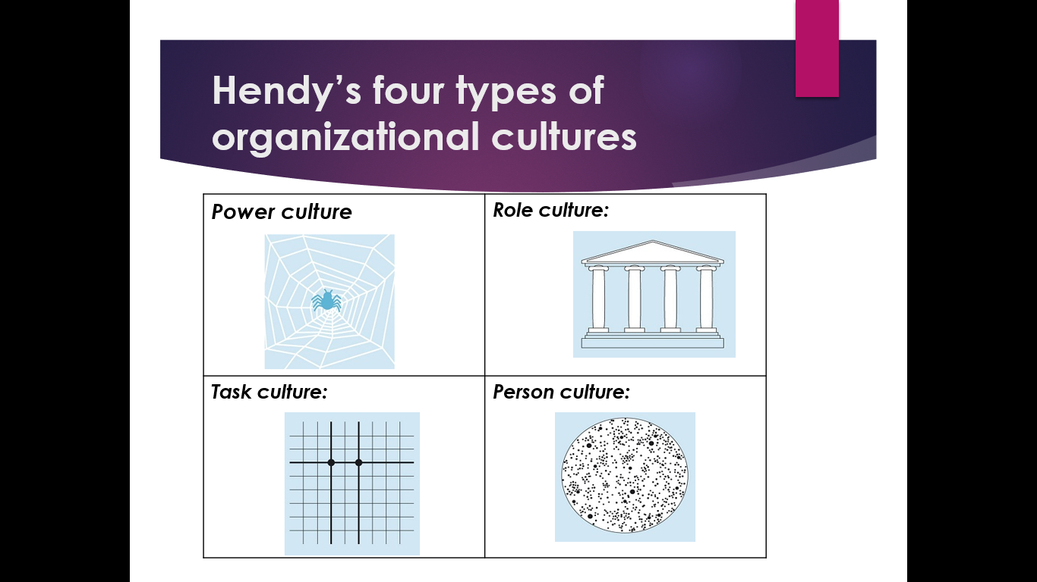
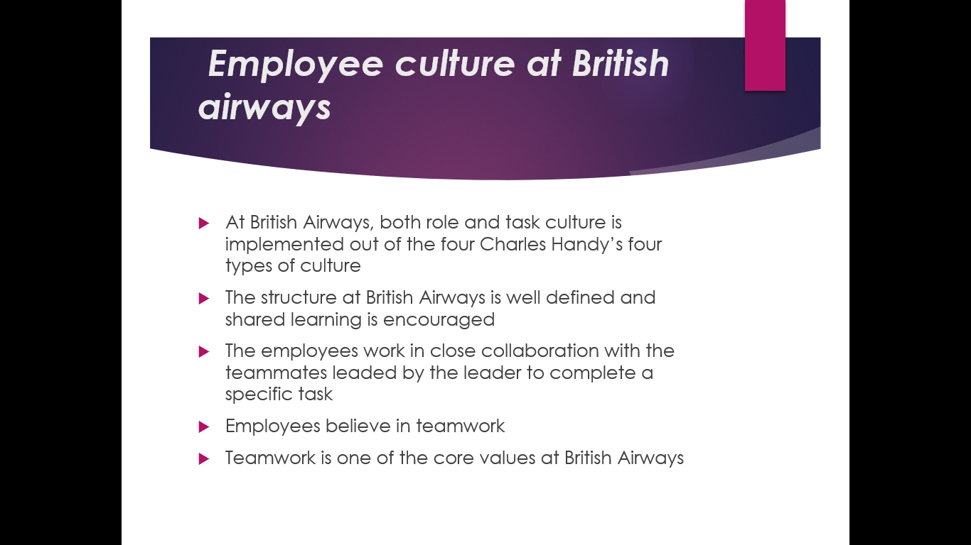
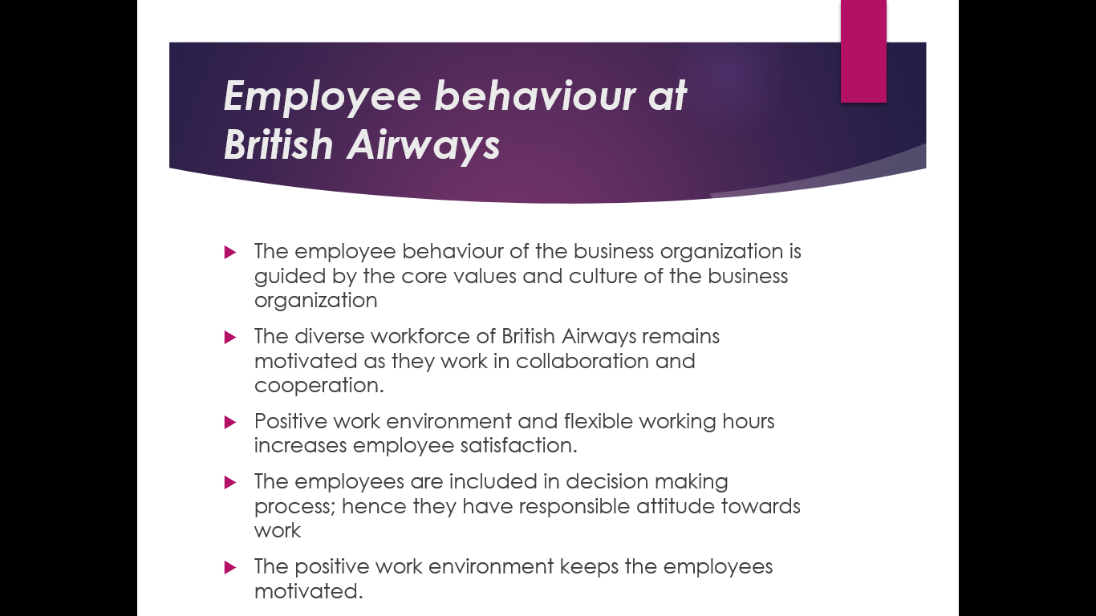

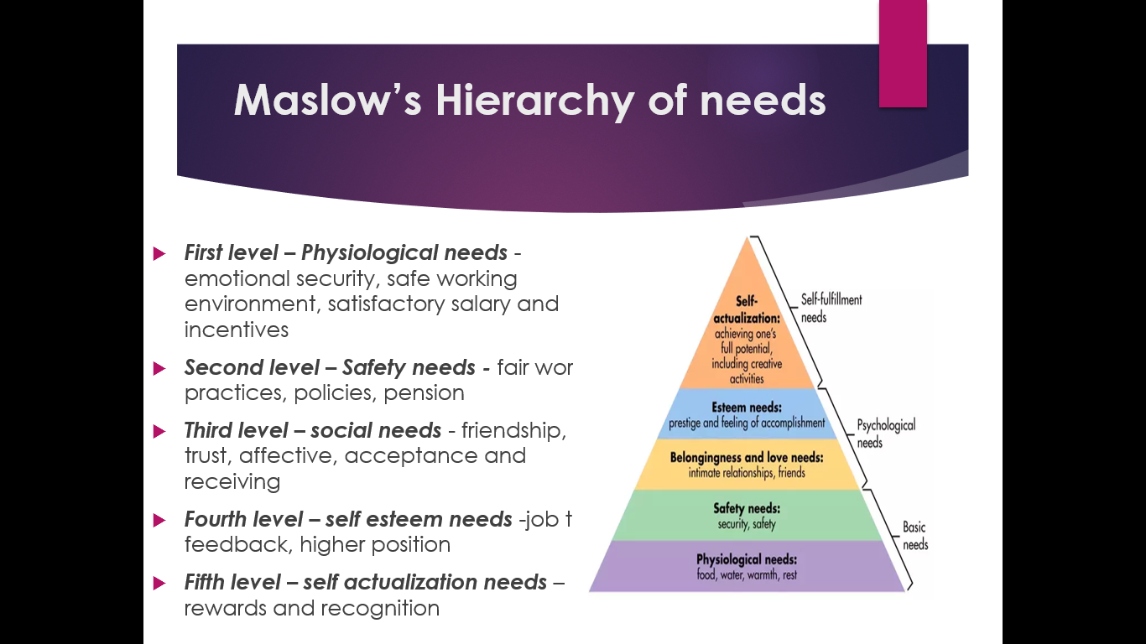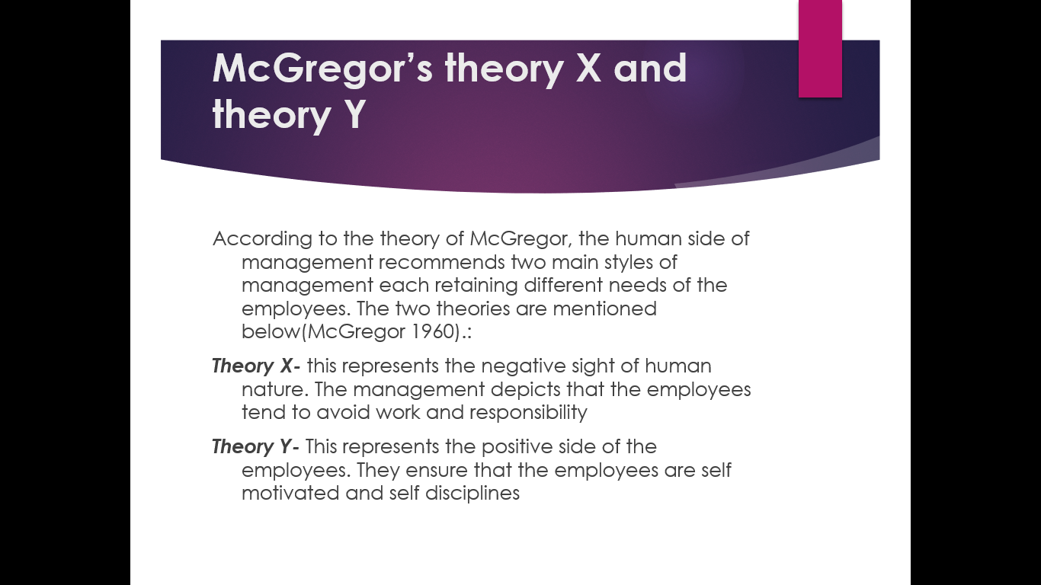
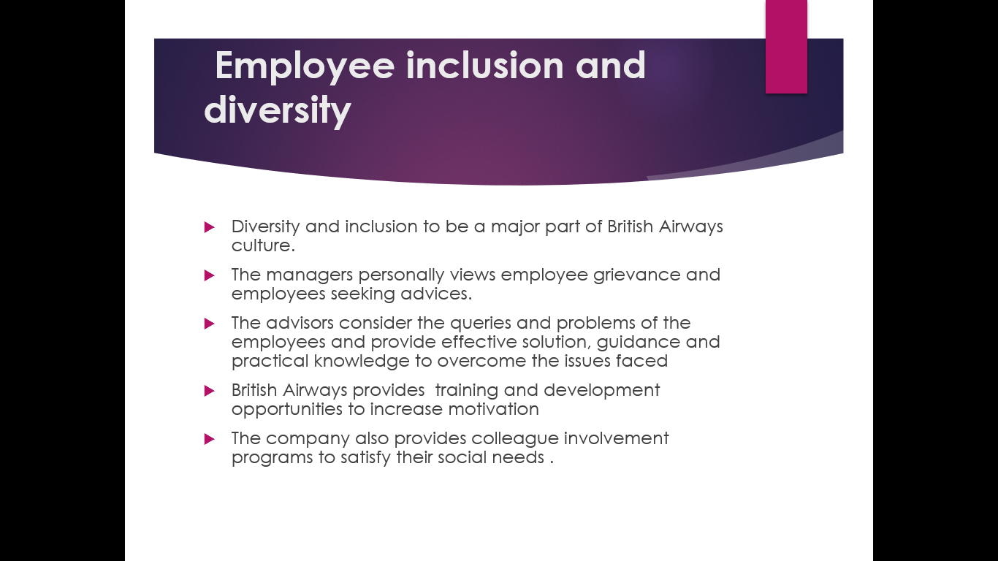
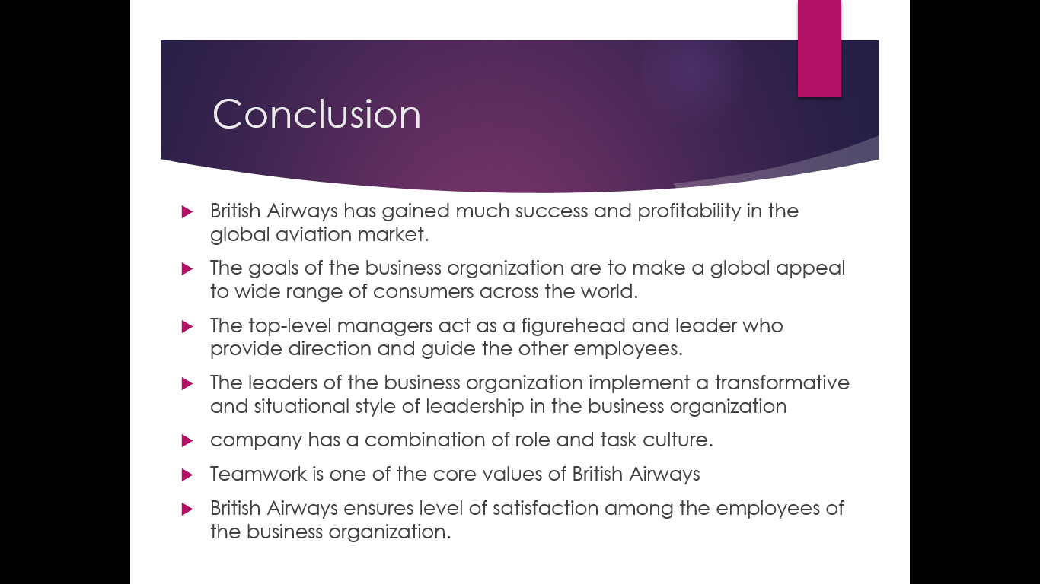
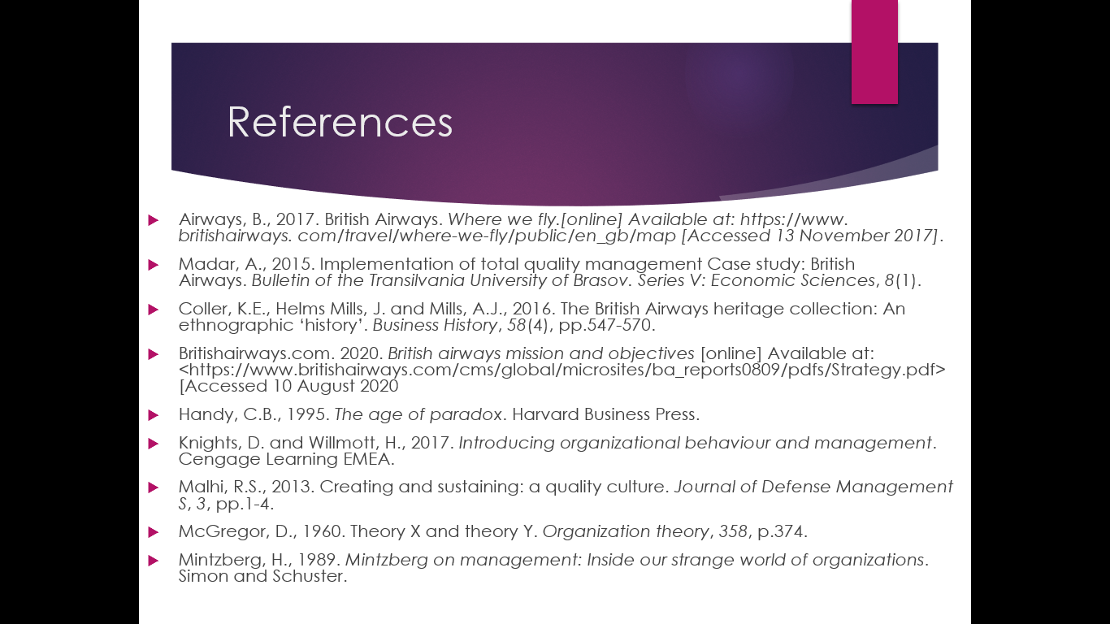

References
Ahmed, P.K., Lim, K.K. and Loh, A.Y., 2012. Learning through knowledge management. Routledge.
Airways, B., 2015. History and Heritage. Available in: http://www. britishairways. com/en-gb/information/about-ba/history-and-heritage. Accessed: September, 8.
Airways, B., 2017. British Airways. Where we fly. [online] Available at: https://www. britishairways. com/travel/where-we-fly/public/en_gb/map [Accessed 13 November 2017].
Baker, P.A., Weller, J.M., Greenland, K.B., Riley, R.H. and Merry, A.F., 2014. Education in airway management. Anaesthesia, 66, pp.101-111.
Bertillo, D., Julius, B. and Salando, D., 2013. Human Resource Management Practices in an Airline Industry: The British Airways Global Perspective. Available at SSRN 2292797.
Bixler, R.P., Johnson, S., Emerson, K., Nabatchi, T., Reuling, M., Curtin, C., Romolini, M. and Grove, J.M., 2016. Networks and landscapes: a framework for setting goals and evaluating performance at the large landscape scale. Frontiers in Ecology and the Environment, 14(3), pp.145-153.
Bjerke, M.B. and Renger, R., 2017. Being smart about writing SMART objectives. Evaluation and program planning, 61, pp.125-127.
Britishairways.com. 2020. British airways mission and objectives [online] Available at: <https://www.britishairways.com/cms/global/microsites/ba_reports0809/pdfs/Strategy.pdf> [Accessed 10 August 2020].
Coller, K.E., Helms Mills, J. and Mills, A.J., 2016. The British Airways heritage collection: An ethnographic ‘history’. Business History, 58(4), pp.547-570.
do Carmo Silva, M., Castro, C.J., Fontes, V.G. and Gomes, C.F.S., 2015. Practices in Internal Marketing According to Charles Handy’s Organizational Culture Typologies. Business and Management Review, 4(12), pp.505-512.
Elmorshidy, A., 2013. Aligning IT with business objectives: A critical survival and success factor in today’s business. Journal of Applied Business Research (JABR), 29(3), pp.819-828.
Grugulis, I. and Wilkinson, A., 201 Mills, A.J., 1995. Man/aging subjectivity, silencing diversity: Organizational imagery in the airline industry. The case of British Airways. Organization, 2(2), pp.243-269.2015. Managing culture at British Airways: hype, hope and reality. Long Range Planning, 35(2), pp.179-194.
Grugulis, I. and Wilkinson, A., 2014. British Airways: culture and structure. © Loughborough University.
Grundy, M. and Moxon, R., 2013. The effectiveness of airline crisis management on brand protection: A case study of British Airways. Journal of Air Transport Management, 28, pp.55-61.
Handy, C.B., 1995. The age of paradox. Harvard Business Press.
Harris, A. and Jones, M., 2018. The dark side of leadership and management.
Hendry, J., 1999. Cultural theory and contemporary management organization. Human Relations, 52(5), pp.557-577.
KANE‐URRABAZO, C.H.R.I.S.T.I.N.E., 2016. Management's role in shaping organizational culture. Journal of nursing management, 14(3), pp.188-194.
Karami, A., 2017. Corporate strategy: evidence from British Airways plc. In the Changing Patterns of Human Resource Management (pp. 46-64). Routledge.
Kattara, H.S., Weheba, D. and El-Said, O.A., 2018. The impact of employee behaviour on customers' service quality perceptions and overall satisfaction. Tourism and Hospitality Research, 8(4), pp.309-323.
Knights, D. and Willmott, H., 2017. Introducing organizational behaviour and management. Cengage Learning EMEA.
Lange, K., Geppert, M., Saka‐Helmhout, A. and Becker‐Ritterspach, F., 2015. Changing business models and employee representation in the airline industry: A comparison of British Airways and Deutsche Lufthansa. British Journal of Management, 26(3), pp.388-407.
Le, P.B. and Lei, H., 2018. Fostering knowledge sharing behaviours through ethical leadership practice: the mediating roles of disclosure-based trust and reliance-based trust in leadership. Knowledge Management Research & Practice, 16(2), pp.183-195.
Les MacLeod EdD, M.P.H., 2012. Making SMART goals smarter. Physician executive, 38(2), p.68.
Lester, D., 2013. Measuring Maslow's hierarchy of needs. Psychological reports, 113(1), pp.15-17.
Madar, A., 2015. Implementation of total quality management Case study: British Airways. Bulletin of the Transilvania University of Brasov. Series V: Economic Sciences, 8(1).
Madar, A., 2015. Implementation of total quality management Case study: British Airways. Bulletin of the Transilvania University of Brasov. Series V: Economic Sciences, 8(1).
Malhi, R.S., 2013. Creating and sustaining: a quality culture. Journal of Defense Management S, 3, pp.1-4.
McGregor, D., 1960. Theory X and theory Y. Organization theory, 358, p.374.
Mills, A.J., 2017. The Gendering of Organizational Culture: Social and Organizational Discourses in the Making of British Airways☆. In Insights and Research on the Study of Gender and Intersectionality in International Airline Cultures. Emerald Publishing Limited.
Mintzberg, H., 1989. Mintzberg on management: Inside our strange world of organizations. Simon and Schuster.
Mohamed, R.K.M.H. and Nor, C.S.M., 2013. The relationship between McGregor's XY theory management style and fulfillment of psychological contract: A literature review. International Journal of Academic Research in Business and Social Sciences, 3(5), p.715.
Nikčević, G., 2016. THE INFLUENCE OF ORGANIZATIONAL CULTURE ON LEADERSHIP-CASE STUDY MONTENEGRO. Tehnicki Vjesnik/Technical Gazette, 23(1).
Pheysey, D.C., 20133. Organizational cultures: Types and transformations. Taylor & Francis US.
Podgorodnichenko, N., Edgar, F. and McAndrew, I., 2020. The role of HRM in developing sustainable organizations: Contemporary challenges and contradictions. Human Resource Management Review, 30(3), p.100685.
Russo, G.M., Tomei, P.A., Linhares, A.B.J. and Santos, A.M., 2013. Correlation between organizational culture and compensation strategies using Charles Handy's typology. Performance Improvement, 52(7), pp.13-21.
Shukla, L., 2013. An Examination of The Impact Of Leadership Style On Employee Satisfaction In British Airways. International Journal of Innovative Research and Development (ISSN 2278–0211), 2(5).
Smith, K.G. and McKee, A.D., 2012. The British Airways Employee Assistance Programme: a community response to a company's problems. Occupational Medicine, 42(1), pp.43-46.
Speight, R., 2013. Changing the way, we change: Managing the soft strands of change at British Airways World Cargo. Journal of Change Management, 1(1), pp.91-99.
Tunnicliffe, V., Metaxas, A., Le, J., Ramirez-Llodra, E. and Levin, L.A., 2020. Strategic environmental goals and objectives: setting the basis for environmental regulation of deep seabed mining. Marine Policy, 114.
Upchurch, M., 2010. Creating a sustainable work environment in British Airways: implications of the 2010 cabin crew dispute.
Ustaomer, T.C., Durmaz, V. and Lei, Z., 2015. The effect of joint ventures on airline competition: the case of American airlines, British airways and Iberia joint business.
Willis, S., Clarke, S. and O'Connor, E., 2017. Contextualizing leadership: Transformational leadership and Management‐By‐Exception‐Active in safety‐critical contexts. Journal of Occupational and Organizational Psychology, 90(3), pp.281-305.

