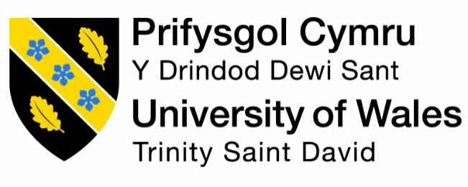

REFLECTIVE PORTFOLIO

Name: Ioan Man
Student number: 2015341
Module code: BMSW4005_BIRM
Module code: Professional Career Development
Lecturer’s name: Farah Islam
Assignment title: Reflective Portfolio

2022

Table of Content

Introduction ............................................................................................................... page 3
Audit of my personal skills and competencies .......................................................... page 4
Skills and knowledge required to be an IT support assistant............................ page 4
Audit of my skills and competencies, using the . Personal Development Plan (PDP) analytical tool............................................ page 5
The Driscoll’s Reflective Cycle model applied to what I have learned during this module..................................................................................................... page 8
Conclusion .............................................................................................................. page 13
Reference list .......................................................................................................... page 14

Introduction

I have previously applied for the job of IT Support Technician at Avery Healthcare in Northampton. The company has more than 60 care homes and more are being build and need a hard working IT support assistant specialist in networking and setting up computer equipment. Although is not a typical job for an Healthcare student, IT technicians and experts are always needed in this sector. I chosen this job because of my IT studies, credentials and vast experience in the IT industry sector.
The first part of this assignment I will list the most important skills that I believe to be required for being an excellent IT support assistant. After that, I will make an objective audit of my personal skills, knowledge and competencies that fit this job, using the Personal Development Plan (PDP) tool, highlighting my strengths and weaknesses, and creating a detailed time frame and plan meant to improve my skills by eliminating my weak points and improving my strengths.
I consider my analysis to be very fair and objective, but unavoidably, a small amount of subjectivity could be present, although I have tried to eliminate it completely.
Finally, in the second part of this assignment, I will use the Driscoll’s Reflective Cycle model, to describe and assess the most important concepts I have learned during this module.

Audit of my personal skills and competencies

My approach in the process of developing a Personal Development Plan (PDP) is to increase my self-awareness and complete an assessment process. I will identify and better understand my strengths and weaknesses.

Like everybody, I have many strengths, but also some weaknesses.

 | My strengths are:  - Ambition,  - Attention to detail,  - Perfectionist,  - Reliability,  - Highest quality work. | My weaknesses that I have to improve in my short term schedule:  - Communication,  - Time management,  - Procrastination,  - Slower pace,  - Not good at multitasking  - Tendency to get overwhelmed
 | Opportunities  I feel that I have many opportunities that are waiting for me. The most important is to act. First of all, I am a fast learner and I like to take advantage of getting involved in new projects and learn new things. My best opportunity at this moment is to do research, get involved and invest in my future and education. | Threats AI threat  In the medium to long term future, everybody, including people working in the IT department will eventually be replaced by robots and AI machines.

The next step is to try, to convert threats into opportunities and the weaknesses into strengths. You can also match strengths with opportunities and insist on them to achieve your goals. Also, matching weaknesses with threats will show you where you need to improve and what you should avoid.

Skills required to be an effective IT support assistant

The role of IT support assistant is a complex job that require many skills and especially a lot of knowledge in the field of IT. This knowledge expands from installing new equipment and managing networks, maintaining equipment and networks, fi
Here these are the most important skills required to be a successful IT support assistant.
An effective IT assistant has ideally developed his skills during many years of experience. Some of the most important skills that make the difference between success or failure in this industry are:
- Reliability a Being a reliable IT support assistant could be the most important thing required, because all the companies are looking for a employee that they can constantly count on each time to successfully complete their task.

- Time management (deliver on time) and multitasking
A job in IT support can be most if the tomes overwhelming and you quickly find yourself stuck in with an issue that can make you stuck and unable to progress further in solving your task. This can be very frustrating and nerve-wracking wrecking. A good IT specialist has to always respect his deadlines and try to meet the company’s expectation by always making his job on time highest quality work, but in a reasonable amount of time.
Multitasking is the ability to do many tasks simultaneously or in a specific time frame. This will make your job much better, by making you use your time much more efficiently. Instead of being stuck forever, you can switch to another task.

- Passionate and up-to-date with the latest technology
Most of people that are following an IT career, do this job from passion, because they all love computers, and technology. Whiteout passion, I consider that it's almost impossible to do this job successfully for a long period of time.

- Analytical thinking
Analytical thinking is the process of identifying the problem, define it, collect data, extract information from the data collected in order to identify a workable solution for that problem. I consider that the ideal candidate must be a very analytical individual.

- Patience
Patience can be a very tricky skill to master in the IT sector. Working under pressure can be very stressful and patience is a must in this sector.

- Communication skill
Although it’s a job in the IT sector, the communication skill must not be overlooked. It is also important because in my job I will work with other staff and stakeholders.

- Problem solving skill
In such a job, that everyday you bump into many equipment and software issues, it is critical to be very good to manage and solve all the problems that the equipment ad the networks are confronting with. Whether we like it or not, in the IT sector, we will always bump into many technical issues that are not always very easy to fix.
On one hand, the equipment, like computers and networks, need a lot of effort to install and set them up, and on the other hand, the software used on these equipment, needs always to be maintained, updated and debugged.

- Continuously learning
In IT, the trends in technology are always changing and therefore, to be successful in this sector you must be like a sponge, ready to absorb and learn new things everyday. Sometimes, the things we learned in school, like for example, the software used, becomes outdated and you must lean new operating systems and new software programs that always emerge on the market.

- Flexibility and ability to adapt
In this job, very rarely everything goes smoothly or according to the plans, therefore a good IT support assistant must be very flexible, and must have the ability to be flexible and easily adapt, by finding alternative solution to a problem that looks to be unsolvable.

is not so easy to achieve success in this industry because of the very harsh competition. A good manager must have a very strong and reliable team of video editors that can deliver the A Personal Development Plan (PDP) is a plan aimed to help you develop your skills that are important in your workplace. This plan is extremely important because if used accordingly it can really help you improve your skills and furthermore your chances of getting a decent job and be successful in your career.
Now what? – I will take advantage of this plan and stick to it for a long time, in order to improve and maximize my work skills.

The Driscoll’s Reflective Cycle model applied to what I have learned during this module

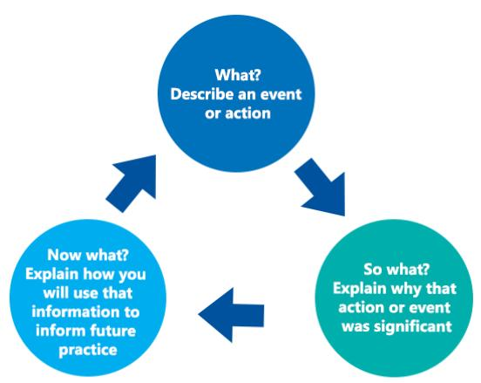
Next, I will use Driscoll’s Reflective Cycle model to analyse my experience and the concepts I have acquired and used during this module. I have decided to use this Reflective model because it has the advantage of being simplified compared to Gibbs reflective model, bit in our case the chosen one fits better for our purpose.
I really enjoyed this module because I had the opportunity to learn many important theoretical and practical things that I am very positive will come in handy in life and especially in my professional career.
was all
Self-awareness tools
The main goal of this module was to improve our self-awareness using the tools that are available to us. Self-awareness is our conscious knowledge of our character, feelings, desires and motivations. We were introduced to the 4 levels of conscience, and we got familiar with the tools used to increase the self-awareness like Johari’s Window. After that we were introduced to different learning styles, which I consider to be very useful.
So What? – Improving self-awareness is crucial, and while 95% of population think they are self-aware, the reality is that A very small percent of people, only 10 to 15%, are self-aware. Improving self-awareness is something exceedingly difficult to achieve, but once it’s done, it will change your life forever. In that week, we completed a personality test, which revealed my personality type. After completing the questions, I was surprised to see that my personality type was a ‘Mediator’ as you can see it below:
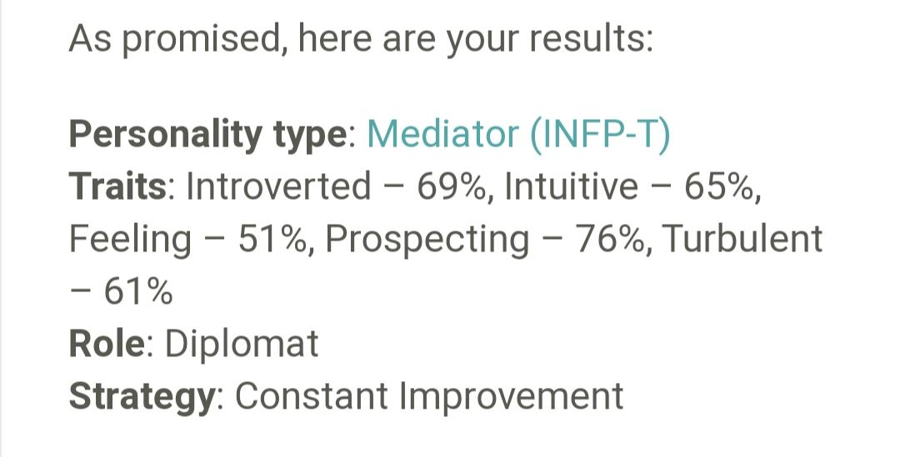
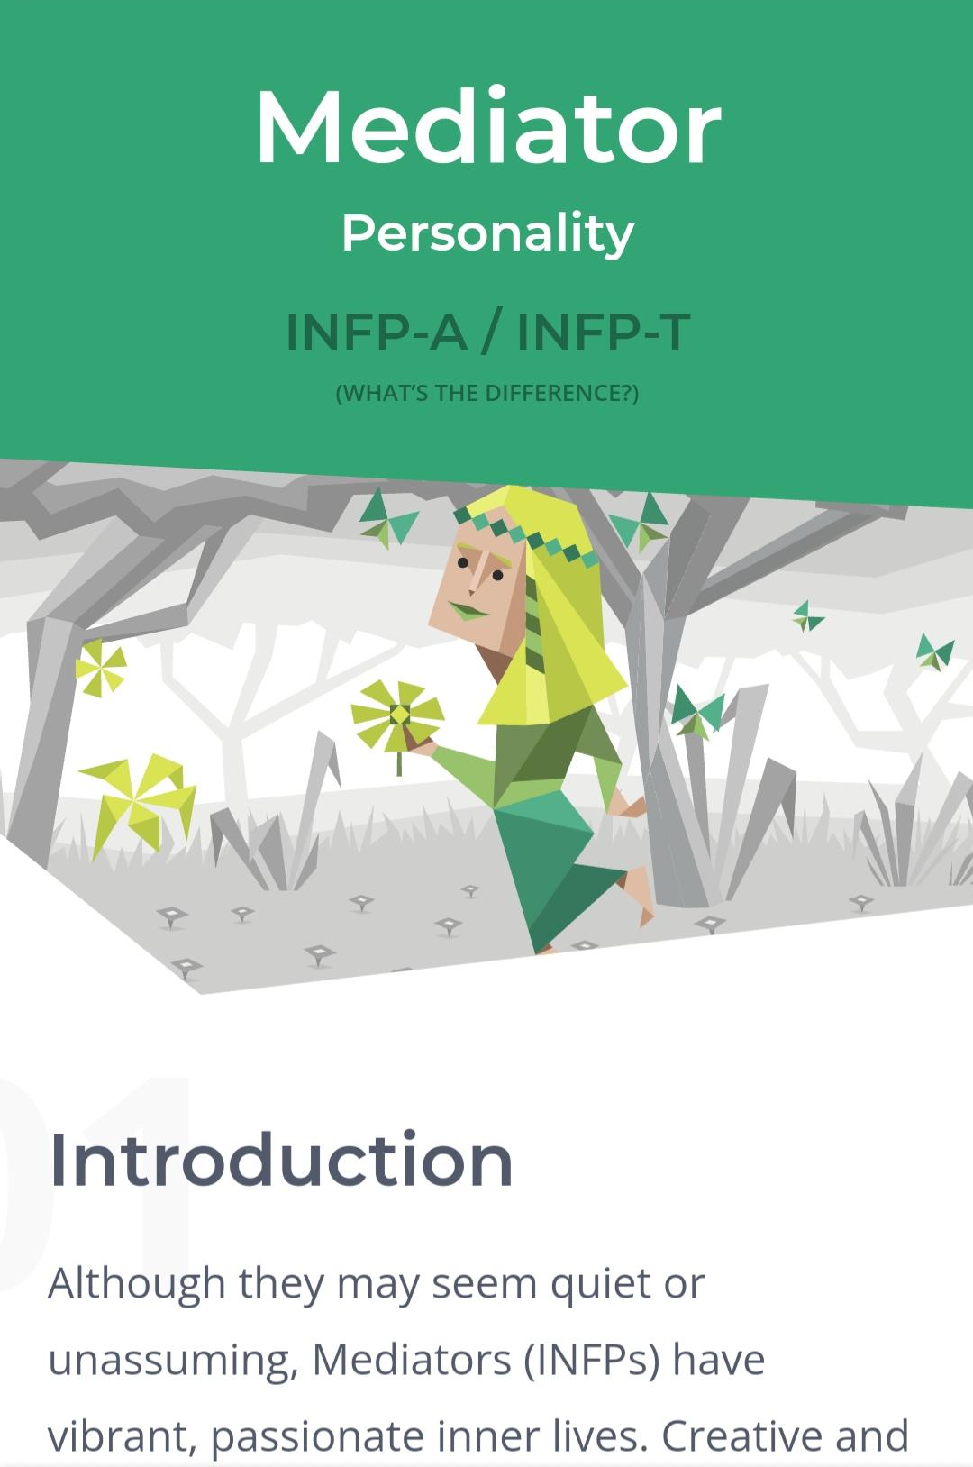
Now what? – I will try to improve my self-awareness using various tools, and I will asses my progression using Johari's window. This will help me a lot and I feel it could potentially change my perception of life. This will help me tremendously in my career. We also found that different people are more efficient using different learning styles.
Employment opportunities
What? - In this session, we explored the employment opportunities and strategies for finding employment. We also looked at the future trends in work and how to improve the knowledge of ourselves.
So what? – Employment opportunities are the best options available to us, according to our motivations, career aspirations, personality, strengths and weaknesses.
Now what? – I fell that all this information will widen my career options and I will find my suitable career much easier. During that course we also completed a ‘Career Motivation Test'
that revealed that motivates me the most in my career. I added a screenshot with my test result, from which results that I am mostly motivated by financial reward.
I also completed a learning style test that showed with proportions through which type of stimuli I learn more efficiently. I will use this knowledge in a smart way, so that I can maximize my learning retention. I displayed below the test result:
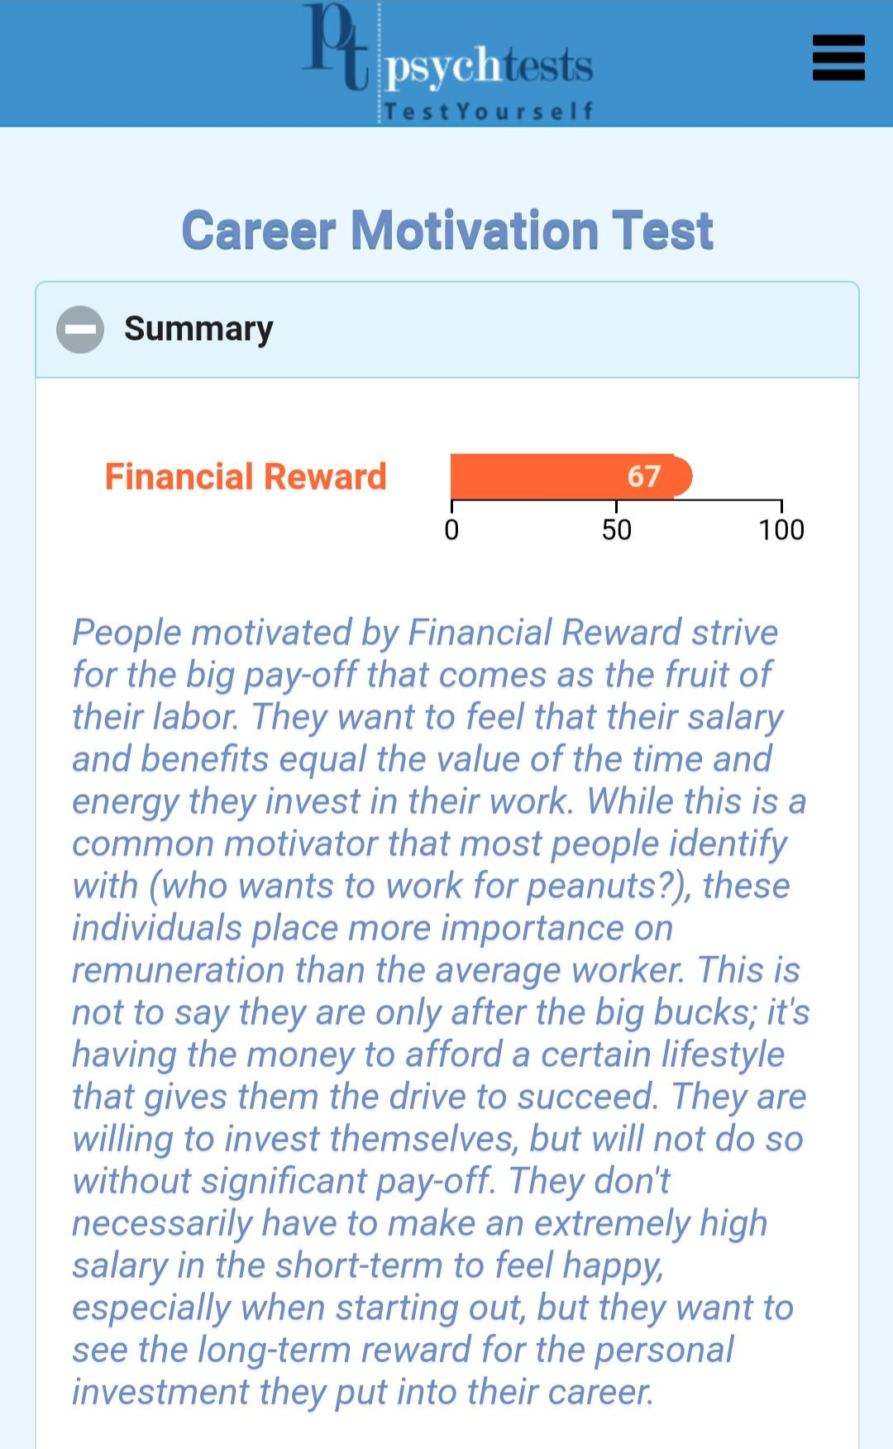

Mock Interview
What? – During this module, we conducted a simulation of a real job interview. I have applied for the position of IT Support assistant for a large company of 60 care homes. Previously we also learned hoe to create a successful cover letter, an attractive Curriculum Vitae (CV).
So what? - The ‘Mock Interview’ was a good opportunity to assess our ability to write a covering letter and a CV, and especially how to behave during a job interview in order to be successfully selected from all of the candidates.
Now what? - After this mock interview, I received very precious and detailed feedback regarding my overall performance, and how to improve my chances of getting hired in the future. If before, I had looked at an interview with scepticism, now I know exactly what to expect. This session helped me to formulate a nice cover letter and a detailed and favourable CV that will increase my chances of getting hired. We also learned what mistakes should be avoided when we are having job interview. I believe this is precious knowledge that makes the difference between being rejected or being hired. In order to understand better, the job interview process, we have analysed it from the perspective of the interviewee, as well as the employer.

Career development
What? – During this module, we debated the important subject of career development.
So what? - Career development represents the process of learning and improving your skills in order to make your job better and easier, but also to progress in the future to better jobs. Career development process, tools and strategies to achieve success. We also created mental models of the ideal job.
Now what? - I will apply go through all the processes, apply the strategies and use all the tools I have learned about in this session, so that I can do a better job at my workplace. This is for the moment only, because later I want to change my job and hopefully using these strategies and tools, I will finally get my dream job.
Employment legislation
What? – The employment legislation is a very important part of this module.
So what? - The employment legislations regulate the relationships between employers and employee through legal standards. The employment law comes into play in these areas: recruitment, employment contract, data protection, pay and holiday entitlement, working time, health and safety at work, discrimination, discipline and grievance, dismissals and redundancies.
Now what? - Learning the employment legislation was very interesting for me and was my favourite subject in this entire module. I feel that having the knowledge you can take advantage and avoid being exploited, discriminated, or abused at your working place. I think that is particularly important for everybody should be familiar with this employment legislation.

Conclusion

I honestly consider that the outcome of this module was totally positive and it was a total success. During my self-assessment process, I found things about my personality that I never knew before.
Having this precious extra information and knowledge will definitely help me achieve my career goals much more easily in the future.

Reference list:

Cameron, S. (2013) The business student’s handbook : skills for study and employment . Harlow, England :, Financial Times Prentice Hall.
Chappelow, C. (2001) Keeping your career on track [electronic resource] : twenty success strategies . Greensboro, N.C. :, Center for Creative Leadership.
Cottrell, S. (2021) Skills for success : personal development and employability . 4th edition. London :, Red Globe Press .
Driscoll's model of Reflection (no date) NursingAnswers.net. Available at: https://nursinganswers.net/reflective-guides/driscoll-model-of-reflection.php

Neugebauer, J, & Evans-Brain, J. (2016), Employability: Making the Most of Your Career Development, SAGE Publications, Limited, London.
Adam and Charles Black (Firm) (ed.) (2009) Get yourself promoted : how to move up the career ladder. Revised edition. London, [England] :, A&C Black.

