Component 2- Individual report- Information Systems Improvements
[Name of Institute]:Trinity saint David University of Wales in London
[Name of Student]:Camano Benedictus
[Student ID]:2412206
[Tutors Name]:Amitave Banik
[Date]:01-05-2026

TABLE OF CONTENTS

1. Introduction 3
Overview of the Business Scenario 3
Organisational Features Relevant to Information Systems 3
Key Challenges Faced by the Organisation 3
2. Evaluation of Existing Systems 4
Analysis of Current Information Systems 4
Critical Evaluation of Electronic Business Systems 4
Identification of Inefficiencies and Gaps 5
3. Recommended Solution 5
Proposed Information Systems 5
Justification Based on Business Needs, Efficiency, Cost, and Scalability 5
Improvement in Operations, Data Management, and Decision-Making 6
Proposed Integrated Information System 6
4. Implementation Plan 6
Project Initiation and Requirements Gathering 6
System Selection and Vendor Evaluation 7
Data Migration and System Configuration 7
System Testing and Pilot Implementation 8
Employee Training and Change Management 8
Full Deployment, Integration, and Monitoring 8
Gantt Chart 9
5. Conclusion 9
REFERENCES 10

Component 2- Individual report- Information Systems Improvements

1. Introduction

Overview of the Business Scenario
Kalori Ltd. is a fast-growing retailer of consumer electronics that has 30 physical stores and an expanding online store. Despite the high sales growth rate in the organisation, the organisation is facing serious operational issues due to outdated and ineffective information systems. An information system, technically, refers to a combination of hardware, software, databases and networks that work together to process and distribute information. It is a resource as a business strategy that assists in decision-making, coordination, and competitive advantage in an organisation (Rajabov and Alimov, 2025). The systems of Kalori Ltd. are not in line with business expansion and lead to inefficiencies in all departments and lack of competitiveness in a digital retail environment (Vo Van et al., 2026).

Organisational Features Relevant to Information Systems
To successfully develop and use information systems, managers must be knowledgeable of organisational attributes such as structure, processes, culture, and environment. Kalori ltd. is a vibrant retailing atmosphere that demands timely decision making, responsiveness to customers and interdepartmental coordination. The organisation has sales, inventory, finance and marketing departments which require integrated data. However, absence of coordination demonstrates absence of alignment of systems. The organisational culture is another factor since the opposition to technological change can hinder the adoption. In addition, there are other external factors such as the compliance with GDPR and growing cyber threats that require safe and compliant systems (Potluri, 2025).

Key Challenges Faced by the Organisation
The main problem is the inefficient manual tracking of inventory that leads to the incorrect stock level and poor order fulfilment that consequently lead to customer dissatisfaction and financial loss. Another issue is fragmented customer information that limits the use of CRM. Spreadsheet reporting is manual and reduces the speed of decision-making and accuracy. The organisation is also threatened by weak access controls and lack of compliance with data protection regulations as far as data security is concerned. Finally, the lack of system integration among departments leads to duplication of work and inefficiencies, which highlights the need to have a modern information system (Kostiuk et al., 2025).

2. Evaluation of Existing Systems

Analysis of Current Information Systems
The current information systems in use by Kalori Ltd. are outdated, fragmented and very dependent on manual systems. The inventory management system relies on manual data entry, which predisposes human mistakes and slowness in updating stock data. The customer data system is decentralised with the information being stored in different platforms and it is difficult to build a complete picture of customer behaviour. In addition, the organisation uses spreadsheets to report on financial and sales which limits scalability and predisposes the organisation to inaccuracies. These systems lack real time processing which is required in a fast-paced retail setting. The absence of advanced analytics software also limits the ability of the organisation to extract insights out of the data and make informed decisions (Wissuchek and Zschech, 2025).

Critical Evaluation of Electronic Business Systems
The contemporary organisations have electronic business systems such as ERP, CRM and Business Intelligence systems which are very important. ERP systems bring together the key business processes in a single system, which improves efficiency and accuracy of data. CRM systems are meant to deal with customer contact and enhance customer satisfaction, whilst Business Intelligence systems provide decision-making abilities. Automation, integration, and real-time access to data are some of the key advantages of these electronic systems compared to the existing systems at Kalori Ltd. However, they also have their own challenges such as being expensive to implement and organisational change is necessary. However, the cons are not so severe as the benefits of increased efficiency, precision and scalability, which is why they are required to organisations that aspire to achieve sustainable growth (Aggarwal et al., 2025).

Identification of Inefficiencies and Gaps
The main inefficiency of the existing systems of Kalori Ltd. is the lack of interdepartmental integration resulting in information silos and inconsistencies. This affects the efficiency of operations and the probability of mistakes. The other significant gap is absence of real time data processing that limits the organisation to respond quickly to changes in the market. The lack of centralized CRM system cannot enable the effective management of customer relations and makes the marketing strategies less efficient. Moreover, lack of audit trails and poor security puts the organisation at risk of data breach and non-compliance with regulations. These loopholes highlight the significance of an integrated and holistic information system that can support the development and operations of the organisation (Olatinsu and Eke, 2025).

3. Recommended Solution

Proposed Information Systems
To address the issues faced by Kalori Ltd., a hybrid system, which includes an Enterprise Resource Planning system, Customer Relationship Management system and Business Intelligence tools, should be implemented. The ERP system will integrate the major business processes such as inventory, finance and sales into a single system which will ensure data consistency and efficiency in operations. CRM system will bring together customer information, which will enable personalised marketing and improved customer service. BI tools will facilitate real-time analytics and reporting, which will facilitate data-driven decision-making. In addition, cloud computing technology will enhance scalability, flexibility, and accessibility of the system (Vo Van et al., 2026).

Justification Based on Business Needs, Efficiency, Cost, and Scalability
The proposed system will be aligned with the business needs of Kalori Ltd. since it will assist in addressing the primary operational issues and support the further growth. ERP systems are used to automate the processes and reduce the number of manual operations, which leads to improved efficiency and reduces errors. CRM systems also enhance customer interaction by providing an insight into customer behaviour which can be exploited to facilitate certain marketing strategies. Cloud solutions do not necessitate significant upfront investment in infrastructure and are therefore cost effective to growing organisations. In addition, cloud systems can be scaled and it implies that the organisation can expand its business without making major upgrades in the system. This makes the solution proposed to be suitable in a rapidly expanding retailer like Kalori Ltd. (MUSA and ABRAHAM, 2025).

Improvement in Operations, Data Management, and Decision-Making
The suggested system will significantly improve the effectiveness of the operations since it will automate the inventory management process and give real-time updates on the stock in all channels. This will reduce stock variances and improve order fulfilment. The data management will also improve as all the data will be stored in a centralized database, which will be consistent and accurate. Business Intelligence tools will be incorporated to avail real-time data to managers and develop precise reports to improve decision-making. Further advancement of data analysis can be achieved by more advanced technologies such as artificial intelligence to identify patterns and predict future trends and make proactive decisions (Johri, 2025).

Proposed Integrated Information System
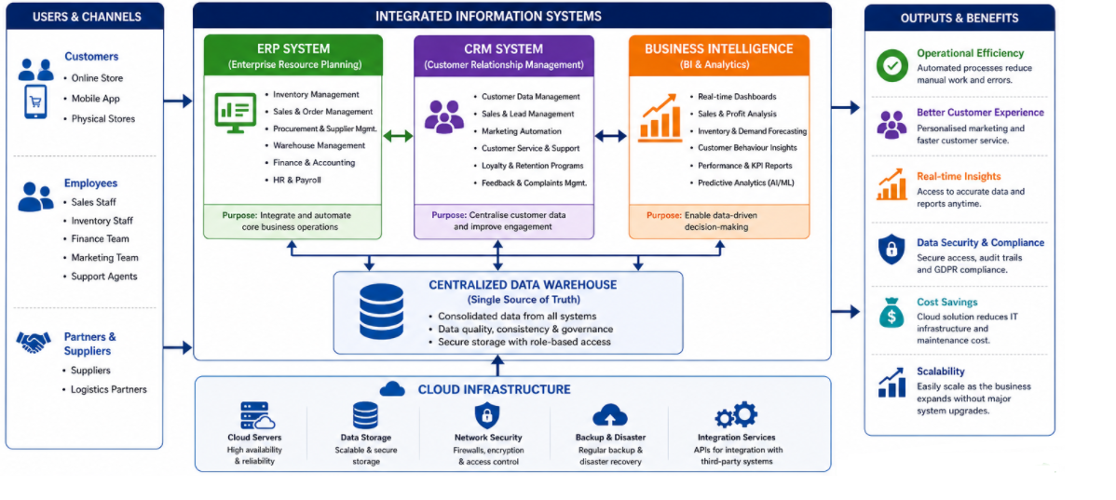

4. Implementation Plan

Project Initiation and Requirements Gathering
The process of the implementation of Kalori Ltd. must begin with a formal project initiation stage where the scope, objectives and expected results of the new information system are clearly defined. Since this is the phase, the key stakeholders in all the units like sales, finance, inventory, marketing, and customer service are involved to ensure that all the operational needs are captured accurately. A detailed requirements analysis is required to get acquainted with the current areas of pain such as inventory mismatch, fragmented customer information, and slow reporting. This is to ensure that the system is created based on the business requirements and long-term plan. Aftabi et al. (2025) emphasise that requirement analysis during the first phase increases the efficiency of the system as it balances the technical design with organisational risk and complexity of operation.

System Selection and Vendor Evaluation
Once the requirements are finalised, Kalori Ltd. should proceed with the evaluation and selection of the most suitable ERP, CRM, and Business Intelligence vendors. This includes comparing different solutions based on functionality, scalability, integration capability, cost and long term support. Preference should be given to the use of cloud-based systems because they are flexible and less infrastructure is needed. The selected system must also be capable of processing data in real-time and cross-departmental integration. This is necessary because the choice of a vendor can lead to system inefficiency and additional costs in the future. According to Vo Van et al. (2026), the decision to use scalable and cloud-based information systems is positively influencing the organisational performance and operational efficiency.

Data Migration and System Configuration
The second step after selecting the system is to move the available data in the existing legacy systems to the new integrated platform. This involves cleaning, validating and rearranging data to be correct and consistent. Special attention should be paid to inventory records and customer data as they are the central part of the operations of Kalori Ltd. Once the migration process has been completed, the system must be tuned to fit business processes, including sales processes, inventory policies, and reporting lines. Proper configuration will imply that the system will be efficient and will reflect real business requirements. According to Kostiuk et al. (2025), data should be properly integrated to reduce the risks of the system and offer credible flow of information between the systems that are interconnected.

System Testing and Pilot Implementation
Before full deployment, Kalori Ltd. needs to conduct intensive system testing to identify and correct technical failures, performance issues and security concerns. The testing will include functionality testing, integration testing and user acceptance testing. After it has been tested successfully, there should be a pilot implementation in some of the stores or departments. This will allow the organisation to test how the system will perform in a real working environment and make the required adjustments. Pilot testing will reduce the chances of a massive system breakdown and will enable easier complete implementation. Aftabi et al. (2025) argue that phased testing strategies help to increase the reliability of the system and reduce disruption of operational activities during digital transformation.

Employee Training and Change Management
Training and change management are necessary to achieve successful system adoption. Kalori Ltd. must develop systematic training programmes which are user specific such as managers, warehouse workers and marketing departments. The training must be founded on the system navigation, data entry, reporting and security practices. In addition, change management strategies such as communication campaigns, leadership support and feedback mechanisms should be embraced in order to reduce employee resistance. The most advanced systems may fail due to lack of proper user adoption, unless they are properly trained. Rajabov and Alimov (2025) state that the effectiveness of the implementation of digital systems is highly dependent on the organisational preparedness and the engagement of employees.

Full Deployment, Integration, and Monitoring
The final stage is the complete rollout of the system to all stores and departments in stages to stabilize. The new system must be fully integrated with the existing e-commerce systems and financial systems to enable data flow. After deployment, a system to monitor the performance of the systems, identify problems and ensure security should be implemented. Efficiency and reliability of the systems will be guaranteed by periodical audits and performance reviews. According to Wissuchek and Zschech (2025), the effectiveness of enterprise information systems in the dynamic business environment in the long term is determined by the need to monitor and supervise them on the basis of analytics.

Gantt Chart
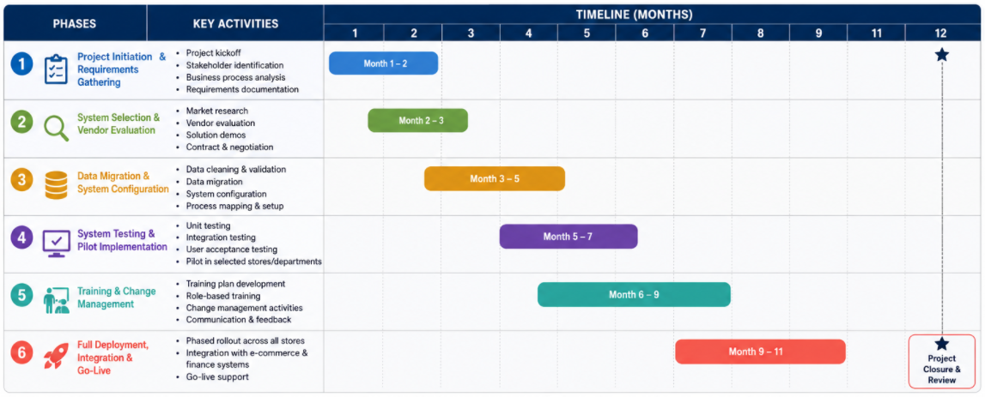

5. Conclusion
The existing issues that Kalori Ltd. is facing concerning the old and ineffective information systems that do not suit a growing organization and are posing severe challenges to the operations of the organisation. The failure to integrate, poor data management and poor security controls are affecting business performance and customer satisfaction. The proposed solution, which is the implementation of an integrated ERP, CRM, and Business Intelligence system will assist in overcoming these challenges by improving the efficiency, managing the data more efficiently, and making more effective decisions. The implementation plan provides a methodical means of accepting the new system with the least disruptions and successful integration. Overall, the suggested information system will assist Kalori Ltd. to achieve operational excellence, customer satisfaction, and long-term growth in a competitive market.

REFERENCES

Aftabi, N., Moradi, N., Mahroo, F. and Kianfar, F., 2025. SD-ABM-ISM: An integrated system dynamics and agent-based modeling framework for information security management in complex information systems with multi-actor threat dynamics. Expert systems with applications, 263, p.125681.
Aggarwal, K., Khoa, B.T., Sagar, K.D., Agrawal, R., Dhingra, M., Dhingra, J. and R, L.K., 2025. Marketing information system based on unsupervised visual data to manage transportation industry using signal processing. Expert Systems, 42(1), p.e13384.
Akindele, O., Ajayi, S., Oyegoke, A.S., Alaka, H.A. and Omotayo, T., 2025. Application of Geographic Information System (GIS) in construction: a systematic review. Smart and Sustainable Built Environment, 14(1), pp.210-236.
Das, A., 2025. Geographical Information System–driven intelligent surface water quality assessment for enhanced drinking and irrigation purposes in Brahmani River, Odisha (India). Environmental Monitoring and Assessment, 197(6), p.629.
Johri, A., 2025, October. Impact of artificial intelligence on the performance and quality of accounting information systems and accuracy of financial data reporting. In Accounting Forum (Vol. 49, No. 5, pp. 1096-1120). Routledge.
Kostiuk, Y., Skladannyi, P., Samoilenko, Y., Khorolska, K., Bebeshko, B. and Sokolov, V., 2025. A system for assessing the interdependencies of information system agents in information security risk management using cognitive maps. Cyber Hygiene & Conflict Management in Global Information Networks 2024, 3925, pp.249-264.
MUSA, O.A. and ABRAHAM, M., 2025. The Impact Of Information And Communication Technology (Ict) Adoption On Accounting Practices And Financial Reporting Accuracy In Public Institutions. International Journal of African Research Sustainability Studies.
Olatinsu, O. and Eke, C., 2025. Audit trails, financial transparency, and internal control effectiveness in public financial management systems. International Journal of Research in Management, 7(1), pp.1352-1363.
Potluri, S., 2025. Policy-aware secure data governance in distributed information systems using explainable AI models. International Journal of AI, BigData, Computational and Management Studies, 6(3), pp.1-10.
Rajabov, S.B. and ogli Alimov, J.S., 2025. Modern Approaches to Modernizing the Management System in Higher Education through Digital Technologies. Academic Journal of Science, Technology and Education, 1(5), pp.34-38.
Storey, V.C., Yue, W.T., Zhao, J.L. and Lukyanenko, R., 2025. Generative artificial intelligence: Evolving technology, growing societal impact, and opportunities for information systems research. Information Systems Frontiers, pp.1-22.
Vo Van, H., Abu Afifa, M. and Saleh, I., 2026. Accounting information systems and organizational performance in the cloud computing era: evidence from SMEs. Sustainability Accounting, Management and Policy Journal, 17(1), pp.267-299.
Wei, X., Kumar, N. and Zhang, H., 2025. Addressing bias in generative AI: Challenges and research opportunities in information management. Information & Management, 62(2), p.104103.
Wissuchek, C. and Zschech, P., 2025. Prescriptive analytics systems revised: a systematic literature review from an information systems perspective. Information systems and e-business management, 23(2), pp.279-353.

