Welsh Air Ambulance Charity Awareness Campaign


The implementation phase of our project was exciting and characterized by creativity, teamwork, and careful planning. This phase involved implementing our plans and turning ideas into tangible products. Our team took on two exciting projects: designing T-shirts and baking cupcakes. Both projects required coordinated efforts and strict adherence to our Gantt chart, which meticulously detailed our schedule and milestones.

“The Gantt chart is one of the most used planning and controlling tools in projects today”.
Geraldi, J. and Lechter, T. (2012) ‘Gantt charts revisited: A critical analysis of its roots and implications to the management of projects today’, International journal of managing projects in business, 5(4), pp. 578–594. Available at: https://doi.org/10.1108/17538371211268889. YOU JUST NEED TO PUT THE HIGHLIGHTED SECTION INTO THE REFERENCE LIST

The T-shirt project was a testament to our team's creativity and strategic planning. We began by brainstorming ideas and settling on unique designs that would resonate with our target audience. Each team member brought their unique perspective, resulting in a diverse range of designs. The cupcake project was another opportunity for our team to showcase their versatility and ability to juggle multiple tasks efficiently, further highlighting our team's capabilities. This project phase was a dynamic and rewarding experience. Our tasks showcased our creativity and hard work and underscored the importance of effective planning and teamwork.

Appendices
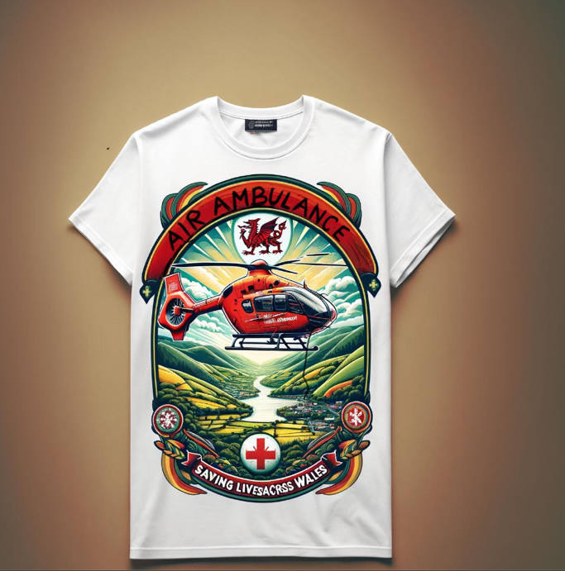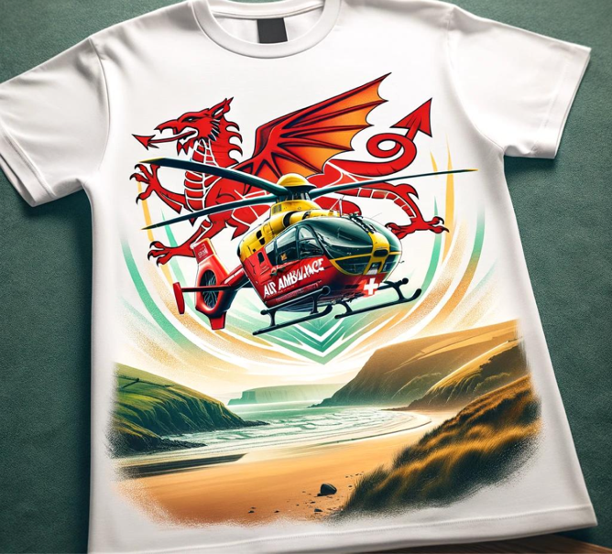
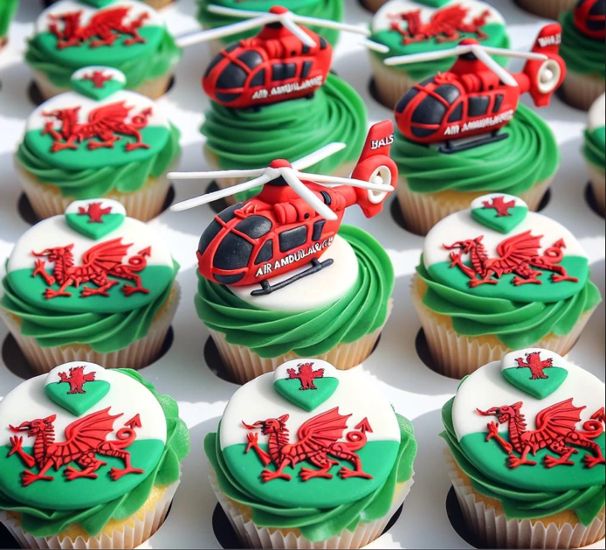

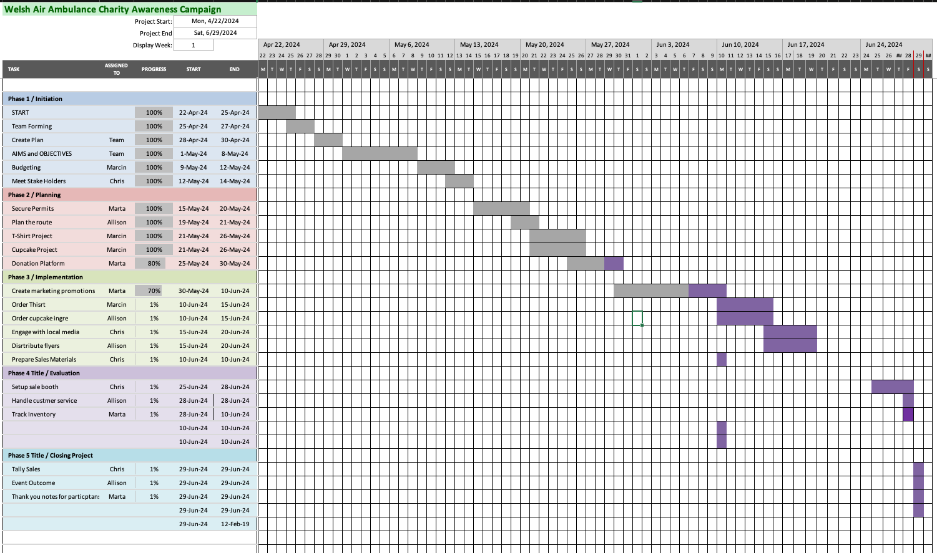

References

Geraldi, J. and Lechter, T. (2012) ‘Gantt charts revisited: A critical analysis of its roots and implications to the management of projects today’, International journal of managing projects in business, 5(4), pp. 578–594. Available at: https://doi.org/10.1108/17538371211268889.

