Module Name: Managing People
Module Code: LCBB5004
Component 2: Individual Report
Student ID: 2025748

Table of Contents
Introduction 3
Identification of Issues, challenges and their impact in organisations 4
Recruitment and Selection 4
Performance Management 6
Employee Engagement 7
Implementing Best Practices or Approaches 8
To ensure effective recruitment and selection 8
To ensure better performance management 9
To ensure more employee engagement 10
Conclusion 11
Reference 12

List of Figures
Figure 1 Recruitment and Selection Model (Source: Author) 4
Figure 2 Best Practice and Approach (Source: Author) 11

Introduction
It's no secret that employees are the backbone of every successful business, yet far too many executives and HR experts fail to recognize the role that well-managed employees can play in advancing organizational goals. Human resource is the origin of people management, which spreads to managers and workers throughout a business. It's the lifeblood of any thriving enterprise, and in today's cutthroat business climate, it's more important than ever to hold on to the top talent. Employee morale, engagement, turnover, and team communication can all benefit from skilled people management (Weightman, 2013). Human resource managers are responsible for hiring and developing new employees, monitoring and enhancing their performance, providing ongoing training and development opportunities, and fostering a productive work environment (Cardy and Carson, 2011). But there are lots of complex challenges and issues related to the process of these HR tasks such as recruitment and selection, employee engagement and performance management. The aim of this report is to discuss all these issues and challenges as well as implement best practices of these mentioned activities.

Identification of Issues, challenges and their impact in organisations

Recruitment and Selection
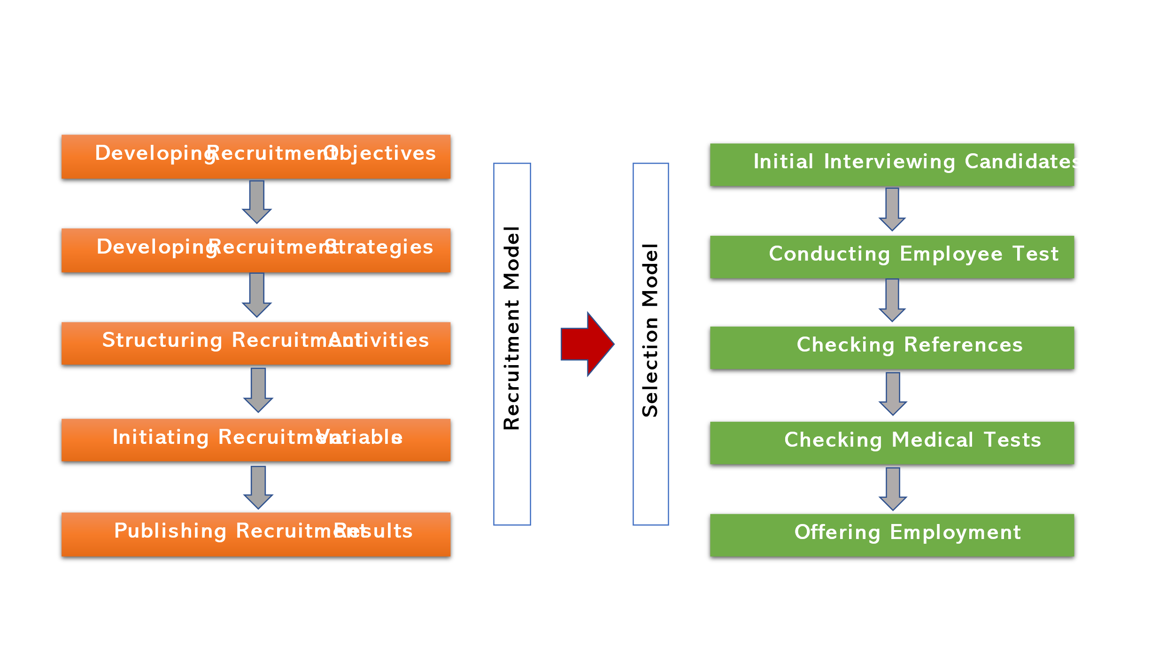
Knowledge and Expertise on the organization's recruitment and selection practices have been offered by numerous researchers, and it is considered to be severe and substantial. Recruitment is the process by which a company identifies and evaluates potential employees for open positions. The term selection refers to the procedure of choosing the best possible candidate among several others. The purpose of the recruitment procedure is to fairly and lawfully match the applicant's competence, knowledge, abilities, and experience with the needs of the position whereas the purpose of the selection process are to find and hire the most qualified and best-suited candidates for open positions inside the business (Kamran, Dawood and Hilal, 2015). A detailed model of the recruitment and selection process is given below:
Figure 1 Recruitment and Selection Model (Source: Author)
Recruitment and Selection Issues and Challenges
- Attracting the Right Candidates: It can be a time-consuming and challenging process to find the ideal candidate for a position. Finding qualified candidates is the biggest difficulty as the statement has been agreed by 76% of hiring managers (Turner, 2022). Many hiring managers have difficulty finding suitable candidates because they either do not broaden their search enough or are too vague about the qualities they are seeking.
- Shortage of Qualified Candidates: The most prevalent difficulty encountered by hiring managers is a shortage of candidates with the necessary abilities. 63% of recruiters report that a lack of qualified candidates is their top challenge (Turner, 2022). So, HR has to perform the tedious task of evaluating applications and profiles to exclude those that aren't appropriate.
- Slow Recruitment Procedures: The talent acquisition team aims for a quick recruitment rate because unfilled positions waste money and slow down business. However, the time it takes to make a hire can vary widely from industry to industry, putting extra stress on recruiters and driving up the annoyance level of hiring teams. Inadequate numbers of eligible applicants may lengthen the hiring process. The top candidates may leave for other companies if the hiring process takes too long or if the hiring teams have trouble coming to a consensus.
- Lack of Providing Significant Candidate Experience: Because a positive candidate experience enhances the likelihood that the candidate would accept the offer and a negative experience decreases the likelihood that the candidate will accept the offer, it is important to create a positive applicant experience during the hiring process. 80% of applicants who have a negative experience during the hiring process have said they are open about sharing their stories, with one-third of those persons taking the initiative to do so (Venkatraman and Abbas, 2019).
- Fair Selection Process: The recruiters also have the difficult duty of making sure the selection process is fair. Unconscious prejudices are often to blame for the difficulty many firms have in attracting and hiring people from underrepresented groups. Because of this prejudice, many promising employees leave their companies for rivals.

Performance Management
Performance management is a method used to boost organizational efficiency by fostering and maintaining high levels of performance among workers (Armstrong, 2021). Managers can foster a productive workplace for their teams and their organizations by emphasizing their employee's professional growth and ensuring that organizational objectives are consistent with those of team members and employees as individuals. Human Resources relies heavily on performance management to onboard, cultivate, and retain workers, as well as evaluate their output (Boyne, 2010). The PM system can be periodic, methodical, and objective. Companies like Accenture, Deloitte, Microsoft, General Electrics, and many more have realized the benefits of moving away from annual performance evaluations and toward more fluid and continuous forms of performance management. There are two popular approaches to performance management: Objective and Key Results (OKR) and Management by Objectives (MBO).
Performance Management Issues and Challenges
- Lack of Goal Setting Clarity: Uncertainty about goals is one of the first performance difficulties that get in the way of efficient performance management. When there is a lack of clarity in the organization's goals and vision, employees are left wondering what they should be doing, and management has no clear yardsticks by which to judge their success. There will always be room for debate over what defines successful performance in the absence of clear goals.
- Lack of Proper Evaluation Tools: Mapping and measuring performance and productivity is essential for effective performance management and for addressing performance issues. Yet most businesses lack metrics and key performance indicators to track this. 58% of the managers stated that they are not improving because of ineffective traditional PM systems (Marko, 2022). Neither uniform nor inspiring, their methods and definitions of what makes good performance tend to be developed on the fly.
- Employees Having Trust Issues in the Process: Workers feel their voices aren't heard in the performance management process. The evaluations don't take into consideration the genuine estimate of an employee's performance or potential, as they are susceptible to the whims and favouritism of the reviewer (Dörfler and Nudurupati, 2012). Organizations often struggle to persuade workers to adopt a more equitable performance evaluation method.
- Poor Communication and Feedback System: Employee performance concerns are often the result of a lack of open communication and a tendency toward working in silos. As a result of difficulties in conveying information, productivity decreases. In addition, many organizations lack the tolerance for giving chances to employees for reducing errors and the willingness to provide constructive feedback to employees. The majority of workers (64%) believe that feedback could be better (Marko, 2022). Problems in productivity or high rates of employee turnover are common outcomes of ineffective feedback.

Employee Engagement
The term employee engagement refers to an approach taken in the workplace that creates favourable conditions for all employees to give their absolute best effort every day, while also being fully invested in and enthusiastic about the organization's success and committed to its stated values and goals (Sun and Bunchapattanasakda, 2019). Trust, honesty, mutual commitment, and open lines of communication are the cornerstones of an engaged workforce. Edwin Locke's goal-setting theory is the most well-known of the several theories of employee engagement currently in use in the workplace (Shoaib and Kohli, 2017). Clarity, difficulty, dedication, feedback, and task complexity are the five components that make up this framework.
Employee Engagement Issues and Challenges
- Big Communication Gap Exists: Workers are less invested in their work when they are kept in the vagueness about company functions and objectives. They will also lose motivation if they aren't given adequate opportunities to collaborate with others or if their efforts aren't appropriately acknowledged. It can be difficult to bridge these communication gaps at a time when many businesses are transitioning to full-time remote work.
- Measuring Employee Engagement: Measuring employee enthusiasm has always been difficult since it often comes off as more of a subjective experience than a hard number. Companies can't evaluate the success or identify problem areas in their endeavours unless it has some mechanism to track progress. Finding out where the company is in terms of employee engagement is more challenging as it will help them craft more targeted tactics.
- Lack of Employer Support or Appreciation: Many employees feel disengaged when they observe that the company isn’t showing any kind of support or sign of belonging to them. 73% of the employees, in this case, would consider leaving the organisation (Mia & Jouany, 2022). An employee might face different situations including needing motivation/appreciation for good work or going through some difficult times and may need support to get rid of such a challenging situation. But when organisations don’t show support, it ultimately reduces their morale and engagement with the company.

Implementing Best Practices or Approaches

To ensure effective recruitment and selection
Enhancing Employers Branding
Creating a solid employer branding strategy to introduce potential employees to the company's culture. Before applying, this tactic will introduce potential employees to your firm and its values. Culture may also be used as a magnet to draw in qualified applicants, which is great news for businesses. Companies like Sodexo, Coca-Cola, and Accenture, among many others, have strong organisational cultures and are embracing diversity in their hiring practices and adopting strategies that ensure all applicants are evaluated fairly (Stefan, 2022). If companies highlight their firm's norms and values along with their focus on diversity, equality and inclusion in the recruitment materials, it’ll attract the attention of those who are already interested in working for the organization.
Upgrading to a More Data-Based Approach
Practising a data-driven approach to hiring allows for better, more well-informed choices to be made across the company. Large corporations like Nestle, Unilever, GSK, etc. use a data-driven strategy since it allows them to centralize all of their hiring information in one place. These days, a growing number of businesses invest in and use an Application Tracking System (ATS) to maintain an up-to-date database of applicants (Chungyalpa and Karishma, 2016). Employing this method will let businesses sidestep the need for reciprocity and speed up the process of hiring new employees.

Leveraging Interactive Digital Methods for Smooth Candidate Experience
Businesses that recognize the value of leveraging digital resources in the recruitment process tend to have the best success rates. By making full use of all of its digital resources, the organization can recruit just the most qualified people. Some firms use innovative techniques for interactive recruitment to entice the most qualified candidates to join their ranks. In comparison to more conventional approaches, these offer a more positive experience for the applicants. Among these strategies is the use of social media to locate and connect with potential employees, the administration of online, interactive examinations during the hiring process, and regular communication via email. For example, British American Tobacco (BAT) is one of the many large corporations that use these dynamic approaches to assure a positive applicant experience.

To ensure better performance management
Developing and Updating PM Systems
Lesson that has been learned from the COVID-19 epidemic is that adapting the company strategy to accommodate societal changes isn't always easy (Green, 2022). Holding firm to outdated decisions in light of new realities can result in penalizing and eventually losing talented workers. 81% of HR directors are modifying their approaches to performance management to boost output (Marko, 2022). Therefore, updating the current system is essential. Companies like Adobe, Goldman Sachs, etc., who had their roots in the more archaic PM methods, have recently switched to a more modern, standardized PM approach. Furthermore, the SMART goal-setting framework should be utilized. Goals are more likely to be accomplished if they are well-defined, well-communicated, SMART (specific, measurable, actionable, relevant, and time-bound), and realistic. When objectives are well-defined, workers have a better chance of meeting them.
Ensuring Frequent and Constructive Feedback
One of the finest ways to monitor and enhance employee performance is through consistent feedback. Employees, as well as the team and the company as a whole, can benefit from this approach. Many companies report that installing a continuous and constructive feedback tool has helped them establish a culture of frequent feedback, which in turn has increased employee engagement. The majority of HR directors (89%) believe that continuous performance management is more beneficial than traditional performance management (Marko, 2022). Both continuous feedback and peer feedback are examples of this type of technology. To foster a productive working environment, businesses like Cargill have implemented "Everyday Performance management" systems that emphasize ongoing feedback and developed positive employment relationship (Maier, 2018). The organization's culture of openness and fair evaluations is enhanced by this method of feedback. Organisations like Facebook also rely on such a continuous-based peer-to-peer feedback system.

To ensure more employee engagement
Fostering a Positive and Transparent Working Environment
When workers have more faith in their managers when they experience elevation, support, and a sense of personal connection from them. Strengthened employee engagement can be influenced by displaying empathy and creating a work environment that values its employees. Major corporations like IBM and Netflix prioritize this method. Another technique to establish credibility and show humanity is to make information readily available. Everyone is on the same page thanks to the use of a variety of communication and knowledge management solutions that ensure a constant presence from leadership and make information easily accessible.
Promoting Flexibility and Employee Wellbeing
Facilitating a healthy work-life balance is a key factor in employee engagement, which may be increased by providing employees with more options for how they spend their time at work. Employees at Kaiser Permanente can fully dedicate themselves to their work because of the company's generous leave policies. Furthermore, more and more businesses are also spending money on unique incentives that improve workers' health and, in turn, keep them dedicated to their jobs. Subsidized massages, foosball and video game stations, on-site physicians, gym and swimming pool subscriptions, and death benefits for employees' families are just a few of the advantages that Google offers its employees (Acharya, 2020). In the end, this shows how much the company values its employees and motivates them to give their all.
Figure 2 Best Practice and Approach (Source: Author)

Conclusion
Organizational change methods that ignore the importance of people in favour of focusing solely on systems and structures are doomed to fail. Managers need to be hands-on with their workers to bring about meaningful and long-lasting performance improvements. When an organisation has excellent people management in place, it will be seen as an employer of choice, which will help the company attract and retain the best employees. A better performance management system will develop the working tendency of the people which will supplement the organisational productivity significantly. Employee morale will rise as a result of successful employee engagement implemented through efficient People Management practices, which in turn will lead to increased performance and productivity.

References
Acharya, S. (2020). Employee engagement in Google - Strategies, OffiNeeds. Available at: https://www.offineeds.com/employee-engagement-in-google/ (Accessed: November 7, 2022).
Armstrong, M. (2021). Performance management. Pearson, London.
Boyne, G. A. (2010). Performance management: Does it work? Public management and performance: Research directions, 207-226.
Cardy, R. L. and Carson, K. P. (2011). Managing human resources. Upper Saddle River, NJ: Pearson/Prentice Hall.
Chungyalpa, W. and Karishma, T. (2016). Best practices and emerging trends in recruitment and selection. Journal of Entrepreneurship & Organization Management, 5(2), pp.1-5.
Dörfler, V. and Nudurupati, S. (2012). Performance measurement: challenges for tomorrow. International journal of management reviews, 14(3), 305-327.
Green, S. (2022) The Ultimate Guide to Performance Management: 5-step process and best practices, HubSpot Blog. HubSpot. Available at: https://blog.hubspot.com/marketing/performance-management (Accessed: November 7, 2022).
Kamran, A., Dawood, J. and Hilal, S. B. (2015). Analysis of the recruitment and selection process. In Proceedings of the Ninth International Conference on Management Science and Engineering Management (pp. 1357-1375). Springer, Berlin, Heidelberg.
Maier, S. (2018) What Google, Adobe, and Cargill changed about their performance management strategies, HR Daily Advisor. Available at: https://hrdailyadvisor.blr.com/2017/11/03/google-adobe-cargill-changed-performance-management-strategies/ (Accessed: November 7, 2022).
Marko, H. (2022) 15 performance management statistics to know in 2022, TrueList. Available at: https://truelist.co/blog/performance-management-statistics/#:~:text=65%25%20of%20organizations%20in%202021,dropped%20to%2031%25%20in%202022. (Accessed: November 7, 2022).
Mia, M. and Jouany, V. (2022) 8 employee engagement statistics you need to know in 2022 [infographic], Haiilo. Available at: https://haiilo.com/blog/employee-engagement-8-statistics-you-need-to-know/ (Accessed: November 7, 2022).
Shoaib, F. and Kohli, N. (2017). Employee engagement and goal setting theory. Indian journal of health & wellbeing, 8(8).
Stefan, D. (2022) 9 companies around the world embracing diversity in a big way, SocialTalent. Available at: https://www.socialtalent.com/blog/diversity-and-inclusion/9-companies-around-the-world-that-are-embracing-diversity (Accessed: November 7, 2022).
Sun, L. and Bunchapattanasakda, C. (2019). Employee engagement: A literature review. International Journal of Human Resource Studies, 9(1), 63-80.
Turner, N. (2022) 2022 HR Statistics, Trends & Data: Ultimate list, People Managing People. Available at: https://peoplemanagingpeople.com/articles/hr-statistics/ (Accessed: November 7, 2022).
Venkatraman, S. and Abbas, A. (2019). Challenges in recruitment and selection process: An empirical study. Challenges, 10(2), 35.
Weightman, J. (2013). Managing people. CIPD Publishing.

